- Create MariaDB DB on EC2.

- Launch an instance and run following commands to install and start Maria DB.
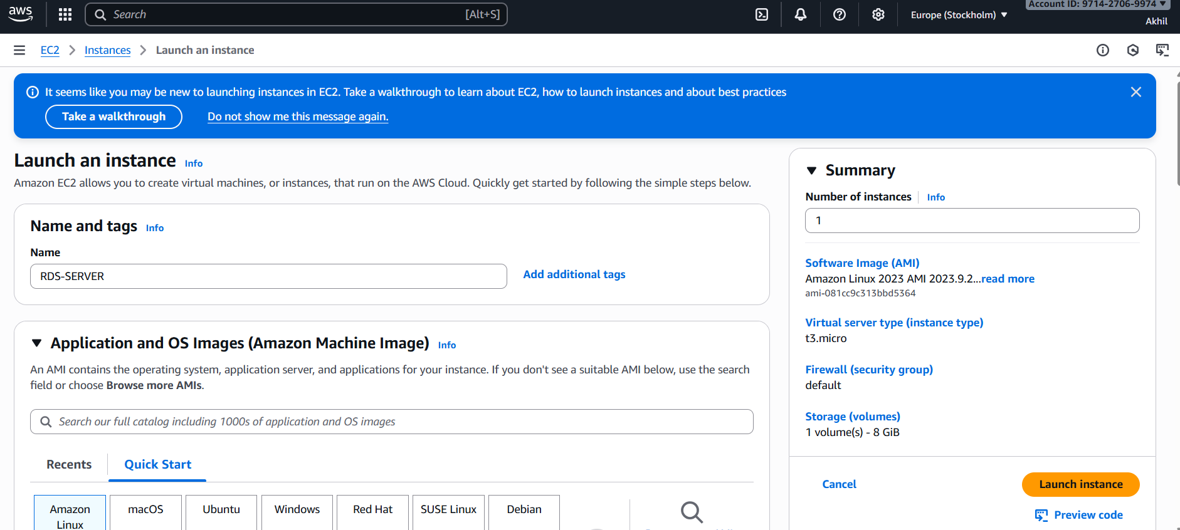
- Yum install -y mariadb105-server
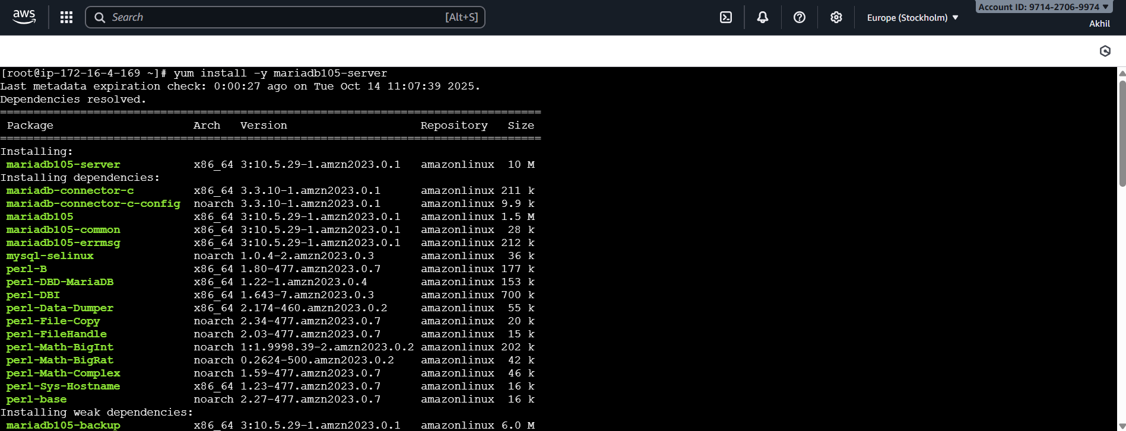
- Systemctl enable mariadb
- Systemctl start mariadb
- Systemctl status mariadb
- Yum -y update
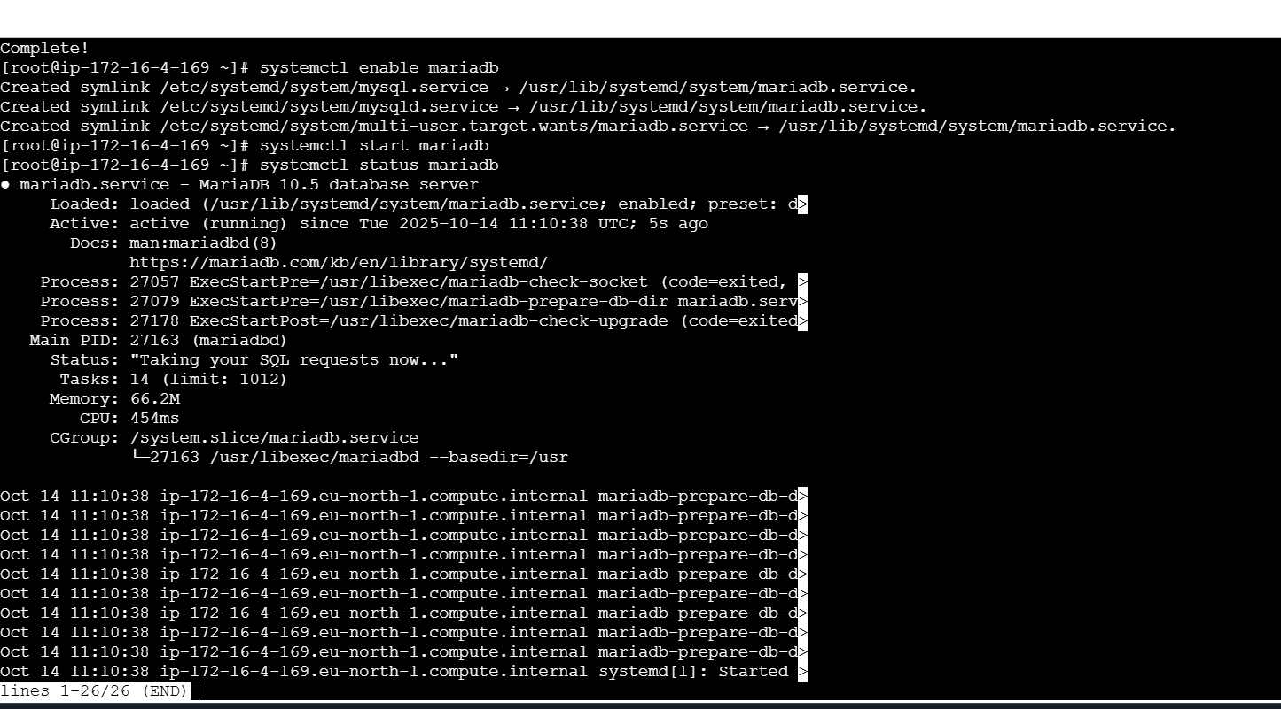
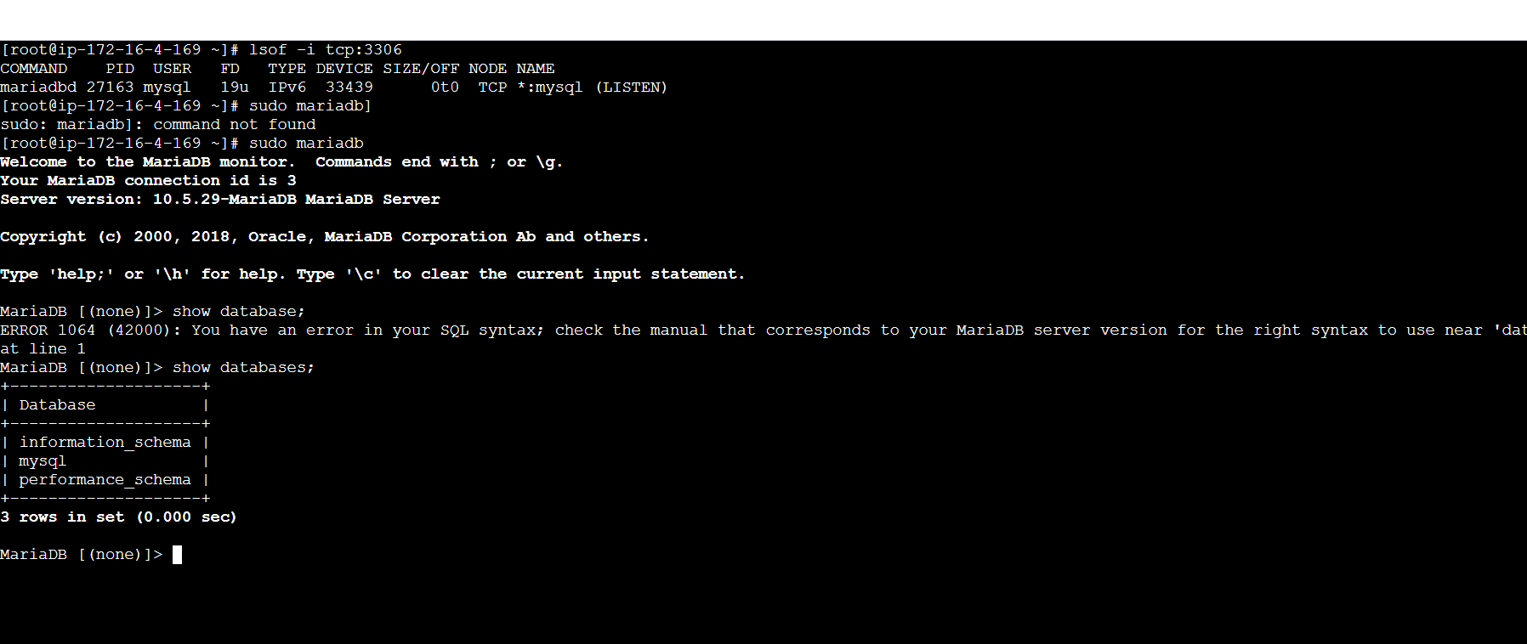
- Insert some dummy data.

- Run following commands to set environmental variable.
- DBName=productiondb
- DBPassword=admin123456
- DBRootPassword=admin123456
- DBUser=syeduser
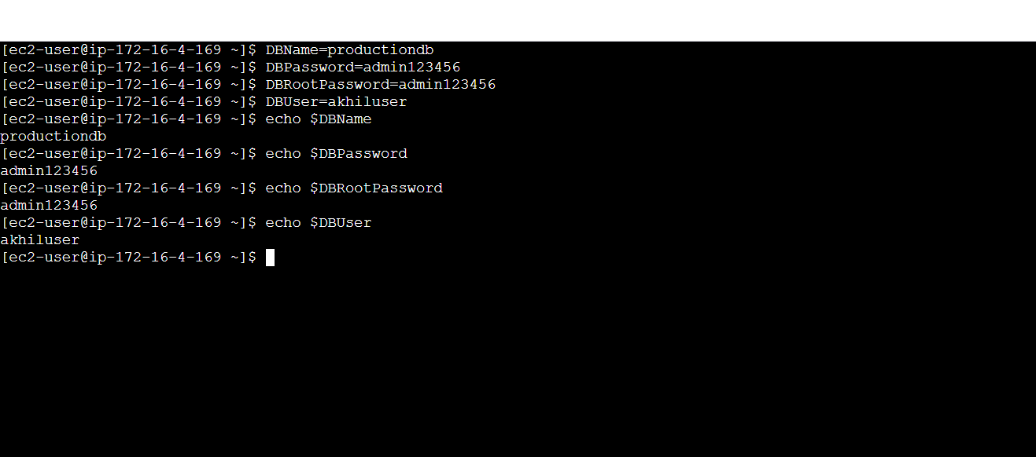
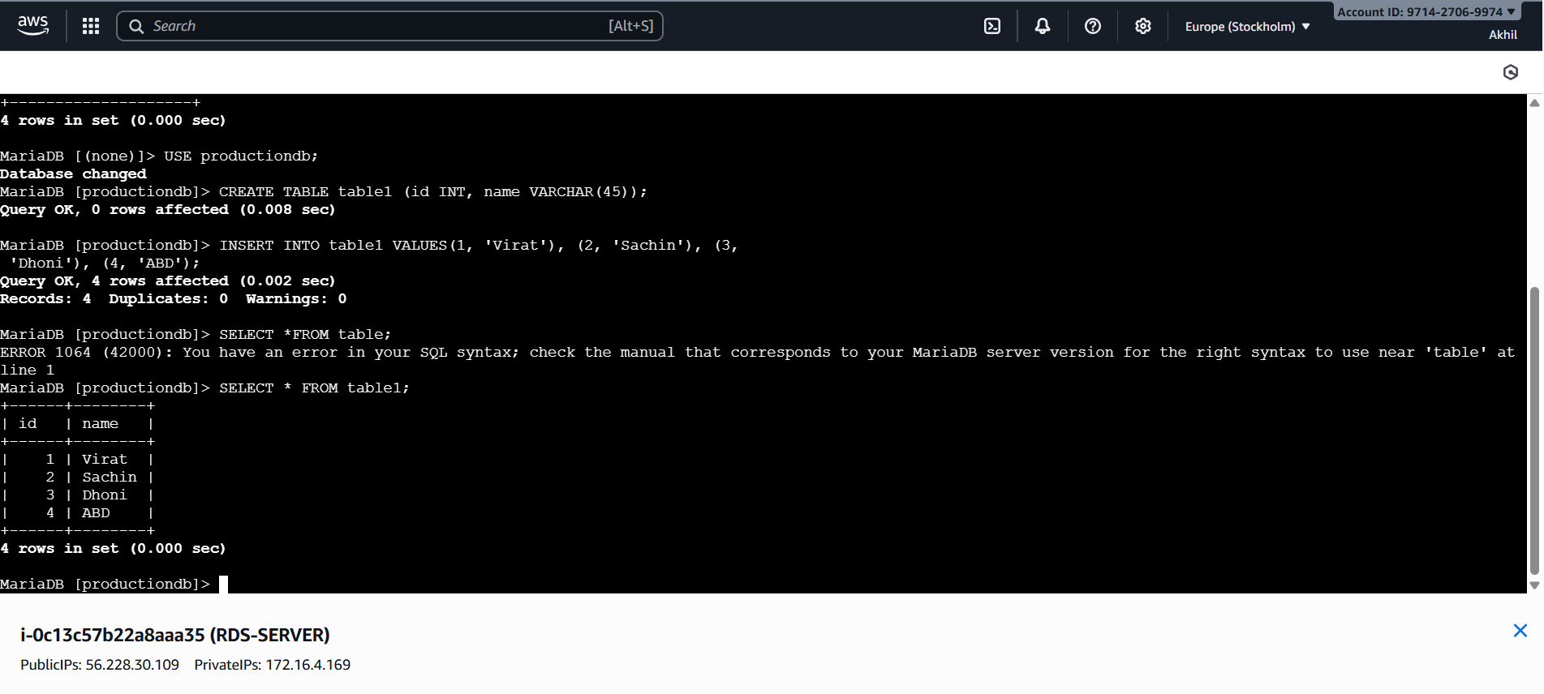
- Take the backup of dummy data on EC2.

- Run following command to take backup and store it in .sql file

- mysql dump -u root -p user_name > file_name.sql

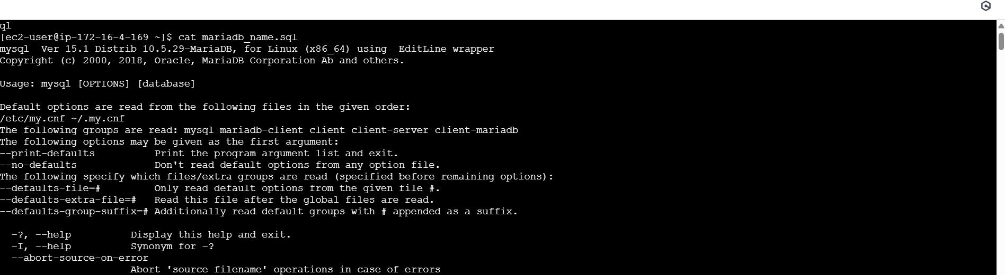
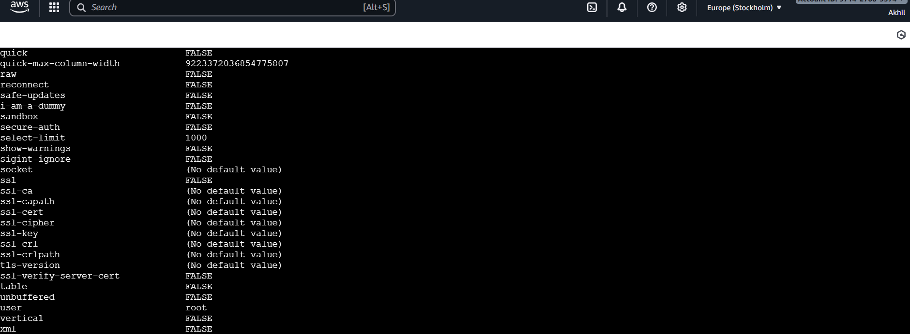
- Launch MariaDB RDS instance.

- Login to AWS, select Aurora and RDS
- Click on Database and click on create database
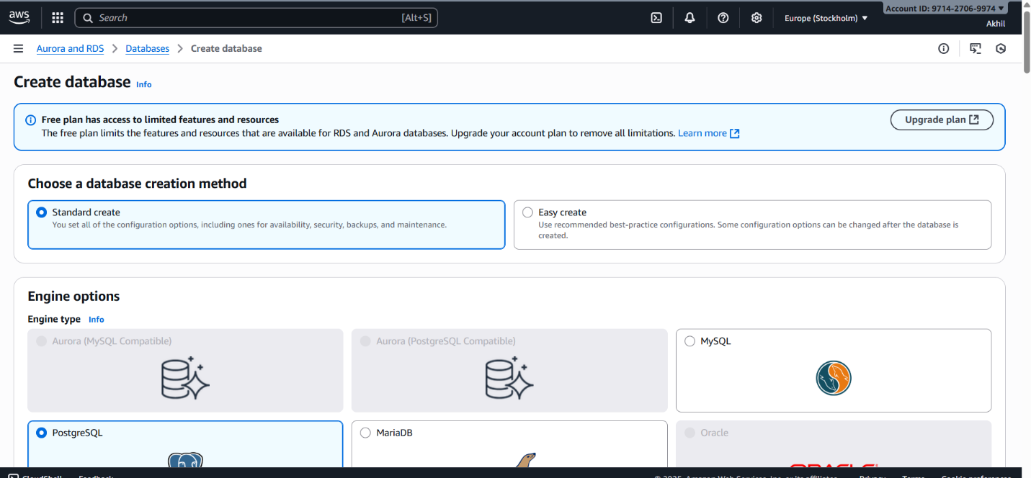
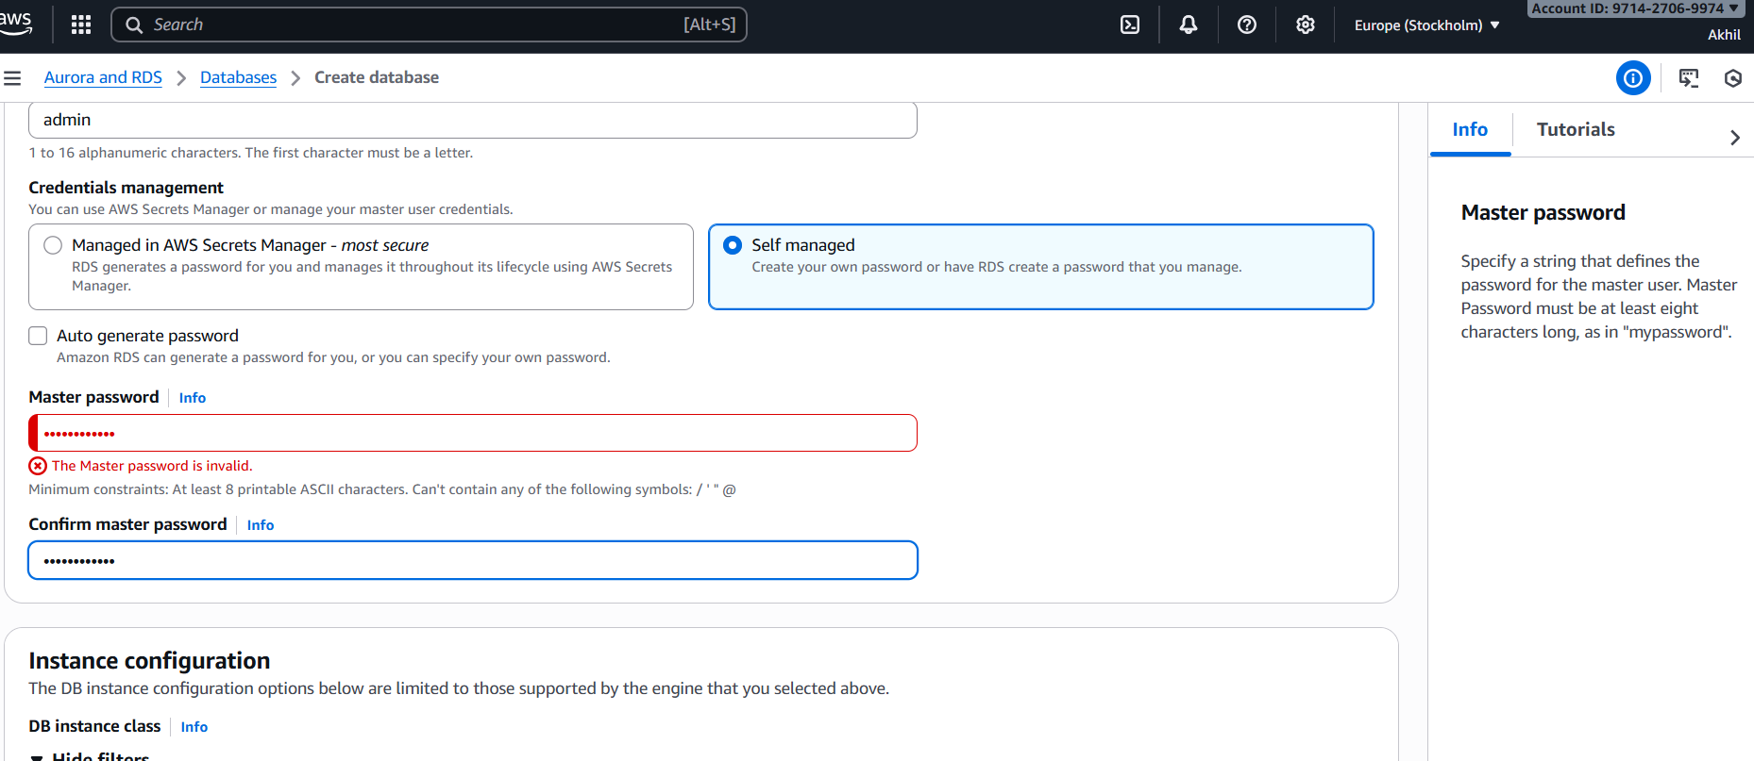
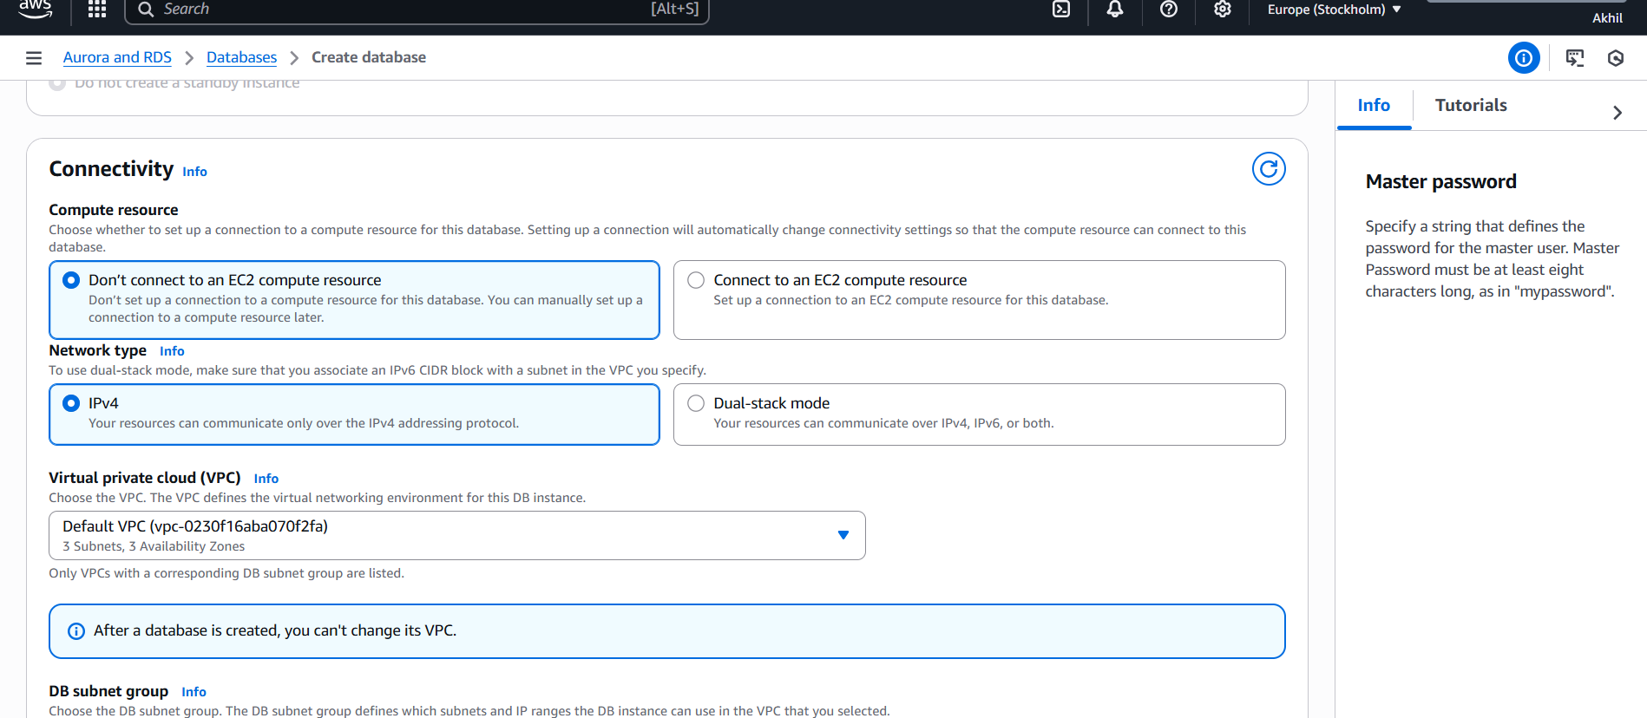
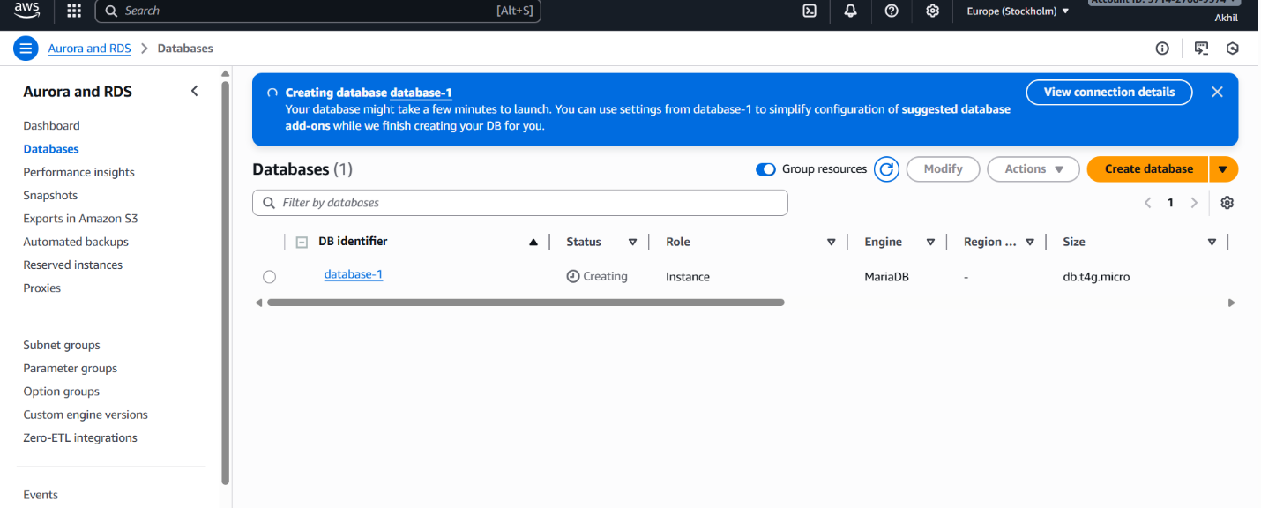
- Migrate database from EC2 to RDS.

- Take the dump of the DB using the command mqsqldump -u root -p database_name > file_name.sql
- Migrate the DB dump to RDS using the following commands:

mysql -h endpoint -p 3306 -u user_name –p RDS_database_name
show databases;
create database database_name;
exit
mysql -h endpoint -p 3306 -u user_name –p RDS_database_name < file_name.sql
mysql -h endpoint -p 3306 -u user_name –p RDS_database_name
show database;
use database_name;
select * from table1;
- Install MySQL DB on EC2.

Step 1: Remove Mariadb using following commands

sudo dnf remove -y mariadb105*
sudo dnf clean packages
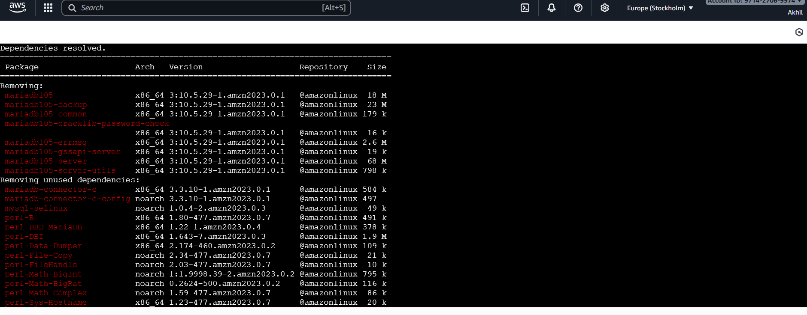
Step 2: Goto /opt directory and run the following commands to download and install the MYSQL.
sudo wget https://dev.mysql.com/get/mysql80-community-release-el9-1.noarch.rpm
sudo dnf install mysql80-community-release-el9-1.noarch.rpm -y
sudo rpm --import https://repo.mysql.com/RPM-GPG-KEY-mysql-2023
sudo dnf install mysql-community-server -y
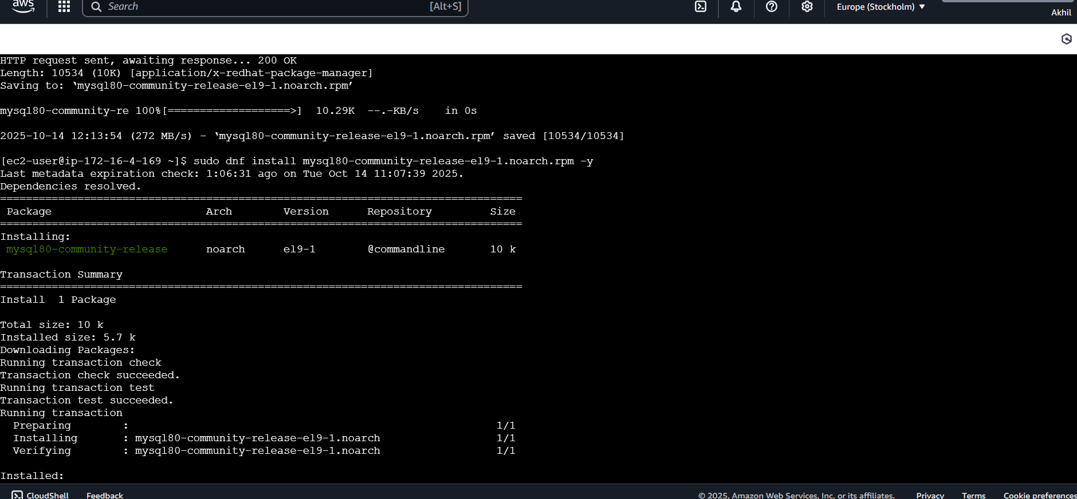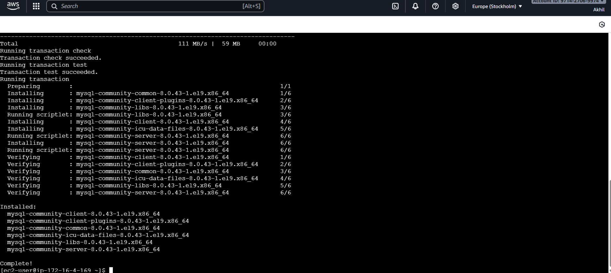
sudo systemctl start mysqld
sudo systemctl enable mysqld
sudo mysql_secure_installation
sudo systemctl status mysqld
- Launch MySQL RDS image.

- Login to AWS, select Aurora and RDS
- Click on Database and click on create database
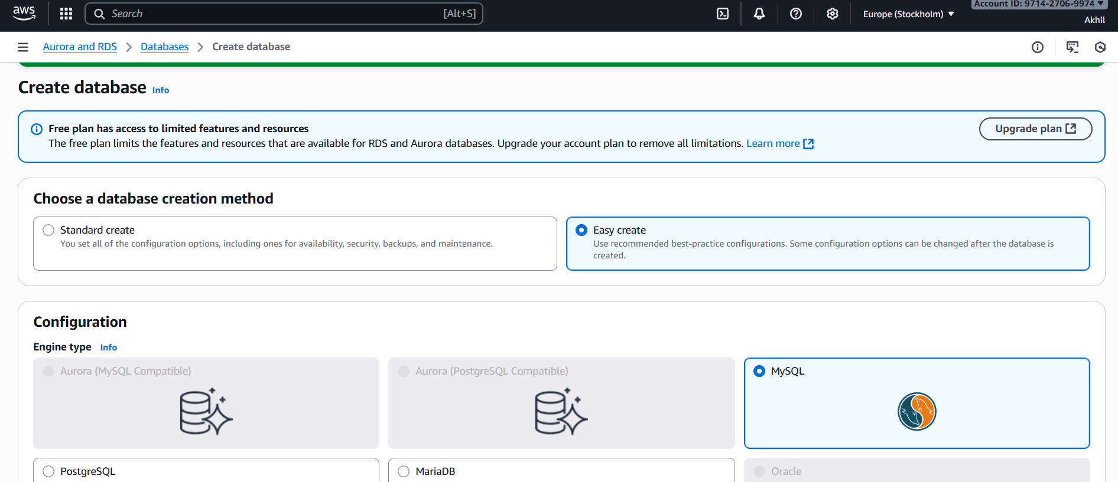
- Select standard create
- Select Mysql
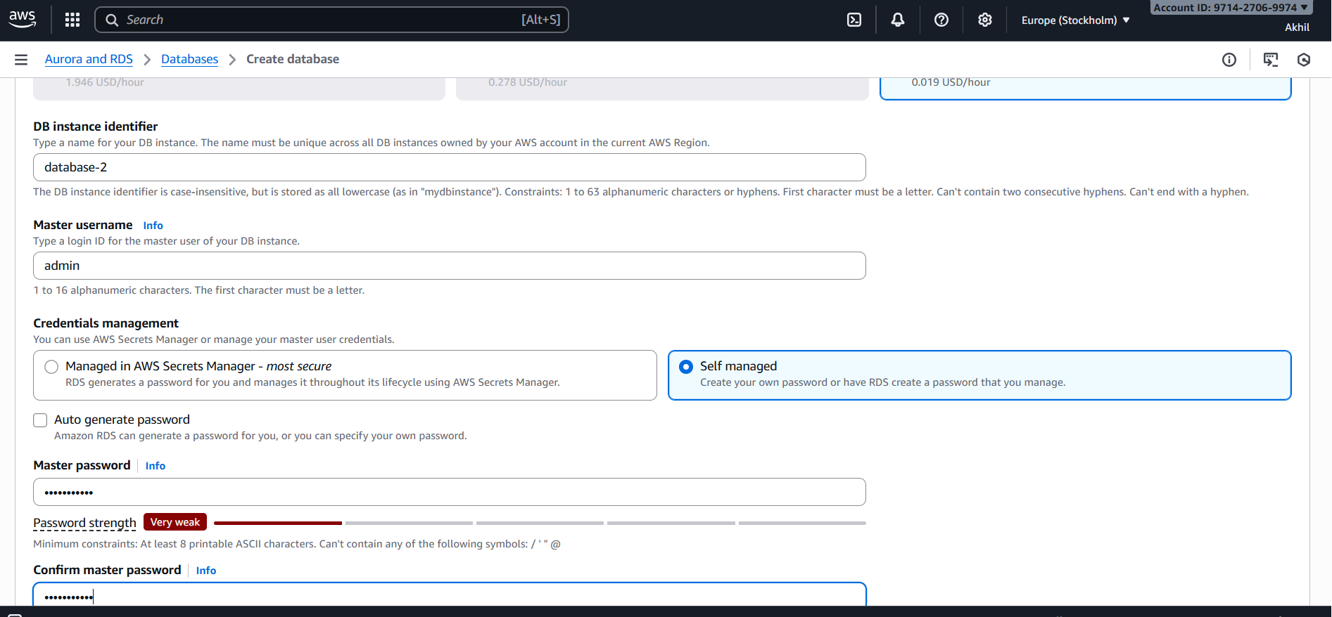
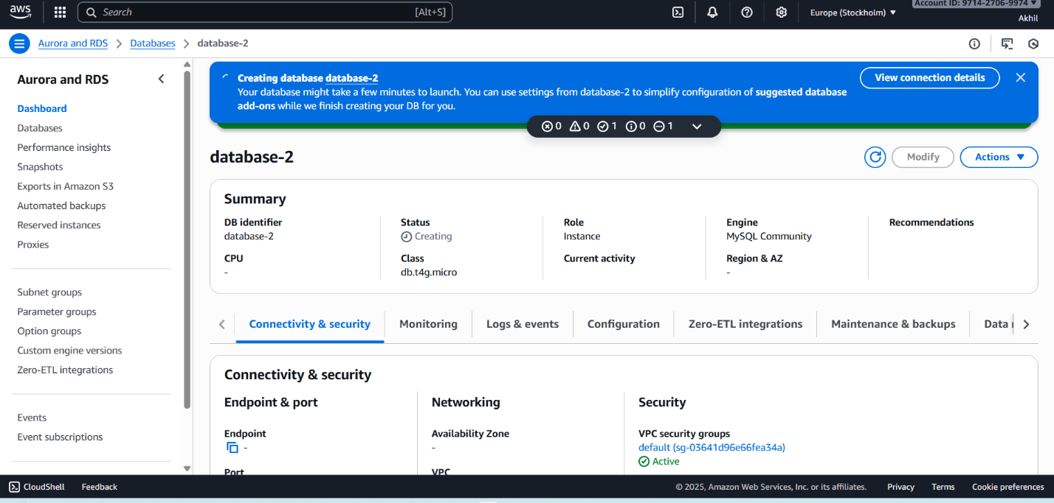

- Configure Multi-AZ.

- Goto RDS select Database
- select database click on Actions
convert to multi AZ deployment
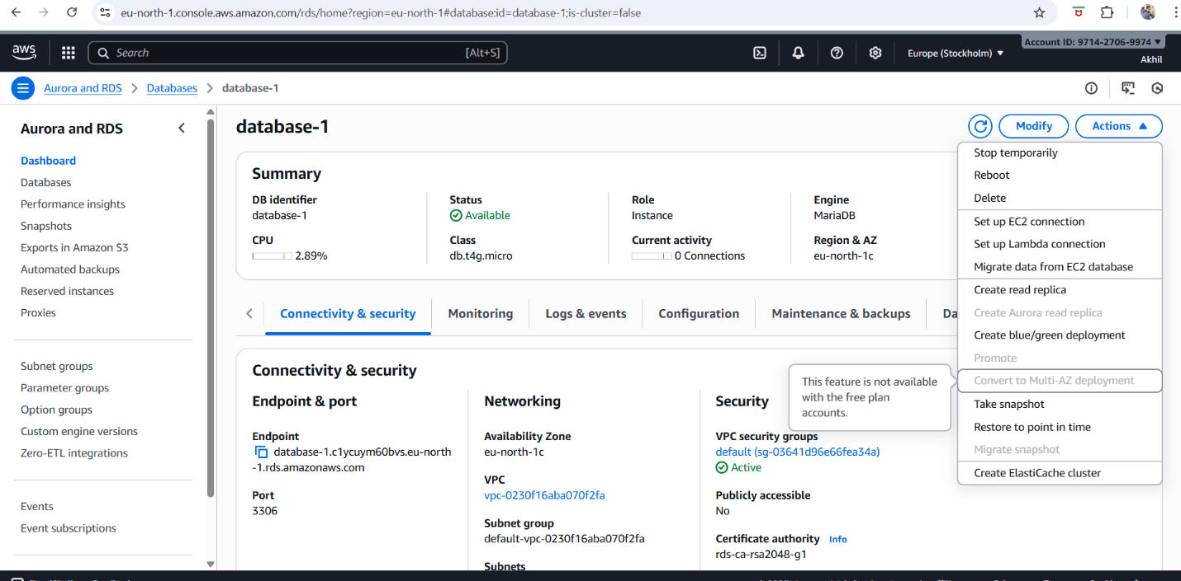
- Take backup of DB and restore the DB.

- Go to the RDS
- Click on action and click on the snapshot
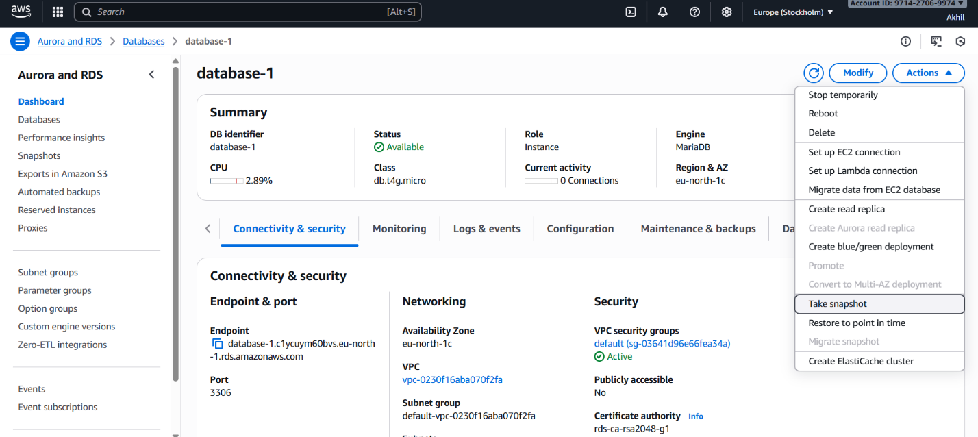
- After taking snapshot delete the database.
- Goto RDS select snapshots
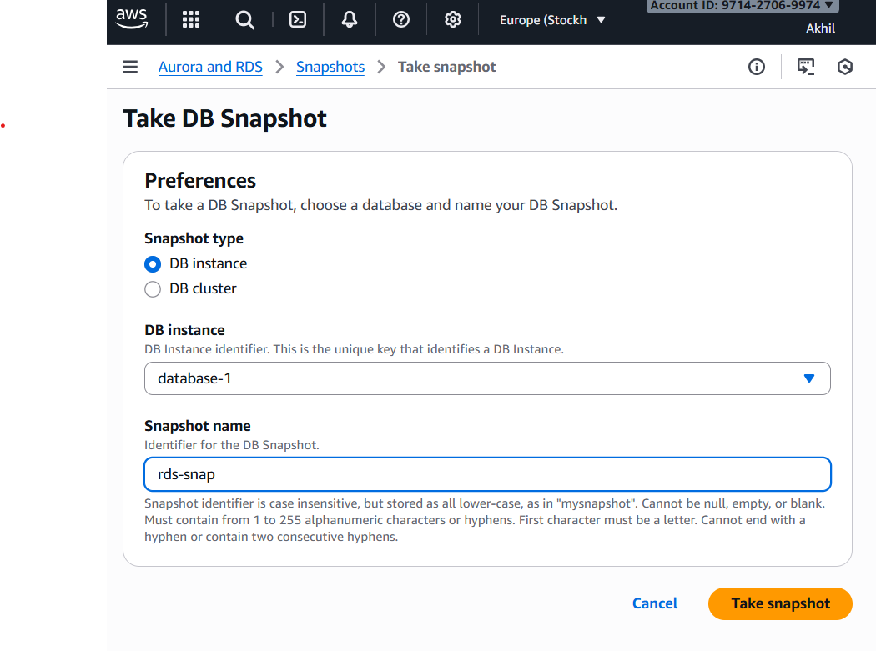
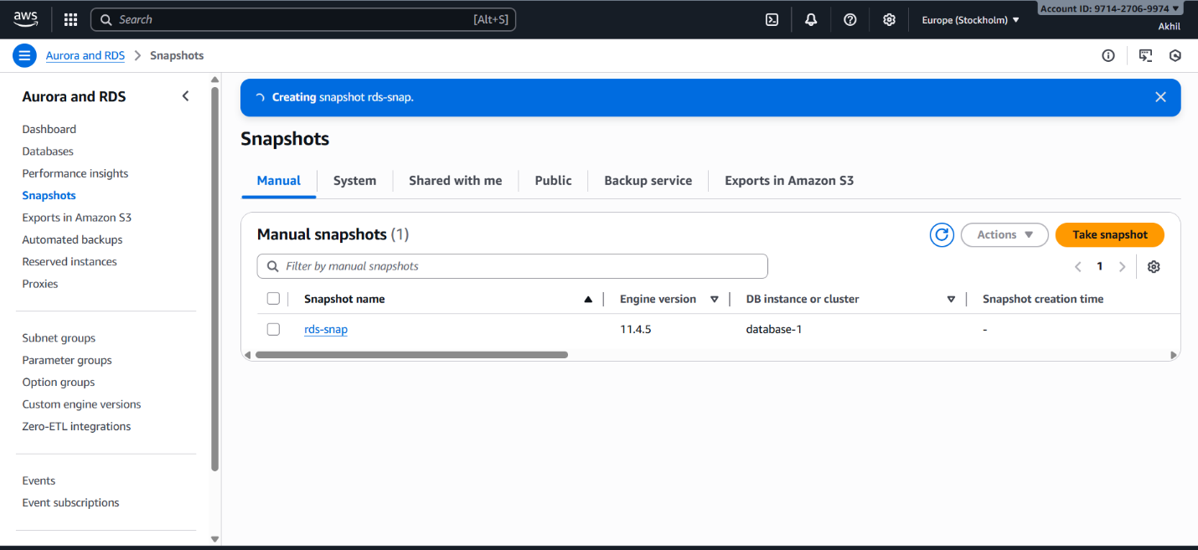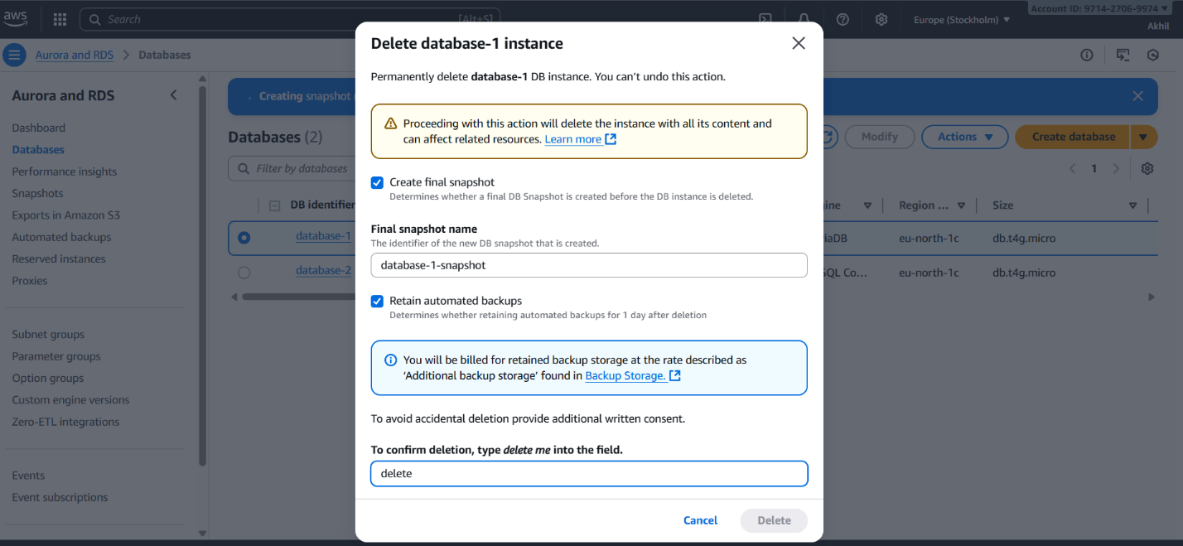
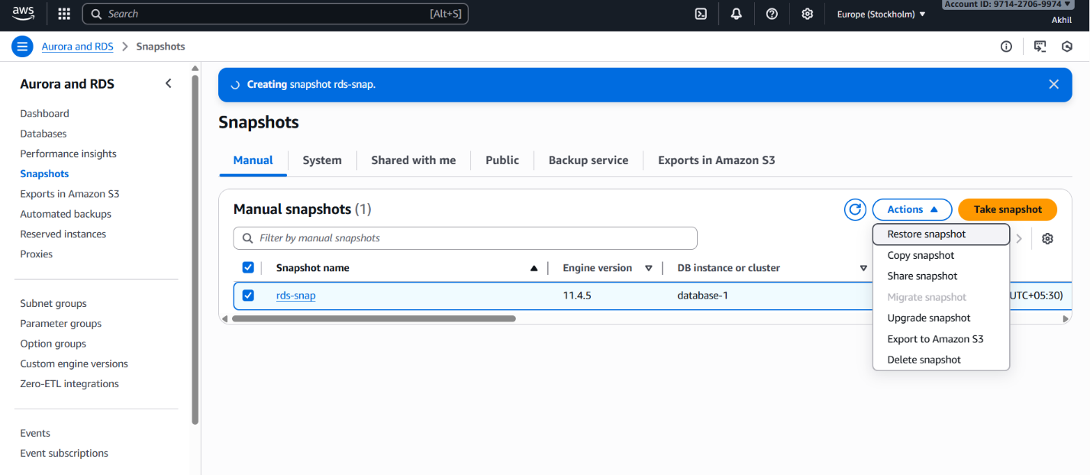
- Create read replica.

Create Read Replica
- Select your primary DB instance.
Click Actions → Create read replica
