BASH SCRIPTS ASSIGNMENT01
Simple output
#!/bin/bash
# Simple output script
echo "Hello World"
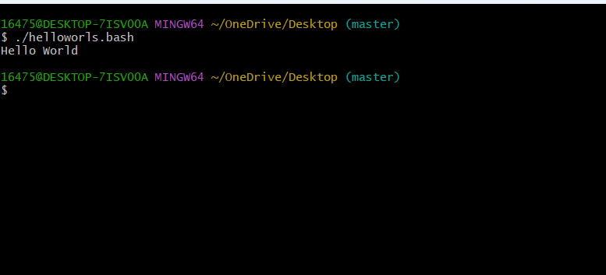
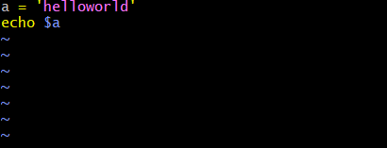
- Variable a = ‘hello world’
- Echo $a – to get variable value.
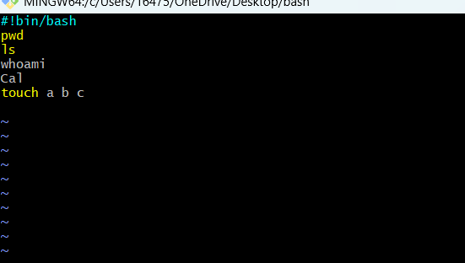
#!bin/bash
Pwd
Ls
Whoami
Cal
Touch a b c
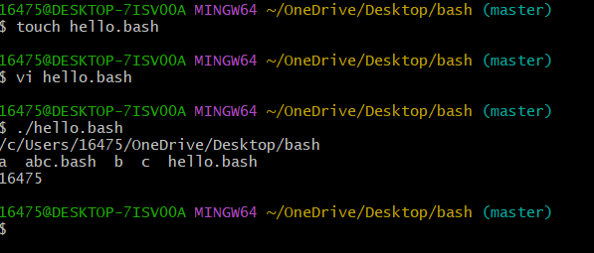
Defining variables
#!/bin/bash
# Example of defining variables
a=akhil
b=goud
c=Linux class
echo "My first name is $a"
echo "My surname is $b"
echo “I am in $c”
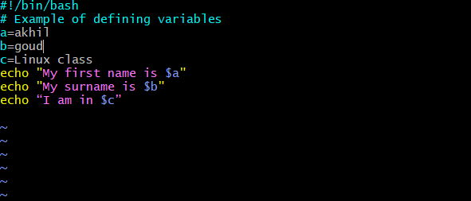
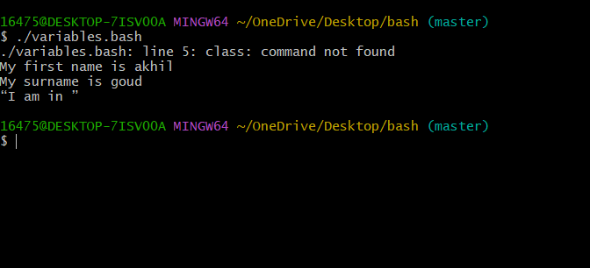
# Define small tasks

whoami
echo
pwd
echo
hostname
echo
ls -ltr
echo
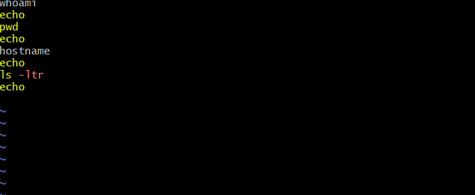
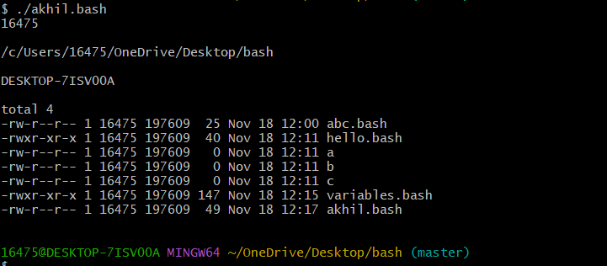
Read Input

#!/bin/bash
# Read user input

echo "What is your first name?"
read a
echo

echo "What is your last name?"
read b
echo

echo Hello $a $b

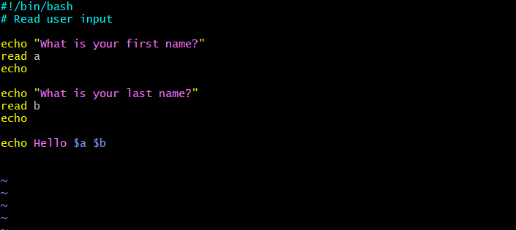
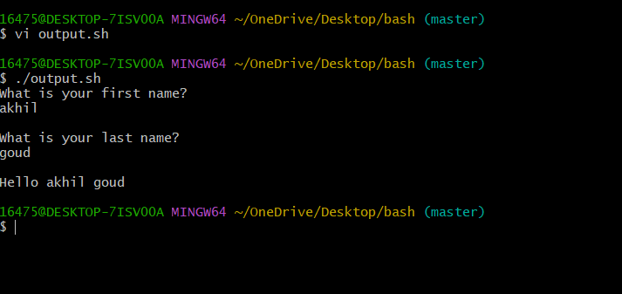

Scripts to run commands within

#!/bin/bash
# Script to run commands within

clear
echo "Hello `whoami`"
echo
echo "Today is `date`"
echo
echo "Number of user login: `who | wc -l `"
echo

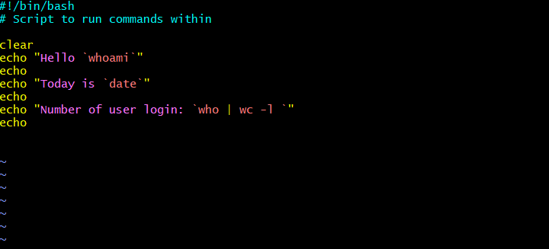
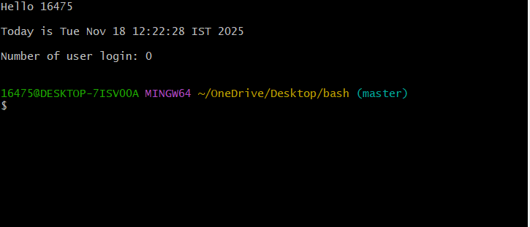
Read input and perform a task

#!/bin/bash
# This script will rename a file
echo Enter the file name to be renamed
read readinpu.bsh
echo Enter the new file name
read read.bash
mv $readinpu.bash $read.bash
echo The file has been renamed as $newfilename
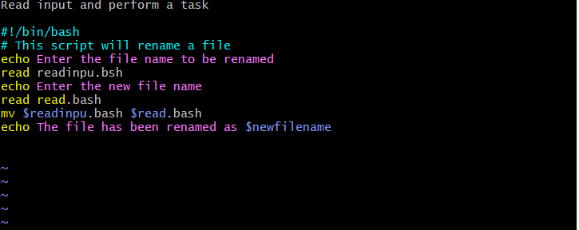

IF SCRIPT
#!/bin/bash
count=10
if [ $count -eq 100 ]
then
echo count is 100
else
echo count is not 100
fi
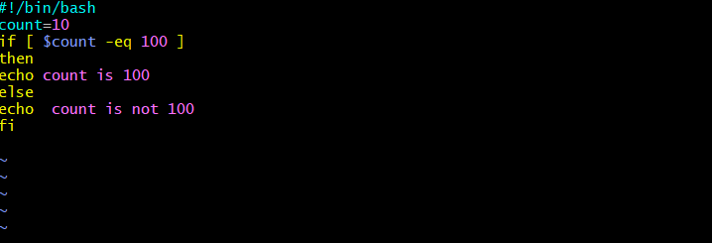
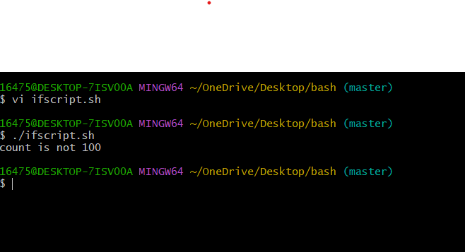
#!/bin/bash

echo
echo Please chose one of the options below
echo
echo 'a = Display Date and Time'
echo 'b = List file and directories'
echo 'c = List users logged in'
echo 'd = Check System uptime'
echo

read choices

case $choices in

a) date;;
b) ls;;
c) who;;
d) uptime;;
*) echo Invalid choice - Bye.

Esac
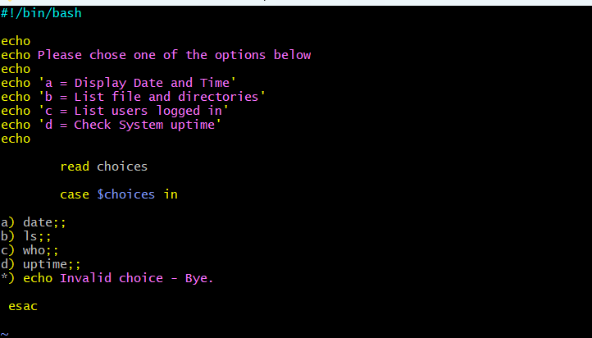
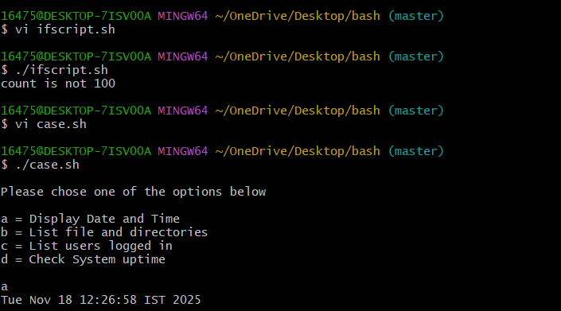

do-while Script

- Script to run for a number of times

#!/bin/bash

c=1
while [ $c -le 5 ]
do
echo "Welcone $c times"
(( c++ ))
done
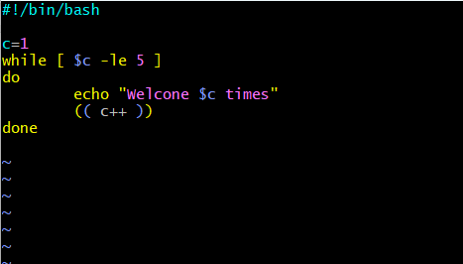
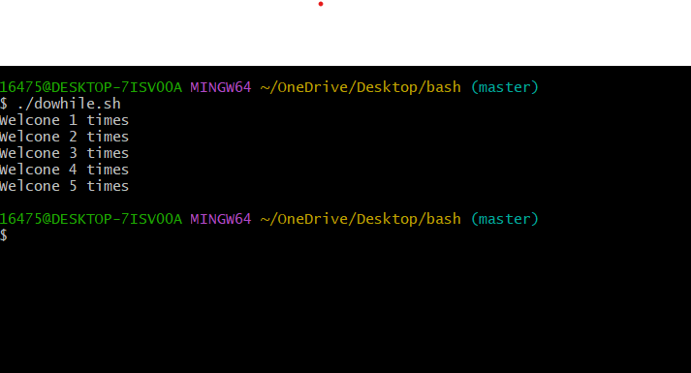
2) Script to run for a number of seconds
#!/bin/bash

count=0
num=10
while [ $count -lt 10 ]
do
echo
echo $num seconds left to stop this process $1
echo
sleep 1

num=`expr $num - 1`
count=`expr $count + 1`
done
echo
echo $1 process is stopped!!!
echo
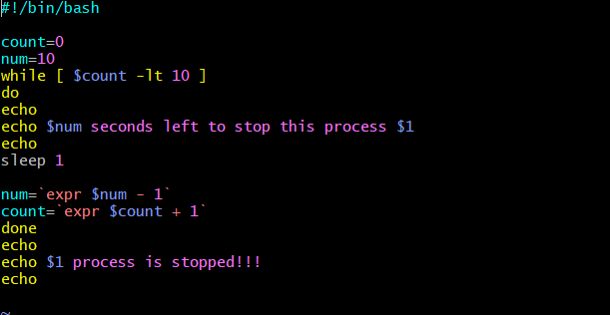
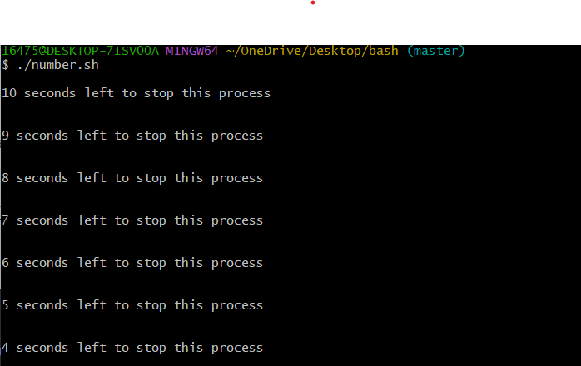

- Simple for loop output

#!/bin/bash

for i in 1 2 3 4 5
do
echo "Welcome $i times"
done
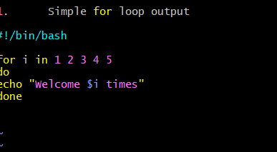
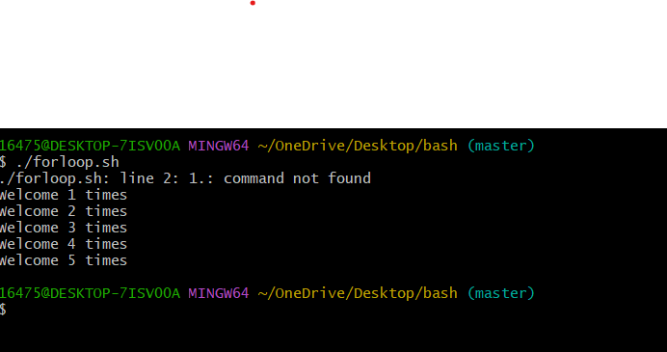
- Simple for loop output

#!/bin/bash

for i in eat run jump play
do
echo See akhil $i
done
