Bash script assignment02
- Create a bash script to check if a directory is available or not.
#!/bin/bash
# Set the directory path to check
DIR="/path/to/your/directory"
# Check if the directory exists
if [ -d "$DIR" ]; then
echo "Directory '$DIR' exists."
else
echo "Directory '$DIR' does not exist."
fi
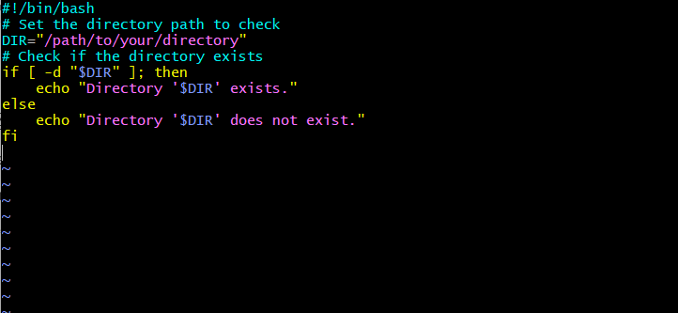
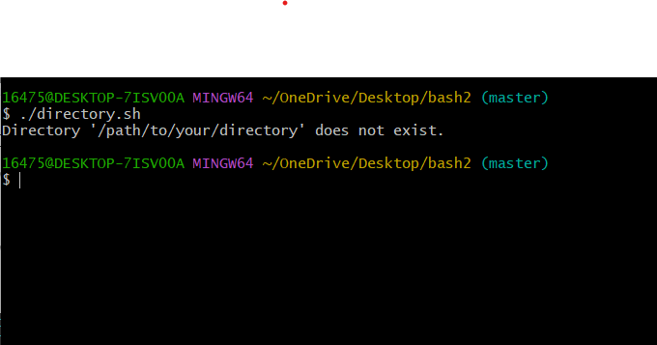
- Create a bash script to create multiple files.
#!/bin/bash
# Create multiple files
touch file1.txt file2.txt file3.txt
echo "Files created: file1.txt, file2.txt, file3.txt"
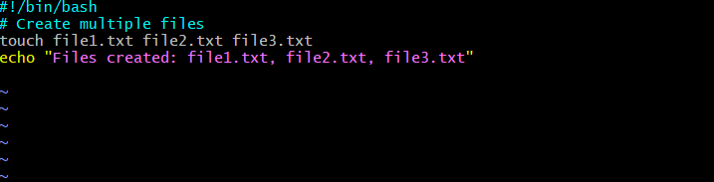
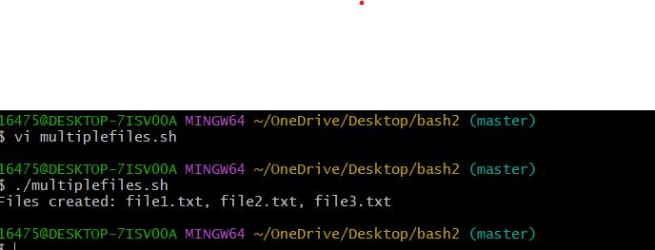
- Create a bash script to take a backup of a directory.

#!/bin/bash

NOW=$(date +"%a")
case $NOW in
Mon)
echo "Full backup";;
Tue|Wed|Thu|Fri)
echo "Partial backup";;
Sat|Sun)
echo "No backup";;
*) ;;
Esac
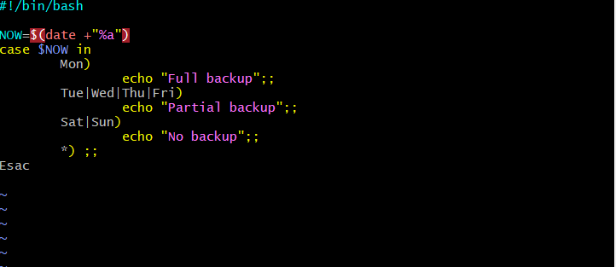
- Create a bash script to install Nginx on an EC2 server.
#!/bin/bash
#install nginx on ec2 server

yum update
yum install nginx
systemctl start nginx
systemctl status nginx
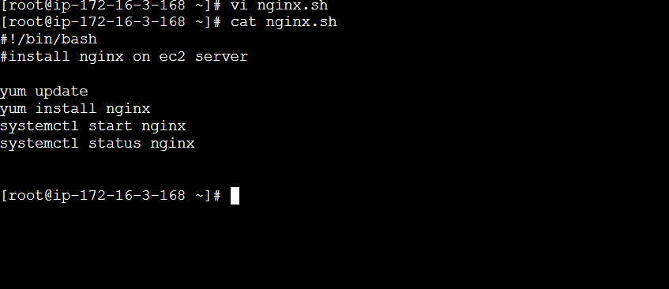
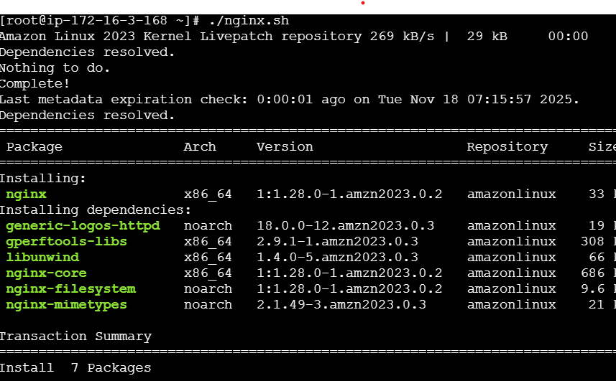
- Create a bash script to install Apache Tomcat on an EC2 server.
#!/bin/bash
yum install java
yum install tomcat
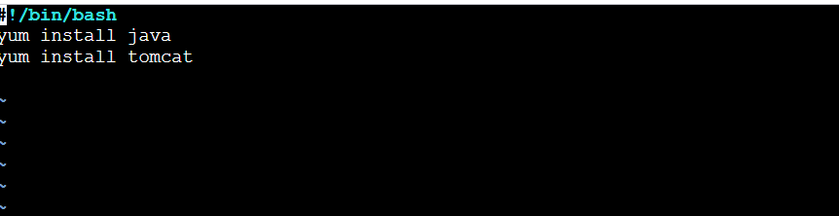

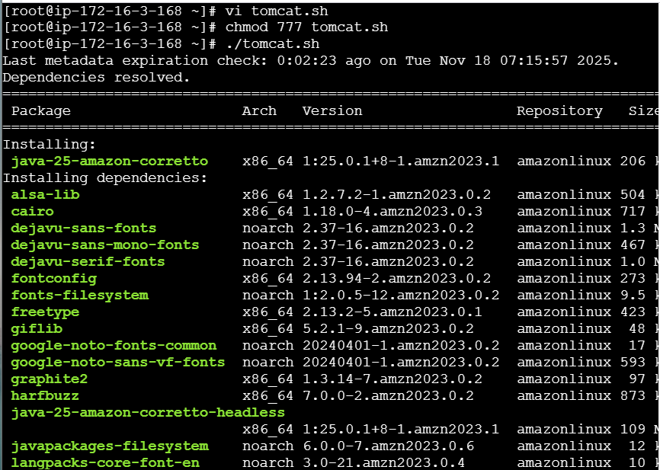
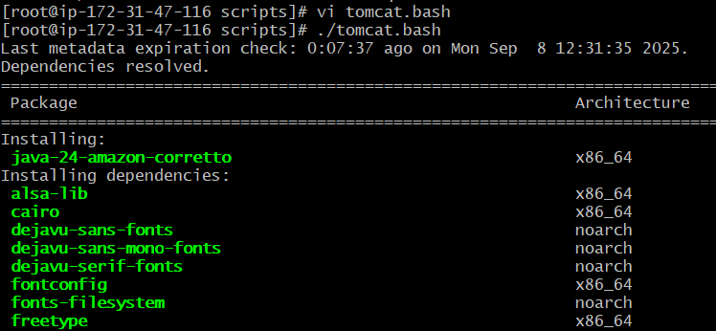
- Create a bash script to check if the Nginx service is running, if not running then script should start the service.
#!/bin/bash
# check if nginx service is active
if systemctl is-active --quiet nginx; then
echo " nginx is running."
else
echo " nginx is not running. attempting to start it..."
sudo systemctl start nginx

# re-check status after attempting to start
if systemctl is-active --quiet nginx; then
echo " nginx started successfully."
else
echo " failed to start nginx. check logs with: sudo journalctl -u nginx"
fi
fi
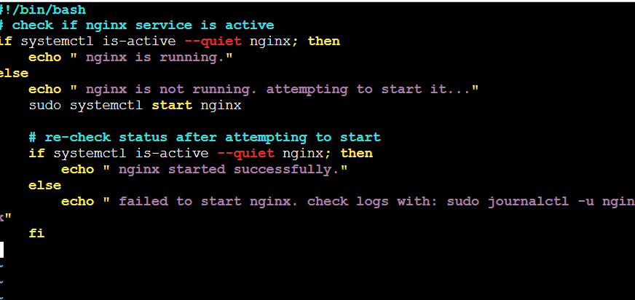
- Create a bash script for a calculator.
#!/bin/bash

echo " simple bash calculator"

# read first number
read -p "enter first number: " num1

# read operator
read -p "enter operator (+, -, *, /): " op

# read second number
read -p "enter second number: " num2

# perform calculation
case $op in
+) result=$(echo "$num1 + $num2" | bc);;
-) result=$(echo "$num1 - $num2" | bc);;
\*) result=$(echo "$num1 * $num2" | bc);;
/)
if [ "$num2" == "0" ]; then
echo " error: division by zero"
exit 1
fi
result=$(echo "scale=2; $num1 / $num2" | bc);;
*) echo " invalid operator"; exit 1;;
esac
echo "result: $result"
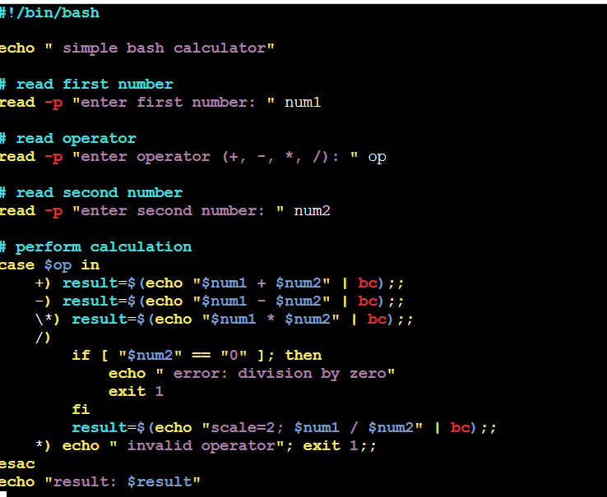
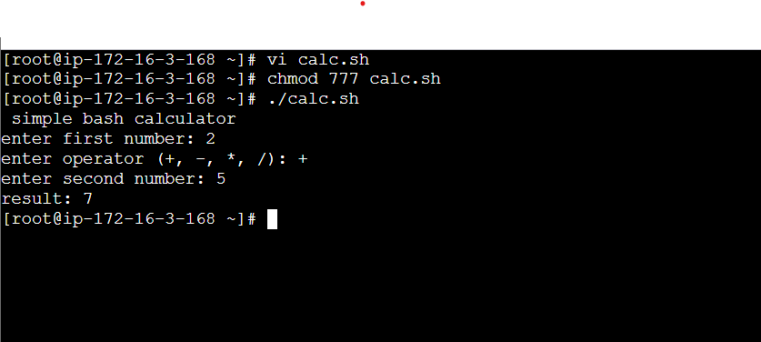
- Create a bash script to check if a directory exists, if not then create a directory.
#!/bin/bash
# Set your target directory
DIR="./DIRECTORY”
# Check if the directory exists
if [ -d "$DIR" ]; then
echo "Directory '$DIR' already exists."
else
echo " Directory '$DIR' not found. Creating it..."
mkdir -p "$DIR"
echo " Directory '$DIR' created successfully."
Fi
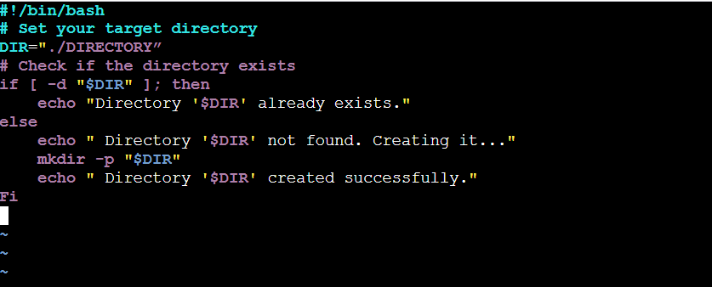
- Create a bash script to delete the last 3 lines of a file.
#!/bin/bash
# Usage: delete last 3 lines of file

FILE="$1"

if [[ ! -f "$FILE" ]]; then
echo "Error: File '$FILE' not found."
exit 1
fi

# Create a temporary file excluding the last 3 lines
head -n -3 "$FILE" > "${FILE}.tmp"
# Replace original file with trimmed version
mv "${FILE}.tmp" "$FILE"
echo "Removed last 3 lines from '$FILE'."
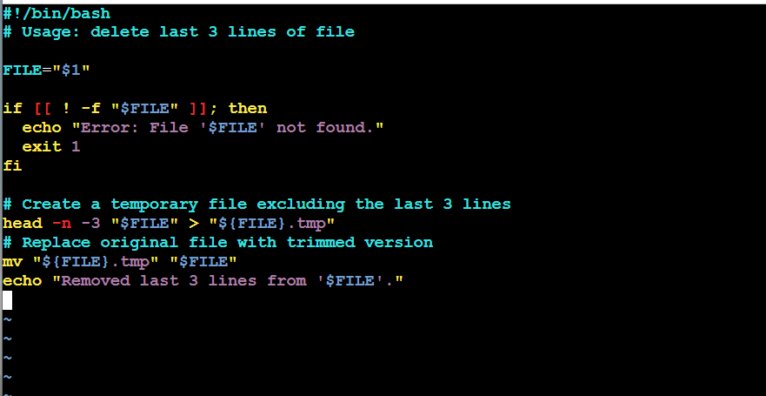
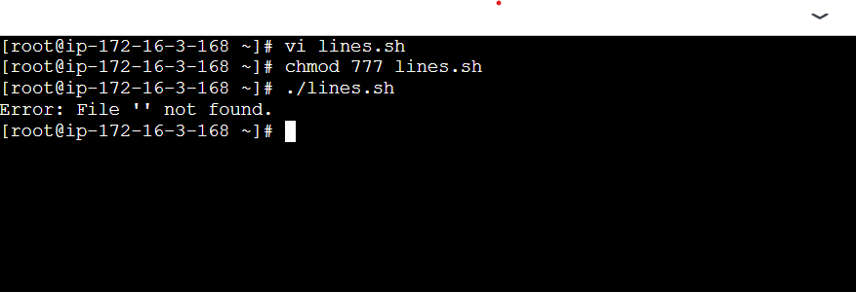
- Bash script to monitor cpu and if it is more than 80% then send email notification.

#!/bin/bash

# CPU threshold
THRESHOLD=80

# Get current CPU idle percentage using top
CPU_IDLE=$(top -bn2 | grep "Cpu(s)" | tail -n1 | awk -F',' '{print $4}' | awk '{print $1}')
CPU_USAGE=$(echo "100 - $CPU_IDLE" | bc)

# Convert to integer
CPU_INT=${CPU_USAGE%.*}

# Check threshold
if [ "$CPU_INT" -gt "$THRESHOLD" ]; then
echo "Warning: CPU usage is at ${CPU_USAGE}% (Threshold: ${THRESHOLD}%)"
else
echo " CPU usage is normal: ${CPU_USAGE}%"
fi
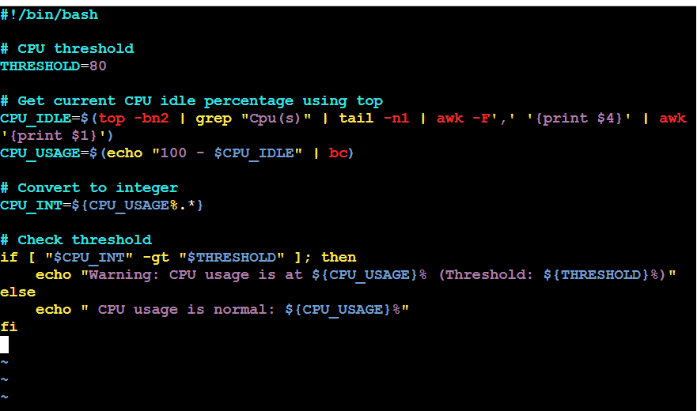

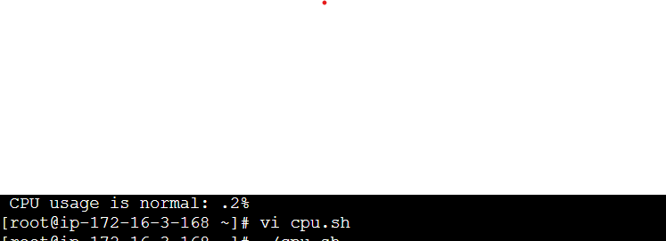

- Bash script to monitor disk space and if it is more than 80% then send email notification.
#!/bin/bash

# Threshold percentage
THRESHOLD=80

# Get disk usage info
df -H --output=pcent,target | tail -n +2 | while read -r line; do
# Extract percentage and mount point
USAGE=$(echo "$line" | awk '{print $1}' | tr -d '%')
MOUNT=$(echo "$line" | awk '{print $2}')

if [ "$USAGE" -gt "$THRESHOLD" ]; then
echo "Warning: Disk usage on $MOUNT is ${USAGE}% (Threshold: ${THRESHOLD}%)"
# Optional: trigger email or log here
fi
done
- Bash script to monitor memory and if it is more than 80% then send email notification.
#!/bin/bash
# define the memory usage threshold (80%)
threshold=80
# get total memory and used memory in mb
# free -m outputs memory in mb
# awk is used to extract the relevant numbers from the 'mem:' line
total_memory=$(free -m | awk 'nr==2 {print $2}')
used_memory=$(free -m | awk 'nr==2 {print $3}')
# calculate memory usage percentage
# 'bc' is used for floating-point arithmetic
if [[ "$total_memory" -gt 0 ]]; then
memory_percentage=$(echo "scale=2; ($used_memory * 100) / $total_memory" | bc)
else
memory_percentage=0
fi

# compare memory usage with the threshold
# 'echo' is used with 'bc' to perform the comparison
# the result is then evaluated in an 'if' statement
if (( $(echo "$memory_percentage > $threshold" | bc -l) )); then
echo "warning: high memory usage!"
echo "current memory usage: ${memory_percentage}% (${used_memory}mb / ${total_memory}mb)"
else
echo "memory usage is within acceptable limits: ${memory_percentage}%"
fi

