1)Install git
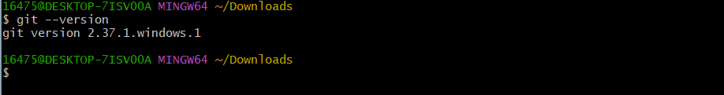
2) create a repo in github with README.md and .ignore file
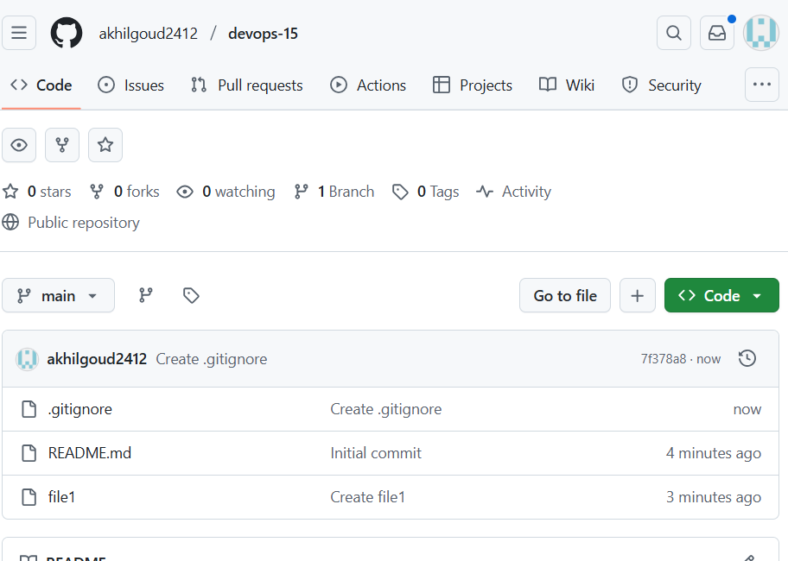
3)clone the created repo to local
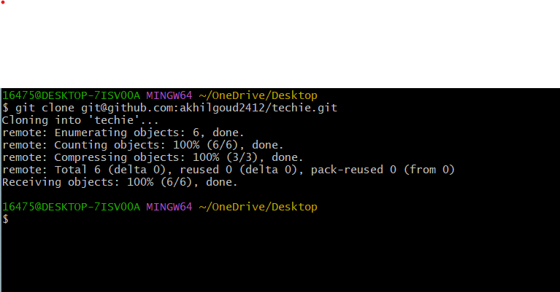
4)create two files in local repo
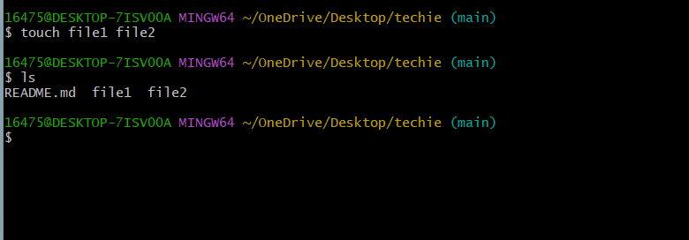
5)commit two files and push to central repo
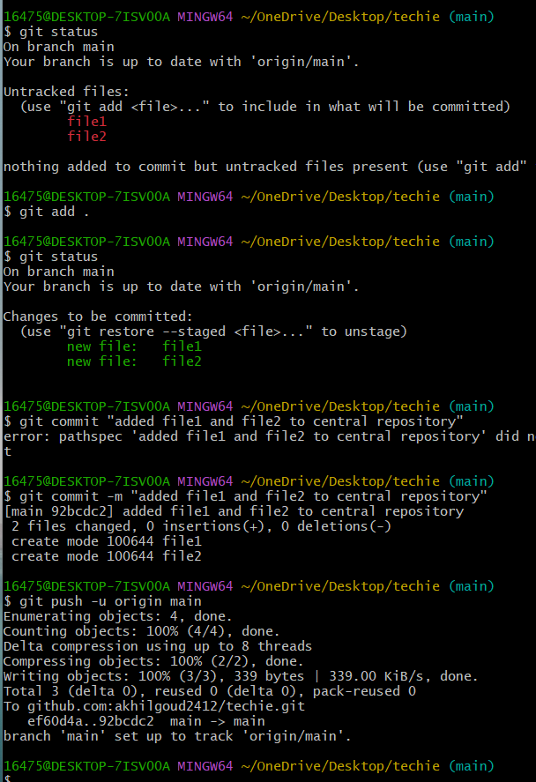
6)create a branch in local and create a sample file and push to central
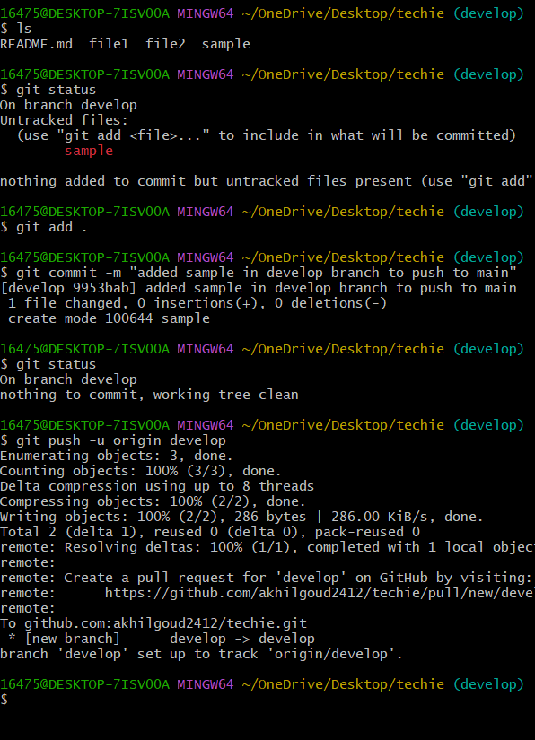
7)create a branch in github and clone that to local
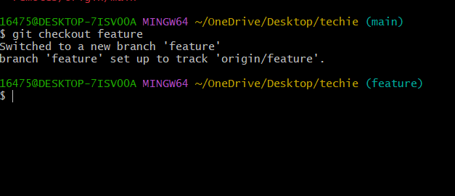

8)merge the created branch with master in git local
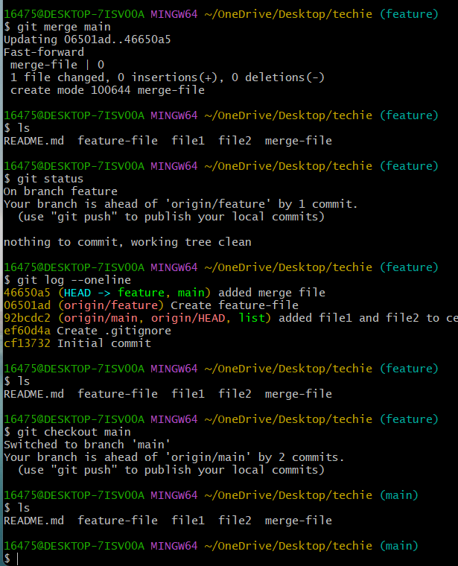
9)merge the created branch with master in github by sending a pull request
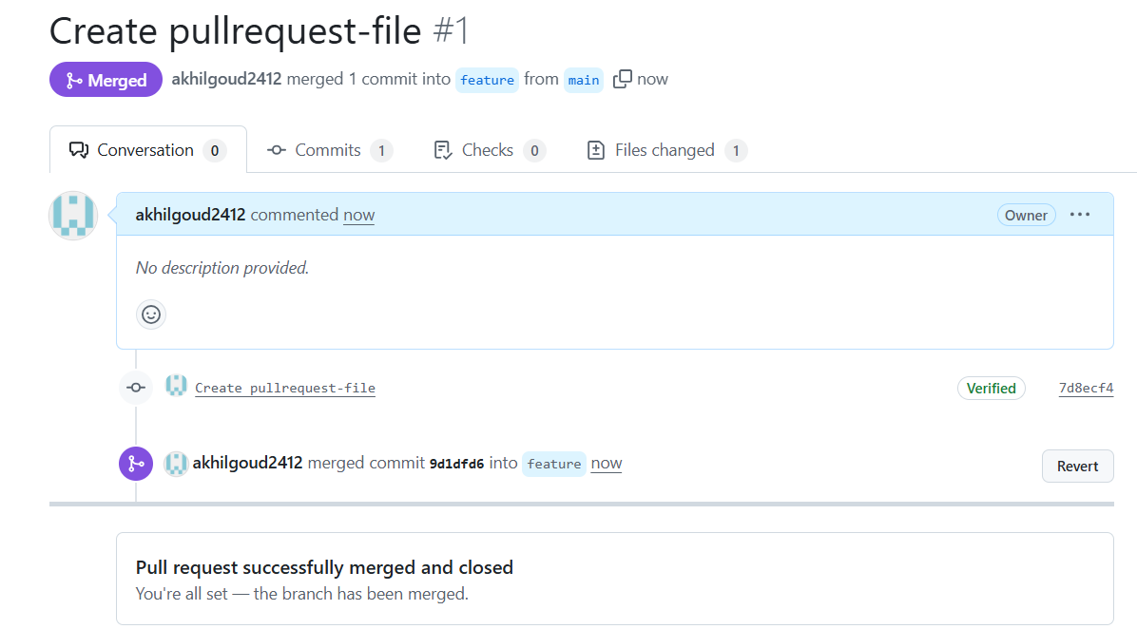
10)create a file in local and send that to branch in github
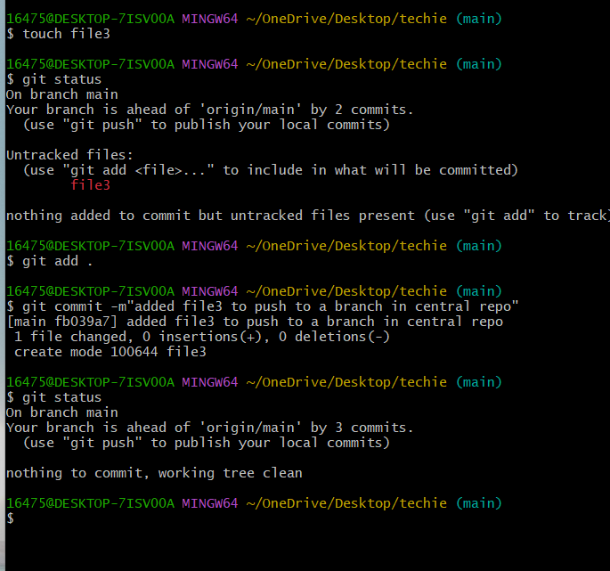
11)clone only a branch from github to local
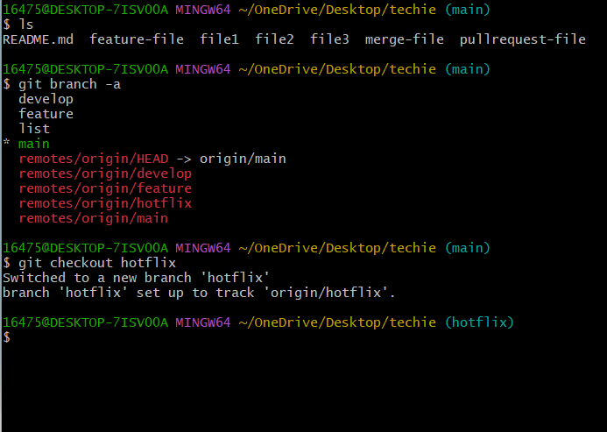
12)create a file with all passwords and make that untrackable with git
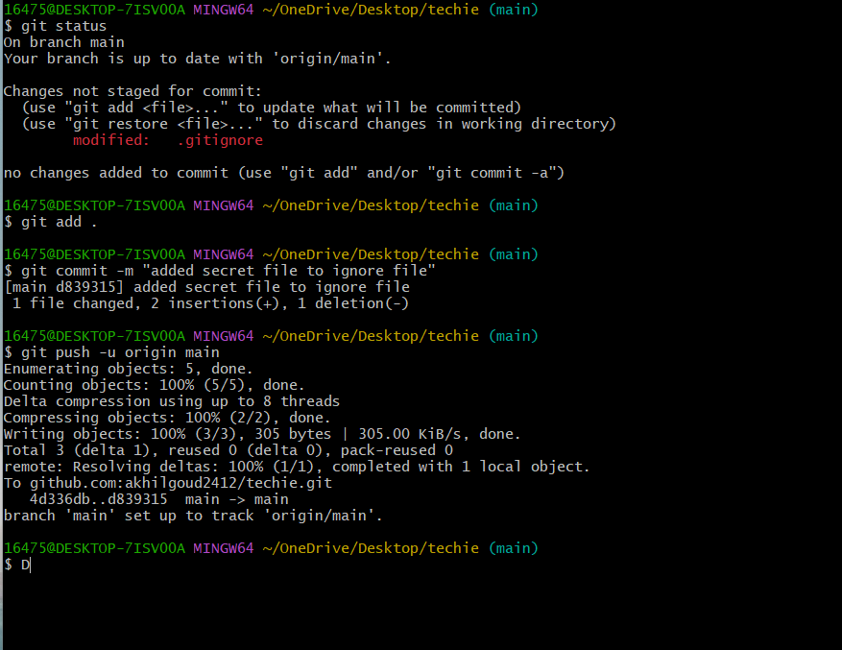

13)make a commit and make that commit reset without savings changes
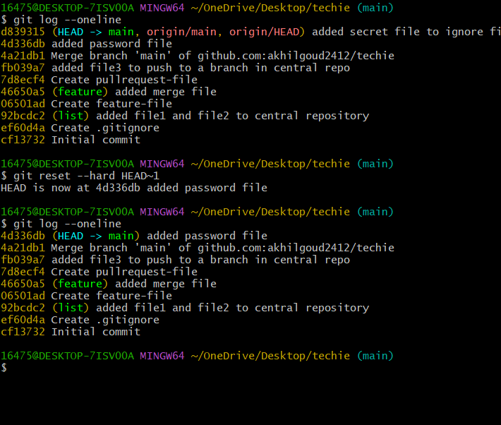
14)Revert a committed commit to the older version
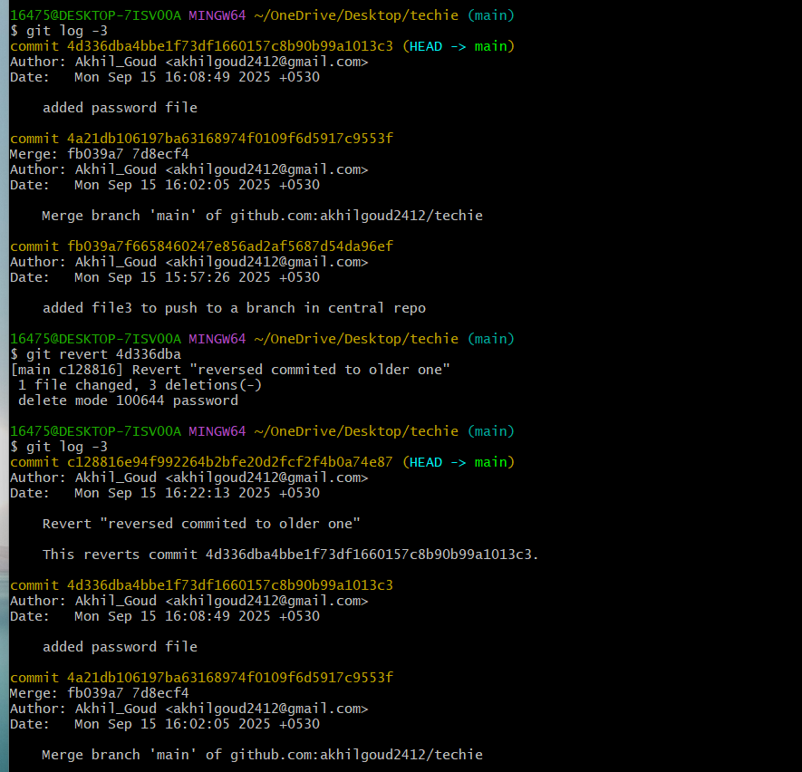
15)push a file to stash without saving the changes and work on another file
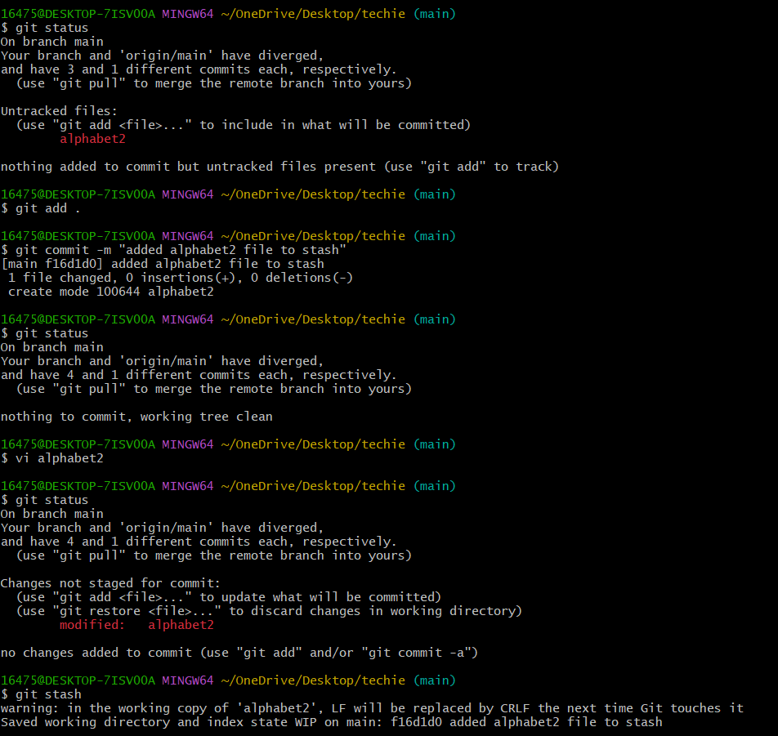
16)undo the stash file and start working on that again
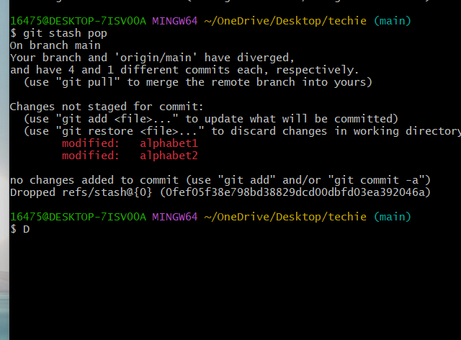
17)generate a ssh-keygen
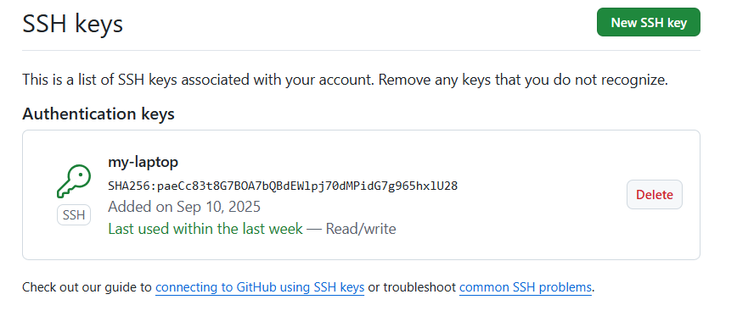
19) Basic understanding of .git file
-- when we initialize using git init
--it prepares a directory to track changes
--creates a hidden. git directory in the project

20)check all the log of git
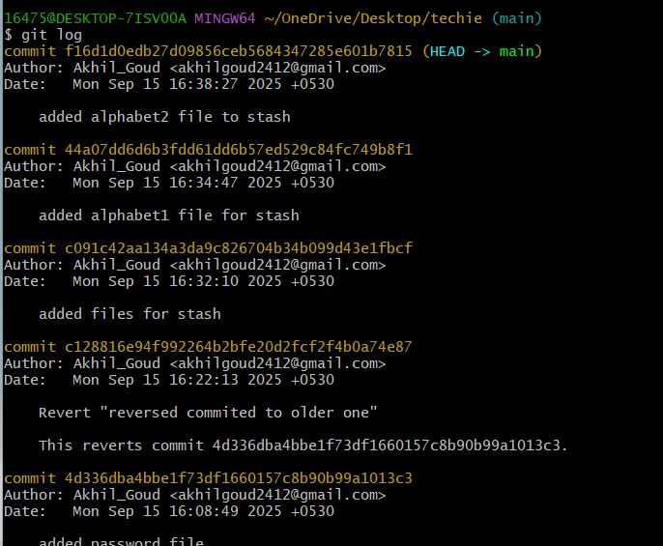
21)Rename the commit message
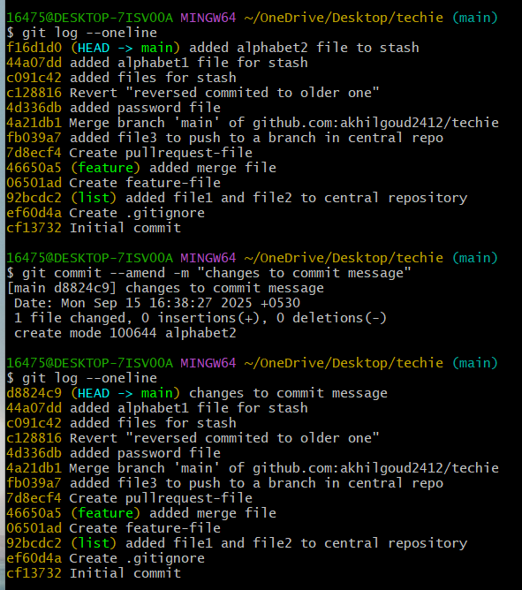

22)merge multiple commits into single commit
