- Launch one EC2 using Amazon Linux 2 image and add a script in user data to install Apache.
- Go to aws console login to your account.
- Click on launch instance.
- Give the nametag to your instance
- Select the amazon linux 2023
- Select instance type t3.micro : can be changed according to the requirement.
- Give the key pair you have already created or create new key pair.
- In network setting allow all traffic
- Configure the storage volume required
- Scroll down and click on advanced details scroll down
- You will find user data i.e boot strapping where you can add a script to run after launching you can also write script to install services.
- Write there a script to install apache (httpd)
#!/bin/bash

# Update package list
sudo yum -y update

# Install Apache HTTP Server
sudo yum -y install httpd

# Enable and start the service
sudo systemctl enable httpd
sudo systemctl start httpd

# Confirm status
sudo systemctl status httpd
- Then click on launch instance
- Instance is successfully launched
- Copy the ipv4 public address of the instance
- Go to the location where you have downloaded the key
- Right click and run git bash here.
- Connect to the instance : ssh -i “keypair.pem” ec2-user@ “ipv4 public”- address of the instance
- You can see the connected to instance and httpd (apache) is also running.
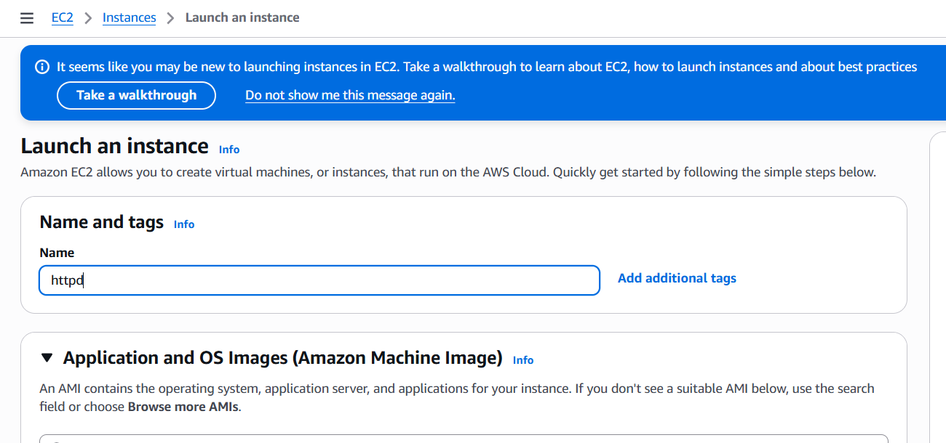
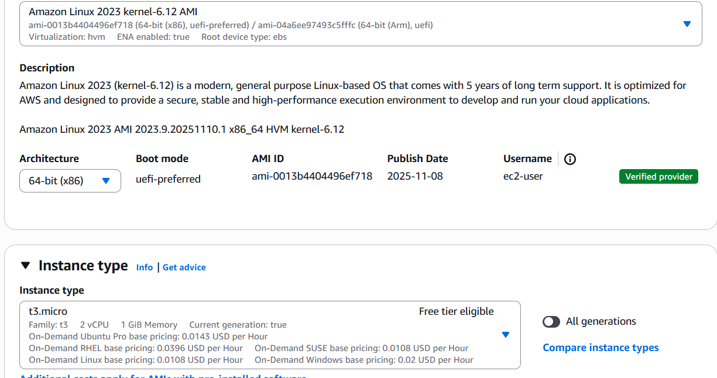
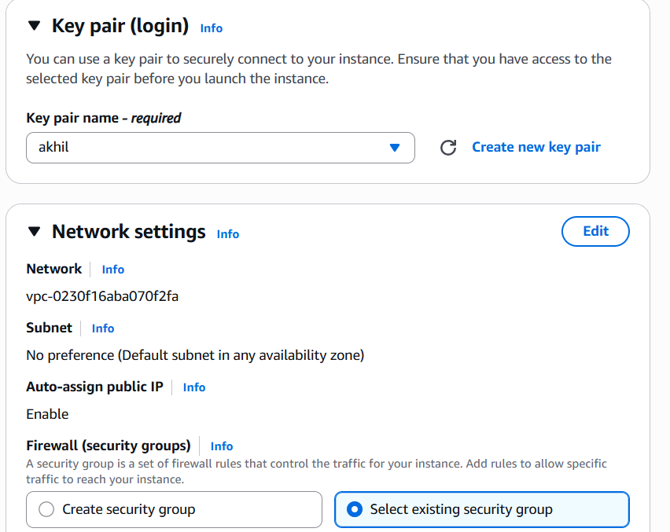
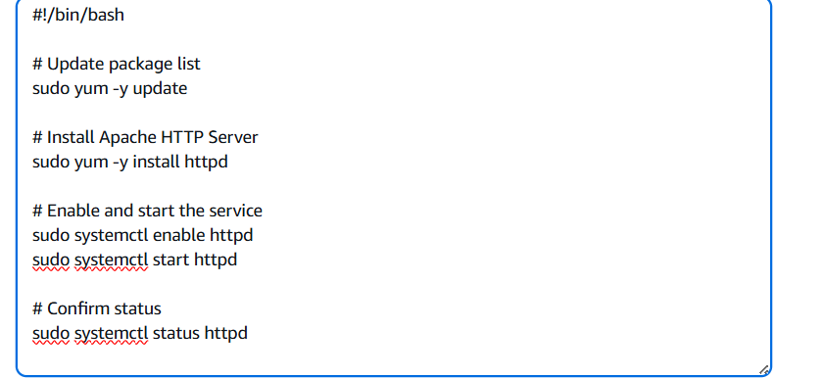
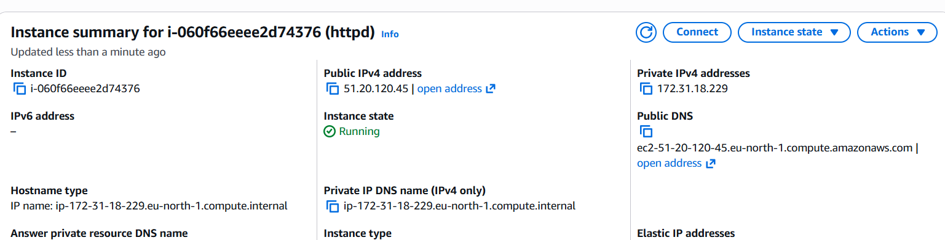
2.Launch one EC2 using Ubuntu image and add a script in user data to install Nginx.
- Click on launch instance.
- Give the nametag to your instance
- Select the ubuntu AMI
- Select instance type t3.micro : can be changed according to the requirement.
- Give the key pair you have already created or create new key pair.
- In network setting allow all traffic
- Configure the storage volume required
- Scroll down and click on advanced details scroll down
- You will find user data i.e boot strapping where you can add a script to run after launching you can also write script to install services.
- Write there a script to install nginx
#!/bin/bash

# Update package list
sudo apt update -y

# Install NGINX
sudo apt install nginx -y

# Enable and start NGINX
sudo systemctl enable nginx
sudo systemctl start nginx

# Check status
sudo systemctl status nginx
- Then click on launch instance
- Instance is successfully launched
- Click on connect, at top click on ssh ,copy the command to connect to instance.
- Copy the ipv4 public address of the instance
- Go to the location where you have downloaded the key
- Right click and run git bash here.
- Connect to the instance : ssh -i "aws_challenge.pem" ubuntu@ec2-13-61-174-130.eu-north-1.compute.amazonaws.com
- You can see the connected to instance and nginx is also running.
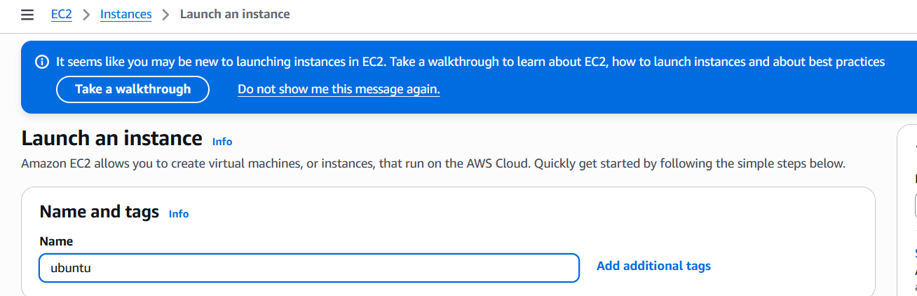
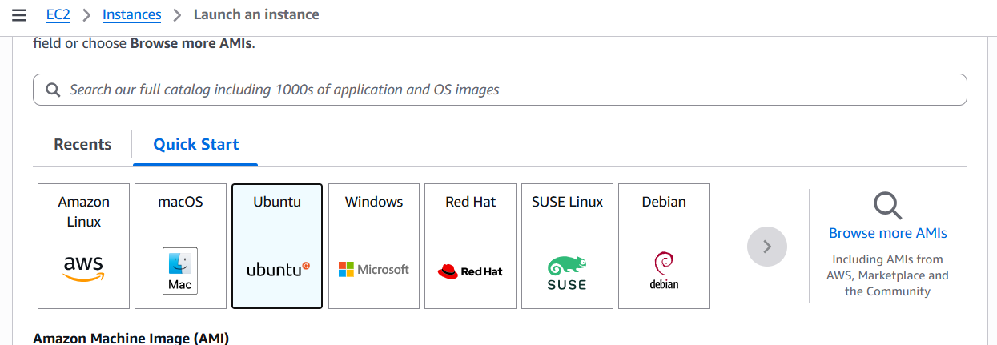
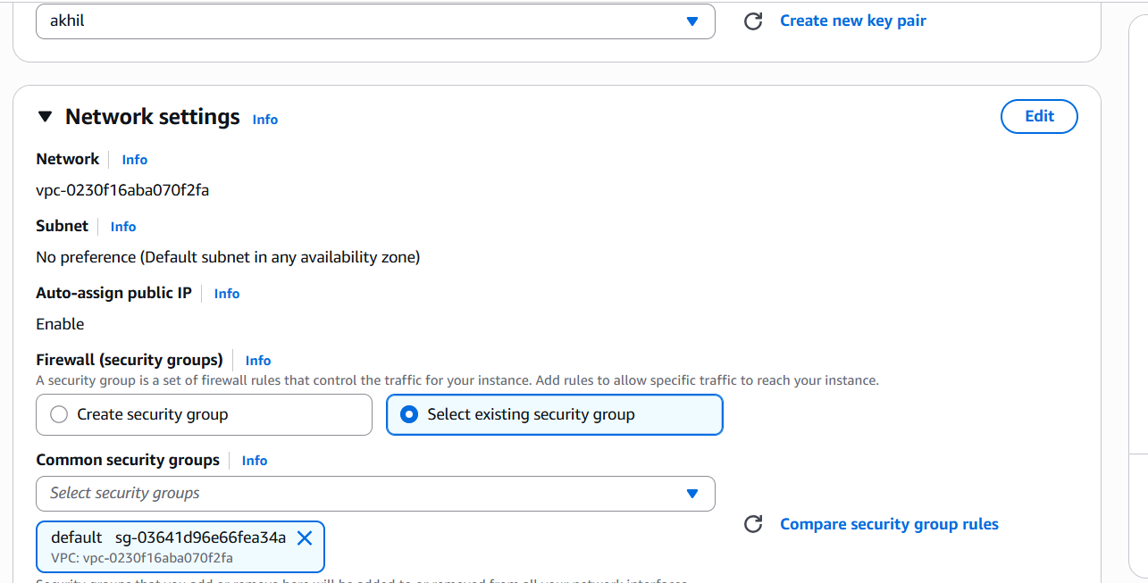
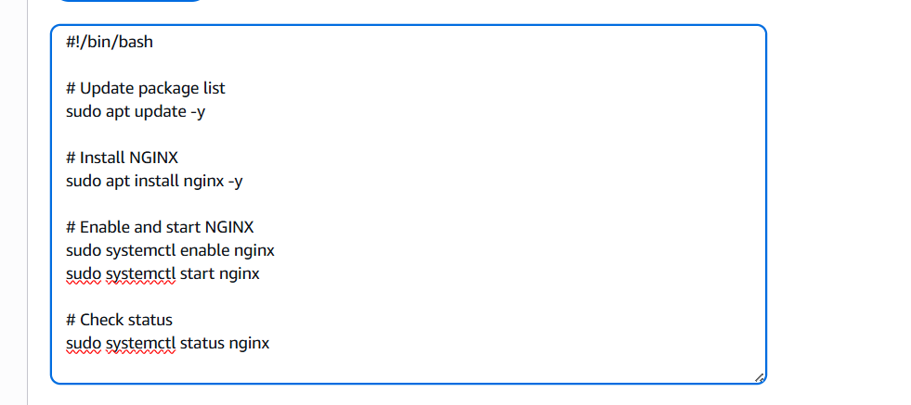
- Take a snapshot of the instance created in Task 1.
- Go to ec2 console on left side click On snapshot
- Click on create snapshot.
- Select instance and the instance you want to create the snap shot.
- Provide key name
- Then click on create snapshot.
- Snapshot is successfully created
- Select that instance
- Got to actions image – click on create image
- The image to the instance is created.
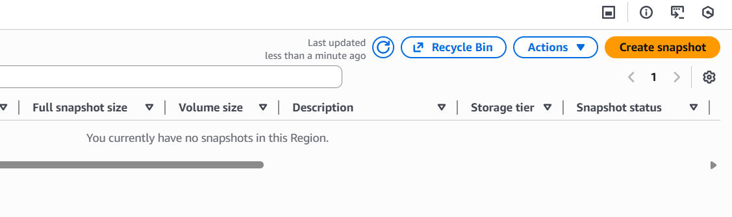
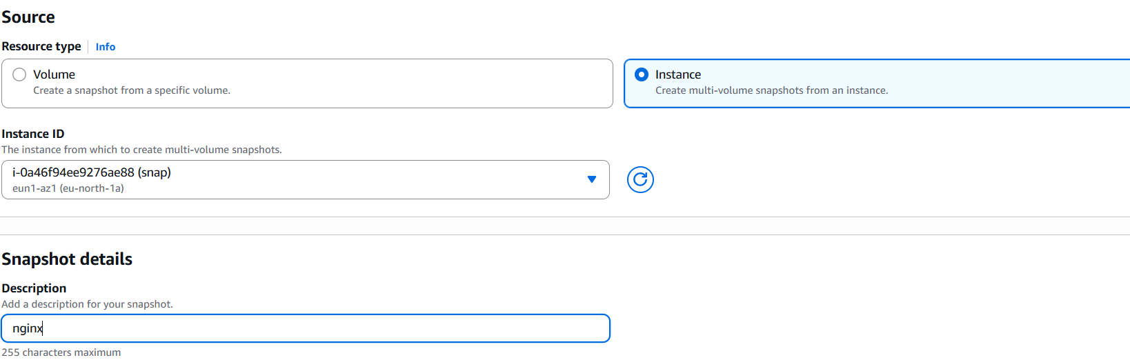

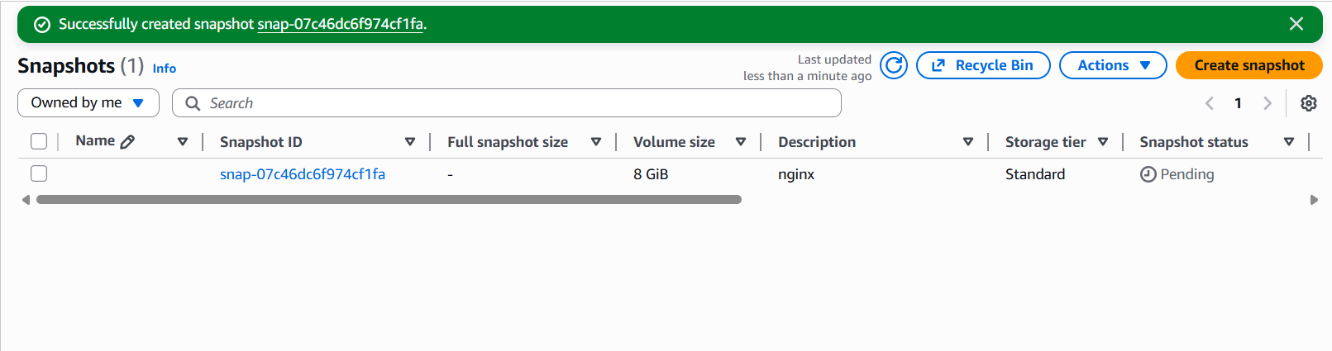
- Assign passwordless authentication for the EC2 created in Task 2.
- Open git bash
- Enter ssh-key gen to create key to connect.
- It will show the key has been generated to the file path.
- Copy the path and use cat to show the key copy the key
- Then connect to the instance : ssh -i “keypair.pem” ec2-user@ipv4 adress
- Go to ssh directory – vi authorized keys –paste the copied ssh key you have generated
- then save the file and exit

- Launch any EC2 using the spot purchasing option.
- Launch instance
- Select ami image
- Select instance type
- Go to advanced options
- Go to advanced options at the last
- Find the purchasing options.
- EC2 Purchasing Options
- On-Demand Instances – Pay, by the second, for the instances that you launch.
- Savings Plans – Reduce your Amazon EC2 costs by making a commitment to a consistent amount of usage, in USD per hour, for a term of 1 or 3 years.
- Reserved Instances – Reduce your Amazon EC2 costs by making a commitment to a consistent instance configuration, including instance type and Region, for a term of 1 or 3 years.
- Spot Instances – Request unused EC2 instances, which can reduce your Amazon EC2 costs significantly.
- Dedicated Hosts – Pay for a physical host that is fully dedicated to running your instances, and bring your existing per-socket, per-core, or per-VM software licenses to reduce costs.
- Dedicated Instances – Pay, by the hour, for instances that run on single-tenant hardware.
- Capacity Reservations – Reserve capacity for your EC2 instances in a specific Availability Zone.
- You can explore these in more detail on AWS's official EC2 purchasing guide.
- Select your purchasing option as per the project requirement and lauch the instance

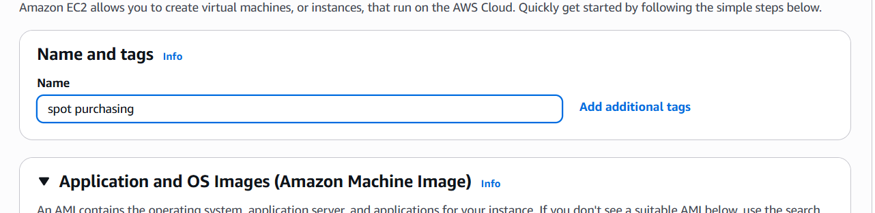
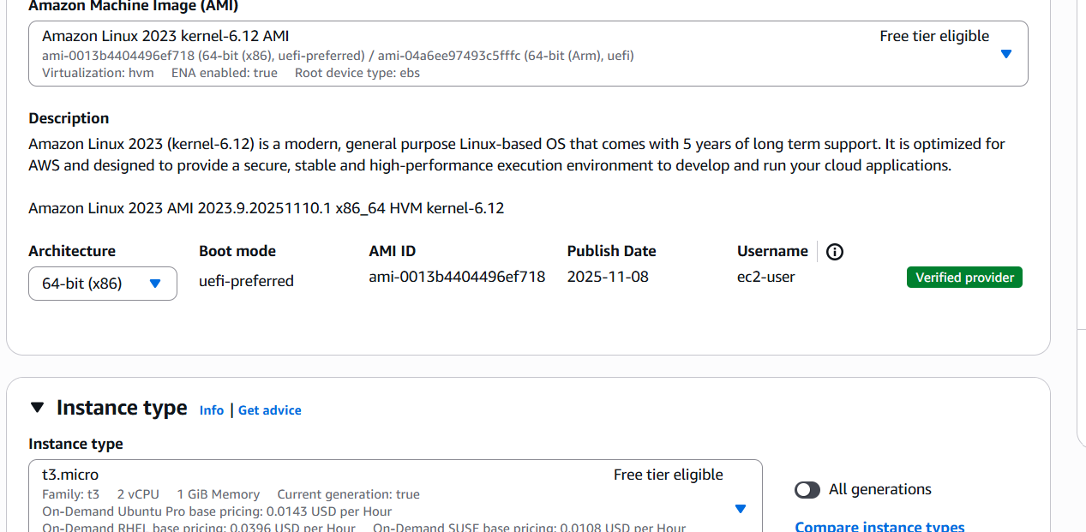
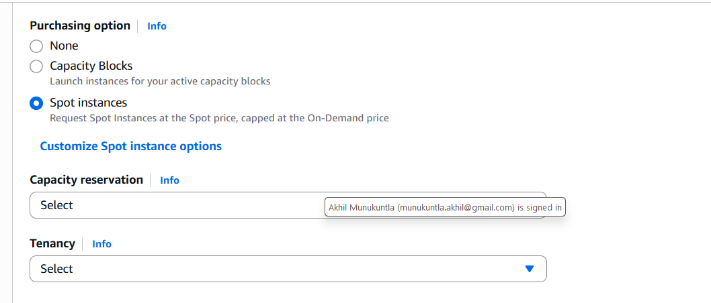
7.Enable termination policy on the EC2 created in Task 2.
  - Go to instance
  - Got to actions – instance setings – change termination protection.
  - Enable and save it.
  - Then the termination policy will be created for the instance
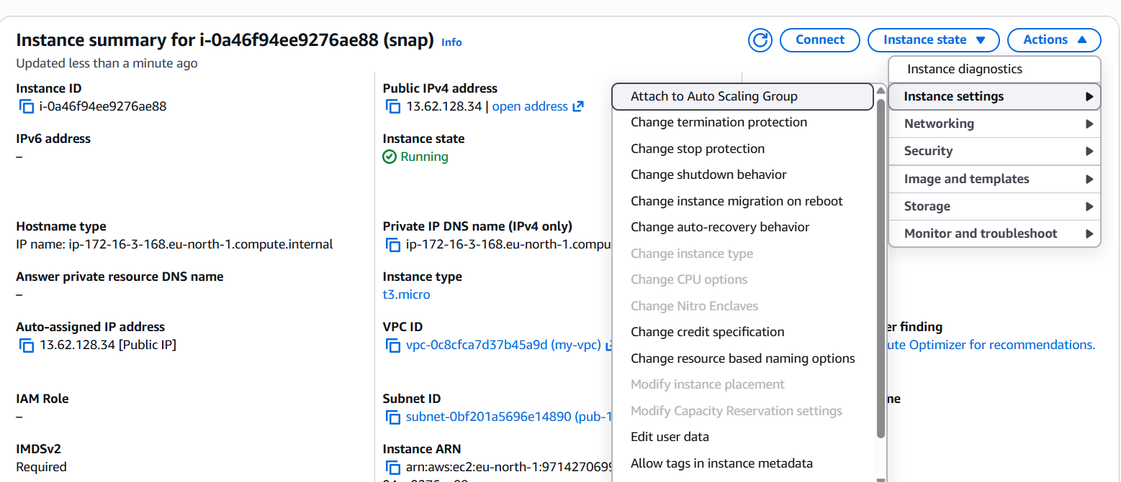
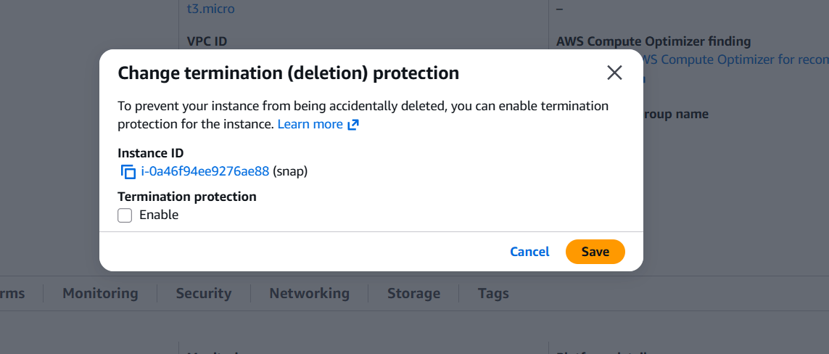
8.Launch one EC2 using AWS CLI.
- Go to aws console login
- Search I am
- Go to iam user – my security credentials – create acess key
- Launch instance
- Connect to the instance
- Wget “url” – to download the aws cli for linux
- Aws configure
- Give the acess key – secret acess key tat you have created
- Give the region – output type
- You can get the details of the instances.

