- Create VPC with 2 private and 2 public subnets.

Step 1: Create VPC
- Go to AWS Console → VPC
- Click Your VPCs → Create VPC
- Choose: VPC Only
- Enter details:
Setting | Value
Name | my-vpc
IPv4 CIDR | 172.31.0.0/16

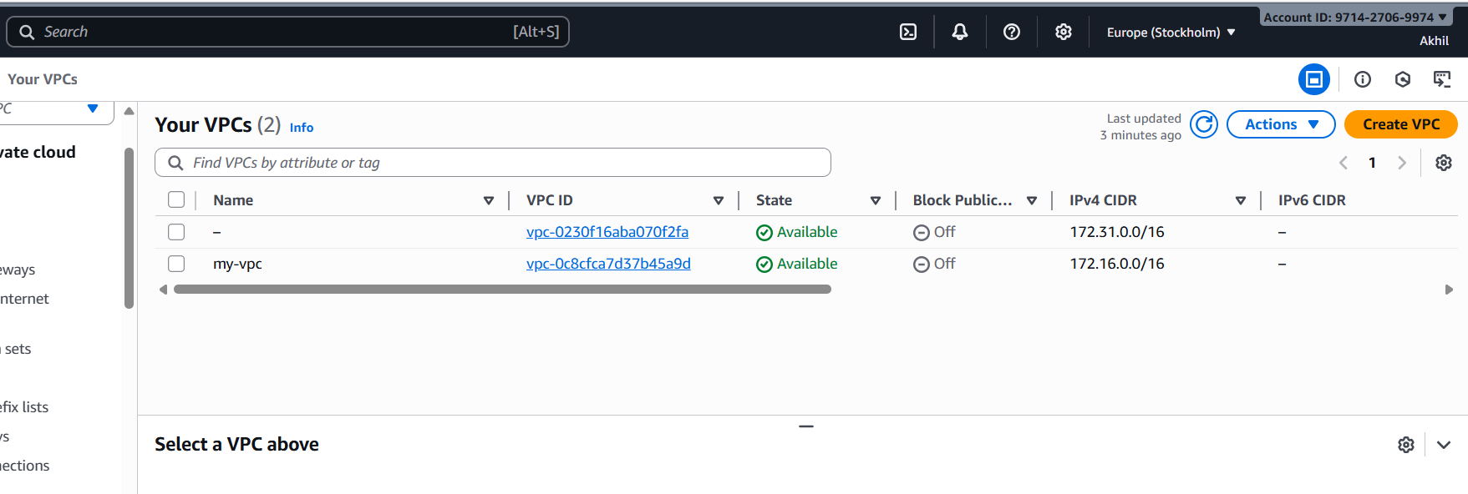
Create 2 Public Subnets
You must divide the /16 VPC CIDR into smaller /24 subnets.
Use these CIDRs:
- Public Subnet 1: 172.31.1.0/24
- Public Subnet 2: 172.31.2.0/24
Steps:
- Go to Subnets → Create subnet
- Select VPC: custom-vpc
Create Public Subnet 1
- Name: public-subnet-1
- AZ: Choose any (e.g., ap-south-1a)
- CIDR: 172.31.1.0/24
Create Public Subnet 2
- Name: public-subnet-2
- AZ: Another AZ (e.g., ap-south-1b)
- CIDR: 172.31.2.0/24
Click Create subnets
Create 2 Private Subnets
Use these CIDRs:
- Private Subnet 1: 172.31.3.0/24
- Private Subnet 2: 172.31.4.0/24
Steps:
Repeat creation process.
Create Private Subnet 1
- Name: private-subnet-1
- AZ: ap-south-1a
- CIDR: 172.31.3.0/24
Create Private Subnet 2
- Name: private-subnet-2
- AZ: ap-south-1b
- CIDR: 172.31.4.0/24
Click Create subnets

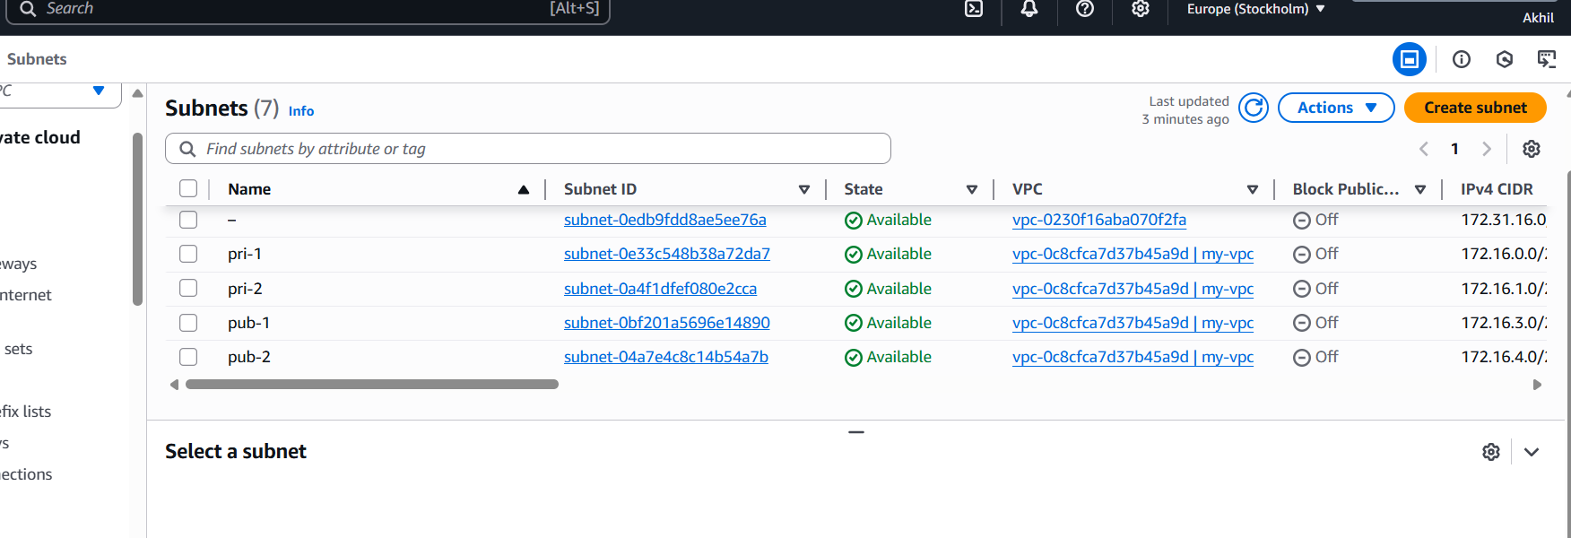
- Enable DNS Hostname in VPC
  - Step 1: Go to VPC Console
- Open AWS Management Console
- Navigate to VPC service

  - Step 2: Select Your VPC
- On the left menu → Click Your VPCs
- Select the VPC you created (example: custom-vpc)

  - Step 3: Edit DNS Settings
- After selecting the VPC, click Actions
- Choose Edit VPC settings
  - You will now see two options:
- Enable DNS Resolution
- Enable DNS Hostnames

  - Step 4: Enable DNS Hostnames
  - Make sure BOTH are turned ON:
- Setting | - Required State
- Enable DNS Resolution | - ✔ Enabled
- Enable DNS Hostnames | - ✔ Enabled

  - Step 5: Save
  - Click Save changes

  - 🎉 Completed Successfully
  - Your VPC now supports:
- EC2 instances with public DNS names
- Smooth connectivity for NAT gateway, internet access, and Route 53 setups.

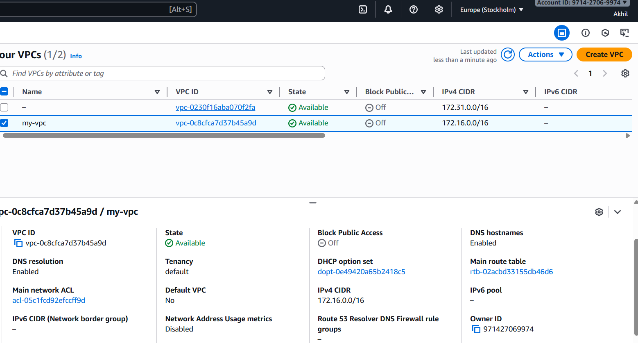
- Enable Auto Assign Public ip in 2 public subnets
- Step 1: Go to VPC Console
- Open AWS Management Console
- Go to VPC service

- Step 2: Open Subnets
- On the left menu, click Subnets
- Select your public-subnet-1

- Step 3: Enable Auto-Assign Public IP (for Public Subnet 1)
- Select public-subnet-1
- Click the Actions button (top right)
- Choose Edit subnet settings
- Enable:
- ✔ Auto-assign IP settings →
Enable auto-assign public IPv4 address
- Click Save

- Step 4: Repeat for Public Subnet 2
- Select public-subnet-2
- Click Actions → Edit subnet settings
- Enable:
- ✔ Enable auto-assign public IPv4 address
- Click Save

- 🎉 Done!
- Now any EC2 instance launched in:
- public-subnet-1
- public-subnet-2
- will automatically get a Public IPv4 Address

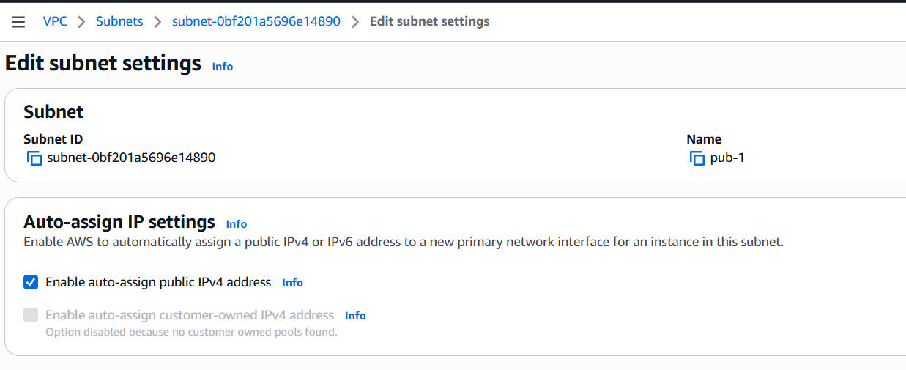
- Add 2 private subnets in private route table
- Step 1: Go to VPC Console
- Open AWS Management Console
- Go to VPC service

- Step 2: Open Route Tables
- On the left menu → Click Route Tables
- Select your private route table
  - Example name: private-rt

- Step 3: Open Subnet Associations
- After selecting the route table, scroll down
- Click the tab Subnet associations
- Click Edit subnet associations

- Step 4: Select Private Subnets
- You will see a list of all subnets in your VPC.
- Check:
- ✔ private-subnet-1
✔ private-subnet-2

- Step 5: Save
- Click Save associations

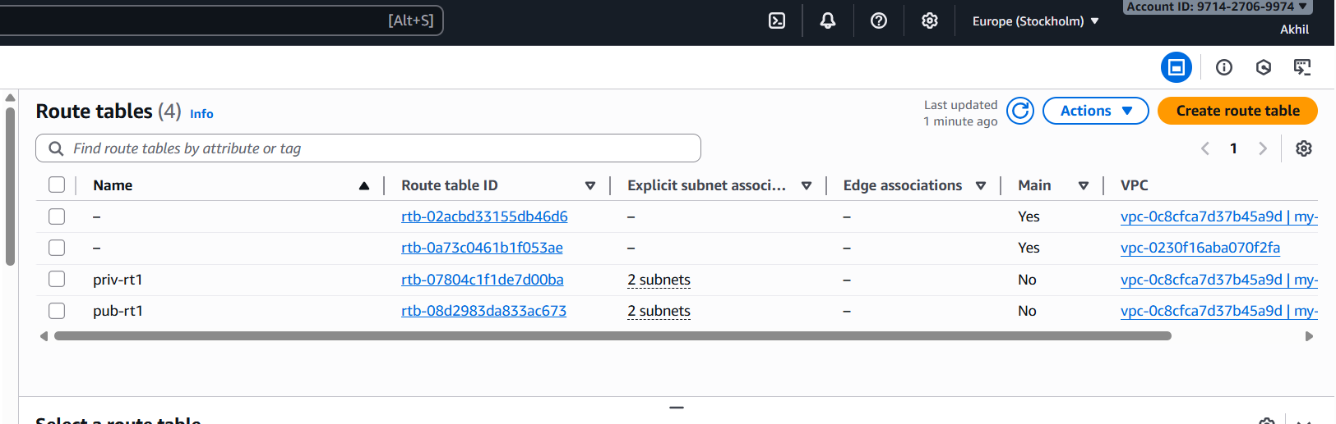
- Add 2 public subnets in public route table
- Step 1: Go to VPC Console
- Open AWS Management Console
- Go to VPC service

- Step 2: Open Route Tables
- On the left side menu → Click Route Tables
- Select your public route table
  - Example name → public-rt

- Step 3: Go to Subnet Associations
- With the route table selected:
- Scroll down → Click Subnet associations
- Click Edit subnet associations

- Step 4: Select the Public Subnets
- You will see all subnets from your VPC.
- Check:
- ✔ public-subnet-1
✔ public-subnet-2

- Step 5: Save
- Click Save associations

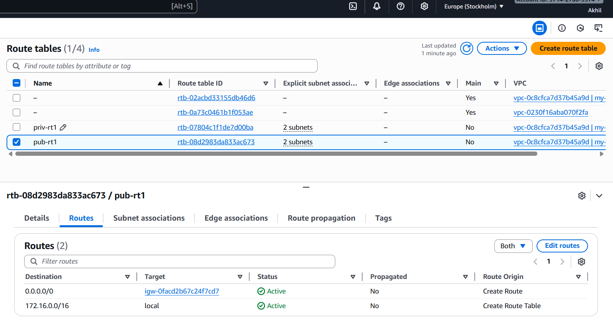

6) Public route table will have the routes to internet and local
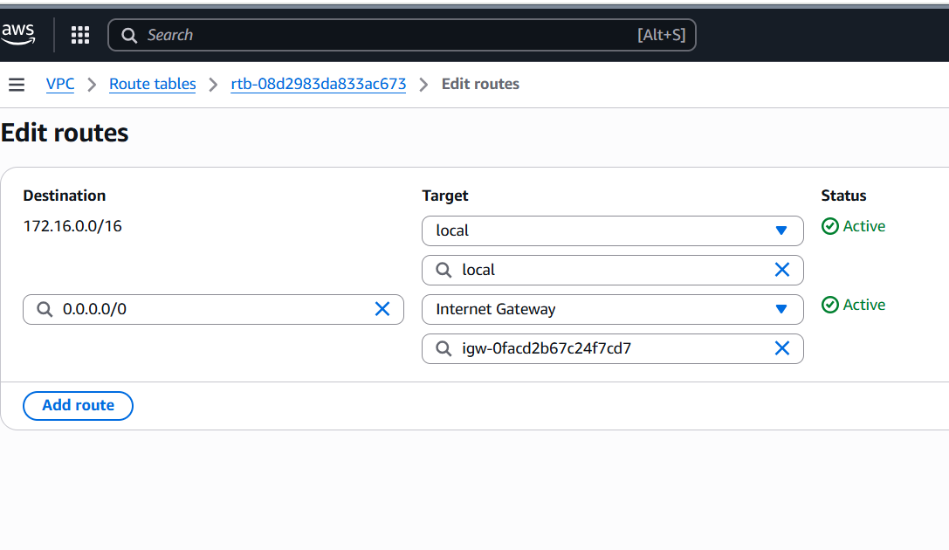
7) Create Ec2 in public subnet with t2micro and install php
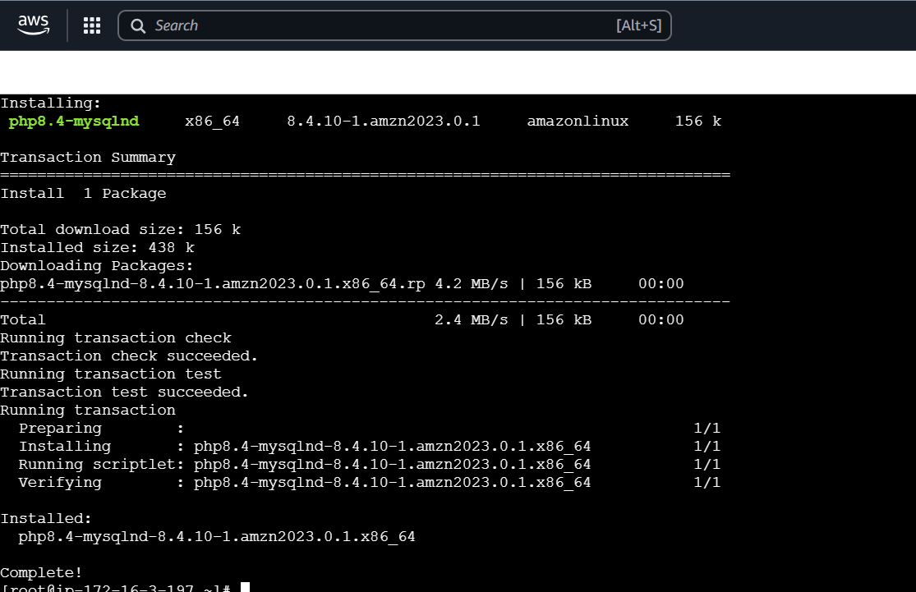
8) Configure Nat gateway in public subnet and connect to private Instance
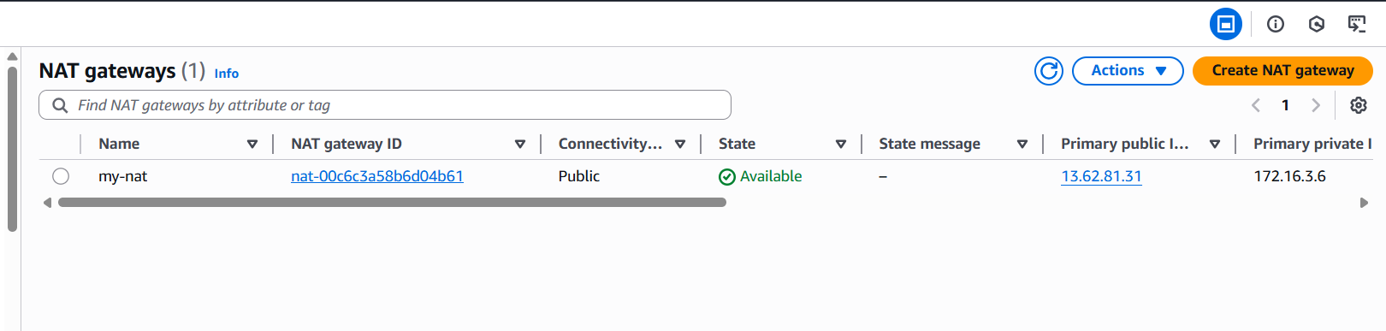
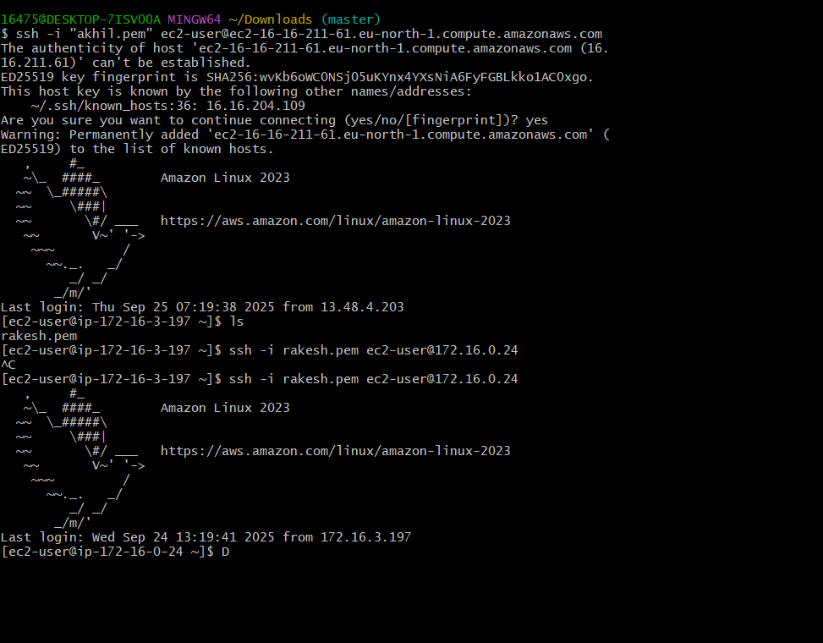
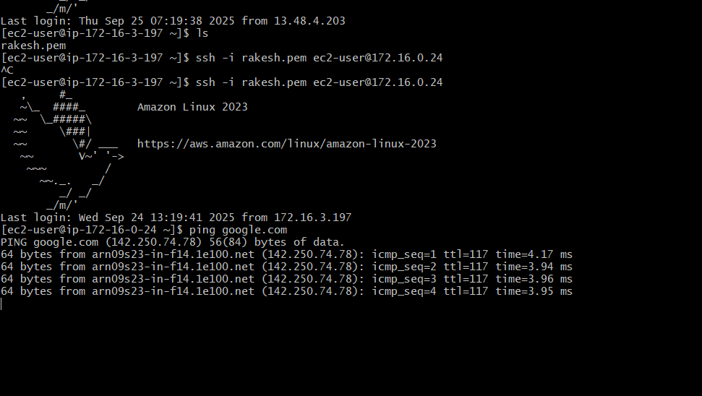
9) Install Apache Tomcat in private ec2 and deploy a sample app.
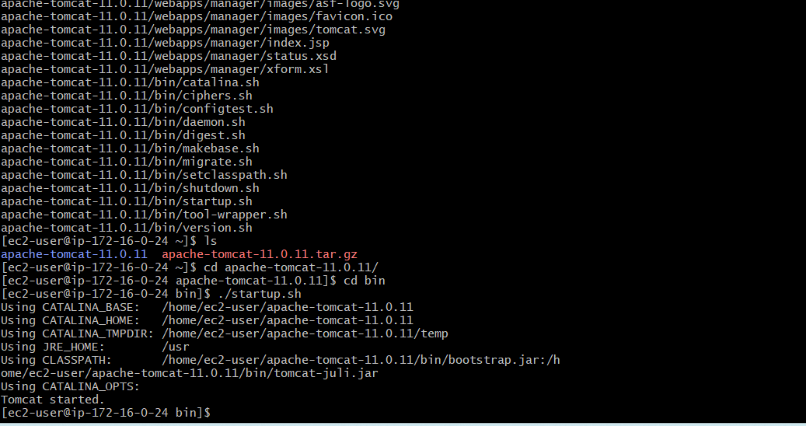
10) Configure VPC flow logs and store the logs in s3 and CloudWatch.
