**BMP180**

**General description**

The **BMP180** is the function compatible, new generation of high precision digital pressure sensors for consumer applications. The BMP180 is designed to be connected directly to a microcontroller of a mobile device via the I2C bus. The BMP180 consists of a piezo-resistive sensor, an analog to digital converter and a control unit with E2PROM and a serial I2C interface. It delivers the uncompensated value of pressure and temperature. The E2PROM has stored 176 bit of individual calibration data. This is used to compensate offset, temperature dependence and other parameters of the sensor. The BMP180 is based on piezo-resistive technology for EMC robustness, high accuracy and linearity as well as long term stability.

**Pin configuration**

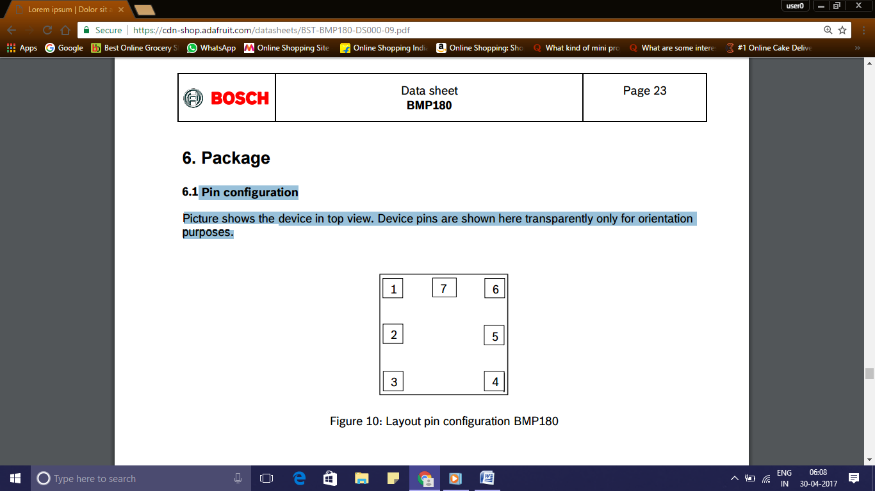 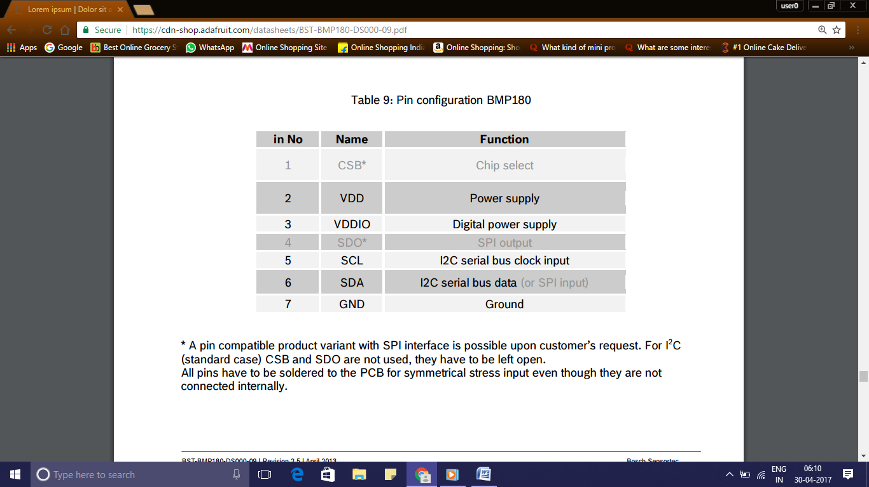

**Working**

* Calculation of true temperature and pressure in steps of 1Pa (= 0.01hPa = 0.01mbar) and temperature in steps of 0.1°C.
* With the measured pressure p and the pressure at sea level p0 e.g. 1013.25hPa, the altitude in meters can be calculated with the international barometric formula:

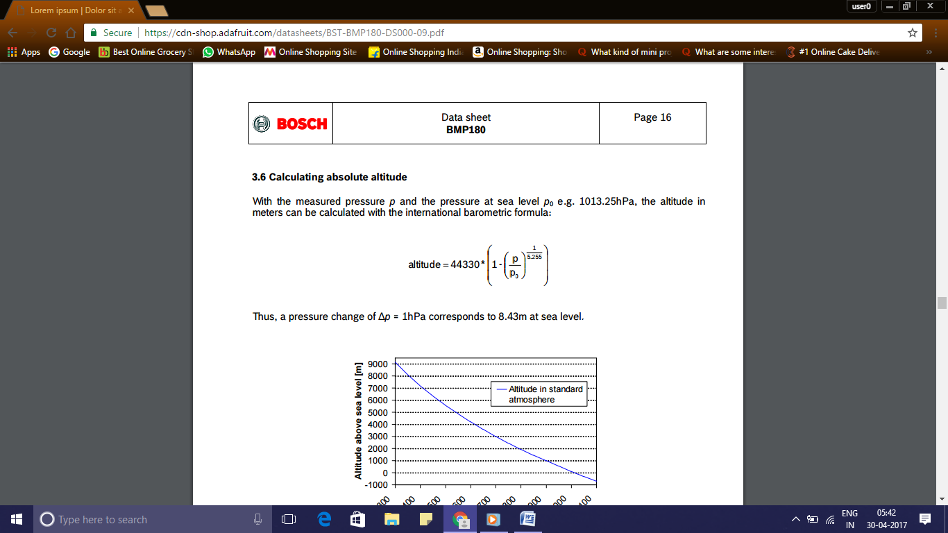

* With the measured pressure p and the absolute altitude the pressure at sea level can be calculated:

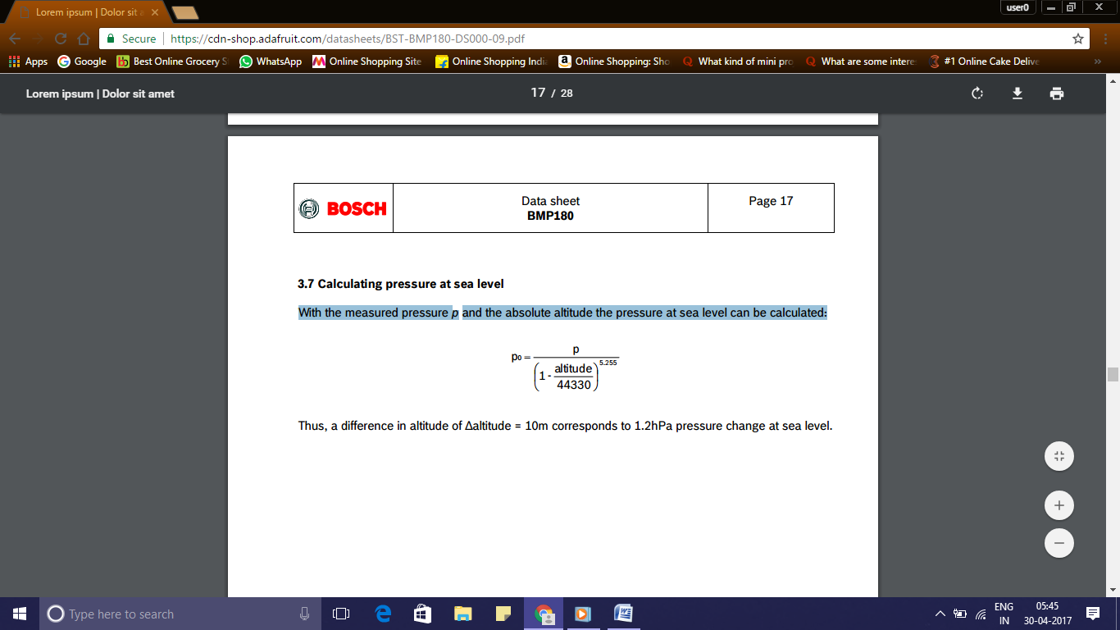

**I2C Interface**

I 2C is a digital two wire interface with clock frequencies up to 3.4Mbit/sec. (I2C standard, fast and high-speed mode supported) .SCL and SDA needs a pull-up resistor, typ. 4.7kOhm to VDDIO (one resistor each for all the I2C bus) The I2C bus is used to control the sensor, to read calibration data from the E2PROM and to read the measurement data when A/D conversion is finished. SDA (serial data) and SCL (serial clock) have open-drain outputs.

**I2C protocol**

The I2C interface protocol has special bus signal conditions. Start (S), stop (P) and binary data conditions are shown below. At start condition, SCL is high and SDA has a falling edge. Then the slave address is sent. After the 7 address bits, the direction control bit R/W selects the read or write operation. When a slave device recognizes that it is being addressed, it should acknowledge by pulling SDA low in the ninth SCL (ACK) cycle. At stop condition, SCL is also high, but SDA has a rising edge. Data must be held stable at SDA when SCL is high. Data can change value at SDA only when SCL is low. Even though VDDIO can be powered on before VDD, there is a chance of excessive power consumption (a few mA) if this sequence is used, and the state of the output pins is undefined so that the bus can be locked. Therefore, VDD must be powered before VDDIO unless the limitations above are understood and not critical.

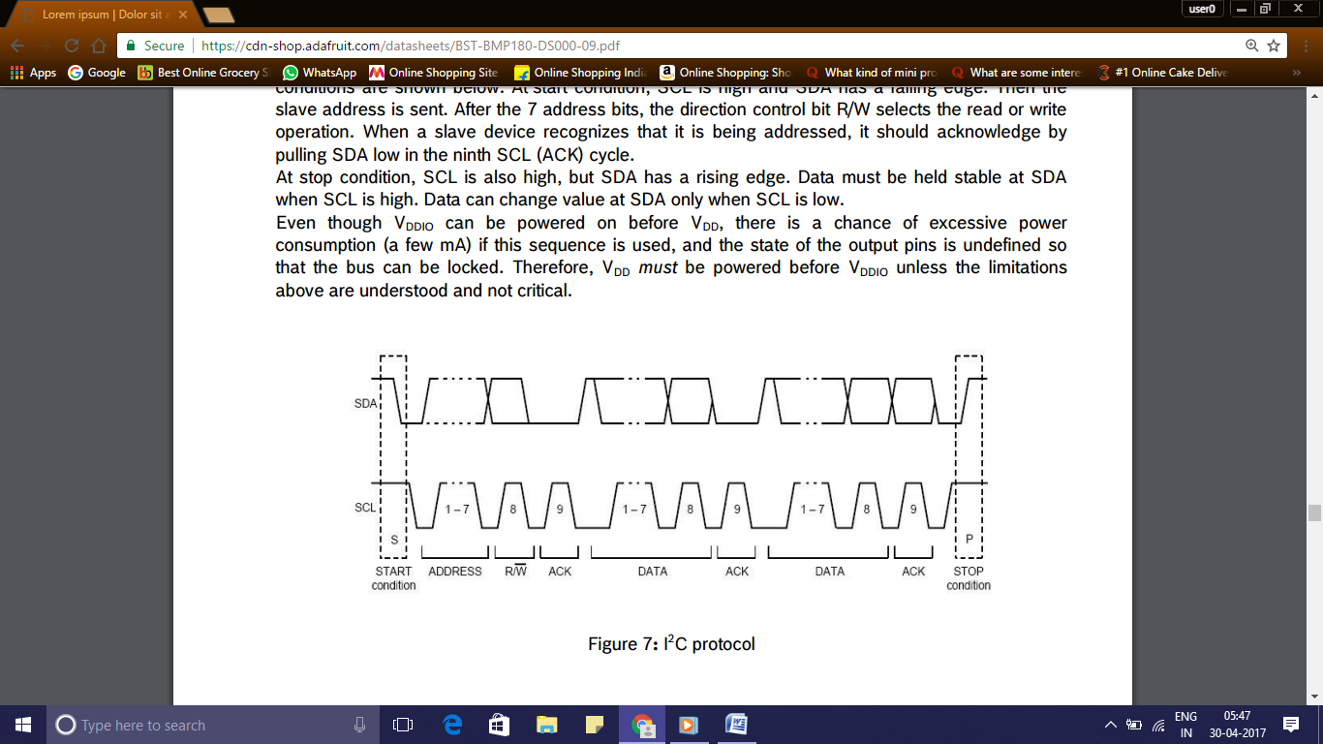

**Typical applications**

* Enhancement of GPS navigation (dead-reckoning, slope detection, etc.)
* In- and out-door navigation
* Leisure and sports
* Weather forecast
* Vertical velocity indication (rise/sink speed)

**16x2 LCD**

**General Description**

LCD (Liquid Crystal Display) screen is an electronic display. A 16x2 LCD display is very basic module and is very commonly used in various devices and circuits. These modules are preferred over seven segments and other multi segment [LED](http://www.engineersgarage.com/content/led)s. The reasons being: LCDs are economical; easily programmable; have no limitation of displaying special & even [custom characters](http://www.engineersgarage.com/microcontroller/8051projects/create-custom-characters-LCD-AT89C51) (unlike in seven segments), [animations](http://www.engineersgarage.com/microcontroller/8051projects/display-custom-animations-LCD-AT89C51) and so on.

A **16x2 LCD** means it can display 16 characters per line and there are 2 such lines. In this LCD each character is displayed in 5x7 pixel matrix. This LCD has two registers, namely, Command and Data.

The command register stores the command instructions given to the LCD. A command is an instruction given to LCD to do a predefined task like initializing it, clearing its screen, setting the cursor position, controlling display etc. The data register stores the data to be displayed on the LCD. The data is the ASCII value of the character to be displayed on the LCD.

Pin Diagram

