Overview:

The Financial Data Analysis System is a Python-based project designed to address the challenge of efficiently analyzing large financial datasets, such as stock prices, cryptocurrency data, or transaction logs. It aims to provide rapid, scalable analysis of time series financial data, enabling users to identify trends, detect anomalies, and make informed decisions in the fast-paced world of finance. The system works with data represented as tuples of (timestamp, value), allowing flexibility across different financial instruments. It employs divide-and-conquer techniques, including Merge Sort for efficient data sorting (O(n log n) time complexity), a divide-and-conquer implementation of Kadane's Algorithm for finding periods of maximum gain or loss, and a divide-and-conquer Closest Pair of Points algorithm for anomaly detection. These algorithm choices reflect the need for both efficiency and accuracy when dealing with potentially massive financial datasets. The system is designed to handle real-world data sourced from public financial APIs or historical datasets, with a built-in function to fetch stock data using the yfinance library. This approach allows for meaningful analyses on substantial amounts of financial data, while the modular structure of the FinancialAnalysisSystem class enables easy extension to incorporate additional analysis techniques or handle different types of financial data as needed.

Structure:  
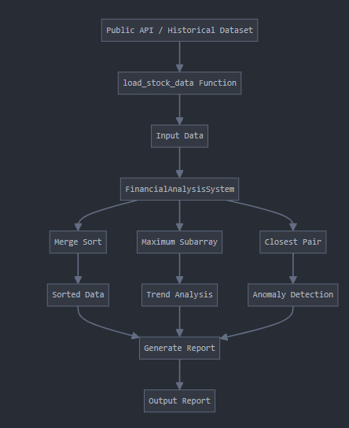

load_stock_data Function fetches real stock data from a public API (Yahoo Finance via yfinance library). It then Formats the data into a list of (timestamp, price) tuples for use in the FinancialAnalysisSystem.

FinancialAnalysisSystem Class is the core class that orchestrates the entire analysis process. It encapsulates all the necessary methods to perform financial data analysis. Some key methods include

merge_sort(arr): Implements the Merge Sort algorithm to efficiently sort the input data based on timestamps.

max_subarray(prices): Uses a divide-and-conquer approach to find the period of maximum gain or loss in the price data.

closest_pair(points): Implements a divide-and-conquer algorithm to find the closest pair of points, which is used for anomaly detection.

analyze(): This is the main method that ties everything together. It sorts the data, finds the period of maximum gain, detects anomalies, and generates a comprehensive report.

To use the Financial Analysis System, first ensure you have the required libraries installed (numpy and yfinance). Then, run the script, which will automatically load stock data for the specified symbol (e.g., 'AAPL') over the past year. After loading the data, the system will perform financial analysis and generate a report detailing the period of maximum gain and any detected anomalies, which will be printed to the console.



This part of the code sorts the stock data using the merge sort algorithm. The merge sort algorithm sorts these tuples based on their timestamps (the first element of each tuple). It then uses a list comprehension to extract only the prices from the sorted data.

This part of code is calculating the period of maximum gain in the stock prices using the max subarray algorithm. The start index represents the best day to buy, and the end index represents the best day to sell.



This line is calling the closest_pair method of the FinancialAnalysisSystem class to detect anomalies in the stock data. The two points identified as the "closest pair" represent the most significant anomaly in the dataset.

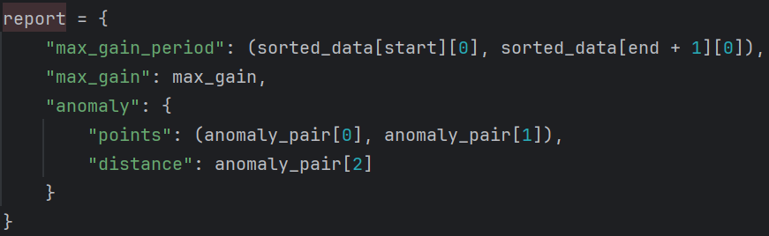

This code creates a dictionary called report that summarizes the results of the financial analysis. "max_gain_period" is a tuple with the start and end timestamps of the period with the maximum gain. "max_gain" is the value of the maximum gain calculated earlier. "anomaly" is a nested dictionary containing information about the detected anomaly, including the two points that form the closest pair and the distance between these points

Conclsion:  
The Financial Analysis System provides valuable insights into stock price trends and anomalies. It successfully identifies periods of maximum gain, which can be crucial for investment decision-making. The anomaly detection feature highlights unusual price movements, potentially signaling significant market events or data inconsistencies. However, the system has limitations. Its reliance on historical data means it may not account for future market changes or external factors. The closest pair algorithm for anomaly detection, while effective, may not capture all types of financial anomalies and could be computationally intensive for large datasets. Potential improvements include incorporating more advanced statistical methods for trend analysis, implementing machine learning algorithms for more nuanced anomaly detection, and adding real-time data processing capabilities.