Assignment Oct 06 2025
Code Executions
HelloWorld and Addition
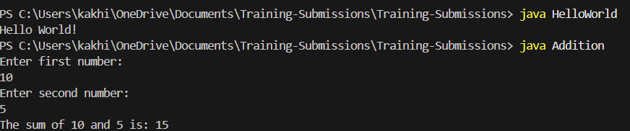

Calculator and Reversing a String
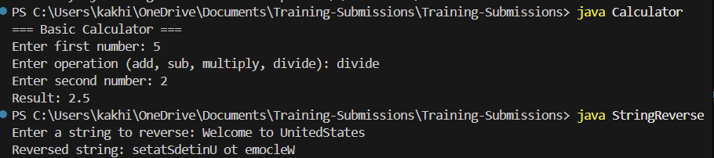

Multithread Program
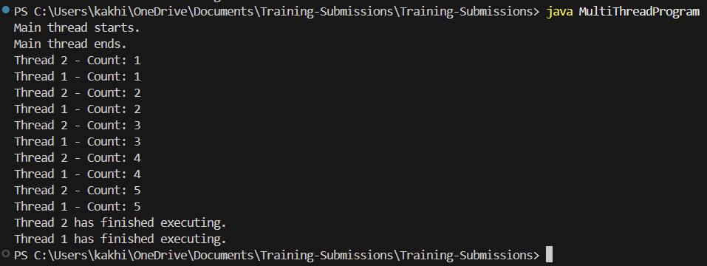
Tic Tac Toe game
