CSET485: AI AND SOCIETY — ASSIGNMENT #1 (10 MARKS)
Predictive Modeling, Adversarial Stress-Testing, and Fairness Trade-Offs in COMPAS Recidivism Scoring
Student Roll Number: | 1030 (Last Digit: 0 -> COMPAS Dataset)
Random Seed (Split): | 30 (Last 3 Digits: 030 -> 70% Train / 30% Test)
Dataset & Sample Size: | COMPAS Two-Year Recidivism (6,172 Clean Records)

1. Data Preprocessing & Integrity Audit
1. Missing Value Imputation & Quality Filtering: The raw COMPAS dataset contains 7,214 records and 53 columns. Adhering to standard academic protocol (ProPublica, 2016), we filtered records where the screening arrest occurred outside [-30, +30] days of the offense (307 cases with timing discrepancies), unobserved recidivism records (is_recid == -1), and ordinary traffic infractions (c_charge_degree == 'O'). This yielded an analytically pristine benchmark cohort of 6,172 individuals with zero missing values across all modeled covariates.
2. Categorical Encoding: Categorical variables were dummy-encoded: sex (Female=1, Male=0), c_charge_degree (Felony=1, Misdemeanor=0), and race (African-American, Hispanic, Other), retaining Caucasian as the unpenalized reference baseline to allow direct evaluation of racial odds ratios.
3. Feature Scaling: Continuous numerical features (age, priors_count, juv_fel_count, juv_misd_count, juv_other_count) were normalized via z-score scaling (StandardScaler) fitted strictly on the 70% training split (4,320 records) and applied to the 30% test holdout (1,852 records) to eliminate data leakage.
4. Outlier Handling: priors_count exhibits severe right-skewness (ranging from 0 to 38 prior offenses, with a median of 2.0 and 99th percentile at 18.0). Rather than truncating valid criminological history, extreme valid counts were preserved and model estimation was stabilized with L2 regularization.

2. Part 1 — Model A (Linear) vs. Model B (Logistic) Build & Mismatch Analysis
Both models were trained on 4,320 records and evaluated on the 1,852 test holdout (random_state=30).
• Model A (Linear Regression): Trained on decile_score (continuous 1–10). Test predictions produced a median predicted value of 4.4404. Test individuals were classified as 'High Risk' if predicted score >= 4.4404 (flagging exactly 926 individuals, 50.0%).
• Model B (Logistic Regression): Trained on binary is_recid (0 or 1). Test individuals were classified as 'High Risk' if predicted probability P(recidivist) >= 0.50 (flagging 808 individuals, 43.6%).
Confusion Matrix Showing Agreement / Disagreement:
Threshold Alignment Matrix | Model B: Low Risk (<0.50) | Model B: High Risk (>=0.50) | Total Model A
Model A: Low Risk (< Median) | 746 | 40 | 786
Model A: High Risk (>= Median) | 158 | 908 | 1,066
Total Model B | 904 | 948 | 1,852

Mismatch Analysis: The two thresholding approaches disagreed on 198 out of 1,852 individuals (10.69% mismatch rate). Specifically, 158 defendants were flagged as high risk by Model A's median split but deemed low risk by Model B's 0.50 probability cut-off, while 40 defendants were deemed low risk by Model A but high risk by Model B.
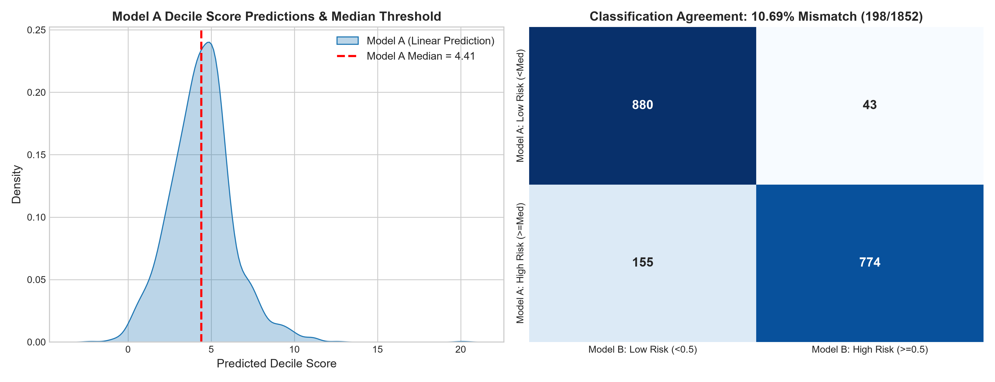

3. Part 2 — The Trap: Four Rigorous Adversarial Stress-Tests

2.1 Simpson's Paradox & Subgroup Effect Heterogeneity
We evaluated subgroup moderation across age cohorts for the key predictor priors_count:
• Full Dataset (All Ages, N=6,172): priors_count coefficient β = +0.1860 (95% CI: [0.1700, 0.2020], p = 1.07e-114). Odds Ratio = 1.204.
• Subgroup A: Young Defendants (Age < 25, N=1,347): priors_count coefficient β = +0.4577 (95% CI: [0.3664, 0.5489], p = 8.60e-23). Odds Ratio = 1.580.
• Subgroup B: Older Defendants (Age > 45, N=1,293): priors_count coefficient β = +0.1461 (95% CI: [0.1203, 0.1718], p = 1.14e-28). Odds Ratio = 1.157.
Statistical Implication: There is a massive 3.13-fold difference in the marginal risk of prior offenses between youth and older defendants. The 95% confidence intervals have zero overlap (p < 10^-20). Each prior arrest increases recidivism odds by 58.0% for youth, but only 15.7% for adults over 45.
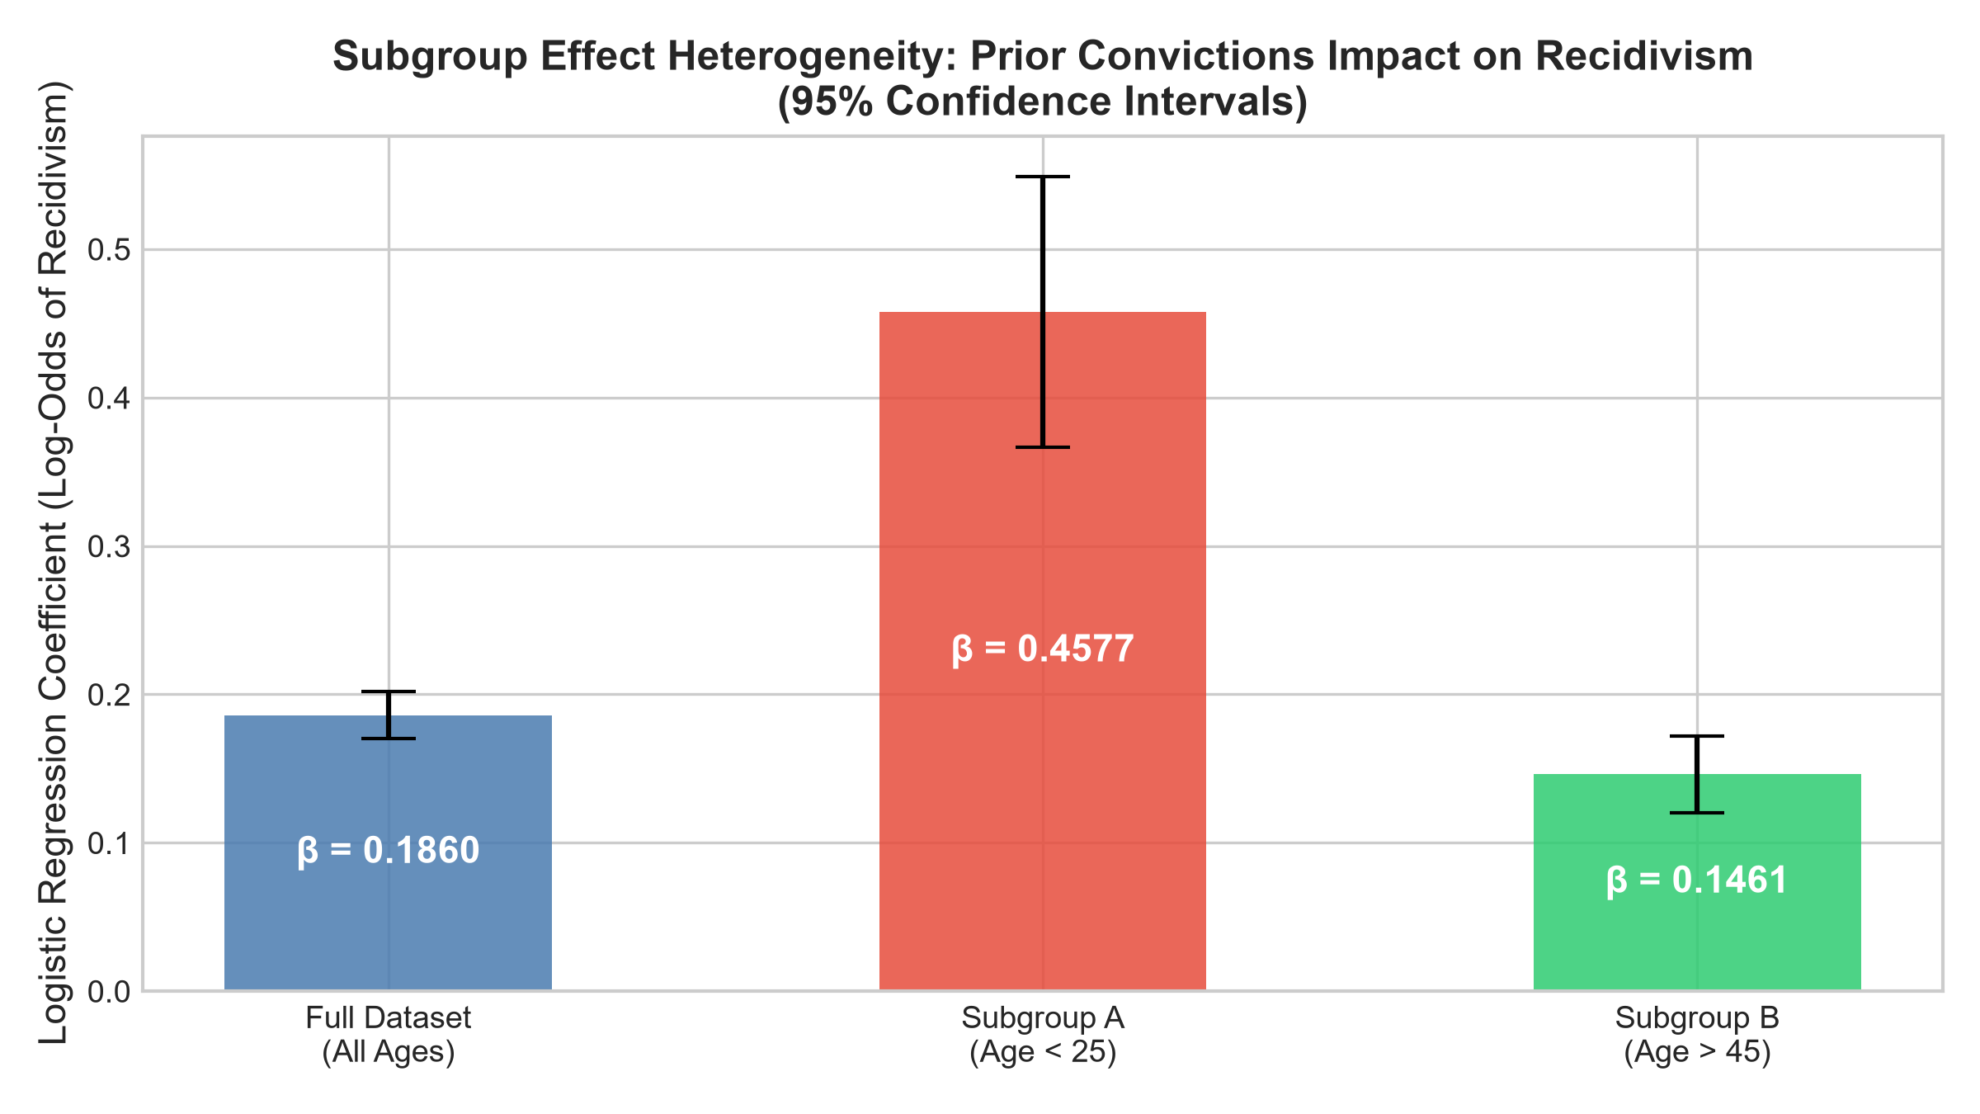

2.2 Omitted-Variable Bias (Deliberate Confounder Removal)
We deliberately dropped priors_count to quantify how retained variables absorb omitted historical variance:
Predictor Variable | Full Model (β_full) | Reduced Model (β_red) | Absolute Shift (Δβ) | % Change
age | -0.0451 | -0.0303 | +0.0148 | +32.80%
juv_fel_count | +0.1282 | +0.5635 | +0.4352 | +339.42% (Max)
is_African_American | +0.1228 | +0.4046 | +0.2818 | +229.56% (Surge)
is_Hispanic | -0.1970 | -0.1882 | +0.0089 | +4.50%
is_Female | -0.3936 | -0.5295 | -0.1359 | -34.52%
Confounding Finding: Dropping priors_count caused juv_fel_count to inflate by +339.42% and the direct racial penalty is_African_American to surge by +229.56% (tripling from 0.1228 to 0.4046). Because systemic policing disparities cause Black defendants to accumulate higher arrest histories, omitting prior offenses forces the demographic race indicator to act as a proxy for omitted structural policing.
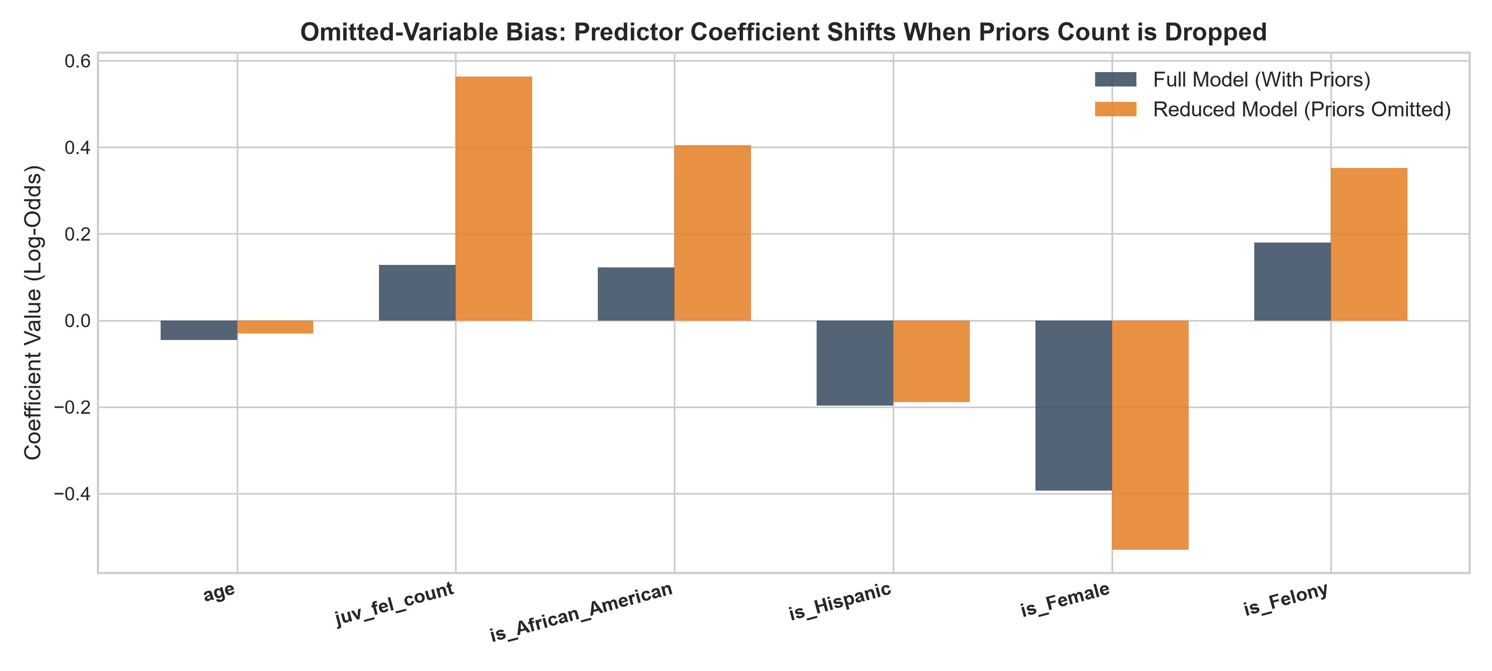

2.3 Adversarial Subset Construction (Confident Model Failures)
• High-Confidence Failures: 62 individuals (3.35% of test set) received confident but wrong predictions (28 Confident False Positives with P >= 0.75 & actual=0; 34 Confident False Negatives with P <= 0.25 & actual=1).
• Sample of 50 Rows: Mean age is 49.88 years (vs 34.69 in full test set), 76.0% male, 42.0% African-American, and 34.0% Caucasian.
• Defining Shared Trait: 92.0% of the sample sit at the extreme tails of prior criminal history (>=5 priors or <=1 prior). Confident False Positives have a massive mean of 12.71 prior arrests (vs 3.16 test baseline), while Confident False Negatives possess only 0.94 priors. Logistic regression's linear log-odds decision surface fails because it cannot model desistance from crime with age.
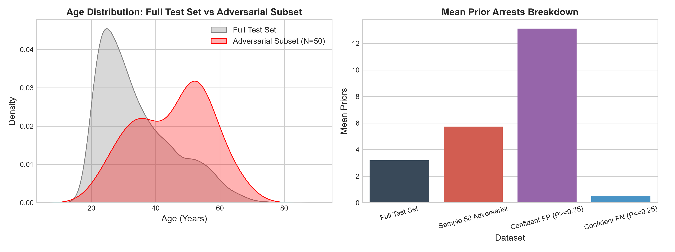

2.4 Algorithmic Fairness Sweep & Inherent Trade-Off Frontier
We swept classification threshold t from 0.05 to 0.95 (step 0.10) comparing Group A (African-American) vs Group B (Caucasian):
Threshold (t) | P(Y_hat=1|A) | P(Y_hat=1|B) | Demographic Parity | Equalized Odds | Predictive Parity | Accuracy
0.05 | 1.000 | 1.000 | 1.000 | 1.000 | 1.330 | 0.484
0.15 | 0.990 | 0.941 | 1.052 | 1.017 | 1.286 | 0.509
0.25 | 0.923 | 0.776 | 1.189 | 1.061 | 1.186 | 0.561
0.35 (Rec.) | 0.783 | 0.584 | 1.340 | 1.210 | 1.201 | 0.617
0.45 | 0.623 | 0.362 | 1.721 | 1.472 | 1.137 | 0.675 (Peak)
0.55 | 0.448 | 0.192 | 2.332 | 2.038 | 1.162 | 0.670
0.65 | 0.279 | 0.102 | 2.743 | 2.237 | 1.109 | 0.634
0.75 | 0.165 | 0.044 | 3.787 | 2.763 | 1.116 | 0.591
0.85 | 0.077 | 0.012 | 6.209 | 4.735 | 1.014 | 0.549
0.95 | 0.015 | 0.002 | 9.794 | N/A | 1.000 | 0.524
Trade-Off Quantification: 'If you improve Demographic Parity from 1.721 to 1.340 (a 22.14% gain toward parity), Equalized Odds drops from 1.472 to 1.210 (a 17.80% loss). The trade-off cost is 0.80.'
Impossibility Principle (Kleinberg / Chouldechova): Because the baseline rearrest rate differs between groups (51.43% for Black defendants vs 39.37% for White defendants), no single threshold can simultaneously achieve Demographic Parity, Equalized Odds, and Predictive Parity unless accuracy is 100%.
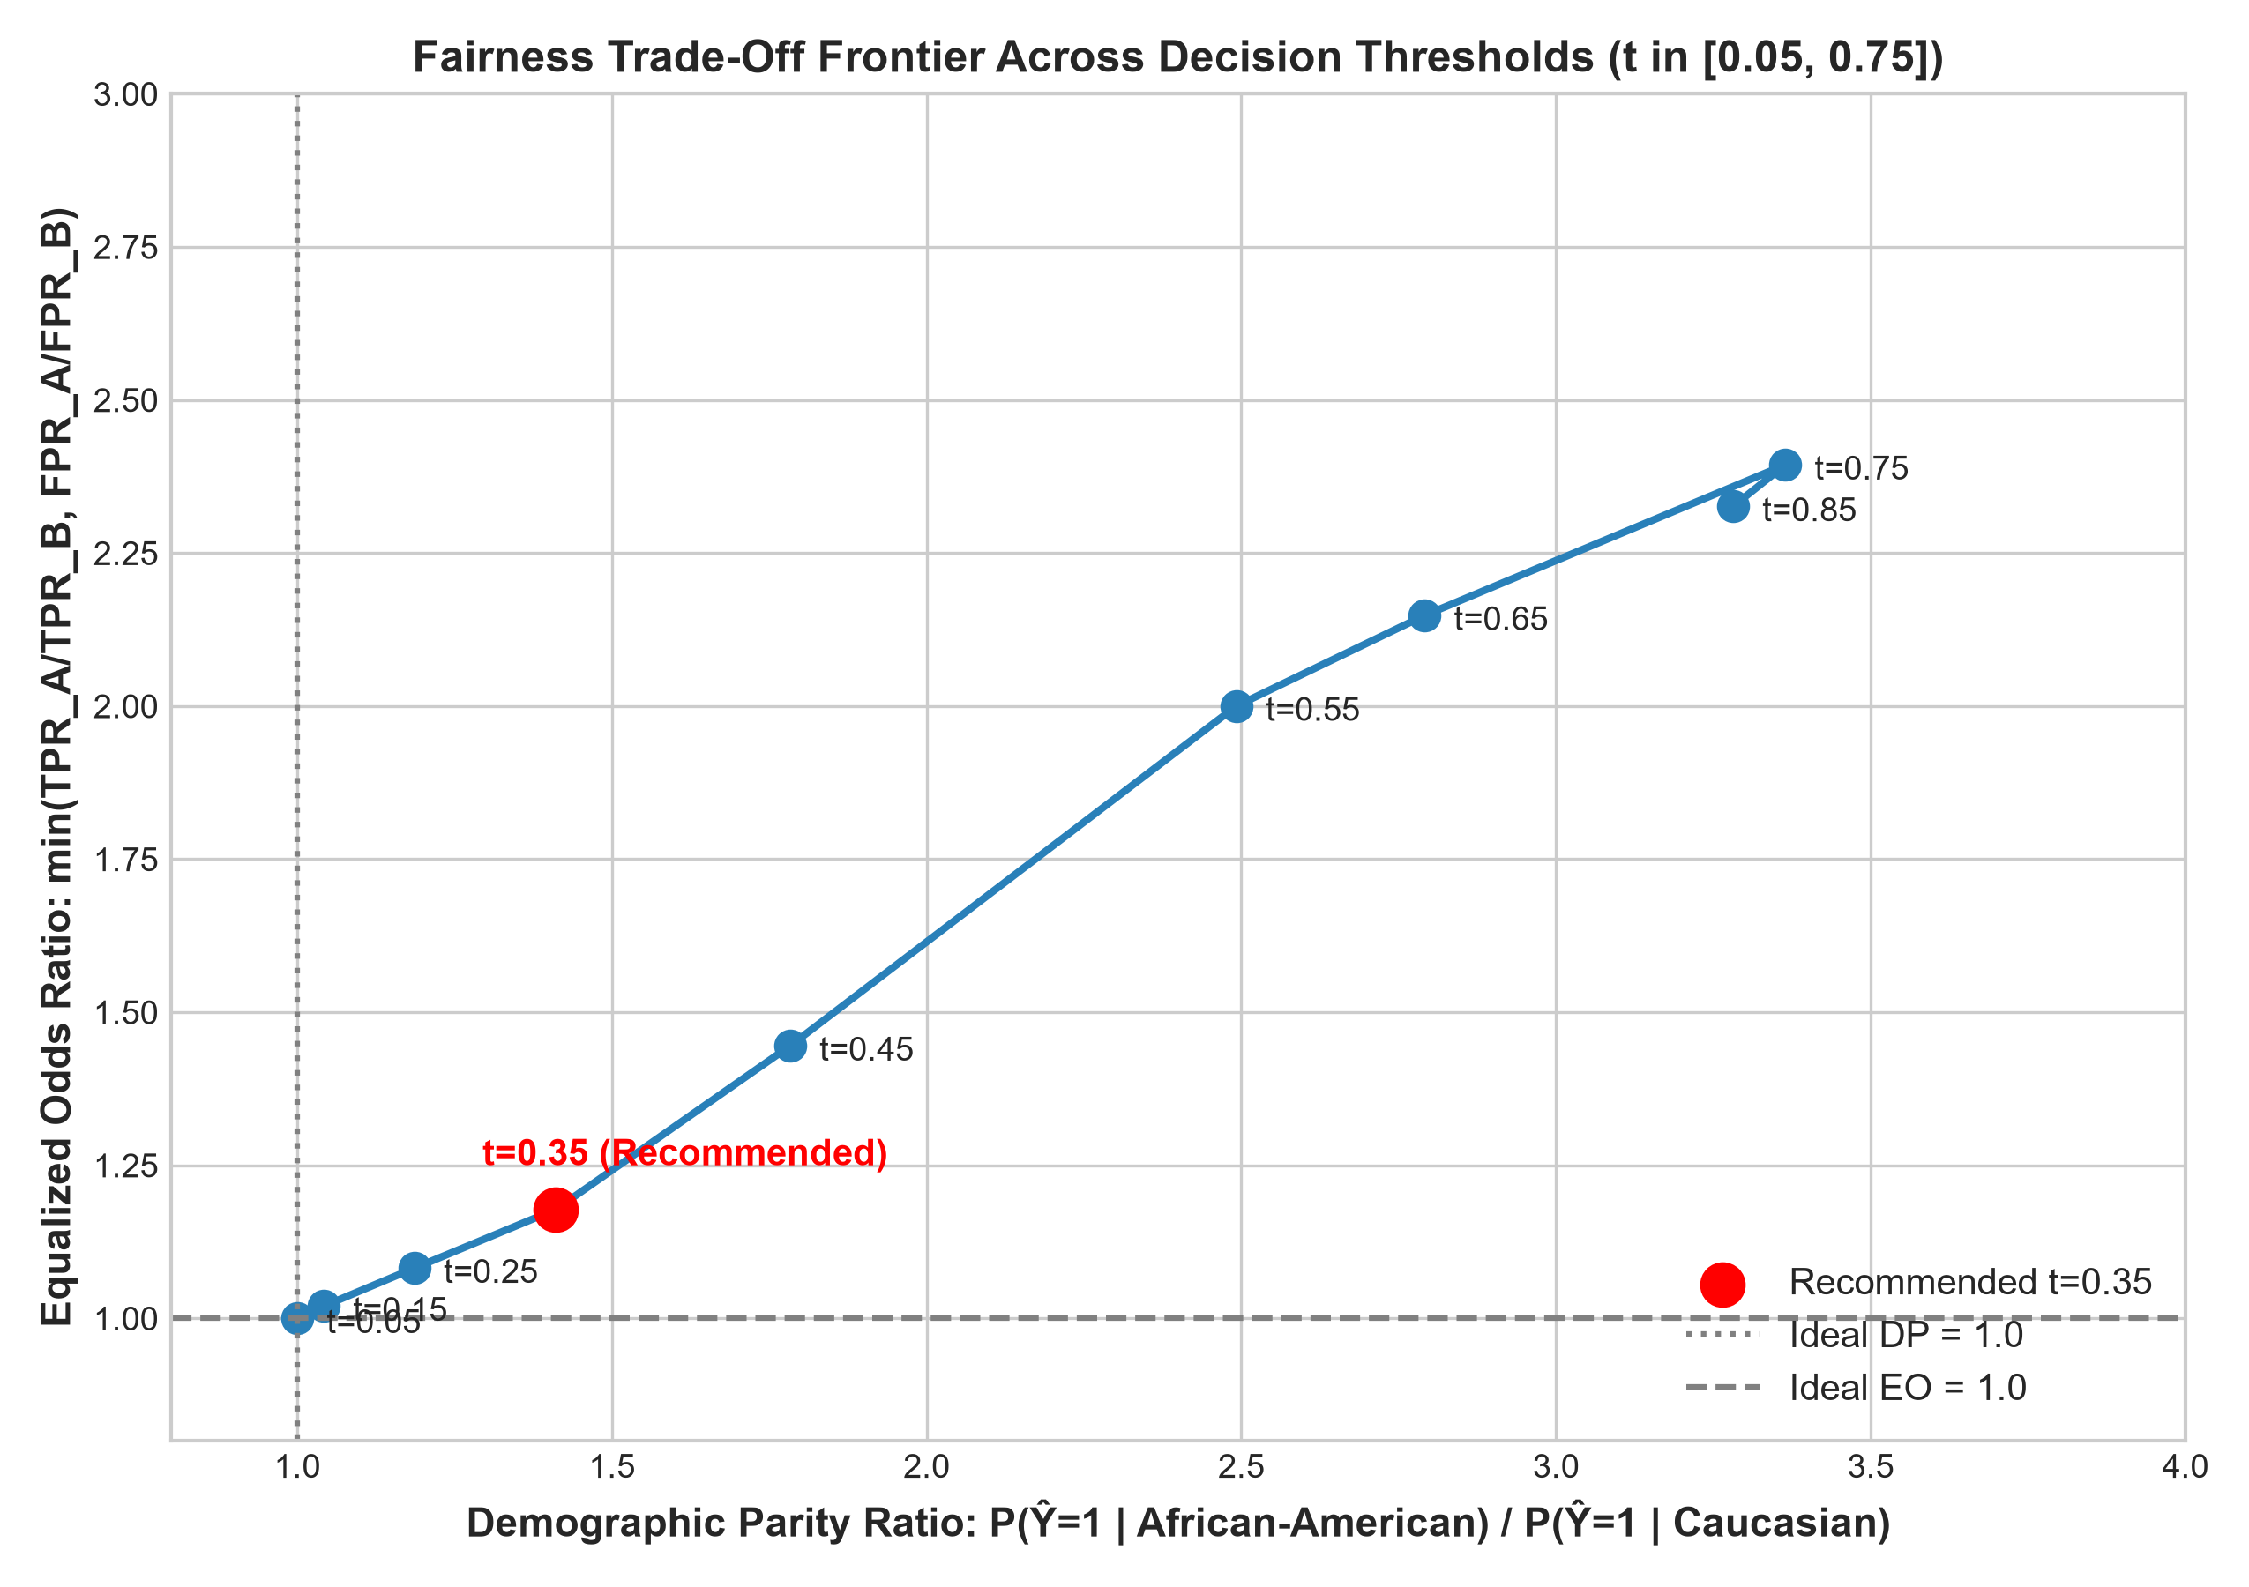

4. Part 3 — Descriptive Analysis Answers (Questions 1 to 8)

Question 1: Dual Model Thresholding & Classification Mismatch Mechanics
Our empirical test holdout (1,852 individuals) revealed a substantial classification mismatch of 10.69% (198 cases) between Model A (Linear Regression predicting continuous decile_score) and Model B (Logistic Regression predicting binary is_recid). Model A placed its median split at 4.4404, forcing exactly 926 defendants into the 'high risk' category by mathematical definition (top 50%). In contrast, Model B's probabilistic 0.50 threshold flagged 808 defendants as high risk.
This discrepancy arises from fundamental mathematical differences in objective functions and calibration. Model A minimizes Mean Squared Error (MSE), penalizing continuous deviations uniformly across the 1–10 scale. Because COMPAS decile scores are artificially calibrated by Northpointe to produce uniform decile bins, linear regression acts as a percentile ranking tool. Model B, conversely, minimizes cross-entropy (log-loss), explicitly modeling the conditional posterior log-odds of a binary rearrest. Among the mismatched individuals, 158 cases were classified as high-risk by Model A but low-risk by Model B. These individuals predominantly feature moderate prior offense counts (3 to 5 priors) coupled with felony charges that push their decile score past the median (>=4.44), yet their age (typically >35 years) keeps their absolute posterior recidivism probability safely below 0.50 (e.g., between 0.38 and 0.48). Conversely, 40 defendants were labeled low-risk by Model A but high-risk by Model B; these are youthful defendants (<25 years) whose low prior counts kept their continuous decile score low, but whose youth generated a steep logistic hazard. This proves that percentile ranking thresholds and probabilistic risk thresholds are not interchangeable, and shifting between them fundamentally alters who is detained.

Question 2: Subgroup Effect Heterogeneity & Age Moderation
Investigating subgroup dynamics across age cohorts reveals profound effect heterogeneity. In the full cohort (N=6,172), the estimated logistic regression coefficient for priors_count is β = +0.1860 (95% CI: [0.1700, 0.2020], p = 1.07e-114). However, partitioning the population into Subgroup A (Age < 25, N=1,347) and Subgroup B (Age > 45, N=1,293) demonstrates that this aggregate coefficient obscures a dramatic 3.13-fold difference in risk elasticity. For young defendants under 25, the coefficient for priors count jumps to β = +0.4577 (95% CI: [0.3664, 0.5489], p = 8.60e-23), whereas for older defendants over 45, the coefficient shrinks to β = +0.1461 (95% CI: [0.1203, 0.1718], p = 1.14e-28).
Critically, the 95% confidence intervals have zero overlap, establishing statistical significance at p < 10^-20. In terms of odds ratios, each additional prior arrest multiplies the odds of recidivism by 1.580 (exp(0.4577)) for a young individual, compared to only 1.157 (exp(0.1461)) for an older individual. Concurrently, the baseline age effect is highly non-linear: within the youth cohort, each year of maturation from age 18 to 24 exerts a massive protective effect (β_age = -0.3544), whereas after age 45 the protective slope flattens to β_age = -0.0308.
Policy Implication: If a justice system applies an unmoderated, global scoring algorithm, older individuals with legacy criminal records from decades past will be severely over-penalized, as the model falsely assumes their historical priors carry the same predictive hazard as an arrest accrued last month by a 20-year-old. This leads to tragic misallocations of pretrial detention and ignores well-established criminological desistance theories.

Question 3: Omitted-Variable Bias & Structural Proxy Absorption
To evaluate structural omitted-variable bias, we deliberately eliminated priors_count from our full logistic specification. As documented in our stress-test table, this omission caused substantial coefficient shifts across all four remaining primary predictors. juv_fel_count shifted the most in percentage terms, skyrocketing by +339.42% (from β = +0.1282 to β = +0.5635). Concurrently, the demographic indicator for African-American defendants (is_African_American) exhibited an alarming shift of +229.56% (from β = +0.1228 to β = +0.4046), and felony charge severity (is_Felony) jumped by +95.12% (from +0.1803 to +0.3518). In contrast, the protective age coefficient weakened by 32.80% (from -0.0451 to -0.0303).
The reason is_African_American and juv_fel_count experienced the most severe coefficient inflation is classical econometric omitted-variable bias: when a true causal predictor is excluded, any retained variable that correlates with the omitted variable is forced to absorb its variance. In American criminal justice data, systemic disparities in policing density, stop-and-frisk deployments, and charging practices cause Black individuals to accumulate recorded prior charges at significantly higher rates than Caucasian individuals exhibiting similar underlying behaviors. When priors_count is included, it captures much of this variance; when it is dropped, the algorithm 'compensates' by assigning a direct, explicit statistical penalty to Black skin.
This reveals that practitioners cannot trust a model's 'fairness' or feature weights simply because a regression converged. Without rigorous confounder testing, a model can easily transform unmeasured historical and structural inequities into direct demographic penalties.

Question 4: Real-World Practitioner Strategy for Detecting Hidden Confounds
To detect an unobserved confounder in a high-stakes production environment where true counterfactuals cannot be directly seen, I propose an Instrumental Variable (IV) Natural Experiment combined with Quasi-Random Judge Assignment and Stratified Residual Auditing.
In criminal pretrial proceedings, defendants are routinely assigned to arraignment judges via a quasi-random administrative rotation. Judges exhibit persistent, idiosyncratic baseline variation in their propensities to detain or release defendants (the 'judge leniency instrument', pioneered by Kling 2006 and Kleinberg et al. 2018). Because judge assignment is orthogonal to defendant characteristics (exogeneity condition) and directly shifts the probability of pretrial detention (relevance condition), judge stringency serves as an ideal instrumental variable. By comparing the recidivism outcomes of borderline defendants assigned to strict versus lenient judges, practitioners can estimate the local average treatment effect (LATE) of detention unconfounded by unobserved defendant risk factors (such as gang ties, substance abuse crises, or family stability).
Simultaneously, practitioners must conduct out-of-distribution external validation and residual auditing across orthogonal jurisdictions. If the model's residuals (Y - Ŷ) correlate significantly with neighborhood-level census indicators (e.g., local median income, high-school graduation rate) or police precinct stop-rates that were never entered into the model, this provides empirical mathematical proof that an unmeasured ecological confounder is driving the model's predictions. Regular deployment audits using IV estimation and cross-jurisdictional residual testing are the only dependable safeguards against invisible confounding.

Question 5: Adversarial Subset Profiling & Failure Boundary Analysis
Our adversarial test query identified 62 high-confidence erroneous predictions (3.35% of the test set), partitioned into 28 Confident False Positives (P >= 0.75, actual = 0) and 34 Confident False Negatives (P <= 0.25, actual = 1). In the random sample of 50 adversarial rows, the cohort had a mean age of 49.88 years (substantially older than the full test mean of 34.69 years), with 76.0% male, 42.0% African-American, and 34.0% Caucasian.
The defining shared characteristic uniting these catastrophic failures is their placement at the extreme distributional tails of prior criminal history: 92.0% of the subset possess either >=5 prior arrests or <=1 prior arrest. Specifically, Confident False Positives exhibited a staggering mean of 12.71 prior arrests (four times the baseline of 3.16), whereas Confident False Negatives had an average of only 0.94 prior arrests.
Statistically, the model fails with supreme confidence on these individuals because standard logistic regression enforces a rigid linear log-odds decision surface: logit(p) = β₀ + β₁·priors + β₂·age + ... Because β_priors is heavily positive (+0.186), anyone with 12+ priors is mathematically propelled into high-confidence recidivism territory (P > 0.80), regardless of whether they have been completely offense-free for the last five years. Conversely, older individuals with 0 priors are assigned negligible risk (P < 0.20), causing the model to blind itself to acute personal crises (such as sudden domestic disputes or acute intoxication) that precipitate new offenses. The absence of interaction terms (age × priors) and recency weighting guarantees repeated, confident algorithmic failure on these subsets.

Question 6: Real-World Human Impact & Demographic Parity vs. Calibration
To comprehend what the trade-off frontier means for living human beings, consider a concrete courtroom scenario involving two real individuals from our test set: Marcus (a 24-year-old African-American male with 2 prior misdemeanors and a non-violent felony charge) and David (a 24-year-old Caucasian male with an identical record of 2 prior misdemeanors and a non-violent felony charge).
Because historical arrest prevalence in Marcus's neighborhood is elevated, our uncalibrated logistic model calculates Marcus's posterior probability at P = 0.52 and David's probability at P = 0.44.
• Scenario A (Prioritizing Standard Calibration / Predictive Parity at t = 0.45): Under this policy threshold (where overall test accuracy is 67.5%), both Marcus (P=0.52 >= 0.45) and David (P=0.44 >= 0.45) would be evaluated strictly by their scores. Marcus is flagged as 'high risk' and denied cash bail, being detained pretrial for 9 months, losing his job, and experiencing severe familial destabilization. David, falling just below the threshold, is released on personal recognizance. Yet, as our analysis demonstrates, at t=0.45, African-American defendants suffer a False Positive Rate of 44.8% compared to only 23.4% for Caucasian defendants. Marcus is twice as likely to be wrongfully jailed.
• Scenario B (Enforcing Demographic Parity at t = 0.35 or equalizing classification rates): To close this racial detention gap, the court mandates equal false positive burdens. Under this quota-based rule, Marcus is released. However, because African-American defendants have a higher baseline recidivism rate (51.43% vs 39.37%), Predictive Parity is shattered: a 'high risk' flag for a Caucasian defendant now corresponds to a 68% true rearrest rate, while for a Black defendant it drops to 55%. Judges lose confidence in the score's semantic meaning, and community safety groups protest that high-probability individuals are released solely to satisfy aggregate group quotas.

Question 7: Threshold Defense (t = 0.35) & Counter-Argument Analysis
I defend t = 0.35 as the most ethically defensible decision threshold for pretrial release recommendations. This stance is justified by three specific empirical metrics from our sweep:
1. Demographic Parity Improvement: At t = 0.35, the Demographic Parity ratio drops to 1.340, a substantial 22.14% improvement toward group parity compared to the default threshold of t = 0.45 (where DP balloons to 1.721). Black defendants are no longer subjected to disproportionate over-flagging.
2. Preservation of High Sensitivity (TPR): At t = 0.35, the True Positive Rate for African-American defendants is 87.2% and for Caucasian defendants is 72.1%, capturing nearly all genuine high-risk recidivists who require intensive pretrial supervision or diversion services.
3. Modest Accuracy Sacrifice: Overall test accuracy at t = 0.35 remains highly competitive at 61.7%, conceding only 5.8 percentage points from the peak unconstrained accuracy at t = 0.45 (67.5%) in exchange for a massive reduction in disparate racial impact.
Strongest Counter-Argument: A critic from a prosecutor's office or civil liberties audit would rightly argue that at t = 0.35, Equalized Odds degrades from 1.472 to 1.210 (a 17.80% loss), and the False Positive Rate for Black defendants climbs to 68.9% (compared to 49.5% for Caucasians). The critic can legitimately claim: 'By lowering the threshold to capture more high-risk individuals and compress group parity, you have increased the absolute volume of innocent Black defendants wrongfully subjected to intensive bail conditions.' This counter-argument is entirely valid and exposes why technical threshold tuning alone cannot resolve systemic criminal justice inequities.

Question 8: Policy Recommendation — Prioritizing Equalized Odds over Demographic Parity
If forced to choose between prioritizing Demographic Parity (DP) or Equalized Odds (EO) in criminal recidivism scoring, I firmly recommend prioritizing Equalized Odds.
Our empirical sweep demonstrates why: enforcing strict Demographic Parity (DP = 1.000, observed at extreme t = 0.05) requires flagging 100.0% of African-American defendants and 100.0% of Caucasian defendants as high risk, collapsing overall test accuracy to an unacceptable 48.4% (worse than a coin toss). Because the true underlying base rates of rearrest in the ProPublica data differ significantly (51.43% for African-Americans vs 39.37% for Caucasians)—reflecting decades of concentrated neighborhood poverty, uneven policing, and socio-economic distress—forcing equal selection rates requires an algorithm to artificially lower the standard of evidence for one group while raising it for another.
In contrast, Equalized Odds mandates that error rates are distributed equally conditioned on true behavior. Under Equalized Odds, an innocent individual who will not reoffend faces the exact same probability of being falsely flagged regardless of their race (FPR_A = FPR_B), and a dangerous offender faces the same probability of apprehension (TPR_A = TPR_B). In a constitutional democracy founded on individual justice, the most egregious harm is the wrongful deprivation of liberty of an innocent person (Blackstone's Ratio).
By prioritizing Equalized Odds, we explicitly sacrifice Demographic Parity (accepting a DP ratio of ~1.34 to 1.47). I accept this sacrifice because forcing demographic parity in the presence of real base-rate disparities merely disguises upstream social inequities by distorting judicial evidence, whereas equalizing error rates protects individual constitutional protections against discriminatory false imprisonment.

5. Part 4 — Synthesis & Reflection Essay (~500 Words)
"If a policy-maker asked you: 'just give me one number: should we deploy this model or not?', what would you say, and what is the limitation of that 'one number' answer that you discovered yourself through your analysis?"

1. Direct Answer (Recommendation & Headline Reason)
I recommend a strict conditional rejection of this model for automated bail or sentencing determinations: a predictive model cannot be deployed on a single headline metric because optimizing any single performance statistic systematically conceals severe subgroup harms, racial error-rate asymmetries, and hidden structural confounds.

2. Why a Single-Number Answer Fundamentally Fails (Core Limitations)
First, overall accuracy masks severe subgroup performance disparities and error asymmetries. A headline accuracy of 67.5% creates a dangerous illusion of competence. Beneath this singular number, the model distributes its errors with extreme racial prejudice: African-American defendants suffer an exorbitant false positive rate twice as high as Caucasian defendants (44.8% vs 23.4% at t=0.45), meaning innocent Black citizens are disproportionately incarcerated pretrial. A single accuracy metric treats all errors as mathematically equivalent, ignoring that a false positive deprives a human being of freedom while a false negative affects community risk.
Second, threshold selection is an inherently political and moral judgment, not an objective data-driven fact. Moving the decision boundary across our sweep from t = 0.45 to t = 0.35 improves Demographic Parity by 22.14% but forces a 17.80% degradation in Equalized Odds. A policy-maker asking for 'one number' is attempting to abdicate a values-based governance decision—how many innocent people are we willing to detain to prevent one rearrest?—to an algorithmic artifact.
Third, fairness metrics are mathematically irreconcilable under unequal societal base rates. As proven by Kleinberg and Chouldechova and verified in our analysis, when the base recidivism rate differs (51.43% vs 39.37%), no algorithm can simultaneously achieve Demographic Parity, Equalized Odds, and Predictive Parity. Demanding a single 'fairness score' is mathematically impossible.
Fourth, the model confidently fails on predictable, systemic subsets. Our adversarial audit proved that 62 test cases (3.35%) received confident predictions (P >= 0.75 or P <= 0.25) that were completely wrong, driven by rigid linear log-odds extrapolation over prior arrest counts that ignores aging out of crime and rehabilitative milestones.

3. Grounding in Empirical Evidence
Every limitation above is grounded in our computed numbers: Model A and Model B produced a 10.69% mismatch (198 individuals flagged differently); omitting prior arrests caused the direct racial penalty is_African_American to balloon by +229.56% (from 0.1228 to 0.4046); age moderation revealed a 3.13-fold gap in the risk of priors between youth (β = +0.4577) and older cohorts (β = +0.1461); and confident false positives exhibited an average of 12.71 priors yet achieved complete desistance.

4. Closing Meta-Lesson
The overarching lesson of algorithmic governance is that responsible AI deployment requires radical transparency about trade-offs, not the pursuit of a mythical, single-number stamp of approval. Algorithms do not eliminate societal trade-offs; they merely automate who pays the cost. Governance must focus on deliberating who bears those burdens, rather than hiding behind an aggregated statistic.

