Business Requirements Document
BusinessNow PSA — Professional Services Automation Platform
Version 1.0 · Draft for Review · May 2026
CONFIDENTIAL — INTERNAL USE

Document Control
Field | Value
Document Title | BusinessNow PSA — Professional Services Automation Platform — Business Requirements Document
Version | 1.0
Status | Draft for Review
Date | May 2026
Author | Business Analyst, BusinessNow Product Team
Approver | Head of Professional Services, CFO, CIO
Classification | Internal — Confidential

1. Executive Summary
BusinessNow PSA is an end-to-end Professional Services Automation platform designed to run a consulting / professional services business from sales through to cash. Today our delivery teams operate across disconnected tools — CRM in one system, project plans in spreadsheets, timesheets in a separate app, invoicing in the finance ERP — leading to revenue leakage, late billing, poor utilisation visibility, and reactive resource decisions.
BusinessNow PSA consolidates the full lifecycle into a single platform: opportunities convert into projects with one click, resources are auto-reserved when deals reach 70% probability, time is logged against real allocations, and invoices are auto-drafted the moment a milestone completes. Leadership gets real-time portfolio health and capacity insight without chasing spreadsheets.

High-Level Goals
- Eliminate revenue leakage between milestone completion and invoice issue
- Increase billable utilisation by 5–8 percentage points through better resource visibility
- Compress the sales-to-delivery handover from days to minutes
- Provide a single source of truth for project, resource, and financial data

2. Business Objectives
# | Objective | Target | Baseline | Window
O1 | Reduce time from milestone complete → invoice issued | ≤ 2 business days | 9 days | Quarterly
O2 | Increase consultant billable utilisation | 75% | 67% | Monthly
O3 | Reduce unbilled revenue (WIP) ageing > 30 days | ≤ 5% of WIP | 18% | Monthly
O4 | Cut weekly timesheet entry time per consultant | ≤ 8 minutes | ~25 minutes | Quarterly
O5 | Improve revenue forecast accuracy (90 days) | ± 5% variance | ± 18% variance | Quarterly
O6 | Reduce avg resource staffing turn-around | ≤ 24 hours | 4–5 days | Monthly
O7 | Achieve 95% on-time project delivery (vs baseline) | ≥ 95% | 78% | Quarterly

3. Scope

3.1 In-Scope
- CRM — Account, prospect, and opportunity management; pipeline forecasting; one-click opportunity → project
- Project Delivery — Project planning, baselines, change orders, templates, project health
- Resource Management — Capacity planning (12–52 weeks), AI-assisted staffing, request workflows, skills matrix
- Time & Attendance — Weekly timesheets, AI Time Assistant, approvals, time-off & holidays
- Finance — Rate cards, milestone-triggered auto-draft invoicing, billing schedules, revenue recognition, NetSuite GL export
- Reports & Analytics — 12+ pre-built reports; CSV / XLSX / PDF export
- Administration — RBAC (4 roles), audit log, custom fields, project & document templates, system config
- Integrations — NetSuite (GL), Microsoft 365 / Google Calendar (AI Time Assistant), SAML/OIDC SSO

3.2 Out-of-Scope (Phase 1)
- Customer-facing project portal beyond view-only access
- Mobile native apps (responsive web only)
- Expense management & reimbursement
- Procurement / vendor invoicing
- Recruitment / applicant tracking
- Payroll integration
- Multi-currency consolidation reporting (single reporting currency)
- Fixed-asset tracking
- HR core (performance management, learning, advanced leave types)

4. Stakeholders
Stakeholder | Role | Key Responsibilities
Executive Sponsor (CEO/COO) | Decision authority, budget owner | Approves scope, funding, go-live decision
Head of Professional Services | Business owner | Defines delivery process, owns adoption
CFO / Finance Controller | Finance owner | Owns billing, revenue recognition, GL integration
Resource / Talent Manager | Operations owner | Owns staffing process, capacity planning
Project Managers (PMs) | Primary user | Plan, staff, track, and bill projects
Consultants / Delivery Team | Primary user | Log time, view allocations, raise time-off
Sales Leadership | Pipeline owner | Owns CRM data quality, conversion flow
IT / Security | Technical owner | Owns SSO, integrations, security review
Customer Account Owners | External stakeholder | View project status via customer portal
Internal Audit | Compliance | Reviews audit log, access controls, SoD

5. Functional Requirements

5.1 CRM
- FR-CRM-01: Capture and maintain accounts with hierarchy (parent/child)
- FR-CRM-02: Track prospects with source, stage, owner, value
- FR-CRM-03: Manage opportunities with weighted pipeline, stage probability, expected close
- FR-CRM-04: Auto-create soft resource reservations when opportunity ≥ 70% probability
- FR-CRM-05: One-click 'Convert to Project' — copies team, dates, value, contacts
- FR-CRM-06: Roll-up pipeline value by account, owner, region, service line

5.2 Project Delivery
- FR-PRJ-01: Create projects from templates or from scratch
- FR-PRJ-02: Plan with phases, tasks, dependencies, milestones
- FR-PRJ-03: Snapshot a baseline plan and track variance vs current
- FR-PRJ-04: Compute project health (On Track / At Risk / Off Track) using rules on schedule, budget, CSAT
- FR-PRJ-05: Raise, route, approve change orders (scope, value, dates) with audit trail
- FR-PRJ-06: Bulk-update task status, owner, dates, priority
- FR-PRJ-07: Attach documents and forms to projects, with version history
- FR-PRJ-08: Capture project status updates (weekly RAG report) visible to customer portal

5.3 Resource Management
- FR-RES-01: Show capacity vs demand on a heatmap, 12–52 weeks ahead
- FR-RES-02: Distinguish hard (committed) and soft (probable) allocations
- FR-RES-03: Maintain a skills matrix with proficiency level and last-used date
- FR-RES-04: Suggest top-3 candidates for any open role, with a clear 'why' for each
- FR-RES-05: Support resource request types: New, Replace, Extend, Reduce, Change Role, Remove
- FR-RES-06: Factor approved time-off and public holidays into capacity automatically

5.4 Time & Attendance
- FR-TIM-01: Render a weekly grid pre-filled from active allocations
- FR-TIM-02: Provide an AI Time Assistant proposing entries from calendar & activity
- FR-TIM-03: Allow submission for PM approval; comments required on rejection
- FR-TIM-04: Lock approved entries from retroactive edits (admin override with audit)
- FR-TIM-05: Capture time-off requests against PTO balance and approval chain
- FR-TIM-06: Enforce per-region time policies (max hours/day, mandatory comments, billable rules)

5.5 Finance
- FR-FIN-01: Maintain rate cards (bill / cost) per role per project, with effective dates
- FR-FIN-02: Auto-draft an invoice when a milestone is marked complete
- FR-FIN-03: Support recurring (monthly/quarterly) and milestone-based billing schedules
- FR-FIN-04: Recognise revenue separately from invoicing (percent-complete, milestone, as-billed)
- FR-FIN-05: Export approved invoices and journals to NetSuite via batch / API
- FR-FIN-06: Calculate and display margin (revenue − cost) at project, account, portfolio level

5.6 Reports & Analytics
- FR-RPT-01: Provide 12+ pre-built reports (Performance, Utilization, Capacity, Health, Revenue, Budget vs Actual, Burn-Down, Timesheet Submissions, CSAT, Interval IQ, Operations)
- FR-RPT-02: Allow export to CSV, XLSX, PDF
- FR-RPT-03: Allow saved views and scheduled email distribution
- FR-RPT-04: Support filtering by date range, region, account, project, role, person

5.7 Administration
- FR-ADM-01: Enforce 4-role RBAC: Account Admin, Super User, Collaborator, Customer
- FR-ADM-02: Capture an audit log of every create/update/delete with actor, timestamp, before/after
- FR-ADM-03: Configure custom fields on accounts, projects, tasks
- FR-ADM-04: Maintain project and document templates
- FR-ADM-05: Configure regions, holiday calendars, branding, tax codes

6. Non-Functional Requirements

6.1 Performance
ID | Requirement | Target
NFR-P-01 | Page load (P95) primary screens | ≤ 2.0 s
NFR-P-02 | API response (P95) reads | ≤ 400 ms
NFR-P-03 | API response (P95) writes | ≤ 800 ms
NFR-P-04 | Concurrent active users supported | 1,500
NFR-P-05 | Capacity heatmap render (500 ppl × 52 wk) | ≤ 3.0 s

6.2 Availability & Reliability
- NFR-A-01: Production uptime ≥ 99.9% measured monthly
- NFR-A-02: RPO ≤ 15 minutes; RTO ≤ 4 hours
- NFR-A-03: Daily backups retained 30 days; weekly backups 12 months

6.3 Security
- NFR-S-01: SSO (SAML 2.0 / OIDC) with MFA enforced
- NFR-S-02: TLS 1.2+ in transit; AES-256 at rest
- NFR-S-03: RBAC enforced server-side, not just UI
- NFR-S-04: Annual pen-test; quarterly vulnerability scans
- NFR-S-05: Secrets in vault; no credentials in code/config

6.4 Compliance
- NFR-C-01: GDPR — right to access, export, erase personal data
- NFR-C-02: SOC 2 Type II controls; annual audit
- NFR-C-03: Data residency — EU customer data hosted in EU region
- NFR-C-04: Audit log retention ≥ 7 years for financial records

6.5 Usability & Accessibility
- NFR-U-01: WCAG 2.1 Level AA on primary user journeys
- NFR-U-02: Responsive desktop / tablet / mobile (≥ 375 px)
- NFR-U-03: Localisation for en-US, en-GB, de-DE, fr-FR at launch
- NFR-U-04: New PM can plan a 5-phase project from template in ≤ 10 minutes

7. Screen Flow & Site Map
The diagram below shows the primary navigation paths through BusinessNow PSA. All authenticated users land on the Dashboard, then branch into one of seven modules. Each module exposes a set of sub-pages or tabs. Cross-module flows (highlighted at the bottom) drive the most important business outcomes.
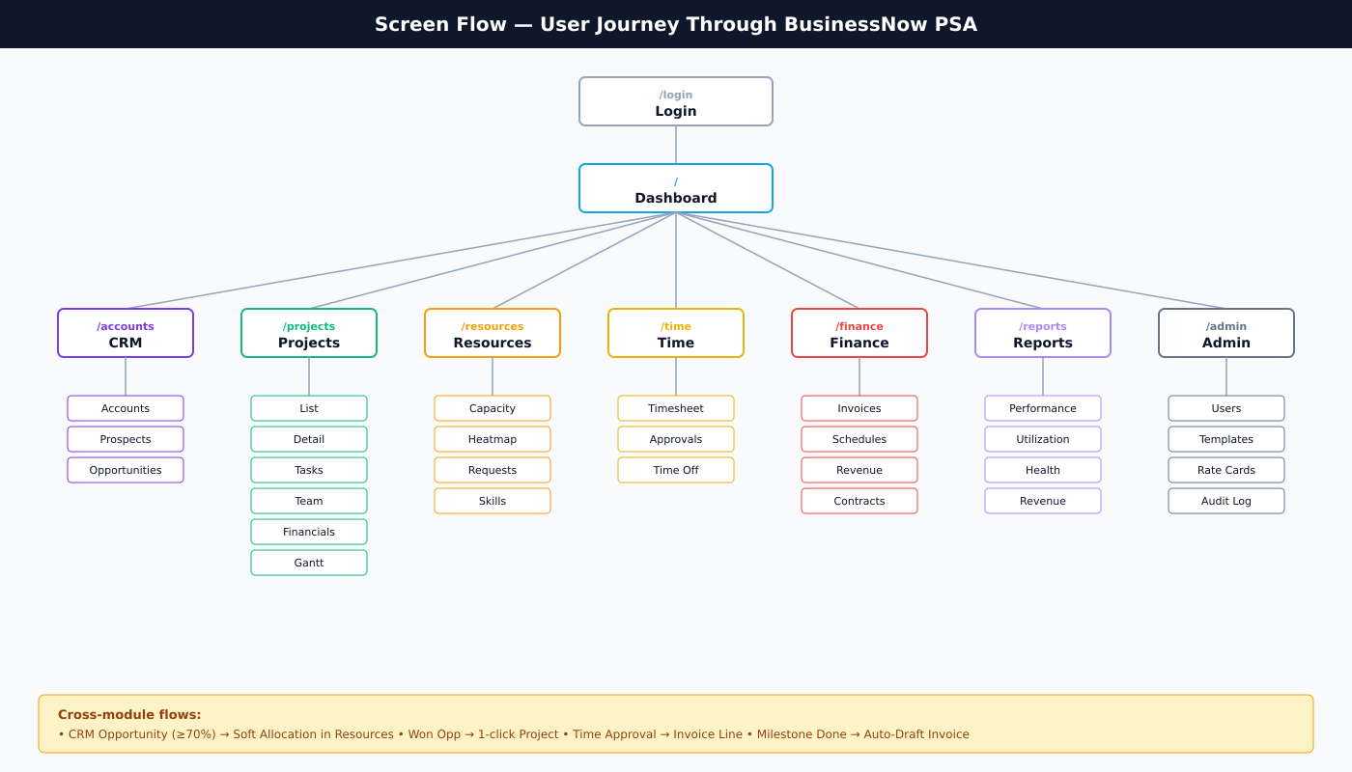
Figure 7.1 — Primary screen flow and module hierarchy

7.1 Page Inventory
Module | Route | Sub-pages / Tabs
Auth | /login | Login
Dashboard | / | KPI cards, My Tasks, Onboarding checklist
CRM | /accounts · /prospects · /opportunities | Accounts, Prospects, Opportunities
Projects | /projects · /projects/:id | List + 10 Detail tabs (Tasks, Team, Financials, Changes, CSAT, Documents, Forms, Gantt, Time, Updates)
Resources | /resources | Capacity, Heatmap, Projects Timeline, People Timeline, Requests, Skills Matrix
Time | /time | Timesheet, Approvals, Time Entries, By Project, By User, Time Off
Finance | /finance | Invoices, Billing Schedules, Revenue Recognition, Contracts
Reports | /reports | 12 reports (Performance, Utilization Grid, Capacity Planning, CSAT, Interval IQ, Budget vs Actual, Burn-Down, Revenue, Utilization, Project Health, Timesheet Submissions, Operations)
Admin | /admin | 17 tabs (Users, Templates, Skills, Job Roles, Tax Codes, Time Categories, Task Statuses, Time Settings, Holidays, Rate Cards, Custom Fields, Activity Defaults, Placeholders, Audit Log, Settings, Archived, Document Templates)
Command Center | /command-center | Portfolio Overview, Over-Allocated Resources, Resource Requests
Notifications | /notifications | Notification Inbox

8. Business Process Flows
The four flows below cover the most critical end-to-end journeys in the platform. Together they describe how work moves from a sales prospect to recognised revenue without manual handoffs.

8.1 Sales → Delivery (Opportunity to Project)
How a qualified opportunity becomes a delivered project, with resourcing reserved early.
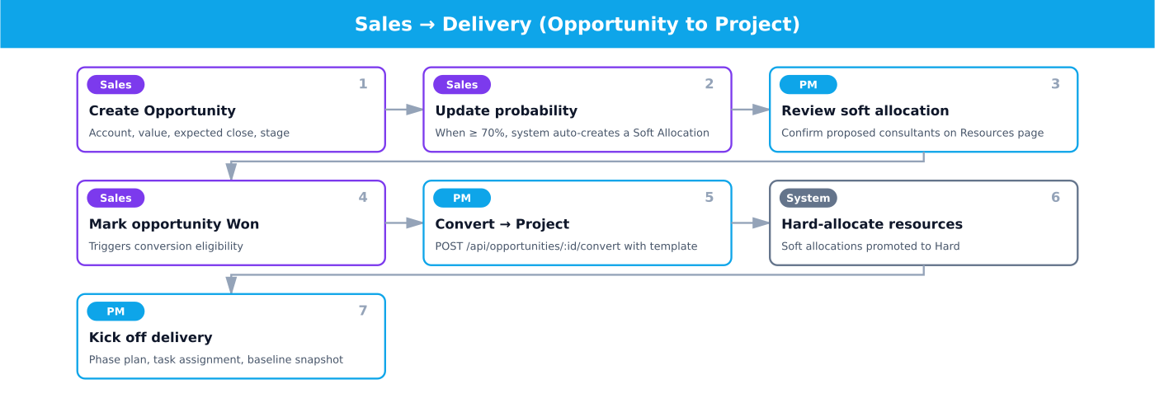
Figure 8.1 — Sales → Delivery (Opportunity to Project)
# | Actor | Action | Detail
1 | Sales | Create Opportunity | Account, value, expected close, stage
2 | Sales | Update probability | When ≥ 70%, system auto-creates a Soft Allocation
3 | PM | Review soft allocation | Confirm proposed consultants on Resources page
4 | Sales | Mark opportunity Won | Triggers conversion eligibility
5 | PM | Convert → Project | POST /api/opportunities/:id/convert with template
6 | System | Hard-allocate resources | Soft allocations promoted to Hard
7 | PM | Kick off delivery | Phase plan, task assignment, baseline snapshot

8.2 Time → Approval → Invoice
From a logged hour through approval into a draft invoice.
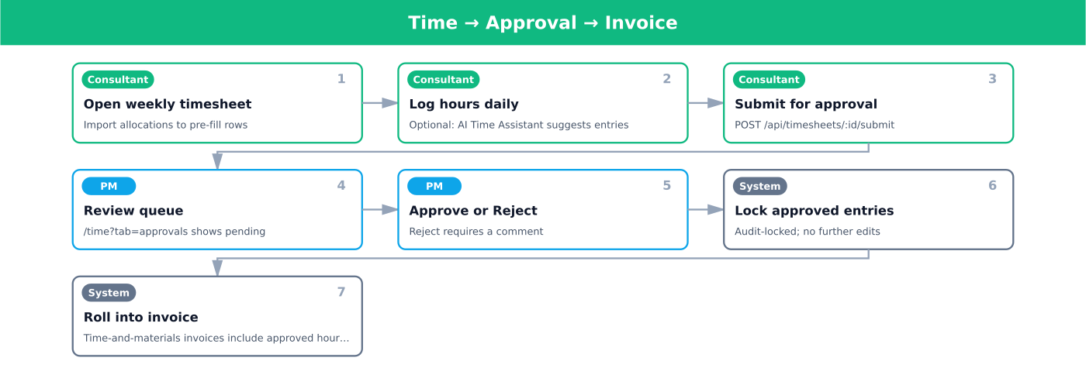
Figure 8.2 — Time → Approval → Invoice
# | Actor | Action | Detail
1 | Consultant | Open weekly timesheet | Import allocations to pre-fill rows
2 | Consultant | Log hours daily | Optional: AI Time Assistant suggests entries
3 | Consultant | Submit for approval | POST /api/timesheets/:id/submit
4 | PM | Review queue | /time?tab=approvals shows pending
5 | PM | Approve or Reject | Reject requires a comment
6 | System | Lock approved entries | Audit-locked; no further edits
7 | System | Roll into invoice | Time-and-materials invoices include approved hours × bill rate

8.3 Resource Request → Allocation
How unmet demand on a project is fulfilled.
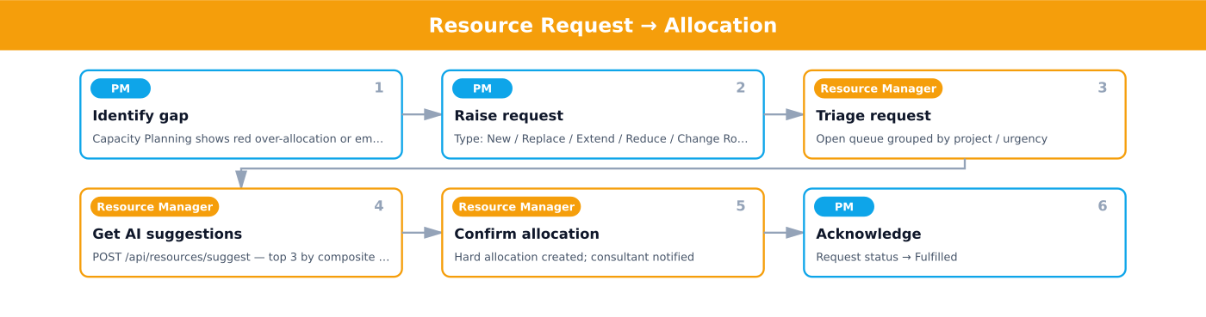
Figure 8.3 — Resource Request → Allocation
# | Actor | Action | Detail
1 | PM | Identify gap | Capacity Planning shows red over-allocation or empty role
2 | PM | Raise request | Type: New / Replace / Extend / Reduce / Change Role / Remove
3 | Resource Manager | Triage request | Open queue grouped by project / urgency
4 | Resource Manager | Get AI suggestions | POST /api/resources/suggest — top 3 by composite score
5 | Resource Manager | Confirm allocation | Hard allocation created; consultant notified
6 | PM | Acknowledge | Request status → Fulfilled

8.4 Milestone → Auto-Draft Invoice
Milestone completion creates a billable event.
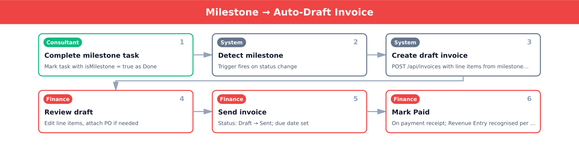
Figure 8.4 — Milestone → Auto-Draft Invoice
# | Actor | Action | Detail
1 | Consultant | Complete milestone task | Mark task with isMilestone = true as Done
2 | System | Detect milestone | Trigger fires on status change
3 | System | Create draft invoice | POST /api/invoices with line items from milestone value
4 | Finance | Review draft | Edit line items, attach PO if needed
5 | Finance | Send invoice | Status: Draft → Sent; due date set
6 | Finance | Mark Paid | On payment receipt; Revenue Entry recognised per policy

9. User Stories
Stories are grouped by module and prioritised using MoSCoW (MustShouldCould). All Must stories are in scope for Phase 1.

9.1 CRM
ID | Role | Priority | Story | Acceptance Criteria
US-CRM-01 | Super User | Must | As a PM, I want to convert a Won opportunity into a Project in one click so the delivery team can start without rekeying data. | Project is created with name, account, value, dates pre-filled. Soft allocation from opportunity is upgraded to hard.
US-CRM-02 | Super User | Must | As a PM, I want a soft allocation auto-created when an opportunity hits 70% probability so I can reserve consultants before the deal closes. | Allocation is created with type=soft, sourceOpportunityId set, dates from opportunity.
US-CRM-03 | Account Admin | Should | As an Admin, I want to view all accounts with pipeline value rolled up so I can prioritise relationship investment. | Account list shows count + sum of open opportunities per account.

9.2 Projects
ID | Role | Priority | Story | Acceptance Criteria
US-PRJ-01 | Super User | Must | As a PM, I want to clone a project from a template so I don't manually re-create phase / task structures. | POST /api/projects/from-template clones phases, tasks, baseline allocations.
US-PRJ-02 | Super User | Should | As a PM, I want to bulk-update task status / assignee / priority so I can rebalance a sprint quickly. | Bulk action bar appears when ≥1 row selected; PATCH /api/tasks/bulk persists; success toast shows count.
US-PRJ-03 | Super User | Must | As a PM, I want a baseline of the project plan so I can track variance over time. | Snapshot stored on POST /api/projects/:id/baselines; variance % visible in tasks view.
US-PRJ-04 | Collaborator | Must | As a consultant, I want to see my assigned tasks across all projects in one view so I know what to work on. | Dashboard 'My Tasks' card lists open tasks where assigneeId = current user.
US-PRJ-05 | Customer | Could | As a client stakeholder, I want a read-only status page for my project so I can self-serve health and milestones. | Read-only portal route /portal/:projectId; no edit affordances visible.

9.3 Resources
ID | Role | Priority | Story | Acceptance Criteria
US-RES-01 | Super User | Must | As a PM, I want AI suggestions for who to allocate so I match skills and respect capacity. | POST /api/resources/suggest returns ≥3 candidates with compositeScore, reasons, skill match details.
US-RES-02 | Super User | Must | As a PM, I want to see capacity vs demand for the next 12 weeks so I can spot bench / overload. | Capacity Planning chart renders weekly bars per person; over-allocation highlighted red.
US-RES-03 | Super User | Must | As a PM, I want to raise a Resource Request for a missing skill so a Resource Manager can fulfil it. | Request types: New / Replace / Extend / Reduce / Change Role / Remove; status workflow Open → Fulfilled / Rejected.
US-RES-04 | Collaborator | Should | As a consultant, I want to see my upcoming allocations 4 weeks ahead so I can plan. | Personal calendar view shows confirmed + soft allocations.

9.4 Time
ID | Role | Priority | Story | Acceptance Criteria
US-TME-01 | Collaborator | Must | As a consultant, I want a weekly timesheet grid so I can log time efficiently. | Rows = active project allocations; columns = Mon–Sun; total row at bottom.
US-TME-02 | Collaborator | Must | As a consultant, I want to import my allocations into the timesheet so I don't re-add projects each week. | POST /api/timesheets/import-allocations adds one zero-hours row per overlapping project; dedupes.
US-TME-03 | Collaborator | Could | As a consultant, I want AI to suggest time entries based on my activity so I don't forget. | AI Time Assistant returns suggested rows; user can accept/dismiss.
US-TME-04 | Super User | Must | As a PM, I want to approve / reject timesheets with a comment so I can correct mistakes. | POST /api/timesheets/:id/approve locks entries; POST .../reject reopens with required comment.
US-TME-05 | Collaborator | Must | As a consultant, I want to request time off and see my remaining balance so I can plan leave. | Time-off form validates against balance; status: Requested / Approved / Rejected.

9.5 Finance
ID | Role | Priority | Story | Acceptance Criteria
US-FIN-01 | Super User | Must | As a PM, I want a draft invoice auto-created when I mark a milestone task Done so I don't forget to bill. | On task.status = Done AND task.isMilestone, POST /api/invoices created with status=Draft, line items from milestone value.
US-FIN-02 | Account Admin | Must | As an Admin, I want to maintain rate cards (bill / cost) per role per project so invoicing and margin are accurate. | Rate card editor; effective date ranges; new project inherits org default.
US-FIN-03 | Super User | Must | As a Finance Lead, I want to record revenue separately from billing so recognition follows policy not invoice timing. | Revenue entries entity with project, period, amount, recognition method.

9.6 Reports
ID | Role | Priority | Story | Acceptance Criteria
US-RPT-01 | Super User | Must | As a leader, I want a Utilisation report by consultant so I can identify bench and overload. | Report shows billable / total / utilisation % per consultant per month; CSV export.
US-RPT-02 | Super User | Must | As a leader, I want a Project Health snapshot across the portfolio so I can intervene early. | Single page: count by health, top 5 At Risk, recent flag changes.

9.7 Admin
ID | Role | Priority | Story | Acceptance Criteria
US-ADM-01 | Account Admin | Should | As an Admin, I want a guided onboarding checklist on the dashboard so I can stand up the org without docs. | 4 step cards visible to admins only: add users / create project / allocate / submit timesheet; auto-dismiss when done.
US-ADM-02 | Account Admin | Must | As an Admin, I want every write action recorded in an immutable audit log so I can investigate any change. | logAudit() called on every POST/PATCH/DELETE; entries show actor, time, entity, before, after.
US-ADM-03 | Account Admin | Should | As an Admin, I want to manage Document Templates (SOPs, handover notes) so teams reuse approved content. | CRUD on document_templates table; 'From Template' button on Project Documents page applies template content.

10. Roles & Permissions

10.1 Role Definitions
Role | System ID | Description | Typical Title
Account Admin | account_admin | Full administrative control over the org. Manages users, roles, settings, rate cards, audit log. | Operations Director, IT Admin
Super User | super_user | Day-to-day operator. Manages projects, resources, finance approvals, and reports. | Project Manager, Finance Lead, Resource Manager
Collaborator | collaborator | Delivery team member. Logs time, views own allocations, updates assigned tasks. | Consultant, Senior Consultant
Customer | customer | External read-only. Views status of own projects. | Client Stakeholder, Sponsor

10.2 Permission Matrix
Capability | Account Admin | Super User | Collaborator | Customer
CRM — Manage Accounts/Opportunities | ✓ | ✓ | View own | —
CRM — Convert Opportunity to Project | ✓ | ✓ | — | —
Projects — Create & Edit | ✓ | ✓ | — | —
Projects — View Assigned | ✓ | ✓ | ✓ | Read-only own
Tasks — Create / Assign / Edit | ✓ | ✓ | Edit own | —
Resources — Capacity & Heatmap | ✓ | ✓ | Self only | —
Resources — Allocate / Request | ✓ | ✓ | — | —
Time — Submit own Timesheet | ✓ | ✓ | ✓ | —
Time — Approve / Reject | ✓ | ✓ (PM) | — | —
Time — Time-off request & approve | ✓ | ✓ (mgr) | Self submit | —
Finance — View Invoices | ✓ | ✓ | — | Own project only
Finance — Edit Rate Cards | ✓ | — | — | —
Finance — Send Invoice / Mark Paid | ✓ | ✓ (Finance) | — | —
Reports — View Standard | ✓ | ✓ | Self KPIs | —
Reports — Export CSV / XLSX | ✓ | ✓ | — | —
Admin — User & Role Management | ✓ | — | — | —
Admin — Audit Log | ✓ | — | — | —
Admin — Templates / Custom Fields / Settings | ✓ | Limited | — | —

10.3 RBAC Principles
- Permissions are checked server-side on every write endpoint, not just hidden in the UI.
- Customers are scoped strictly to projects they are explicitly granted access to.
- Account Admin actions on users, roles, rate cards, and audit log are themselves audited.
- Approval permissions (timesheet, time-off) can be delegated per project / per team within Super User.
- Role changes take effect at next login; revocations are immediate.

11. Assumptions, Constraints & Dependencies

11.1 Assumptions
- A1: Existing CRM and timesheet data exportable in CSV for migration
- A2: NetSuite remains the system of record for the GL
- A3: Identity provider (Azure AD / Okta) in place for SSO
- A4: Stable network connectivity at all delivery offices and remote
- A5: Business sponsors available for weekly UAT during validation

11.2 Constraints
- C1: Phase 1 launch must complete before fiscal year 2027 start
- C2: Total Phase 1 budget capped at approved business case
- C3: Single reporting currency (USD) at launch
- C4: NetSuite GL integration via 4-hour batch (not real-time)
- C5: Customer portal limited to view-only in Phase 1

11.3 Dependencies
- D1: SSO configuration — IT
- D2: NetSuite API credentials & sandbox — Finance Systems
- D3: Skills taxonomy sign-off — Talent / HR
- D4: Rate-card data sign-off per region — Finance Controller
- D5: Customer-portal terms — Legal Counsel

12. Success Metrics (KPIs)
KPI | Owner | Baseline | Target (12 mo post go-live)
Days from milestone complete → invoice issued | CFO | 9 | ≤ 2
Billable utilisation (firm-wide) | Head of PS | 67% | 75%
Unbilled WIP > 30 days (% of total WIP) | CFO | 18% | ≤ 5%
On-time project delivery (vs baseline) | Head of PS | 78% | ≥ 95%
Avg time on weekly timesheets per consultant | Head of PS | ~25 min | ≤ 8 min
Timesheet submission compliance (Mon EOD) | Head of PS | 71% | ≥ 95%
Revenue forecast accuracy (90 days, ± variance) | CFO | ± 18% | ± 5%
Resource staffing turn-around (request → assigned) | Resource Mgr | 4–5 days | ≤ 24 h
User adoption (active weekly / licensed) | Product | n/a | ≥ 90%
CSAT (project-end survey) | Head of PS | 7.8 / 10 | ≥ 8.5 / 10

13. Risks & Mitigation
ID | Risk | Likelihood | Impact | Mitigation
R1 | Low user adoption (resistance to new timesheet flow) | Medium | High | Pre-launch champions, in-app guidance, AI Time Assistant, manager-level adoption dashboards
R2 | Migration data quality issues (stale CRM, dirty rate cards) | High | Medium | Pre-migration data audit, cleanse-and-validate sprint, dry-run to staging
R3 | NetSuite GL integration mapping errors | Medium | High | Joint design with Finance Systems, parallel-run for one billing cycle, reconciliation report
R4 | Scope creep (Phase 2 features pulled in) | High | Medium | Locked Phase 1 backlog, formal change-request process via Steering
R5 | SSO / identity readiness slips | Medium | High | Early IT engagement; fallback to local auth for pilot only
R6 | Performance under peak load (month-end billing) | Medium | High | Load test at 2× peak; auto-scaling infra; queue-based invoice generation
R7 | Data residency / GDPR compliance gap | Low | High | EU region deployment validated; DPIA before go-live
R8 | Key person dependency (single SME on resource model) | Medium | Medium | Pair-working, documented design decisions, knowledge-transfer
R9 | Customer portal exposes sensitive data unintentionally | Low | High | Field-level access review; pen-test on portal; default-deny posture
R10 | Sponsor turnover during programme | Low | High | Quarterly steering, documented decisions, broad sponsor coalition

14. Timeline & Milestones

14.1 High-Level Schedule
Phase | Window | Key Deliverable
Discovery & Mobilisation | Weeks 1–4 | Signed BRD, governance, env access
Design | Weeks 5–10 | Solution design, migration plan, integration design
Build — Sprint 1 (CRM + Projects) | Weeks 11–14 | CRM and Projects modules feature-complete
Build — Sprint 2 (Resources + Time) | Weeks 15–18 | Resources and Time modules feature-complete
Build — Sprint 3 (Finance + Reports) | Weeks 19–22 | Finance, Reporting, NetSuite integration
Build — Sprint 4 (Admin + Polish) | Weeks 23–25 | RBAC, audit, custom fields, templates
System Integration Test (SIT) | Weeks 26–28 | All defects ≤ Sev-2 closed
User Acceptance Test (UAT) | Weeks 29–31 | UAT sign-off by business owners
Data Migration & Cutover | Weeks 32–33 | Production data loaded & reconciled
Pilot Go-Live (1 region) | Week 34 | ~50 users live, hypercare
Phased Rollout | Weeks 35–40 | Full firm live
Post Go-Live Hypercare | Weeks 41–48 | ≤ 5 critical defects, KPI tracking starts

14.2 Key Milestones
# | Milestone | Target | Owner
M1 | BRD approved | End of Week 4 | Sponsor
M2 | Solution design signed off | End of Week 10 | BA + IT
M3 | Build complete | End of Week 25 | Delivery Lead
M4 | UAT sign-off | End of Week 31 | Business Owners
M5 | Pilot go-live | Week 34 | Programme Manager
M6 | Full rollout complete | End of Week 40 | Programme Manager
M7 | Phase 1 closure & benefits review | End of Week 48 | Sponsor

15. Approval & Sign-Off
Name | Role | Decision | Date | Signature
 | Executive Sponsor (CEO/COO) | ☐ Approve ☐ Reject ☐ Approve with comment
 | Head of Professional Services | ☐ Approve ☐ Reject ☐ Approve with comment
 | Chief Financial Officer | ☐ Approve ☐ Reject ☐ Approve with comment
 | Chief Information Officer | ☐ Approve ☐ Reject ☐ Approve with comment
 | Head of IT Security | ☐ Approve ☐ Reject ☐ Approve with comment

— End of Business Requirements Document — BusinessNow PSA v1.0 —

