Sedore Feedback
4/24/2026

Project
- Creating a new Project
  - Should have option to select project template. i.e. Create Project from Project Template and then a drop down list of project templates to choose from.
  - Also, what would be great is if you can add project template “segments” imbedded into a project. For example, I could have a Project Template of Build Phase that has lots of template tasks. I would add the template into my project to bring in all the Build Phase template tasks as a jump start to creating my project.
  - We need KSAP as an Account for Internal Projects.
    - Question: Should we have specific internal accounts? For example, should we have KSAP Services, KSAP Development, KSAP IT, KSAP Admin or just one KSAP?
  - Type: Should we have a Type called Internal for Internal Projects?
- Project Budget needs to be a dynamic field that sums up all SOW and Change Orders for that project. For example, the original SOW for the project when created may be $10,000. Then during the course of the project, we may add Change Orders. Example:
Date | Budget Description | Amount | Total Project Budget | Hours | Total Project Hours | Document Link
2025-06-01 | Original SOW | $10,000 | $10,000 | 150 | 150 | SOW Link
2025-08-15 | Change Order 1 | $3,000 | $13,000 | 25 | 175 | CO1 link
2026-02-01 | Change Order 2 | $5,000 | $18,000 | 50 | 225 | CO2 Link
- The documents should be attached to the project
- At any time I should be able to see the total budget (dollars and hours) and a detail of each budget item
- I would prefer the Project Description be Mandatory to force people to think and be detailed but I’m ok with optional if others prefer it.
- Staffing
  - Wanted to add resources from Staffing tab. Not sure if/how to do that.
  - If done through Allocations, New Allocation, then the Project should be a drop down of existing projects.
- Task
  - Adding Task, the default status should be Not Started.
  - The Task statuses I like are (Not Started, Started, On Hold, Canceled, Completed). I don’t like todo, blocked or In Review. Others may have other recommendations or disagree… so we would want other input here
  - Instead of Est. Hours, I prefer Planned Hours. The categories/names I like for hours and budget are Planned, Estimate, Actual, ETC.
    - Planned – Hours planned for the task originally
    - Estimate – Initially is set to Planned value but can be adjusted by PM or user as work is being performed
    - Actual – Actual Hours entered against the task
    - Therefore, we can calculate Estimate At Complete by adding Actual + ETC.
    - ETC is calculated as Estimate – Actual (Allow for negative values(highlight in red) to show task effort has exceeded recent estimate
    - So, for example,
      - create task,
        - Planned = 10 hrs
        - Estimate = 10 hrs
        - Actual = 0
        - ETC = 10 (10 – 0)
        - EAC = 10 = 0 + abs(10)
      - After task has been worked on, say 4 hrs have been logged against it, the values would be:
        - Planned = 10 hrs
        - Estimate = 10 hrs
        - Actual = 4
        - ETC = 6 (10 – 4)
        - EAC = 20 = 4 + abs(6)
      - After task has been worked on some more, the resource realizes they need 5 more hours than what the planned effort was. They logged another 3 hours as well so the values would be:
        - Planned = 10 hrs
        - Estimate = 15 hrs
        - Actual = 7
        - ETC = 8 (15 – 7)
        - EAC = 15 = 7+abs(8)

      - Then the user works on it for 20 more hours and doesn’t update the Estimate, looks like this:
        - Planned = 10 hrs
        - Estimate = 15 hrs
        - Actual = 27
        - ETC = -12 (15 – 27)
        - EAC = 39 = 27+abs(-12)
  - Task Planned hours should be a calculated field of the sum of the hours of the resources planned hours on that task
  - Similar concept with Actual Hours and Estimate hours.
  - Task Linking (I think its wrong or I don’t understand)
    - I added a Predecessor task to what I would have been the successor task i.e. I have
    - 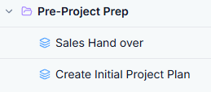
    - Where I want to complete the Sales Hand Over and then start the Create Initial Project Plan task.
    - I added a predecessor link on Create Initial Project Plan and identified Sales Hand Over. However, when I look at it, it on the Create Initial Project Plan task, it shows Sales Hand over as a successor. It should be the opposite.
    - 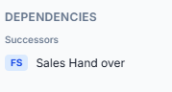
    - When I look at the Gannt Representation, the tasks are in order and the links are right
    - 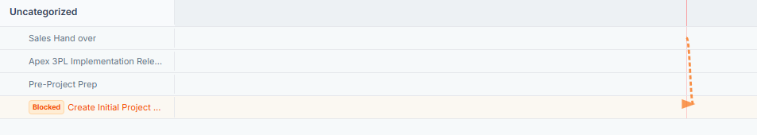
    - In my example, the leveling should be
    - 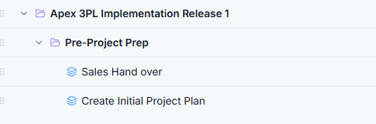
    - 0.0 Apex 3PL Implementation Release 1
    - 1.0 Pre-Project Prep
    - 1.1Sales Hand over
    - 1.2 Create Initial Project Plan
    - When I tried to add another parent task and then a task under it, that parent task didn’t show up in the child task drop down.
    - 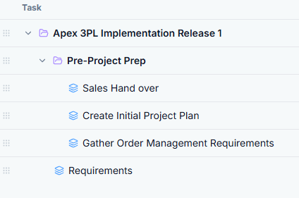
    - I added Requirements Parent and then went to add Gather Order Management Requirements to be a child of Requirements but Requirements wasn’t an option to select in the Parent.
    - I think tried to edit or move Gather Order Management Requirements and I was not able to do that. I need to be able to move tasks . Preferably to drag and drop. So for example, I would drag Gather Order management Requirements and drop under Requirements and slide to the right so it knows it’s a subtask.
    - Need ability to undo changes. I think we want ability to click Save rather than it automatically save changes.
    - I tried to create a project rate card. I use override standard and couldn’t figure out where it went or how to update it.
    - I was able to create Rate Cards for my project from the Rate Card menu.
      - Question: Does Cost make sense at the rate card or is cost tied to a resource.
      - Ex. Akhil has cost of $50/hr; Assigned to project A as Soln Arch. Sellat $175; assigned to Project B as Consultant for $125.
        - Akhil’s cost doesn’t change based on project or rate card but the sell does.
Contract Manager
- New Contract button doesn’t do anything.
Change Order
- New Change Order
  - Project Name should be a drop down list. i.e. can only create a Change Order for an existing project
  - I don’t know what Project ID is or if necessary.
  - I would like the ability to link to the Change Order document and/or object stored in the BusinessNow product.
Financials
- I typed my project in the search and it didn’t find it.

PMO Settings
- Rate Card: When I click on Rate Card under PMO settings, I get an error (tells me to go to dashboard). You may not have that linked up to the Rate Card functionality
- Timecodes. I think of this structure differently and I think we need to get this right. Brian is aware of how I set this up at 3G so I would ask Brian to look at this and how I set up and think about categories, activities, investments, groupings, bill vs non-bill. If he likes this better than what I set up, we can go with this. If he wants me to break it down again, I can spend the time to describe.
- Project Template
  - Create Task isn’t quite right, missing info, also has task dependency which doesn’t make sense at creation. Can’t have multiple nested layers
  - Expand and contract carrot doesn’t work.
  - Also I think we need a Project Group on left pain and within that is all the project stuff like Project Template, Project, …

