KSAP | CATALYST
Health Dashboard: Metrics & Charts
Built from a real OTM health-dashboard reference, filtered to what governs automation — not infrastructure
You asked for a Health Dashboard with real metrics and charts, using the reference dashboard you attached as the source of truth. That reference turned out to be a live Oracle OTM operations dashboard with four tabs — Transmissions, Bulk Plans, Scalability Overview, and Statistics (an “Oracle Health Check” screen). It has 15+ distinct widgets across infrastructure, business volume, and automation health. This document catalogues all of them, keeps the ones that belong in Catalyst, explicitly excludes the ones that don't and says why, and turns the result into the revised specification for Feature 3.9 (Healthcheck Dashboard) from the Feature Validation document.

1. Source & Method
The filter applied to every widget in the reference was one question: does this help someone govern OTM/GTM automation and business throughput — Catalyst's job — or does it monitor infrastructure that Oracle, a DBA, or an APM tool already owns? The first category was kept. The second was excluded on purpose, so this dashboard doesn't quietly grow into a server-monitoring product Catalyst was never meant to be.

2. Full Inventory Reviewed
Every widget found across the reference's four tabs, and the call made on each one.
Element | Source tab | What it shows | Verdict
Fresh / Staged count tiles | Transmissions | Pending, unprocessed message counts | KEEP
Fresh & Staged by Hour (chart) | Transmissions | Hourly throughput trend | KEEP
Hourly Transmission by Message Type (chart) | Transmissions | Throughput by business object type | KEEP
Hourly Transmission by App Machine (chart) | Transmissions | Throughput by server | EXCLUDE — machine/infra tier
Transmissions by Message Type (recent log) | Transmissions | Scrollable recent activity | KEEP
Transmissions by Machine (recent log) | Transmissions | Scrollable recent activity by server | EXCLUDE — machine/infra tier
App Server / Web Server Responding + Response Time | Scalability Overview | Server uptime and latency | EXCLUDE — APM/infra scope
Logs Enabled | Scalability Overview | Which native OTM logs are on | EXCLUDE — low value, config-only
Process Schedules in next 1 hour | Scalability Overview | Upcoming scheduled job runs | KEEP
Business Sequence (current / max) | Scalability Overview | Sequence / XID counters | KEEP — upgraded to a chart
Database Jobs | Scalability Overview | Currently running DB jobs | EXCLUDE — DBA tier
Cluster / failover / data-queue topology | Scalability Overview (deep) | App and web cluster health | EXCLUDE — infra tier
Critical Parameter Statistics (RAG grid) | Statistics / Health Check | Automation health by domain | KEEP — core widget
Critical Data Statistics (volume grid) | Statistics / Health Check | Business volume by domain | KEEP — core widget
Long Running Queries drill-down | Statistics / Health Check | Session, SQL ID, duration vs. threshold | KEEP

Why the exclusions matter
Server responding/latency, DB job lists, and cluster/failover topology are real and useful — but they belong to Oracle Enterprise Manager or the customer's own infrastructure monitoring, not to Catalyst. Catalyst's differentiator, established in the product foundation, is automation governance: what agents and AI agents are doing, not whether a web server is up. If a customer later wants infrastructure co-monitoring inside Catalyst, that's a deliberate future integration decision, not something that should sneak in as a dashboard widget.

3. The Health Dashboard: Widgets, Metrics, Charts
3.1 Automation Throughput (KPI tiles + hourly chart)
The reference's “Fresh/Staged” tiles and hourly-by-message-type chart, kept and re-pointed at Catalyst's own object model rather than raw OTM message types — so the same chart now shows the thing Catalyst actually governs: which kind of automation is doing the work.
- KPI tiles: Fresh (queued, unprocessed) count and Staged count, per domain, refreshed on the same polling cycle as Agent Trace.
- Chart: hourly volume, stacked by trigger type — Classic Agent, AI Agent, Manual/Ad-hoc — instead of by raw message type, so a spike is immediately traceable to which kind of automation caused it.
- Recent-activity table: Time, Object Type, Domain, Count — reusing Agent Trace's already-ingested log data rather than a separate feed.
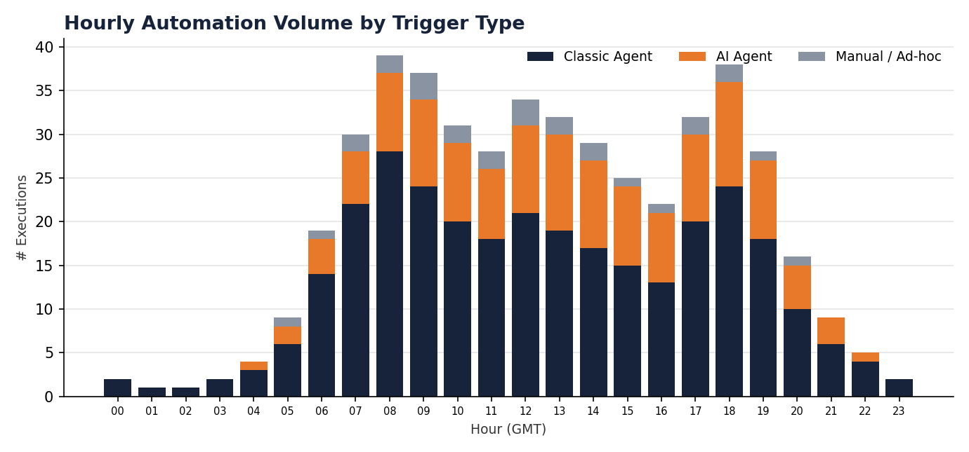
Sample: hourly automation volume, stacked by trigger type. Data source: Agent Trace (3.7) via the Object Model (3.15).
3.2 Business Process Volume (multi-domain grid)
The reference's Critical Data Statistics grid, kept close to as-is — it's exactly the kind of at-a-glance operational read a super user or ops lead needs, and it was already multi-domain.
Metric | PTY | SAO | LatAm
Orders in Process | 102 | 9296 | 41
Bulk Plans Run | 0 | 0 | 3
Shipments Created | 0 | 0 | 12
Shipments Approved | 0 | 0 | 9
Item Master Load Received | 5 | 5 | 5
Pending Split | 1 | 8 | 0

Full metric catalog for this widget: Orders in Process, Number of Bulk Plans Run, Number of Orders Planned, Number of Shipments Created, Number of Shipments Approved, Weight of Shipments Processed, Item Master Load Received, Pending Split, Split as Order Base, Split Orders Ready for Planning/Execution. Each cell is bound to a saved query per domain (same binding mechanism as the Healthcheck Dashboard's custom-metric support), with red text as the default rule for an unexpected zero and green for a healthy non-zero read — that default rule must be overridable per metric, since a genuine zero is sometimes correct.
3.3 Automation & Query Health (RAG grid + drill-down)
The reference's Critical Parameter Statistics grid, kept in full — this is the single most valuable widget in the source material, because it's already exactly the shape Feature 3.9 needed: a configurable metric, a threshold, a status, and a domain column that repeats across every domain Catalyst already knows about from Workflow Mapping.
Parameter | PUNL66 | Brazil | Mexico
Inbound Transmissions | ● Normal | ● Normal | ● Normal
Outbound Transmissions | ● Normal | ● Normal | ● Normal
Bulk Plan Run | ● Normal | ● Normal | ● Critical
Long Running Queries | ● Critical | ● Warning | ● Normal
Pre-Split to Split | ● Normal | ● Critical | ● Critical
Split to Planning | ● Normal | ● Critical | ● Critical
Planning to Execution | ● Normal | ● Normal | ● Normal

Full metric catalog: Inbound Transmissions, Outbound Transmissions, Bulk Plan Run, Object Locks, Ad-hoc Logs, Long Running Queries, Tender Sent / Tender Response Received, Pre-Split to Split, Split to Planning, Planning to Execution, Long Run Scheduled Reports. Each status is Green/Amber/Red against a per-metric, per-domain threshold (configuration and ownership rules already defined in Feature 3.9). Clicking a Red or Amber cell opens a drill-down: for a Long Running Query breach, the session ID, SQL ID, actual duration, and the threshold it exceeded — reusing the same underlying data Agent Trace (3.7) already captures rather than building a second query-monitoring pipeline.
3.4 Recurring Schedule Preview (table)
The reference's “Process Schedules in next 1 hour” panel, kept as a direct front-end for Recurring Process Health (3.8) rather than a separate feature — it's the same data, just previewed forward instead of backward.
- Columns: Schedule time, Program/Agent, Domain, Topic.
- Configurable look-ahead window, default 1 hour, matching the reference.
- Data source: Recurring Process Health (3.8) — no separate ingestion.
3.5 Capacity Risk — Sequence / Refnum Exhaustion (new chart, upgraded from the reference)
The reference tracked this as a plain current-value/max-value table (“Business Sequence”) — easy to include, easy to overlook, because nothing about a table of two numbers signals urgency. Sequence and XID counters silently approaching their maximum is a real, well-documented cause of unplanned OTM outages, so this is worth calling out as a genuine addition rather than a like-for-like port: turn it into a percentage-utilized chart with threshold lines, so risk is visible at a glance instead of requiring someone to do the division in their head.
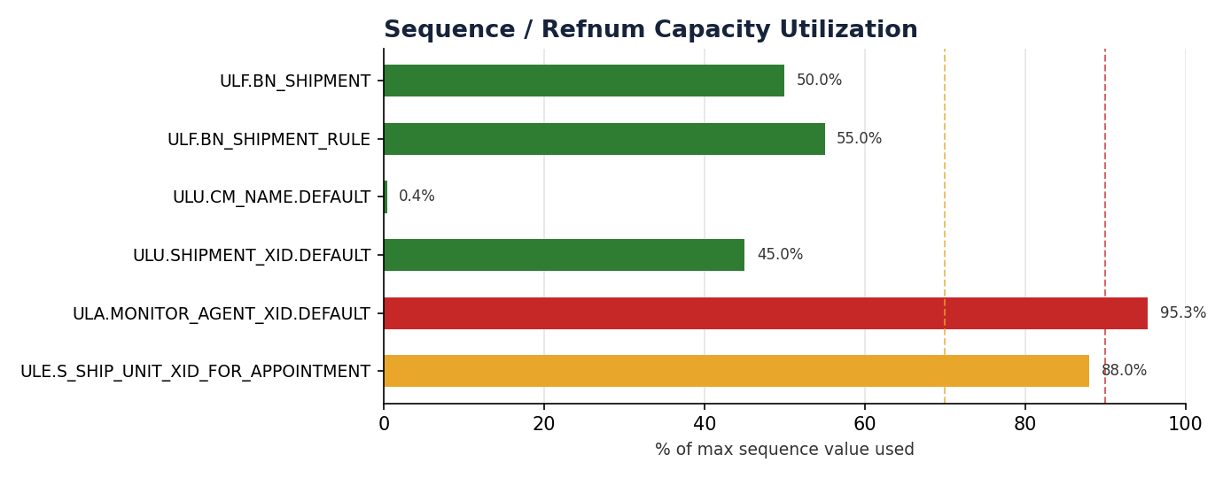
Sample: sequence capacity utilization, amber at 70%, red at 90% (both configurable). Two of six sequences shown are already past the amber line — exactly the kind of thing a plain current/max table hides until it's too late.
- Metric: current value ÷ max value per sequence/refnum, expressed as a percentage.
- Thresholds: amber and red lines, configurable per customer, defaulting to 70% / 90%.
- Alerting: a sequence crossing red fires through the shared Alerting Channel (3.17), the same path as every other threshold breach in this dashboard.
- Data source: an extension to the Object Model (3.15) scan to also capture each sequence's current and max value — this is a new data point, not previously scoped, and is called out as Feature 3.19 below.

4. Updated Feature Spec — Healthcheck Dashboard (3.9, revised)
This supersedes the generic version of Feature 3.9 in the Feature Validation document. The verdict and the fix from that document still stand; what follows is the concrete widget catalog that fix was waiting on.
In scope: The five widgets in Section 3 of this document — Automation Throughput, Business Process Volume, Automation & Query Health, Recurring Schedule Preview, and Capacity Risk — each bound to OOB metrics or custom saved queries per domain, each with its own threshold configuration, each alerting through the shared Alerting Channel (3.17).
Out of scope: Any infrastructure-tier widget listed as EXCLUDE in Section 2 — server responding, response time, DB job lists, and cluster/failover topology. If a future customer contract requires these, they are scoped as a separate infra co-monitoring feature, not added here.
Functional behavior
- An admin selects an OOB metric from the catalog above or binds a custom saved query, per domain.
- For RAG-style metrics (3.3), the admin sets amber/red thresholds; for volume metrics (3.2), the admin sets the expected-nonzero rule per metric.
- The dashboard renders all five widgets on one screen, scoped to the domains the logged-in role has access to.
- Any Amber or Red status, in any widget, fires through the shared Alerting Channel (3.17) and is also visible in-app regardless of delivery success.
- Clicking a Red cell in the Automation & Query Health grid opens the relevant drill-down — Agent Trace (3.7) for agent-triggered breaches, or the query-level detail for a Long Running Query breach.
Business rules & edge cases
- A custom saved query that errors or returns no rows shows “metric unavailable,” never a false Green or Red.
- A metric with no configured threshold yet shows as “unconfigured,” distinct from both a healthy and an unhealthy state, so an empty setup can never be mistaken for “all clear.”
- Sequence capacity percentages are computed at scan time and are only as fresh as the last Object Model scan — the dashboard shows the “as of” timestamp for that reason.
Acceptance criteria
Given | When | Then
a domain's Bulk Plan Run metric breaches its configured threshold | the check runs | the cell turns Red, a drill-down is available, and an alert fires via the shared channel
a sequence crosses 90% of its max value | the next scan completes | the capacity chart shows it in red and an alert fires
a custom saved query bound to a Business Process Volume metric fails | the dashboard renders | that cell shows “metric unavailable,” not a false zero or false green
Depends on: Object Model (3.15, extended per 3.19 below), Agent Trace (3.7), Recurring Process Health (3.8), Alerting & Notification Channel (3.17), RBAC (3.13).

5. New Addition Required: Sequence / Refnum Capacity Tracking
Feature 3.19, extending the Object Model (3.15). The reference dashboard already proved this data is available and worth tracking; it just wasn't previously scoped as part of Catalyst's ingestion.
In scope: During each Object Model scan, capture every sequence/refnum's current value and configured max value alongside the existing agents/events/saved queries/refnums extraction; expose the resulting percentage to the Capacity Risk widget (3.5).
Out of scope: Modifying or resetting sequence values from within Catalyst — read and report only.
Acceptance criteria
Given | When | Then
a connected environment with configured sequences | an Object Model scan completes | each sequence's current value, max value, and percentage used are captured in that snapshot
a sequence has no defined max value in OTM | it is scanned | it is shown as “capacity unknown” rather than a misleading 0%
Depends on: Object Model (3.15).

6. Next Step
The Health Dashboard now has a concrete widget catalog, sample charts, and a revised, testable spec for Feature 3.9, plus one new feature (3.19) it depends on. This slots directly into the punch list already handed to Fable 5 — add 3.19 to the build sequence alongside the Object Model work in item 1, since they're the same effort.

