ExpenseWise - API Documentation

Postman - API Test Screenshots
1. POST /api/auth/register - User Registered (201 Created)
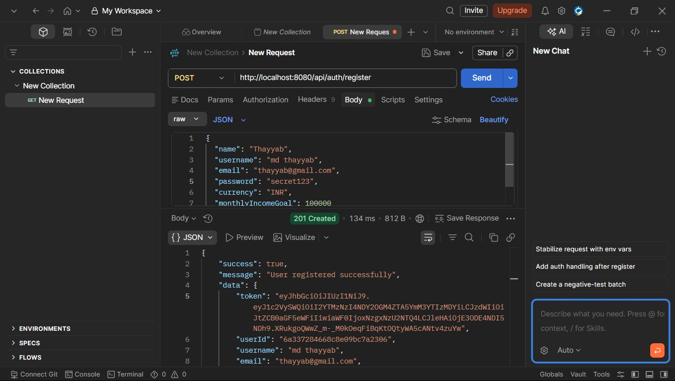
2. POST /api/auth/login - Login Successful (200 OK)
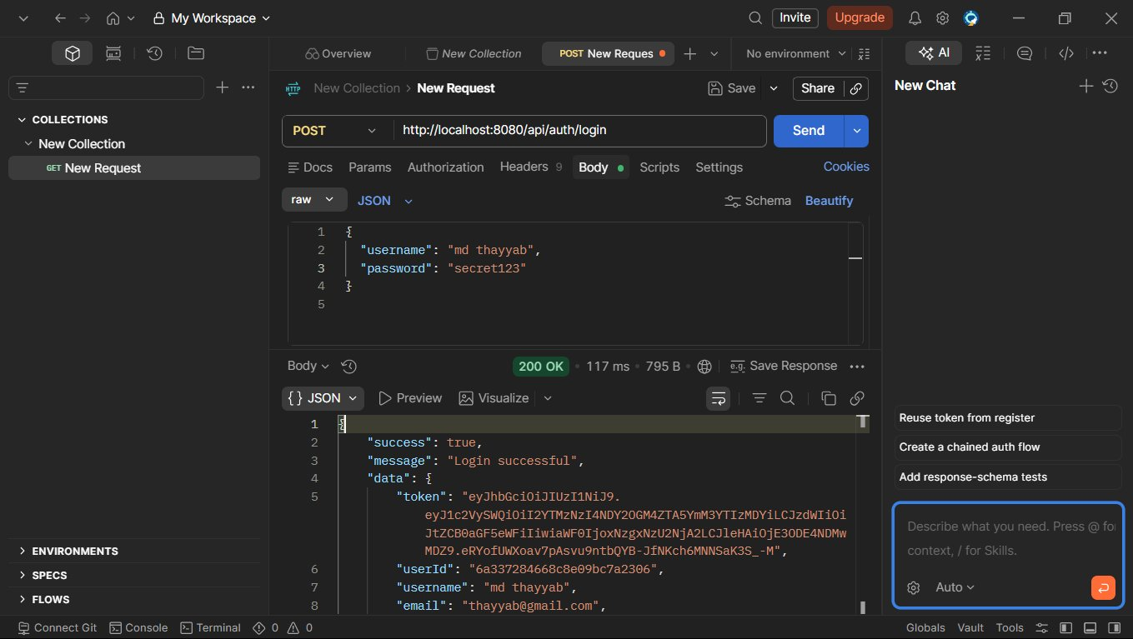
3. GET /api/categories - Categories Fetched (200 OK)
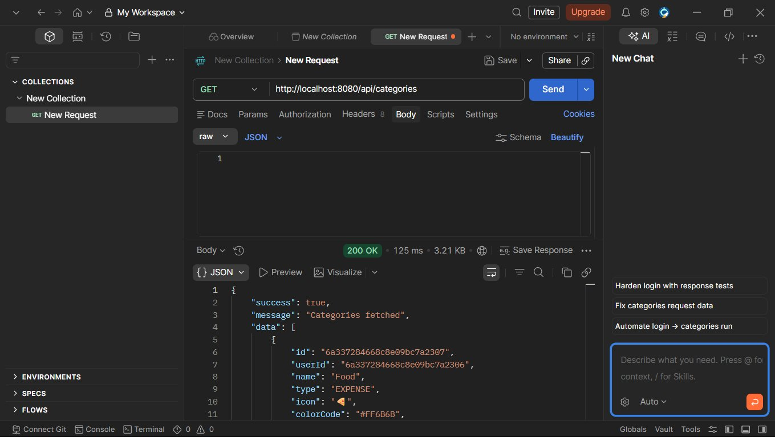
4. GET /api/categories/type/EXPENSE - Categories by Type (200 OK)
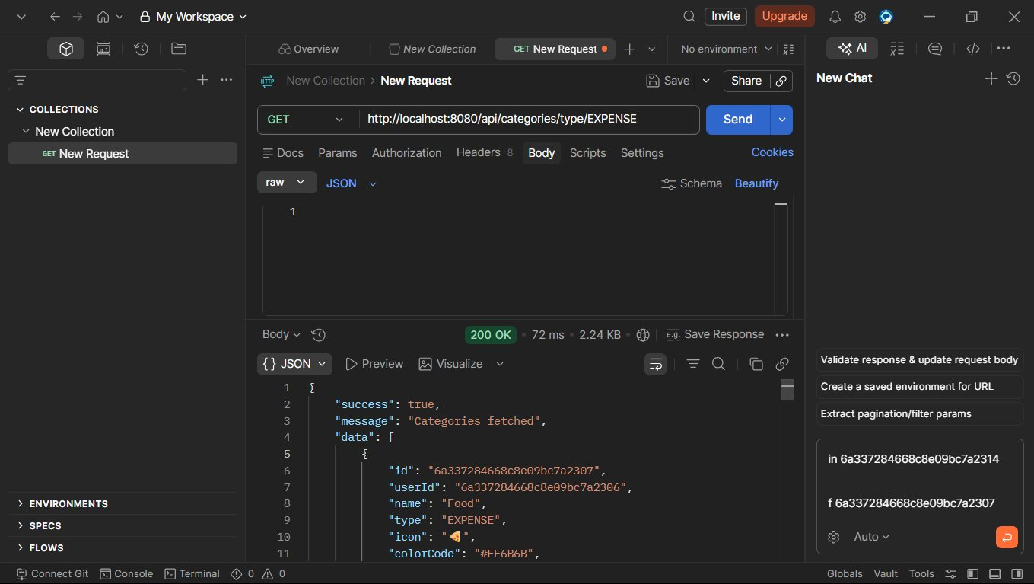
5. POST /api/expenses - Expense Added (201 Created)
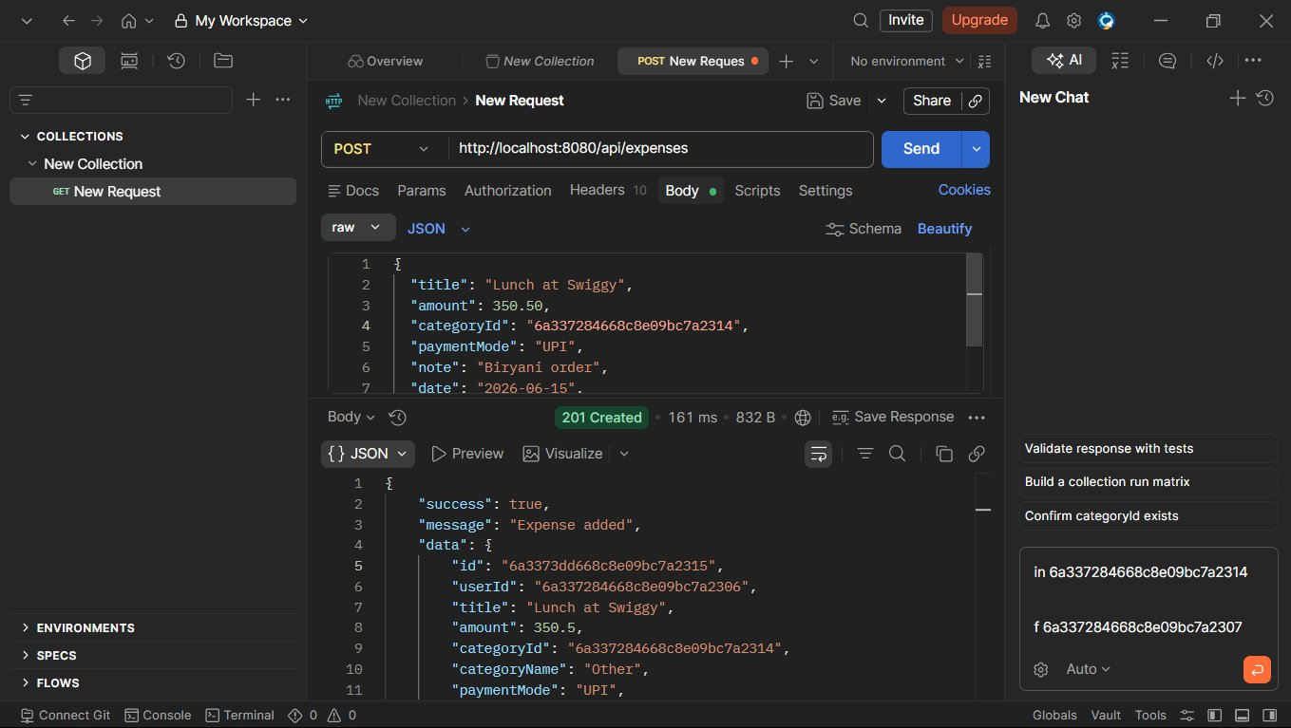
6. GET /api/expenses/search?keyword=swiggy - Search Results (200 OK)
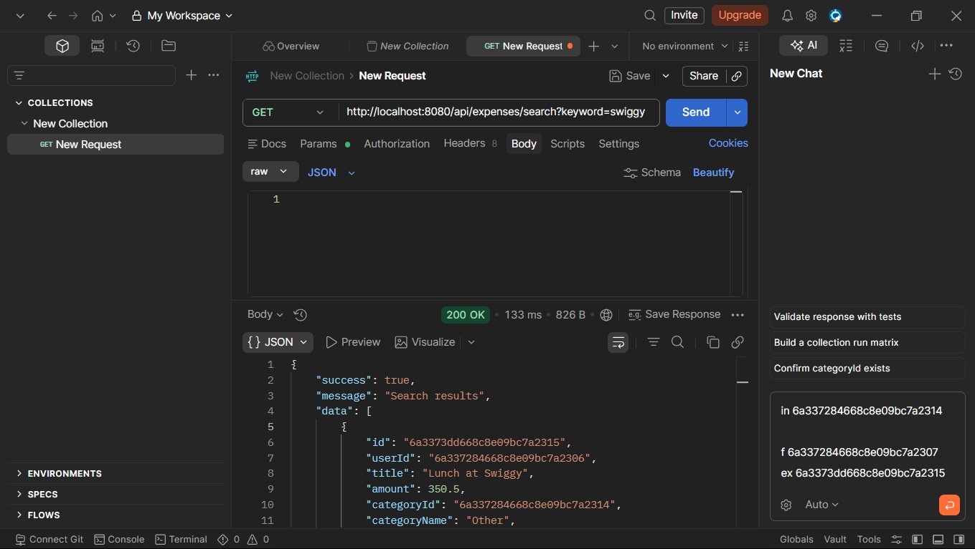
7. GET /api/expenses/filter?month=6&year=... - Filtered by Month/Year (200 OK)
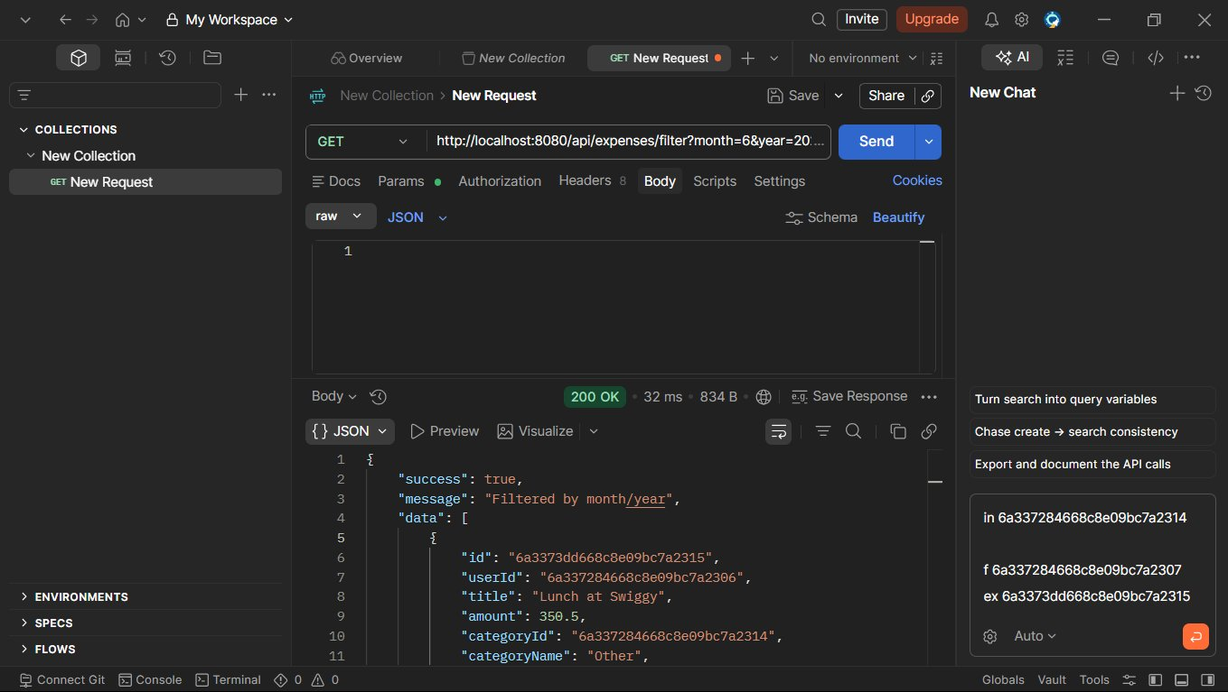
8. POST /api/incomes - Income Added (201 Created)
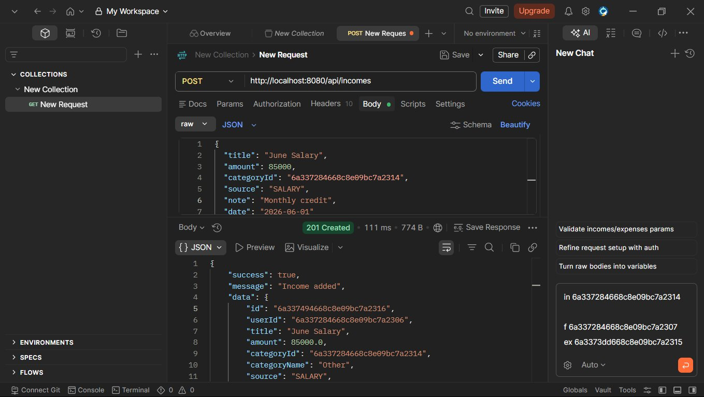
9. POST /api/budgets - Budget Set (201 Created)
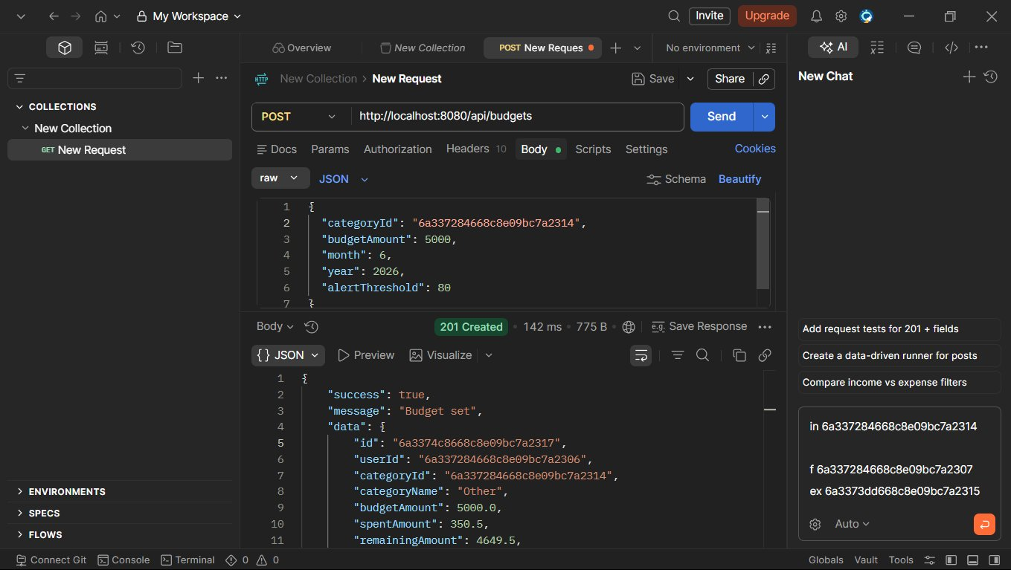
10. POST /api/expenses - Expense Added (Grocery run, 201 Created)
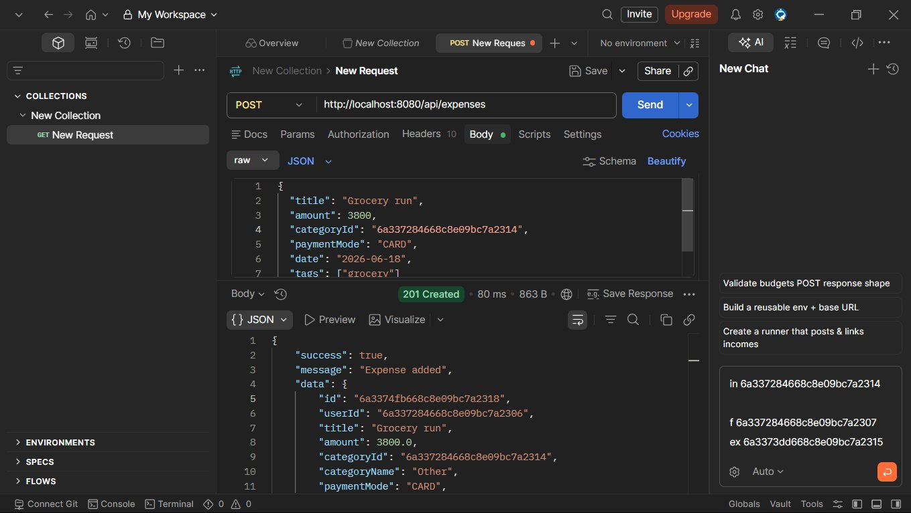
11. GET /api/reports/summary?month=6&year=... - Monthly Summary (200 OK)
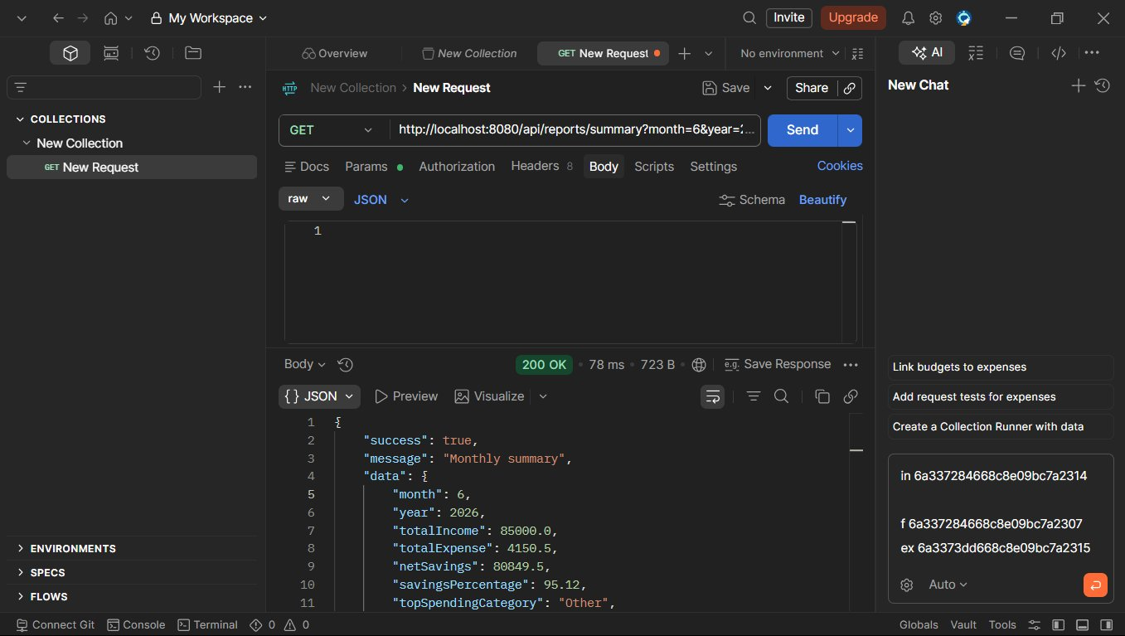
12. GET /api/reports/income-vs-expense?month=... - Income vs Expense (200 OK)
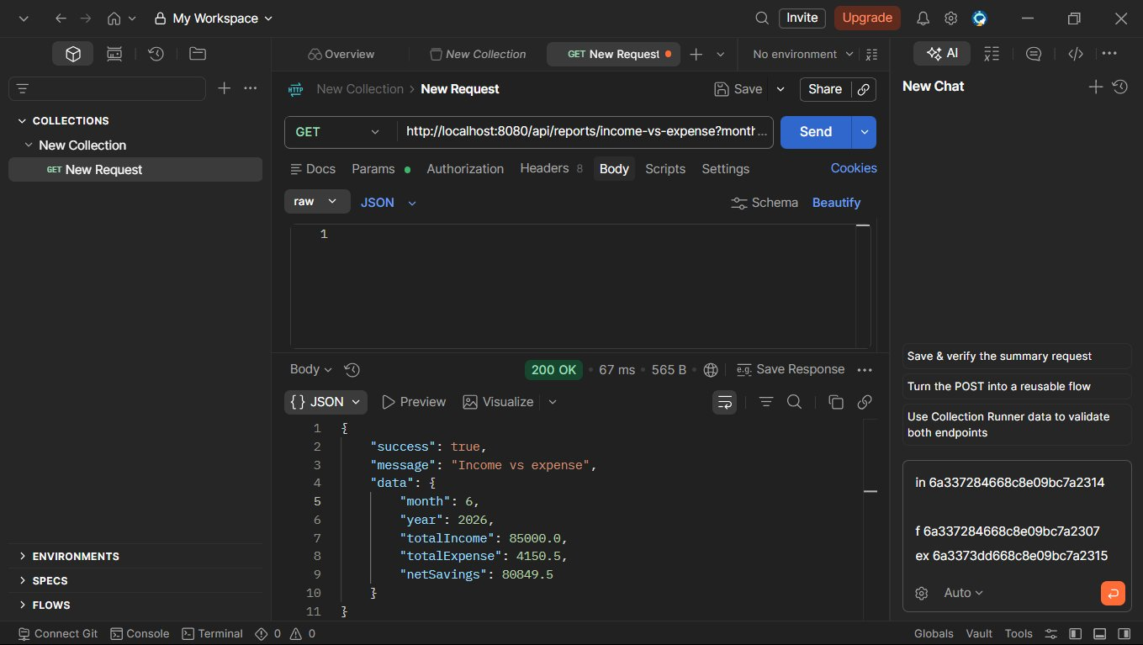
13. GET /api/reports/top-expenses?month=6&y... - Top Expenses (200 OK)
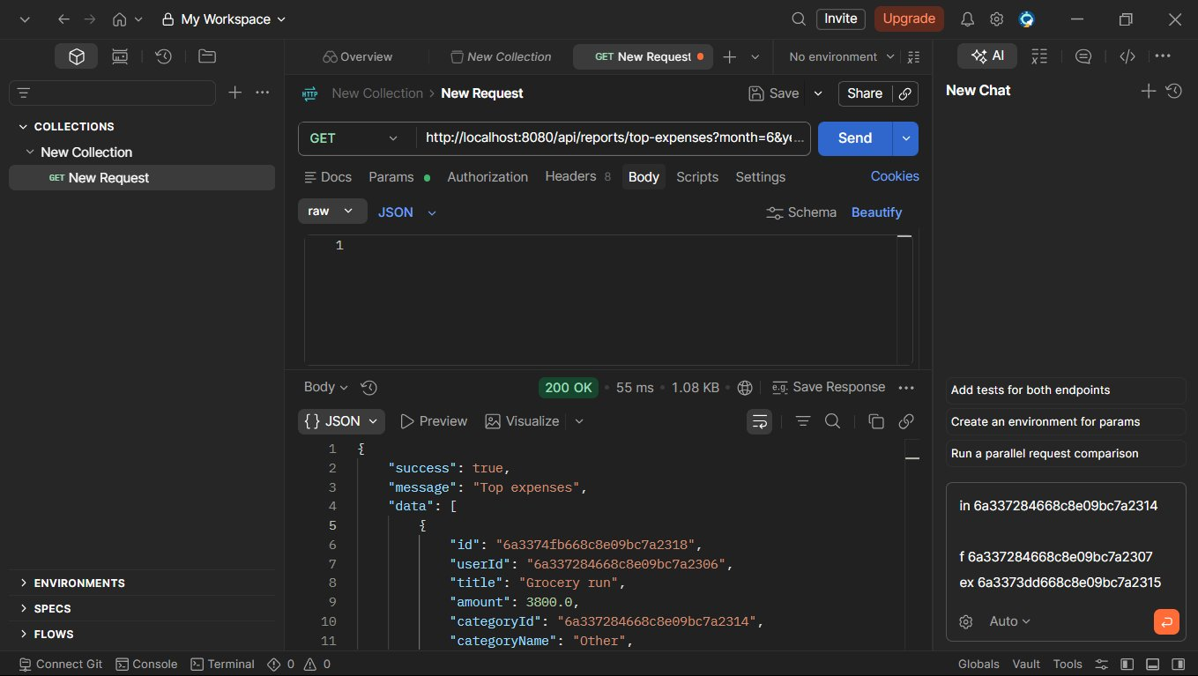
14. PUT /api/auth/profile - Profile Updated (200 OK)
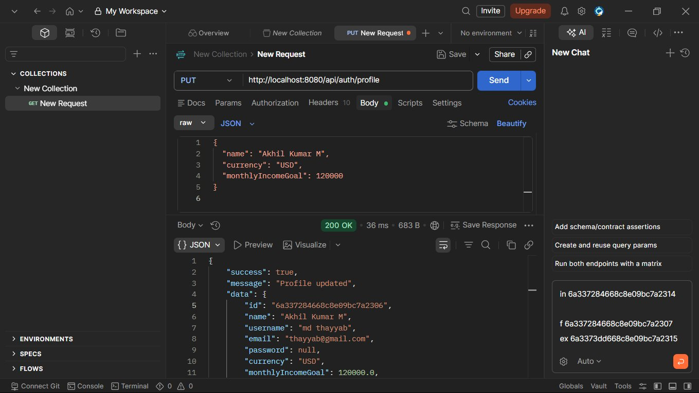

MongoDB Compass - Database Screenshots
1. Collection: budgets (1 document)
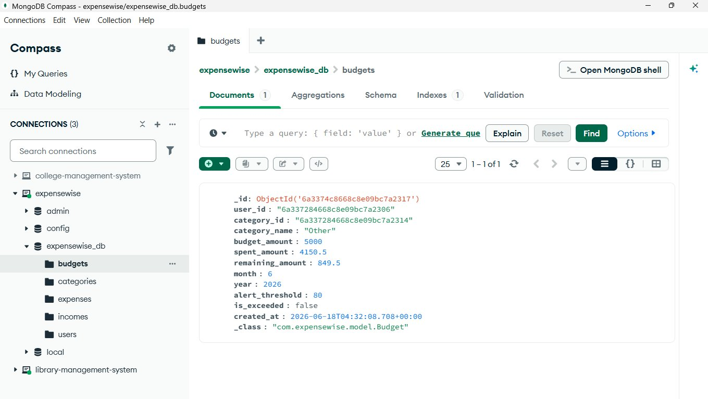
2. Collection: categories (42 documents)
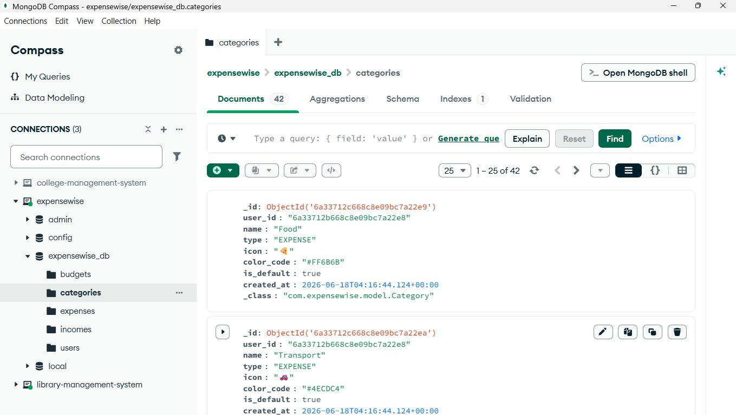
3. Collection: expenses (2 documents)
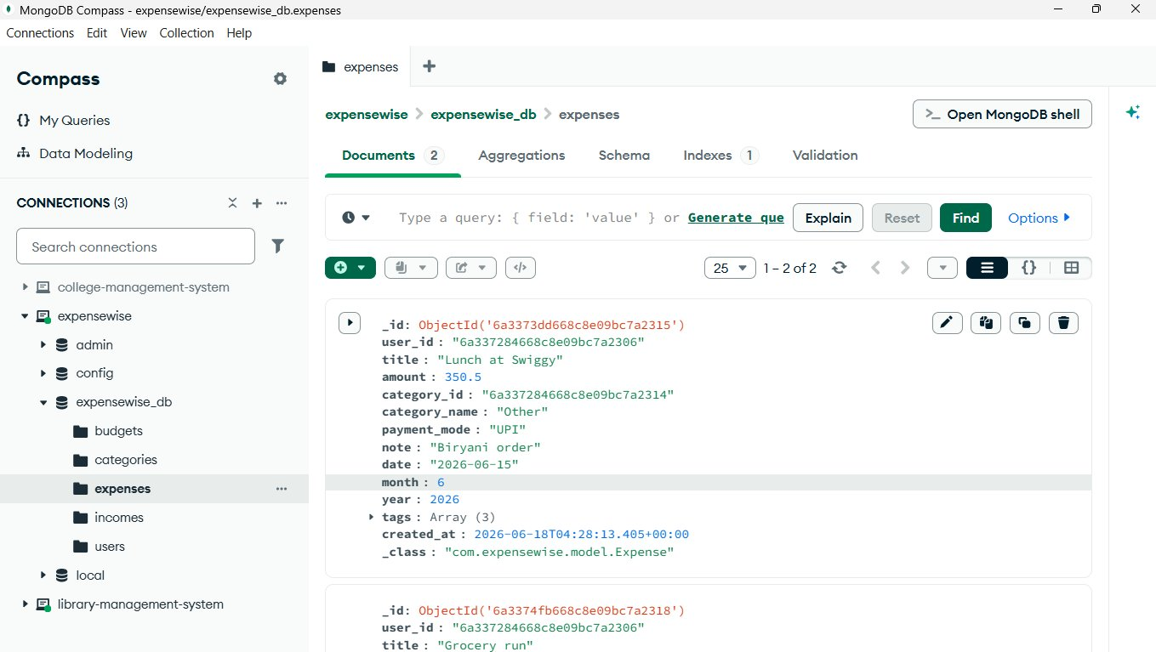
4. Collection: incomes (1 document)
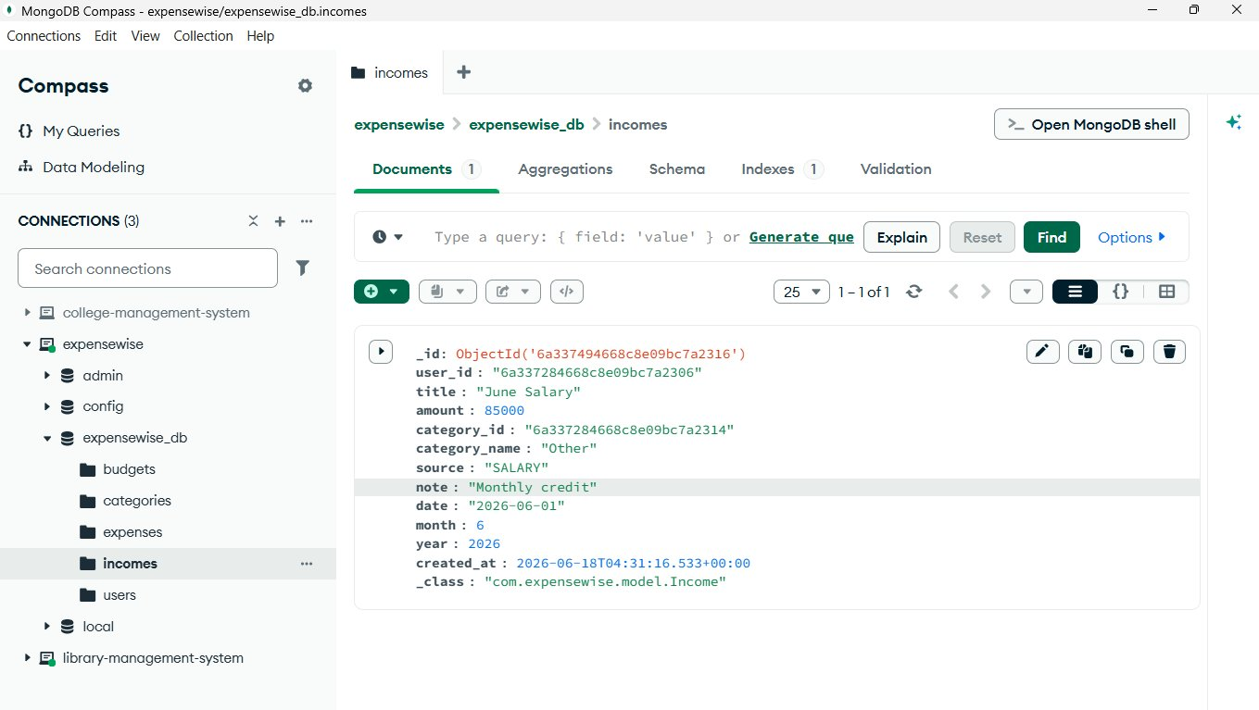
5. Collection: users (3 documents)
