FINAL PROJECT REPORT
Library Management System

A RESTful API-based Backend System
Built with Spring Boot, MongoDB & JWT Authentication
Submitted By:
[Student Name / Team Name]
[Enrollment Number / Roll Number]
[Department / Institution]
Date: June 2026

1. Project Overview

The Library Management System is a backend application developed using Spring Boot and MongoDB. It provides a comprehensive RESTful API to manage all core library operations including books, members, transactions, and user authentication.

The system enables library staff and administrators to perform complete CRUD operations, search and filter books, manage member registrations, track book borrowing and returns, and monitor overdue transactions through secure, token-protected API endpoints.

2. Project Title

Project Title: Library Management System — RESTful API Backend

This project focuses on designing and implementing a fully functional backend for a Library Management System. The system exposes well-structured REST APIs for all major library operations such as user registration and authentication, book management, member management, and transaction tracking (book borrowing, returning, and overdue handling).

3. Objectives

- Design and implement RESTful APIs for complete library management operations.
- Implement secure JWT-based user authentication and authorization.
- Enable CRUD operations for Books, Members, and Transactions.
- Support paginated and sorted listing of books and members.
- Provide search functionality for books by title and author.
- Track and retrieve overdue transactions to enforce library policies.
- Use MongoDB as a NoSQL database for flexible and scalable data storage.
- Test and validate all API endpoints using Postman.

4. Tools and Technologies Used

Tool / Technology | Version | Category | Purpose
Spring Boot | 3.x | Backend REST API Framework | Java-based framework for building REST APIs
MongoDB | 6.x | NoSQL Database | Document-oriented database for storing library data
Postman | 10.x | API Testing Tool | Used for testing and validating REST API endpoints
MongoDB Compass | 1.x | Database GUI | GUI tool for viewing and managing MongoDB collections
Java | JDK 17 | Programming Language | Core language used for backend development
Maven | 3.9.x | Build Tool | Project build and dependency management
Spring Security + JWT | 6.x | Authentication | Token-based authentication and authorization
Lombok | 1.18.x | Java Library | Reduces boilerplate code in Java classes

5. System Architecture

The Library Management System follows a layered MVC architecture. The presentation layer (Controller) handles incoming HTTP requests and routes them to the appropriate service. The business logic layer (Service) processes the data and enforces rules. The persistence layer (Repository) interacts with the MongoDB database using Spring Data MongoDB.

Architecture Layers:
- Controller Layer — Handles HTTP requests and responses (REST endpoints)
- Service Layer — Contains business logic, validation, and processing
- Repository Layer — Spring Data MongoDB repositories for DB interaction
- Model Layer — POJO entities mapped to MongoDB collections
- Security Layer — JWT filter chain for authentication on protected routes

MongoDB Collections:
- books — Stores book records (title, author, ISBN, availability, etc.)
- members — Stores library member profiles and contact details
- transactions — Tracks book borrow/return events and due dates
- users — Stores registered user credentials for authentication

6. API Modules

6.1 Authentication Module
- POST /api/auth/register — Register a new user
- POST /api/auth/login — Authenticate user and issue JWT token

6.2 Book Management Module
- POST /api/books — Add a new book to the library
- GET /api/books?page=0&size=10&sort=title — Get paginated and sorted book list
- GET /api/books/search?title=...&author=... — Search books by title/author
- GET /api/books/{id} — Retrieve a specific book by ID
- PUT /api/books/{id} — Update book details

6.3 Member Management Module
- POST /api/members — Register a new library member
- GET /api/members?page=0&size=10 — Get paginated member list
- GET /api/members/{id} — Retrieve a specific member by ID
- PUT /api/members/{id} — Update member information

6.4 Transaction Module
- GET /api/transactions — Retrieve all borrow/return transactions
- GET /api/transactions/overdue — Retrieve all overdue transactions

7. Output Screenshots with Explanation

The following screenshots demonstrate the actual API responses captured using Postman, and the database state verified through MongoDB Compass.

7.1 Postman — API Test Results

7.1.1 User Registration (POST /api/auth/register)
A new user is registered by sending a POST request with username, email, and password. The API returns HTTP 201 Created upon successful registration, confirming the user has been saved to the users collection in MongoDB.

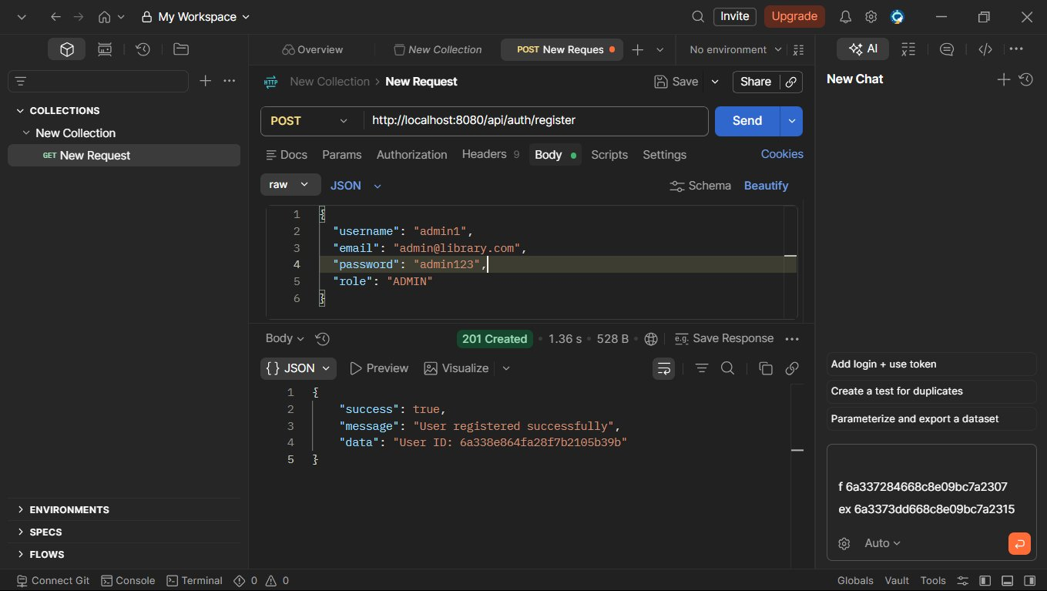
Figure 1: POST /api/auth/register — User Registered Successfully (201 Created)

7.1.2 User Login (POST /api/auth/login)
The registered user logs in with their credentials. On success, the server returns HTTP 200 OK along with a JWT access token. This token must be included in the Authorization header for all subsequent protected API calls.

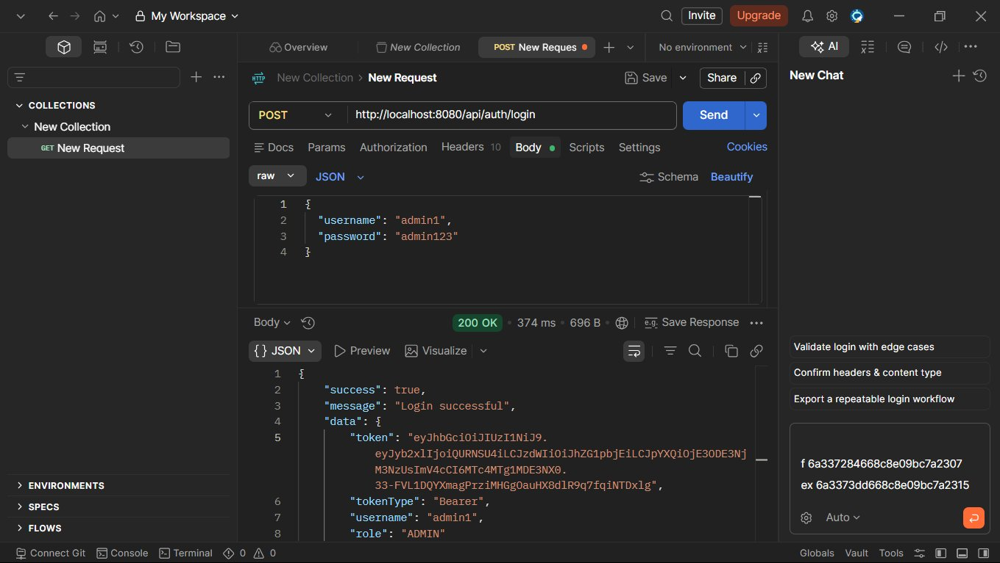
Figure 2: POST /api/auth/login — Login Successful, JWT Token Returned (200 OK)

7.1.3 Add New Book (POST /api/books)
A new book record is created by sending a POST request with book details such as title, author, ISBN, and available copies. The API returns HTTP 201 Created confirming the book has been added to the library catalog.

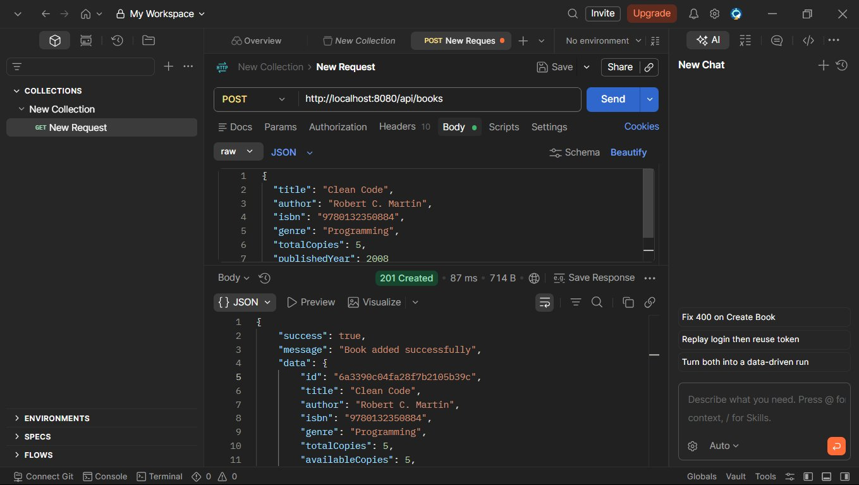
Figure 3: POST /api/books — Book Added Successfully (201 Created)

7.1.4 Get All Books with Pagination (GET /api/books)
Books are retrieved with pagination and sorting support. Query parameters page, size, and sort allow controlled retrieval. The response includes a paginated list of books along with total count and page metadata.

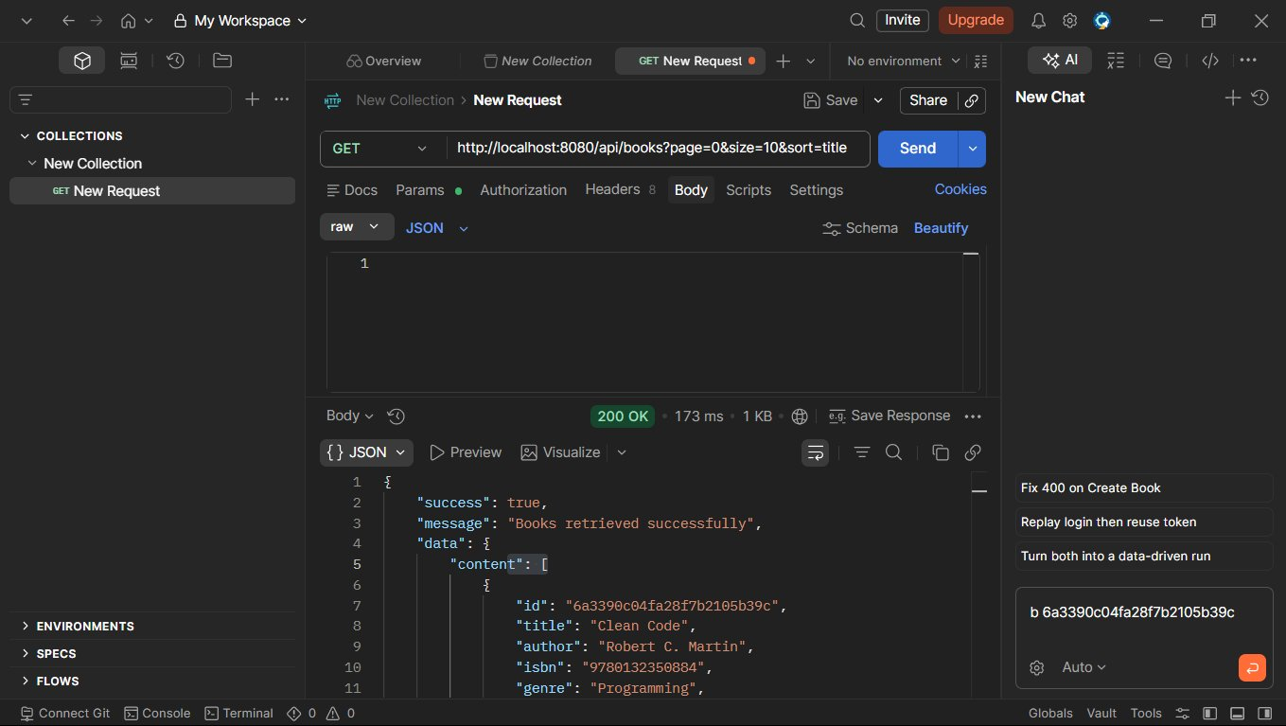
Figure 4: GET /api/books?page=0&size=10&sort=title — Books Retrieved with Pagination (200 OK)

7.1.5 Search Books (GET /api/books/search)
Books can be searched by title and/or author using query parameters. The API performs a partial/full match and returns all matching books, enabling library staff to quickly locate specific titles.

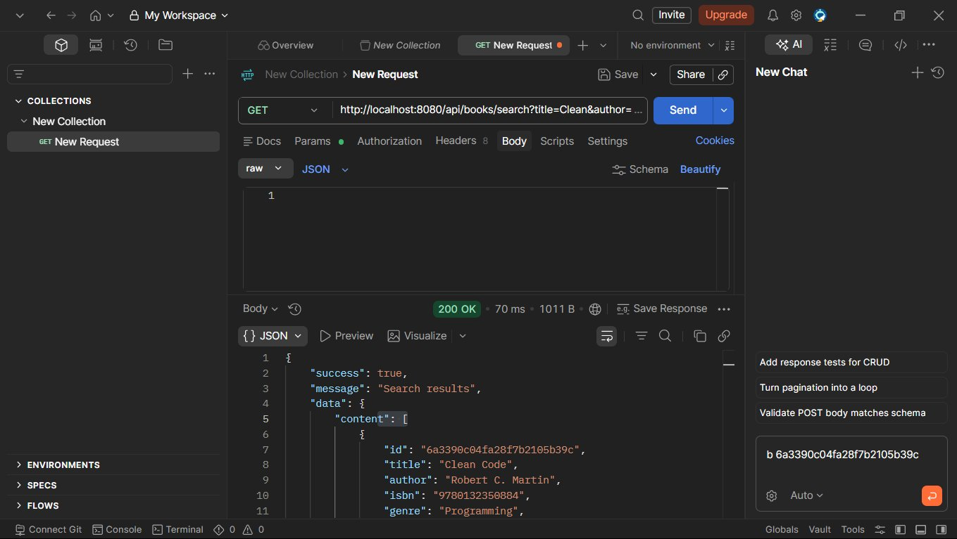
Figure 5: GET /api/books/search — Search Results Returned (200 OK)

7.1.6 Get Book by ID (GET /api/books/{id})
A specific book can be fetched using its unique MongoDB document ID. The API returns full book details including title, author, ISBN, and availability status.

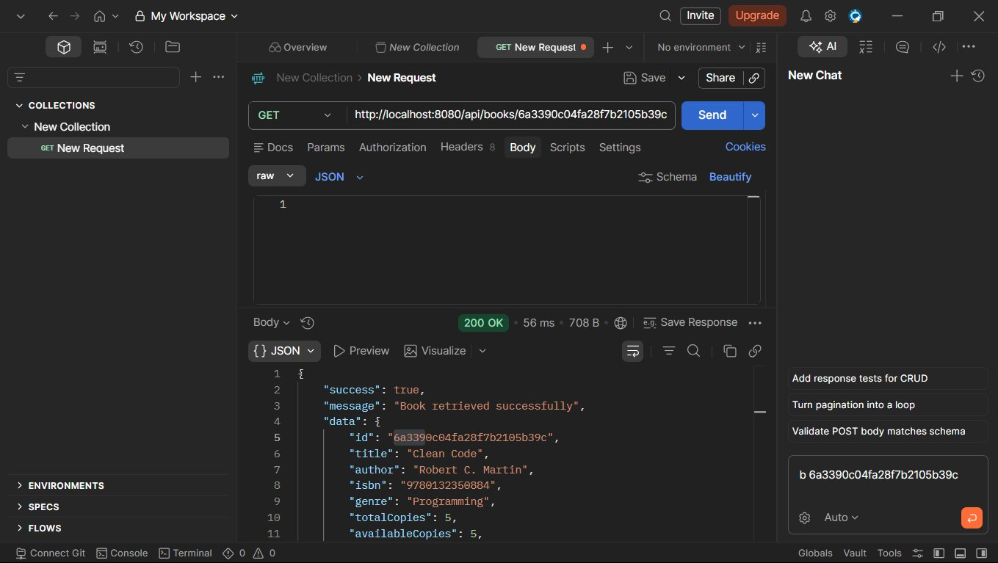
Figure 6: GET /api/books/{id} — Book Retrieved Successfully (200 OK)

7.1.7 Update Book (PUT /api/books/{id})
Book information can be updated using a PUT request with the book ID and updated fields in the request body. The API returns the updated book record on success.

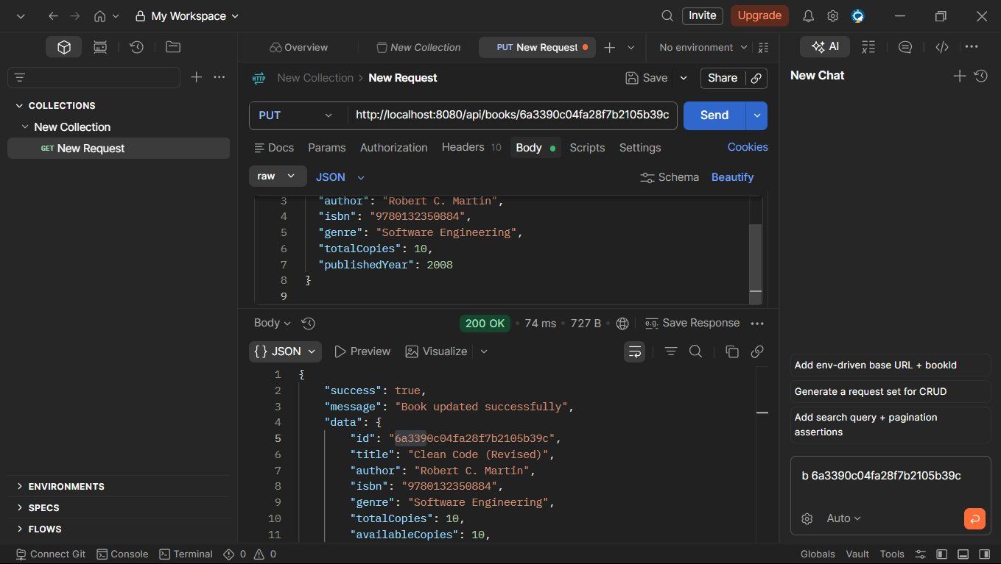
Figure 7: PUT /api/books/{id} — Book Updated Successfully (200 OK)

7.1.8 Register Member (POST /api/members)
A new library member is registered by submitting their name, contact details, and membership type. The API returns HTTP 201 Created confirming the member has been enrolled in the system.

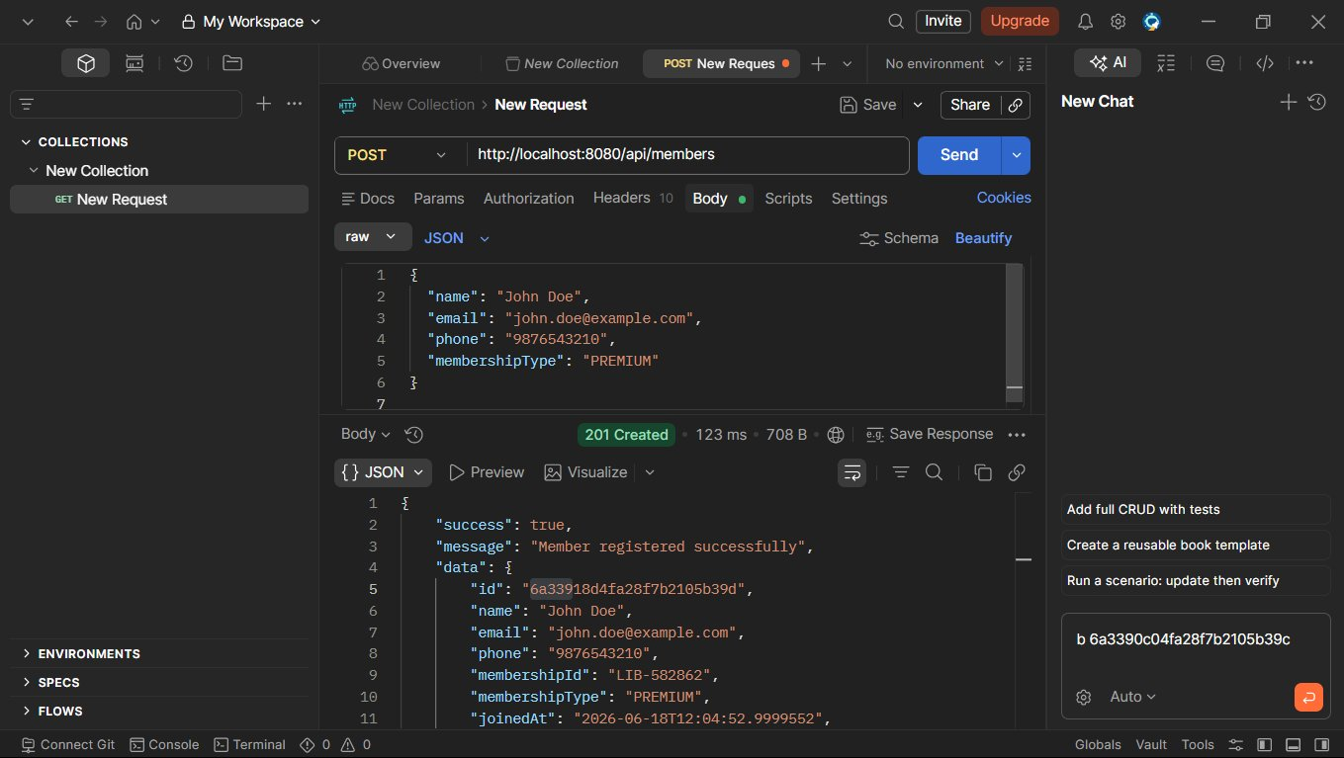
Figure 8: POST /api/members — Member Registered Successfully (201 Created)

7.1.9 Get All Members (GET /api/members)
A paginated list of all library members is retrieved. This endpoint supports page and size parameters to control the number of records returned, enabling efficient handling of large member databases.

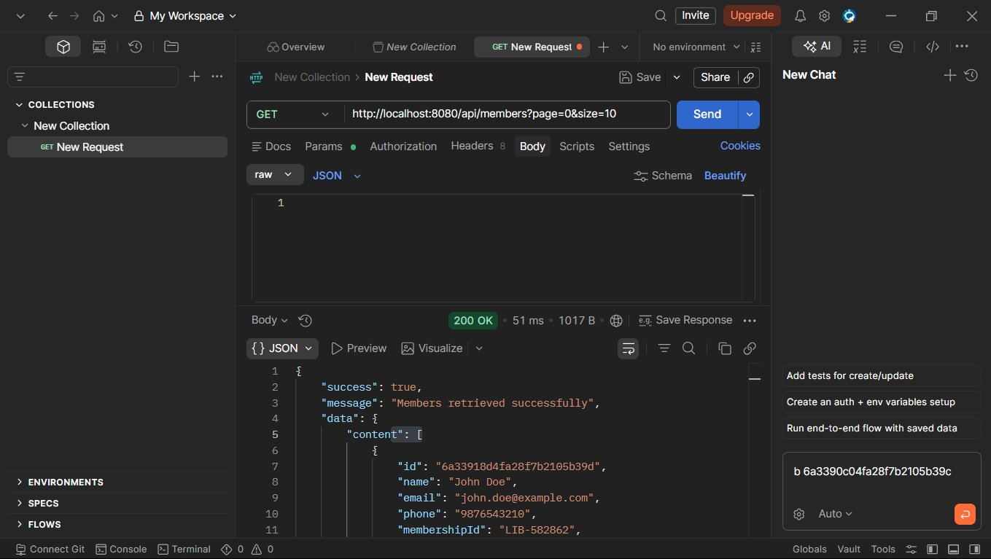
Figure 9: GET /api/members?page=0&size=10 — Members Retrieved (200 OK)

7.1.10 Get Member by ID (GET /api/members/{id})
Full details of a specific member are fetched using their unique ID. This is used to view individual member profiles and check their current borrowing status.

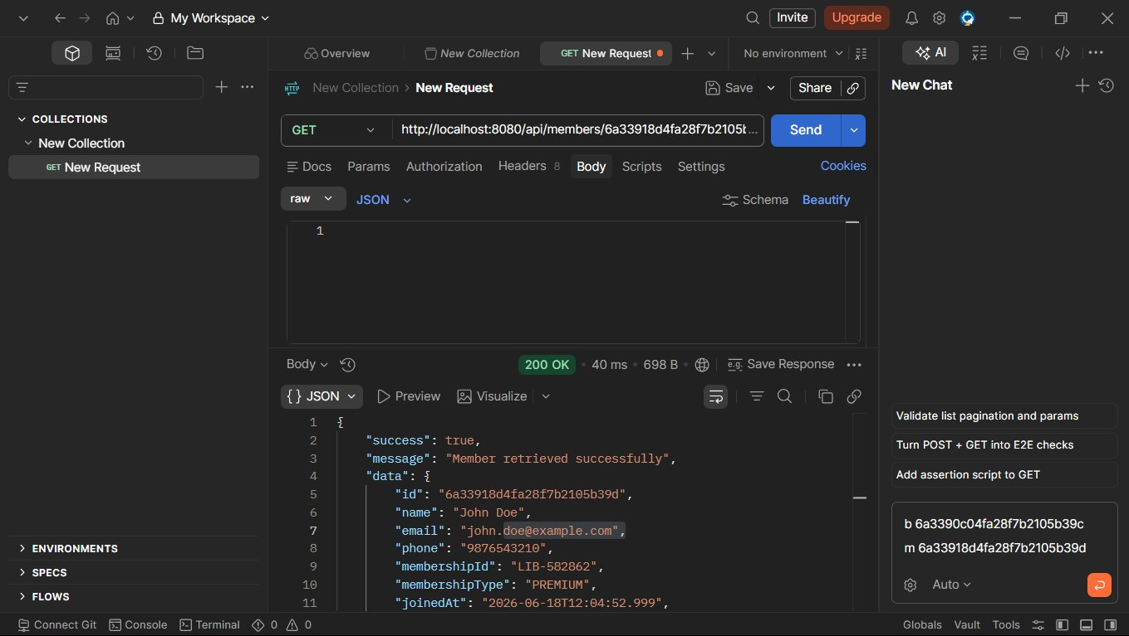
Figure 10: GET /api/members/{id} — Member Retrieved Successfully (200 OK)

7.1.11 Update Member (PUT /api/members/{id})
Member information such as contact details or membership type can be updated. The API returns the updated member record confirming the changes have been saved.

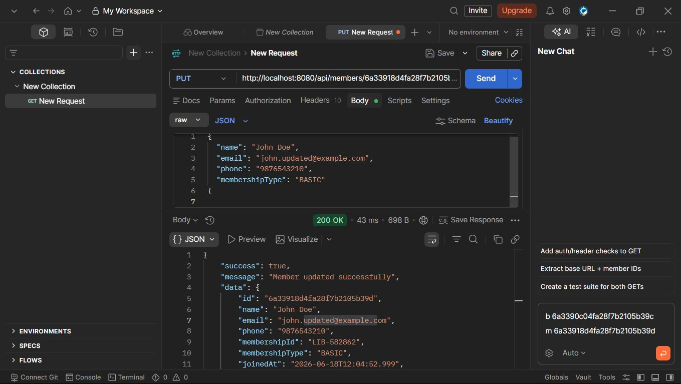
Figure 11: PUT /api/members/{id} — Member Updated Successfully (200 OK)

7.1.12 Get All Transactions (GET /api/transactions)
All borrowing and return transactions are retrieved. Each transaction record contains the book reference, member reference, borrow date, due date, and return status, providing a complete audit trail.

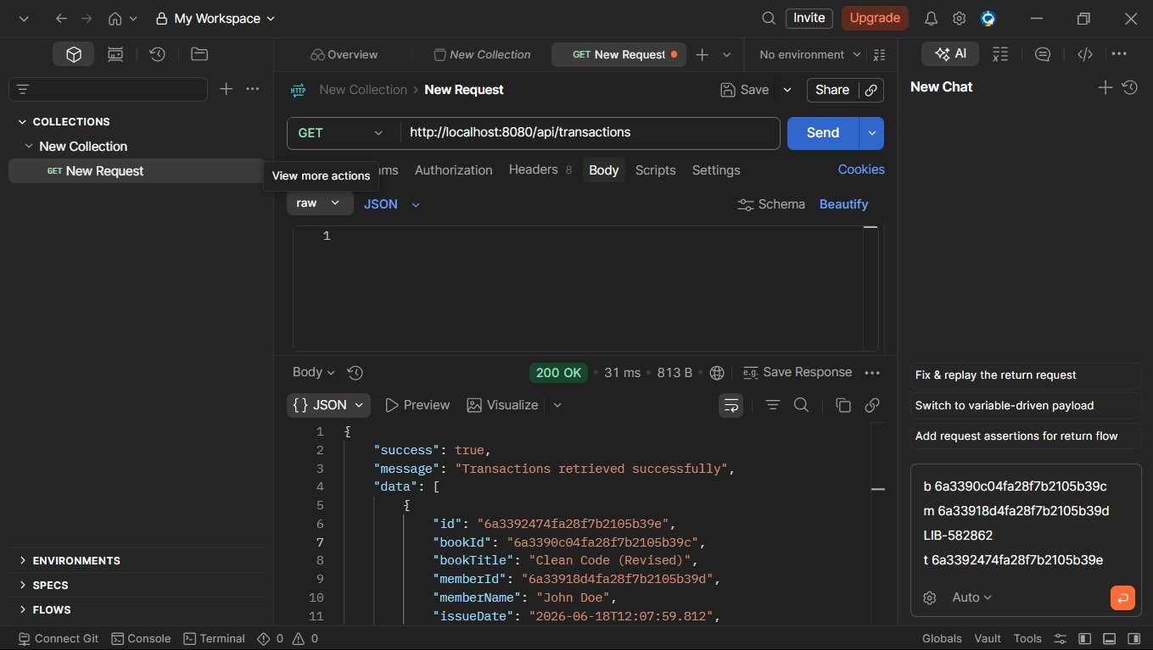
Figure 12: GET /api/transactions — All Transactions Retrieved (200 OK)

7.1.13 Get Overdue Transactions (GET /api/transactions/overdue)
Transactions where the return date has passed the due date are flagged as overdue. This endpoint returns all such records, helping library staff identify members with unreturned books and enforce fine policies.

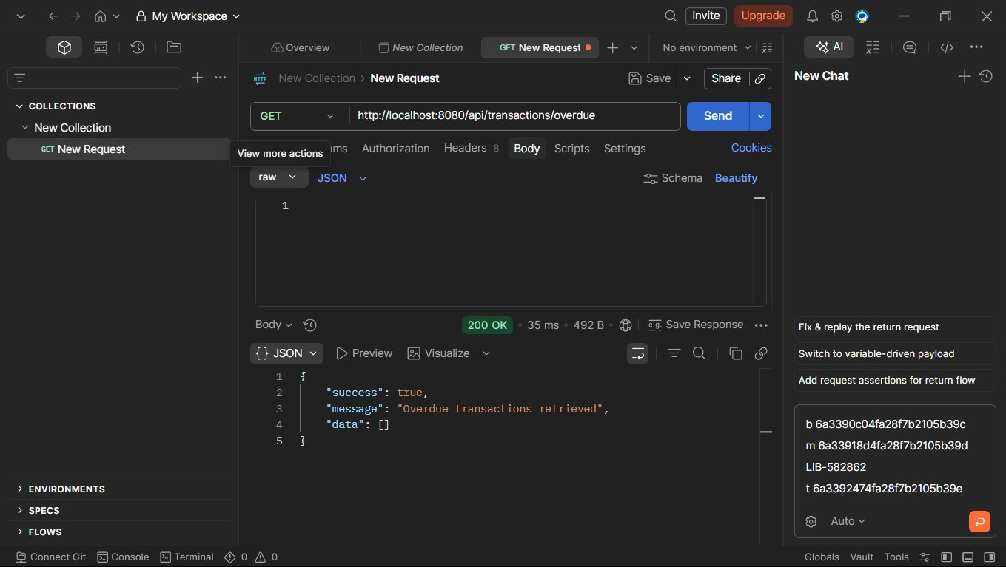
Figure 13: GET /api/transactions/overdue — Overdue Transactions Retrieved (200 OK)

7.2 MongoDB Compass — Database Verification
The following screenshots show the data stored in MongoDB collections as verified through MongoDB Compass, confirming that all API operations correctly persist data to the database.

7.2.1 books Collection
The books collection stores all book documents. Each document includes fields such as title, author, ISBN, genre, available copies, and timestamps. The screenshot confirms a book record was successfully inserted via the POST /api/books API.

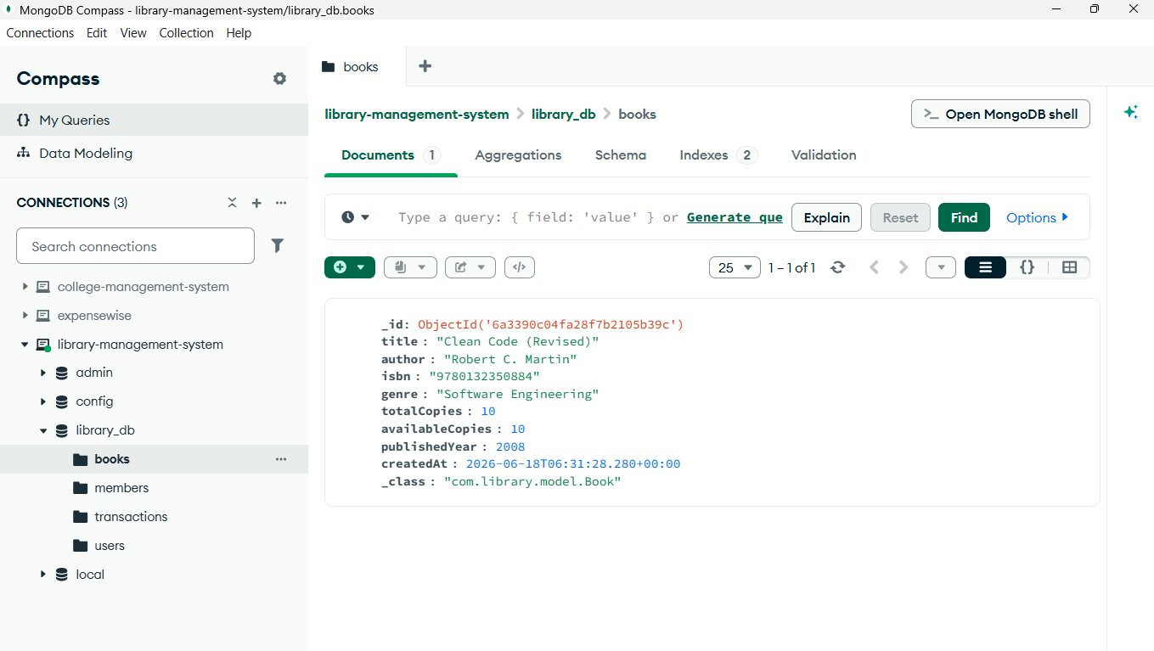
Figure 14: MongoDB Compass — books collection with inserted book document

7.2.2 members Collection
The members collection stores library member profiles. Each document contains name, email, phone, membership type, and registration date, demonstrating successful data persistence from the POST /api/members endpoint.

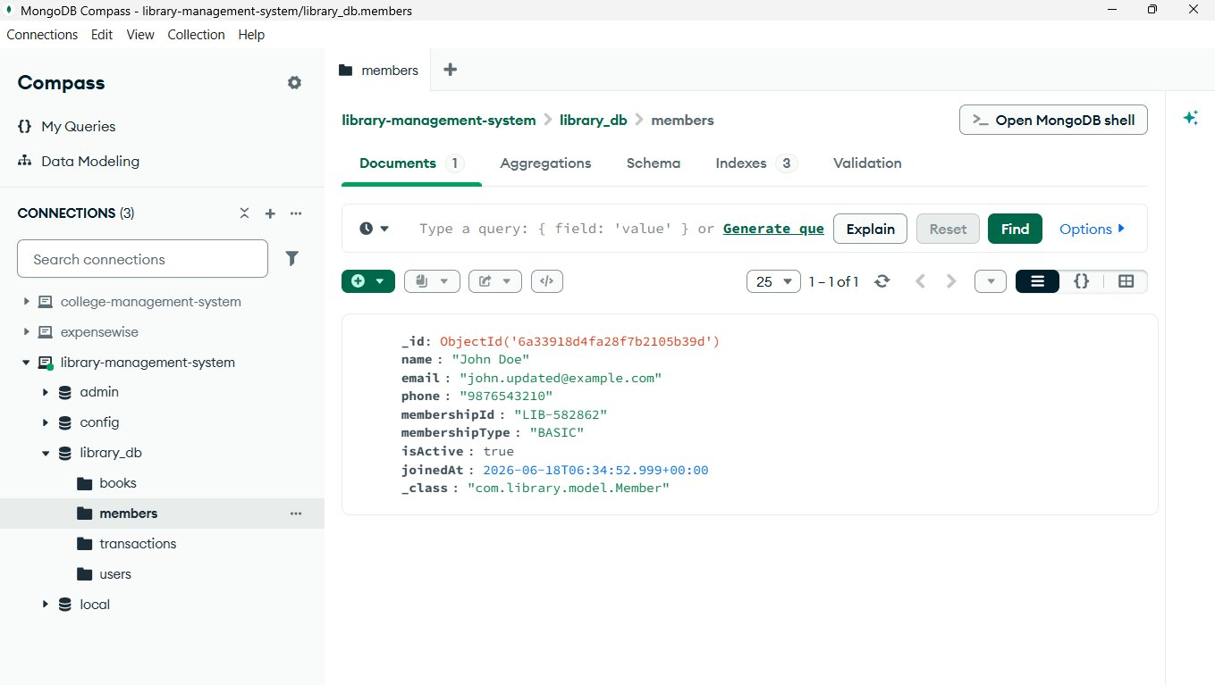
Figure 15: MongoDB Compass — members collection with registered member document

7.2.3 transactions Collection
The transactions collection records all borrowing events. Each document references a book and member by ID, along with borrow date, due date, return status, and overdue flag, enabling full traceability of book circulation.

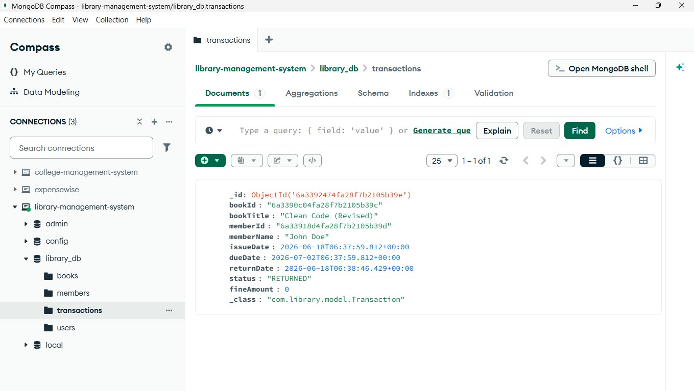
Figure 16: MongoDB Compass — transactions collection with borrow transaction document

7.2.4 users Collection
The users collection holds registered user credentials. Passwords are stored in encrypted form (BCrypt hash), and the collection confirms that user registration through POST /api/auth/register correctly persists user data to the database.

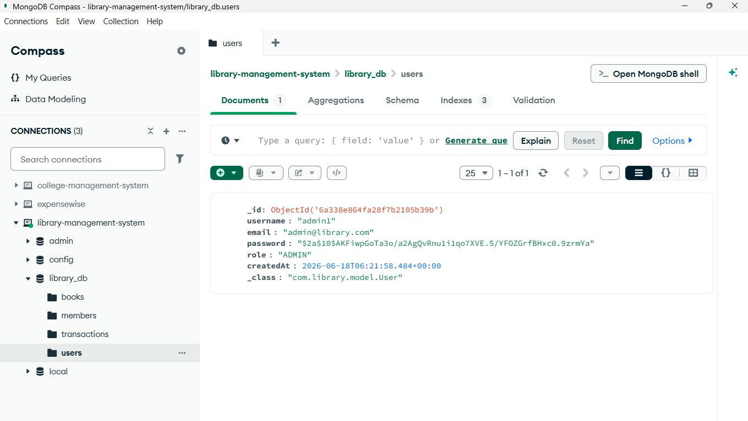
Figure 17: MongoDB Compass — users collection with registered user document

8. Outcome

The Library Management System backend was successfully developed and all planned API endpoints were implemented, tested, and validated. The key outcomes of this project are:

- A fully functional RESTful API backend for library management was built and deployed locally.
- Secure JWT-based authentication ensures only authorized users can access protected endpoints.
- Complete CRUD operations for Books, Members, and Transactions are working correctly.
- Pagination and sorting are implemented for book and member listing endpoints.
- Book search by title and author returns accurate, relevant results.
- Overdue transaction detection accurately identifies unreturned books past their due date.
- All data is correctly persisted to MongoDB and verified via MongoDB Compass.
- All 13 API endpoints returned the expected HTTP status codes (200 OK / 201 Created) during Postman testing.

The project demonstrates a clean separation of concerns through layered architecture, making the codebase maintainable and extensible for future feature additions such as fine calculation, email notifications, or a frontend interface.

9. Summary

This project involved the development of a complete backend system for a Library Management System using Spring Boot as the application framework and MongoDB as the database. The system was designed with a layered MVC architecture to ensure clean separation between the API layer, business logic, and data persistence.

The core functionality covers four major domains: User Authentication (registration and JWT-based login), Book Management (add, update, search, paginate, retrieve), Member Management (register, update, paginate, retrieve), and Transaction Tracking (list all transactions and identify overdue ones).

All endpoints were rigorously tested using Postman, with every API returning correct HTTP status codes and properly structured JSON responses. MongoDB Compass was used to verify data integrity, confirming that each API operation correctly reflected changes in the respective MongoDB collections.

The implementation successfully demonstrates the use of modern Java backend development practices including RESTful design principles, NoSQL database integration, Spring Security with JWT, Lombok for code reduction, and Spring Data MongoDB for repository management.

10. Conclusion

The Library Management System project has been successfully completed with all planned features implemented and verified. The system provides a robust, secure, and scalable backend that can serve as a foundation for a full-stack library management application.

Through this project, the following learning outcomes were achieved: understanding of RESTful API design principles, hands-on experience with Spring Boot framework, practical knowledge of MongoDB document modeling, implementation of JWT-based security, and effective use of Postman for API testing and validation.

The use of Spring Boot and MongoDB as the core technology stack proved effective for rapidly developing a production-quality backend with minimal boilerplate. The system is designed to be easily extendable — future enhancements could include a frontend interface, automated fine calculation, email notification for due dates, and role-based access control for admin versus member users.

Overall, this project serves as a comprehensive demonstration of building a real-world RESTful API backend application using modern Java technologies, and it met all the defined objectives within the project scope.

— End of Report —

