Library Management System - API Documentation

Postman - API Test Screenshots
1. POST /api/auth/register - User Registered Successfully (201 Created)
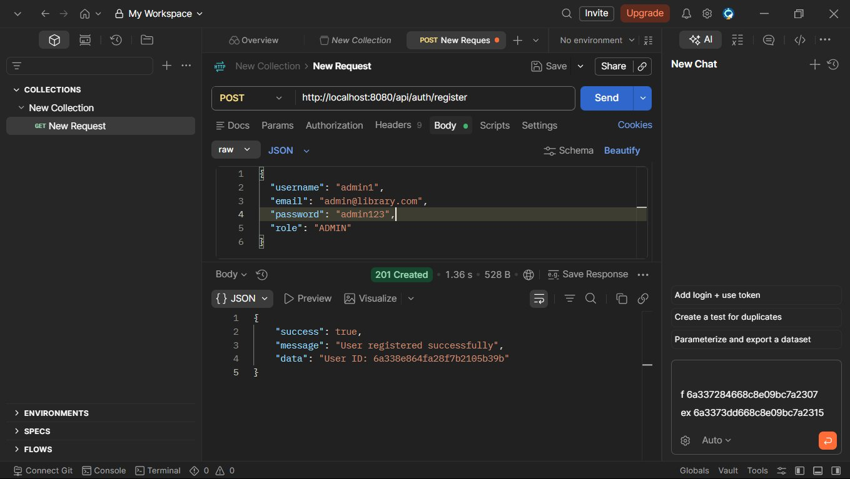
2. POST /api/auth/login - Login Successful (200 OK)
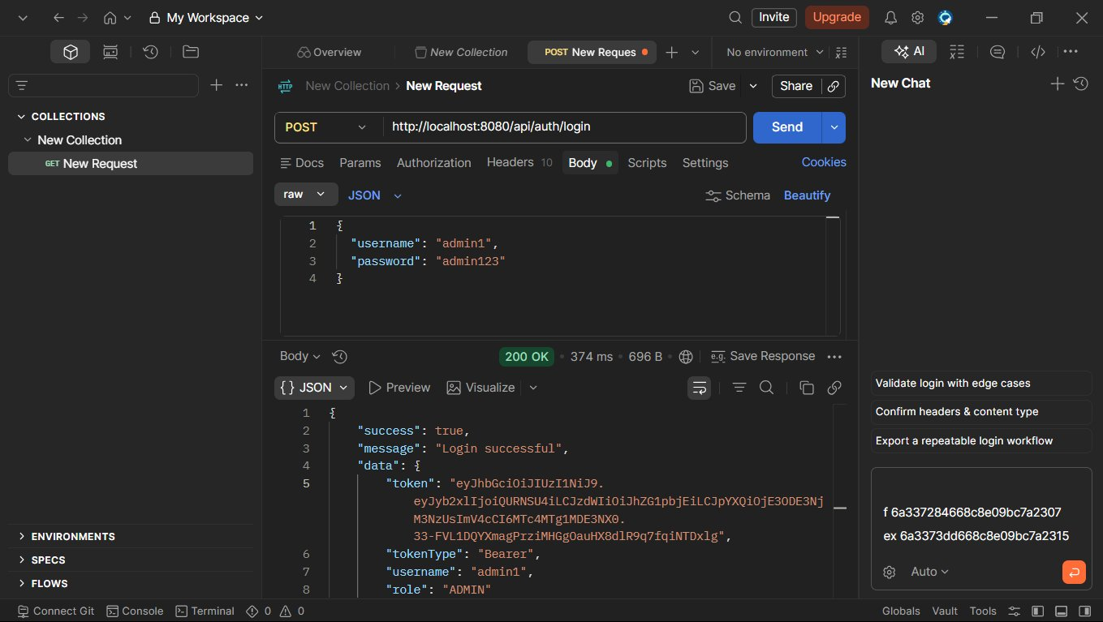
3. POST /api/books - Book Added Successfully (201 Created)
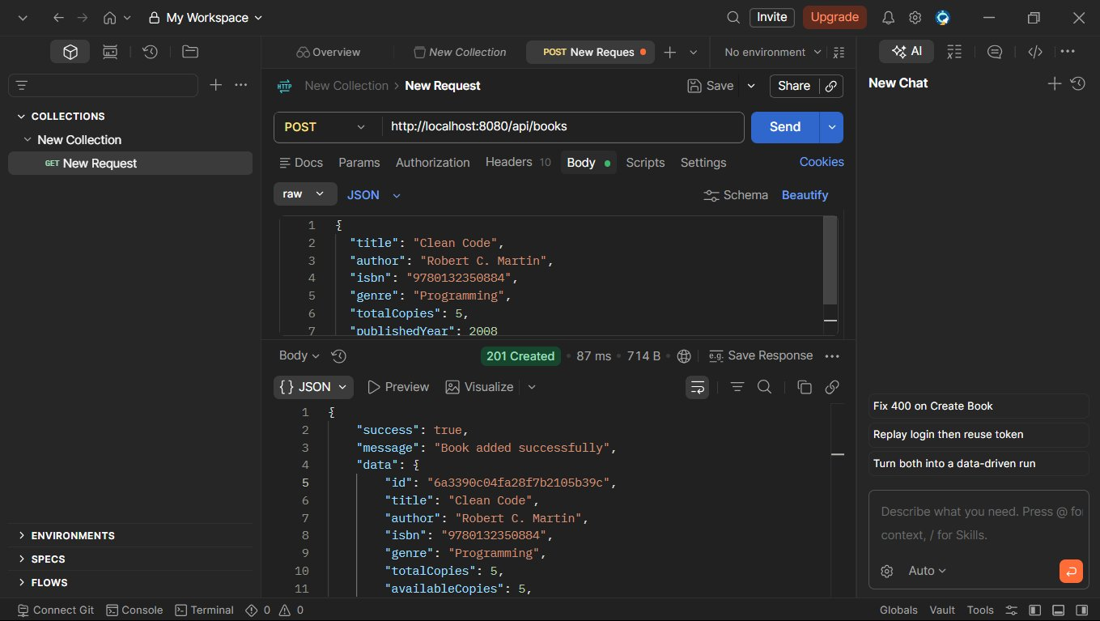
4. GET /api/books?page=0&size=10&sort=title - Books Retrieved (200 OK)
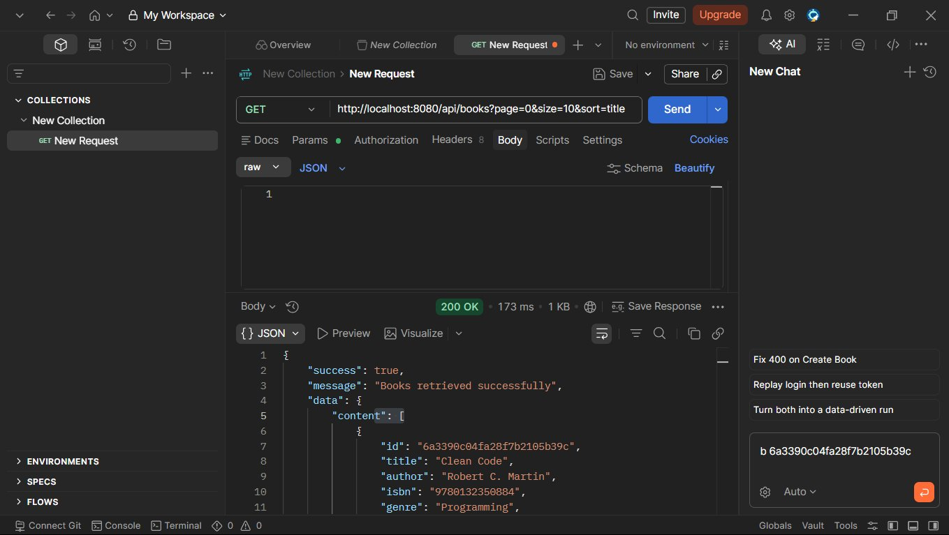
5. GET /api/books/search?title=Clean&author=... - Search Results (200 OK)
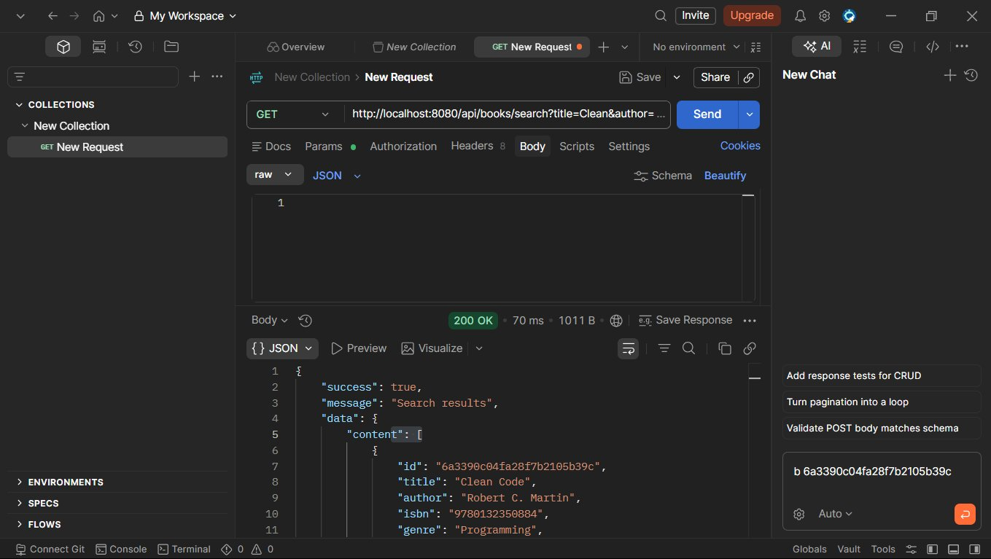
6. GET /api/books/{id} - Book Retrieved Successfully (200 OK)
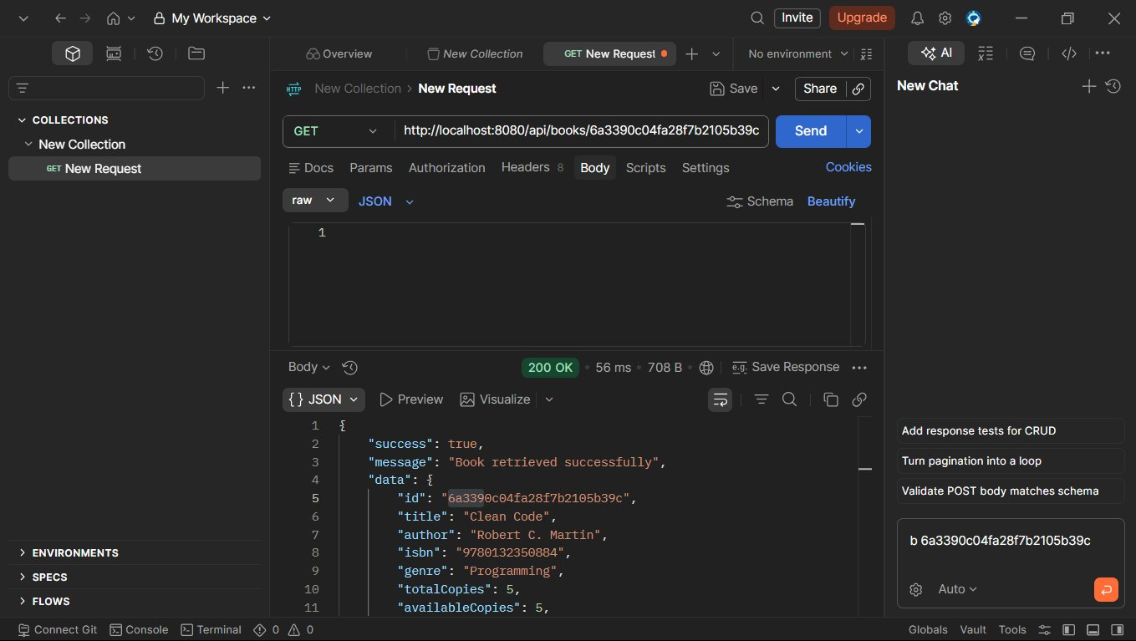
7. PUT /api/books/{id} - Book Updated Successfully (200 OK)
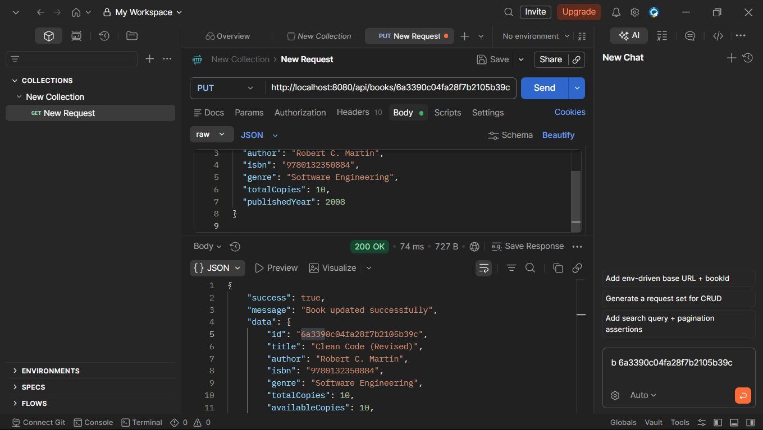
8. POST /api/members - Member Registered Successfully (201 Created)
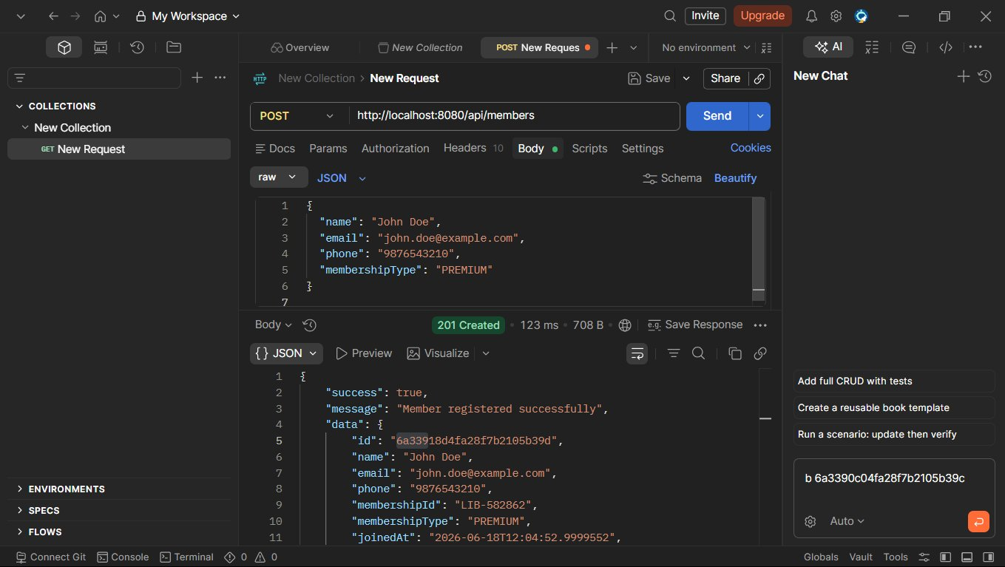
9. GET /api/members?page=0&size=10 - Members Retrieved (200 OK)
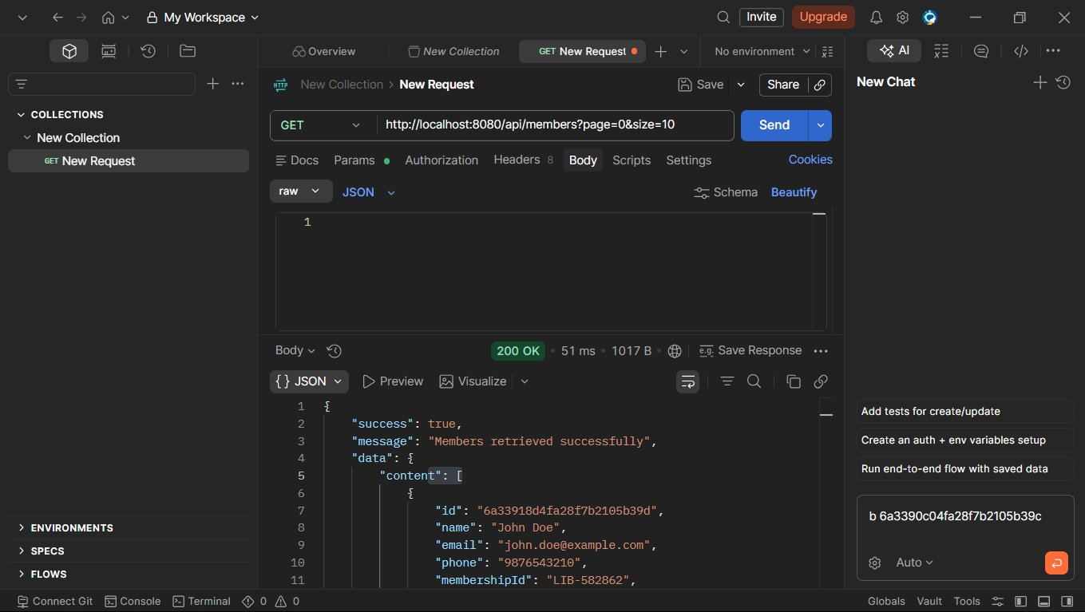
10. GET /api/members/{id} - Member Retrieved Successfully (200 OK)
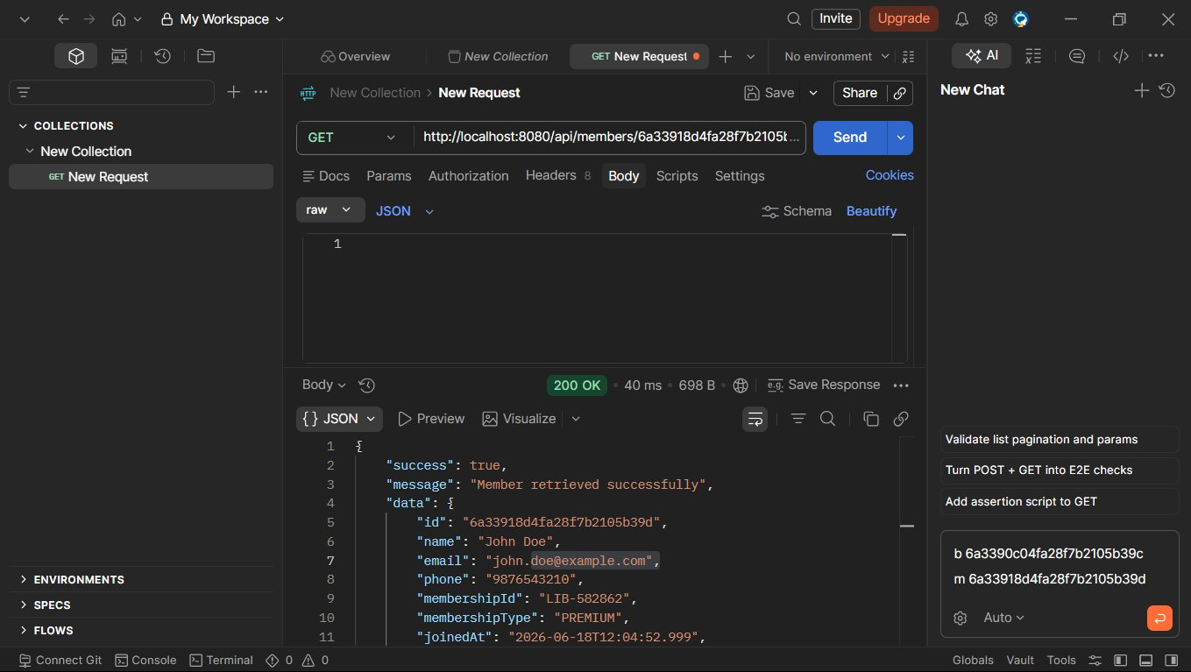
11. PUT /api/members/{id} - Member Updated Successfully (200 OK)
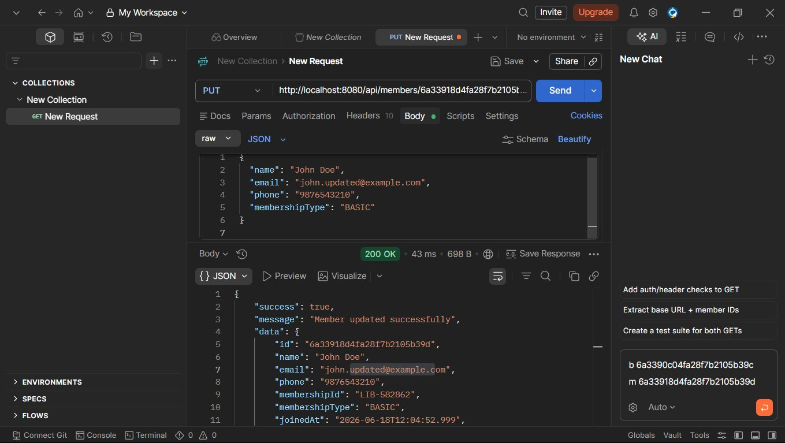
12. GET /api/transactions - Transactions Retrieved Successfully (200 OK)
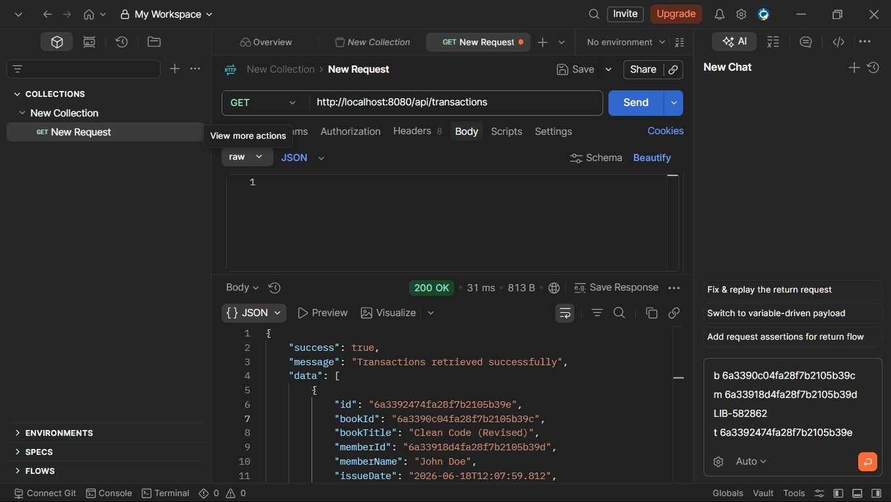
13. GET /api/transactions/overdue - Overdue Transactions Retrieved (200 OK)
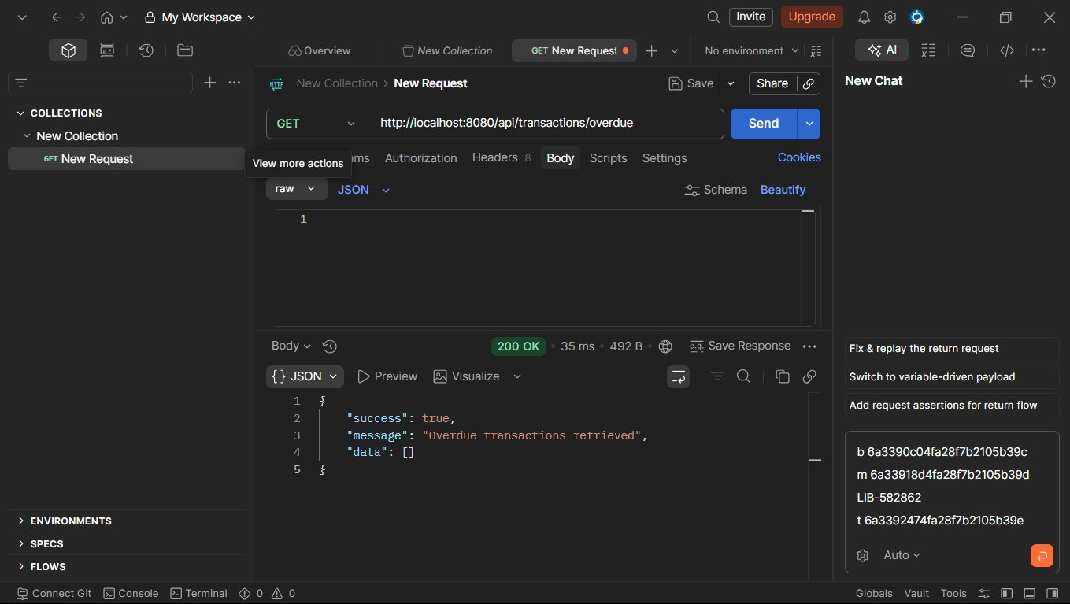

MongoDB Compass - Database Screenshots
1. Collection: books (1 document)
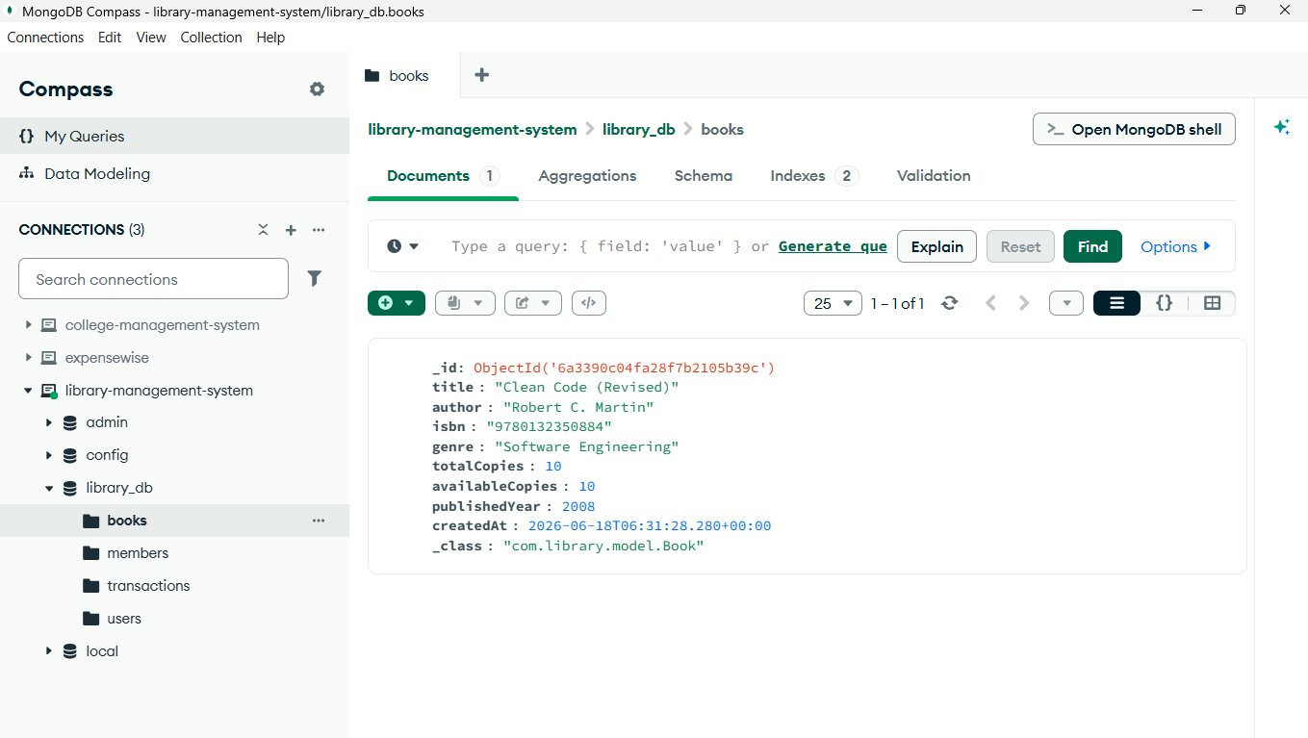
2. Collection: members (1 document)
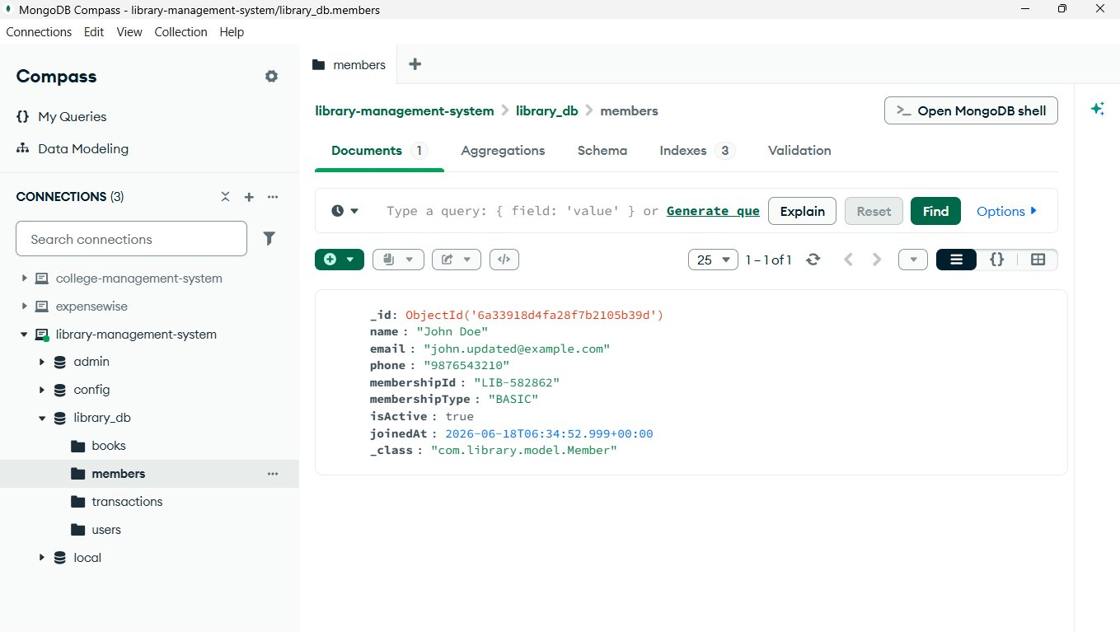
3. Collection: transactions (1 document)
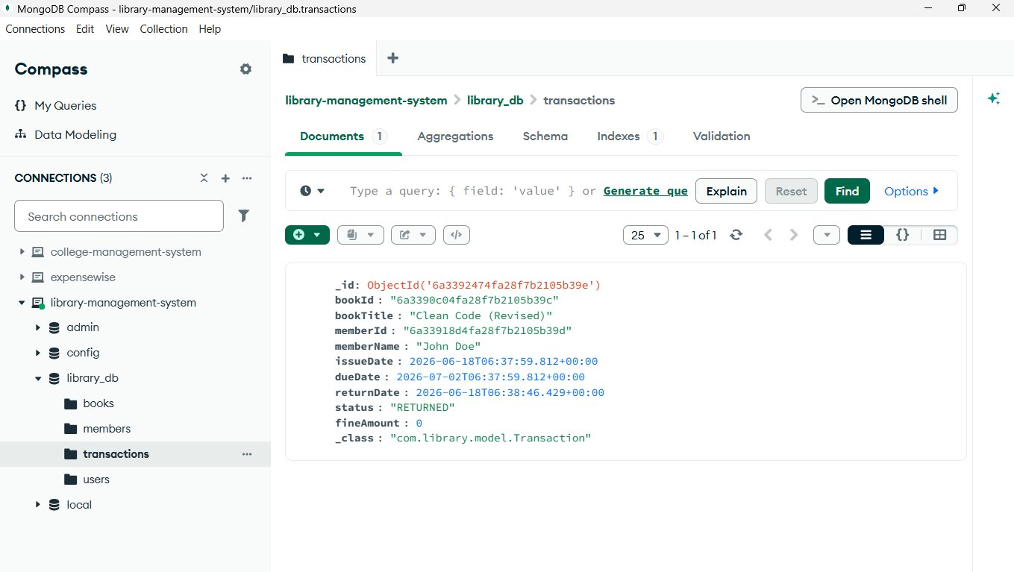
4. Collection: users (1 document)
