Bharat Connect × LEDGERS
Onboarding: Screens, APIs and Endpoints (Tech Handover)
Document owner: Akhil Manoj · Audience: LEDGERS engineering · Version 1.0 · 03-Oct-26
Sources: Partner development and integration handbook v1.8 (R3.8), NBBL B2B API specs (b2bSwagger_Release3.8_v1.30.json), and the clickable prototype (github.com/akhilledgers/bharatconnectflow).

Version History
Version | Date | Created / Updated by | Description | Review Date | Reviewed by
1.0 | 03-Oct-26 | Akhil Manoj | Initial version: screens up to onboarding, mapped to Bharat Connect APIs

Index
Version History 1
1. Purpose and Scope 3
1.1 In scope 3
1.2 Out of scope (separate documents) 4
2. How the Integration Works 4
2.1 Roles 4
2.2 Request → Ack → asynchronous response 5
2.3 Security and connectivity (one-time setup) 5
2.4 Endpoints used in this journey 6
3. Common Objects (all APIs) 7
3.1 Ack / Nack (every call, both directions) 8
4. End-to-End Flow 8
4.1 Connection states 8
4.2 Sequence: new business 9
4.3 Sequence: B2B ID already exists 10
5. Screens 11
5.1 Dashboard: Not connected 11
5.2 Top-bar icon and popover: Not connected 12
5.3 Dashboard and popover: ID found 13
5.4 Onboard to Bharat Connect page 16
5.5 Submitting and success 19
5.6 End state: Connected 20
5.7 Failure states 22
6. Validation Rules and Error Handling 26
6.1 Validations LEDGERS runs before calling Bharat Connect 26
6.2 Mapping outcomes to the UI 27
7. Sample Payload: reqRegEntity 27
8. Data LEDGERS Must Store 28
9. Open Questions 29

1. Purpose and Scope
This document gives the engineering team everything needed to build the Bharat Connect onboarding journey in LEDGERS: every screen up to the point a business is onboarded, the Bharat Connect for Business APIs each screen calls, the request and response fields, and how API outcomes map back to what the user sees.

1.1 In scope
Area | Screens | APIs
Discovery | Dashboard banner and top-bar Bharat Connect icon (popover) in every pre-onboarding state | reqCheckEntity / respCheckEntity
Onboard a new business | Onboard to Bharat Connect page, in-button progress, success hand-off | reqCheckId / respCheckId, reqRegEntity / respRegEntity, respEntityKyc
Link an existing B2B ID | ID found banner / popover, in-place linking | reqMapEntity / respMapEntity, reqFetchEntity / respFetchEntity
Failure handling | Needs attention and Assisted setup states | Ack / Nack, resp error fields, reqCheckStatus / respCheckStatus
End state | Connected Bharat Connect page and connected popover | Data returned by respRegEntity / respFetchEntity

1.2 Out of scope (separate documents)
- Editing the profile after onboarding (reqEditEntity), creating extra B2B IDs (reqRegId), editing or deactivating IDs (reqEditId), activating or deactivating the business (reqActivateEntity).
- Level 2 / Level 3 verification upgrades (GSTIN OTP, bank penny-drop, KYC documents).
- Invoices, bills, purchase orders, payments, search and invites.

2. How the Integration Works

2.1 Roles
Party | Who | Role in onboarding
Business user | The LEDGERS customer (business admin) | Gives consent and clicks Onboard. Never talks to Bharat Connect directly.
AI / OU (LEDGERS) | LEDGERS as the Agent Institution (or via its Operating Unit) | Verifies the business, builds and signs the API requests, receives asynchronous responses on its webhook, stores the result.
BBPCU | Bharat Connect for Business central unit (NBBL) | Registers the business and its B2B IDs, returns responses and KYC activation.

2.2 Request → Ack → asynchronous response
Every Bharat Connect API is a POST and works the same way. LEDGERS never gets the business result in the HTTP response; it arrives later on LEDGERS' webhook.
- LEDGERS sends reqXxx to BBPCU.
- BBPCU replies immediately with an Ack (accepted) or Nack (rejected with errorCd, errorDtl, errorField). Ack timeout: 5 seconds.
- BBPCU later calls LEDGERS' webhook with respXxx, carrying the business result (resp.result = SUCCESS / PARTIAL / FAILURE). Response timeout: 180 seconds.
- LEDGERS replies to that webhook call with its own Ack / Nack after validating it.
- If no respXxx arrives within 180 seconds, LEDGERS calls reqCheckStatus with the original txn.id to find out what happened.
Each request and its response share the same txn.id; the response also carries resp.reqMsgId = the request's head.msgId. Store both so responses can be matched to the business and screen that started them.

2.3 Security and connectivity (one-time setup)
- Signing and encryption: every object except head is signed (JWS-style, ECDSA). PII and financial fields (for example bank account number) are encrypted. See handbook Annexure D.
- Webhook: LEDGERS shares a webhook URL and port with NBBL; all respXxx calls land there.
- Network: static source IP whitelisted by NBBL; TLS certificate issued from a CSR shared with NBBL (Section B.4). Separate setup for sandbox and production.
- Certification: NBBL shares sandbox test cases that must pass before production access.

2.4 Endpoints used in this journey
Paths are relative to the BBPCU base URL NBBL provides for each environment (sandbox, production). The Swagger file lists a placeholder server only.
# | Endpoint | Direction | Purpose | Triggered by
1 | POST /v1/onboarding/business/reqCheckEntity | LEDGERS → BBPCU | Is this PAN already registered on Bharat Connect? | LEDGERS on first load of a business (decides banner state)
2 | POST /v1/onboarding/business/respCheckEntity | BBPCU → LEDGERS webhook | Result: NEW or EXISTING (+ existing business and its B2B IDs) | BBPCU
3 | POST /v1/onboarding/business/reqCheckId | LEDGERS → BBPCU | Is the proposed B2B ID available? | Onboarding page load, and after the user changes Based On
4 | POST /v1/onboarding/business/respCheckId | BBPCU → LEDGERS webhook | Availability per B2B ID (YES / NO) | BBPCU
5 | POST /v1/onboarding/business/reqRegEntity | LEDGERS → BBPCU | Register the business and create its default B2B ID | Onboard to Bharat Connect button
6 | POST /v1/onboarding/business/respRegEntity | BBPCU → LEDGERS webhook | Registration result with the registered business | BBPCU
7 | POST /v1/onboarding/business/respEntityKyc | BBPCU → LEDGERS webhook | Business KYC accepted and marked Active (or pending / failed) | BBPCU, after respRegEntity or respMapEntity
8 | POST /v1/onboarding/business/reqMapEntity | LEDGERS → BBPCU | Map an existing Bharat Connect business and its B2B IDs to LEDGERS | Connect B2B ID / Link Existing ID button
9 | POST /v1/onboarding/business/respMapEntity | BBPCU → LEDGERS webhook | Mapping result | BBPCU
10 | POST /v1/onboarding/business/reqFetchEntity | LEDGERS → BBPCU | Fetch full details of the existing business (to fill the connected page) | After a successful map
11 | POST /v1/onboarding/business/respFetchEntity | BBPCU → LEDGERS webhook | Full business record + B2B ID details | BBPCU
12 | POST /v1/checkTxn/reqCheckStatus | LEDGERS → BBPCU | Status of any transaction by txn.id | LEDGERS when a response times out
13 | POST /v1/checkTxn/respCheckStatus | BBPCU → LEDGERS webhook | COMPLETED / IN_PROGRESS / FAILED with errors | BBPCU

Note: reqMapEntity and reqFetchEntity are defined in the Swagger file but are not described in the handbook's Annexure A. Confirm with NBBL that this is the intended way to link an existing business to a new AI (see Open Questions).

3. Common Objects (all APIs)
Every request and response carries head, most carry txn, and all carry signatures. Full per-API field lists are in the Swagger file (Release 3.8, v1.30).
Field | Required | Format | How LEDGERS fills it
head.ver | Yes | ^[0-9]{1,3}[.][0-9]{1,3}$ | API version agreed with NBBL (e.g. 1.0)
head.ts | Yes | ISO date-time with offset | Time the message is created, e.g. 2026-10-03T11:20:00+05:30
head.msgId | Yes | MSG + 32 alphanumeric (35 chars) | New, unique per message. Responses echo it in resp.reqMsgId
head.aiId | Yes | 4 chars [A-Z0-9] | LEDGERS' AI ID issued by NBBL
head.ouId | No | 4 chars [A-Z0-9] | Operating Unit ID, if LEDGERS connects through an OU
head.orgId | Yes | 4 chars [A-Z0-9] | Organisation ID issued by NBBL
head.prodType | Yes | B2B | Always B2B
head.recipientB2BId | No | 1–100 chars | Not used in onboarding
txn.id | Yes | TNF + 32 alphanumeric (35 chars) | New per business transaction; same id on request and its response. Used by reqCheckStatus
txn.ts | Yes | ISO date-time | Transaction time
txn.type | Yes | INVOICE, ENTITY, PO, PAYMENT, SEARCH, DISPUTE, FINANCE | ENTITY for every onboarding API
txn.refId / txn.refUrl / txn.note | No | 1–35 / 1–35 / 1–50 chars | Optional internal reference
signatures[].protectedInfo / signature | Yes | 1–256 chars each | Produced by the signing step (Annexure D)

3.1 Ack / Nack (every call, both directions)
Field | Required | Format | Meaning
api | No | 1–35 chars | API name being acknowledged
msgId | Yes | MSG + 32 | msgId of the request being acknowledged
txnId | Yes | TNF + 32 | txnId of the request
result | Yes | SUCCESS, FAILURE | Ack = SUCCESS, Nack = FAILURE
errorCd / errorDtl / errorField | No | Per error-code list (Annexure C) | Why it was rejected and which field
ts | Yes | ISO date-time | Ack time

4. End-to-End Flow

4.1 Connection states
LEDGERS keeps one connection state per business. It drives the banner, the top-bar icon colour and popover, and what Settings → Bharat Connect shows.
State | Icon dot | Meaning | Entered when
Not connected | Grey | Business is not on Bharat Connect | respCheckEntity → status = NEW
ID found | Orange | PAN already registered on Bharat Connect, not yet linked to LEDGERS | respCheckEntity → status = EXISTING and aiOrgConnection = NO
Setting up | Yellow | Request sent, waiting for Bharat Connect | Ack received for reqRegEntity / reqMapEntity, response not yet received
Connected | Green | Onboarded and active | respRegEntity or respMapEntity SUCCESS (and respEntityKyc SUCCESS where applicable)
Needs attention | Red | Bharat Connect rejected a field the user can fix | Nack or resp FAILURE with an errorField that maps to an editable field
Assisted setup | Blue | Cannot be completed automatically | FAILURE not fixable by the user, KYC FAILURE, or repeated timeouts

4.2 Sequence: new business
Step | Screen | LEDGERS action | API | Result
1 | Any page (background) | Validate PAN format and PAN type; check consent basis | reqCheckEntity | NEW → Not connected banner. EXISTING → ID found (4.3)
2 | Dashboard / top bar | User clicks Get My B2B ID | — | Opens Onboard to Bharat Connect page
3 | Onboarding page | Build default B2B ID (Annexure F) and check it | reqCheckId | YES → show ID. NO → offer the other basis (PAN / GSTIN) or a disambiguation suffix
4 | Onboarding page | User changes Based On or Public / Private | reqCheckId (if ID changed) | New ID shown
5 | Onboarding page | User ticks consent and clicks Onboard to Bharat Connect | reqRegEntity | Button shows spinner. Nack → Needs attention / Assisted setup
6 | Onboarding page | Ack received | — | State = Setting up (spinner continues)
7 | Onboarding page | Webhook receives respRegEntity | respRegEntity | SUCCESS → store objectId, B2B ID, verification level. FAILURE → error mapping (section 6)
8 | Onboarding page | Webhook receives respEntityKyc | respEntityKyc | SUCCESS → Connected: button shows tick, toast, connected page
9 | Any | No response in 180 s | reqCheckStatus | COMPLETED → as step 7. IN_PROGRESS → keep Setting up. FAILED → section 6

4.3 Sequence: B2B ID already exists
Step | Screen | LEDGERS action | API | Result
1 | Background | Check PAN | reqCheckEntity | EXISTING with businessDetails[] (name, objectId, B2B IDs, aiOrgConnection) → ID found banner and orange icon
2 | Dashboard / popover | User clicks Connect B2B ID (banner) or Link Existing ID (popover) | reqMapEntity (objectId, PAN, b2BIds, verificationLevel) | Button shows Linking… State = Setting up
3 | — | Webhook receives respMapEntity | respMapEntity | SUCCESS → continue. FAILURE → section 6
4 | — | Fetch the full record to fill LEDGERS | reqFetchEntity → respFetchEntity | Store objectId, B2B IDs (with PUBLIC / PRIVATE, ACTIVE / INACTIVE), bank, contacts
5 | — | KYC confirmation (txnType = MAP TO AI) | respEntityKyc | SUCCESS → Connected, toast “Linked to your existing Bharat Connect ID.”

Handbook rule not yet in the prototype: when the PAN already exists, the handbook asks the AI to show the existing public details and offer (a) proceed with the existing business, (b) edit the existing details, and for sole proprietors only (c) create a new business (multiOrgAllowed = YES). The prototype implements (a) only. Engineering should build (b) and (c) or confirm with Product before release.

5. Screens
All screenshots are from the prototype at 1440 × 900. The data shown is the seeded demo business (Stock Holding Corporation of India Limited).

5.1 Dashboard: Not connected
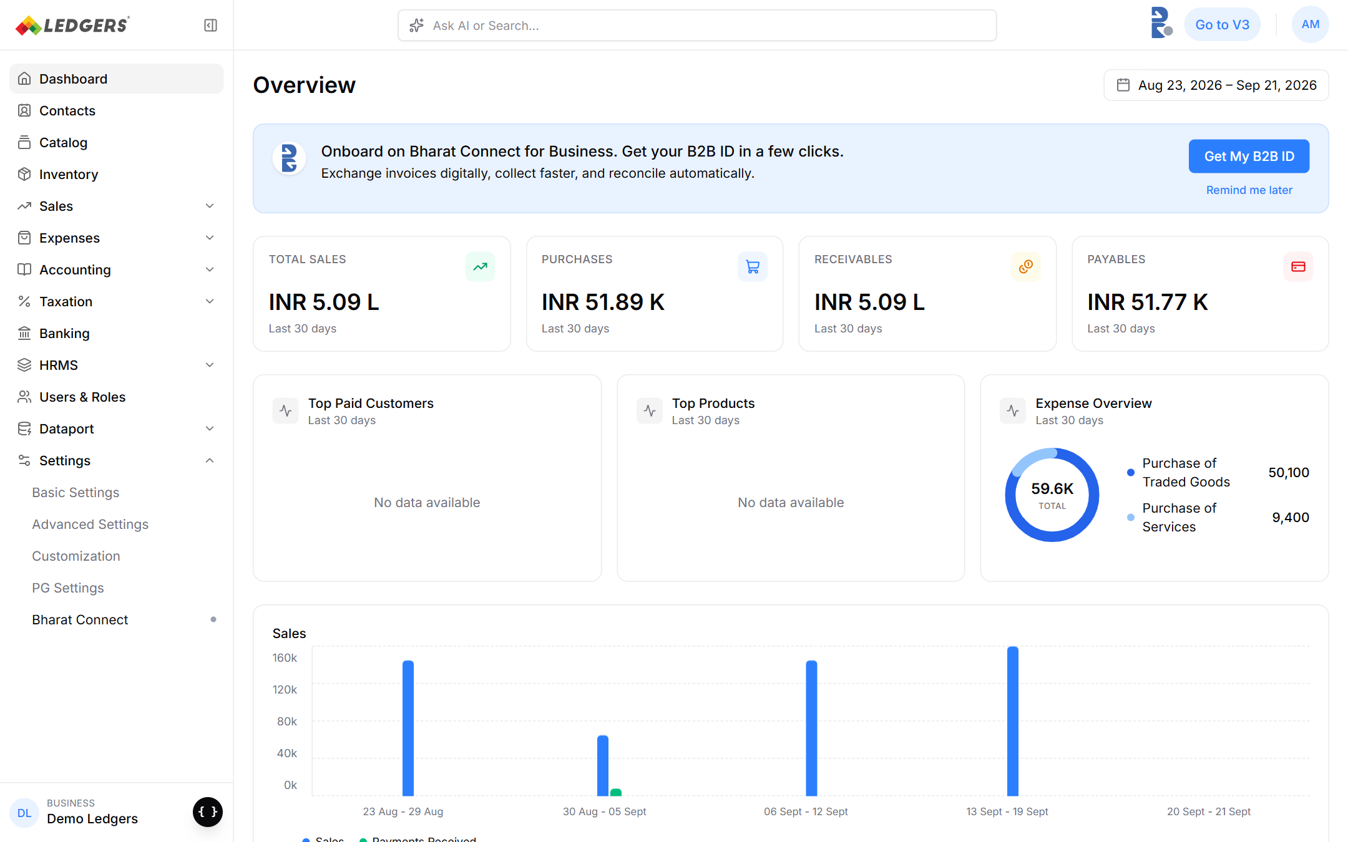
Figure 1: Dashboard banner when the business is not on Bharat Connect.
Element | Behaviour | Data / API
Banner title | “Onboard on Bharat Connect for Business. Get your B2B ID in a few clicks.” | Shown when state = Not connected (respCheckEntity NEW)
Subtitle | “Exchange invoices digitally, collect faster, and reconcile automatically.” | Static
Get My B2B ID | Opens Settings → Bharat Connect (onboarding page) | No API
Remind me later | Hides the banner for a snooze period | LEDGERS-only (store snooze per business)

5.2 Top-bar icon and popover: Not connected
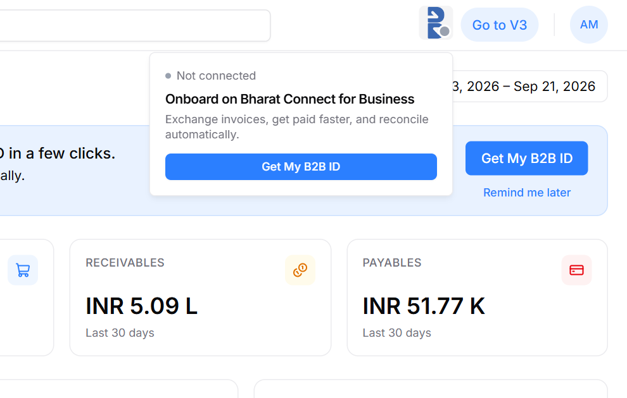
Figure 2: Bharat Connect icon in the top bar (grey dot) with its hover popover.
The Bharat Connect icon sits in the top bar on every page. The dot colour follows the connection state (section 4.1). Hovering opens a popover whose title, body and button change per state; the button leads to the same action as the banner. No API is called by the popover itself.

5.3 Dashboard and popover: ID found
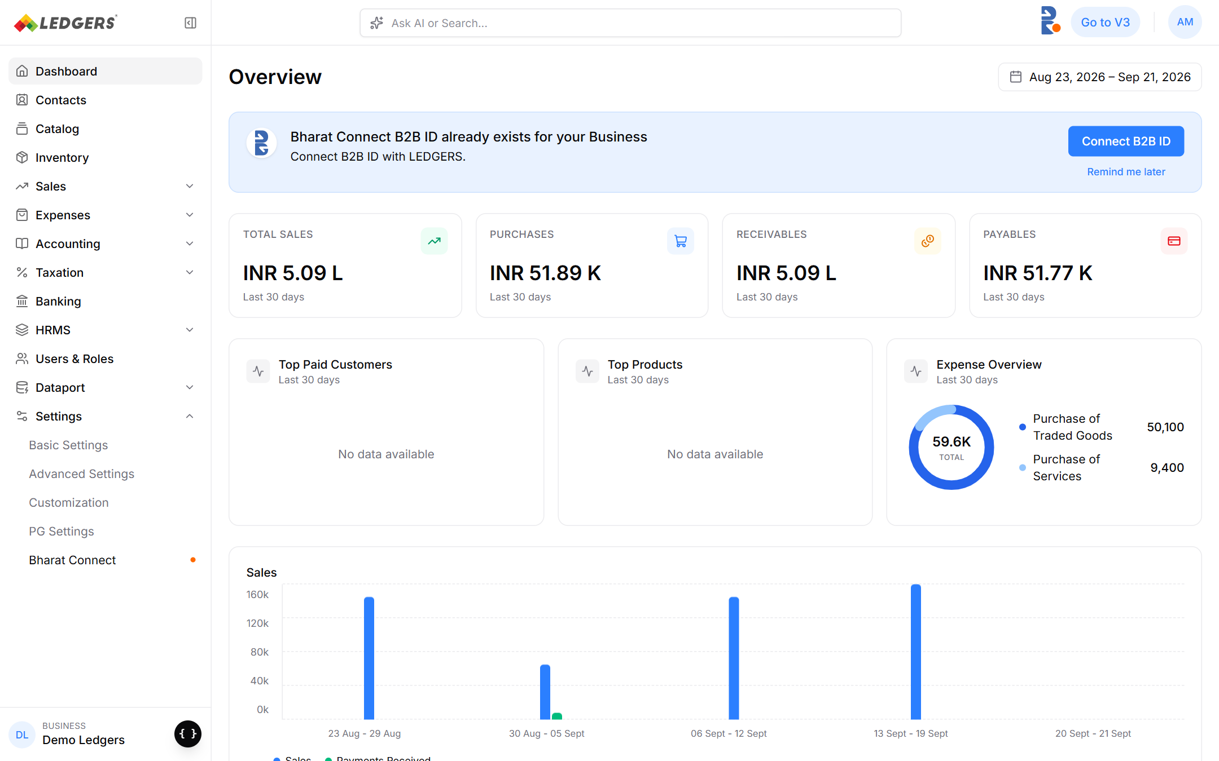
Figure 3: Banner when the PAN already has a Bharat Connect business.
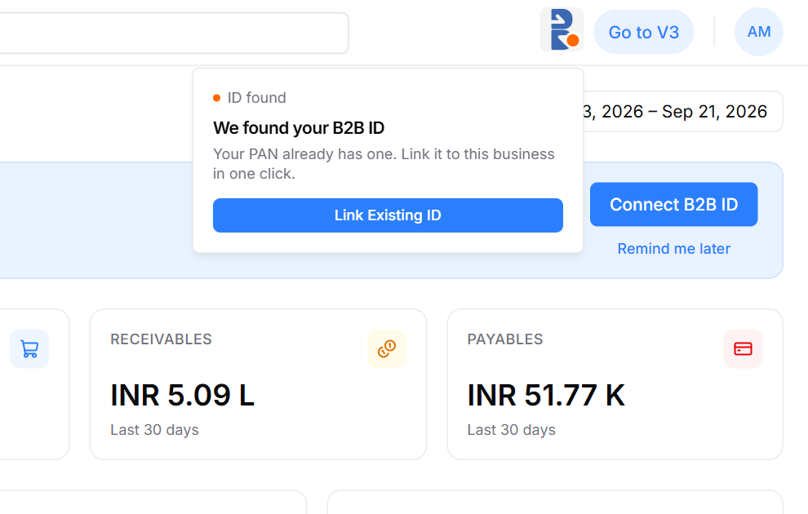
Figure 4: Popover in the ID found state (orange dot).
Element | Behaviour | Data / API
Banner title / body | “Bharat Connect B2B ID already exists for your Business” / “Connect B2B ID with LEDGERS.” | respCheckEntity: status = EXISTING, aiOrgConnection = NO
Connect B2B ID / Link Existing ID | Links in place; button shows “Linking…”, then the business is Connected | reqMapEntity → respMapEntity → reqFetchEntity → respEntityKyc
Existing ID shown after linking | The default B2B ID returned by Bharat Connect | respCheckEntity businessDetails[].checkB2BIds, confirmed by respFetchEntity institute.defaultB2BId

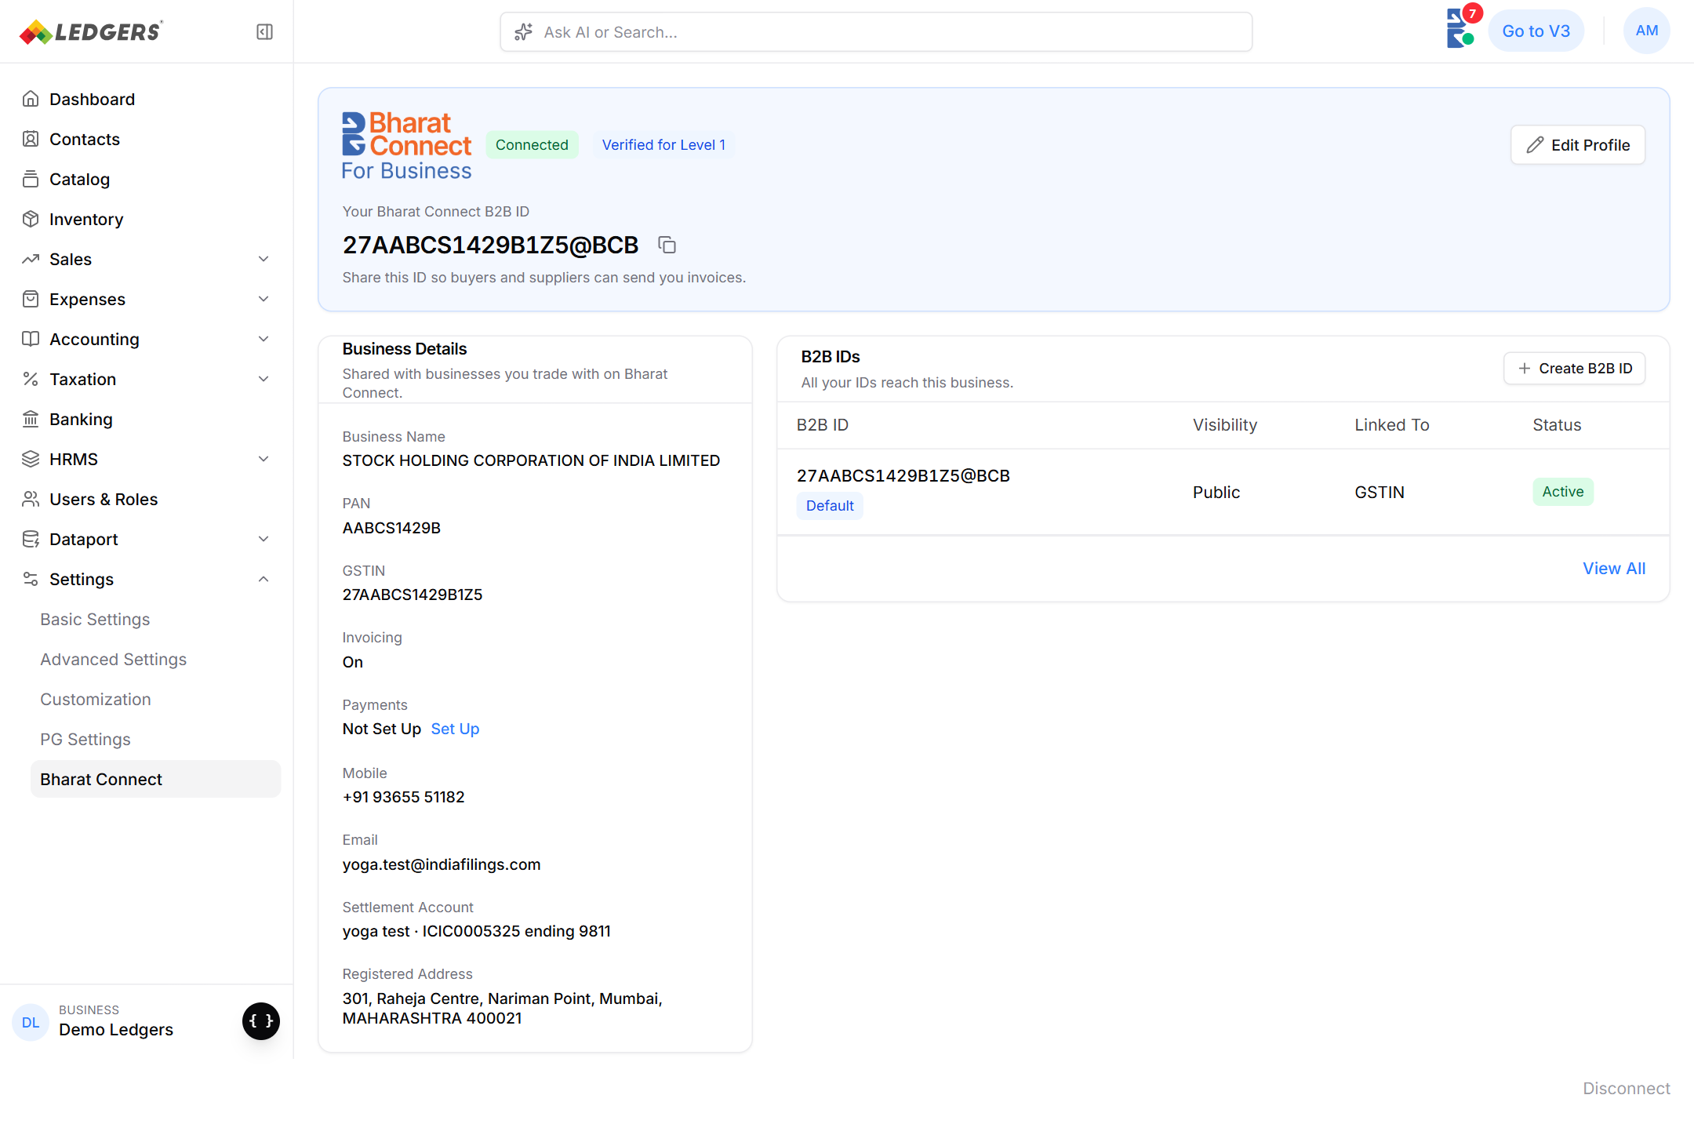
Figure 5: Connected page right after linking an existing ID.

5.4 Onboard to Bharat Connect page
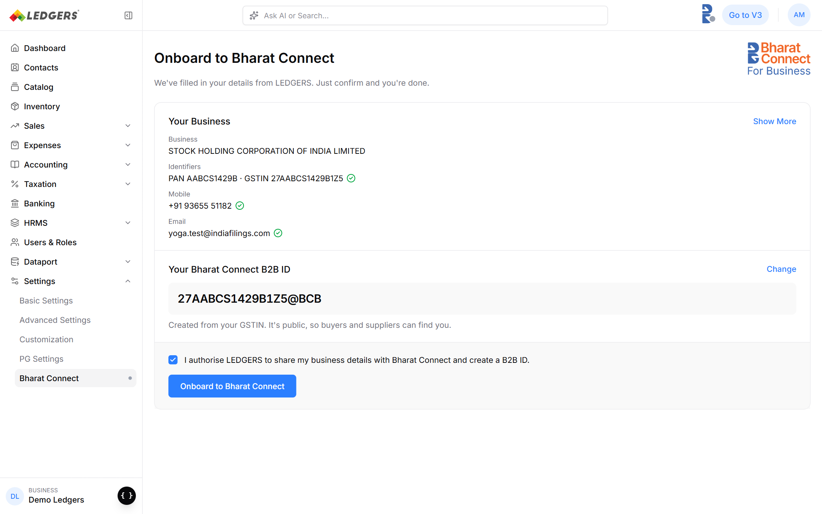
Figure 6: Onboarding page. All details are pre-filled from LEDGERS; the user only confirms.
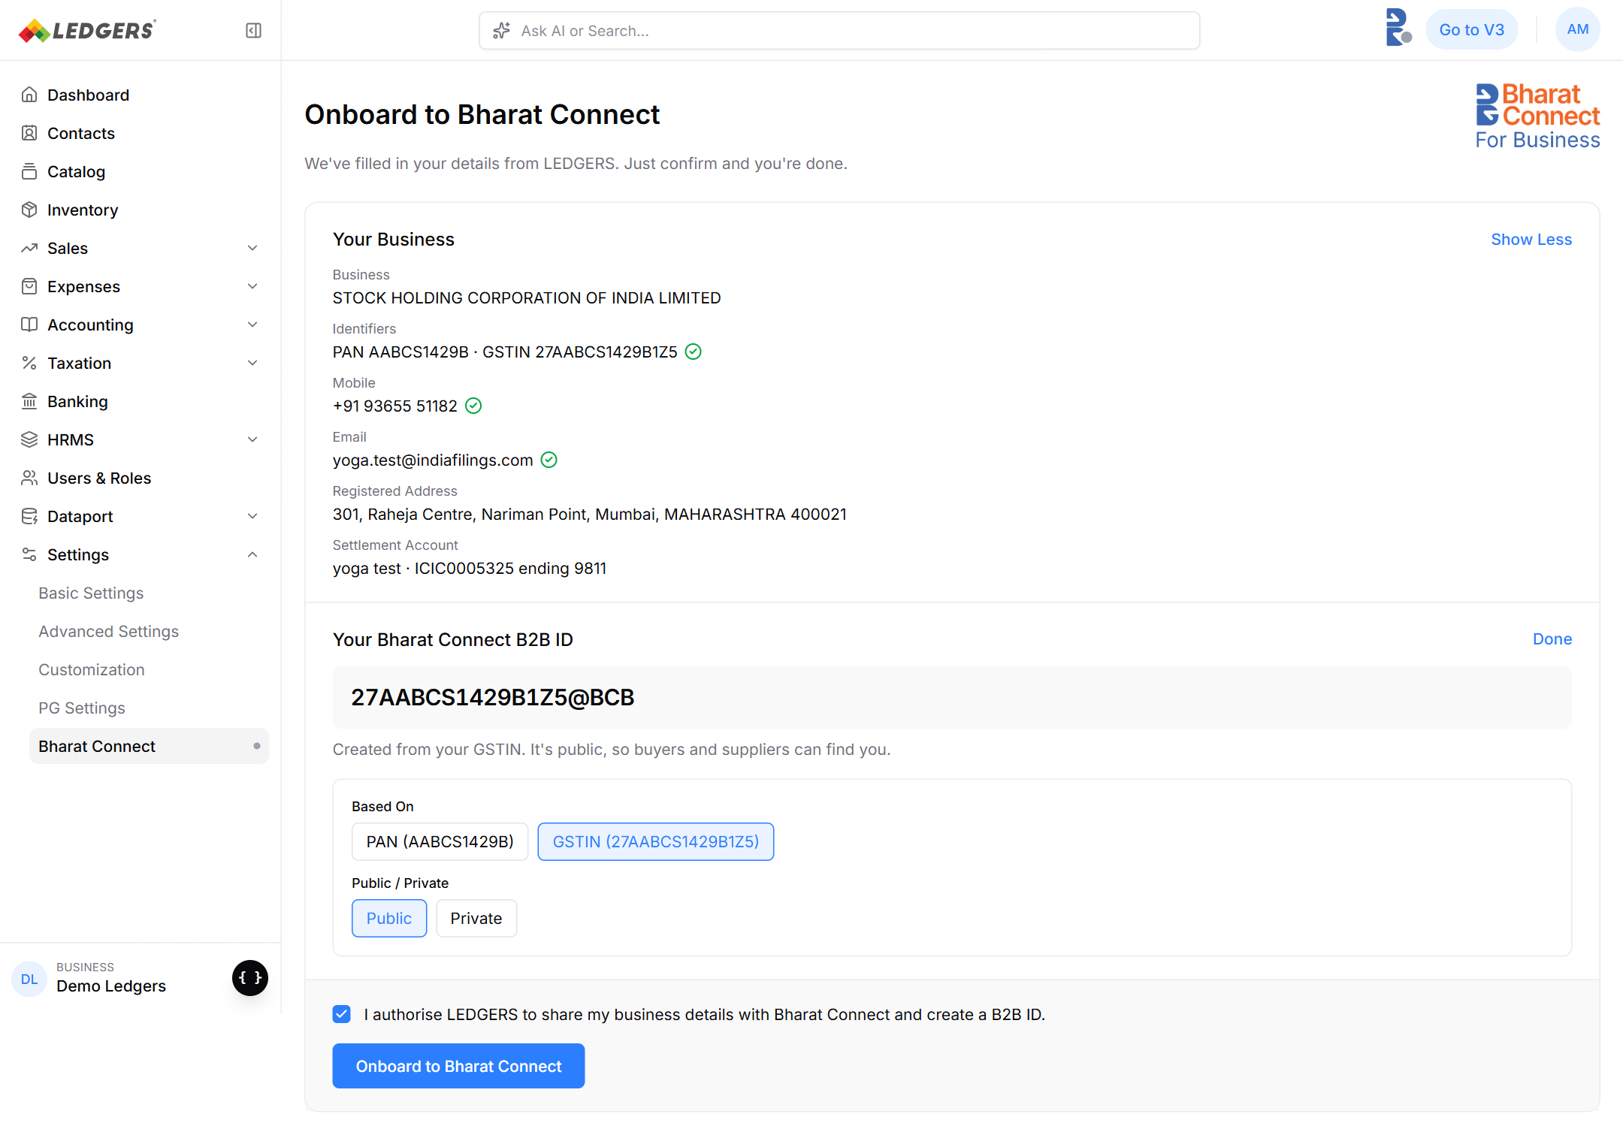
Figure 7: Show More (address, settlement account) and Change (Based On, Public / Private) expanded.
Section / element | What it shows / does | Source | Goes into reqRegEntity as
Business | Legal name | LEDGERS business (GST portal) | institute.name
Identifiers | PAN · GSTIN, green tick when verified | LEDGERS business | institute.lei (PAN) and primaryBusinessIdentifier / otherBusinessIdentifiers
Mobile | Business mobile, tick if OTP-verified | LEDGERS signup OTP | institute.primaryContactNumber
Email | Business email, tick if OTP-verified | LEDGERS signup OTP | institute.primaryEmail
Show More → Registered Address | Address line, city, state, pincode | LEDGERS business | institute.addresses[] (type REGISTERED ADDRESS)
Show More → Settlement Account | Beneficiary · IFSC ending #### | LEDGERS banking | institute.bankAccounts[] (optional at Level 1)
Your Bharat Connect B2B ID | Proposed default ID, e.g. 27AABCS1429B1Z5@BCB | Built by LEDGERS per Annexure F; availability via reqCheckId | institute.defaultB2BId
Change → Based On | PAN or GSTIN (companies with a GSTIN). Sole props also enter Proprietor / Karta name | User choice | Primary identifier and the ID format
Change → Public / Private | Public: anyone can find the business. Private: only shared contacts | User choice | Visibility of the default ID (see Open Questions)
Consent | “I authorise LEDGERS to share my business details with Bharat Connect and create a B2B ID.” | Captured on click; store user, time, IP | Precondition for reqCheckEntity / reqRegEntity (Level 1 consent)
Onboard to Bharat Connect | Submits. Disabled until consent is ticked | — | Sends reqRegEntity

5.5 Submitting and success
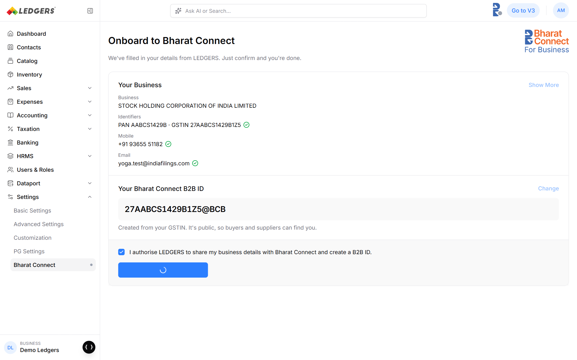
Figure 8: After clicking Onboard: the button shows only a spinner; the form stays visible and Change / Show More are locked.
Prototype phase (screen-reader label) | Real-world meaning
Sending your details… | reqRegEntity sent, waiting for Ack (≤ 5 s)
Creating your B2B ID… | Ack received, waiting for respRegEntity (≤ 180 s)
Confirming… | respRegEntity SUCCESS, waiting for respEntityKyc
Tick (green) | Connected. Hold ~1.5 s, toast “Onboarded to Bharat Connect. Your B2B ID is …”, then show the connected page

If the user leaves the page while it is in progress, the request keeps going on the server. The state stays Setting up (yellow dot) and the result is applied when the response arrives.

5.6 End state: Connected
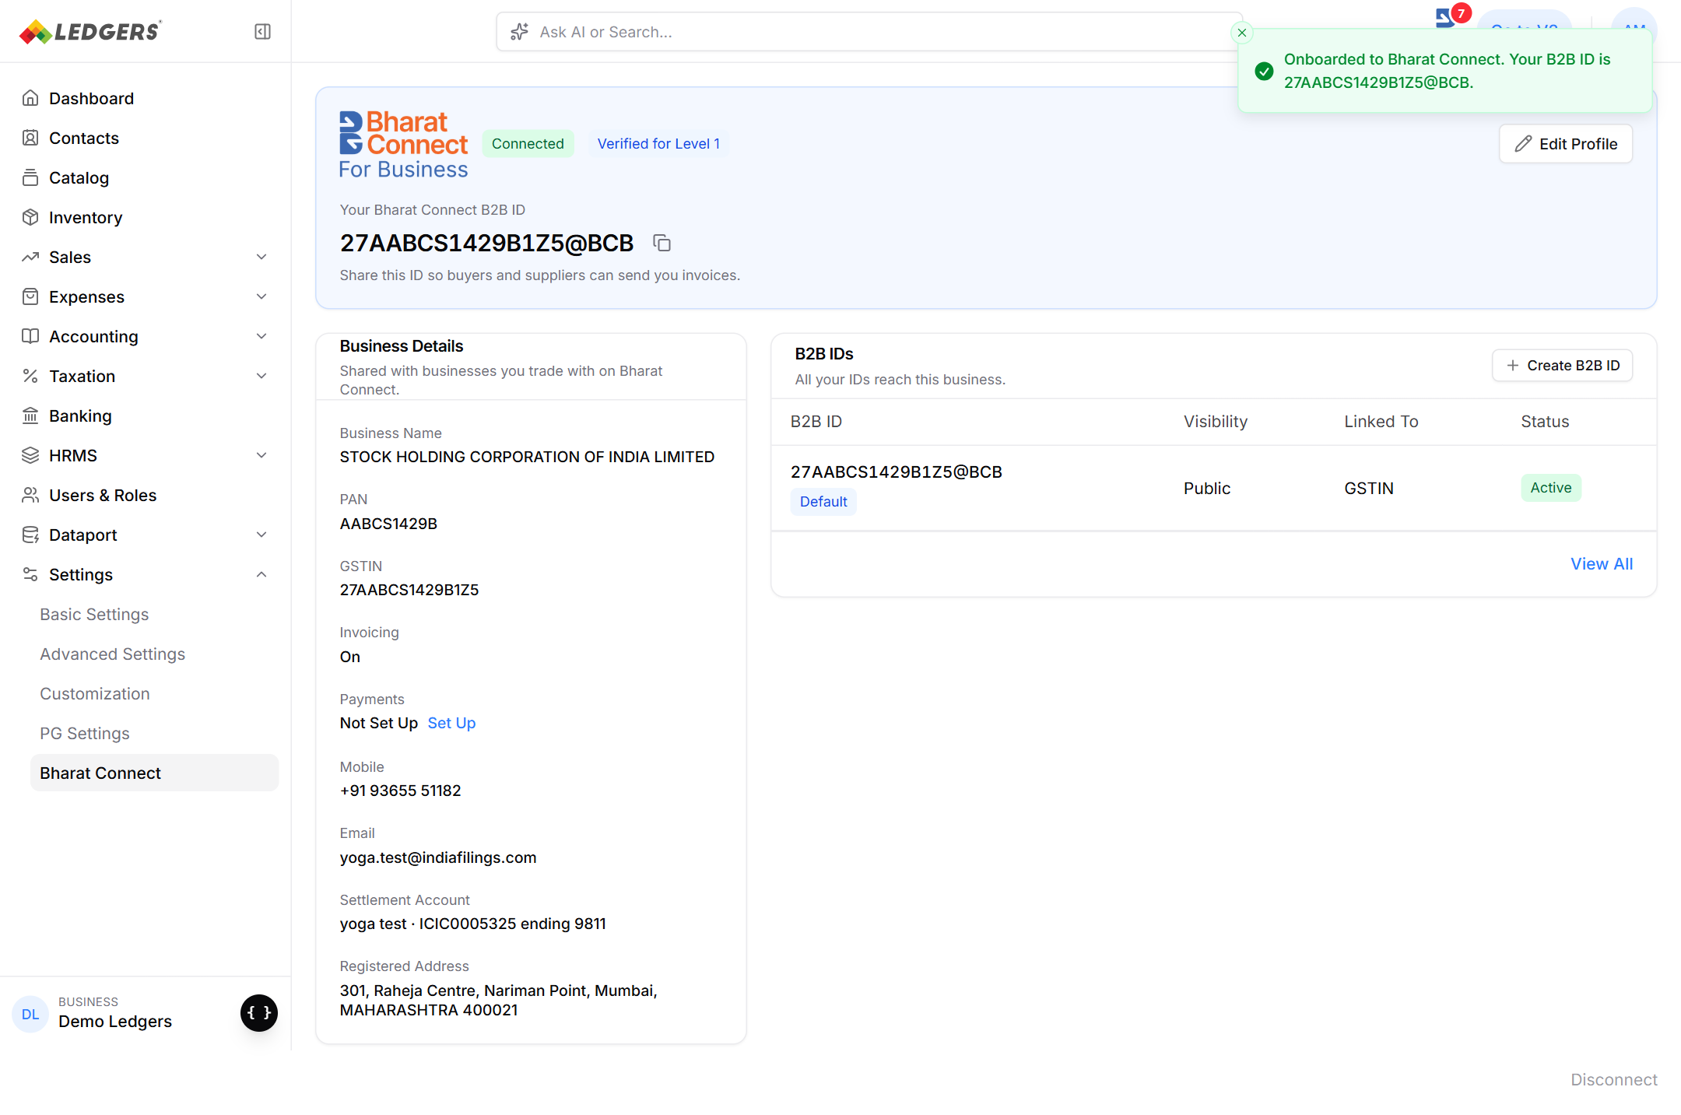
Figure 9: Settings → Bharat Connect once connected.
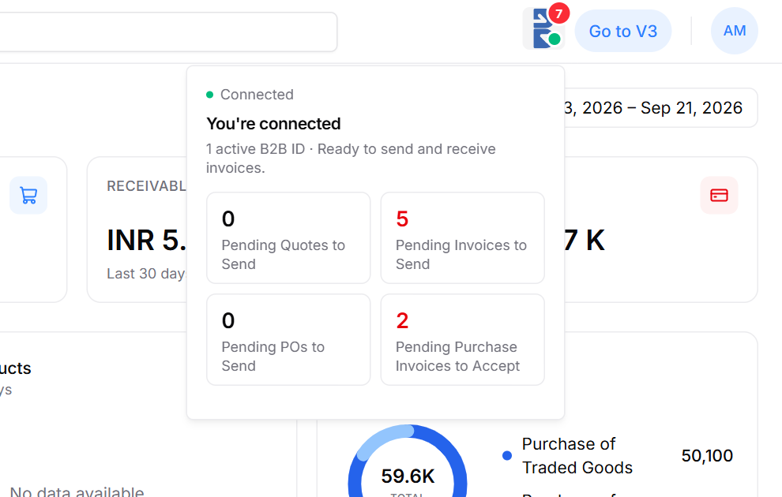
Figure 10: Connected popover with pending counts (these come from invoice APIs, out of scope here).
Element | Source after onboarding
B2B ID + copy | respRegEntity institute.defaultB2BId (or respFetchEntity for a linked business)
Verified for Level N | institute.verificationLevel: 1 → Level 1, 3 → Level 2, 5 → Level 3
Business Details card | Stored copy of what was registered (respRegEntity / respFetchEntity institute)
B2B IDs card | Default ID from registration; for linked businesses, every entry in respFetchEntity b2BIdDetails[] (id, PUBLIC / PRIVATE, ACTIVE / INACTIVE)
Invoicing / Payments | Invoicing On after Connected. Payments needs Level 2 + bank (not part of onboarding)

5.7 Failure states
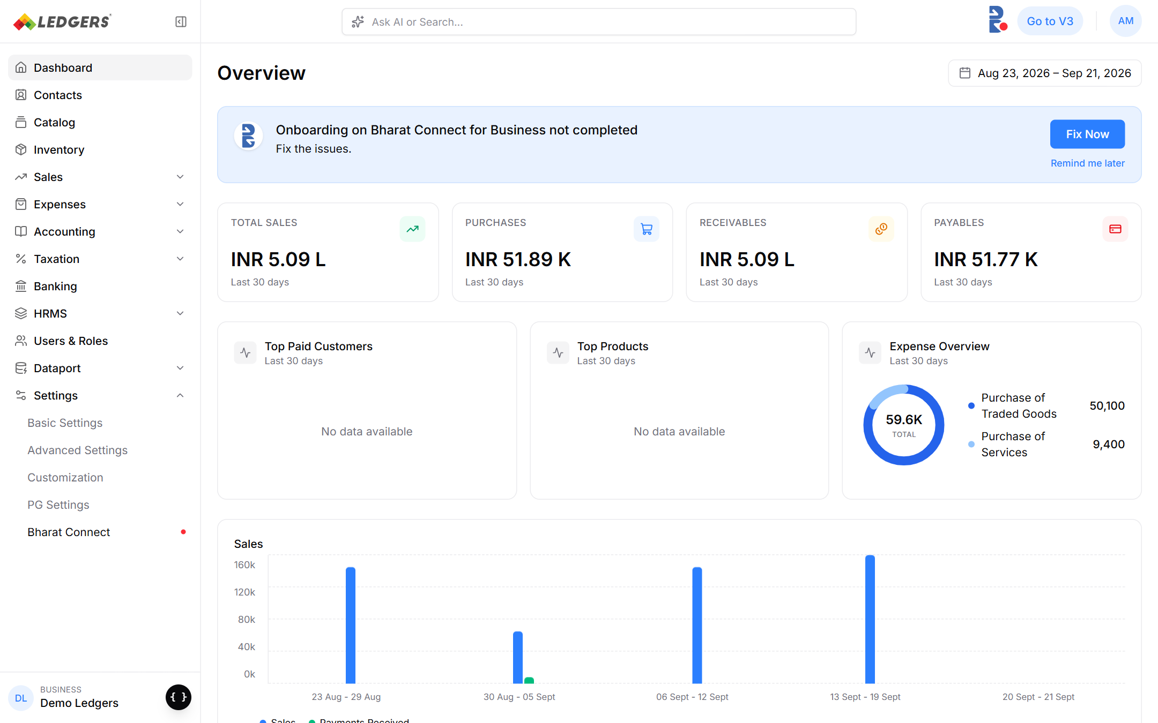
Figure 11: Needs attention: Bharat Connect rejected a field the user can fix.
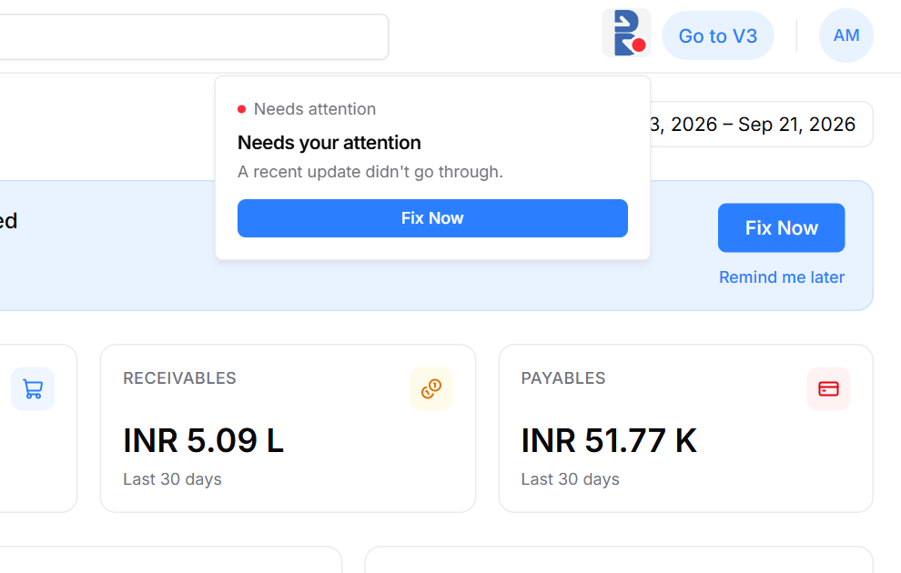
Figure 12: Needs attention popover (red dot).
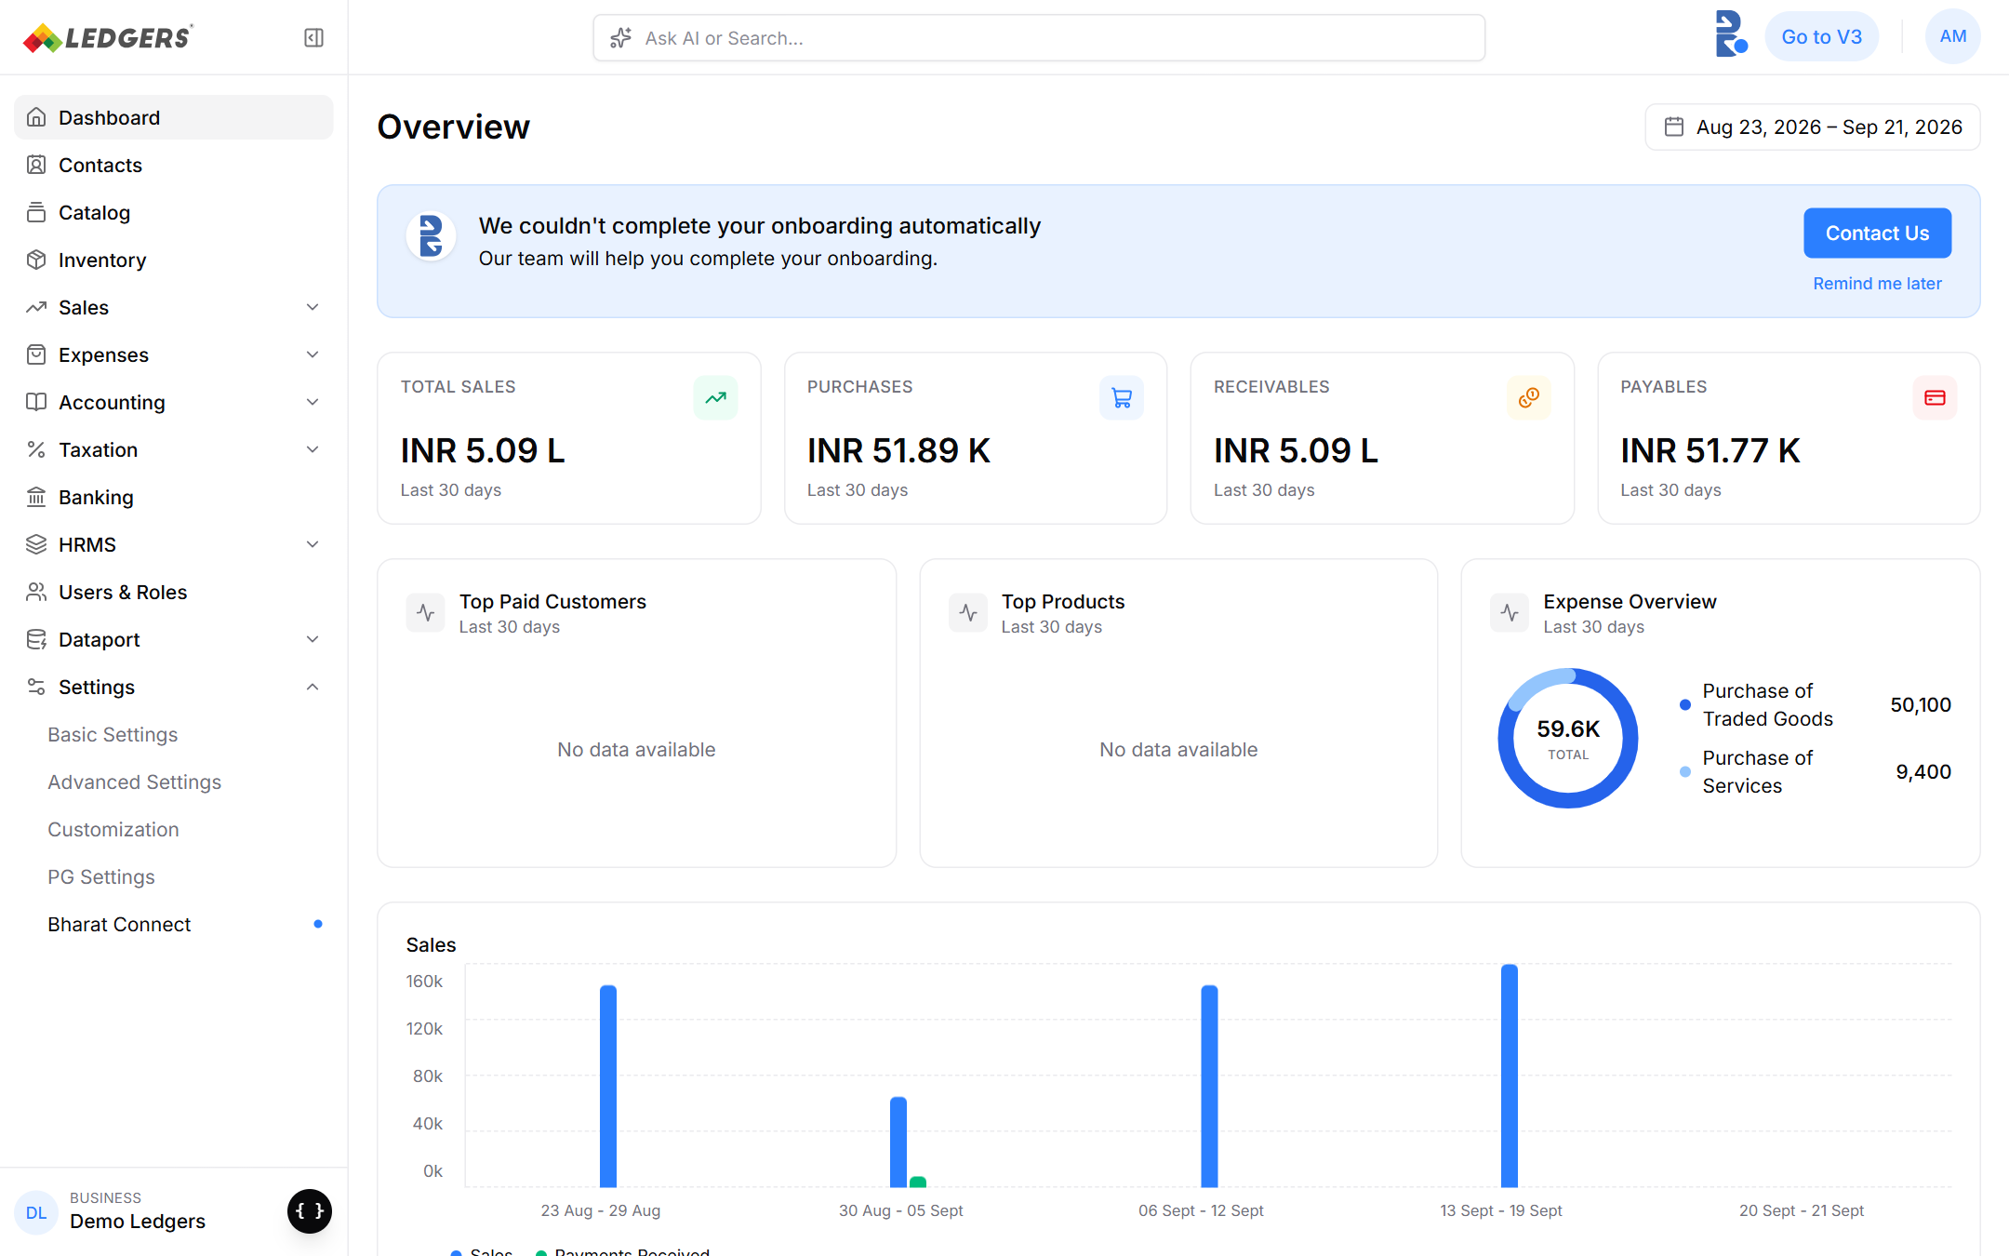
Figure 13: Assisted setup: onboarding could not be completed automatically.
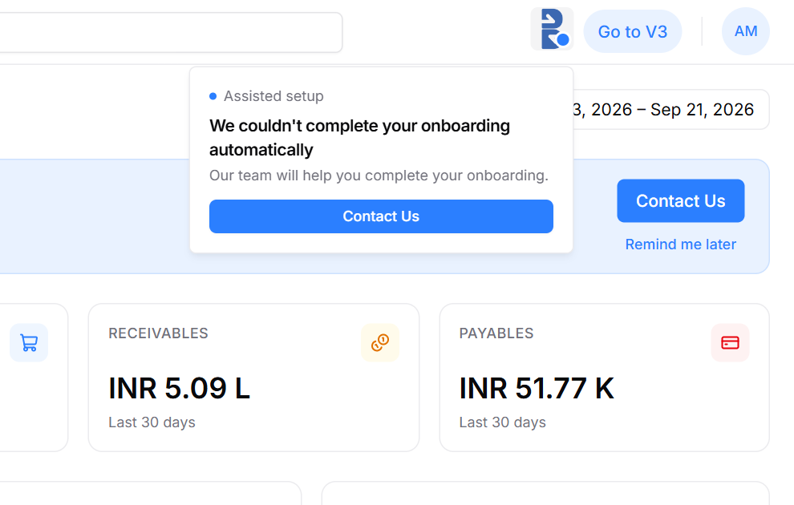
Figure 14: Assisted setup popover (blue dot).
State | Banner | Button | Triggered by
Needs attention | “Onboarding on Bharat Connect for Business not completed” / “Fix the issues.” | Fix Now → profile field named in the error | Nack or resp FAILURE with an errorField LEDGERS can map to an editable field
Assisted setup | “We couldn't complete your onboarding automatically” / “Our team will help you complete your onboarding.” | Contact Us | Errors the user cannot fix, KYC FAILURE, repeated timeouts

6. Validation Rules and Error Handling

6.1 Validations LEDGERS runs before calling Bharat Connect
Rule | Detail | Source
PAN format | ^[A-Z]{5}[0-9]{4}[A-Z]$, no spaces | Handbook A.1.1
PAN vs business type | 4th character P ↔ sole proprietor; anything else ↔ non-sole prop | Handbook A.1.1
Consent | Explicit consent captured and stored (user, time, IP) before any call | Handbook A.1.1, Annexure Q Level 1
Contacts | Every mobile and email sent is OTP-verified | Annexure Q Level 1
Name match | Business name matches the name on PAN / GSTIN | Annexure Q Level 1, handbook A.1.2
One business per PAN | Non-sole props cannot create a second business on the same PAN | Handbook 1.1
B2B ID format | As per Annexure F (prototype: PAN@BCB / GSTIN@BCB; sole prop AAAA.BBBB.CCCC.DDD@BCB) | Annexure F
Verification level | Send "1" at onboarding. 1 = Level 1, 3 = Level 2, 5 = Level 3 | Annexure Q
Bank account | acNum 4–64 chars; IFSC 11 chars; VPA per Annexure I. Optional at Level 1 | Swagger, Annexure I / Q
Common checks | Field lengths, regexes and mandatory fields as per Swagger | Annexure B

6.2 Mapping outcomes to the UI
Outcome | Example | UI state | What the user sees / does
Nack on request | Schema / signature error | Stay on the onboarding page; log for engineering | Button returns to normal with an error toast; retry allowed
FAILURE, fixable field | errorField = primaryContactNumber | Needs attention | Red dot, banner “…not completed / Fix the issues.”, Fix Now opens the field
FAILURE, not fixable | PAN not found on ITR, identifier mismatch | Assisted setup | Blue dot, banner “We couldn't complete your onboarding automatically”, Contact Us
B2B ID taken | respCheckId availability = NO | Onboarding page | Show the next available ID or ask to switch basis
Timeout | No respRegEntity in 180 s | Setting up | Yellow dot; LEDGERS calls reqCheckStatus in the background
KYC pending / failed | respEntityKyc PENDING / FAILURE | Setting up / Assisted setup | Wait, or route to support with the reason

7. Sample Payload: reqRegEntity
Illustrative body for the demo business (Level 1, default ID based on GSTIN). IDs, signatures and encrypted values are placeholders.
{
"head": { "ver": "1.0", "ts": "2026-10-03T11:20:00+05:30", "msgId": "MSG<32 alphanumeric>",
"aiId": "<AIID>", "orgId": "<ORGID>", "prodType": "B2B" },
"txn": { "id": "TNF<32 alphanumeric>", "ts": "2026-10-03T11:20:00+05:30", "type": "ENTITY" },
"device": { "tag": { "name": "IP", "value": "203.0.113.10" } },
"institute": {
"objectId": "<35-char LEDGERS object id>",
"objectVersion": { "currentVersion": 1, "newVersion": 1 },
"name": "STOCK HOLDING CORPORATION OF INDIA LIMITED",
"alias": "Stock Holding",
"defaultB2BId": "27AABCS1429B1Z5@BCB",
"verificationLevel": "1",
"lei": { "documentName": "PAN", "type": "COMPANY", "value": "AABCS1429B" },
"primaryBusinessIdentifier": { "documentName": "GSTIN", "value": "27AABCS1429B1Z5" },
"addresses": [ { "type": "REGISTERED ADDRESS", "addressLine1": "301, Raheja Centre, Nariman Point",
"city": "Mumbai", "state": "MAHARASHTRA", "country": "INDIA", "pincode": "400021" } ],
"bankAccounts": [ { "businessVPA": "<per Annexure I>", "type": "DEFAULT", "ifsc": "ICIC0005325",
"acNum": "<encrypted>", "beneficiaryName": "yoga test" } ],
"primaryContactNumber": { "type": "MOBILE", "countryCode": "+91", "phoneNumber": "9365551182" },
"primaryEmail": [ "yoga.test@indiafilings.com" ]
},
"signatures": [ { "protectedInfo": "<...>", "signature": "<...>" } ]
}

primaryEmail, checkId.b2BIds and mapEntity.b2BIds are arrays of plain strings in the Swagger schema.

8. Data LEDGERS Must Store
Data | Why
Connection state per business + last updated time | Drives banner, icon and Settings page
Consent record (user, timestamp, IP, consent text version) | Level 1 compliance; audit by NBBL
objectId (LEDGERS-generated or from respCheckEntity) | Key for every later API (edit, fetch, map, KYC)
All msgId / txn.id sent and received, with payload and status | Matching async responses, reqCheckStatus, audit logs
Default B2B ID and all mapped IDs (visibility, status, identifier, bank) | Connected page and B2B IDs card
verificationLevel | Level badge; gates payments and other features
Verification logs (OTP, name match, PAN verification) | Annexure Q: AI must be able to prove the verification
Last error (errorCd, errorDtl, errorField) | Needs attention / Assisted setup content and Fix Now target

9. Open Questions
# | Question | Owner | Blocking?
1 | Is reqMapEntity the correct API to link an existing Bharat Connect business to LEDGERS, and is reqFetchEntity allowed straight after it? | NBBL / Engineering | Yes
2 | Is LEDGERS onboarding as an AI or as a participating AI through an OU? This decides whether head.ouId is sent and whether KYC needs OU back-office confirmation. | Product / NBBL | Yes
3 | Where is Public / Private visibility of the default ID set in reqRegEntity? It is not an institute field (reqRegId / reqEditId carry it). Confirm the default and how to set Private at onboarding. | NBBL | Yes
4 | Which error codes should route to Needs attention vs Assisted setup? Needs the Annexure C list mapped to LEDGERS fields. | Engineering / Product | Yes
5 | Build the handbook's “edit existing details” and sole-prop “create new business” options in the ID found state, or ship with link only? | Product | No
6 | How often should reqCheckEntity be re-run for businesses that are Not connected (someone may onboard the PAN elsewhere)? | Engineering | No
7 | Sandbox and production base URLs, AI ID, org ID and certificates from NBBL. | Engineering / NBBL | Yes

