IndusInd Connected Banking
Product Flows: activation, net banking approval, beneficiaries, single and bulk payments, payouts
Document owner: Stany Devdas · Status: Draft for review · Version 1.0 · 17-Oct-26
IndusInd is the reference Connected Banking bank in LEDGERS Banking. Two IndusInd rules shape every flow: LEDGERS must be approved in IndusInd net banking before the connection goes live, and IndusInd only pays people on the customer's beneficiary list.

Version History
Version | Date | Created / Updated by | Description | Review Date | Reviewed by
1.0 | 17-Oct-26 | Stany Devdas | Initial version: IndusInd flows from the clickable prototype, and how beneficiaries are stored on contacts and employees (field names checked against LEDGERS on 19-Oct-26)

Index
Version History 1
1. Connected Banking activation 3
1.1 What the user chooses 3
1.2 Expected flow 4
1.3 Checks and errors 5
2. Net banking approval (confirmation) 7
2.1 Expected flow 8
2.2 Connection statuses 12
3. Beneficiary addition 13
3.1 Rules 13
3.2 Expected flow: maker & checker 14
3.3 Expected flow: single user 17
3.4 Storing beneficiaries on contacts and employees 17
4. Single payment (New payment) 22
4.1 Expected flow 22
4.2 Checks 26
5. Bulk payment 27
5.1 Expected flow 28
5.2 Row checks 31
6. Payouts, statuses and an expired connection 32
6.1 Payouts tab 32
6.2 Payout details 33
6.3 Expired connection 34
7. Reference 36
7.1 Dev panel switches 36
7.2 Open questions 36

1. Connected Banking activation
The Connect dialog asks only what IndusInd's Register API needs: the Customer ID, how payments are approved in IndusInd net banking, and the net banking user code(s) for that choice. It opens from Connect on the Accounts tab, or from Connect on the Connect a bank account list. Anything LEDGERS already knows (business name, account number, IFSC) is not asked.

1.1 What the user chooses
Approval choice | Fields asked | What it means later
Single user | Customer ID, Net banking user code | The same person makes and approves payments; new beneficiaries are confirmed with an OTP
Maker & checker | Customer ID, Maker user code, Checker user code | Payments and new beneficiaries wait for the checker in IndusInd net banking

1.2 Expected flow
- The user clicks Connect on the IndusInd account. The dialog shows the IndusInd logo, "Connect account ••8251", the Customer ID with "Where do I find it?", and the approval choice.
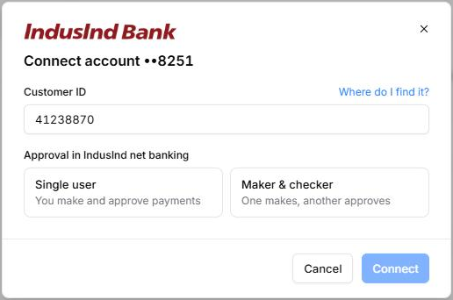
Figure 1: Connect dialog: Customer ID and the approval choice
- "Where do I find it?" explains that the Customer ID is on the account welcome letter and under Profile in IndusInd net banking. Picking Maker & checker adds the maker and checker user codes.
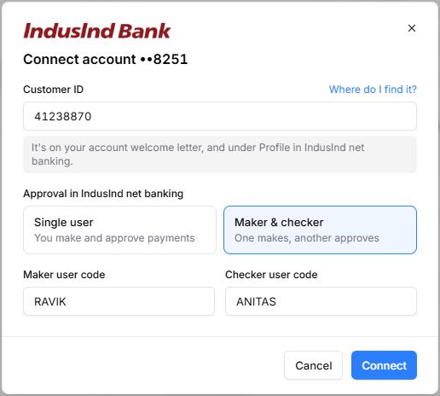
Figure 2: Maker & checker selected, with the maker and checker user codes
- Connect sends the details to IndusInd. When they match the account, the connection moves to net banking approval (section 2); it is not live yet.

1.3 Checks and errors
Check | When | What the user sees
Maker and checker must differ | Before anything is sent | Red line under the checker code; Connect stays disabled
IndusInd can't match the details | After Connect | "IndusInd Bank couldn't match these details to account ••8251. Check them in IndusInd net banking and try again." The form stays filled

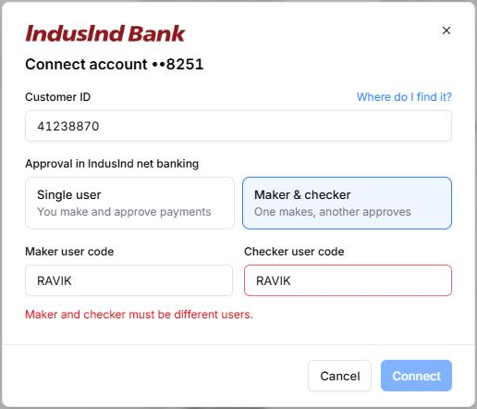  Figure 3: Maker and checker must be different users | 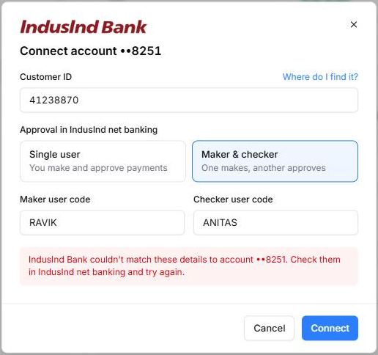  Figure 4: IndusInd couldn't match these details to the account

2. Net banking approval (confirmation)
IndusInd makes the customer approve LEDGERS inside IndusInd net banking before the connection goes live. Until then the account shows Awaiting approval everywhere and nothing can be paid from it.
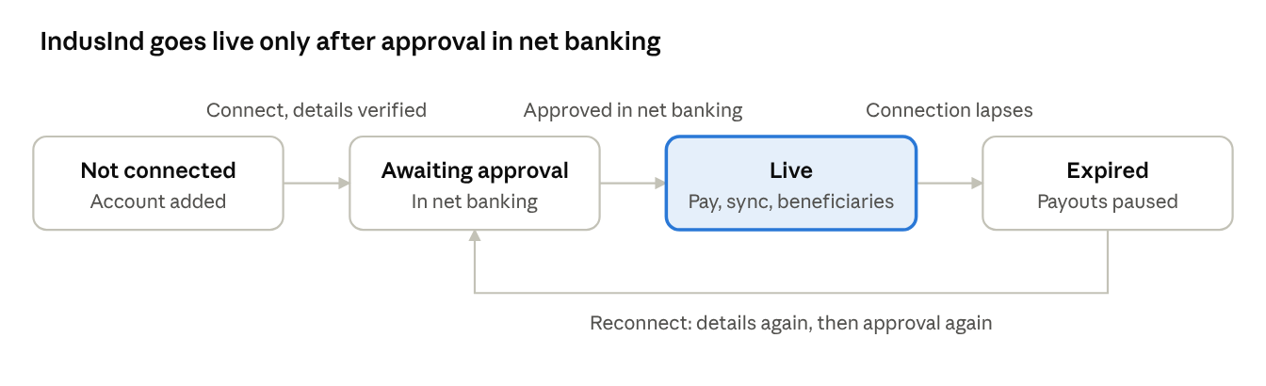
Figure 5: IndusInd connection states

2.1 Expected flow
- Right after a successful Connect, the dialog shows three steps and Open IndusInd net banking.
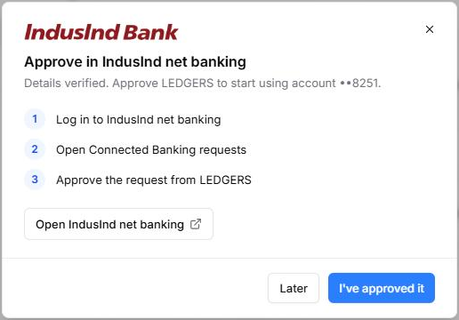
Figure 6: Approve in IndusInd net banking
- I've approved it asks IndusInd whether the approval has gone through. If it hasn't, a grey line says so and the dialog stays open.
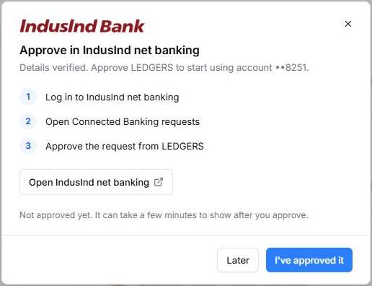
Figure 7: Not approved yet
- Later closes the dialog with the notice "IndusInd ••8251 is waiting for your approval in IndusInd net banking. We'll keep checking." Overview lists it under Needs attention with Check; the Accounts tab shows Check status.
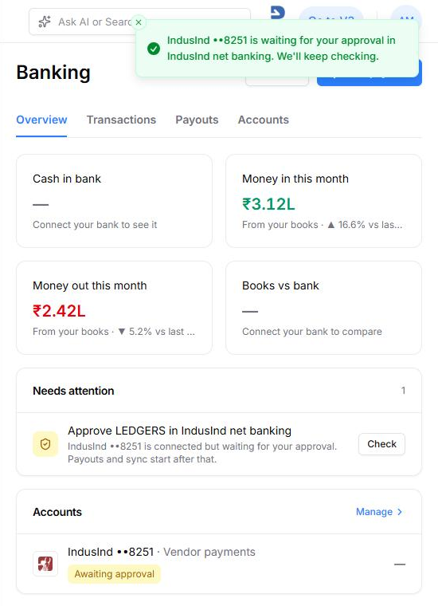
Figure 8: Overview while waiting: the notice, the Needs attention item and the Awaiting approval badge
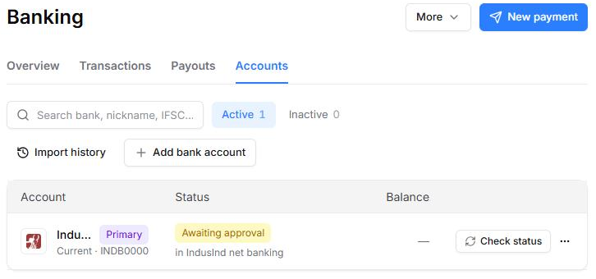
Figure 9: Accounts tab while waiting: Awaiting approval, in IndusInd net banking, Check status
- Once IndusInd confirms the approval, the dialog closes with the notice "IndusInd Bank ••8251 connected". There is no separate success screen. The account turns Live and the balance, statements and beneficiary list start syncing.
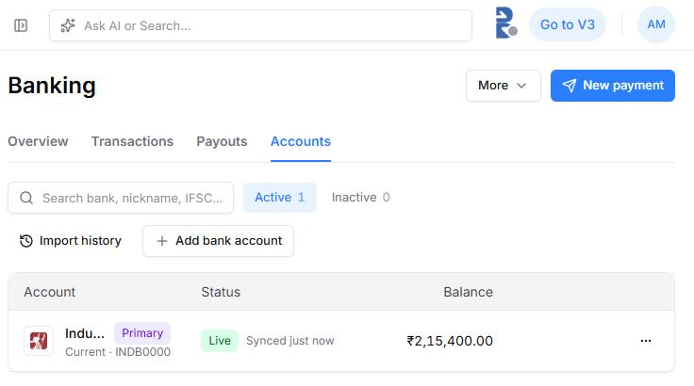
Figure 10: Accounts tab after approval: Live, synced just now, live balance

2.2 Connection statuses
Status | Badge | Next step offered
Not connected | Not connected (grey) | Connect
Awaiting approval | Awaiting approval (amber) | Check status (Accounts), Check (Overview)
Live | Live (green), Synced N min ago | None; Sync now on Transactions
Expired | Connection expired (amber) | Reconnect (section 6.3)

3. Beneficiary addition
IndusInd only pays people on the customer's beneficiary list, which is kept per Customer ID. LEDGERS fetches that list when the account goes live and checks every payee against it inside New payment and Bulk payment, so there is no separate beneficiaries screen.

3.1 Rules
- A payee can be paid from IndusInd only when they are an active beneficiary on that account's Customer ID.
- Each beneficiary has a beneficiary code: the name the customer finds them by in IndusInd net banking. LEDGERS suggests it from the payee's name: A–Z and 0–9 only, upper case, up to 20 characters, unique on the Customer ID (a number is added when taken).
- How a new beneficiary becomes active depends on the approval choice made at Connect:

Approval | After the code | When it can be paid
Single user | An OTP to the registered mobile, then Verify | At once: "Added to your IndusInd beneficiaries"
Maker & checker | Send to checker | After the checker approves it in IndusInd net banking

3.2 Expected flow: maker & checker
- A payee already on the list shows their code under their bank details.
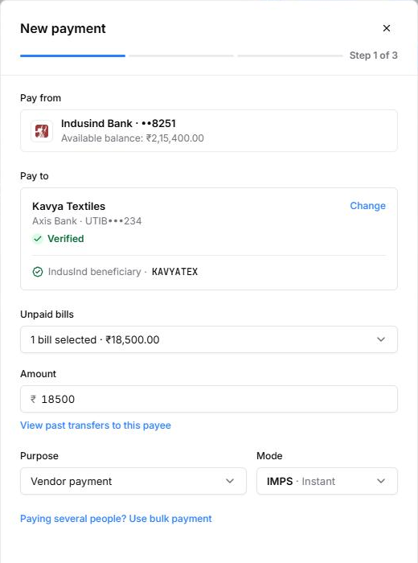
Figure 11: Payee already an IndusInd beneficiary (KAVYATEX)
- A payee who isn't on the list gets one line and Add beneficiary.
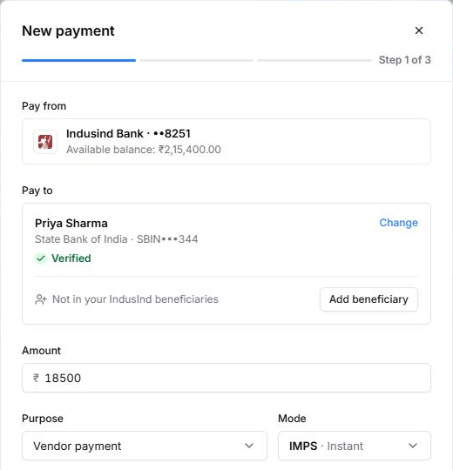
Figure 12: Not in your IndusInd beneficiaries
- Add beneficiary asks for the code, suggested from the name, with Send to checker.
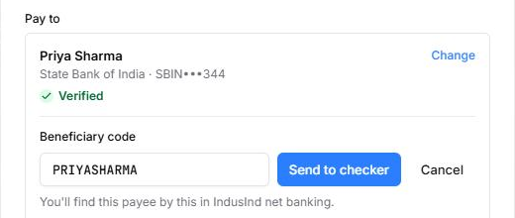
Figure 13: Beneficiary code with Send to checker
- After sending, the payee shows Waiting for checker approval with the code to search for in net banking, a link to IndusInd net banking and Check status. The notice reads "Sent to IndusInd. Your checker approves it in net banking."
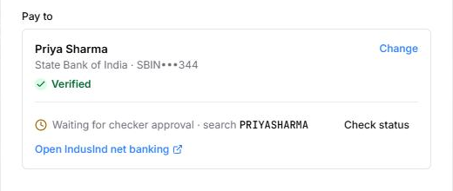
Figure 14: Waiting for checker approval, search PRIYASHARMA
- Check status before the checker has approved shows "Not approved yet"; after approval the payee becomes an active beneficiary ("Beneficiary approved").
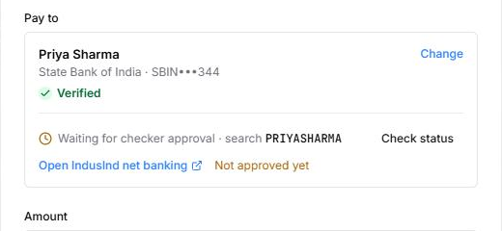  Figure 15: Check status: Not approved yet | 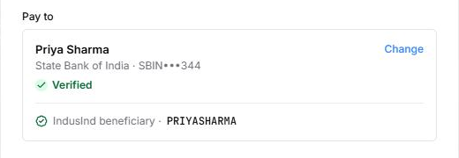  Figure 16: Checker approved: IndusInd beneficiary PRIYASHARMA

3.3 Expected flow: single user
- Add beneficiary asks for the code, then Continue.
- IndusInd sends an OTP to the registered mobile. The user enters it and clicks Verify; the payee is active at once.
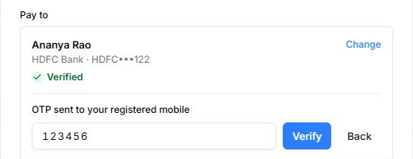
Figure 17: Single user: OTP sent to the registered mobile, Verify
Bulk payment uses the same steps for every new payee at once: one code per payee, then one OTP or one request to the checker (section 5).

3.4 Storing beneficiaries on contacts and employees
A payee's beneficiary status is stored on the payee itself, in the extra_field JSON column of the contacts table and of the employee table, under one top-level key: connected_banking. The existing bank details stay as they are and are only read, to match a beneficiary to the account it was registered for:
Payee | Bank details today (read only) | extra_field today | Change needed
Contact | bank_info[]: one entry per account with account_number, ifsc_code, bank_name, branch, account_type, name. Entries have no id | Exists. Already holds group, business_country, tds, mobile_country_code, and customer / supplier opening balances | None. Add connected_banking beside the existing keys
Employee | bank: one object with accountnumber, ifsccode, bankname, bankbranch, accountname, account_type, update_on, updated_by | Does not exist | Add a nullable JSON column extra_field to the employee table, as on contacts

Other features keep their own keys in the same JSON, so every write must merge into extra_field (or update connected_banking alone), never replace the whole object.

Contact (contacts.extra_field)
One entry per beneficiary registration: a contact with two bank accounts, or one paid from two IndusInd Customer IDs, has an entry for each pair. The existing keys (group, tds, customer, …) stay alongside; only connected_banking is shown.
{
"connected_banking": {
"version": 1,
"beneficiaries": [
{
"bank": "indusind",
"company_bank_account_id": "BA-10231",
"customer_id": "41238870",
"payee_account_number": "20100062834",
"payee_ifsc": "SBIN0000344",
"beneficiary_code": "PRIYASHARMA",
"status": "active",
"approval_mode": "maker_checker",
"source": "added_in_ledgers",
"requested_by": "U-2207",
"requested_at": "2026-10-17T18:08:41+05:30",
"activated_at": "2026-10-17T18:12:05+05:30",
"last_checked_at": "2026-10-17T18:12:05+05:30",
"bank_reference": "IBL-BEN-58812031",
"failure_reason": null
}
]
}
}

Employee (employee.extra_field, new column)
Same shape, in the new column. An employee has one salary account (bank), so there is normally one entry per IndusInd Customer ID the company pays salaries from. The record is identified by its gid.
{
"connected_banking": {
"version": 1,
"beneficiaries": [
{
"bank": "indusind",
"company_bank_account_id": "BA-10231",
"customer_id": "41238870",
"payee_account_number": "50100212345678",
"payee_ifsc": "HDFC0000122",
"beneficiary_code": "ANANYARAO",
"status": "pending",
"approval_mode": "maker_checker",
"source": "added_in_ledgers",
"requested_by": "U-2207",
"requested_at": "2026-10-17T18:20:10+05:30",
"activated_at": null,
"last_checked_at": "2026-10-17T18:20:10+05:30",
"bank_reference": null,
"failure_reason": null
}
]
}
}

Keys
Key | Type | Required | Meaning and rules
connected_banking | object | Yes | Namespace for Connected Banking data on this payee. Merge into it; never overwrite sibling keys of the extra field
version | integer | Yes | Schema version of connected_banking; 1 for this document
beneficiaries | array | Yes | One entry per (Customer ID, payee account). Empty array when none
bank | string | Yes | Connector key: indusind. Only banks with a beneficiary list (IndusInd today) write entries
company_bank_account_id | string | Yes | LEDGERS id of the company's own IndusInd account the payee was added on
customer_id | string | Yes | IndusInd Customer ID of that account. The beneficiary list belongs to the Customer ID, so two company accounts on one Customer ID share entries
payee_account_number | string | Yes | The payee account the beneficiary was registered for, exactly as in bank_info[].account_number (contact) or bank.accountnumber (employee)
payee_ifsc | string | Yes | Matching IFSC: bank_info[].ifsc_code (contact) or bank.ifsccode (employee)
beneficiary_code | string | Yes | A–Z, 0–9, upper case, 1–20 characters, unique across the Customer ID's list
status | string | Yes | pending: sent to the checker (maker & checker). active: can be paid. rejected: the checker or IndusInd declined it. removed: no longer on the bank's list
approval_mode | string | Yes | single (added with an OTP) or maker_checker (approved by the checker in net banking)
source | string | Yes | added_in_ledgers (Add beneficiary) or synced_from_bank (found on the list fetched when the account went live)
requested_by | string | If added in LEDGERS | LEDGERS user id who added it
requested_at | ISO 8601 | Yes | When it was added in LEDGERS, or first seen on the bank's list
activated_at | ISO 8601 or null | No | When it became active; null while pending
last_checked_at | ISO 8601 | Yes | Last time LEDGERS asked IndusInd about it (Check status, list sync)
bank_reference | string or null | No | Beneficiary id IndusInd returns, if its API returns one
failure_reason | string or null | No | Bank's reason when rejected or removed

How LEDGERS reads and writes it
Event | What changes in the JSON
Account goes live | Fetch IndusInd's beneficiary list for the Customer ID. For every listed account that matches a contact's bank_info[] or an employee's bank (account number + IFSC), add an entry with source: synced_from_bank, status: active
Add beneficiary, single user, OTP verified | Add an entry with status: active, approval_mode: single, activated_at = now
Add beneficiary, maker & checker | Add an entry with status: pending, approval_mode: maker_checker, activated_at: null
Check status, checker approved | Set status: active, activated_at, last_checked_at
Check status, not yet | Update last_checked_at only
Checker or bank declines | Set status: rejected and failure_reason; the payee shows "Not in your IndusInd beneficiaries" again
Payee's bank details change | Leave the old entry. It no longer matches the new account number + IFSC, so the payee needs adding again for the new account

Is this payee payable from this IndusInd account? Look for an entry where bank = indusind, customer_id = the paying account's Customer ID, payee_account_number and payee_ifsc match the account being paid, and status = active. No such entry means the payee shows "Not in your IndusInd beneficiaries · Add beneficiary"; a pending entry shows "Waiting for checker approval".

4. Single payment (New payment)
New payment pays one payee from the IndusInd account in three steps: details, review, OTP.

4.1 Expected flow
- Step 1 shows the account to pay from with its live balance, then one search over contacts and employees.
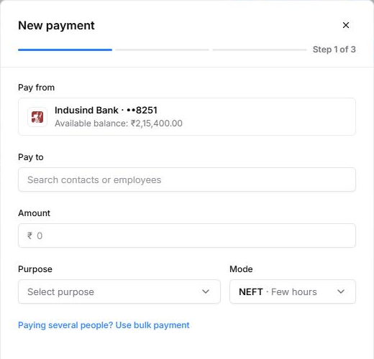
Figure 18: New payment, step 1: Pay from IndusInd with live balance
- Each result shows the payee's bank and whether their account is verified; an unverified account carries a small amber tag. A contact with unpaid bills brings them in, and the amount follows the bills selected. Purpose and mode are dropdowns.
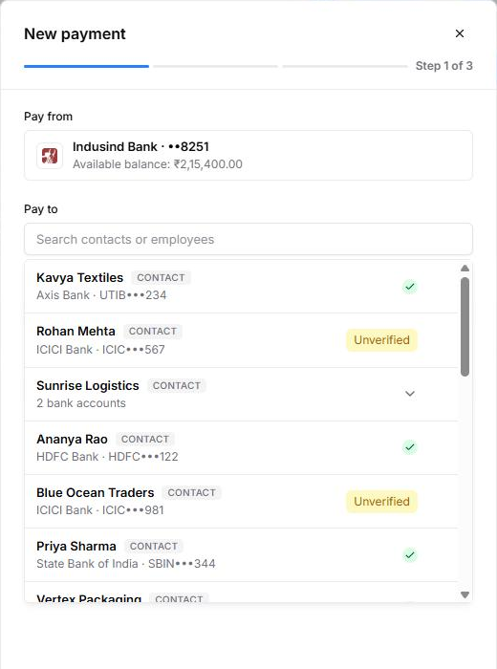
Figure 19: Pay to: contacts and employees with their bank and verification
- If the payee isn't an IndusInd beneficiary, they're added right here (section 3).
- Review payment shows the whole payment on one card. Under maker & checker it adds an Approval row.
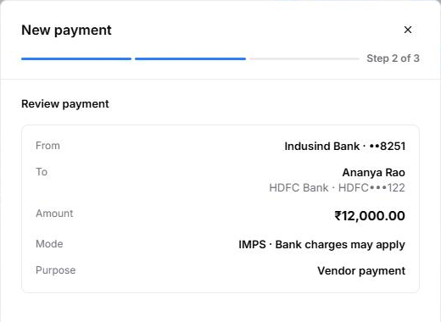  Figure 20: Review, single user | 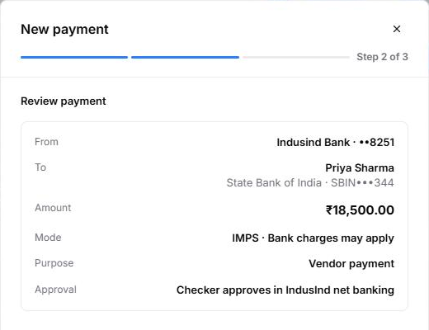  Figure 21: Review, maker & checker with the Approval row
- The last step is an OTP from IndusInd to the registered mobile: Verify & Pay (single user) or Verify & Submit (maker & checker).
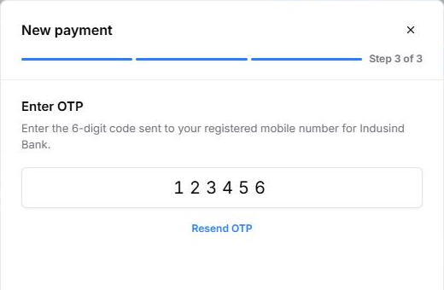
Figure 22: Enter OTP
- The result screen says what happens next, and the payment appears on the Payouts tab (section 6).
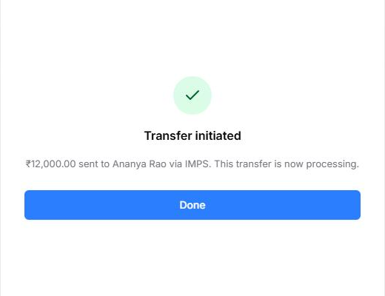  Figure 23: Single user: transfer initiated, now processing | 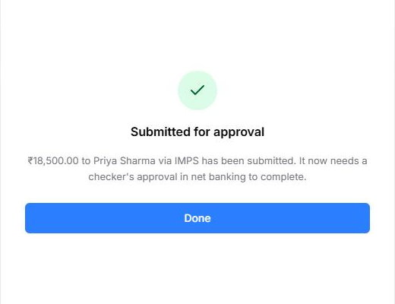  Figure 24: Maker & checker: submitted for the checker's approval

4.2 Checks
Check | What the user sees
Payee not an IndusInd beneficiary | "Not in your IndusInd beneficiaries · Add beneficiary" on the payee; Review payment needs them active
Amount above the available balance | "Amount exceeds available balance" under the amount
Payee account unverified | Amber "Unverified" tag; a warning only

5. Bulk payment
Bulk payment (More › Bulk payment) pays many payees from IndusInd in one batch, with one review and one OTP. It uses the same pieces as New payment.

5.1 Expected flow
- Payees are added one by one (Add payment) or from a file (Upload file, with Download template). Each row shows its own problem; the footer keeps a running count, total, available balance and how many rows need attention.
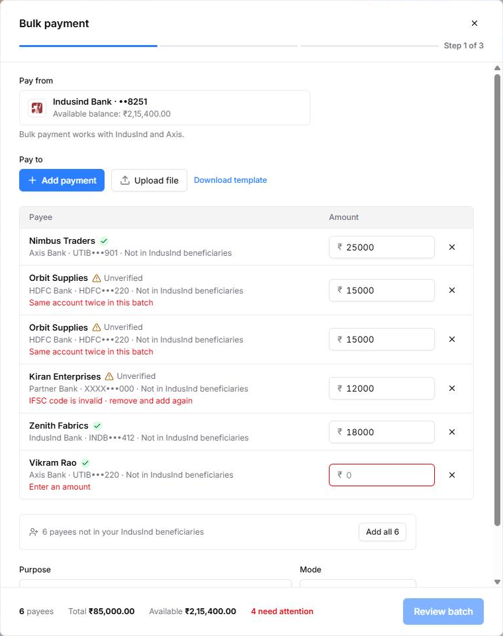
Figure 25: Bulk payment after an upload: row issues and 4 need attention
- Add all asks for one beneficiary code per new payee, suggested from their names, then one OTP for the set (single user) or one request to the checker.
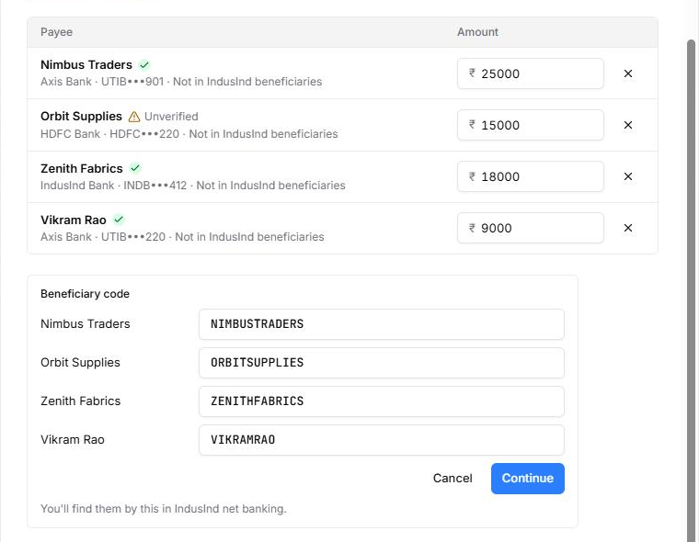
Figure 26: Beneficiary codes for all four new payees
- Once added, each row shows its code, and Review batch turns on when nothing needs attention.
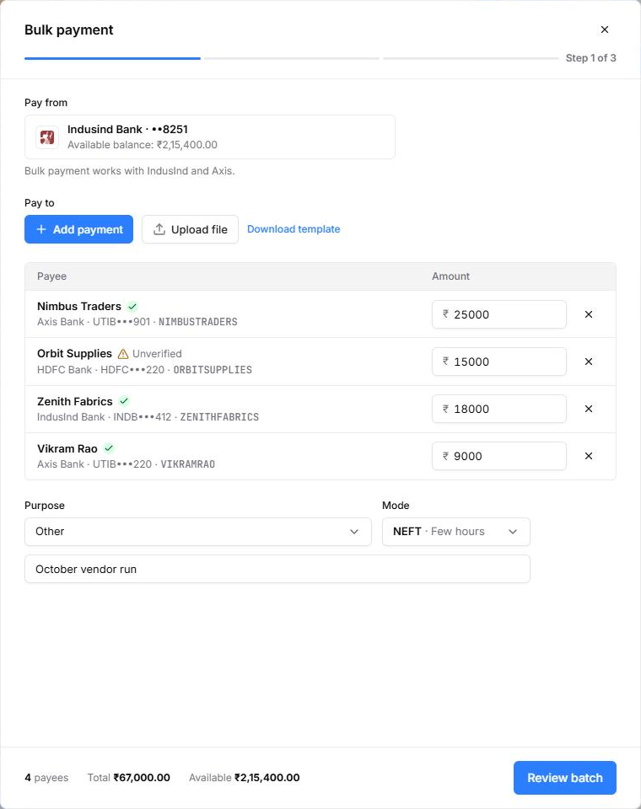
Figure 27: Batch ready: every payee carries an IndusInd beneficiary code
- The review lists the batch total and every payee. After the OTP, the result confirms how many payments went out.
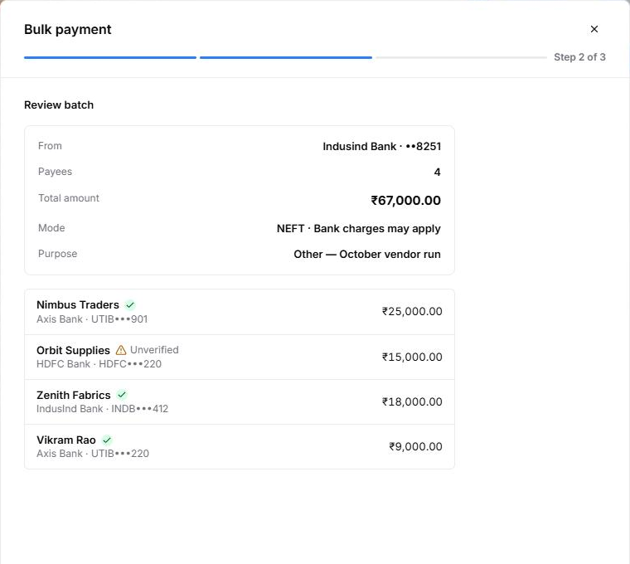  Figure 28: Review batch | 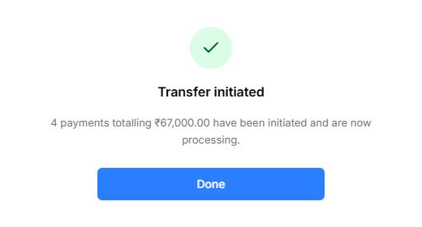  Figure 29: Transfer initiated: 4 payments totalling ₹67,000.00

5.2 Row checks
Row issue | How it's fixed
Same account twice in this batch | Remove one row
IFSC code is invalid | Remove the row and add the payee again
Enter an amount | Type the amount in the row
Unverified (amber tag) | A warning only; the payment can still go
Not in IndusInd beneficiaries | Add all below the list (section 3)

6. Payouts, statuses and an expired connection
Every payment made from LEDGERS lands on the Payouts tab: paid this month, what's with the bank, what's awaiting the checker, and what needs action.

6.1 Payouts tab
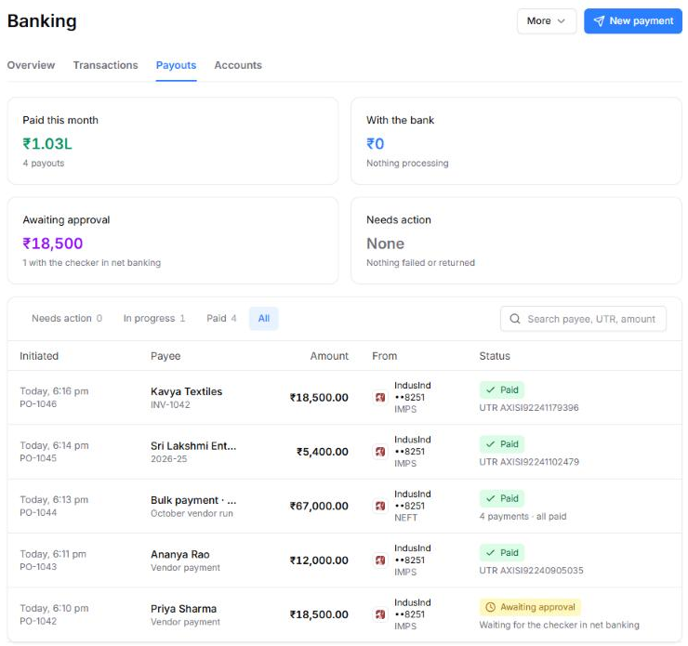
Figure 30: Payouts tab: summary cards and IndusInd payouts
Status | Meaning | Next step
Awaiting approval | Maker & checker: waiting for the checker in IndusInd net banking | The checker approves; it can be cancelled from LEDGERS
Processing | With IndusInd | Settles on its own
Paid | Done, with a UTR; vouchers are created and matched in the books | Download or share the advice
Failed, Rejected, Returned | Didn't go through; listed under Needs action and on Overview | Make a new payment (no Retry, by design)
Cancelled | Withdrawn before the checker approved | None

6.2 Payout details
Each row opens a drawer with the timeline and the details.
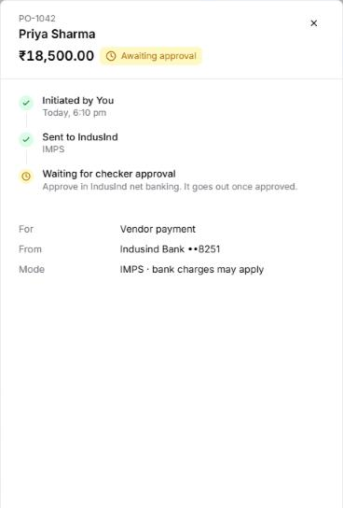  Figure 31: Awaiting the checker, with Cancel payout | 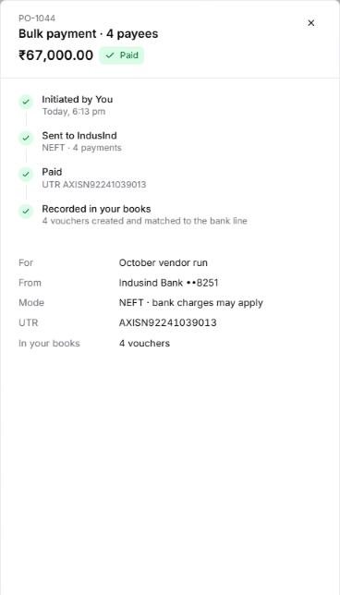  Figure 32: Bulk payout paid: UTR and 4 vouchers in the books

6.3 Expired connection
- When the IndusInd connection lapses, Overview shows the last known balance, flags connection expired under Needs attention, and pauses payouts from that account.
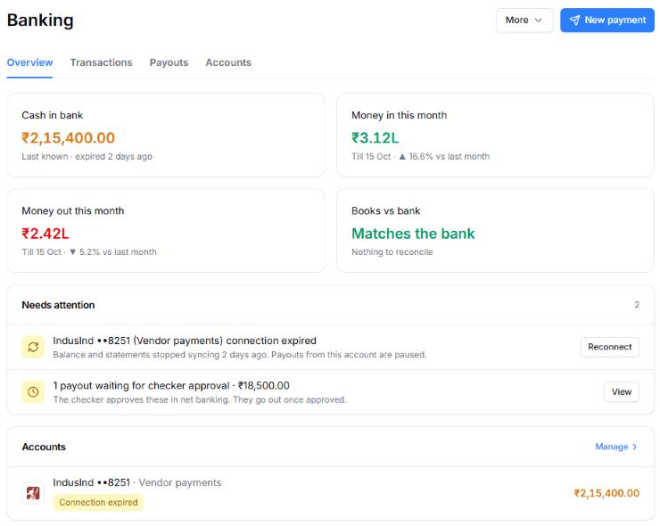
Figure 33: Overview with the IndusInd connection expired
- Reconnect opens the Connect dialog with the approval choice kept. It asks for the details again, then goes through net banking approval as in section 2.
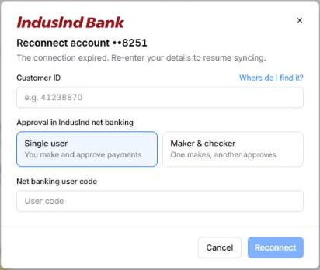
Figure 34: Reconnect account ••8251

7. Reference

7.1 Dev panel switches
In the prototype, { } at the bottom of the sidebar › Banking sets how the simulated bank answers the next time LEDGERS asks.
Group | Switch | Options | Shows
Business stage | Stage | New business · no bank … Several banks | Swaps the whole dataset
Try | Approve payouts, Fail a payout, Reset data | Buttons | The checker approves everything waiting; a processing payout fails; reset this stage
Bank API | Connect / Reconnect banking | Succeeds, Rejected | Section 1.3's rejection
Bank API | Approved in net / corporate banking | Approved, Not yet | Section 2's "Not approved yet"
Bank API | Checker approved new beneficiaries | Approved, Not yet | Section 3's "Not approved yet"
Accounts | Connection, per account | Live, Requested, Approval, Expired, Off | Any connection state directly
Accounts | Approval, per account | Checker, Single | Switch between the maker & checker and single-user flows
Accounts | Bank balance | Normal, Low | The balance checks in sections 4–5

7.2 Open questions
- The three approval steps ("Open Connected Banking requests", …) are placeholders: confirm IndusInd's exact net banking menu names.
- Confirm the beneficiary code rules with IndusInd: 20 characters, A–Z and 0–9, unique per Customer ID.
- Schema change: add the extra_field JSON column to the employee table (contacts already have it, with nested objects).
- Does IndusInd's API return a beneficiary id (bank_reference), and a reason when the checker rejects one?

