Bharat Connect × LEDGERS
Contacts, Invoices and Bills: Screens and Flows (Hand-over)
Document owner: Akhil Manoj · Audience: LEDGERS product, design and engineering · Version 1.2 · 14-Oct-26
Section owners: Contacts and Catalog — Karthik · Invoices — Vairavan · Bills — Ranjith
Sources: the clickable prototype (github.com/akhilledgers/bharatconnectflow, branch bills-item-review-bc-view), the Partner development and integration handbook v1.8 (R3.8), the B2B Swagger R3.8 v1.30, and the Flow Audit against R3.8 (13-Oct-26).

Version History
Version | Date | Created / Updated by | Description | Review Date | Reviewed by
1.0 | 13-Oct-26 | Akhil Manoj | Initial version: Contacts, Sales Invoices and Bills screens and flows
1.1 | 13-Oct-26 | Akhil Manoj | Split into three owner sections (Contacts — Karthik, Invoices — Vairavan, Bills — Ranjith); added Catalog and the Match catalog and create feature; added proposed table schema per section
1.2 | 14-Oct-26 | Akhil Manoj | Bills: default list shows only created bills; Bharat Connect view without the B column; supplier's invoice number in place of internal ids; vendor contact mapped to an existing contact or created from the page (3.5); Appendix A: invoice fields received and sent over the API

Index
Overview (all owners)
What's new in version 1.2
Owners
Phase 1 decisions
The rule behind every screen
Top bar badge (shared)
How every Bharat Connect action behaves (shared)
Running the prototype (shared)
1. Contacts
1.1 Contacts list
1.2 Create Contact: Autofill from GSTIN
1.3 Contact page
1.4 Catalog and the Match catalog and create rules
1.5 Rules
1.6 Data to store (proposed — engineering to confirm)
1.7 Open items
1.8 Try it in the prototype
2. Invoices
2.1 Flow
2.2 Invoices list
2.3 Create Invoice
2.4 After Create: review and send
2.5 Invoice page by status
2.6 Cancel & Delete
2.7 Edit and delete rules
2.8 Rules
2.9 Data to store (proposed — engineering to confirm)
2.10 Open items
2.11 Try it in the prototype
3. Bills
3.1 Flow
3.2 Purchase Invoices list
3.3 Bharat Connect view
3.4 Create Purchase Invoice from Bharat Connect
3.5 Vendor contact: map or create (new in 1.2)
3.6 Match catalog and create: items
3.7 Match catalog and create: Review popup and account type
3.8 Reject
3.9 After Create
3.10 Supplier changes and after Accept
3.11 Rules
3.12 Data to store (proposed — engineering to confirm)
3.13 Open items
3.14 Try it in the prototype
Appendix A. Invoice fields received and sent
A.1 Receiving: supplier's invoice → Create Purchase Invoice
A.2 Sending: LEDGERS sales invoice → reqSendInvoice

Overview (all owners)
This document hands over the second part of the Bharat Connect integration: Contacts, Sales Invoices and Bills. It is split into three sections, one per owner. Each section shows every screen, what the user sees in each state, the rules, the data to store, and the open items for that owner. Onboarding, the Bharat Connect profile and B2B IDs are in the separate Onboarding hand-over (03-Oct-26).

What's new in version 1.2
Change | Where | Section
The Purchase Invoices list shows only bills in the books. Received invoices that are waiting, rejected or cancelled are only in the Bharat Connect view. | Purchase Invoices list | 3.2
The Bharat Connect view drops the B marker column (every row there came over Bharat Connect). | Bharat Connect view | 3.3
Purchase Invoice Number shows the supplier's own invoice number (e.g. VFS/26-27/2031), never LEDGERS' internal id, so it can't be mistaken for a bill number. Bill Number stays "—" until created. | List, Create page, bill page | 3.2–3.4
The vendor is mapped to an existing contact whenever there is one; a contact is created only when there isn't (Select contact or + Create Contact, prefilled). Create needs a vendor contact. | Create Purchase Invoice | 3.5
Create Contact can be opened from Create Purchase Invoice, prefilled from the supplier's invoice, and returns to the page. | Create Contact | 1.2
Fields received and sent in the invoice APIs, mapped to LEDGERS. | Appendix A | A

Owners
Section | Owner | Covers
1. Contacts | Karthik | Contacts list, Create Contact, contact page; the Catalog (Create Catalog, catalog items) and the rules of the Match catalog and create feature
2. Invoices | Vairavan | Sales invoices: list, Create Invoice, send, the buyer's answer, Cancel & Delete
3. Bills | Ranjith | Purchase Invoices list and Bharat Connect view, Create Purchase Invoice from Bharat Connect, Reject; implementation of Match catalog and create, including account type

Match catalog and create sits in two sections on purpose: Karthik owns the catalog and the matching rules (1.4), Ranjith builds them into the bill screens (3.6–3.7). Both sections describe the same feature from their side.

Phase 1 decisions
Decision | What it means on screen | Decided
Accept / Reject only | Bills offer Create (= Accept) and Reject. Return and Edit & Resend are built in the prototype but switched off. | 10-10-2026
Bharat Connect uses LEDGERS' existing role permissions | Send / Cancel an invoice needs Sales → Invoice → Update. Creating a bill from Bharat Connect needs Purchase → Bill → Create and Update. No separate Bharat Connect permission group. | 10-10-2026
A received invoice is not a bill until the user creates it | Received invoices wait in the Bharat Connect view as "Not created": not in totals, not editable, no LEDGERS bill number until created. | 12-10-2026
Nothing is sent automatically | Creating a sales invoice never sends it; the user reviews it and clicks Send. | Prototype
Backend keeps status, remarks and one current version | No version-history table in Phase 1. | 10-10-2026

The rule behind every screen
Not connected: every screen is the normal LEDGERS screen plus one dismissible "Onboard to Bharat Connect" banner. Connected: the same screens at the same addresses, with Bharat Connect added in place: a strip, a column, a status, a button. The one exception is Bills, where received invoices get their own Bharat Connect view on the same page, because they are not bills until created.

Top bar badge (shared)
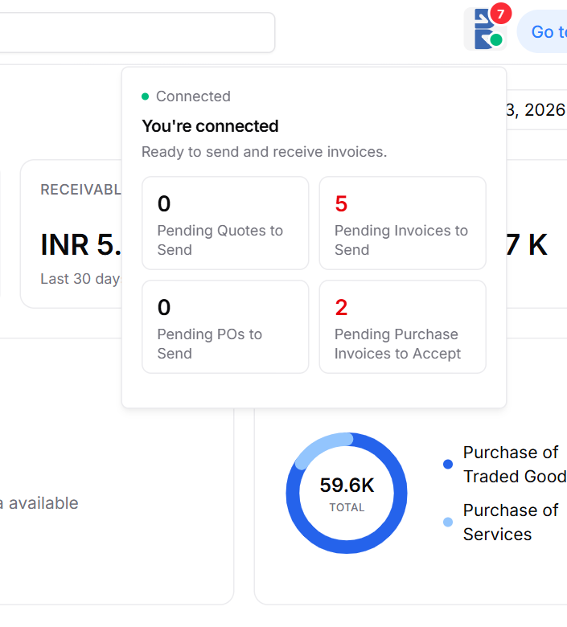
Figure 1: Top-bar badge and popover when connected
Element | Behaviour
Badge | Bharat Connect "B" mark with a status dot (green = connected). The red number counts items waiting: invoices to send, purchase invoices to accept, plus quotes and POs.
Popover (connected) | "You're connected · Ready to send and receive invoices." Counts: Pending Quotes to Send, Pending Invoices to Send, Pending POs to Send, Pending Purchase Invoices to Accept. Each opens its list.

How every Bharat Connect action behaves (shared)
Every action is answered in two steps: Bharat Connect acknowledges it within 5 seconds, and the real result arrives later, within 180 seconds (handbook Annexure E). With no result by then, LEDGERS asks for the transaction's status (Annexure P). Every screen that sends something therefore needs a visible "in progress" state. Every call and its result is logged in bc_events (2.9).

Running the prototype (shared)
Run npm install then npm run dev in the repository and open http://localhost:5173. The { } button at the bottom of the sidebar opens the dev panel. To see connected screens: Dev panel → Bharat Connect → Force connection state → Connected. Each section ends with its own scenarios.

1. Contacts
Owner: Karthik · also owns the Catalog and the Match catalog and create rules
Bharat Connect needs the counterparty's B2B ID before anything can be sent. LEDGERS finds it from the contact's GSTIN once, stores it on the contact, and reuses it everywhere. The Catalog is where every item a bill line is booked against lives.

1.1 Contacts list
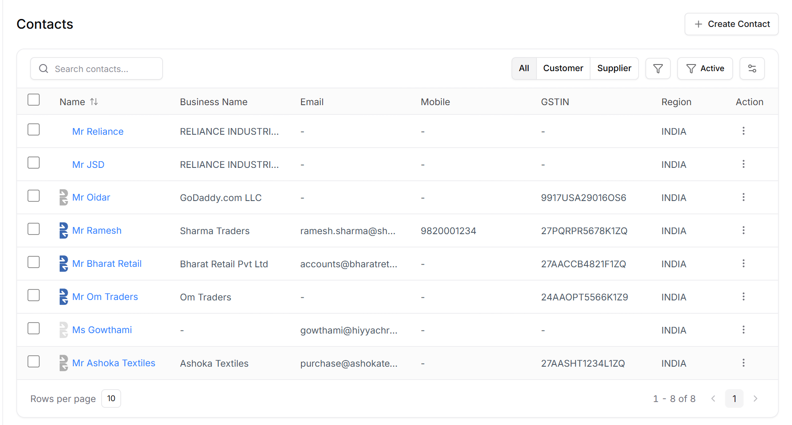
Figure 2: Contacts list, connected
Element | Behaviour
B mark before the name | Full colour: on Bharat Connect. Greyed, with Invite on hover: checked, not on Bharat Connect. Faint: no GSTIN or PAN on file, never checked. Fixed slot so names stay aligned.
Filters | All / Customer / Supplier, as today.

1.2 Create Contact: Autofill from GSTIN
Typing a 15-character GSTIN fills name, PAN and address from the GST portal, as today. When the business is connected, the same box also searches Bharat Connect (reqSearchEntity).
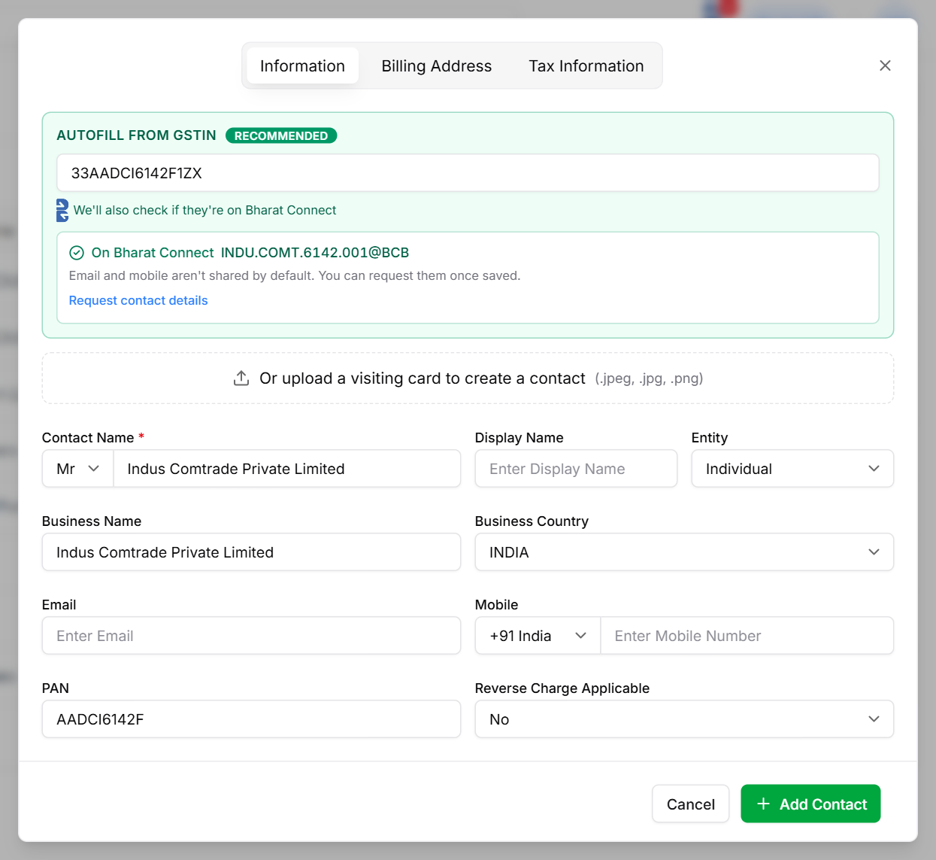
Figure 3: Create Contact: the contact is on Bharat Connect
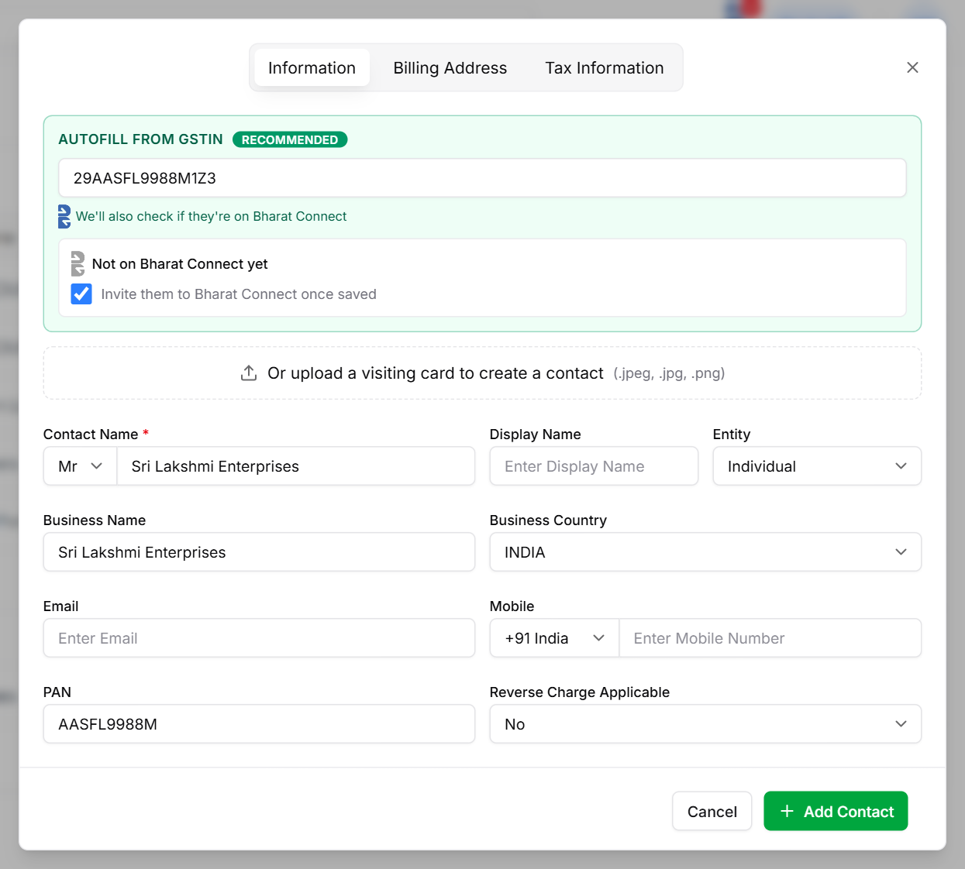
Figure 4: Create Contact: the contact is not on Bharat Connect
Element | Behaviour
"We'll also check if they're on Bharat Connect" | Shown only when this business is connected.
Found: "On Bharat Connect" + B2B ID | Name fills from Bharat Connect. "Email and mobile aren't shared by default. You can request them once saved." with Request contact details (reqNonPublicInfo). Email and mobile are never filled from search.
Not found: "Not on Bharat Connect yet" | "Invite them to Bharat Connect once saved" is ticked by default. Add Contact saves and sends the invite (reqSendInvite).
Add Contact | Saves the contact with its B2B ID, or marks it "not on Bharat Connect".
Opened from Create Purchase Invoice (new in 1.2) | Prefilled from the supplier's invoice: name, GSTIN (with GST autofill of PAN and address), type Supplier, and "On Bharat Connect" with the B2B ID from the invoice (no search needed). Add Contact returns to the purchase invoice with the vendor mapped (3.5).

1.3 Contact page
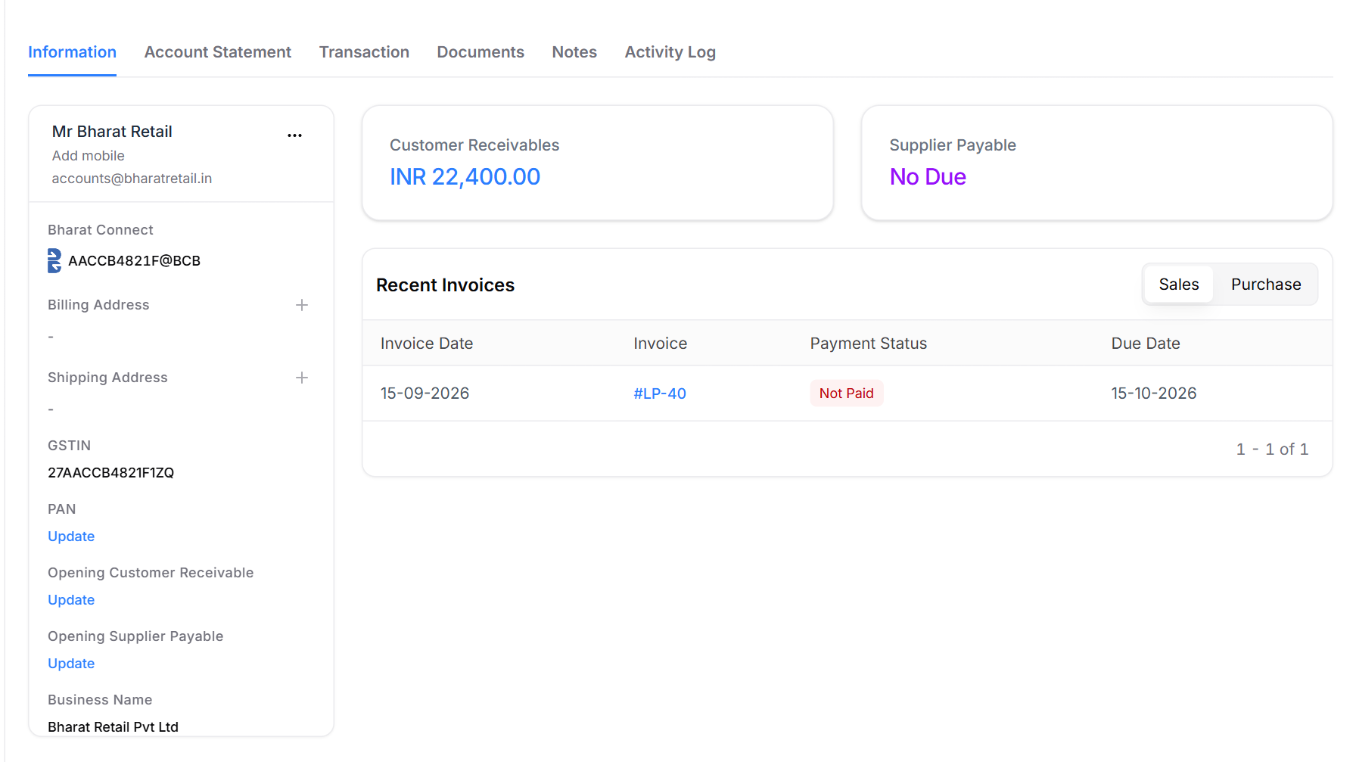
Figure 5: Contact page: Bharat Connect B2B ID in the contact details
Element | Behaviour
Bharat Connect | The contact's B2B ID with the B mark, under the contact details.
Receivables / Payables, Recent Invoices | Invoices and bills are matched to the contact by B2B ID (by name when there is none).

1.4 Catalog and the Match catalog and create rules
Every line of a bill created from Bharat Connect is booked against a catalog item. Karthik owns the catalog and these rules; Ranjith builds them into the bill screens (3.6–3.7).
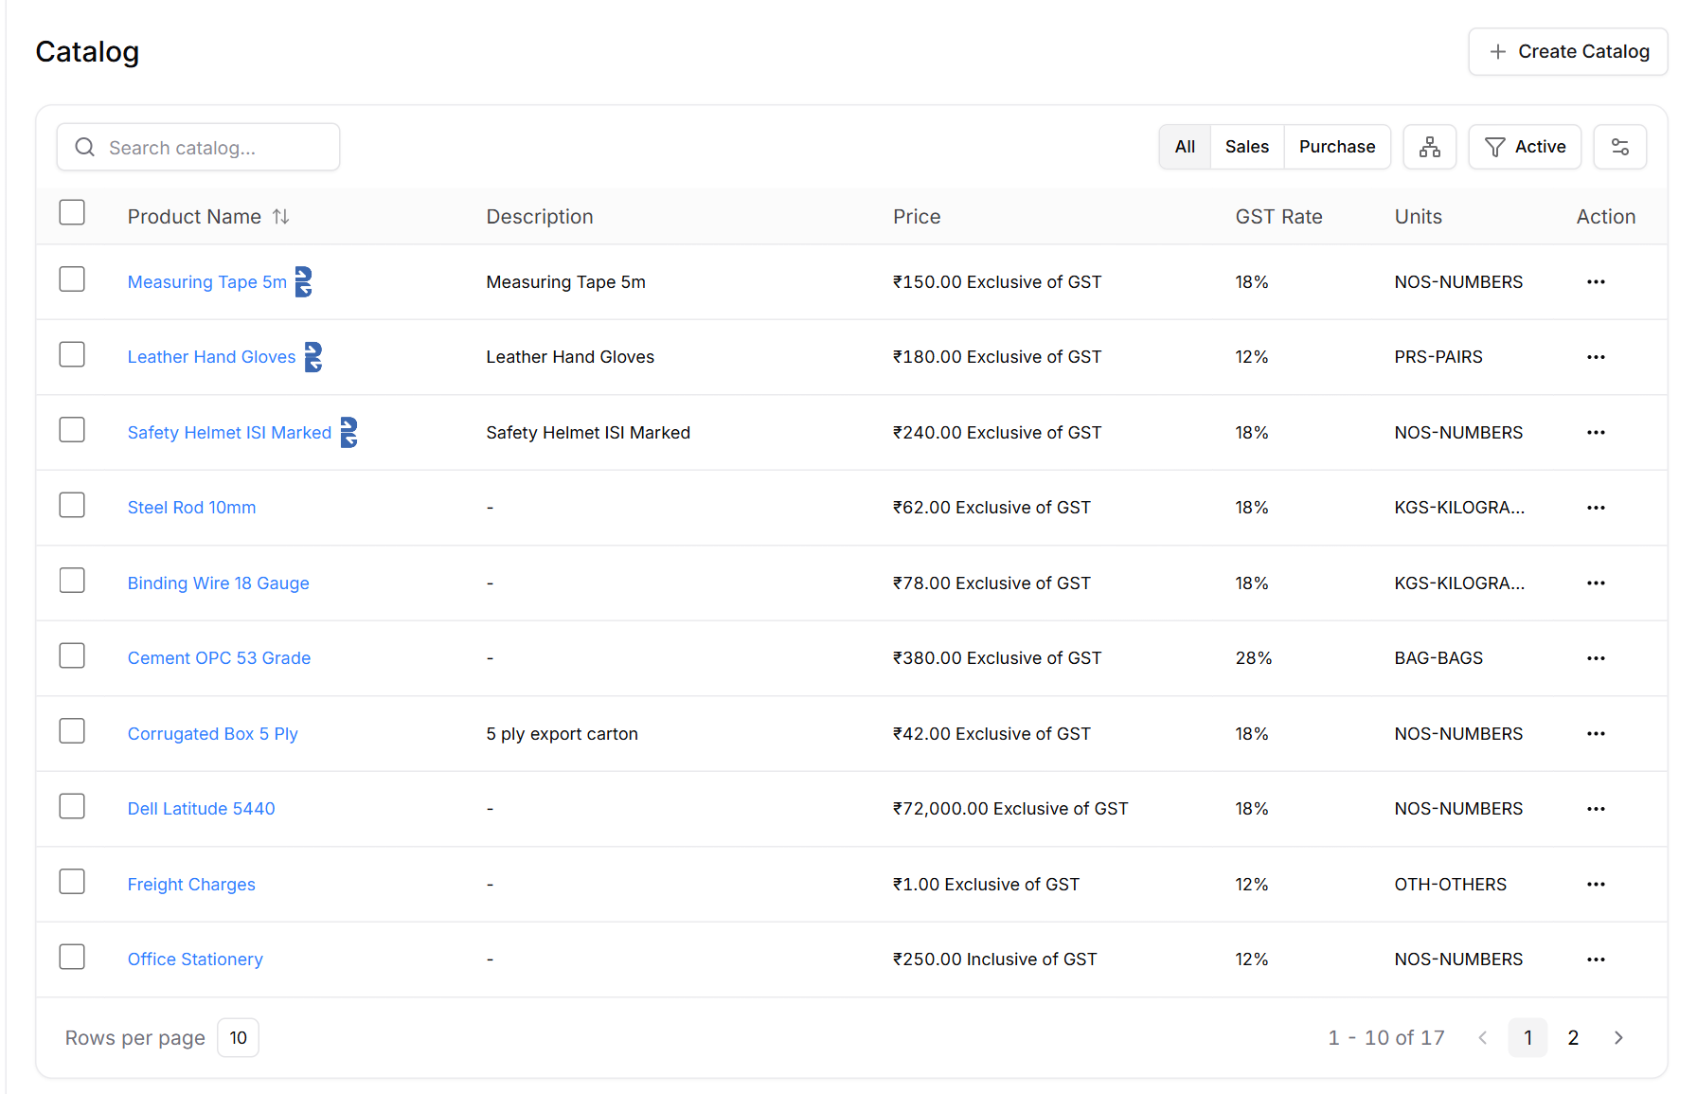
Figure 6: Catalog list: items added from a Bharat Connect bill carry the B mark
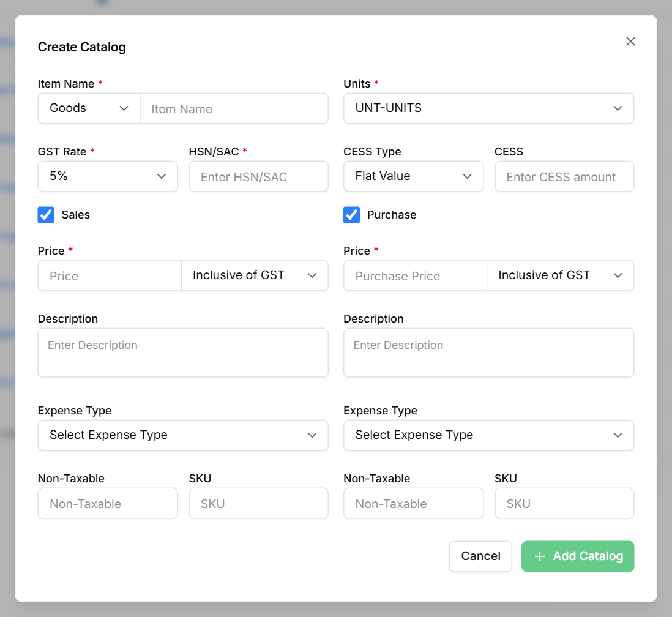
Figure 7: Create Catalog: Sales and Purchase sides, each with its Expense Type
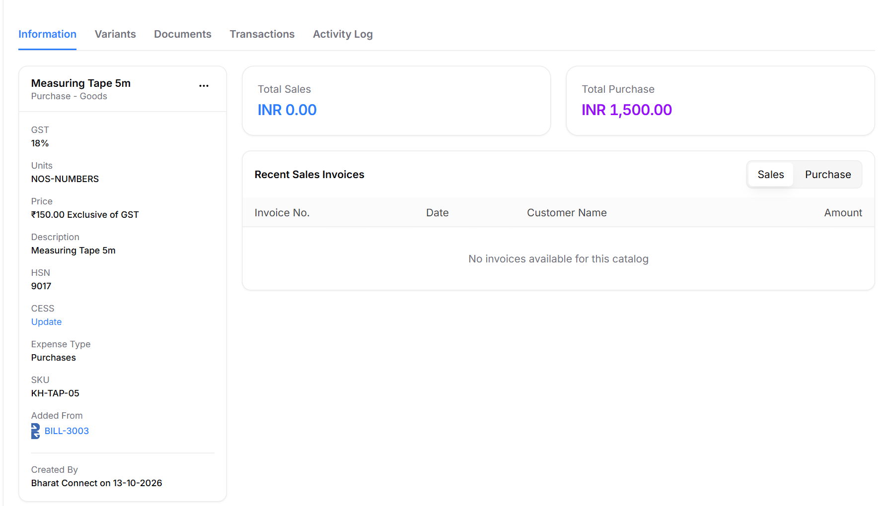
Figure 8: Catalog item added from a bill: Expense Type, SKU (supplier's code), Added From the bill, Created By Bharat Connect

Catalog fields that matter for Bharat Connect
Field | Used for
Item Name, HSN/SAC, GST Rate, Units, Goods / Services | Required by LEDGERS. Name and HSN drive matching; a new item from a bill is prefilled from the supplier's line.
Purchase side ticked | An item can only be bought if Purchase is on. A Sales-only item matched on a bill gets Purchase turned on.
Purchase → Expense Type | The account type the bill line posts to (Purchases, Raw Materials, Packing Materials, Freight Inward, Professional Fees, Repairs & Maintenance, Office Expenses, Consumables).
Purchase → SKU | Filled with the supplier's item code when the item is added from a bill.
Added From · Created By | Set when an item is created from a bill ("BILL-3003", "Bharat Connect"); the list shows the B mark.

Match catalog and create: rules
- Linked before: the same supplier's item (by its item code, or its name when there is no code) was linked on an earlier bill → use that catalog item.
- Exact match: same HSN and same name (ignoring case, spaces and punctuation), Purchase items first → use it.
- Possible match: the most similar name among items with the same HSN (or a close name when the supplier sent no HSN) → preselected, but the user must confirm it.
- No match: nothing is chosen. The user searches the catalog (top 5, ranked by HSN and name) or adds a new item. A line never defaults to "new item".
Rule | Detail
Add new item | Prefilled from the supplier's line: name, HSN/SAC, GST rate, units, Goods/Services. All required. Created with the Purchase side on, price from the bill, SKU = supplier's code.
Account type (Expense Type) | Existing item → its own Expense Type (mapped, no question). New item → chosen in the popup; preselected from an item with the same HSN, else from the HSN/SAC (freight → Freight Inward, packing → Packing Materials, stationery → Office Expenses, services → Professional Fees), else Purchases.
Remember for future bills | Ticked by default. Saves a link supplier + item → catalog item, so the next bill matches automatically.
Nothing is saved until Create | New items and links are written only when the purchase invoice is created. A rejected bill adds nothing.

1.5 Rules
- Search once by GSTIN, store the B2B ID on the contact, and don't search again on every invoice (handbook §2.1).
- Search is limited to 50 results; keep the limit configurable (Release Note 3.8).
- Email and mobile come only through a consent request (handbook §2.2–2.3).

1.6 Data to store (proposed — engineering to confirm)
contacts (new columns) — Bharat Connect identity of a customer or supplier
Column | Type | Notes
bc_b2b_id | varchar(100) null | B2B ID found by search; null when not on Bharat Connect
bc_check_status | enum | not_checked · found · not_found
bc_checked_at | datetime null | Last search; drives the periodic re-check of not_found contacts
bc_verification_level | tinyint null | Counterparty's level from the search (1 / 3 / 5)
bc_invite_sent_at | datetime null | When reqSendInvite was sent

bc_contact_detail_requests (new) — Requests for a counterparty's email / mobile
Column | Type | Notes
id | bigint | Primary key
contact_id | fk → contacts
txn_id | char(35) | Bharat Connect transaction id of reqNonPublicInfo
requested_fields | json | e.g. ["email", "mobile"]
status | enum | sent · shared · declined
requested_at / responded_at | datetime

catalog_items (new columns) — Items created from a bill
Column | Type | Notes
added_from_bill_id | fk → purchase_invoices null | Bill that created the item (Added From)
created_source | enum | user · bharat_connect (Created By)
purchase_expense_type | existing field | Already on the Purchase side as Expense Type; must be set for every purchasable item

catalog_item_links (new) — Remembered supplier item → catalog item
Column | Type | Notes
id | bigint | Primary key
business_id | fk | Our business
supplier_b2b_id | varchar(100) | Supplier's B2B ID
supplier_item_key | varchar(300) | "c:" + supplier item code, or "n:" + normalised item name when there is no code
catalog_item_id | fk → catalog_items | Linked item
created_from_bill_id | fk → purchase_invoices | Bill where the link was made
created_at | datetime | Unique on (business_id, supplier_b2b_id, supplier_item_key)

1.7 Open items
Item | Reference
Re-search contacts marked not on Bharat Connect periodically | Handbook §2.1 note 4
Invite automatically when a contact with a B2B ID is saved (today we only invite contacts not on it) | Handbook §2.4 note 1
Answer other businesses' requests for our contact details (show the request; optional auto-reply) | Handbook §2.3
Ask for the account type when a Sales-only item is bought for the first time (today it is preselected silently) | LEDGERS accounting
Carry the GST tax type from the bill (Exempt, Nil, Zero …) onto a new item's Non-Taxable setting | Release Note 3.8 gstTaxType

1.8 Try it in the prototype
To see | Do this
Contact on / not on Bharat Connect | Contacts → Create Contact; GSTIN 33AADCI6142F1ZX (on it) or 29AASFL9988M1Z3 (not on it)
Items added from a bill | Dev panel → Purchase → Bill item scenarios → All new items → Load; add each line as new; Create; then open Catalog

2. Invoices
Owner: Vairavan
A sales invoice is created in LEDGERS exactly as today. Sending it over Bharat Connect is a separate, deliberate click, and the buyer's answer comes back onto the same invoice.

2.1 Flow
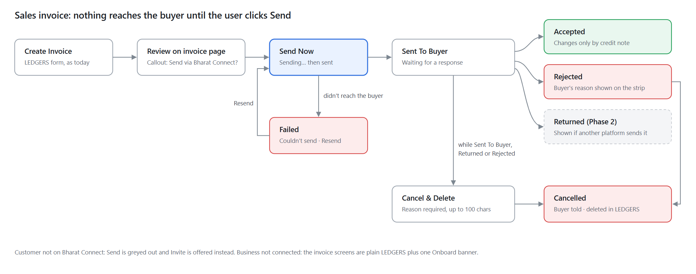
Figure 9: Sales invoice flow

2.2 Invoices list
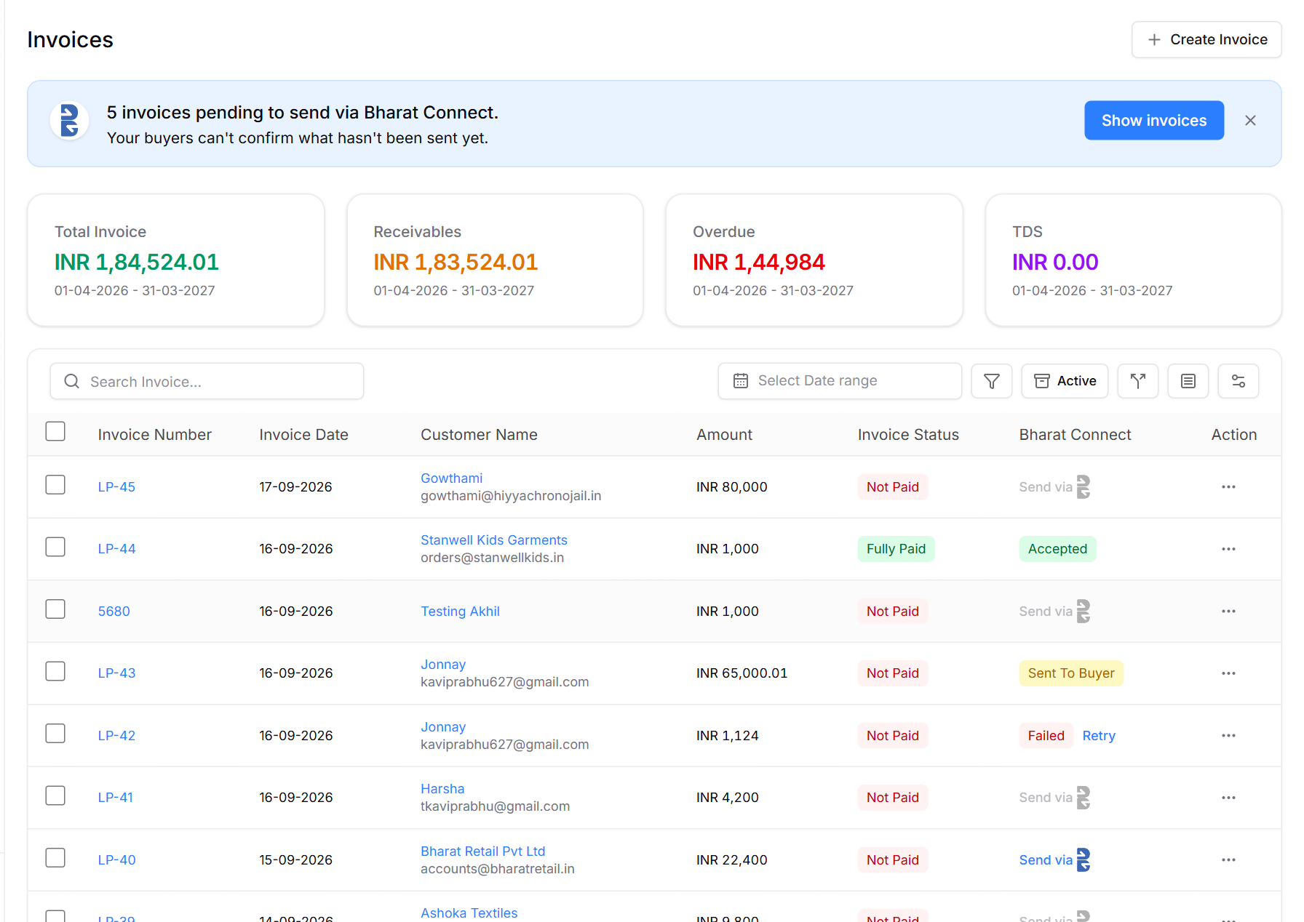
Figure 10: Invoices list, connected: Bharat Connect column
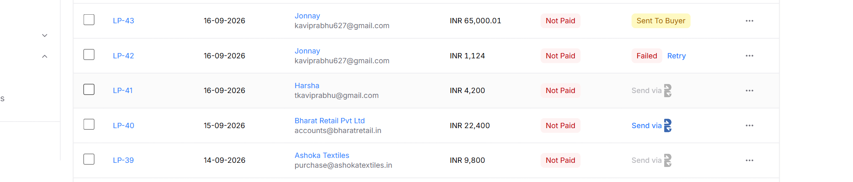
Figure 11: Column states: Sent To Buyer, Failed with Retry, Send via (customer on Bharat Connect), greyed Send via (customer not on it)
Column shows | Meaning | User can
Send via [B] (blue) | Not sent; customer is on Bharat Connect | Click to send
Send via [B] (grey) | Customer is not on Bharat Connect | Hover → Invite to Bharat Connect
Sending… | Being delivered | Wait
Sent To Buyer | Delivered; waiting for the buyer | —
Accepted | Buyer accepted | —
Returned | Buyer returned it (only from other platforms in Phase 1) | Review
Rejected | Buyer rejected it | Cancel & Delete from the invoice page
Failed + Retry | Didn't reach the buyer | Retry
Cancelled | We cancelled it | —

The Filter menu adds Bharat Connect statuses (Pending to send, Sent To Buyer, Accepted, Returned, Rejected, Cancelled, Failed). The banner "N invoices pending to send via Bharat Connect" applies Pending to send in place and can be dismissed for 3 days. Not connected: the banner reads "Get paid faster — onboard to Bharat Connect and send invoices instantly." (7-day snooze, shared with the Dashboard).

2.3 Create Invoice
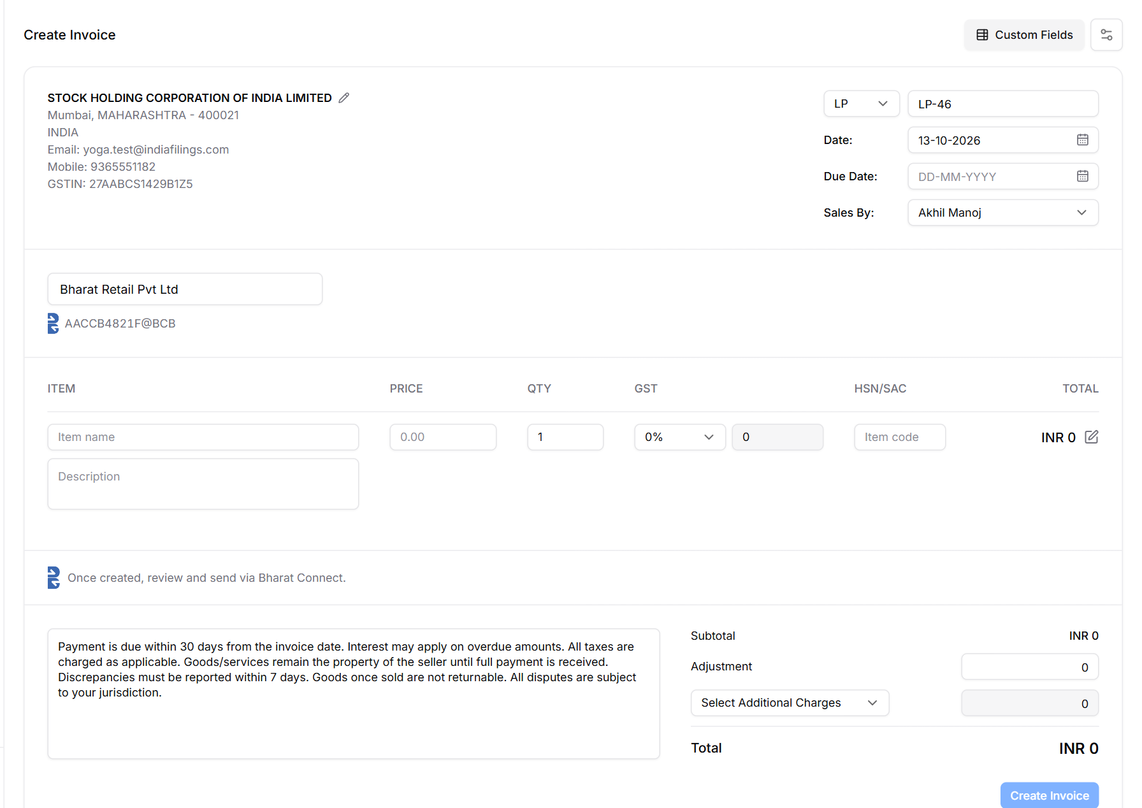
Figure 12: Create Invoice: customer on Bharat Connect
The normal LEDGERS form. Choosing a customer on Bharat Connect shows their B2B ID under the name and "Once created, review and send via Bharat Connect." There is no send checkbox: creating never sends.

2.4 After Create: review and send
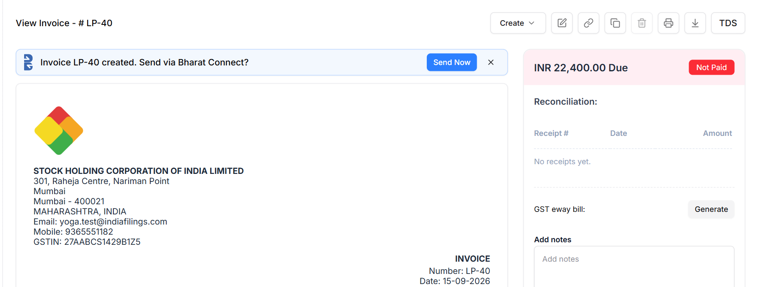
Figure 13: Invoice page right after Create
A callout above the invoice: "Invoice LP-40 created. Send via Bharat Connect?" with Send Now (reqSendInvoice). It shows only right after Create and can be dismissed. Customer not on Bharat Connect → Invite instead; business not connected → Onboard to Bharat Connect.

2.5 Invoice page by status
Once sent, a strip above the invoice shows where it stands, with the counterparty's comment (speech bubble) and the history of status changes (clock).
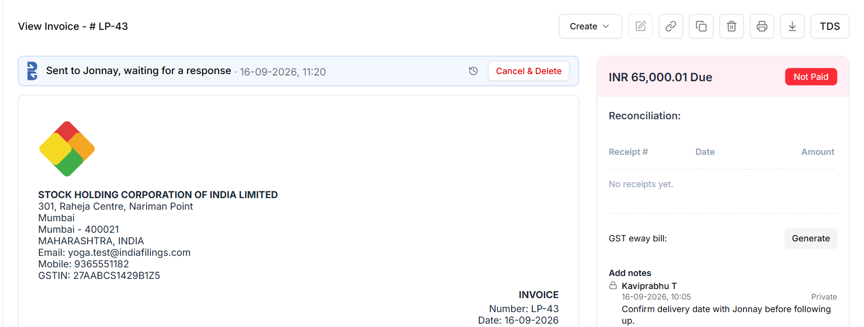
Figure 14: Sent To Buyer
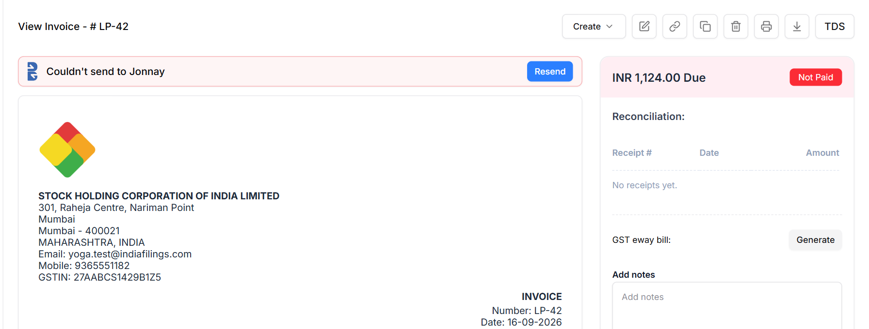
Figure 15: Failed: didn't reach the buyer
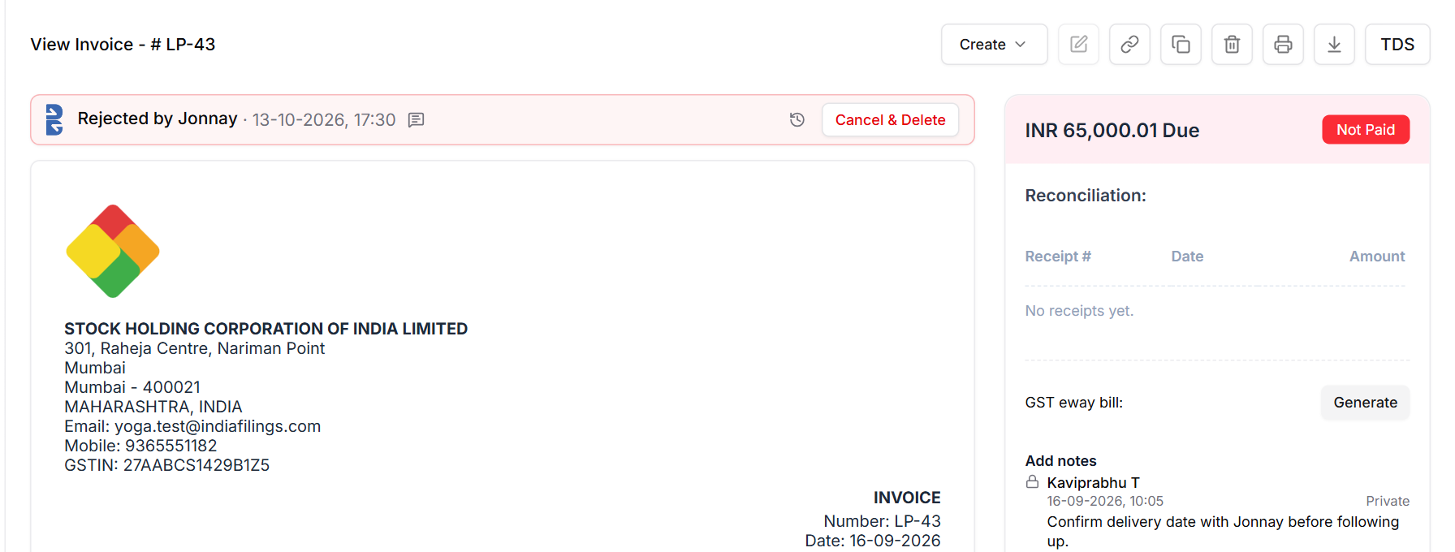
Figure 16: Rejected by the buyer
Status | Strip text | Strip action
Sending | Sending… | —
Sent To Buyer | Sent to {buyer}, waiting for a response · date | Cancel & Delete
Failed | Couldn't send to {buyer} | Resend
Accepted | Accepted by {buyer} · date (+ comment) | None; changes only by credit note
Rejected | Rejected by {buyer} · date (+ comment) | Cancel & Delete
Returned (from other platforms) | Returned by {buyer} · date (+ what to fix) | Cancel & Delete
Cancelled | Deleted in LEDGERS, read-only | —

2.6 Cancel & Delete
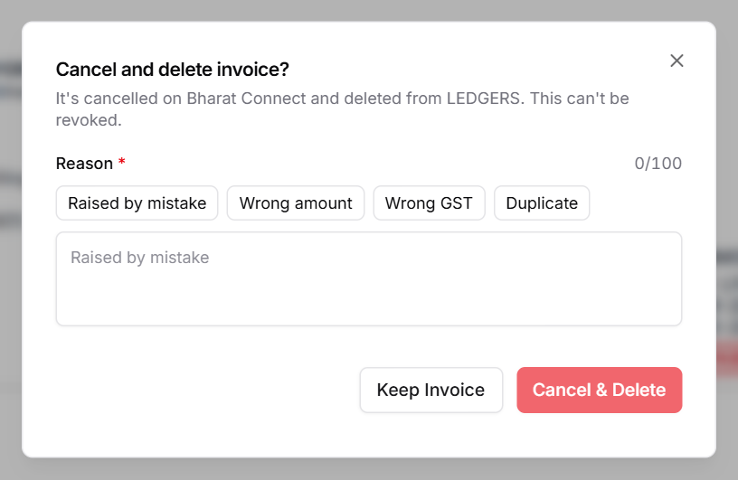
Figure 17: Cancel & Delete
"Cancel and delete invoice? It's cancelled on Bharat Connect and deleted from LEDGERS. This can't be revoked." Reason required, up to 100 characters, with quick picks (Raised by mistake, Wrong amount, Wrong GST, Duplicate). Sent as reqStatusChangeInvoice with supplierAction CANCEL. The deleted invoice is kept for the record, read-only.

2.7 Edit and delete rules
Invoice state | Edit | Delete
Not sent over Bharat Connect | Normal edit | Normal delete
Sent To Buyer / Returned | Blocked: "Sent on Bharat Connect. Cancel & delete it, then create a new one." | Cancel & Delete
Accepted | Blocked: "Accepted invoices can't be edited. Use a credit note." | Blocked: raise a credit note
Rejected | Blocked: cancel & delete, then create a new one | Cancel & Delete
E-invoice (has an IRN) | Never editable | Blocked until the IRN is cancelled
Filed in GSTR-1 | — | Blocked: raise a credit note
Has receipts | — | Blocked: remove the receipts first

2.8 Rules
Rule | Reference
Send only to a buyer with a B2B ID; both businesses at Level 1 or above | Handbook §5.1, Annexure Q
Cancel only from Sent To Buyer, Returned or Rejected; reason 1–100 characters, no double quotes | Annexure H; Excel ReqStatusChangeInvoice; Swagger invoiceStatus.supplierRemarks
Accepted can't be edited or cancelled; correct with a credit note | Annexure H, §5.9
E-invoices are never edited | Handbook §5.2
Before sending: item amounts add up to the total; supplier name and GSTIN match onboarding; only our own bank VPA | Handbook Annexure A §4.1

2.9 Data to store (proposed — engineering to confirm)
sales_invoices (new columns) — Bharat Connect state of a sales invoice
Column | Type | Notes
bc_object_id | char(35) null | Invoice objectId we generate on first send (handbook A§4.1)
bc_send_status | enum | not_sent · sending · sent
bc_status | enum null | Annexure H status: SENT TO BUYER, ACCEPTED, REJECTED, UNDER REVIEW, CANCELLED (later CLOSED, ABANDONED, payment statuses)
bc_buyer_b2b_id / bc_supplier_b2b_id | varchar(100) | IDs the invoice was sent between
bc_version | int | objectVersion; stays 1 in Phase 1 (no Edit & Resend)
bc_last_remarks | varchar(100) null | Latest buyer remarks, shown on the strip
bc_failure_code / bc_failure_detail | varchar null | From the Nack or failed response; drives "Couldn't send"
bc_sent_at | datetime null
deleted_at | datetime null | Soft delete on Cancel & Delete

bc_events (new, shared with Bills) — Every Bharat Connect call and status change; drives the strip's history and comments
Column | Type | Notes
id | bigint | Primary key
document_type / document_id | enum / fk | sales_invoice · purchase_invoice · incoming_invoice
direction | enum | out (we sent) · in (we received)
api | varchar(40) | e.g. reqSendInvoice, respConfirmInvoice, reqStatusChangeInvoice
txn_id / msg_id | char(35) | For matching the asynchronous response and for reqCheckStatus
from_status / to_status | varchar(40) | statusTransition
remarks | varchar(100) null | buyerRemarks or supplierRemarks
ack_result / error_code / error_detail | varchar | Ack or Nack result
payload | json | Full request or response, for audit
actor / created_at | varchar / datetime | User or counterparty; time

2.10 Open items
Item | Reference
Show the payment statuses (Partially Paid, Fully Paid, Payment Initiated) and Closed / Abandoned once those flows exist | Annexure H
Report receipts recorded in LEDGERS as off-platform payments (reqPay), so the buyer sees them | Annexure H, Q; Release Note 3.8
Reminders: at most 3 per invoice | Handbook §6.1

2.11 Try it in the prototype
To see | Do this
Send an invoice | Invoices → LP-40 → Send Now (or Send via in the list)
The buyer's answer | Dev panel → Bharat Connect → Simulate buyer response → Accept / Return / Reject / Fail
Cancel & Delete | Open a Sent To Buyer or Rejected invoice → Cancel & Delete

3. Bills
Owner: Ranjith · also implements Match catalog and create (rules owned by Karthik, 1.4)
A supplier's invoice arrives over Bharat Connect as raw data. It becomes a LEDGERS purchase invoice, with LEDGERS' own bill number and accounting, only when the user creates it, and creating it is the Accept on Bharat Connect.

3.1 Flow
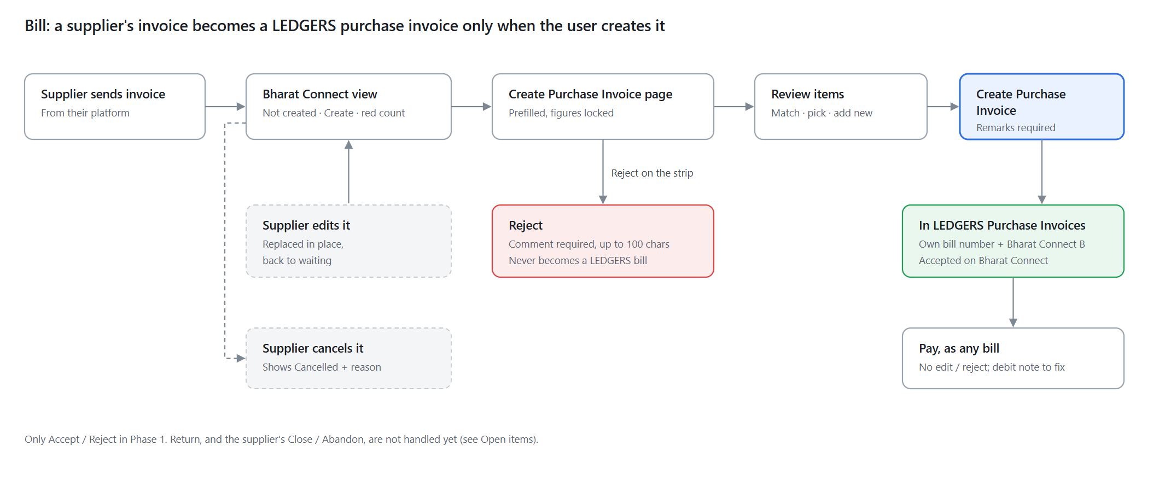
Figure 18: Bill flow

3.2 Purchase Invoices list
Matches the live LEDGERS Purchase Invoices page. By default it shows only bills in the books: LEDGERS' own bills and Bharat Connect invoices that were created (and so accepted). Invoices waiting to be created, rejected or cancelled are not listed here; they live in the Bharat Connect view (3.3).
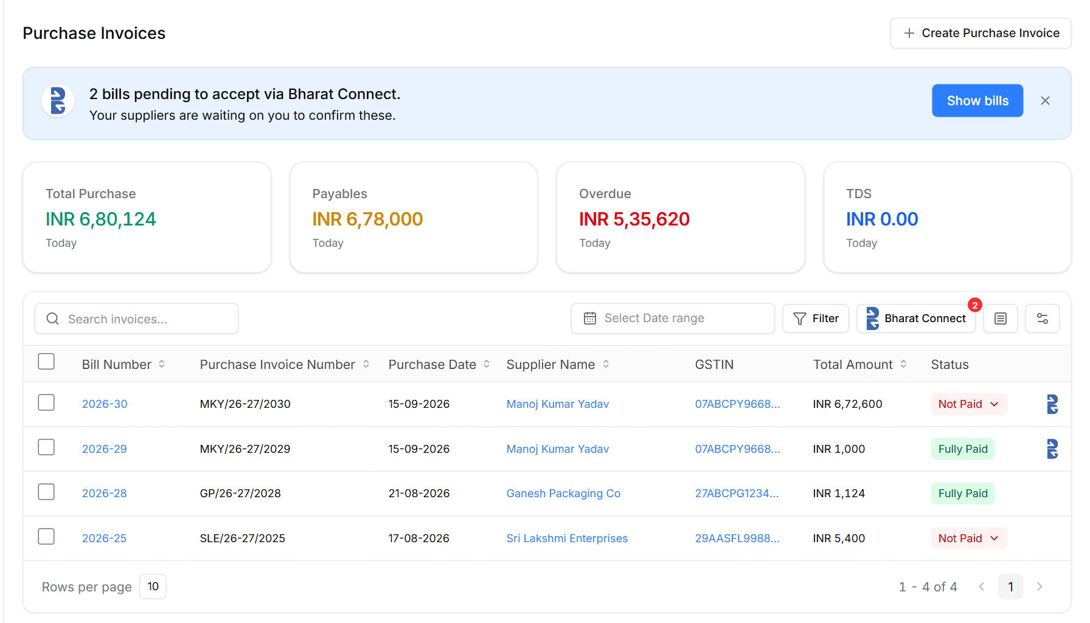
Figure 19: Purchase Invoices list (default view)
Element | Behaviour
Header | Purchase Invoices · Create Purchase Invoice
Stat cards | Total Purchase, Payables, Overdue, TDS (Today). Invoices not yet created are not counted.
Toolbar | Search invoices, date range, Filter, Bharat Connect button with a red count of invoices waiting, columns, settings.
Columns | Bill Number (LEDGERS' own, e.g. 2026-31) · Purchase Invoice Number (the supplier's own number, e.g. MKY/26-27/2030; supplierInvoiceNumber) · Purchase Date · Supplier Name · GSTIN · Total Amount · Status · Bharat Connect mark. Newest bill number first.
Which bills are listed | Created bills only. Waiting, rejected and cancelled Bharat Connect invoices are never in this list or in the stat cards.
Bharat Connect mark | The B logo in its own narrow column after Status marks a bill created from Bharat Connect. It does not change the bill number.
Pending banner | "N bills pending to accept via Bharat Connect. Your suppliers are waiting on you to confirm these." Show bills opens the Bharat Connect view. 3-day dismiss. Not connected: "Onboard to Bharat Connect to receive and confirm bills the moment they land."

3.3 Bharat Connect view
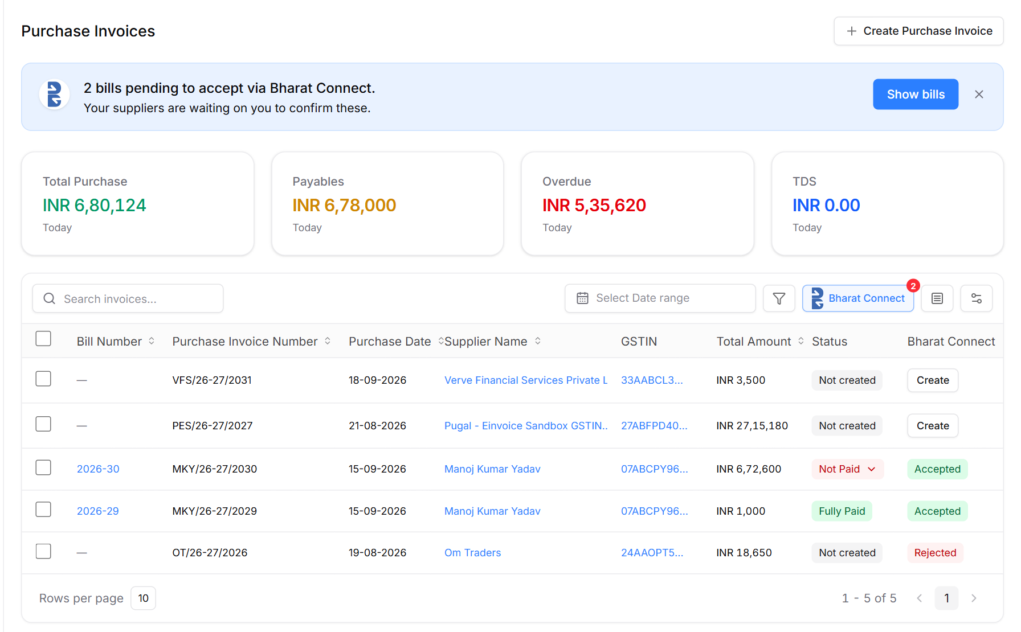
Figure 20: Bharat Connect view: everything received over Bharat Connect
Clicking Bharat Connect lists every invoice received over Bharat Connect in any status, waiting first, with a Bharat Connect column and status filter. Waiting and rejected invoices show Bill Number "—" (no LEDGERS number until created) and Status "Not created"; waiting ones have Create. Purchase Invoice Number is the supplier's number. There is no B marker column here, since every row came over Bharat Connect. Clicking the button again returns to the normal list.

3.4 Create Purchase Invoice from Bharat Connect
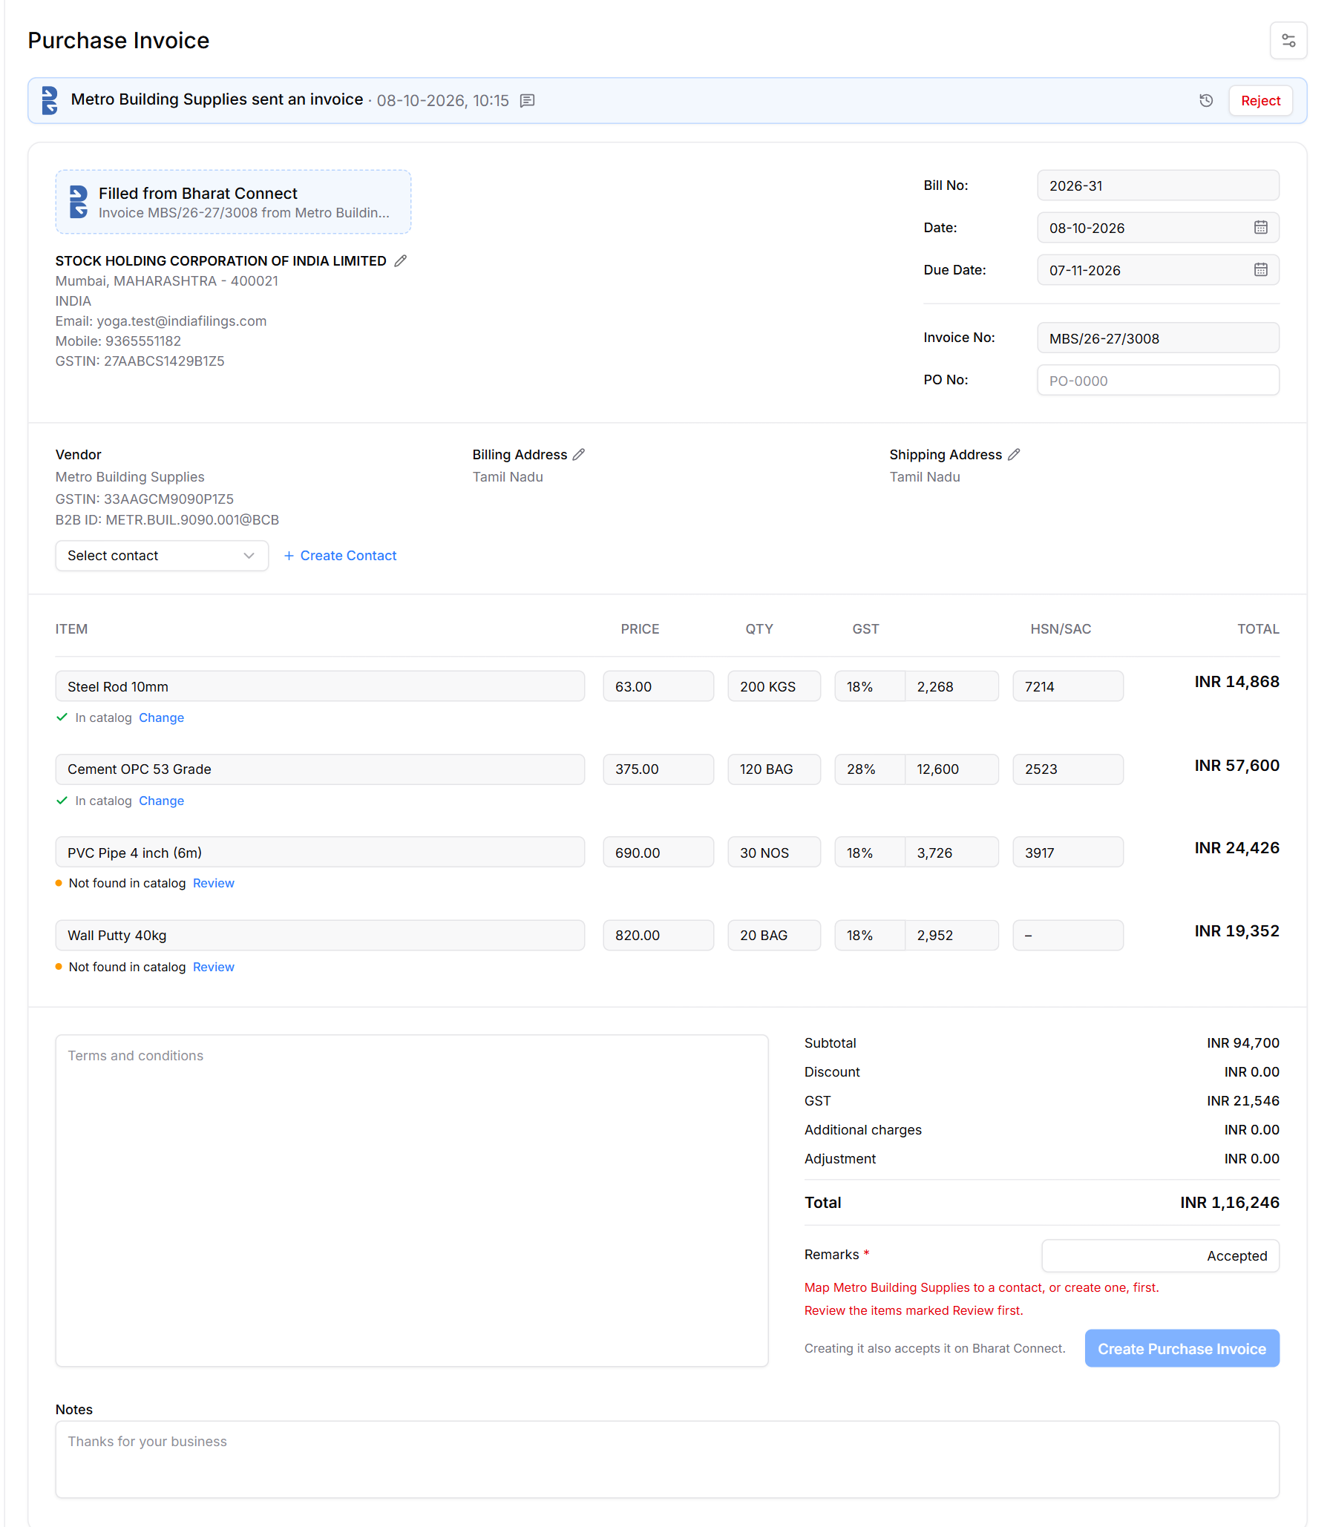
Figure 21: Create Purchase Invoice, prefilled from the supplier's invoice
Part | What it shows / does
Strip | "{Supplier} sent an invoice · date", the supplier's note (speech bubble), history (clock) and Reject.
Filled from Bharat Connect | Card naming the supplier's invoice the page was filled from.
Bill No · Date · Due Date | Bill No = LEDGERS' next number. Date and Due Date from the supplier's invoice.
Invoice No · PO No | Invoice No = the supplier's invoice number (supplierInvoiceNumber, max 50), never LEDGERS' internal id. PO No optional.
Vendor · Billing Address · Shipping Address | As on LEDGERS' form. Vendor: the LEDGERS contact it's mapped to (3.5), or the invoice's own details until mapped; then GSTIN and B2B ID. Addresses come from the contact, else the state from the GSTIN.
Items | The supplier's item name, price, quantity, GST and HSN, locked. Under each item, its catalog match (3.5).
Totals | Subtotal, Discount, GST, Additional charges, Adjustment, Total.
Remarks * | Sent with the acceptance (buyerRemarks). Required, 1–100 characters, no double quotes, prefilled "Accepted". Right-aligned, half the column wide, grows with the text.
Create Purchase Invoice | "Creating it also accepts it on Bharat Connect." Disabled until the vendor is mapped to a contact ("Map {supplier} to a contact, or create one, first."), every item is resolved ("Review the items marked Review first.") and Remarks is filled.

3.5 Vendor contact: map or create (new in 1.2)
LEDGERS books a purchase invoice against a vendor contact. The supplier is mapped to an existing contact whenever there is one; a contact is created only when there isn't.
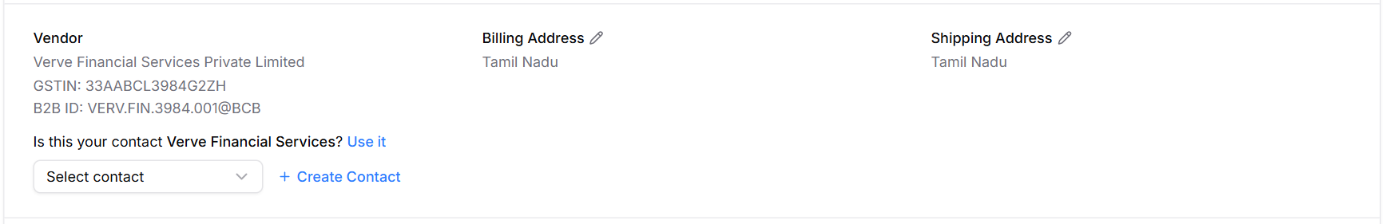
Figure 22: Likely contact found (same name): one click to use it, or pick another, or create
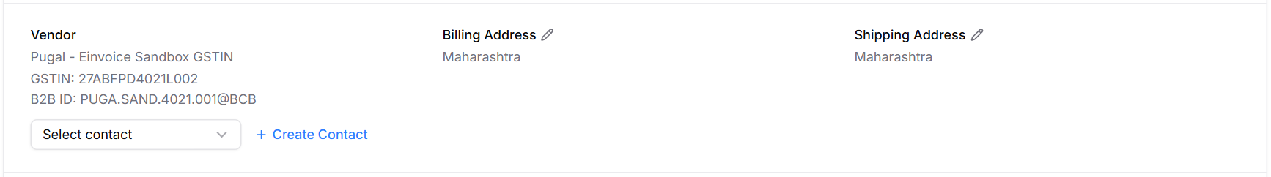
Figure 23: No contact found: Select contact or + Create Contact
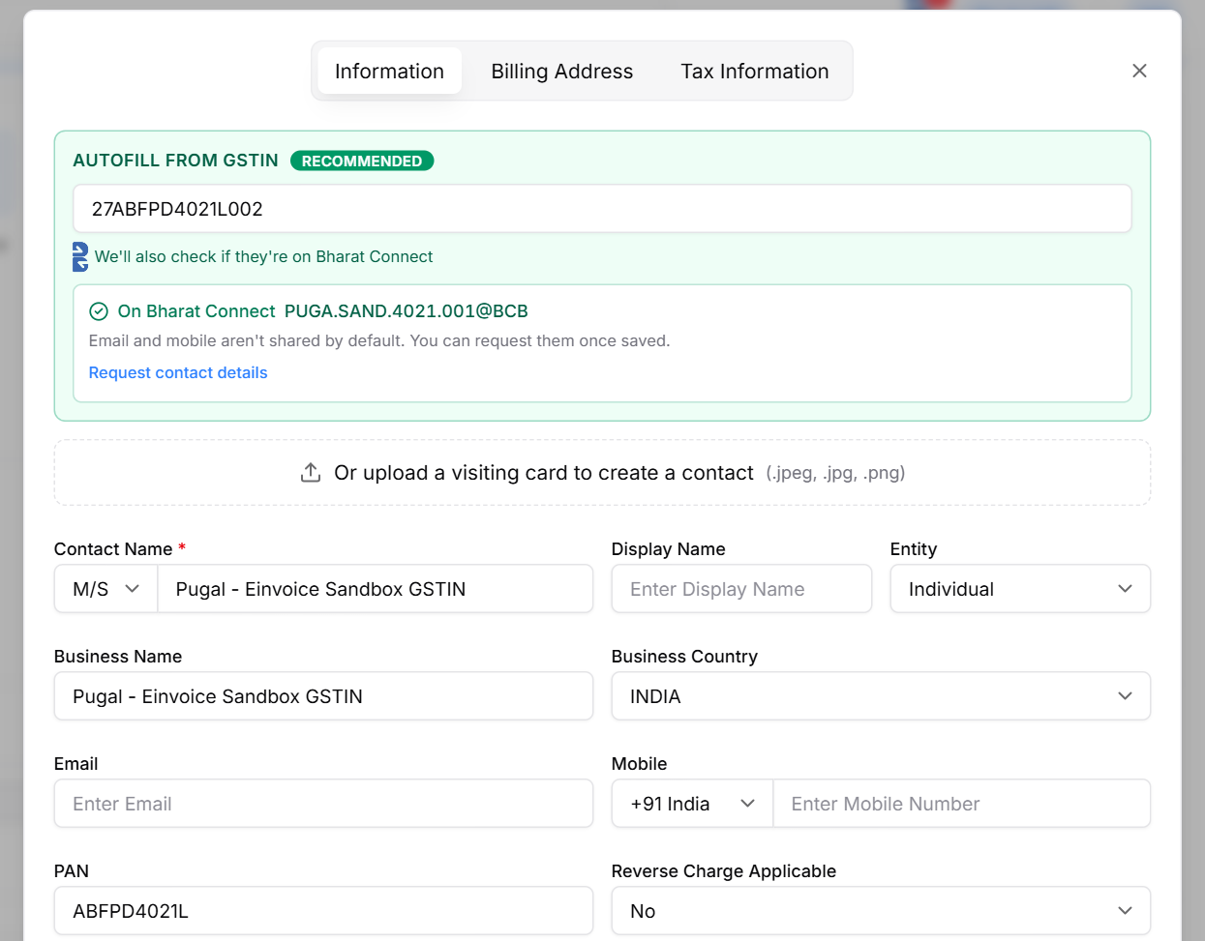
Figure 24: + Create Contact: LEDGERS' Create Contact, prefilled from the supplier's invoice
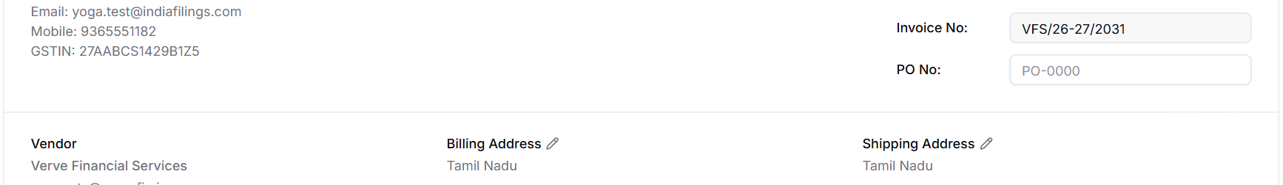
Figure 25: Mapped: vendor details and addresses from the contact, with Change contact
Supplier in Contacts | What the Vendor column shows | User does
Same B2B ID, or same GSTIN | Contact's details; Change contact link | Nothing (mapped automatically)
Same PAN (another state's GSTIN), or same name (ignoring Pvt, Ltd, M/s, punctuation) | "Is this your contact {name}? Use it" above Select contact and + Create Contact | Confirm, or pick another, or create
Not found | Select contact (suppliers first) and + Create Contact | Pick an existing contact, or create one

- A name or PAN match is only suggested, never mapped automatically: it can be a different business or another branch.
- Change contact clears the mapping and shows the choice again.
- On Create, the mapped contact gets the supplier's GSTIN and B2B ID if it didn't have them, so the next bill from that supplier maps by itself.
- Matching order: B2B ID → GSTIN → PAN → name.

3.6 Match catalog and create: items
Implements the rules in 1.4. Each line shows the supplier's item name with its catalog match underneath.
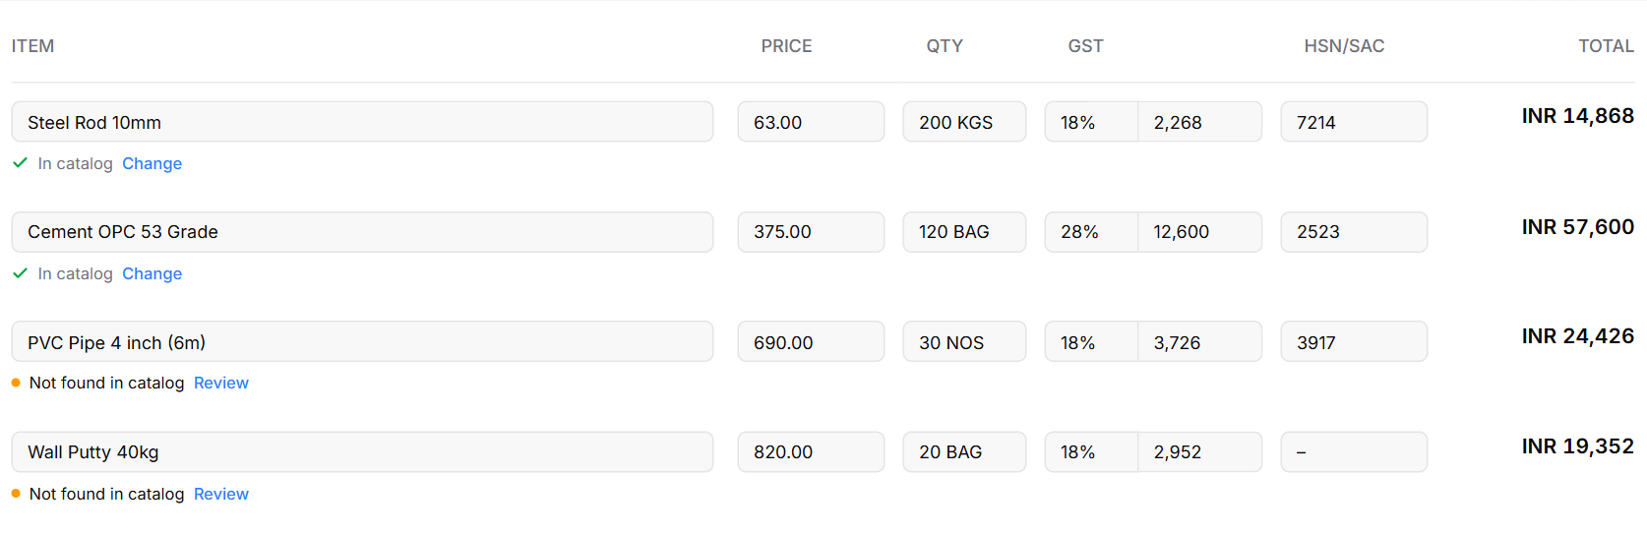
Figure 26: Items: the supplier's item name with its catalog match underneath
Line shows | When | User does
✓ In catalog · Change | Same name and HSN as a catalog item, or linked on an earlier bill | Nothing
✓ Catalog: {item} · Change | Linked to a catalog item with a different name | Nothing
● Possible match: {item} · Review | Same HSN and a similar name | Confirm in the popup
● Not found in catalog · Review | No match | Pick an item, or add a new one
✓ Will be added to catalog · Change | User chose Add new item | Nothing
● New item · details missing · Review | HSN or GST rate missing | Fill them in

3.7 Match catalog and create: Review popup and account type
Review opens one small popup per line, in this order: the match we found, then a short catalog search, then Add new item.
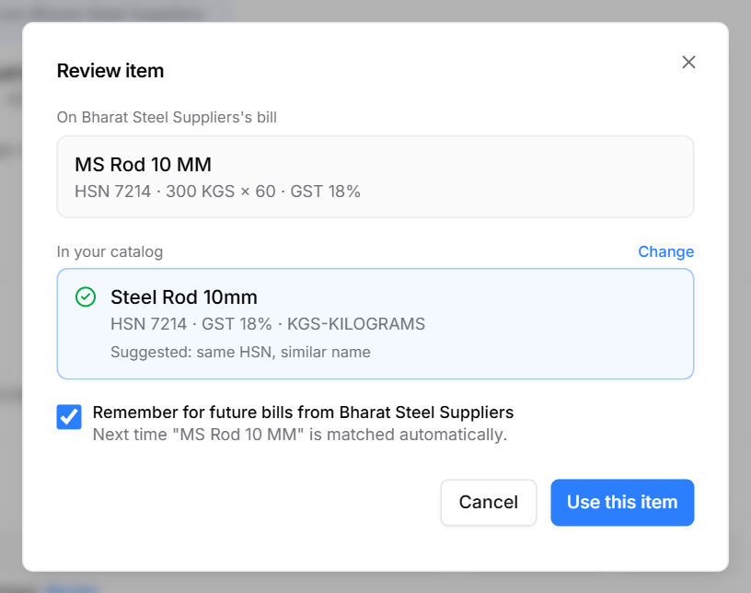
Figure 27: Review: a likely match, preselected
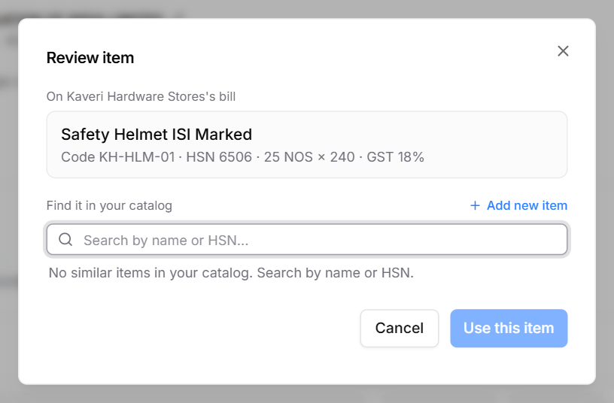
Figure 28: Review: no match, so a catalog search and + Add new item
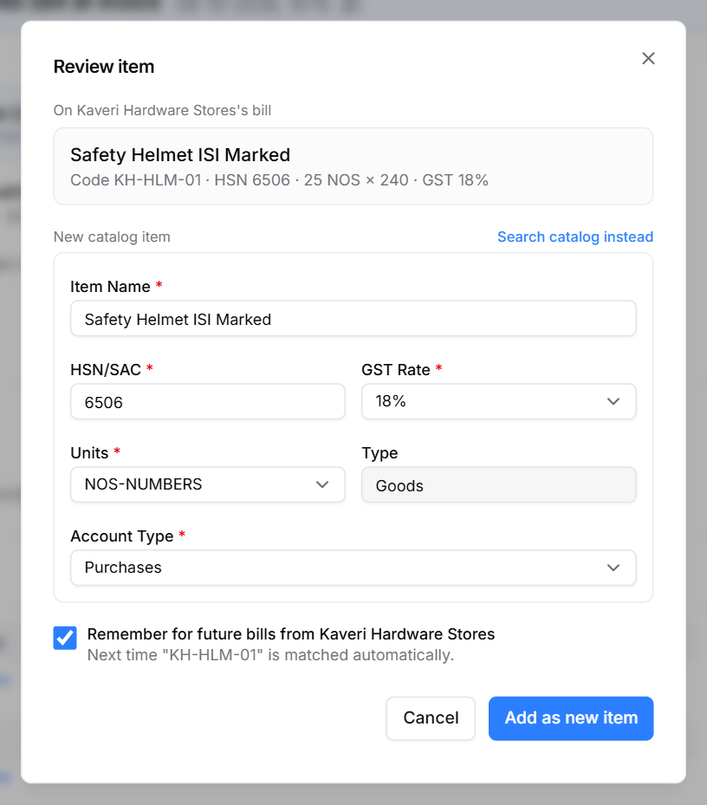
Figure 29: Review: new catalog item with Account Type
Element | Behaviour
On {supplier}'s bill | The supplier's item: name, code, HSN, quantity × price, GST.
In your catalog | The matched item with HSN, GST, unit and why it matched (e.g. "Suggested: same HSN, similar name"). Change opens the search. Use this item confirms.
Find it in your catalog | Search by name or HSN; up to 5 items ranked by HSN and name. + Add new item at the top right.
New catalog item | Item Name, HSN/SAC, GST Rate, Units (prefilled), Type (Goods / Services, from the bill), Account Type (required, preselected per 1.4). Search catalog instead goes back. Button: Add as new item.
Remember for future bills from {supplier} | Ticked by default; saves a catalog_item_links row on Create.

On Create, each line is saved with its catalog item and account; new catalog items are added (Created By Bharat Connect, Added From the bill); remembered links are saved; a Sales-only item gets its Purchase side turned on.

3.8 Reject
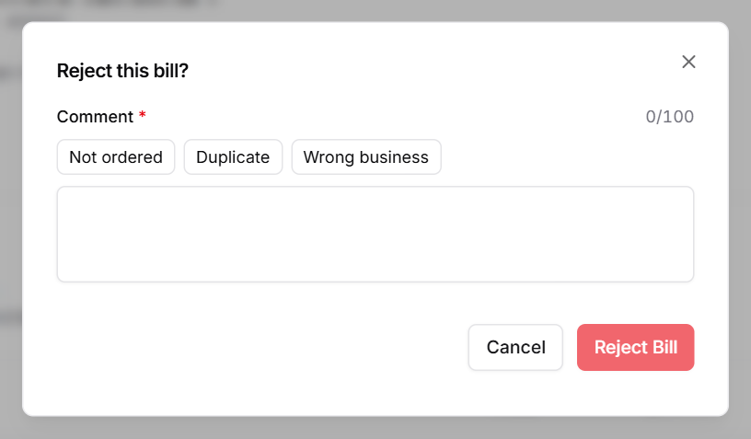
Figure 30: Reject this bill
"Reject this bill?" Comment required, up to 100 characters, with quick picks (Not ordered, Duplicate, Wrong business). Reject Bill sends reqConfirmInvoice with buyerResponse REJECT. A rejected invoice never becomes a LEDGERS bill and adds nothing to the catalog.

3.9 After Create
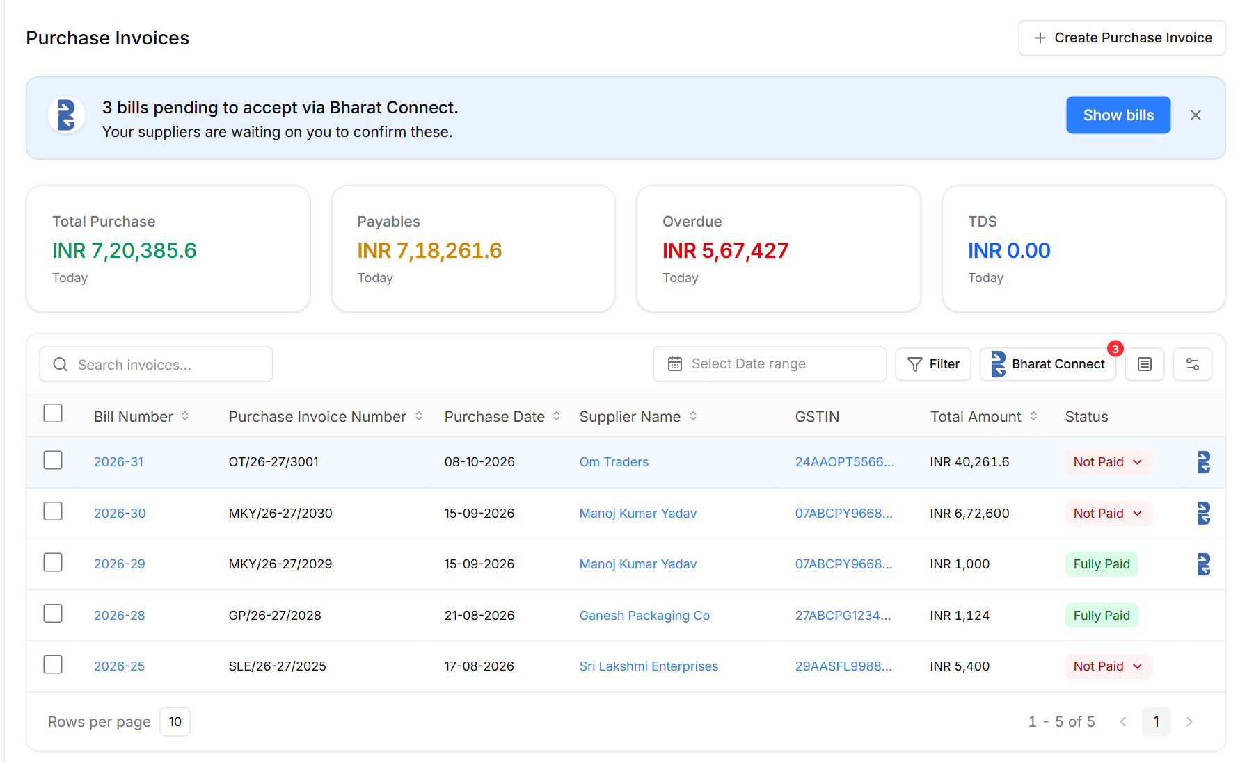
Figure 31: Back on the Purchase Invoices list: the new invoice on top, highlighted, with the Bharat Connect mark
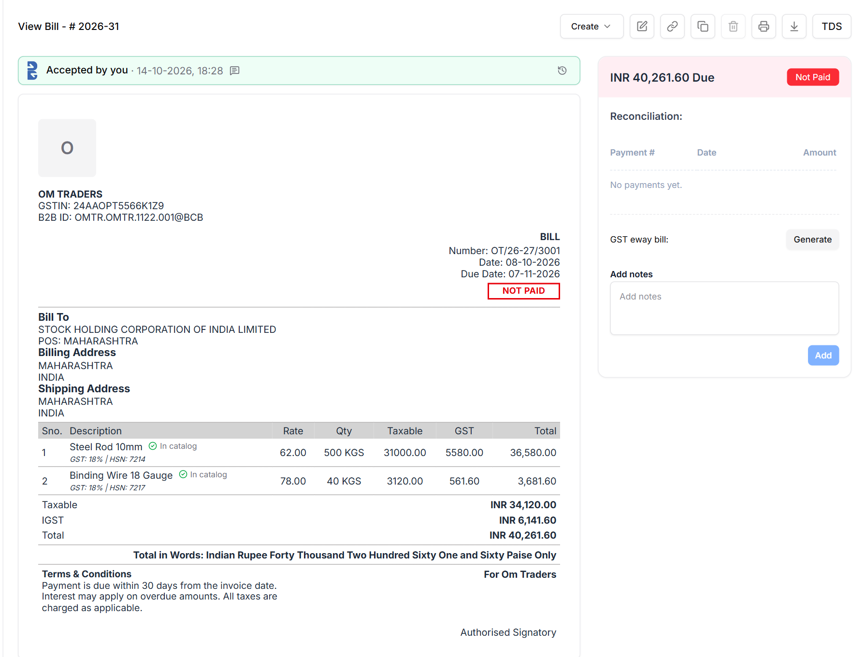
Figure 32: The created bill: "Accepted by you", lines linked to the catalog, B2B ID under the supplier's GSTIN
After Create Purchase Invoice the user lands back on the normal Purchase Invoices list with the new invoice on top and briefly highlighted. The bill page shows "Accepted by you · date"; each line shows In catalog or Added to catalog; the printed bill shows the supplier's B2B ID under their GSTIN. It is then paid like any other bill.

3.10 Supplier changes and after Accept
Event | What the user sees
Supplier edits an invoice still waiting | Replaced in place, stays waiting; the strip notes the revision.
Supplier cancels it | Status Cancelled with the supplier's reason. No Create.
After Accept | No edit, reject, return or cancel on Bharat Connect. Delete is blocked: "Accepted on Bharat Connect. Raise a debit note instead." Only LEDGERS-only fields (expense category) can change.

3.11 Rules
Rule | Reference
Accept / Reject only from Sent To Buyer or Returned | Annexure H; Excel ReqConfirmInvoice
Remarks and Reject comment required, 1–100 characters, no double quotes | Swagger invoiceConfirmation.buyerRemarks
After Accept: correct with a debit note; no edit or cancel | Annexure H, §5.12
Supplier may Cancel from Sent To Buyer, Returned, Rejected; Close or Abandon from Sent To Buyer, Returned, Accepted, Partially Paid | Excel ReqStatusChangeInvoice
As the buyer's platform, validate each incoming invoice and answer the supplier's platform | Handbook §5.1, Annexure A §4.1

3.12 Data to store (proposed — engineering to confirm)
Uses catalog_item_links and catalog_items (1.6) and bc_events (2.9).
bc_incoming_invoices (new) — A supplier's invoice as received, before it is created in LEDGERS
Column | Type | Notes
id | bigint | Primary key
business_id | fk | Our business
bc_object_id | char(35) | Supplier's invoice objectId; unique
supplier_b2b_id / buyer_b2b_id | varchar(100)
supplier_invoice_number | varchar(50) | Shown as Purchase Invoice Number
invoice_date / due_date | date
total_amount | decimal(18,2) | valueDetails.totalInvoiceValue
invoice_type | enum | NEW · DEBIT NOTE (Excel ReqSendInvoice)
payload | json | Full reqSendInvoice invoice object, incl. items, tax split, tax-inclusive and reverse-charge flags
bc_status | enum | Annexure H status, e.g. SENT TO BUYER, ACCEPTED, REJECTED, CANCELLED, CLOSED
bc_version | int | Current objectVersion; supplier edits replace the payload
received_at | datetime
purchase_invoice_id | fk → purchase_invoices null | Set when the user creates it; null = Not created

purchase_invoices (new columns) — A LEDGERS bill created from Bharat Connect
Column | Type | Notes
bc_incoming_invoice_id | fk null | Non-null = created from Bharat Connect (drives the B mark)
contact_id | fk → contacts | Vendor contact the bill is booked against (existing field; set from the mapping in 3.5)
supplier_invoice_number | varchar(50) | Purchase Invoice Number column
bc_status | enum | Mirror of the incoming invoice's status
bc_buyer_remarks | varchar(100) | Remarks sent with the acceptance

purchase_invoice_lines (new columns) — Where each line is booked
Column | Type | Notes
catalog_item_id | fk → catalog_items | Matched or newly added item
account | fk → chart of accounts | Account type (the item's Purchase Expense Type)
supplier_item_code / supplier_item_name | varchar | As sent by the supplier (for the link and for audit)

3.13 Open items
Item | Reference
Show "Accepting…" and create the bill only when Bharat Connect confirms the Accept (respConfirmInvoice); on failure keep it waiting with the error | Handbook §5.4, Annexure E
Handle the supplier's Close and Abandon | Excel ReqStatusChangeInvoice
Use the supplier's line amounts, tax split and tax-inclusive flag instead of recomputing | Swagger itemLists, transactionDetails
Validate each incoming invoice and answer with respSendInvoice | Handbook §5.1, Annexure A §4.1
Item name can be missing (fall back to code or HSN); prefill reverse charge; label supplier debit notes | Swagger, Release Note 3.8
Display: sort icons and the status chevron are visual only; no view of deleted bills | Prototype

3.14 Try it in the prototype
To see | Do this
A new bill from a supplier | Dev panel → Purchase → Receive a bill (supplier; In catalog / New items / Mixed / Missing HSN)
Item matching cases | Dev panel → Purchase → Bill item scenarios → Load: all in catalog, linked before, all new, similar item, Sales-only item, missing HSN/GST, services, mixed
Vendor mapping | Bharat Connect view → Create on Verve (suggested by name) or Pugal (not in Contacts); Dev panel → Purchase → Receive a bill from Om Traders (mapped by B2B ID)
Supplier edits or cancels a waiting bill | Dev panel → Purchase → Simulate supplier (incoming) → Edit / Cancel
Start over | Dev panel → Purchase → Reset catalog and scenario bills (or reload the page)

Appendix A. Invoice fields received and sent
Both directions use the same invoice object of reqSendInvoice (Swagger R3.8 v1.30, Excel ReqSendInvoice v0.6). Fields marked * are mandatory in the API.

A.1 Receiving: supplier's invoice → Create Purchase Invoice
LEDGERS field | API field | Note
Vendor name, GSTIN, B2B ID, address | supplierDetails.legalName*, tradeName, gstin, b2bId*, address, stateCode | Used to map the vendor contact (3.5)
Billing / shipping address | buyerDetails (us), shippingDetails | placeOfSupply from buyerDetails
Invoice No (supplier's) | supplierInvoiceNumber* (max 50) | Purchase Invoice Number column
Date | invoiceReferenceDetails.invoiceStartDate, else ts*
Due Date | advancePaymentDetails.creditDays or paymentMilestones[].milestoneDate | No due-date field; else LEDGERS' default
Reverse charge, tax inclusive, IGST | transactionDetails.reverseChargeTax, isItemAmtTaxInclusive, igstChargable
Item name, code, HSN, goods / services | itemLists[].productDescription, itemCode, hsnCode, isService* | Name, code and HSN are optional in the API
Qty, unit, price, taxable value | quantity*, unit, unitPrice*, totalAmt*, assessmentAmount* | Keep the supplier's amounts
GST rate and tax amounts | gstRate, itemValueDetails[] (CGSTAMT, SGSTAMT, IGSTAMT, CESAMT, DISCOUNT)
Line total, tax type | totalItemValue*, gstTaxType
Totals | valueDetails.assessmentValue*, totalInvoiceValue*, otherValues[] (round-off, TCS, TDS)
Bharat Connect id, version, status | objectId* (INV + 32), objectVersion*, statusTransition* | Store; every later call uses them
Not in the API (LEDGERS supplies) | — | Bill No, catalog item, account type, vendor contact, Remarks

We answer the received invoice with respSendInvoice (SUCCESS or FAILURE after checking it). Create or Reject sends reqConfirmInvoice: objectId*, supplierInvoiceNumber*, objectVersion*, statusTransition*, buyerResponse* (ACCEPT / REJECT), buyerRemarks* (1–100 characters, no double quotes). The bill is booked when respConfirmInvoice returns SUCCESS.

A.2 Sending: LEDGERS sales invoice → reqSendInvoice
API field | From LEDGERS
head*, txn*, device* | Message and transaction ids, our AI / OU / org ids, timestamp; txn.type INVOICE
b2bIds* | supplierB2BId = ours, buyerB2BId = the customer's (from the contact)
objectId*, supplierInvoiceNumber*, ts* | New INV id per invoice; LEDGERS invoice number; invoice date
objectVersion*, statusTransition* | 1 → 1; CREATED → SENT TO BUYER
supplierDetails* | Our b2bId*, legalName*, GSTIN, state, address, contact; must match onboarding
buyerDetails* | Customer b2bId*, tradeName*, GSTIN, placeOfSupply, address
transactionDetails | supplyType, reverseChargeTax, isItemAmtTaxInclusive, igstChargable
itemLists[]* | Per line: serialno*, productDescription, itemCode, hsnCode, isService*, quantity*, unit, unitPrice*, totalAmt*, assessmentAmount*, gstRate, itemValueDetails, gstTaxType, totalItemValue*
valueDetails* | assessmentValue*, totalInvoiceValue*, otherValues (tax totals, round-off, TCS)
invoiceReferenceDetails, eInvoiceInfo | Invoice date and remarks; IRN if an e-invoice
supplierBankAccountDetails, advancePaymentDetails | Our own bank account / VPA only; credit days and amounts paid

Back: respSendInvoice (SUCCESS → Sent To Buyer, FAILURE → Failed with the error), then the buyer's reqConfirmInvoice (Accepted, Rejected or Returned, with remarks). Lines must add up to valueDetails and the supplier name and GSTIN must match onboarding, or the call fails (handbook A§4.1).

