PF Wage Ceiling Revision
Product Flows: Salary Setup, September and October payroll, payslips, reports and the payroll dashboard
Document owner: Stany Devdas · Status: Draft for review · Version 1.0 · 16-Oct-26
Ceiling ₹15,000 → ₹25,000 from 17 Sep 2026.

Version History
Version | Date | Created / Updated by | Description | Review Date | Reviewed by
1.0 | 16-Oct-26 | Stany Devdas | Initial version: per-screen flows, checks and banners, and calculations, derived from the clickable prototype

Index
Version History 1
1. Salary Setup 4
1.1 What changes 4
1.2 Expected flow 5
1.3 Checks and banners 8
1.4 Calculations 10
2. September payroll 11
2.1 What changes 11
2.2 Expected flow 12
2.3 What each answer does 19
2.4 Checks and banners 19
2.5 Calculations 20
3. October payroll 22
3.1 What changes 22
3.2 Expected flow 23
3.3 What October shows, by what happened to September 27
3.4 Checks and banners 27
3.5 Calculations 28
4. Payslips and reports 31
4.1 What changes 31
4.2 Expected flow 32
4.3 Checks and banners 35
4.4 Calculations 36
5. Payroll dashboard 37
5.1 What changes 37
5.2 Expected flow 38
5.3 Checks and banners 40
5.4 Counts 41

1. Salary Setup
Salary Setup stays month-based: a salary structure says what someone earns from a month onward, and that does not change on 17 Sep — only the statutory ceiling does. The mid-month split is handled by the September payroll run, not here. On this page the ceiling shows up in five places, plus one line on the employee profile.

1.1 What changes
Area | LEDGERS v4 today | New
PF limit option | "Limit to ₹1800", hardcoded in the frontend | "Limit to PF ceiling (₹3,000)" — amount read from the ceiling in force, never hardcoded
PF and CTC shown | Capped at ₹1,800 | Worked out at the ceiling in force (₹25,000 from 17 Sep 2026)
NO-PF within the ceiling | Allowed silently | Blue notice on the page; warning on save
Salary effective September 2026 | No note | Note that September PF is split per half in payroll
Revisions made by the system | — | Labelled with the reason, e.g. "PF ceiling — CTC kept the same"
Profile | UAN only | "PF / Pension" line: PF membership and EPS status with dates

1.2 Expected flow
- HR opens an employee → Salary Setup. The PF row shows the basis (12%-Basic / 12% gross excluding HRA / NO-PF) and the limit, now "Limit to PF ceiling (₹3,000)".
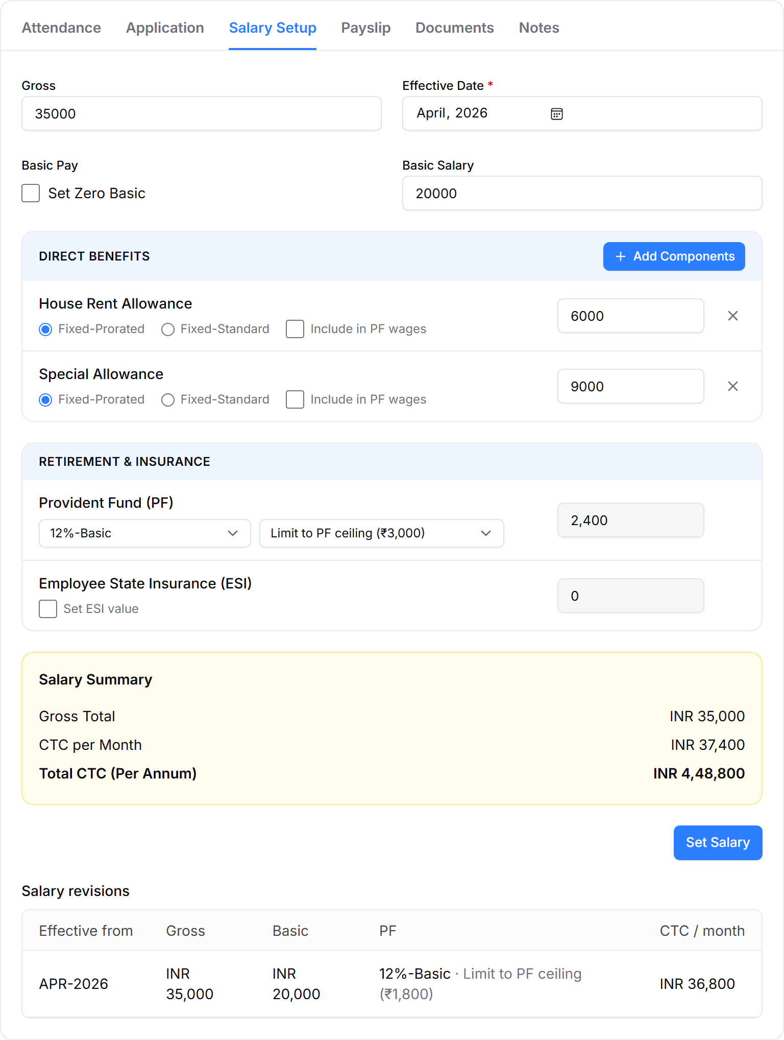
Figure 1: Salary Setup for Rohit Sharma: Limit to PF ceiling (₹3,000), PF ₹2,400, CTC ₹37,400
- If the employee is NO-PF but within the ₹25,000 ceiling, a blue notice sits at the top of the page. Use 12%-Basic from OCT-2026 fills the PF row (12%-Basic, Limit to PF ceiling) and moves the effective month to OCT-2026; HR still clicks Set Salary.
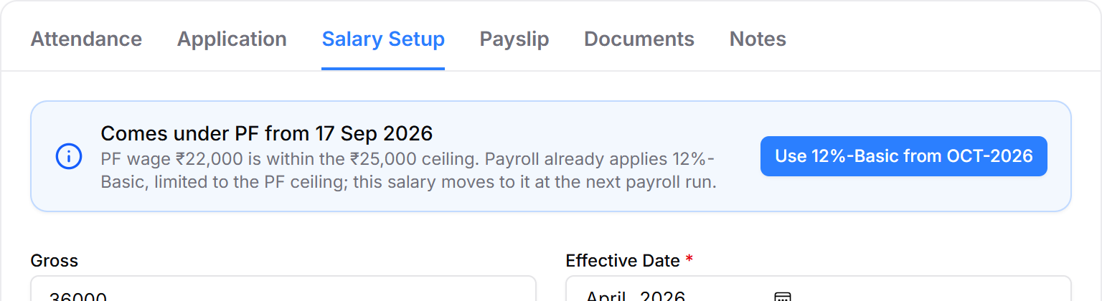
Figure 2: Coverage notice on Meera Iyer's Salary Setup
- If HR clicks Set Salary with NO-PF and a PF wage within the ceiling, a warning asks them to confirm. Use 12%-Basic switches the row; Save as NO-PF anyway saves as entered.
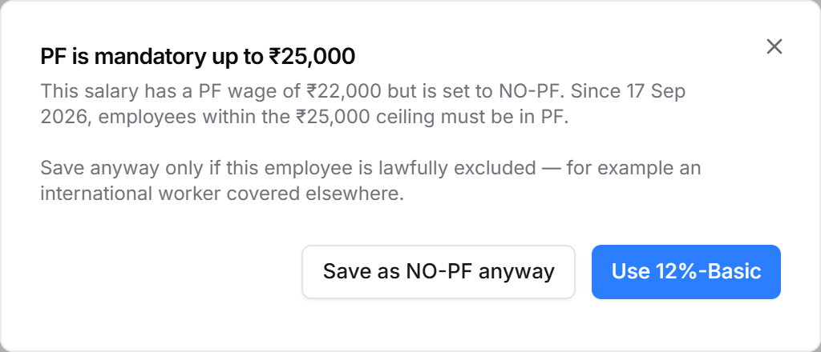
Figure 3: PF is mandatory up to ₹25,000 — save warning
- For a salary effective SEP-2026 (a September joiner or revision), a note under Effective Date explains that September PF is split per half in payroll.
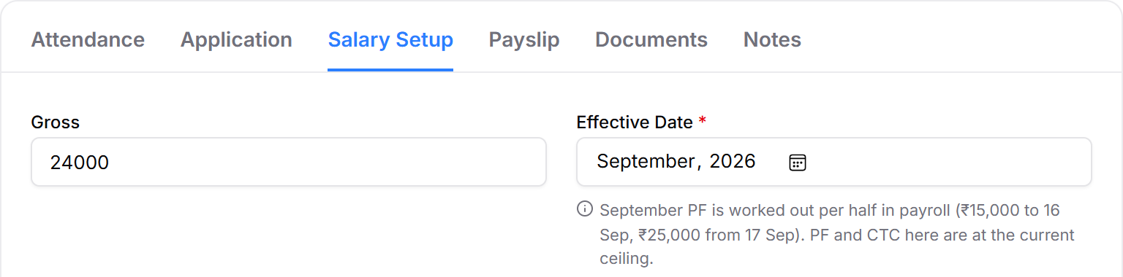
Figure 4: Note under Effective Date for a salary effective September 2026
- After the first payroll run on the new ceiling, the system adds an OCT-2026 revision where needed and labels it. HR does not create these by hand.
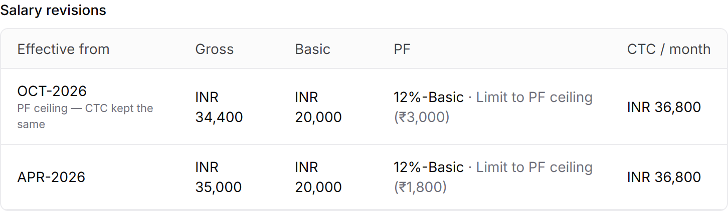
Figure 5: Revision added when CTC was kept the same
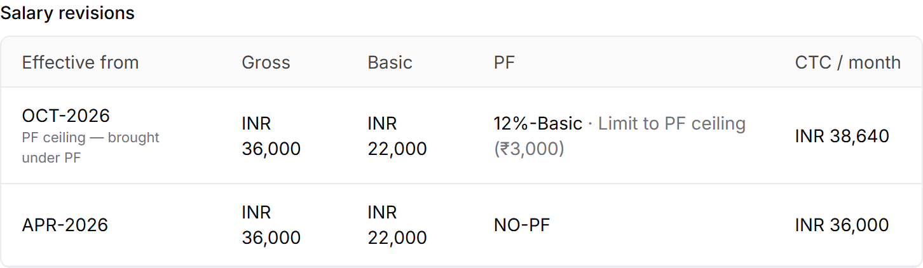
Figure 6: Revision added when an employee was brought under PF
- The employee profile shows PF / Pension below Employment Type.
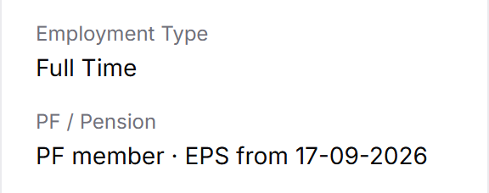
Figure 7: PF / Pension line on the profile

1.3 Checks and banners
Element | Shows when | Wording | What the user can do
Coverage notice (blue) | Salary in force is NO-PF, PF wage on 17 Sep ≤ ₹25,000, employee on the rolls on or after 17 Sep, not an international worker | Comes under PF from 17 Sep 2026. PF wage ₹{wage} is within the ₹25,000 ceiling. Payroll already applies 12%-Basic, limited to the PF ceiling; this salary moves to it at the next payroll run. | Use 12%-Basic from OCT-2026. Disappears once the salary is on PF.
Save warning (dialog) | Set Salary clicked with NO-PF and PF wage ≤ ₹25,000 | PF is mandatory up to ₹25,000. This salary has a PF wage of ₹{wage} but is set to NO-PF. Since 17 Sep 2026, employees within the ₹25,000 ceiling must be in PF. | Use 12%-Basic · Save as NO-PF anyway (only for a lawful exclusion, e.g. an international worker covered elsewhere)
September note | Effective month is SEP-2026 and PF is not NO-PF | September PF is worked out per half in payroll (₹15,000 to 16 Sep, ₹25,000 from 17 Sep). PF and CTC here are at the current ceiling. | Information only
Revision label | The system adds a revision during the first run on the new ceiling | "PF ceiling — brought under PF" or "PF ceiling — CTC kept the same" | Information only
PF / Pension (profile) | Always | See the statuses below | Information only

PF / Pension statuses
Status shown | Rule | Demo employee
PF member · EPS member | PF basis set, under 58, EPS member | Vikram Singh
PF member · EPS from 17-09-2026 | Non-EPS member, PF wage on 17 Sep ≤ ₹25,000 (G.S.R. 847(E)) | Rohit Sharma
PF from 17-09-2026 · EPS from 17-09-2026 | NO-PF, PF wage on 17 Sep ≤ ₹25,000 — newly covered | Meera Iyer
PF member · no EPS (58+) | Age 58 or above | Lakshmi Krishnan
Not a PF member | NO-PF and PF wage above ₹25,000 | —

For anyone who joined after 17 Sep, the start date is their date of joining.

1.4 Calculations
PF wage is Basic plus every component ticked "Include in PF wages" (12%-Basic), or gross less HRA (12% gross excluding HRA). With "Limit to PF ceiling", the PF shown is capped at 12% of the ceiling in force; employer PF equals employee PF.
PF = min( 12% × PF wage, 12% × ceiling )
CTC per month = Gross + Employer PF + Employer ESI
The ceiling is the one in force in the later of the effective month and the current month; each row of the revisions table uses its own month.
Example | PF wage | PF at ₹15,000 ceiling | PF at ₹25,000 ceiling | CTC before → after
Rohit Sharma, 12%-Basic, Limit | ₹20,000 | ₹1,800 | ₹2,400 | ₹36,800 → ₹37,400
Priya Nair, 12%-Basic, Limit | ₹30,000 | ₹1,800 | ₹3,000 | ₹53,800 → ₹55,000
Vikram Singh, 12%-Basic, No Limit | ₹30,000 | ₹3,600 | ₹3,600 | ₹93,600 → ₹93,600
Meera Iyer, NO-PF → covered | ₹22,000 | — | ₹2,640 | ₹36,000 → ₹38,640

When CTC is kept the same, the system reduces Special Allowance so that gross + employer PF equals the old CTC. If Special Allowance is itself PF wage, the PF falls too, so it is solved directly: e.g. Rohit's gross becomes ₹34,400 and CTC stays ₹36,800. That choice is made on the October payroll page (section 3).

2. September payroll
September 2026 is the only month with two ceilings: ₹15,000 for 1–16 Sep and ₹25,000 from 17 Sep. LEDGERS works PF out per half on the September computation page, and Run Payroll asks one question: were September salaries already paid?

2.1 What changes
Area | LEDGERS v4 today | New
PF ceiling | One ceiling for the month | Choice for the whole month: Mid-month change (default) or Old ceiling, full month
Payable days | One number; not validated (Demo Ledgers has 31 in a 30-day September) | Total plus a split per half, filled from attendance; each half validated
Coverage | — | NO-PF employees with PF wage ≤ ₹25,000 come under PF from 17 Sep; non-EPS members join EPS from 17 Sep
Run Payroll | Runs immediately | One question: already paid? Pre-selected from Salary Payment
Comparison | — | Struck-out PF and payout show what was actually paid
After correction | — | One-line status with a Change link
Filter | — | All / Affected by PF ceiling (n)
Payslip | One PF line | PF by period, plus employer EPS / EPF / EDLI

2.2 Expected flow
- HR opens Payroll → Computation and picks SEP-2026. If September was run on the old ceiling, an amber banner says so. Below it, the ceiling choice defaults to Mid-month change.
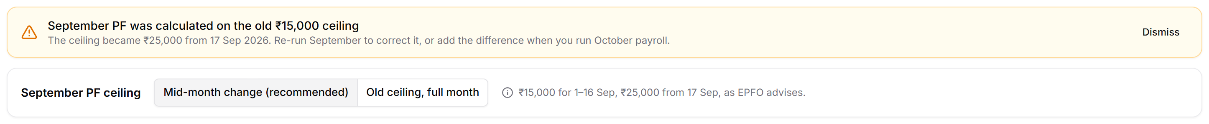
Figure 8: Reminder banner and September PF ceiling choice
- Old ceiling, full month is for a business that actually deposited September PF on ₹15,000. The note changes to say so.
Figure 9: Old ceiling selected
- Affected by PF ceiling narrows the list to the employees whose figures change. Each row shows the payable split, tags for coverage changes, and the as-paid PF and payout struck out under the new figures.
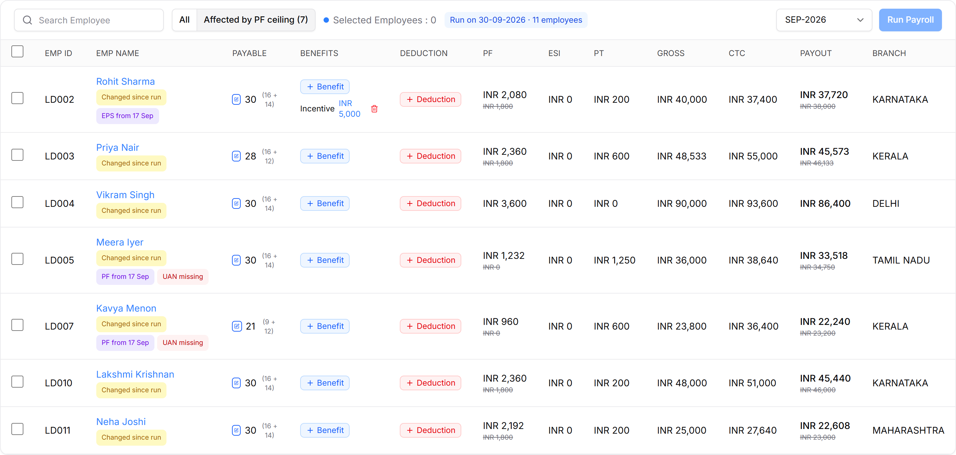
Figure 10: Affected employees with split payable days, tags and as-paid figures
- HR can open a row's payable days to change the split. Halves come from attendance; a typed total spreads loss of pay by days employed in each half. Wrong halves block Save.
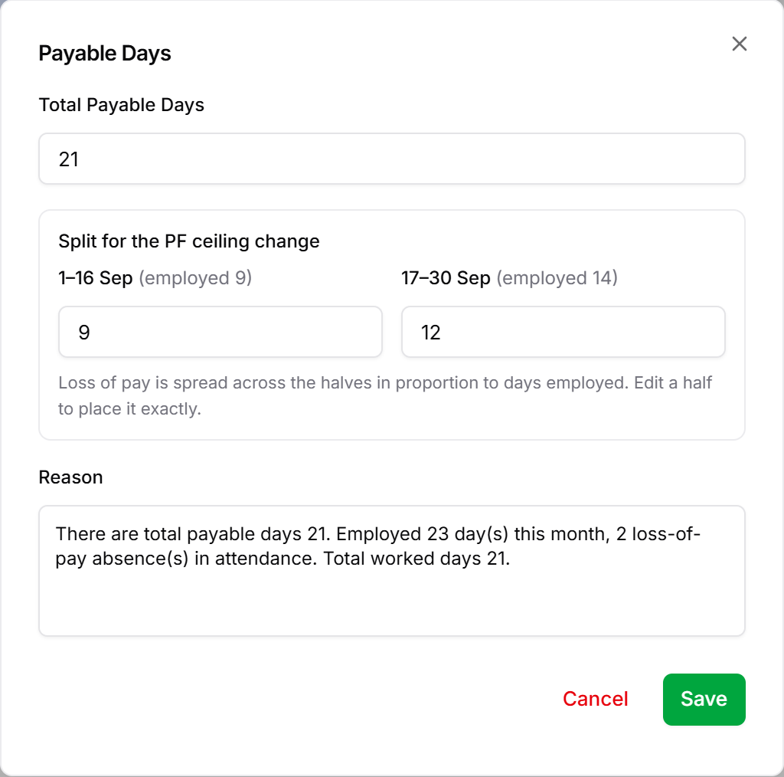
Figure 11: Payable Days with the September split
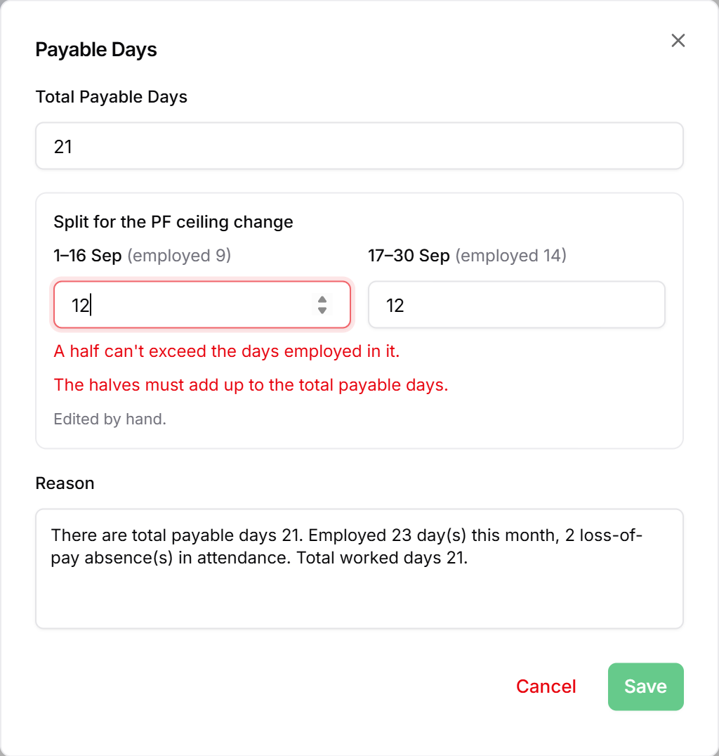
Figure 12: Split validation errors
- HR selects employees and clicks Run Payroll. The dialog shows how many employees' PF changes and asks whether September was already paid.
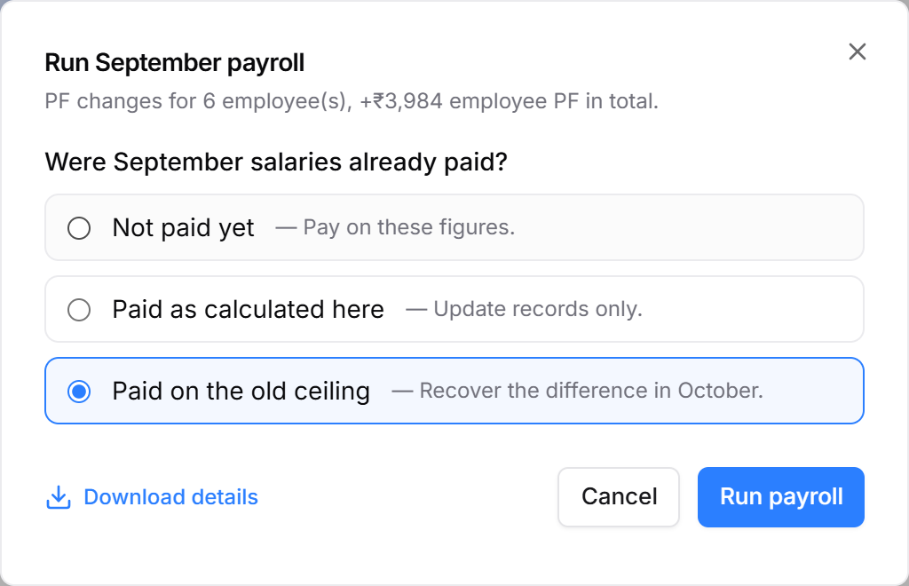
Figure 13: Run September payroll dialog
- After the run, the ceiling choice collapses to a one-line status. Rows read "In payroll" and still show what was paid, struck out. Change reopens the choice.
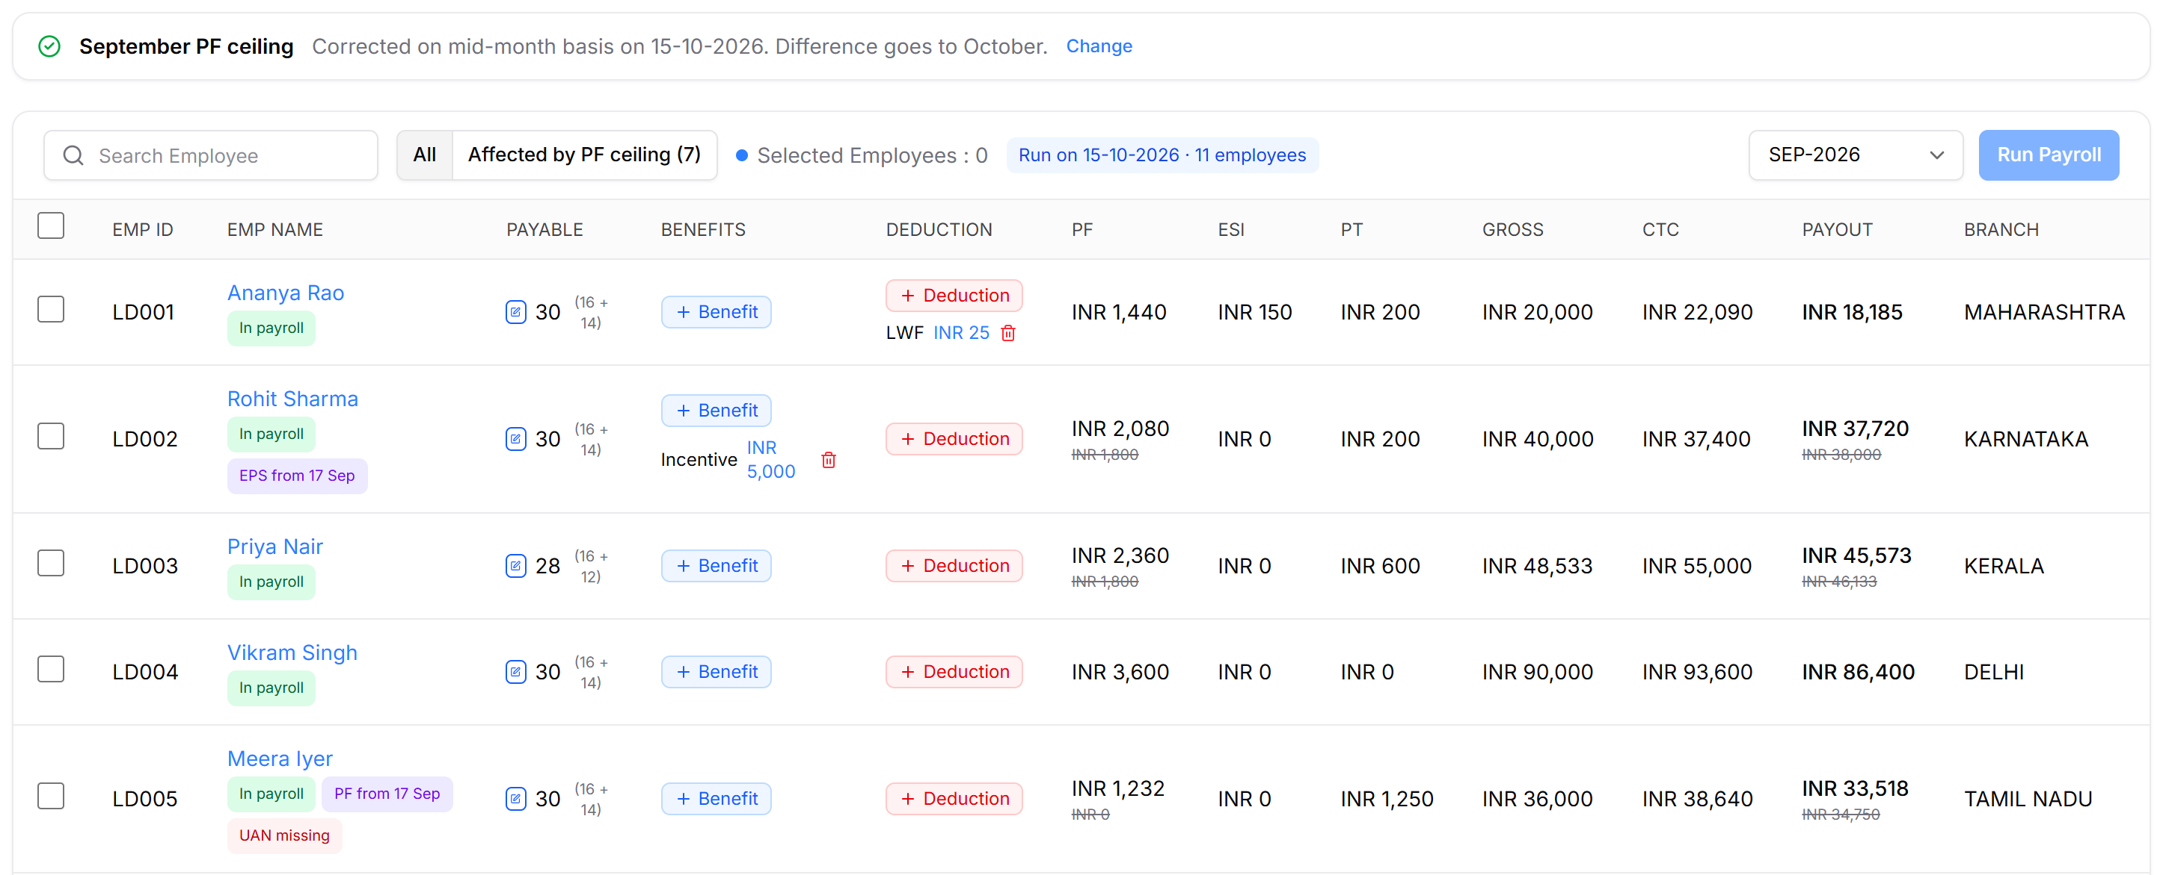
Figure 14: September after correction
- The September payslip shows PF for each half and the employer split.
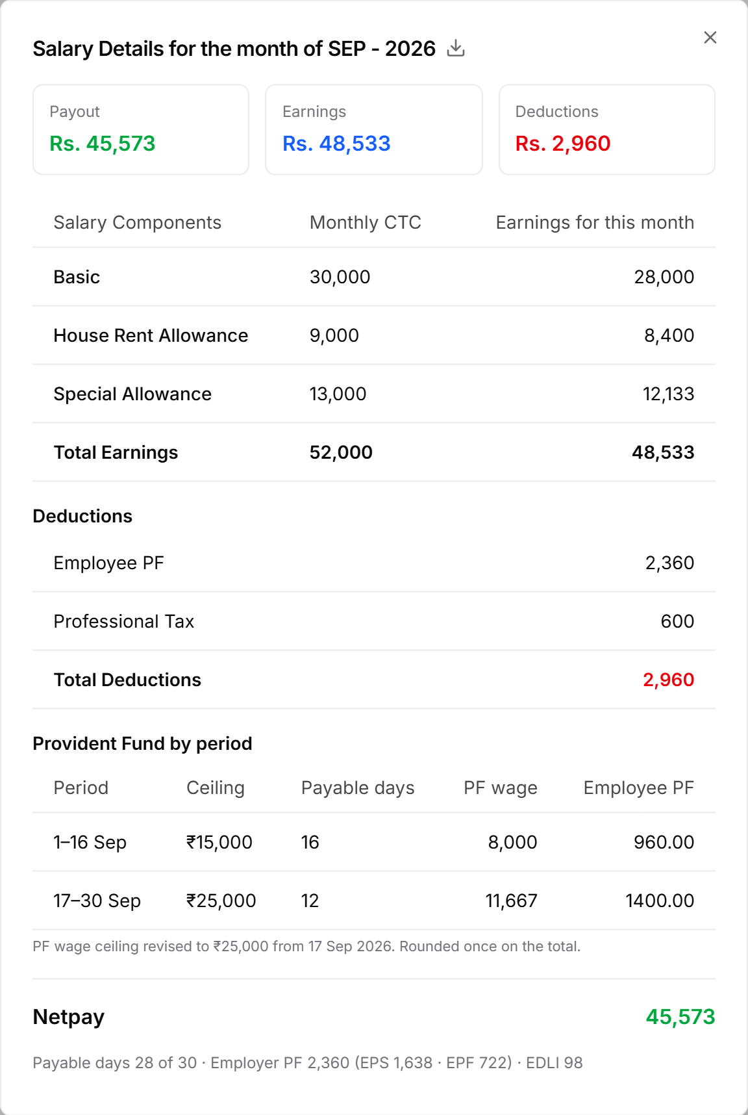
Figure 15: Payslip with PF by period

2.3 What each answer does
Answer | Pre-selected when | September records | Payment record | Difference
Not paid yet | September not marked paid | Updated to the new figures | Unchanged — pay on these figures | None
Paid as calculated here | Paid, and the last run was already on the new ceiling | Updated | Set to the new payout | None
Paid on the old ceiling | Paid, and the last run was on ₹15,000 | Updated; the original paid record is kept | Stays at what was paid | Settled in the first unpaid month (October): employee share deducted, employer share added; exited employees — employer pays

In every case the run records coverage from 17 Sep for newly covered employees and moves their salary to 12%-Basic from October.

2.4 Checks and banners
Element | Shows when | Wording
Reminder banner (amber) | September stands on the old ceiling — not re-run, and the difference not added to October; until dismissed | September PF was calculated on the old ₹15,000 ceiling. The ceiling became ₹25,000 from 17 Sep 2026. Re-run September to correct it, or add the difference when you run October payroll.
Ceiling note | Always, under the choice | Mid-month: ₹15,000 for 1–16 Sep, ₹25,000 from 17 Sep, as EPFO advises. · Old: ₹15,000 for the whole month — only if PF was actually deposited this way.
Status line | After September is corrected | Corrected on mid-month basis on {date}. Difference goes to October. · or: Kept as paid; the difference was added to October.
Row tags | Per employee | Changed since run / In payroll · PF from 17 Sep · EPS from 17 Sep · UAN missing (left out of the ECR)
Payable split errors | On edit; Save disabled | A half can't exceed the days employed in it. · The halves must add up to the total payable days. · More than the {n} day(s) {name} was employed this month.
Run dialog summary | On Run Payroll | PF changes for {n} employee(s), +₹{amount} employee PF in total.
Affected filter | September and October only | Employees whose PF, EPS split or payout differs from what was paid, plus anyone newly under PF or EPS

2.5 Calculations
Each half is worked out on its own and rounded once at the end.
PF wage_{s} = min( W × paid days_{s} ÷ D, C_{s} × E_{s} ÷ E )
W = monthly PF wage; D = days in the month (30); Cₛ = ceiling in that half (₹15,000 or ₹25,000); Eₛ = days employed and PF-covered in that half; E = E₁ + E₂. Loss of pay never reduces the ceiling. Newly covered employees count only from 17 Sep. Employee PF = 12% of the total; EPS = 8.33% of the capped wage for EPS-eligible days (none from age 58); employer EPF = employer PF − EPS; EDLI = 0.5%.
Worked example, Priya Nair — Basic ₹30,000, loss of pay on 22–23 Sep, so paid 16 + 12 days:
Half | Wage for paid days | Ceiling share | PF wage
1–16 Sep | 30,000 × 16 ÷ 30 = 16,000 | 15,000 × 16 ÷ 30 = 8,000 | 8,000
17–30 Sep | 30,000 × 12 ÷ 30 = 12,000 | 25,000 × 14 ÷ 30 = 11,666.67 | 11,666.67

PF wage 19,666.67 → employee PF ₹2,360, EPS ₹1,638, employer EPF ₹722. On the old ceiling it was ₹1,800, so the difference is ₹560.
Employee | Situation | PF on old ceiling | PF on mid-month | Difference
Rohit Sharma | Basic ₹20,000; non-EPS, joins EPS from 17 Sep | ₹1,800 | ₹2,080 (EPS ₹777) | +₹280
Priya Nair | Basic ₹30,000; 2 days LOP after 17 Sep | ₹1,800 | ₹2,360 | +₹560
Lakshmi Krishnan | Basic ₹30,000; age 58+ | ₹1,800 | ₹2,360 (no EPS) | +₹560
Neha Joshi | 12% gross excluding HRA; PF wage ₹22,000 | ₹1,800 | ₹2,192 | +₹392
Meera Iyer | NO-PF, PF wage ₹22,000; newly covered | ₹0 | ₹1,232 | +₹1,232
Kavya Menon | NO-PF, joined 8 Sep, LOP 29–30 Sep; newly covered | ₹0 | ₹960 | +₹960
Vikram Singh | Basic ₹30,000, No Limit | ₹3,600 | ₹3,600 (EPS ₹1,250 → ₹1,638) | Pension split only

Unchanged: Ananya Rao (Basic ₹12,000), Arjun Patel (joined 5 Sep), Sanjay Gupta (joined 20 Sep), Farhan Qureshi (left 10 Sep).
Kavya's ₹960 uses her attendance: both LOP days fall after 17 Sep. If payable days were typed as a total of 21, the loss of pay would be spread across the halves instead and her PF would be ₹1,023.

3. October payroll
October 2026 is the first full month on the ₹25,000 ceiling. Two one-time choices sit on the October computation page, the table updates as they change, and Run Payroll saves them. After that run, October re-runs and later months run as usual.

3.1 What changes
Area | LEDGERS v4 today | New
PF cap | ₹1,800 | ₹3,000 (12% of ₹25,000); EPS and EDLI wages capped at ₹25,000
September difference | — | While September still stands on the old ceiling: Add to October (default) or Don't add
Higher employer PF | CTC rises silently | CTC increases (default) or Keep CTC the same, page-wide, with a switch per employee
Deductions column | — | "PF diff – Sep" line, the employer's share, and any amount carried to November
CTC column | New CTC only | New CTC with the old one struck out
Coverage | — | Recorded by the run if September was not re-run
Run Payroll | One click | Still one click; it also saves the choices

3.2 Expected flow
- HR opens Payroll → Computation and picks OCT-2026. A card shows only the choices still open.
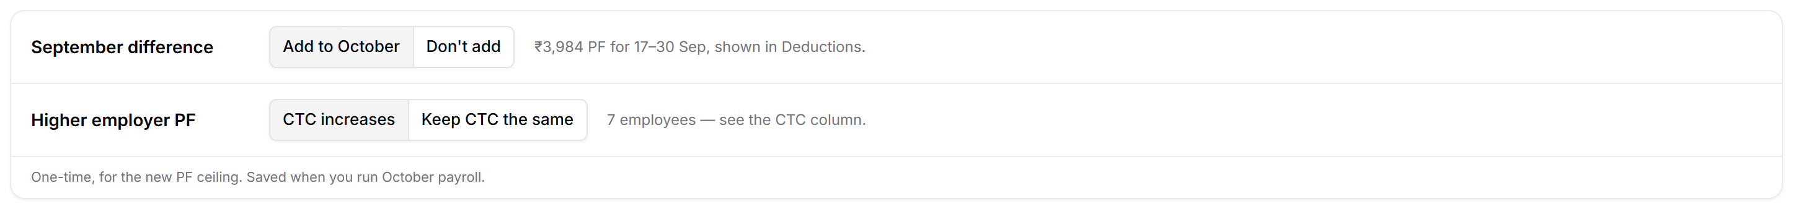
Figure 16: The two one-time choices
- Affected by PF ceiling lists the employees touched by the revision. Each shows PF at the new ceiling, the September difference in Deductions with the employer's share under it, and the CTC with the old figure struck out.
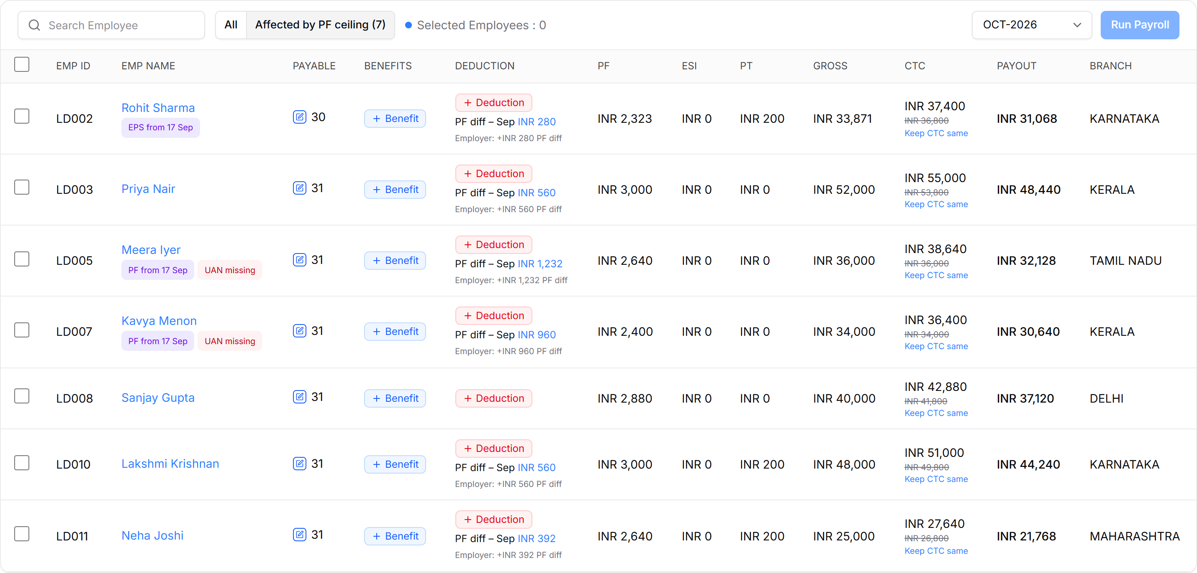
Figure 17: Affected employees with the defaults
- Don't add leaves September as it is and offers a link to re-run September instead.
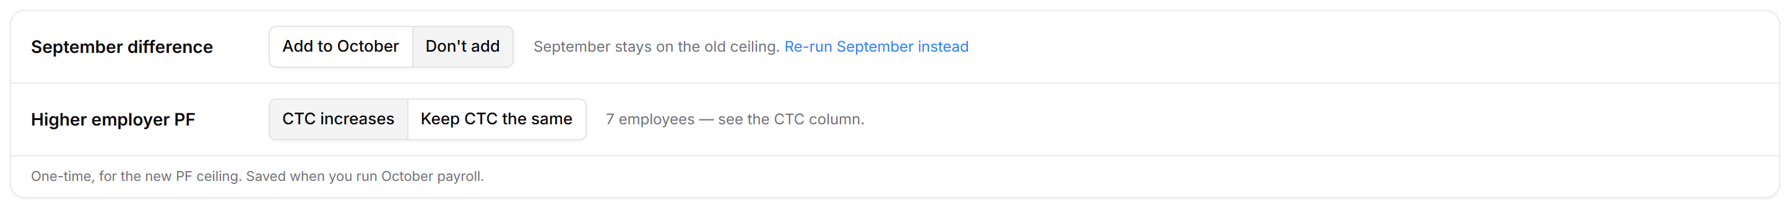
Figure 18: Don't add the September difference
- Keep CTC the same cuts Special Allowance so CTC stays where it was; gross and payout drop. Newly covered employees stay on "CTC increases". Keep CTC same / Let CTC increase under a CTC switches one employee.
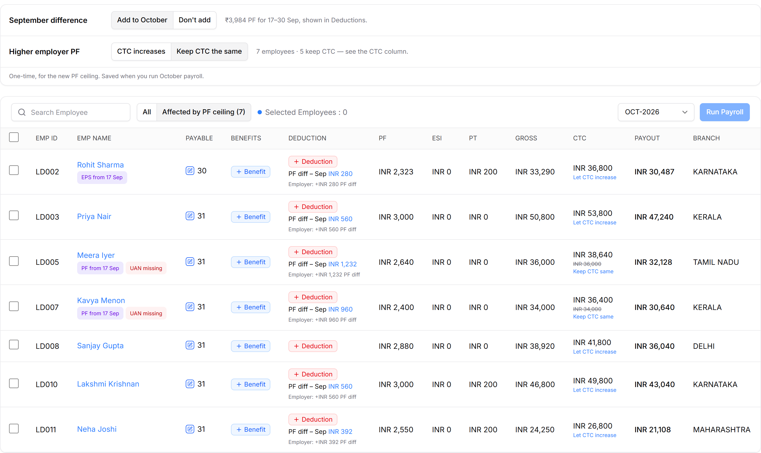
Figure 19: Keep CTC the same, previewed in the table
- If recovering the difference would cut take-home by more than 10%, only part is recovered and the rest moves to November.
Figure 20: Partial recovery under the net-pay floor
- HR selects employees and clicks Run Payroll. The run saves the September difference, adds an OCT-2026 salary revision for each "Keep CTC" employee, and records coverage. The card then disappears and the dashboard card shows both as done.

3.3 What October shows, by what happened to September
September | September difference choice | Difference in October
Re-run, "Paid on the old ceiling" | Not shown | Already created by the September run
Re-run, "Not paid yet" or "Paid as calculated here" | Not shown | None
Not re-run (still on ₹15,000) | Shown, default Add to October | Created by the October run if Add
Switched back to "Old ceiling, full month" | Shown again | Choose Don't add if PF really was deposited on ₹15,000

3.4 Checks and banners
Element | Shows when | Wording
Choices card | OCT-2026, while a choice is still open | Footer: One-time, for the new PF ceiling. Saved when you run October payroll.
September difference note | Add / Don't add | ₹{total} PF for 17–30 Sep, shown in Deductions. · September stays on the old ceiling. Re-run September instead
Higher employer PF note | Always on that row | {n} employees — see the CTC column. · {n} employees · {k} keep CTC — see the CTC column.
Deduction lines | Employee has a September difference | PF diff – Sep INR {amount} · Employer: +INR {amount} PF diff · INR {amount} carried to NOV-2026
CTC cell | Employer PF rises for the employee | New CTC, old CTC struck out, Keep CTC same / Let CTC increase
Not enough allowance | Keep CTC chosen but Special Allowance can't absorb the increase | Employee stays on CTC increases
Affected filter | September and October only | Employees with a September difference line or a CTC change

3.5 Calculations
From October the cap is 12% of ₹25,000, the same for employer PF:
PF = min( 12% × PF wage, 3,000 ) EPS = 8.33% × min( PF wage, 25,000 )
Priya Nair, PF wage ₹30,000: employee PF ₹3,000, EPS ₹2,083, employer EPF ₹917.
September difference. Difference = September on the new ceiling − September as paid, per component. The employee share is deducted in October; the employer share (EPF and EPS) is added to the employer's cost. Exited employees default to employer pays.
Net-pay floor. October take-home may not fall more than 10% below September's net as paid, leaving out September's one-off benefits:
recovered = min( owed, max( 0, payout before recovery − 90% × September net ) )
Employee | September net (less one-offs) | Floor (90%) | October payout before recovery | Owed | Recovered | Carried to November
Meera Iyer | ₹34,750 | ₹31,275 | ₹33,360 | ₹1,232 | ₹1,232 | —
Meera Iyer, with a ₹2,000 October deduction | ₹34,750 | ₹31,275 | ₹31,360 | ₹1,232 | ₹85 | ₹1,147
Rohit Sharma (September included a ₹5,000 incentive) | ₹33,000 | ₹29,700 | ₹31,348 | ₹280 | ₹280 | —

Keep CTC the same. Special Allowance (A) shrinks so that gross + employer PF equals the old CTC (T); G is the rest of gross and W the rest of PF wage. When A is outside PF wage, it drops by exactly the PF increase; when A is PF wage, cutting it lowers PF too, so it is solved directly:
A = ( T − G − 12% × W ) ÷ 1.12 (below the cap) A = T − G − 3,000 (at the cap)
Full-month figures, before PT and TDS:
Employee | CTC before | CTC increases: CTC · take-home | Keep CTC: gross · take-home
Rohit Sharma | ₹36,800 | ₹37,400 · −₹600 | ₹34,400 · −₹1,200
Priya Nair | ₹53,800 | ₹55,000 · −₹1,200 | ₹50,800 · −₹2,400
Sanjay Gupta | ₹41,800 | ₹42,880 · −₹1,080 | ₹38,920 · −₹2,160
Lakshmi Krishnan | ₹49,800 | ₹51,000 · −₹1,200 | ₹46,800 · −₹2,400
Neha Joshi (Special Allowance is PF wage) | ₹26,800 | ₹27,640 · −₹840 | ₹24,250 · −₹1,500 (PF ₹2,550)
Meera Iyer (newly covered) | ₹36,000 | ₹38,640 · −₹2,640 | Stays on CTC increases
Kavya Menon (newly covered) | ₹34,000 | ₹36,400 · −₹2,400 | Stays on CTC increases

Keeping CTC the same costs the employee both shares of the increase. A lower gross can also move an employee's PT slab or bring them under ESI (gross ≤ ₹21,000) from 1 October; the TDS projection is recalculated from October.

4. Payslips and reports
Payslips and the PF report now carry the pension split and the September difference, so what HR files in the ECR matches payroll. The Monthly Pay Report and Salary Register only reflect the new figures.

4.1 What changes
Output | LEDGERS v4 today | New
September payslip | One PF line | PF by period (section 2)
October payslip | — | "PF difference – Sep 2026" deduction; footer shows employer PF split (EPS / EPF), EDLI and the employer's share of the difference
PF report | EPS and EDLI wages hard-capped at ₹15,000; one employer PF figure | Wages capped at the ceiling in force (per half in September); new EPS, Employer EPF and EDLI columns; missing UANs flagged and left out of the export
PF difference (Sep 2026) | — | New report: one row per employee with a difference — source for the difference ECR

4.2 Expected flow
- HR opens an employee → Payslip → OCT-2026. The September difference appears as its own deduction; the footer shows the employer side.
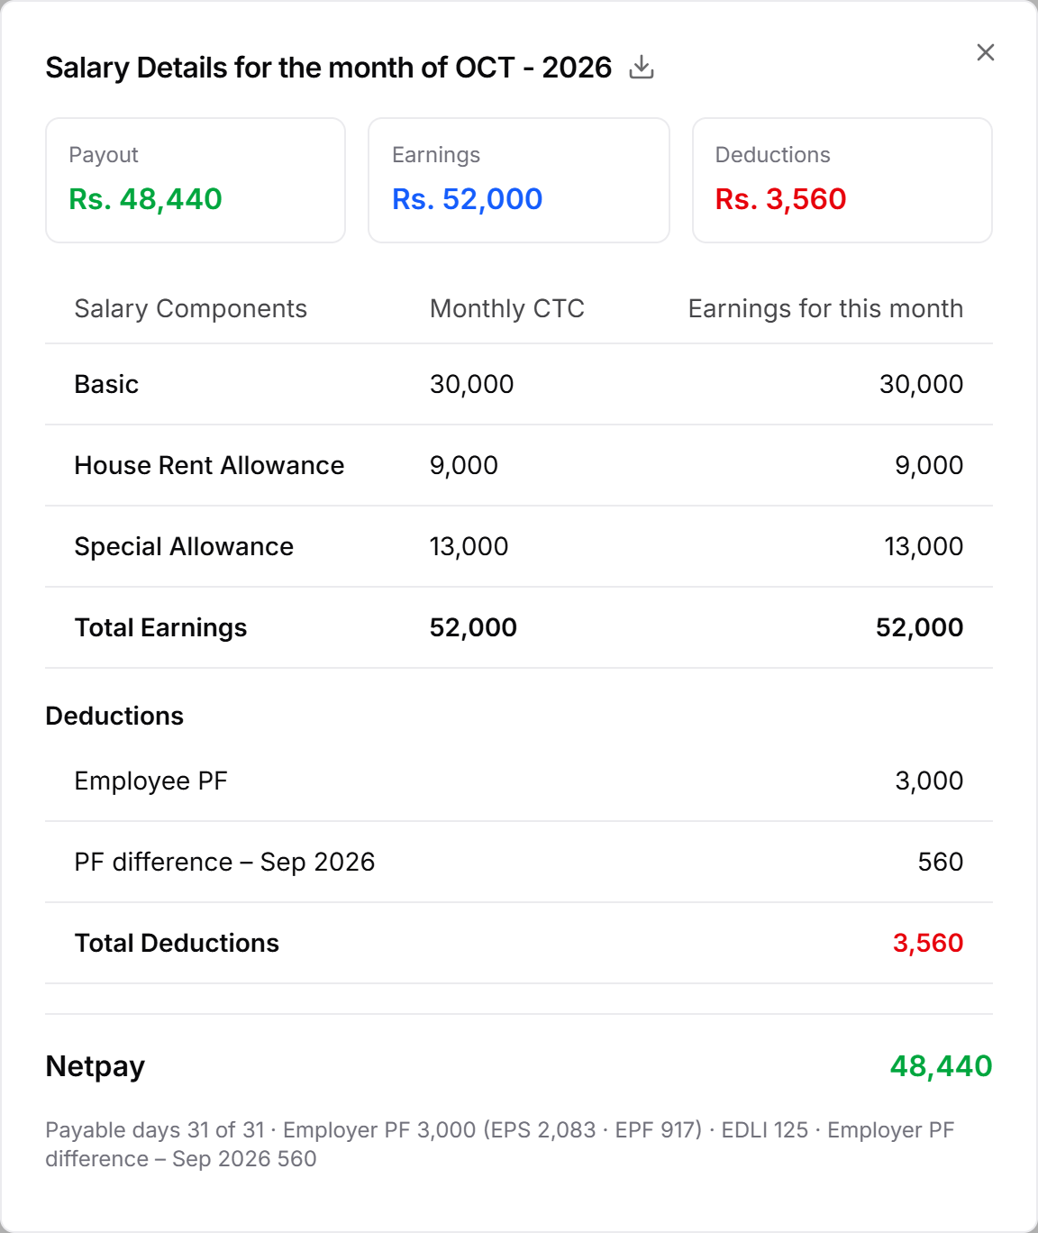
Figure 21: October payslip with the PF difference line
- Payroll Reports → PF Report → SEP-2026 shows September on the new ceiling, per half. Employees without a UAN are flagged.
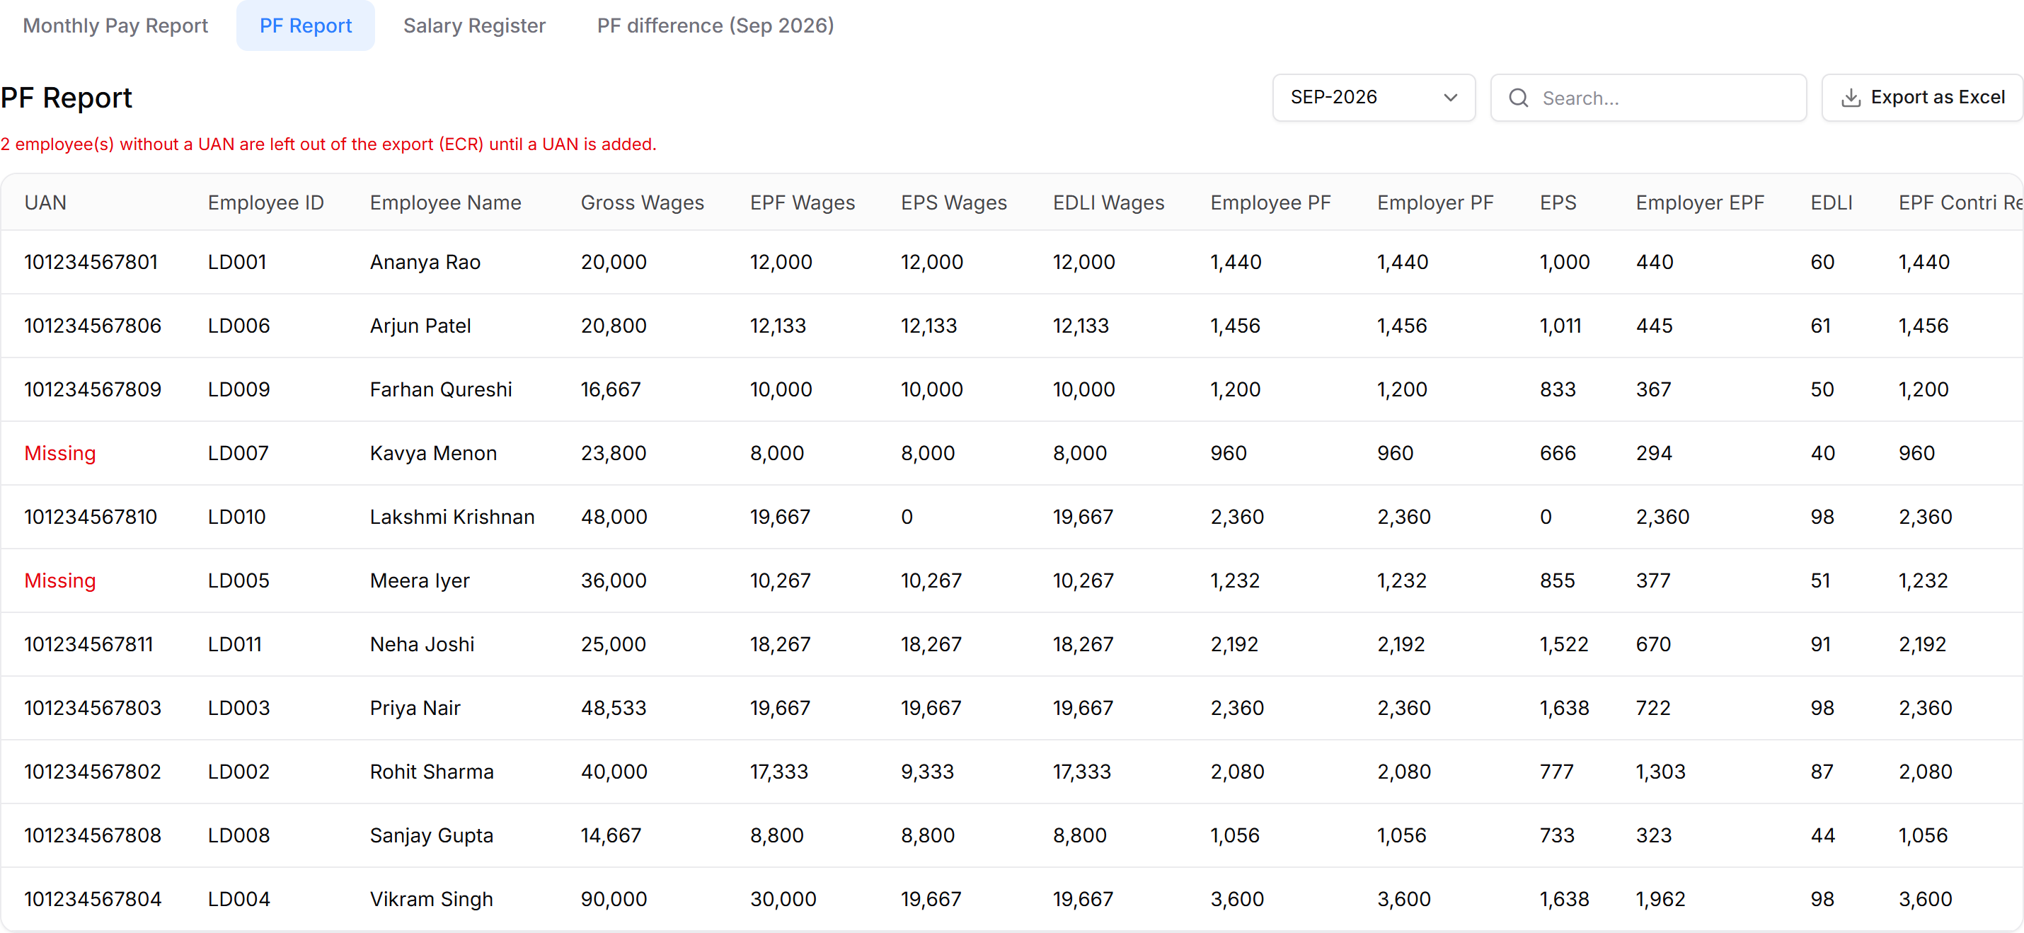
Figure 22: PF report, September 2026
- The same report for OCT-2026 uses ₹25,000 for the whole month.
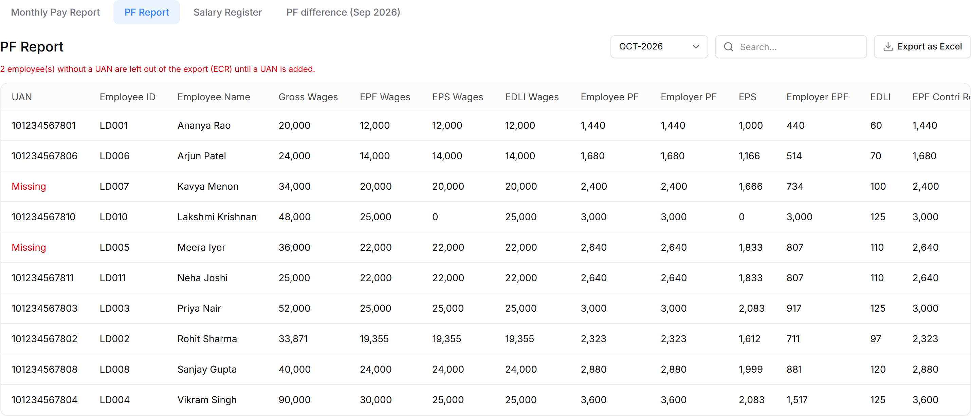
Figure 23: PF report, October 2026
- PF difference (Sep 2026) lists each employee's difference by component, who bears the employee share and the month it is settled in. Export as Excel gives the file for the difference ECR.
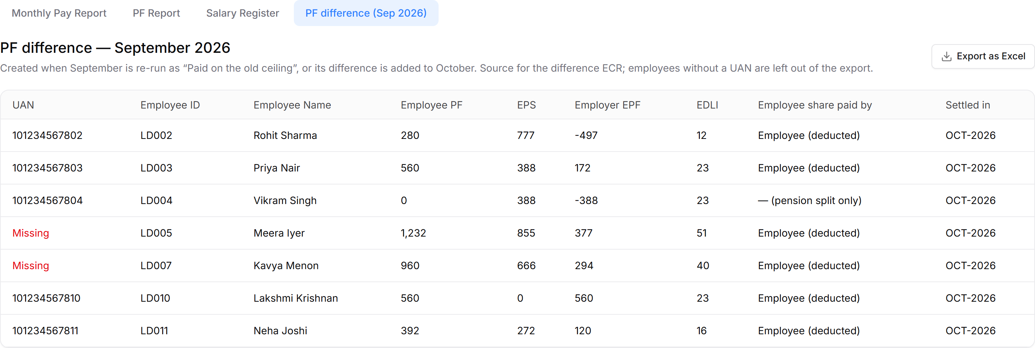
Figure 24: PF difference report

4.3 Checks and banners
Element | Shows when | Wording / behaviour
Missing UAN | Employee has PF but no UAN | UAN cell reads "Missing" in red. Note above the table: {n} employee(s) without a UAN are left out of the export (ECR) until a UAN is added. The export skips them.
EPS of ₹0 | Age 58+, or a non-EPS member before joining EPS | EPS wages and EPS 0; the whole employer PF goes to EPF (Lakshmi Krishnan)
Negative employer EPF in the difference | Employer share moves from EPF to EPS | Shown as a minus, e.g. Rohit −497, Vikram −388; EPS + EPF still equals the employer difference
Report rows | PF report | Only employees with PF deducted in the month

4.4 Calculations
EPS = 8.33% × EPS wages Employer EPF = Employer PF − EPS EDLI = 0.5% × EDLI wages
EPF wages = the PF wage PF was worked out on (uncapped for No Limit). EPS and EDLI wages = the PF wage capped at the ceiling; EPS wages count only EPS-eligible days. In September each half is capped at its own share of the ceiling and the halves are added.
Employee, month | EPF wages | EPS wages | Employee PF | EPS | Employer EPF | EDLI
Priya Nair, Sep | 19,667 | 19,667 | 2,360 | 1,638 | 722 | 98
Rohit Sharma, Sep (EPS from 17 Sep) | 17,333 | 9,333 | 2,080 | 777 | 1,303 | 87
Vikram Singh, Sep (No Limit) | 30,000 | 19,667 | 3,600 | 1,638 | 1,962 | 98
Priya Nair, Oct | 25,000 | 25,000 | 3,000 | 2,083 | 917 | 125
Rohit Sharma, Oct (1 day LOP) | 19,355 | 19,355 | 2,323 | 1,612 | 711 | 97

Difference report. Each component = September on the new ceiling − September as paid. Priya: employee 560, EPS 388, employer EPF 172, EDLI 23. Rohit: employee 280, EPS 777, employer EPF −497 — he was not in EPS before 17 Sep, so part of the employer share moves from EPF to EPS.
Open question: when salaries were paid on the mid-month basis but the September ECR was filed on ₹15,000 ("Paid as calculated here"), no difference is created today, so there is no difference ECR. Should one still be offered?

5. Payroll dashboard
The Payroll Dashboard shows where the business stands on the revision: an amber banner while September is still on the old ceiling, and a read-only card whose three lines tick as the runs happen. Nothing is done on the dashboard itself; each line says where it happened and links there.

5.1 What changes
Area | LEDGERS v4 today | New
Reminder | — | Amber banner while September stands on ₹15,000, with Review September
Revision status | — | "PF wage ceiling revision" card: September · Newly under PF or pension · October CTC
Coverage list | — | Download from the card: who comes under PF or pension, from when, PF wage on 17 Sep, UAN

5.2 Expected flow
- Before any correction, the banner and the card show all three lines open.
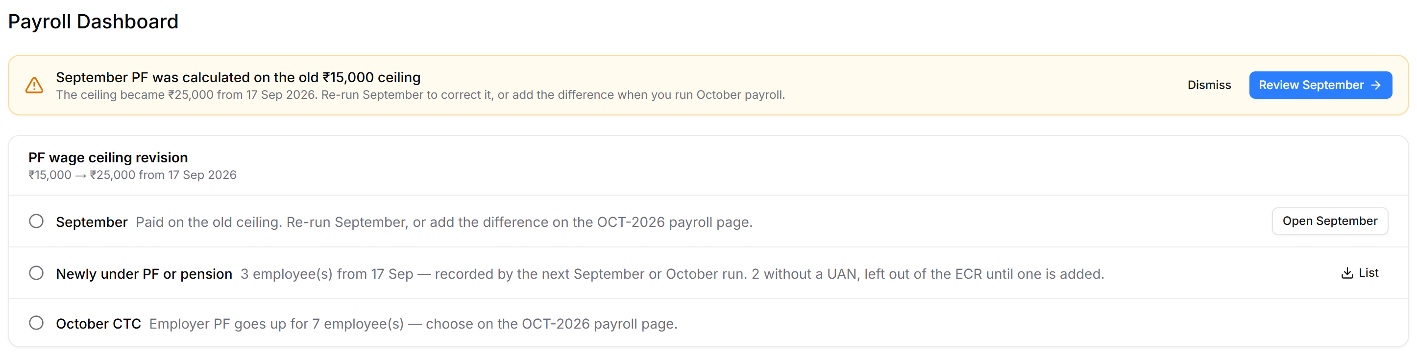
Figure 25: Dashboard before September is corrected
- Re-running September ticks September and coverage; the banner goes.
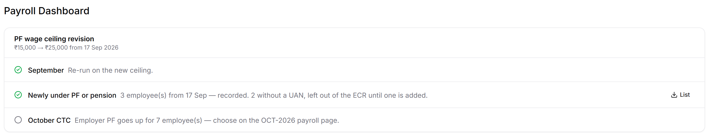
Figure 26: After the September re-run
- Running October ticks October CTC. The card stays as the record of how the revision was handled.
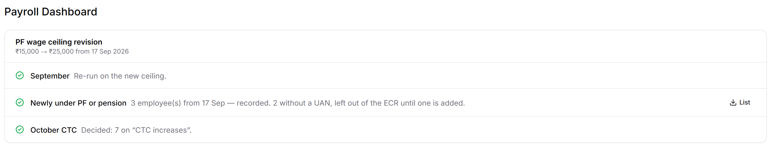
Figure 27: Done — September re-run
- If September was left as paid and the difference added in October, the September line says so.
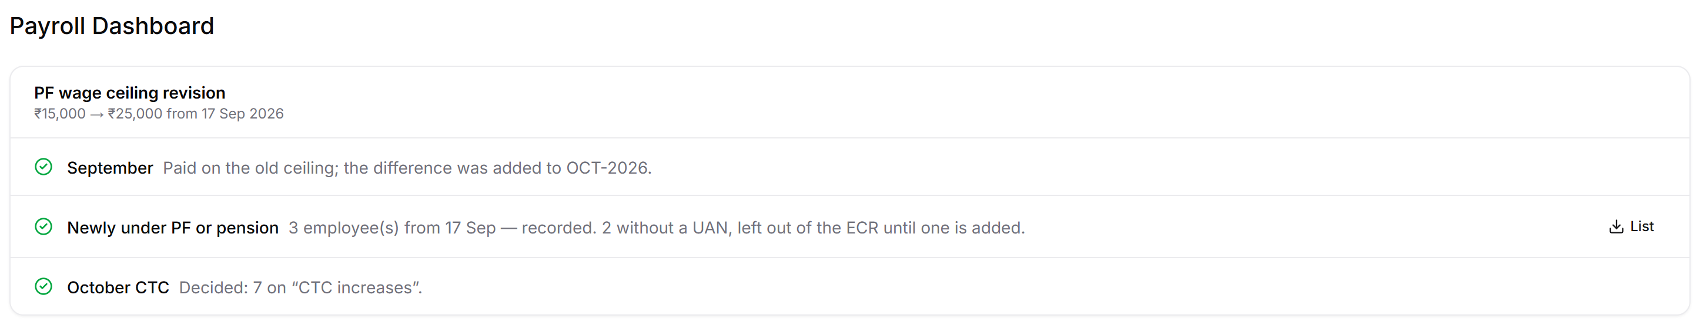
Figure 28: Done — difference added to October

5.3 Checks and banners
Element | Open | Done | Turns done when
Reminder banner | September PF was calculated on the old ₹15,000 ceiling. The ceiling became ₹25,000 from 17 Sep 2026. Re-run September to correct it, or add the difference when you run October payroll. Buttons: Dismiss · Review September | Hidden | September is re-run on mid-month, or its difference is added to October; or it is dismissed
September line | Paid on the old ceiling. Re-run September, or add the difference on the OCT-2026 payroll page. Button: Open September | Re-run on the new ceiling. · or: Paid on the old ceiling; the difference was added to OCT-2026. | Same as the banner, but dismissing does not tick it
Newly under PF or pension | {n} employee(s) from 17 Sep — recorded by the next September or October run. | {n} employee(s) from 17 Sep — recorded. | The first run on the new ceiling records them
… missing UAN | {n} without a UAN, left out of the ECR until one is added. | Same, until a UAN is entered | A UAN is added to the profile
October CTC | Employer PF goes up for {n} employee(s) — choose on the OCT-2026 payroll page. | Decided: {x} on "CTC increases", {y} kept the same CTC. | The October run saves the choice

When nobody's status changes, the coverage line reads "Nobody's PF or pension status changes." When no employer PF rises, the CTC line reads "No change in employer PF." The List download has: Employee ID, Name, Change (PF / Pension), From, PF wage on 17 Sep, UAN, Recorded.

5.4 Counts
- Newly under PF or pension = NO-PF employees with PF wage ≤ ₹25,000 on 17 Sep, plus non-EPS members with wages ≤ ₹25,000 on 17 Sep. Demo: Meera Iyer, Kavya Menon (PF), Rohit Sharma (EPS) = 3.
- October CTC = active employees whose CTC at the ₹25,000 ceiling is above their CTC at ₹15,000 — limited employees with PF wage above ₹15,000, and the newly covered. Demo: 7. No Limit employees are never counted.

