Chatbot with Adaptive Responses – ARIA
Adaptive Response Intelligence Assistant for Customer Support Optimization

A Dissertation
Submitted by

AKHIL MADHU

(AA.SC.P2MCA24074029)
in partial fulfilment of the requirements for the award of the degree of
MASTER OF COMPUTER APPLICATIONS



July 2026

BONAFIDE CERTIFICATE

This is to certify that this dissertation titled "Chatbot with Adaptive Responses – ARIA" submitted in partial fulfilment of the requirements for the award of the Degree of Master of Computer Applications, by Akhil Madhu (AA.SC.P2MCA24074029), is a bona fide record of the work carried out by him under my supervision during the academic term from April 2026 to August 2026 and that it has not been submitted, to the best of my knowledge, in part or in full, for the award of any other degree or diploma.

Athira S Amrita Sindhu M

Reviewer

Date: 23rd July, 2026

DECLARATION

I do hereby declare that this dissertation titled " Chatbot with Adaptive Responses – ARIA", submitted in partial fulfilment of the requirements for the award of the degree of Master of Computer Applications, is a true record of work carried out by me and that all information contained herein, which do not arise directly from my work, have been properly acknowledged and cited, using acceptable international standards. Further, I declare that the contents of this thesis have not been submitted, in part or in full, for the award of any other degree or diploma.


Date: 23rd July, 2026 AKHIL MADHU

Acknowledgement

I would like to express my sincere gratitude to Ms. Yamuna Chimmanda for giving me the opportunity to undertake this major project. I am thankful to my project guide, Mrs. Athira S, for the valuable guidance, suggestions, and support provided throughout the project. I also thank the course coordinators, Mrs. Amrita Sindhu M, faculty members, and reviewers for their instructions and feedback during the project work. I extend my thanks to my family, friends, and classmates for their support and encouragement. This project helped me gain practical experience in developing an AI-assisted customer support application using frontend-backend integration, database persistence, semantic retrieval, and AI integration concepts.

Abstract

ARIA is an AI-assisted customer support application developed to improve the speed and quality of support responses. The system addresses the problem of delayed and inconsistent customer support by providing a structured platform where customer questions can be answered using verified knowledge sources and AI-generated assistance.

The application includes a customer chat interface, an agent workspace, a knowledge base, and an analytics dashboard. The frontend is developed using React with TypeScript, while the backend is implemented using Express with TypeScript. SQLite is used for storing conversations, messages, feedback, and knowledge records.

The AI functionality is implemented through semantic retrieval, Hugging Face embeddings, and Gemini-backed response generation. When a customer asks a question, the system retrieves relevant knowledge, generates a grounded response, and displays confidence, sources, and retrieval details. Customer ratings and agent actions are stored as feedback signals and used to support learning-based analytics.

The project demonstrates how AI can be integrated into a full-stack web application to support customer service workflows. The final system provides knowledge-backed responses, feedback collection, database persistence, analytics, and a practical agent-assist workflow.

List of Figures

Figure 1.1: ARIA application dashboard overview
Figure 3.1: Proposed system architecture of ARIA
Figure 3.2: Data flow diagram of ARIA customer support workflow
Figure 3.3: Use case diagram of ARIA
Figure 3.4: Database schema overview
Figure 4.1: Agent Workspace interface
Figure 4.2: Customer Chat interface with AI-generated response
Figure 4.3: Knowledge Base interface
Figure 4.4: Analytics Dashboard interface
Figure 4.5: System Settings showing live backend and AI status
Figure 4.6: Mastra Platform deployment and observability view
Figure 8.1: GitHub repository structure of ARIA

List of Tables

Table 3.1: Hardware and software requirements
Table 3.2: Module description of ARIA
Table 4.1: Frontend and backend implementation summary
Table 5.1: Test case summary
Table 5.2: API endpoint validation summary
Table 5.3: Final validation result summary
Table 8.1: Repository folder structure

List of Abbreviations

AI | Artificial Intelligence
API | Application Programming Interface
ARIA | Adaptive Response Intelligence Assistant
CSS | Cascading Style Sheets
DFD | Data Flow Diagram
HTML | HyperText Markup Language
JSON | JavaScript Object Notation
LLM | Large Language Model
RAG | Retrieval-Augmented Generation
REST | Representational State Transfer
SPA | Single Page Application
SQL | Structured Query Language
UI | User Interface
UX | User Experience
UML | Unified Modeling Language
VITE | Frontend build tool used for React development
DBMS | Database Management System
NLP | Natural Language Processing
TS | TypeScript
DOM | Document Object Model
HTTP | HyperText Transfer Protocol

Chapter 1

- Introduction
  - Background
- Customer support plays an important role in maintaining user satisfaction in online platforms. In many support environments, agents need to respond to repeated questions related to refunds, delivery, billing, accounts, and product issues. When the number of queries increases, manual handling becomes time-consuming and may lead to delayed or inconsistent responses.
- The growth of Artificial Intelligence has created opportunities to improve support workflows. AI-assisted systems can retrieve relevant information, suggest responses, and help agents resolve queries faster. However, for support systems, it is important that responses are based on verified knowledge rather than random generated content.
- ARIA is developed as an AI-assisted customer support application that combines a web-based interface, backend APIs, database persistence, semantic retrieval, and AI integration. The system helps customers ask questions, allows agents to review AI suggestions, stores feedback, and displays analytics for support performance.

1.2 Problem Statement
- Traditional customer support workflows depend heavily on manual effort. Agents may need to search through documents or policies before replying to customers. This can increase response time and reduce consistency. Another issue is that general AI responses may not always be reliable unless they are connected to verified business knowledge.
- The problem addressed in this project is the need for a support system that can provide fast, consistent, and knowledge-backed responses while still allowing human agents to review and improve the output. The system should also store conversations, feedback, and support metrics so that the performance of the support process can be analyzed.

1.3 Objectives
The main objectives of the project are:
- To develop an AI-assisted customer support web application.
- To provide a customer chat interface for asking support-related questions.
- To create an agent workspace where support agents can review, edit, accept, regenerate, or reject AI suggestions.
- To maintain a knowledge base for storing verified support information.
- To use semantic retrieval for finding relevant knowledge sources.
- To integrate Mastra AI and Gemini-backed response generation.
- To store conversations, messages, feedback, and knowledge records using SQLite.
- To provide analytics for feedback, response quality, source quality, and agent actions.
- To validate the system through API testing, retrieval evaluation, and final workflow testing.

1.4 Scope of the Project
- The scope of this project is limited to building a working prototype of an AI-assisted customer support application. The system focuses on support queries related to common business areas such as refunds, delivery, billing, accounts, and product issues. The application includes frontend screens, backend APIs, SQLite persistence, semantic retrieval, Mastra AI integration, and analytics.
- The project does not focus on training a new machine learning model from scratch. Instead, it uses existing AI services and embedding-based retrieval to build an applied AI system. Features such as login authentication, large-scale production deployment, and enterprise-level access control can be considered as future enhancements.

1.5 Report Organization
This report is organized into eight chapters.
- Chapter 1 introduces the background, problem statement, objectives, and scope of the project.
- Chapter 2 presents the literature review and background study related to AI-assisted support systems, semantic retrieval, and full-stack application development.
- Chapter 3 explains the system design and architecture.
- Chapter 4 describes the implementation details of the frontend, backend, database, retrieval, and AI integration.
- Chapter 5 presents testing, validation, and results.
- Chapter 6 provides the conclusion and future work.
- Chapter 7 contains references used for this project.
- Chapter 8 includes appendix materials such as the GitHub repository link and supporting information.

Chapter 2

- Literature Review/ Background Study
  - Introduction
- This chapter reviews the existing concepts and technologies related to the project.
- The study focuses on customer support systems, AI chatbots, large language models, semantic retrieval, RAG, feedback learning, and full-stack web applications.
- The purpose is to understand the limitations of existing approaches and justify the need for ARIA.

  - Traditional Customer Support Systems
- Customer support systems help users resolve issues related to orders, refunds, delivery, billing, accounts, and products.
- In traditional support workflows, agents manually read customer queries and search for answers from policies or internal documents.
- This can increase response time when query volume is high.
- Repeated questions may lead to agent workload and inconsistent responses.
- A structured system is required to improve response speed, consistency, and traceability.

  - AI-Based Chatbots and Virtual Assistants
- AI chatbots are used to answer customer questions automatically or assist support agents.
- They can reduce waiting time and provide quick first-level responses.
- Chatbots are useful for common and repeated queries.
- However, chatbot responses may become generic if they are not connected to verified knowledge.
- For customer support, accuracy is important because wrong answers can affect user trust.

  - Large Language Models in Support Applications
- Large Language Models can understand natural language and generate human-like responses.
- They are useful for creating support replies based on user questions.
- LLMs can improve the quality and readability of responses.
- The limitation is that LLMs may generate incorrect information if they are not grounded with proper context.
- Therefore, LLM-based support systems should use trusted knowledge sources and human review.

  - Semantic Retrieval and Embeddings
- Semantic retrieval is used to find information based on meaning instead of exact keyword matching.
- Text embeddings convert questions and knowledge records into numerical representations.
- Similar content can be compared using embedding similarity.
- This helps the system find relevant support policies even when the customer uses different words.
- In ARIA, semantic retrieval helps select useful knowledge before generating an AI response.

  - Retrieval-Augmented Generation

- Retrieval-Augmented Generation (RAG) combines information retrieval with AI response generation.
- First, relevant knowledge is retrieved from a knowledge base.
- Then the AI model uses that retrieved context to generate a response.
- This improves answer quality because the response is based on available knowledge.
- It also reduces the chance of unsupported or random AI answers.

  - Human-in-the-Loop Agent Assist
- Human-in-the-loop means that AI suggestions are reviewed by a person before being accepted.
- In customer support, this is useful because agents can verify and improve AI-generated responses.
- Agents may accept, edit, regenerate, or reject suggestions.
- This approach combines the speed of AI with the decision-making ability of human support agents.
- ARIA follows this approach through the Agent Workspace module.

  - Feedback Learning and Analytics

- Feedback helps measure the quality of support responses.
- Customer ratings, agent actions, accepted suggestions, rejected suggestions, and source quality can be stored.
- Analytics can help understand response quality and support performance.
- Feedback records can also highlight which knowledge sources are useful or need improvement.
- ARIA uses feedback and analytics to support continuous improvement of the support workflow.

  - Full-Stack Web Application Development

- A full-stack web application includes frontend, backend, database, and API communication.
- The frontend provides the user interface for customers and support agents.
- The backend handles business logic, API requests, AI integration, and database operations.
- The database stores conversations, messages, feedback, and knowledge records.
- ARIA uses a full-stack structure to combine user interaction, AI processing, persistence, and analytics.

2.10 Research Gap

- Existing systems may provide either manual support, basic chatbot responses, or separate analytics.
- Many chatbot systems do not provide proper human review or source-backed responses.
- Some systems may generate answers without storing feedback or tracking response quality.
- There is a need for a system that combines AI response generation, semantic retrieval, human review, database persistence, and analytics in one workflow.
- ARIA addresses this gap by providing an AI-assisted customer support prototype with customer chat, agent workspace, knowledge base, Mastra AI integration, Gemini response generation, SQLite persistence, and analytics.

2.11 Summary

- This chapter reviewed the main concepts required for the ARIA project.
- Customer support systems need speed, consistency, and verified information.
- AI, semantic retrieval, RAG, and feedback analytics can improve support workflows.
- The literature review supports the design of ARIA as a practical AI-assisted customer support application.

Chapter 3

- System Design / Architecture

  - Introduction

- This chapter explains the design and architecture of the ARIA system.
- It describes the main system components, data flow, modules, hardware/software requirements, and database design.
- The purpose of this chapter is to show how frontend, backend, database, semantic retrieval, and AI services work together.

  - Proposed System Architecture

- ARIA follows a full-stack client-server architecture.
- The frontend is built using React with TypeScript.
- The backend is built using Express with TypeScript.
- SQLite is used for storing application data.
- Semantic retrieval is used to find matching knowledge records.
- Mastra AI and Gemini are used for AI-backed response generation.
- The system has four main user-facing modules:
  - Agent Workspace
  - Customer Chat
  - Knowledge Base
  - Analytics Dashboard

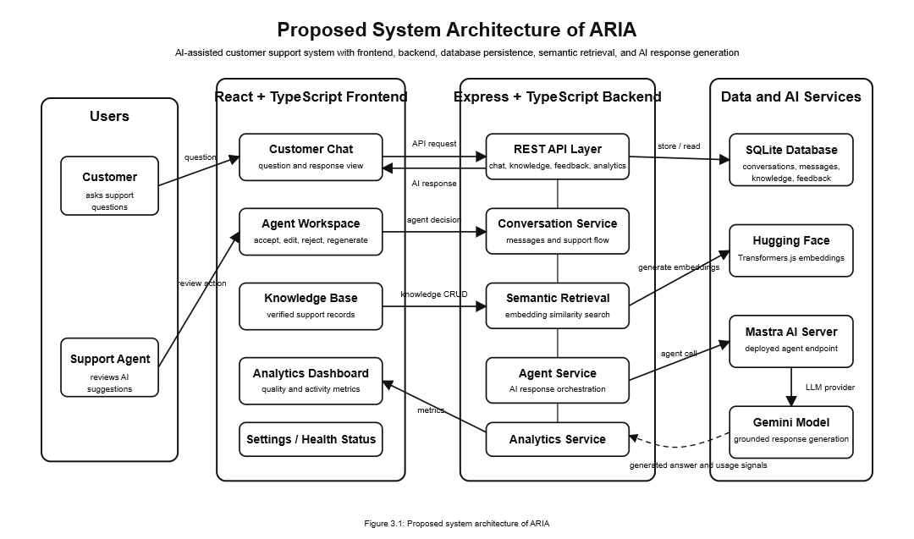
Figure 3.1: Proposed system architecture of ARIA

  - Hardware and Software Requirements

Category | Requirement
Operating System | Windows 10/11 or compatible OS
Processor | Intel i3/i5 or equivalent
RAM | Minimum 8 GB recommended
Browser | Google Chrome / Microsoft Edge
Frontend | React, TypeScript, Vite
Backend | Node.js, Express, TypeScript
Database | SQLite
AI Integration | Mastra AI, Gemini API
Semantic Retrieval | Hugging Face Transformers.js
Development Tools | Visual Studio Code, Git, GitHub, GitHub Desktop
Testing Tools | Browser testing, API endpoint testing, validation scripts

Table 3.1: Hardware and software requirements

  - Module Description
Module | Description
Customer Chat | Allows customers to ask support-related questions and view AI-assisted responses.
Agent Workspace | Allows support agents to review, edit, accept, regenerate, or reject AI suggestions.
Knowledge Base | Stores verified support information used for semantic retrieval.
Backend API | Handles chat, knowledge, feedback, analytics, health, and AI-related requests.
Database Layer | Stores conversations, messages, feedback, knowledge records, and analytics data.
Semantic Retrieval | Matches customer queries with relevant knowledge records based on meaning.
AI Response Generation | Uses Mastra AI and Gemini to generate grounded support responses.
Analytics Dashboard | Displays response quality, source quality, feedback, and agent activity metrics.

Table 3.2: Module description of ARIA
  - Data Flow Design

- Customer enters a question in the chat interface.
- Frontend sends the question to the backend API.
- Backend stores the conversation/message in SQLite.
- Backend searches the knowledge base using semantic retrieval.
- Retrieved knowledge is passed as context to the AI response generator.
- Mastra AI and Gemini generate a response.
- Response is returned to the frontend with confidence, sources, and retrieval details.
- Customer feedback and agent actions are stored for analytics.

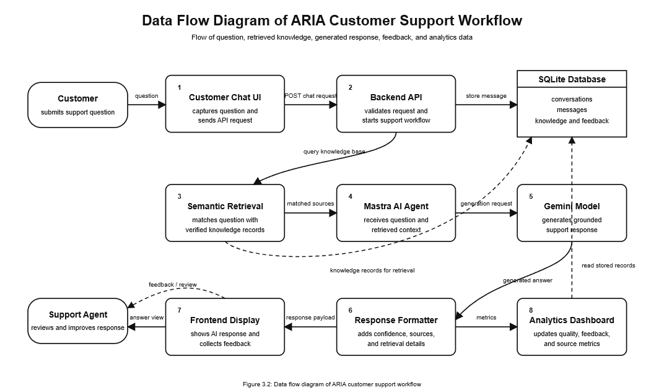

Figure 3.2: Data flow diagram of ARIA customer support workflow

  - Use Case Design

- Roles:
  - Customer
  - Support Agent
  - System/Admin

- Main use cases:
- Ask support question
- View AI response
- Review AI suggestion
- Edit AI response
- Accept or reject suggestion
- Manage knowledge base
- View analytics
- Check system/AI status

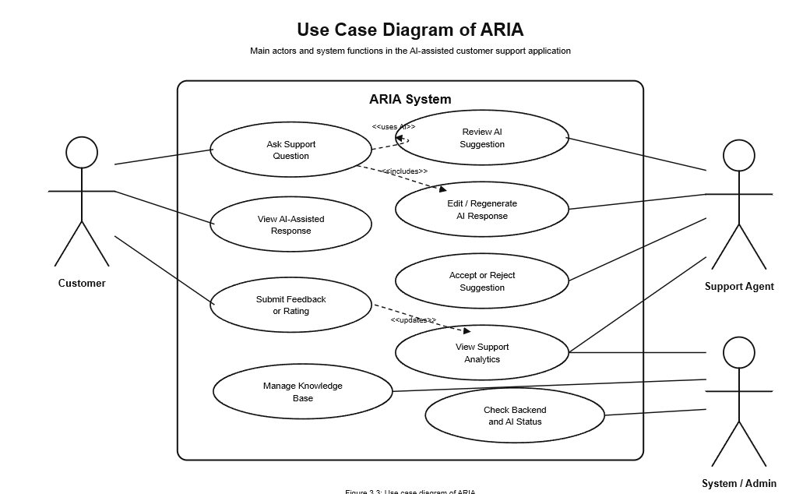
Figure 3.3: Use case diagram of ARIA
  - Database Design

- SQLite is used for lightweight database persistence.
- The database stores the main application records required for conversations, messages, knowledge, feedback, and analytics.
- Major entities:
  - Conversations
  - Messages
  - Knowledge Records
  - Feedback
  - Agent Actions
  - Knowledge Embeddings / Evaluation Records

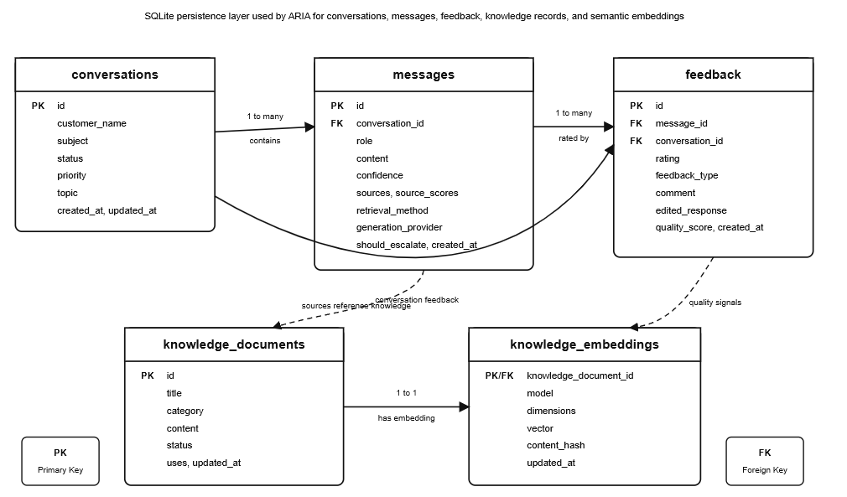

Figure 3.4: Database schema overview

  - Algorithm / Workflow

- Customer submits a support question.
- System receives the request through backend API.
- The question is stored as a message in SQLite.
- Semantic retrieval searches the knowledge base.
- Relevant knowledge records are selected as context.
- AI response is generated using Mastra AI and Gemini.
- Response, confidence score, and sources are returned.
- Agent or customer feedback is collected.
- Feedback and actions are stored for analytics.
- Analytics dashboard updates support performance metrics.

  - Summary

  - This chapter explained the architecture and design of ARIA.
  - The system combines frontend, backend, database, semantic retrieval, AI integration, and analytics.
  - The design supports reliable AI-assisted customer support with human review and feedback tracking.

Chapter 4

- Implementation Details
  - Introduction

  - This chapter explains the implementation of the ARIA application.
  - It describes the frontend, backend, database, AI integration, semantic retrieval, feedback learning, and analytics implementation.
  - The project was implemented as a full-stack web application using React, TypeScript, Express, SQLite, Mastra AI, Gemini, and Hugging Face Transformers.js.

  - Frontend Implementation

- The frontend was developed using React with TypeScript and Vite.
- It provides the main user interface for customers and support agents.
- The application includes:
  - Agent Workspace
  - Customer Chat
  - Knowledge Base
  - Analytics Dashboard
  - Settings / System Status
- The frontend communicates with the backend through REST API calls.
- The UI displays AI responses, confidence score, sources, feedback status, and analytics data.

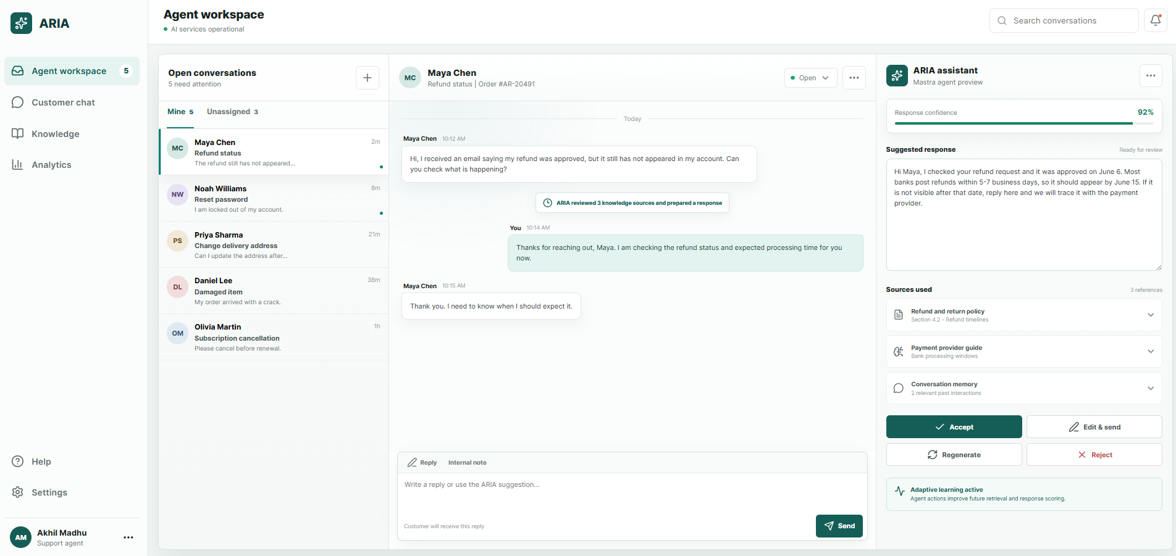
Figure 4.1: Agent Workspace Interface

  - Customer Chat Implementation

- The Customer Chat module allows a customer to enter support-related questions.
- The question is sent to the backend API.
- The AI-generated response is shown in the chat window.
- The response includes confidence, retrieval method, and knowledge source details.
- This module demonstrates the customer-facing part of the support workflow.
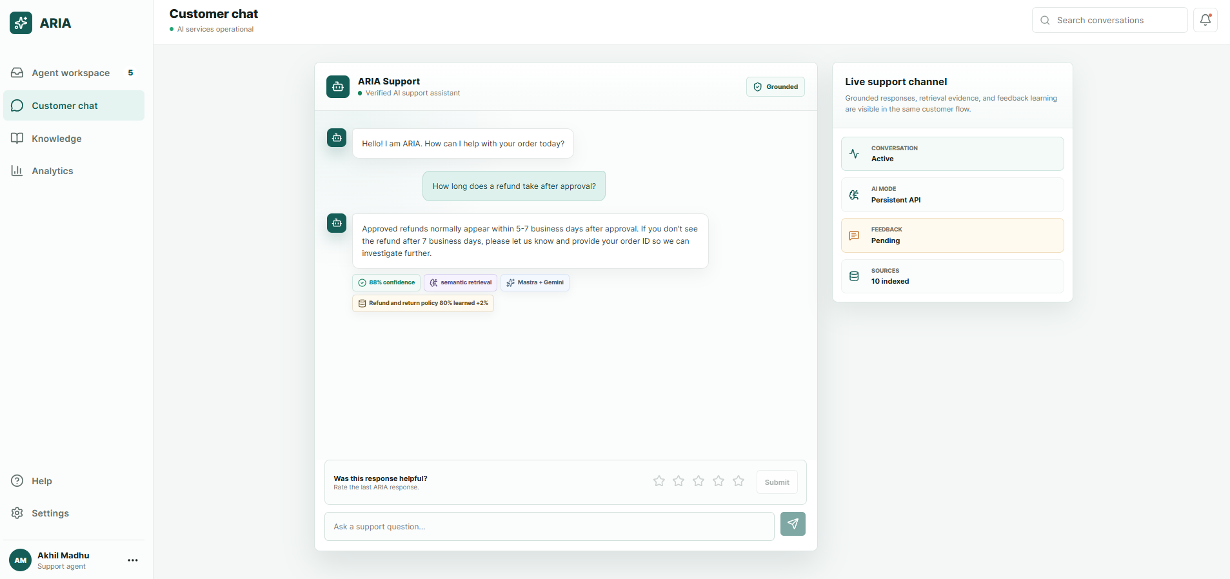
Figure 4.2: Customer Chat interface with AI-generated response

  - Agent Workspace Implementation

- The Agent Workspace allows the support agent to handle customer conversations.
- Agents can review AI suggestions before using them.
- The agent can:
    - accept a suggestion
    - edit a suggestion
    - regenerate a response
    - reject a suggestion
- These actions are stored as feedback signals.
- This creates a human-in-the-loop workflow where AI assists the agent but the final decision remains with the human user.

  - Knowledge Base Implementation

- The Knowledge Base stores verified support information such as policies, FAQs, and procedures.
- Knowledge records are stored in SQLite.
- These records are used by the backend during semantic retrieval.
- The system can retrieve relevant knowledge based on the meaning of the customer question.
- This helps the AI response remain grounded in verified information.
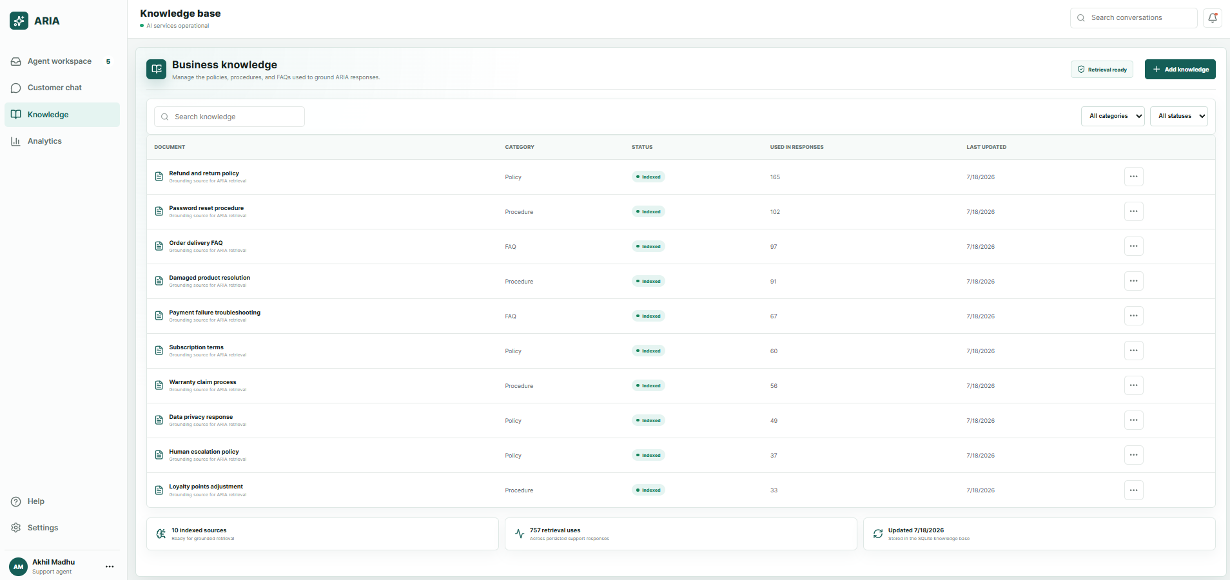
Figure 4.3: Knowledge Base Interface

  - Backend API Implementation

- The backend was implemented using Express with TypeScript.
- It exposes REST API endpoints for chat, conversations, knowledge, feedback, analytics, and health status.
- The backend handles:
  - receiving customer questions
  - storing messages
  - retrieving knowledge
  - calling AI services
  - storing feedback
  - returning analytics data
- The backend acts as the main communication layer between frontend, database, retrieval service, and AI services.

  - Database Implementation

- SQLite is used for database persistence.
- The database stores:
  - conversations
  - messages
  - feedback
  - knowledge documents
  - knowledge embeddings
- SQLite was selected because it is lightweight, simple to configure, and suitable for project prototype/demo requirements.
- The database is created automatically when the backend runs.

  - Semantic Retrieval Implementation

- Semantic retrieval is used to find relevant knowledge records based on meaning.
- The project uses Hugging Face Transformers.js for generating embeddings.
- Customer questions and knowledge records are compared using similarity.
- The best matching knowledge records are selected and passed as context for response generation.
- If semantic retrieval is unavailable, the system can fall back to keyword-based retrieval.

  - Mastra AI and Gemini Integration

- Mastra AI is used to define and deploy the ARIA Support Agent.
- Gemini is used as the LLM provider for response generation.
- The backend sends the customer question and retrieved knowledge context to the Mastra agent endpoint.
- The AI response is generated using Gemini and returned to the backend.
- The final response is sent back to the frontend with confidence and source details.

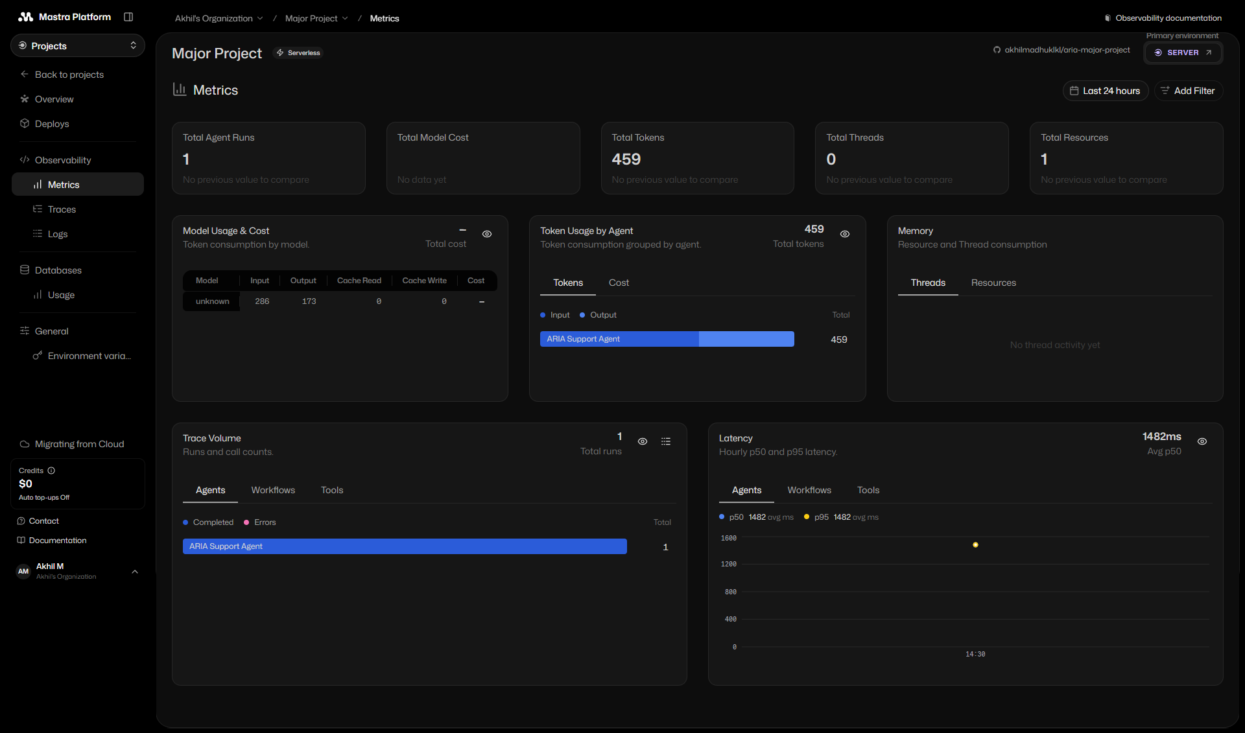
Figure 4.6: Mastra Platform deployment and observability view

  - Feedback Learning Implementation

- The system stores customer feedback and agent actions.
- Feedback includes ratings, accepted suggestions, edited suggestions, and rejected suggestions.
- These records are used to calculate quality scores and support analytics.
- Feedback signals help identify which knowledge sources are useful and which responses need improvement.

  - Analytics Implementation

- The Analytics Dashboard displays support performance information.
- It shows response quality, source quality, feedback records, acceptance rate, and support topic trends.
- Analytics data is calculated from stored conversations, messages, feedback, and knowledge records.

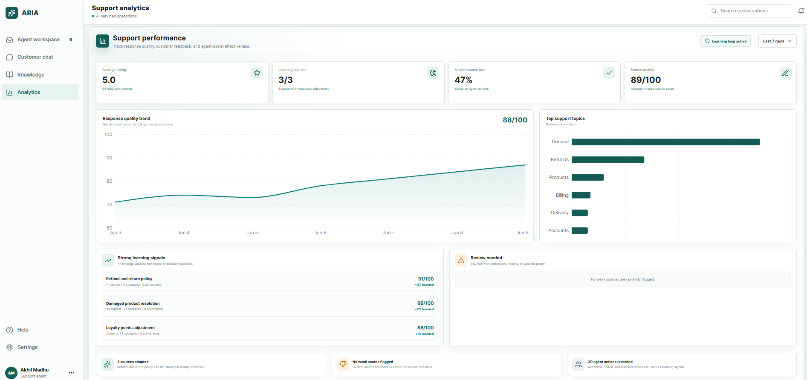
Figure 4.4: Analytics Dashboard Interface

  - System Status and Settings Implementation

- The Settings page shows the status of frontend, backend, database, retrieval, and AI services.
- It helps confirm whether the application is running correctly.
- This is useful during demo and validation.
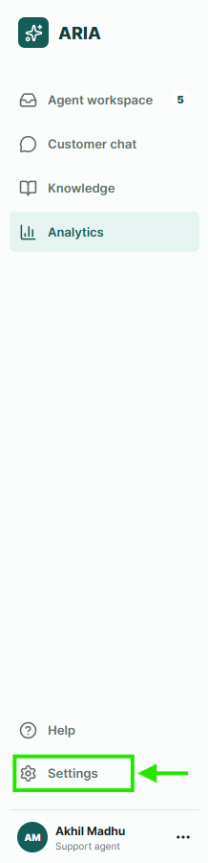
The System Settings modal displays the operational status of the backend API, SQLite database, semantic retrieval service, Mastra Cloud integration, and learning summary. This helps verify that the main components of the application are connected and running correctly.
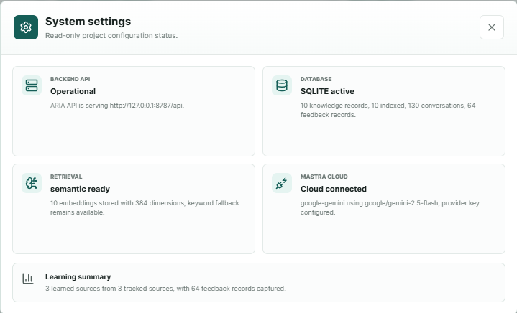
Figure 4.5: System Settings showing live backend and AI Status

  - Implementation Summary Table
Component | Technology Used | Purpose
Frontend | React, TypeScript, Vite | User interface and screen navigation
Backend | Node.js, Express, TypeScript | API handling and business logic
Database | SQLite | Persistent storage
AI Agent | Mastra AI | Agent workflow and deployment
LLM | Gemini | AI response generation
Semantic Retrieval | Hugging Face Transformers.js | Embedding-based knowledge matching
Version Control | Git, GitHub | Source code management
Testing | API tests, build validation, browser checks | Application verification

Table 4.1: Frontend and backend implementation summary

  - Summary

- This chapter explained the implementation of the ARIA system.
- The application was developed as a full-stack AI-assisted customer support platform.
- The frontend, backend, database, semantic retrieval, Mastra AI, Gemini integration, feedback loop, and analytics were implemented and connected successfully.

Chapter 5

- Testing, Validation & Results
  - Introduction

- This chapter explains the testing and validation performed for the ARIA application.
- Testing was done to confirm that the frontend, backend, database, semantic retrieval, AI integration, feedback, and analytics modules work correctly.
- Both manual testing and API-level validation were used.

  - Testing Objectives

- To verify that all frontend screens load correctly.
- To verify that backend API endpoints respond correctly.
- To confirm that SQLite stores conversations, messages, feedback, and knowledge records.
- To validate that semantic retrieval returns relevant knowledge sources.
- To confirm that Mastra AI and Gemini generate proper AI-assisted responses.
- To verify that feedback and agent actions are stored and reflected in analytics.
- To ensure that the final workflow runs smoothly from customer question to AI response and analytics update.

  - Testing Methods

- Frontend testing: checked navigation, screen rendering, forms, buttons, and UI states.
- Backend API testing: tested health, chat, conversations, knowledge, feedback, analytics, and validation endpoints.
- Database validation: confirmed stored conversations, messages, feedback, knowledge records, and embeddings.
- AI integration testing: verified Mastra Cloud endpoint, Gemini response generation, and provider configuration.
- Semantic retrieval testing: checked whether customer questions matched relevant support knowledge.
- Workflow testing: tested complete flow from customer chat to AI response, feedback, and analytics.
- Build validation: confirmed that production build and lint checks passed.

  - Test Case Summary
Test Case ID | Test Scenario | Expected Result | Status
TC-01 | Open frontend application | Application loads without UI errors | Passed
TC-02 | Navigate between sidebar pages | Agent Workspace, Customer Chat, Knowledge, Analytics, and Settings open correctly | Passed
TC-03 | Check backend health API | API returns operational status | Passed
TC-04 | Submit customer question | Question is sent to backend and response is generated | Passed
TC-05 | Verify AI response generation | Response is generated using Mastra/Gemini integration | Passed
TC-06 | Verify semantic retrieval | Relevant knowledge source is returned with confidence/source details | Passed
TC-07 | Check knowledge base records | Indexed knowledge records are displayed | Passed
TC-08 | Submit feedback/rating | Feedback is stored and reflected in analytics | Passed
TC-09 | Agent accepts/edits/rejects response | Agent action is stored as feedback signal | Passed
TC-10 | View analytics dashboard | Metrics and charts are displayed from stored records | Passed
TC-11 | Check system settings status | Backend, database, retrieval, and AI status are shown | Passed
TC-12 | Run final validation script | Final validation completes successfully | Passed

Table 5.1: Test case summary

  - API Endpoint Validation
API Endpoint | Purpose | Validation Result
/api/health | Checks backend, database, retrieval, and AI status | Passed
/api/conversations | Retrieves support conversations | Passed
/api/conversations/:id/messages | Retrieves messages for a conversation | Passed
/api/chat | Sends customer question and receives AI response | Passed
/api/knowledge | Retrieves or manages knowledge records | Passed
/api/feedback | Stores customer feedback | Passed
/api/agent-actions | Stores support agent actions | Passed
/api/analytics/summary | Retrieves analytics summary | Passed

Table 5.2: API endpoint validation summary

5.6 Validation Results
Validation Area | Result
Frontend UI | All major screens loaded correctly
Backend API | API endpoints responded successfully
Database | SQLite persistence verified
Knowledge Base | Indexed records displayed and retrieved
Semantic Retrieval | Relevant sources returned for customer query
AI Integration | Mastra/Gemini response generation verified
Feedback Loop | Customer and agent feedback stored
Analytics | Metrics and charts displayed correctly
Build/Lint Validation | Completed successfully

Table 5.3: Final validation result summary

5.7 Results Discussion
- The system successfully handled customer support questions.
- The AI-generated response was supported by retrieved knowledge sources.
- Confidence score, semantic retrieval status, and Mastra + Gemini integration was visible in the UI.
- Agent actions and customer feedback were stored as learning signals.
- The analytics dashboard displayed response quality, source quality, acceptance rate, and support topic trends.
- The system settings confirmed backend API, SQLite database, semantic retrieval, and Mastra Cloud connection status.

5.8 Summary
- This chapter presented the testing and validation of ARIA.
- The results show that the system works as a full-stack AI-assisted customer support application.
- The frontend, backend, database, semantic retrieval, AI integration, feedback loop, and analytics were tested successfully.
Chapter 6

- Conclusion and Future Work
6.1 Conclusion
- This project developed ARIA, an AI-assisted customer support application.
- The system provides a customer chat interface, agent workspace, knowledge base, analytics dashboard, and system status view.
- The frontend was implemented using React with TypeScript and Vite.
- The backend was implemented using Express with TypeScript.
- SQLite was used for database persistence.
- Semantic retrieval was used to identify relevant knowledge records.
- Mastra AI and Gemini were integrated for AI-assisted response generation.
- The system supports human-in-the-loop review through accept, edit, regenerate, and reject actions.
- Feedback and agent actions are stored and reflected in analytics.
- Testing confirmed that the main modules and workflows function correctly.

6.2 Project Contributions
- Developed a full-stack AI-assisted customer support prototype.
- Implemented frontend screens for customer chat, agent workspace, knowledge base, analytics, and settings.
- Created backend APIs for chat, conversations, knowledge, feedback, agent actions, analytics, and health status.
- Added SQLite database persistence for project records.
- Integrated semantic retrieval using stored knowledge records and embeddings.
- Integrated Mastra AI and Gemini for AI-backed response generation.
- Implemented feedback learning and analytics for tracking response quality and agent actions.
- Validated the system using UI checks, API testing, and final workflow testing.

6.3 Limitations
- The project is developed as an academic prototype and not a large-scale production system.
- Authentication and role-based access control were not implemented in the current version.
- The application uses SQLite, which is suitable for prototype/demo use but may need a more scalable database for production.
- The AI response quality depends on the available knowledge records and external AI provider response.
- The system does not train a custom machine learning model from scratch.
- Large-scale deployment, monitoring, and enterprise-level security can be improved in future versions.

6.4 Future Work
- Add login authentication and role-based access for customers, agents, and administrators.
- Add more advanced knowledge management features such as document upload and automatic indexing.
- Improve semantic retrieval using larger knowledge datasets.
- Add multilingual support for customer queries.
- Integrate email, WhatsApp, or live chat channels.
- Add more detailed analytics and reporting features.
- Use a scalable production database such as PostgreSQL for larger deployments.
- Add automated test coverage for frontend and backend modules.
- Improve deployment with production hosting and monitoring.
- Explore multi-agent workflow as an optional future enhancement.

6.5 Summary
- ARIA demonstrates how AI can be integrated into a full-stack customer support workflow.
- The project combines frontend interaction, backend APIs, database persistence, semantic retrieval, AI response generation, feedback learning, and analytics.
- The final system meets the main objectives of the project and provides a strong foundation for future improvements.

Chapter 7

- References
- A. Vaswani et al., “Attention Is All You Need,” Advances in Neural Information Processing Systems, 2017. [Online]. Available: https://papers.neurips.cc/paper/7181-attention-is-all-you-need
- P. Lewis et al., “Retrieval-Augmented Generation for Knowledge-Intensive NLP Tasks,” Advances in Neural Information Processing Systems, vol. 33, 2020. [Online]. Available: https://papers.nips.cc/paper/2020/hash/6b493230205f780e1bc26945df7481e5-Abstract.html
- N. Reimers and I. Gurevych, “Sentence-BERT: Sentence Embeddings using Siamese BERT-Networks,” Proceedings of EMNLP-IJCNLP, 2019. [Online]. Available: https://arxiv.org/abs/1908.10084
- React, “React Reference Overview,” React Documentation. [Online]. Available: https://react.dev/reference/react
- Microsoft, “The TypeScript Handbook,” TypeScript Documentation. [Online]. Available: https://www.typescriptlang.org/docs/handbook/intro.html
- Vite, “Getting Started,” Vite Documentation. [Online]. Available: https://vite.dev/guide/
- Express.js, “Hello world example,” Express Documentation. [Online]. Available: https://expressjs.com/en/starter/hello-world/
- Node.js, “Node.js Documentation,” Node.js API Documentation. [Online]. Available: https://nodejs.org/api/documentation.html
- SQLite, “SQLite Documentation,” SQLite. [Online]. Available: https://www.sqlite.org/docs.html
- Hugging Face, “Transformers.js,” Hugging Face Documentation. [Online]. Available: https://huggingface.co/docs/transformers.js/index
- Mastra, “Agents overview,” Mastra Documentation. [Online]. Available: https://mastra.ai/docs/agents/overview
- Google AI for Developers, “Gemini API reference,” Google AI Documentation. [Online]. Available: https://ai.google.dev/api

Chapter 8

- Appendix
  - GitHub Repository

- The source code of the ARIA project is maintained in a GitHub repository.
- The repository contains the frontend, backend, database-related files, documentation, report assets, and configuration files used for developing and validating the application.
- GitHub Repository: https://github.com/akhilmadhuklkl/aria-major-project

  - Repository Structure

- The ARIA project follows a structured folder organization.
- The main application files are kept inside the aria-app folder, while project-level documentation and final report assets are maintained in the root repository.

Folder/File | Description
README.md | Main project overview and setup information
REFERENCES.md | References used in the final project report
PROJECT_PLAN.md | Project planning and module-level overview
PROGRESS_LOG.md | Development progress and completed work summary
FINAL_TEST_PLAN.md | Testing plan and validation details
final-report-assets/ | Diagrams and screenshots used in the final report
aria-app/ | Main ARIA application source code
aria-app/src/ | Frontend React TypeScript components and UI logic
aria-app/server/ | Backend Express TypeScript API and services
aria-app/data/ | SQLite database and local data files
aria-app/docs/ | Technical documentation and supporting diagrams
aria-app/package.json | Project dependencies and npm scripts
aria-app/vite.config.ts | Vite frontend build configuration
aria-app/tsconfig.json | TypeScript configuration

Table 8.1: Repository folder structure

aria-major-project/
│
├── README.md
├── REFERENCES.md
├── PROJECT_PLAN.md
├── PROGRESS_LOG.md
├── FINAL_TEST_PLAN.md
├── FINAL_SCREENSHOT_CHECKLIST.md
├── DEMO_SCRIPT.md
├── DEPLOYMENT_PLAN.md
│
├── final-report-assets/
│ ├── figure-3-1-system-architecture.svg
│ ├── figure-3-2-data-flow.svg
│ ├── figure-3-3-use-case.svg
│ ├── figure-3-4-database-schema.svg
│ ├── figure-4-1-agent-workspace-interface.png
│ ├── figure-4-2-customer-chat-ai-response.png
│ ├── figure-4-3-knowledge-base-interface.png
│ ├── figure-4-4-analytics-dashboard-interface.png
│ └── figure-4-5-system-settings-live-status.png
│
└── aria-app/
├── README.md
├── API_REFERENCE.md
├── ARCHITECTURE.md
├── DATABASE_SCHEMA.md
├── FRONTEND_ARCHITECTURE.md
├── SYSTEM_WORKFLOWS.md
├── package.json
├── vite.config.ts
├── tsconfig.json
├── index.html
│
├── public/
│ ├── favicon.svg
│ └── icons.svg
│
├── src/
│ ├── App.tsx
│ ├── App.css
│ ├── main.tsx
│ ├── api.ts
│ ├── constants.ts
│ ├── types.ts
│ ├── mastra/
│ └── components/
│ ├── AgentWorkspace/
│ ├── CustomerChat/
│ ├── KnowledgeBase/
│ ├── Analytics/
│ ├── Layout/
│ └── Common/
│
├── server/
│ ├── index.ts
│ ├── database.ts
│ ├── env.ts
│ ├── agent-service.ts
│ ├── mastra-agent-service.ts
│ ├── semantic-retrieval.ts
│ ├── hybrid-retrieval.ts
│ ├── embedding-service.ts
│ ├── feedback-adaptation.ts
│ ├── mastra/
│ └── scripts/
│ ├── validate-final.ts
│ ├── index-knowledge.ts
│ ├── evaluate-retrieval.ts
│ └── evaluate-adaptation.ts
│
├── data/
│ └── SQLite database files
│
└── docs/
├── figures/
├── screenshots/
└── design/

Figure 8.1: GitHub Repository structure of ARIA

  - Supporting Project Materials

- The appendix includes supporting materials that help understand the implementation and validation of the ARIA project.
- These include application screenshots, architecture diagrams, database schema diagram, data flow diagram, and GitHub repository structure.
- The screenshots included in the report show the main modules of the application such as Agent Workspace, Customer Chat, Knowledge Base, Analytics Dashboard, and System Settings.
- These screenshots provide visual proof that the frontend, backend, database, semantic retrieval, and AI integration are connected and working together.

  - Summary

  - This appendix provides additional supporting information for the ARIA project.
  - It includes the GitHub repository link, repository structure, and supporting materials used for the final report.
  - These details help reviewers understand how the project files are organized and where the implementation resources are maintained.

Date
Student Name and Signature

Name and Signature of the Evaluator.

Date

