**LIST OF EXPERIMENTS(DFA)**

COURSE CODE : CSA1381

COURSE NAME : THEORY OF COMPUTATION

NAME: C.AKHIL

REG NUM: 192110244

**EXPERIMENT NUMBER 12:**

Design DFA using simulator to accept the input string “a” ,”ac”,and ”bac”.

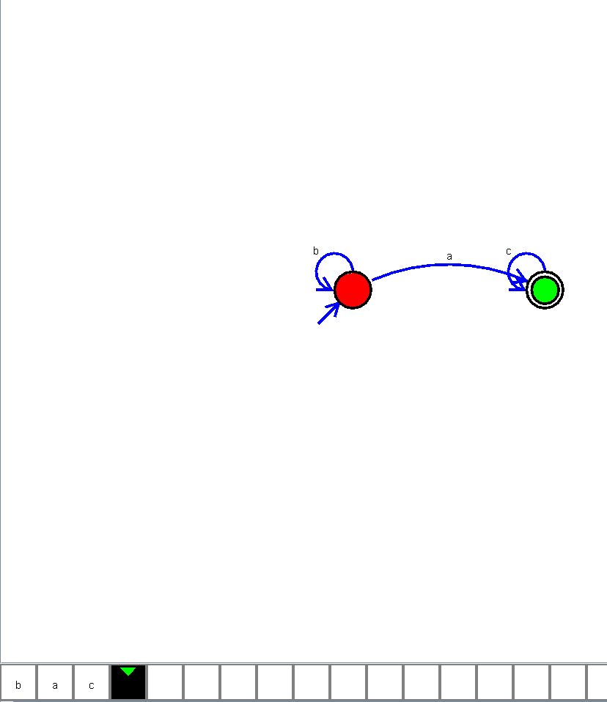

**EXPERIMENT NUMBER 21:**

Design DFA using simulator to accept even number of a’s.

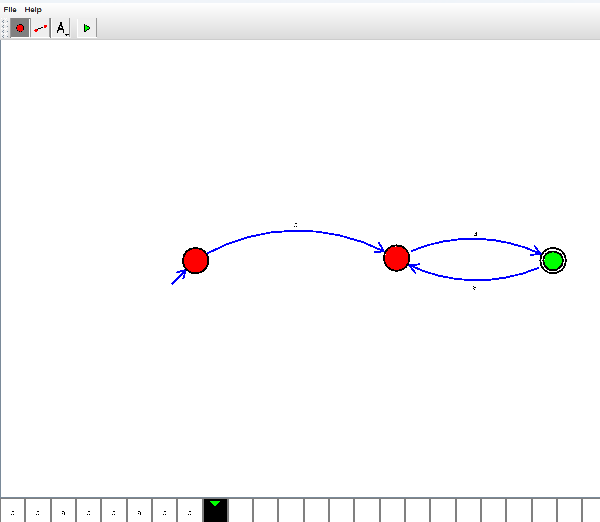

**EXPERIMENT NUMBER 22:**

Design DFA using simulator to accept odd number of a’s

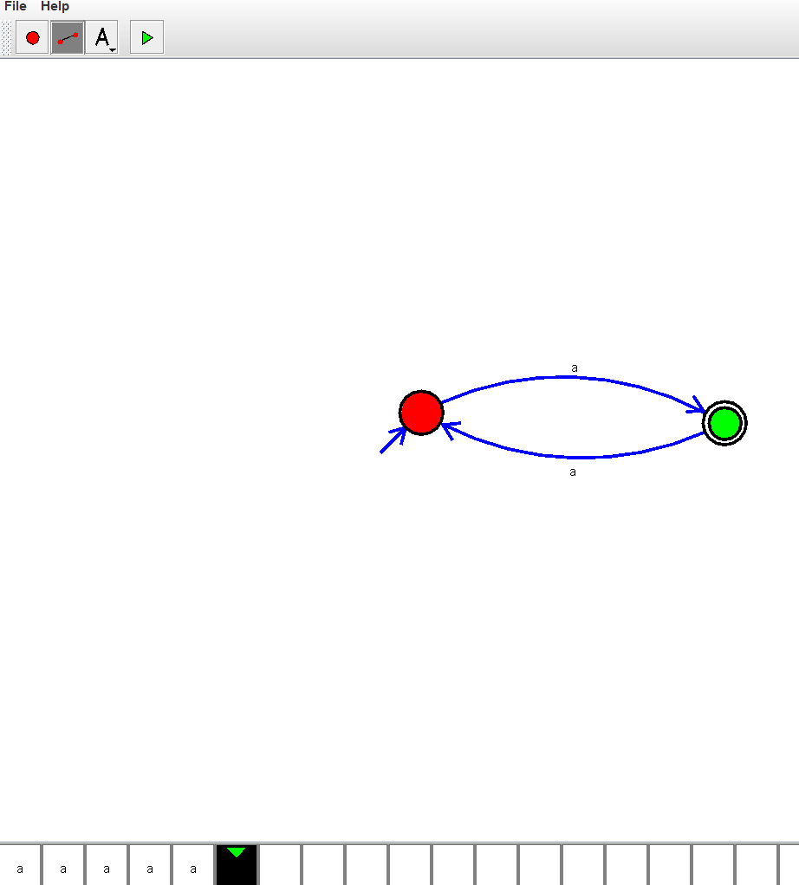

**EXPERIMENT NUMBER 23:**

Design DFA using simulator to accept the string the end with ab over set {a,b)

W= aaabab

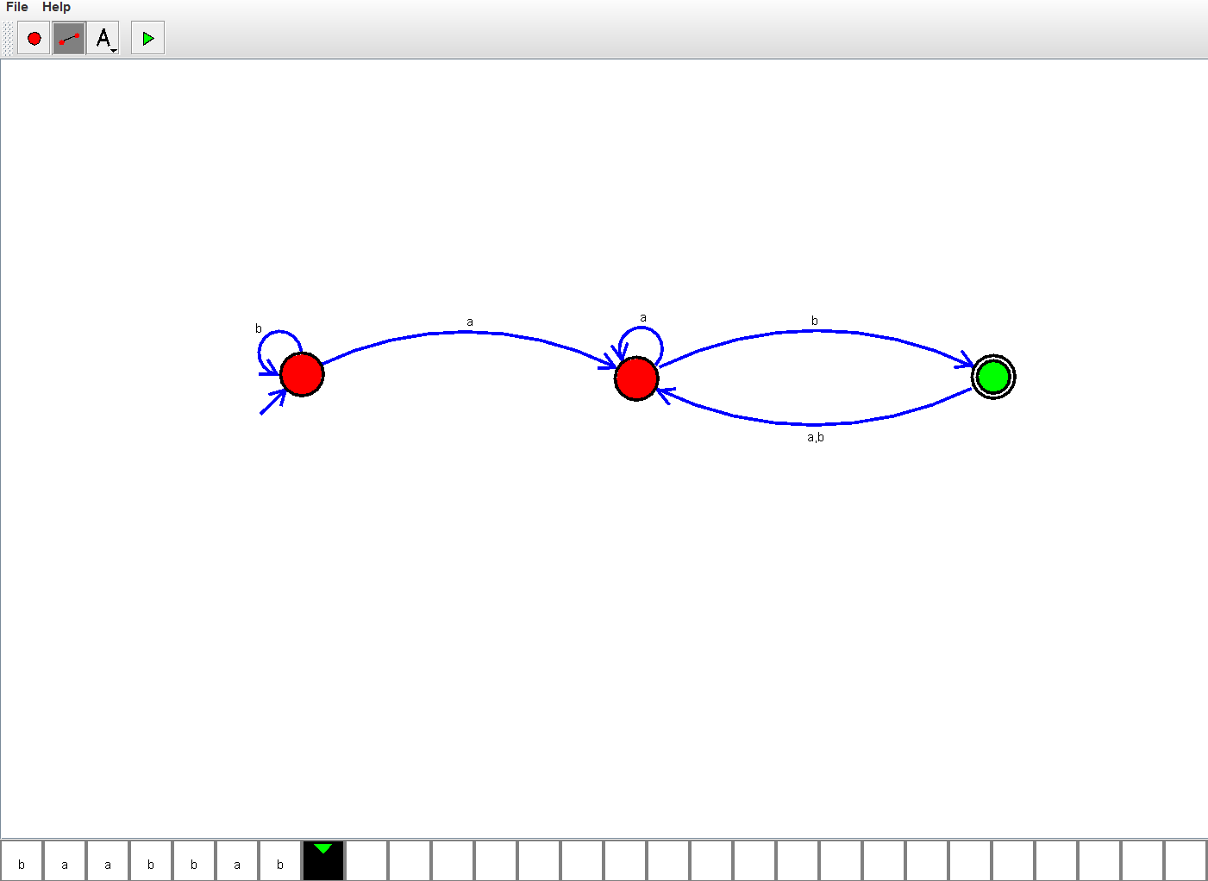

**EXPERIMENT NUMBER 24:**

Design DFA using simulator to accept the string having ‘ab’ as substring over the set {a,b}

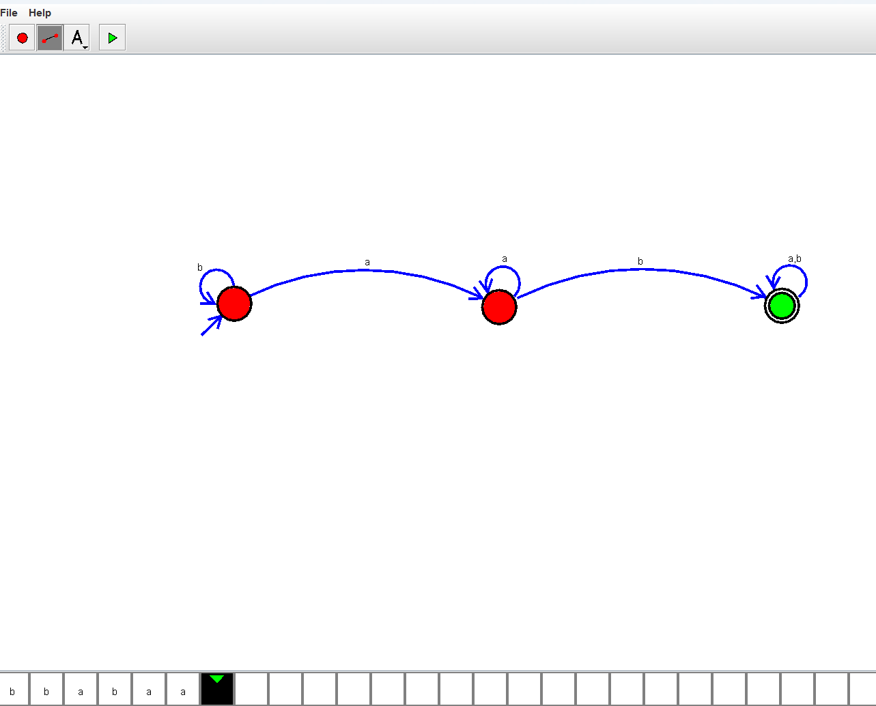

**EXPERIMENT NUMBER 25:**

Design DFA using simulator to accept the string start with a or b over the set {a,b}

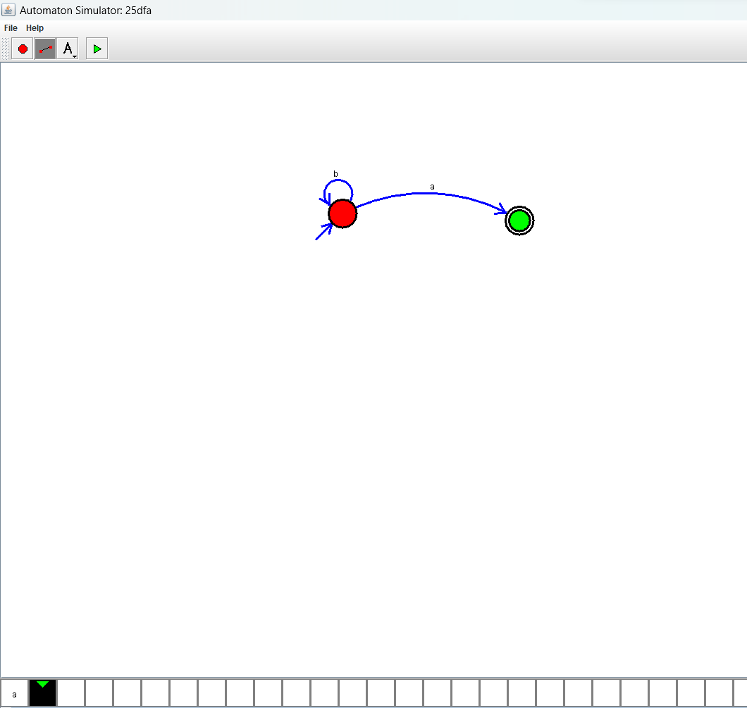

**EXPERIMENT NUMBER 28:**

Design DFA using simulator to accept the string the end with ab over set {a,b)

W= abbaabab

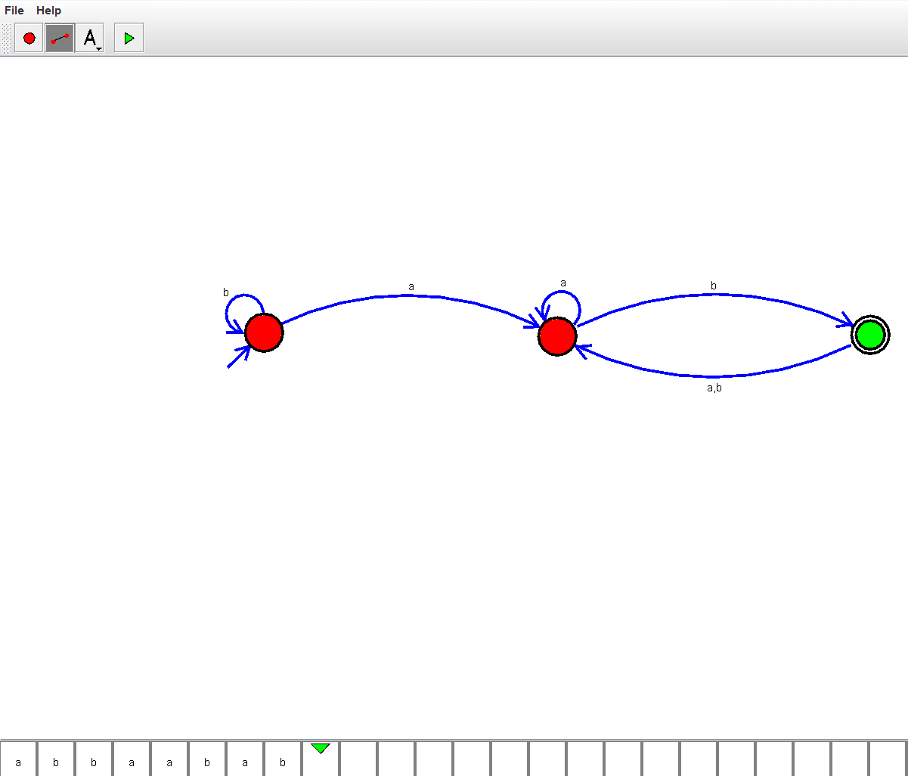

**EXPERIMENT NUMBER 29:**

Design DFA using simulator to accept the input string “bc” ,”c”,and ”bcaaa”.

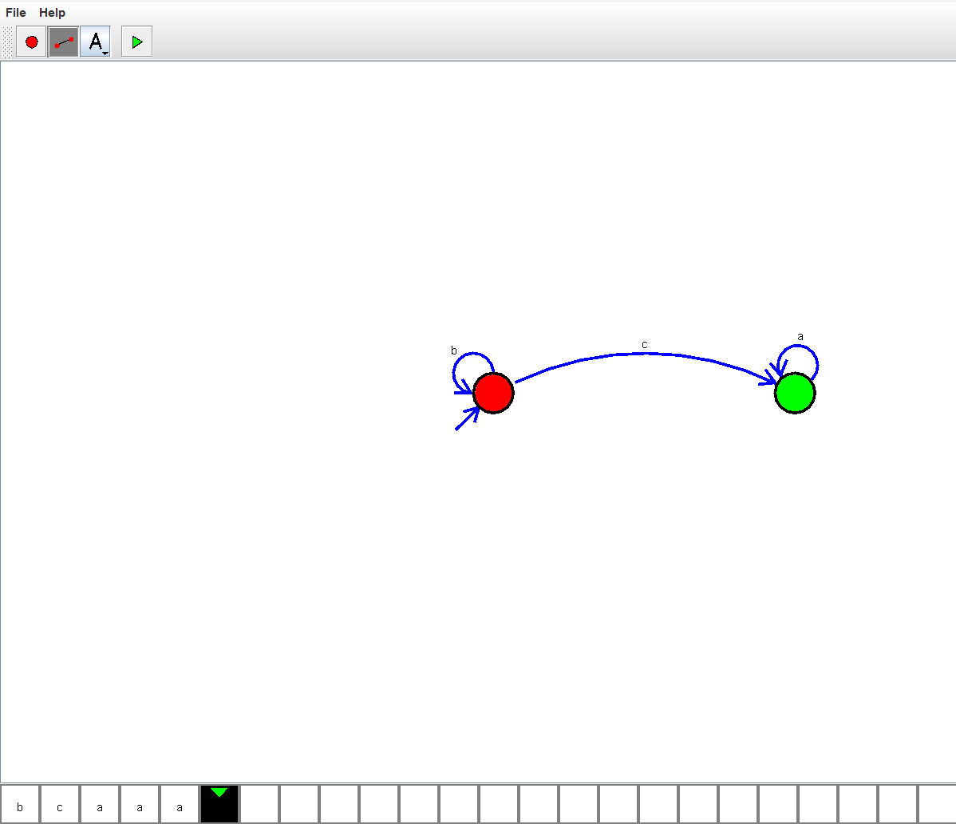

**EXPERIMENT NUMBER 33:**

Design DFA using simulator to accept the string having ‘abc’ as substring over the set {a,b,c}

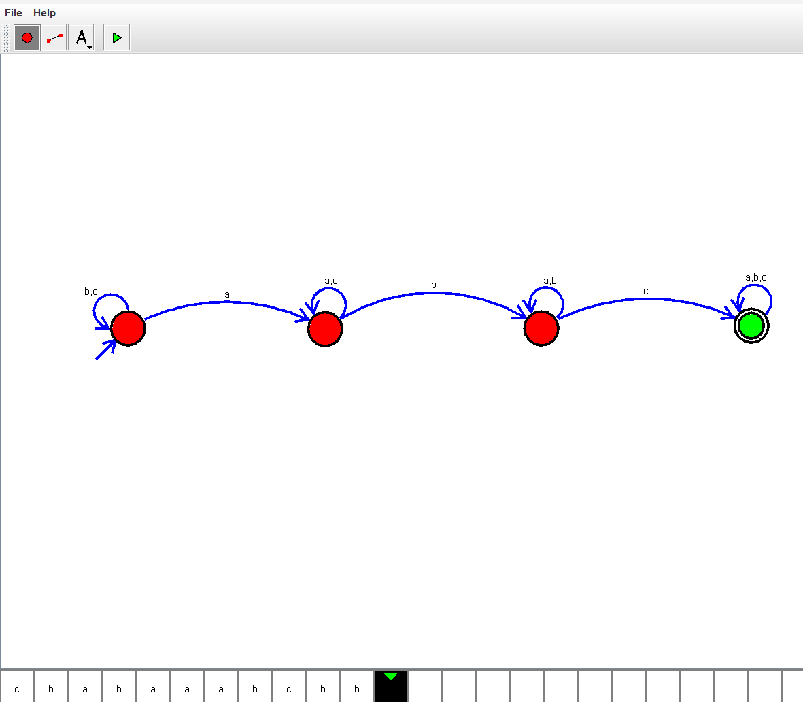

**EXPERIMENT NUMBER 34:**

Design DFA using simulator to accept even number of c’s over the set {a,b,c}

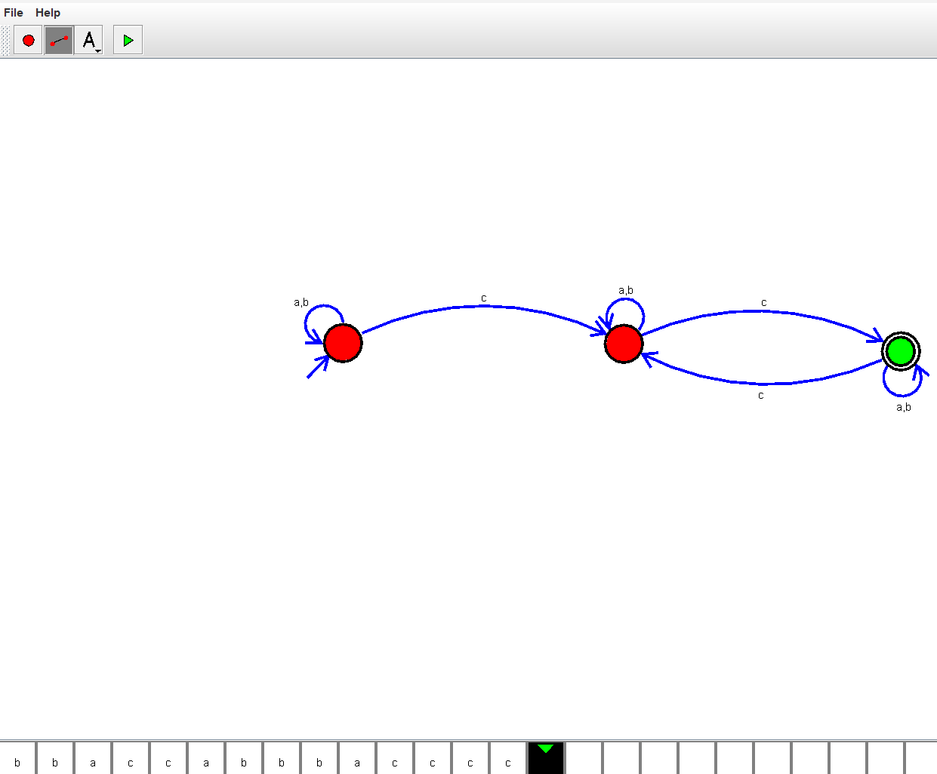

**EXPERIMENT NUMBER 35:**

Design DFA using simulator to accept strings in which a’s always appear tripled over input {a,b}

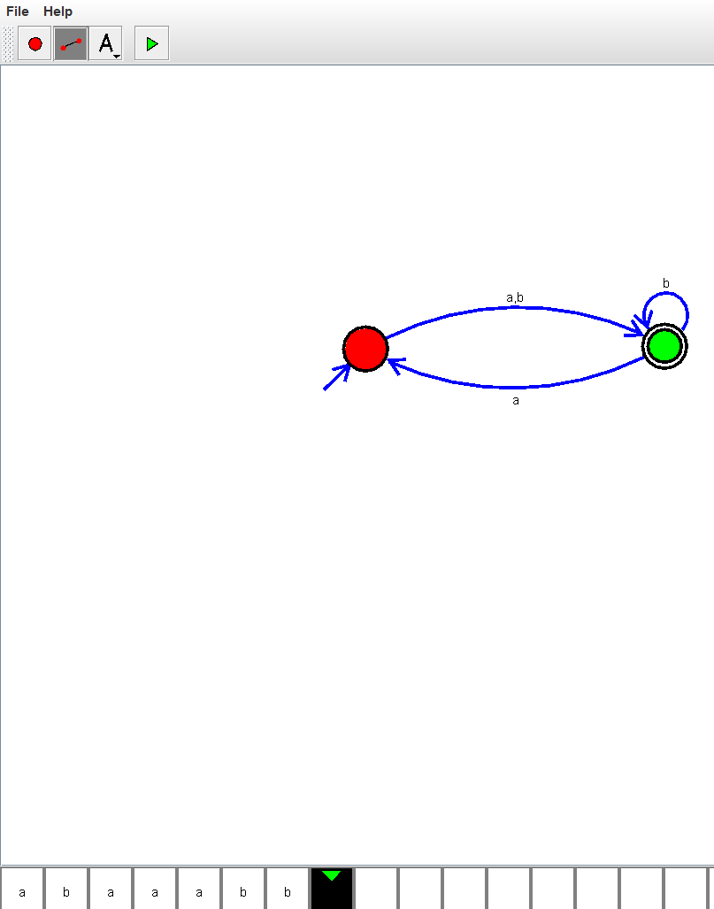

**EXPERIMENT NUMBER 39:**

Design DFA using simulator to accept the string the end with abc over set {a,b,c)

W= abbaababc

