**LIST OF EXPERIMENTS(NFA)**

COURSE CODE : CSA1381

COURSE NAME : THEORY OF COMPUTATION

NAME: C.AKHIL

REG NUM: 192110244

**EXPERIMENT NUMBER 30:**

Design NFA to accept any number of a’s where input={a,b}.

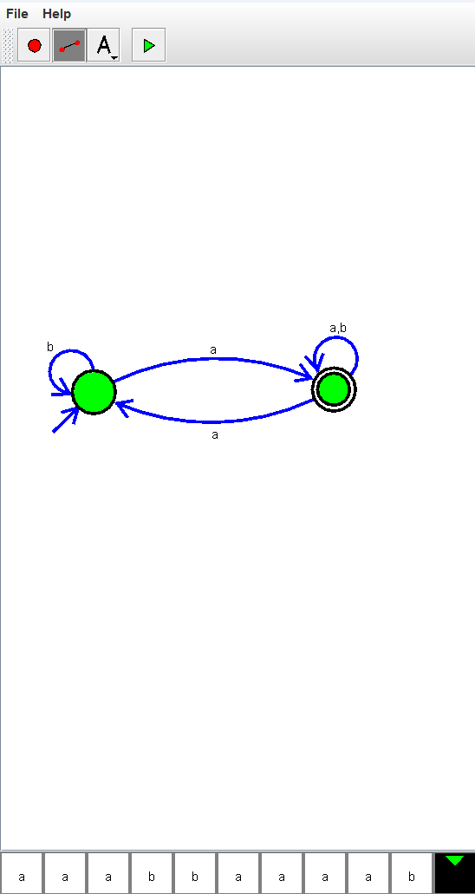

**EXPERIMENT NUMBER 36**

Design NFA using simulator to accept the string the start with a and end with b over set {a,b} and check W= abaab is accepted or not.

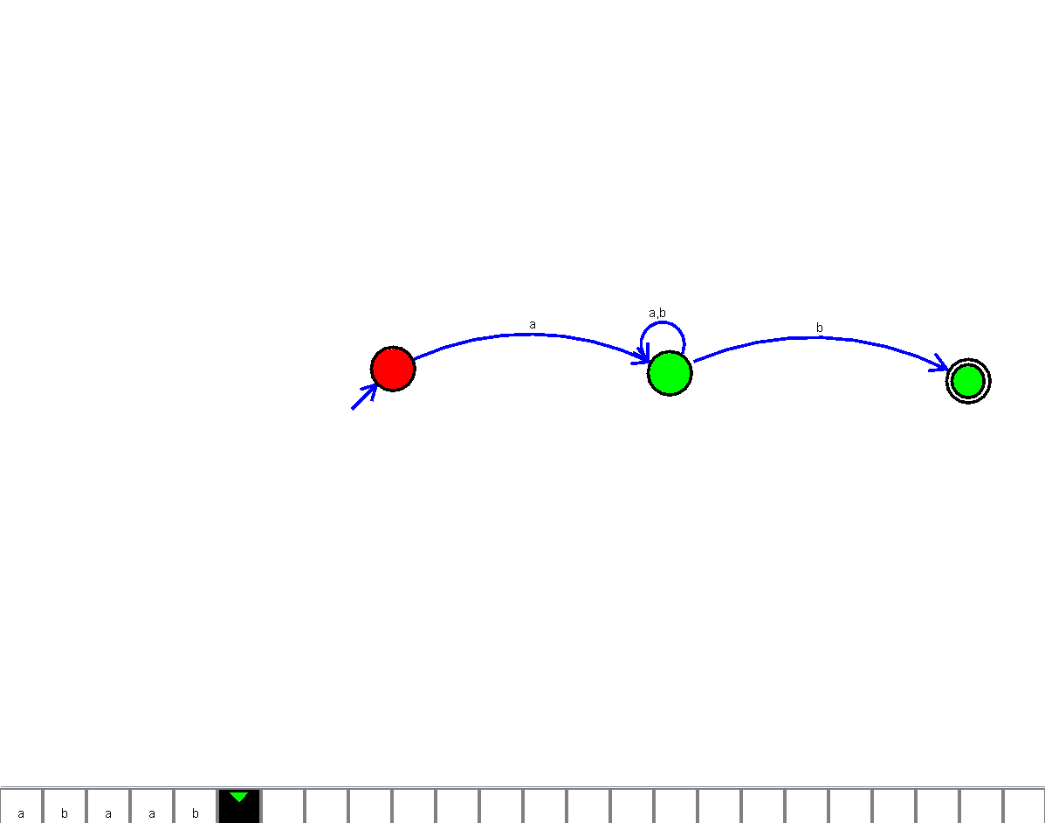

**EXPERIMENT NUMBER 37**

Design NFA using simulator to accept the string that start and end with different symbols over the input {a,b}.

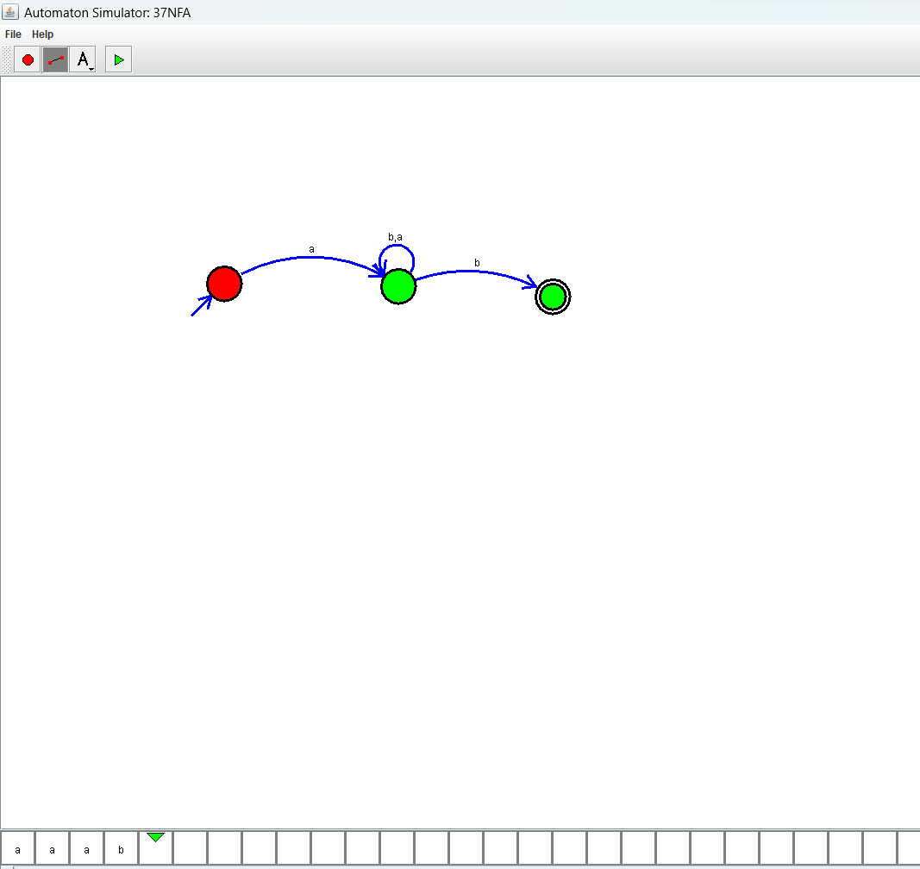

**EXPERIMENT NUMBER 38**

Design NFA using simulator to accept the input string “bbc” ,”c”,and ”bcaaa”.

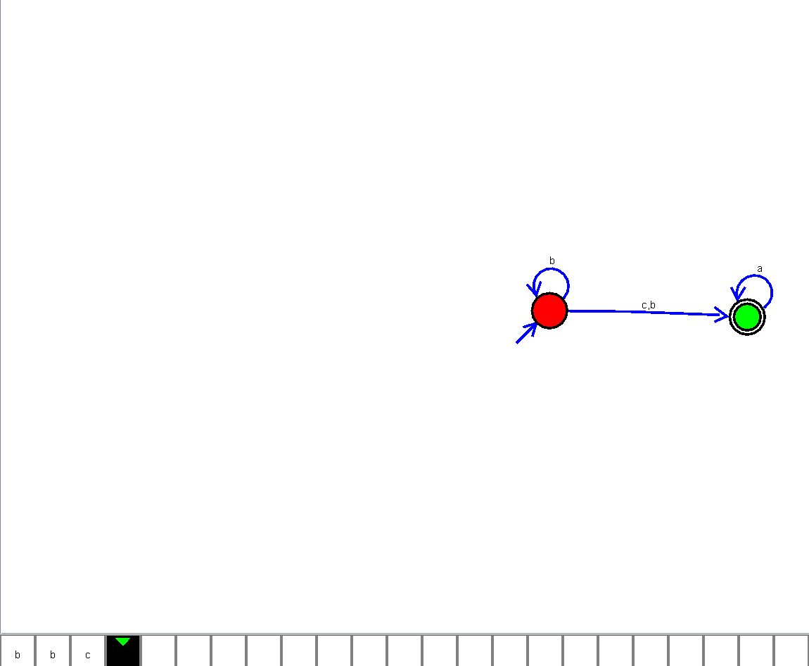

**EXPERIMENT NUMBER 40:**

Design NFA to accept any number of b’s where input={a,b}.

