**LIST OF EXPERIMENTS(DFA)**

COURSE CODE : CSA1381

COURSE NAME : THEORY OF COMPUTATION

NAME: S. C.AKHIL

REG NUM: 192110244

Experiment 13:

Design PDA using simulator to accept the input string aabb

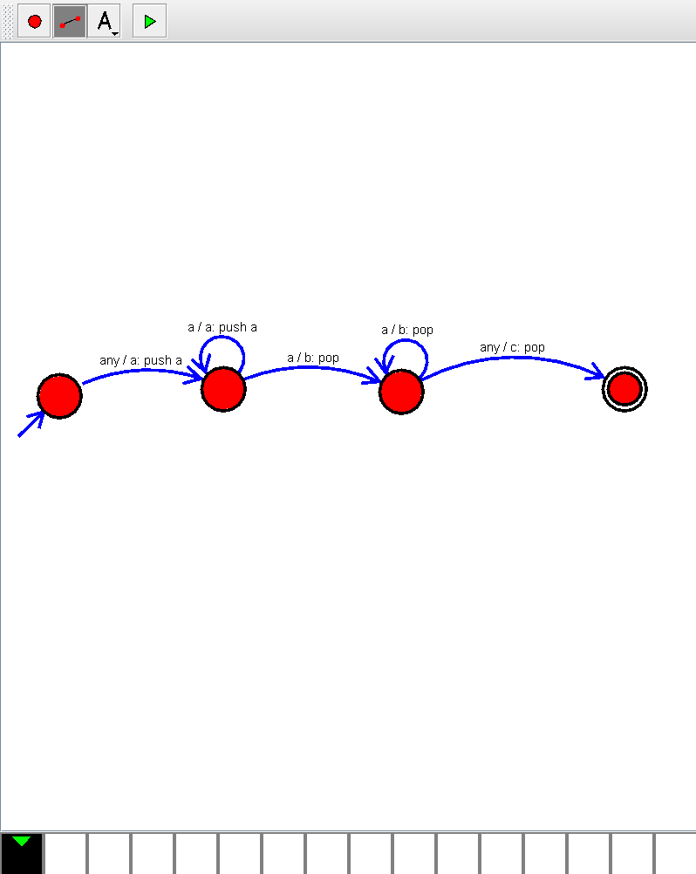

Experiment 14:

Design PDA using simulator to accept the input string anb2n

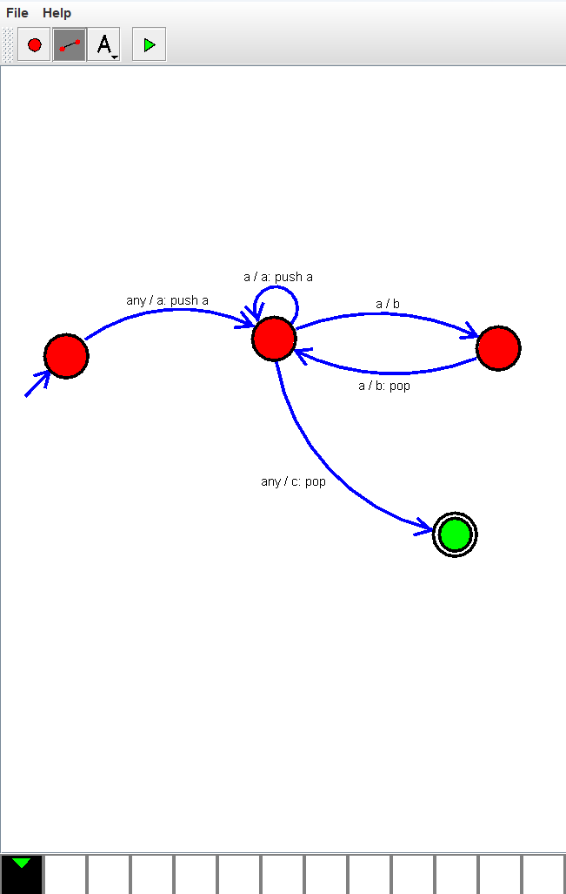

Experiment 31:

Design PDA using simulator to accept the input string anbn

