POLYMORPHISM

1.Create a base class called Person with a virtual function work(). Derive two classes Employee and Manager from the base class. Implement the work() function for each class.



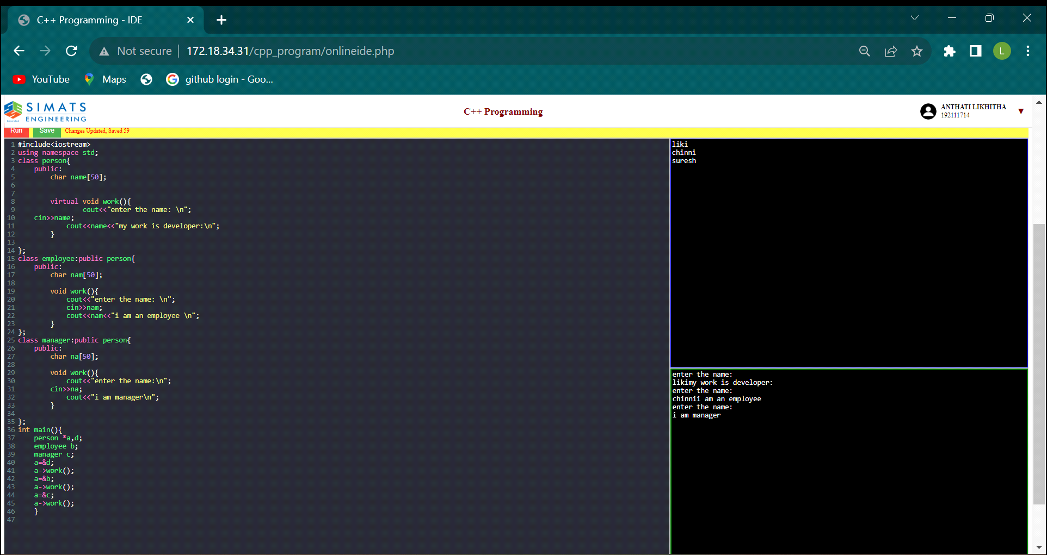

2. Create a base class called Animal with a virtual function eat(). Derive two classes Herbivore and Carnivore from the base class. Implement the eat() function for each 

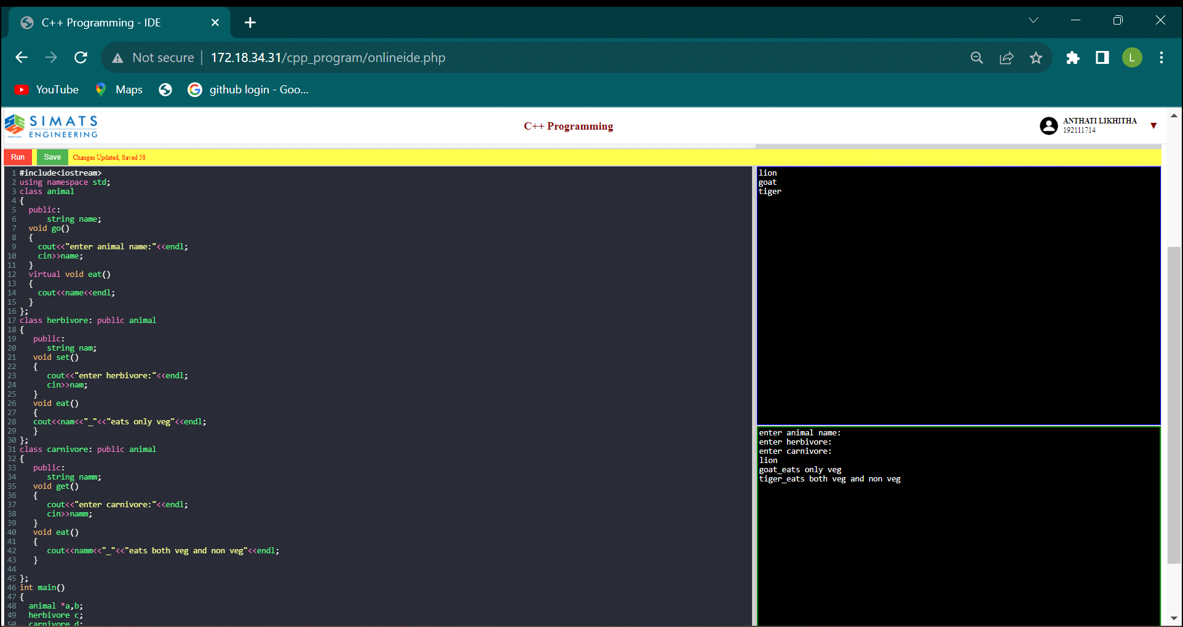

3.. Create a base class called Shape with virtual functions area() and volume(). Derive two classes Sphere and Cylinder from the base class. Implement the area() and volume() functions for each class.

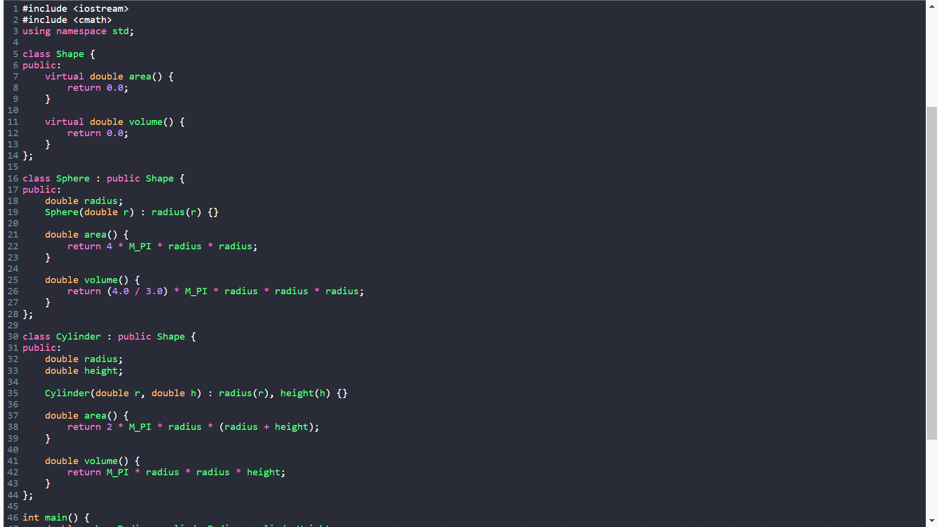

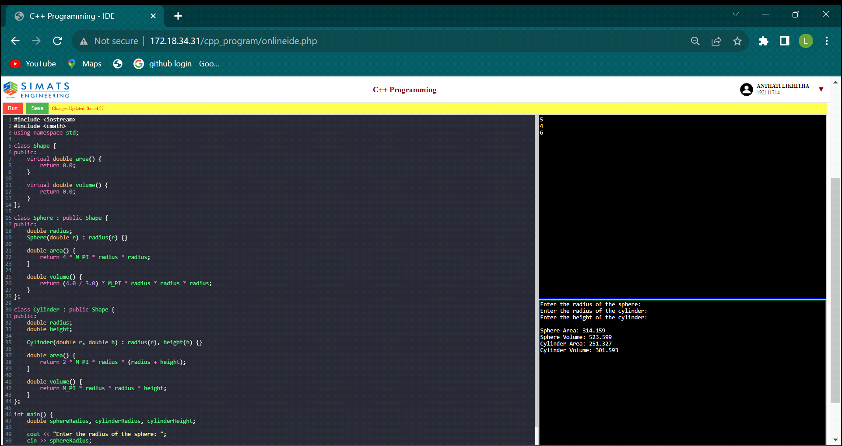

Create a base class called Person with a virtual function greet derive two classes Student and Teacher from the base class. Implement the greet function for each class

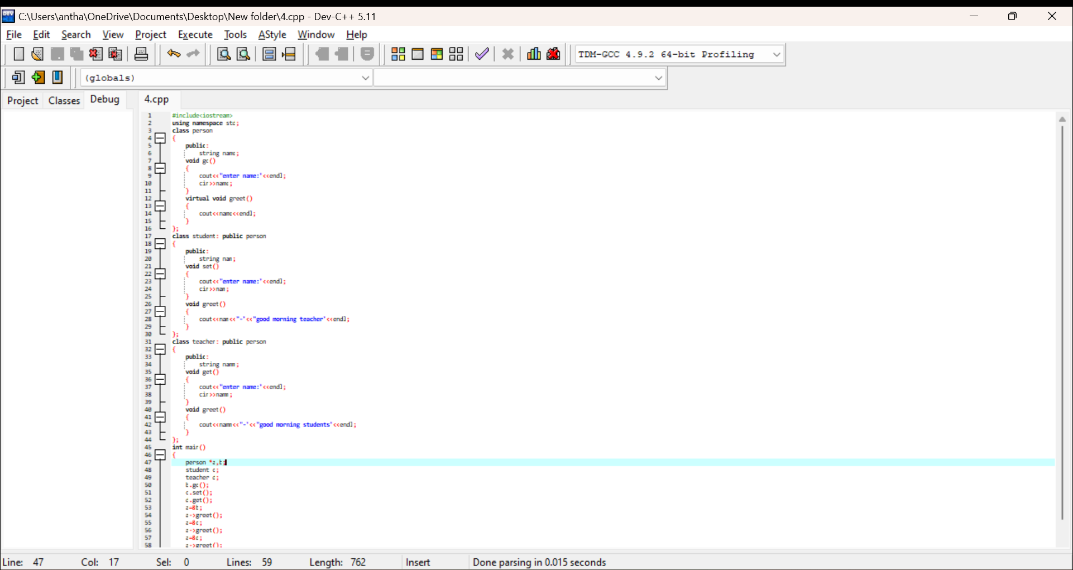

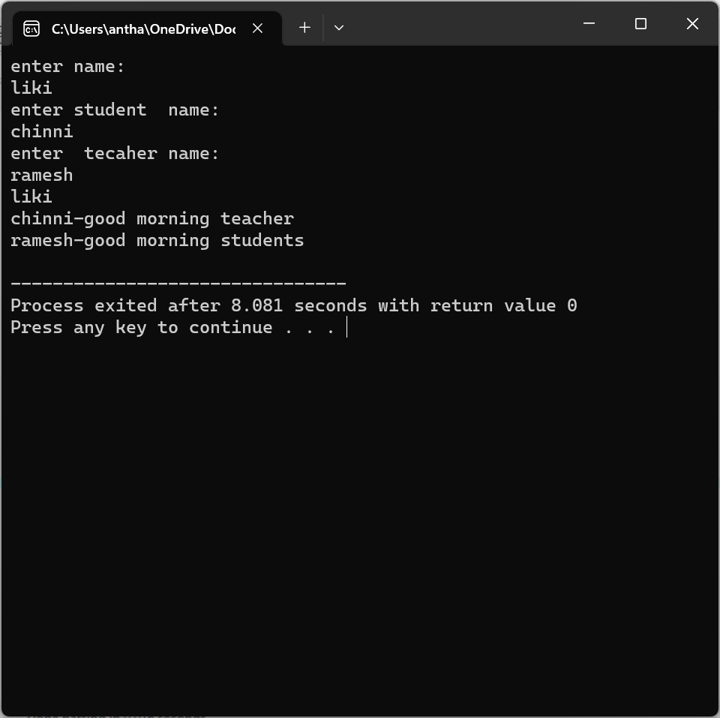

5. Create a base class called Animal with a virtual function move derive two classes Bird and Fish from the base class. Implement the move function for each class.

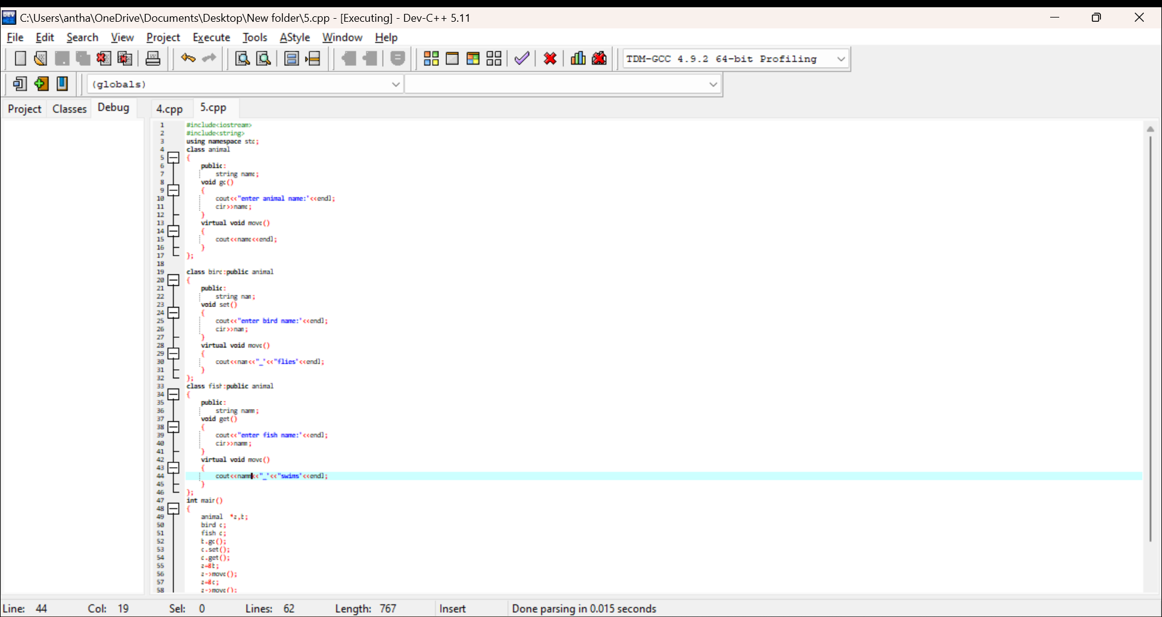

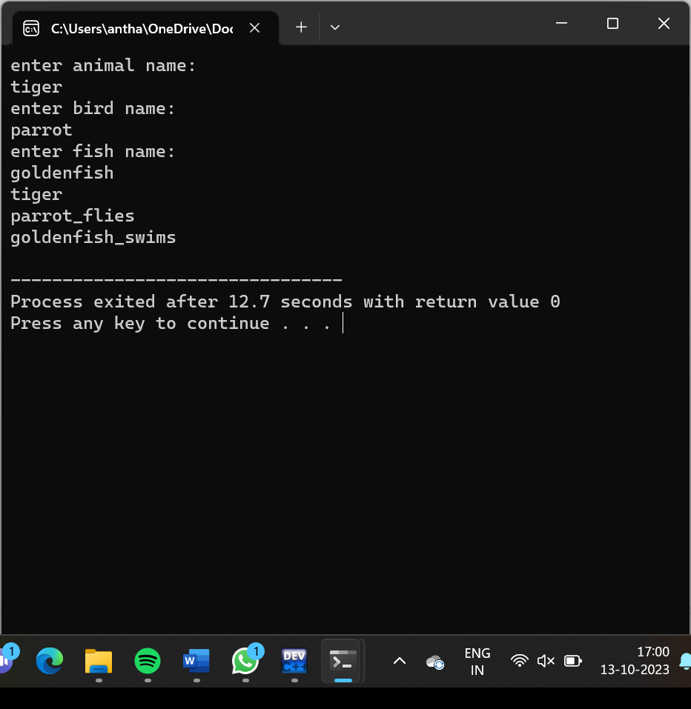

6..Create a base class called Vehicle with a virtual function drive derive two classes Car and Truck from the base class. Implement the drive function for each class

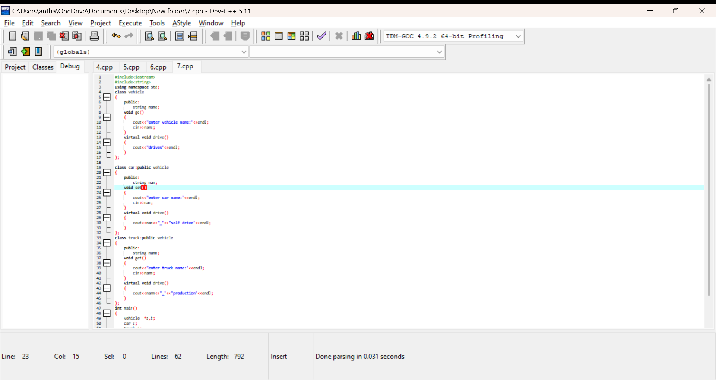

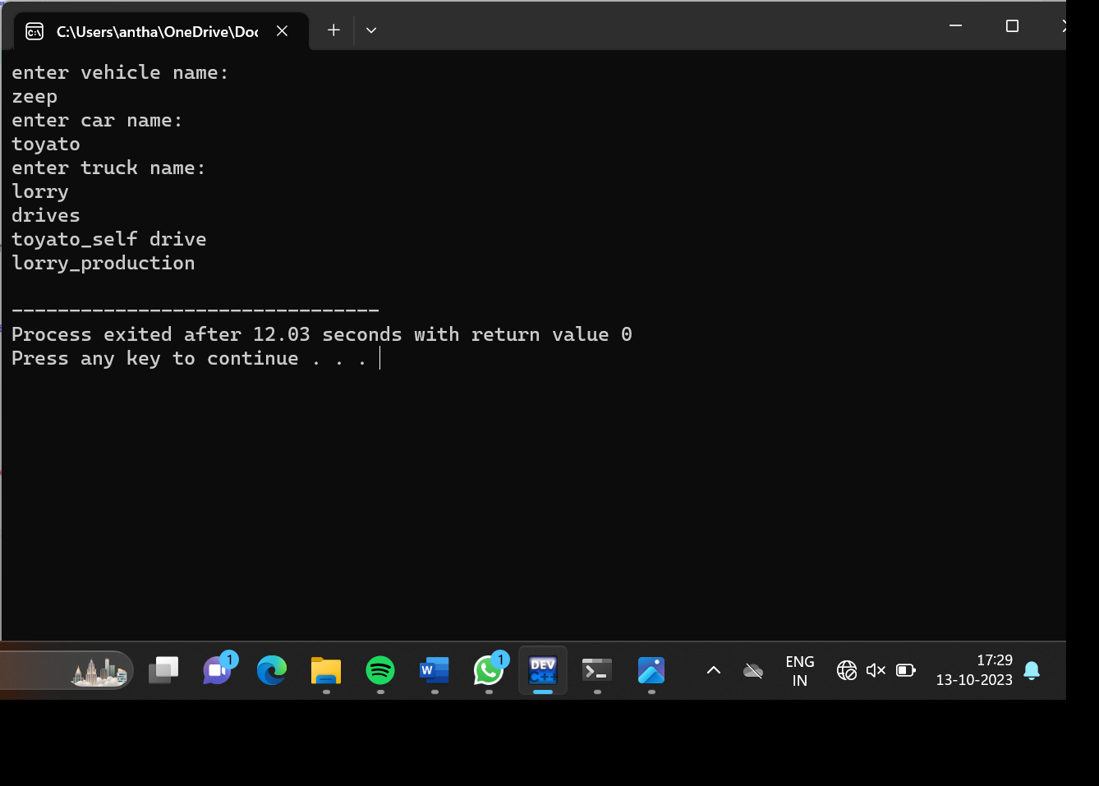

Create a base class called Employee with a virtual function calculatePay Derive two classes Manager and Engineer from the base class. Implement the calculatePay function for each class.

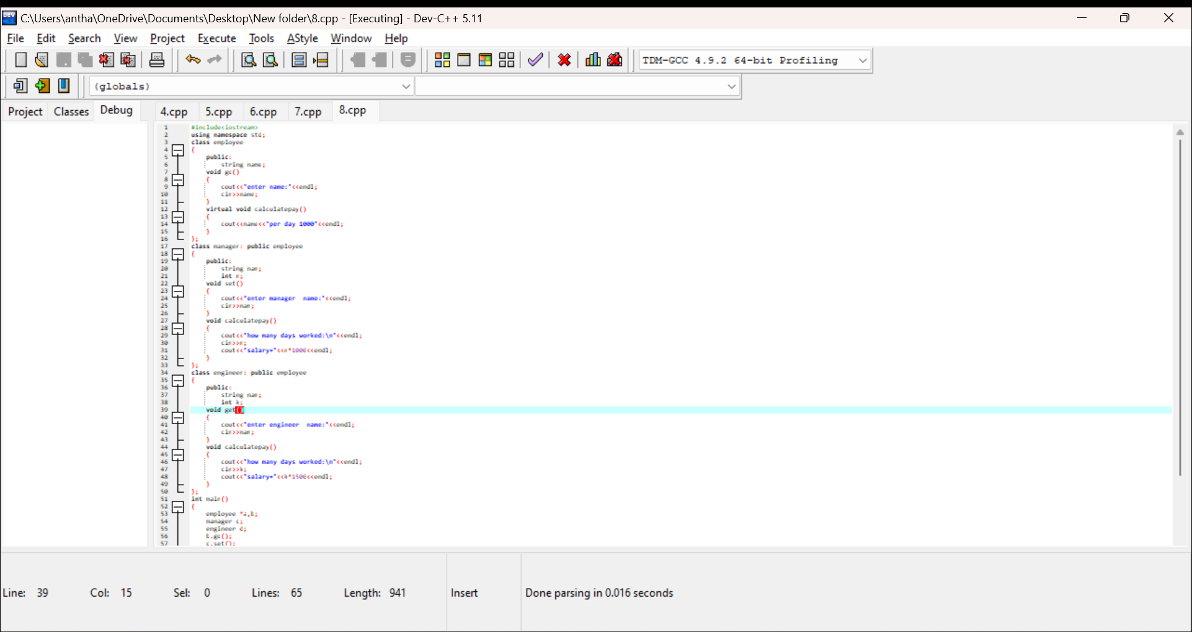

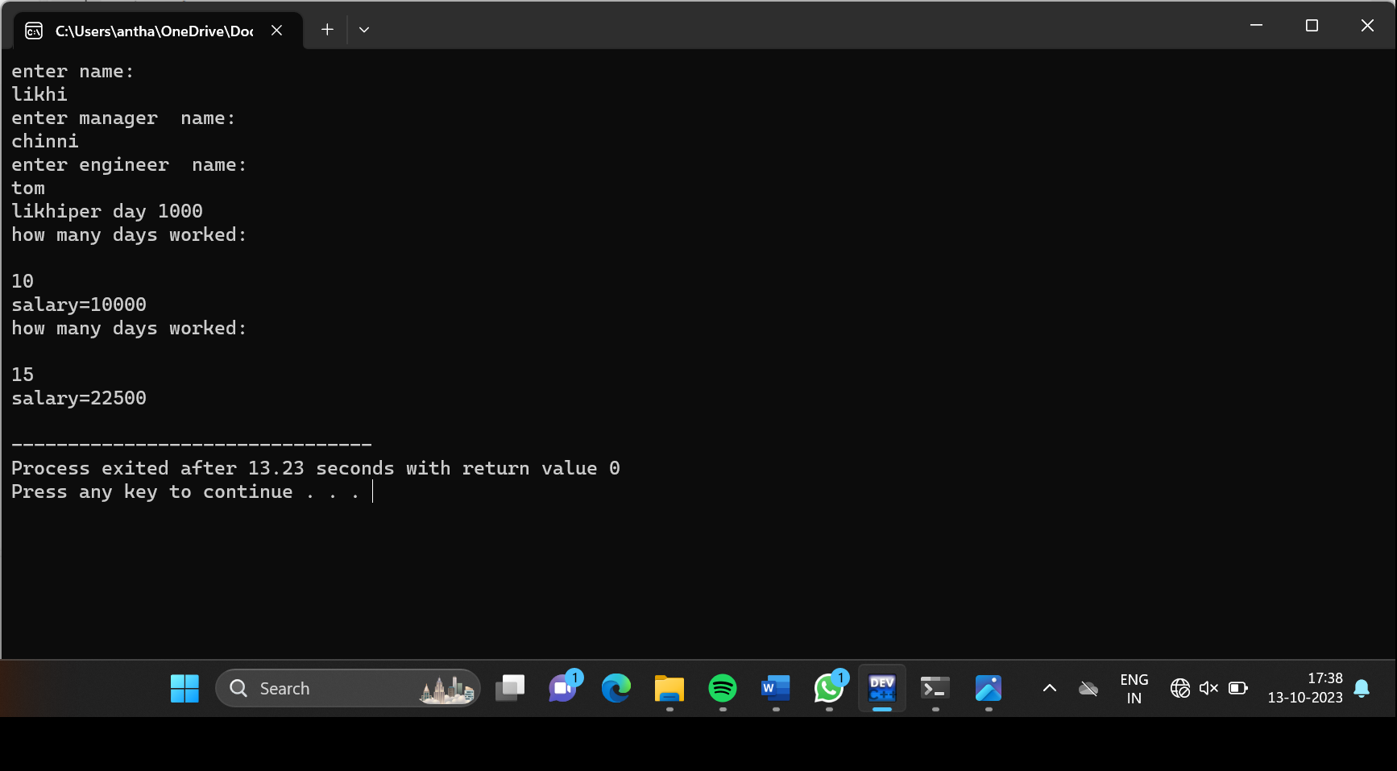

Create a base class called Animal with a virtual function speak Derive two classes Cat and Dog from the base class. Implement the speak function for each class.

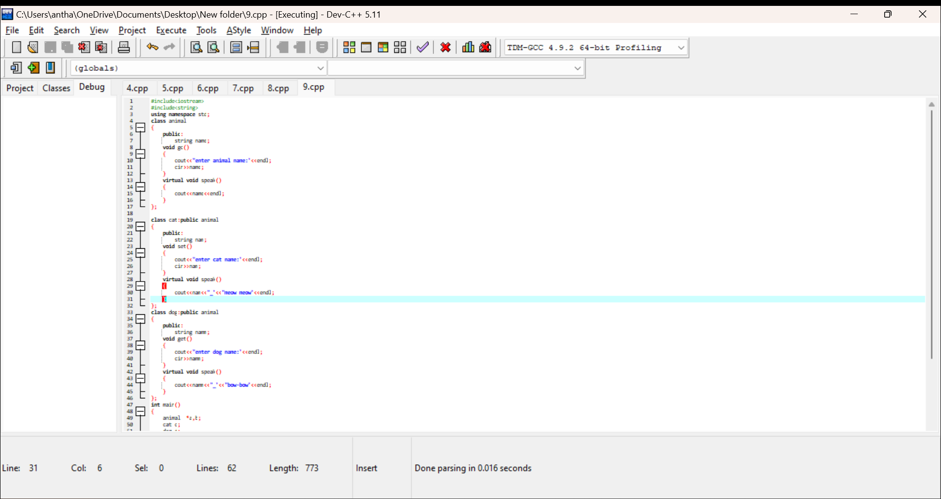

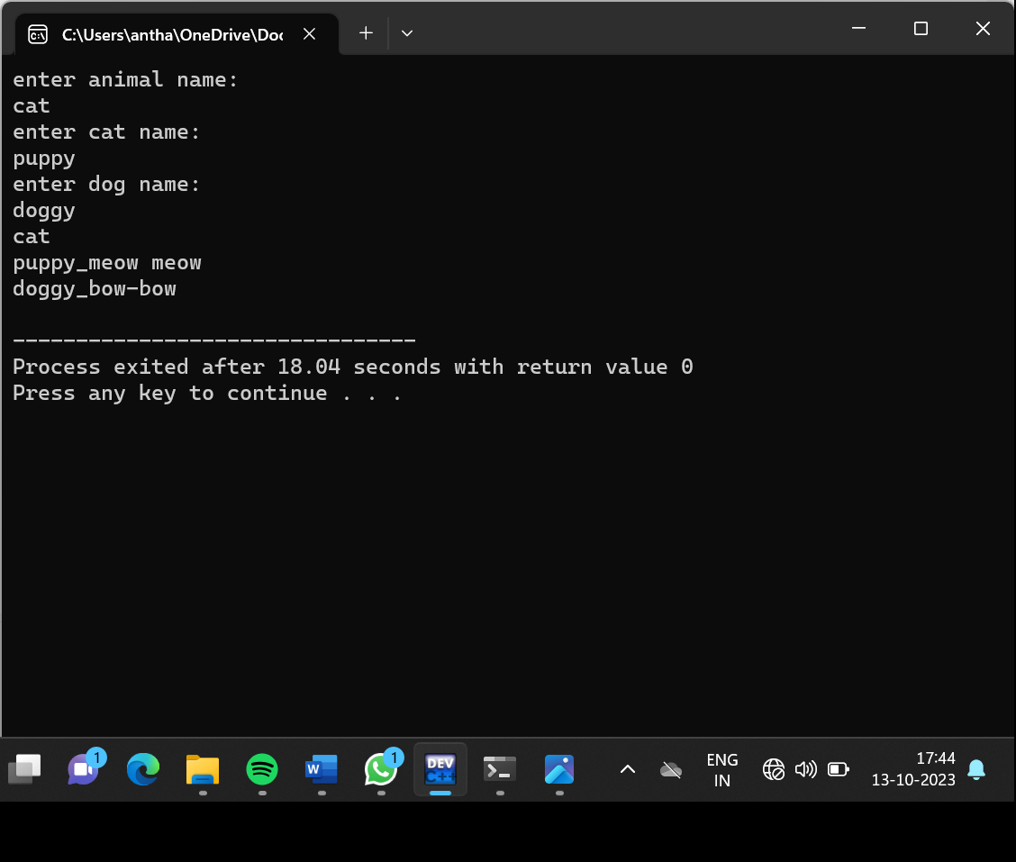

Create a base class called Shape with a virtual function area derive two classes Rectangle and Circle from the base class. Implement the area function for each class.

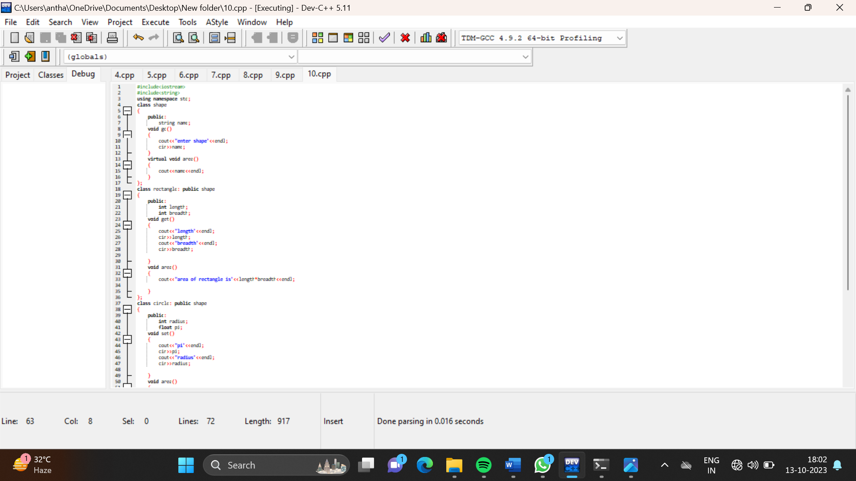

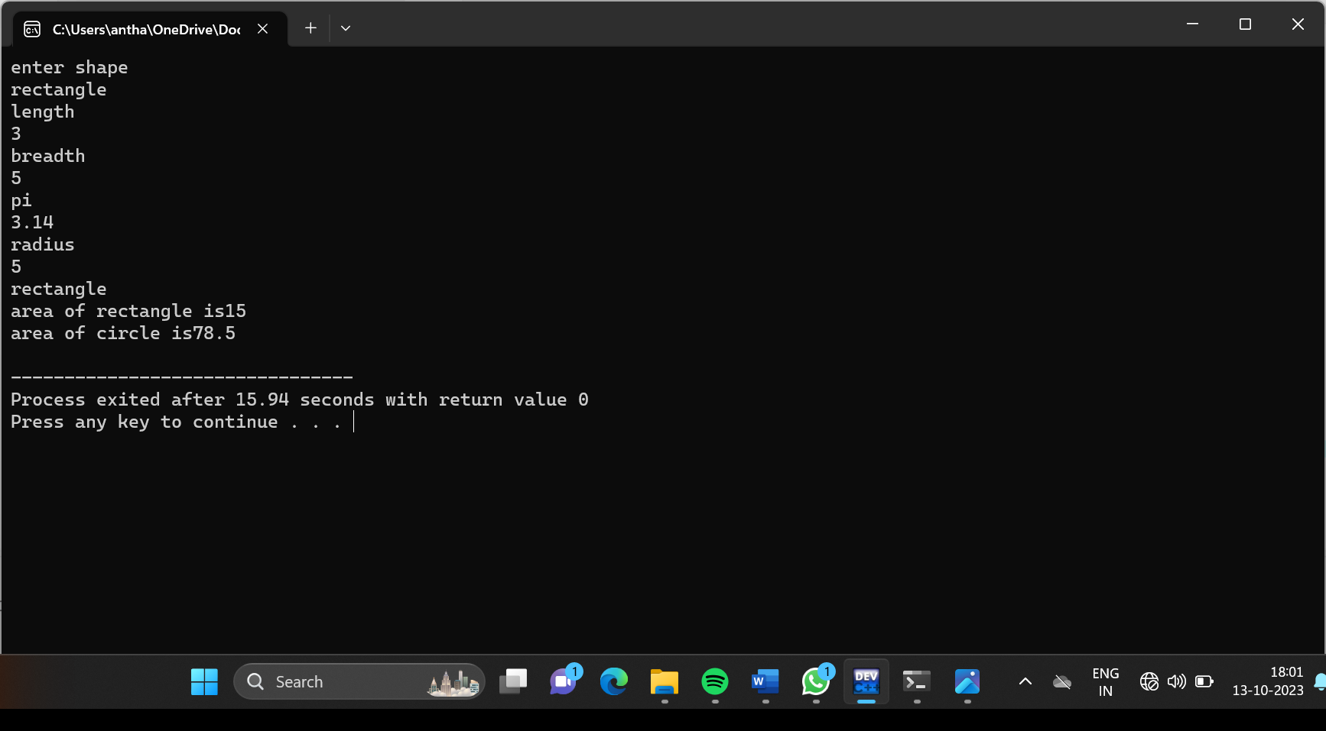

Create a base class called Shape with virtual functions area and perimeter Derive two classes Rectangle and Triangle from the base class. Implement the area and perimeter functions for each class

