**Subjective Questions/Answers**

1. **Which are the top three variables in your model which contribute most towards the probability of a lead getting converted?**

**Answer:**

Coefficient of Logistic Model does explain(s) the importance of the model. Top 3 important variables in the model are:

* Tags_Lost to EINS
* Tags_Closed by Horizzon
* Tags_Busy

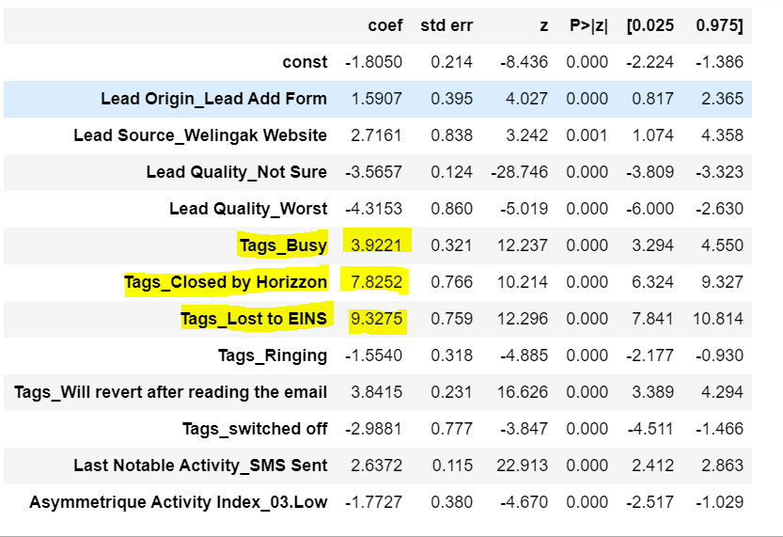

Let(s) see the frequency plot of above identified variables, and see how much they contribute to the conversion of the professionals.

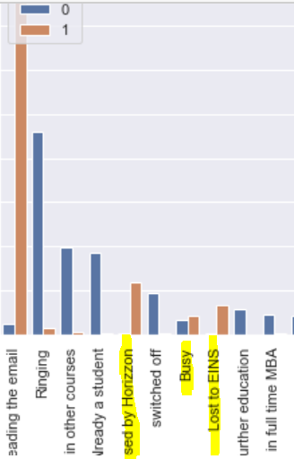

1. **What are the top 3 categorical/dummy variables in the model which should be focused the most on in order to increase the probability of lead conversion?**

**Answer:**

Top 3 important dummy variables in the final model are:

1. Tags_Lost to EINS
2. Tags_Closed by Horizzon
3. Tags_Busy

Top 3 important categorical variables in the original dataset which sales team can influence (Based on coefficients of the final model, and whether the variable was part of the model even after RFE):

1. Tags
2. Lead Source
3. Lead Origin
4. **X Education has a period of 2 months every year during which they hire some interns. The sales team, in particular, has around 10 interns allotted to them. So during this phase, they wish to make the lead conversion more aggressive. So they want almost all of the potential leads (i.e. the customers who have been predicted as 1 by the model) to be converted and hence, want to make phone calls to as much of such people as possible. Suggest a good strategy they should employ at this stage.**

**Answer:**

If 10 new interns are joining the firm, then sales team can handle more prospective leads. So, we can lower the threshold of the cut off to mark the user as hot lead, so that we get more hot leads, which can convert. If we get more hot leads, interns should be able to handle the additional load.

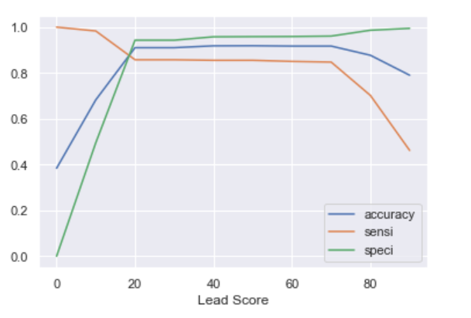

1. **Similarly, at times, the company reaches its target for a quarter before the deadline. During this time, the company wants the sales team to focus on some new work as well. So during this time, the company’s aim is to not make phone calls unless it’s extremely necessary, i.e. they want to minimize the rate of useless phone calls. Suggest a strategy they should employ at this stage.**

**Answer:**

If company has reached the target for the quarter, then we can only pass high quality hot leads so that company is able to generate additional revenue without spending enough time on the process. So, we can increase the threshold of the cut off to mark the user as hot lead, so that we just get high quality leads.