Technologies 🡪 Postman, Spring Boot, Maven, H2

Unit Testing 🡪 Junit (run com.points.PointsServiceTest.java class)

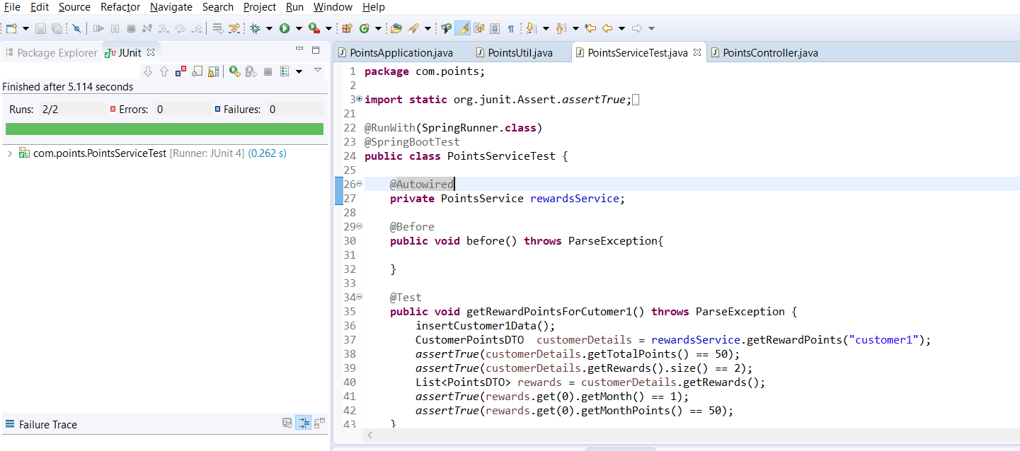

this will create sample data in H2.

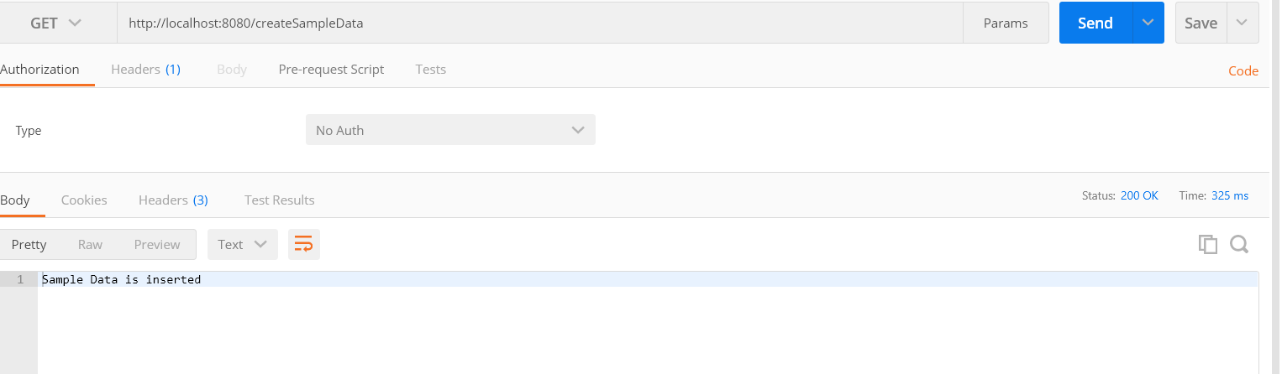

Get the customer total earning points and monthly wise total earning points

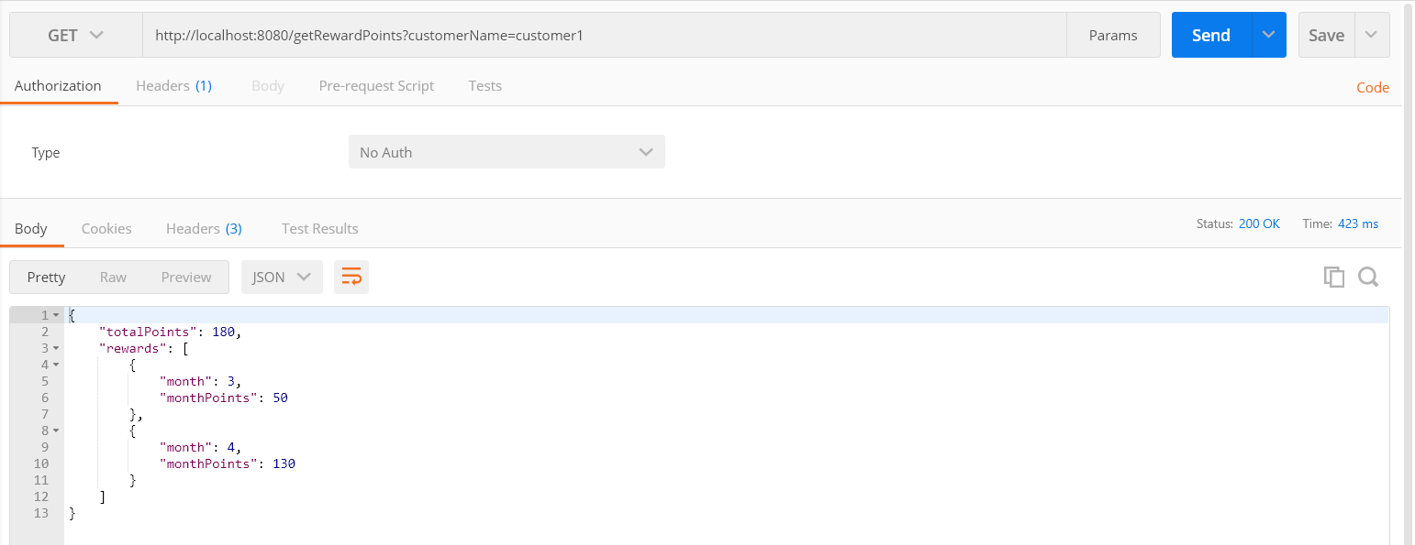

Get the customer total earning points and monthly wise total earning points

