Solidworks Final Project

AERE161, Spring 2022

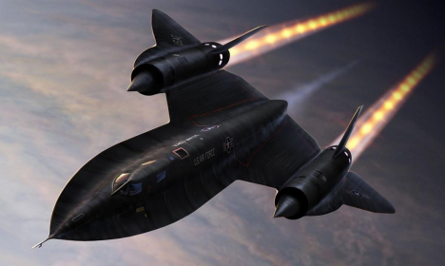Lockheed SR-71A Blackbird

Group A5:

Nick McCullough

Ryan Dunn

Joshua Hediger

Akhilesh Nevatia

David Lane

History of the SR-71A Blackbird

The SR-71 was designed secretly in the 1950’s by Lockheed Martin for reconnaissance missions by the U.S. Air Force. The aircraft was designed to reach Mach 3.2 (2,200+ mph) and is one of the fastest jet-powered, piloted aircraft ever created. It was commissioned in 1964 for military use and flew until 1988. The U.S. Air Force loaned three SR-71 Blackbirds to NASA for aeronautical research in the 1990s. The U.S. Air force retired the Blackbird in 1998 and NASA retired the Blackbird 1999.

Specifications

There were two versions of the blackbird, the SR-71A was the normal version used by the U.S. Air Force and a modified SR-71B was later used as a trainer version by NASA. The aircraft is rather large for a jet with a length of 107.4’ and wingspan of 55.6’. The aircraft was almost entirely made of titanium and other exotic alloys due to the intense heat from high-speed flight. Two Pratt & Whitney J58 turbojet engines powered the SR-71 Blackbird. These engines would each produce over 32,500 lb of thrust. However, a majority of the speed of the SR-71 came from its engine and aircraft design and not the engine’s thrust itself. Each engine used a conical spike inlet that would move back and forth, allowing for higher air pressure. This design also allowed air to bypass the engines as well, going directly into the afterburners, allowing them to be used as ramjets. It could easily out run missiles by increasing speed and altitude, it would fly up to 85,000 feet. The aircraft could essentially remain in the air indefinitely if needed, with in-air refueling. An exotic fuel was specifically designed to be used for the SR-71 Blackbird and it would need to refuel in flight just after takeoff. However, this is one of the reasons the aircraft was retired in addition to constant maintenance, among other reasons.

How we went about this project

We created a google drive so we can all view and work on the project, presentation and Solidworks parts as a group. We also created a discord server the first week and that is how we communicated throughout the entire project in addition to meeting in person. 

The server had multiple channels:

• Project channel: all information for the project, timeline and due dates • Chat channel: general chat, availability and meetings

• Voice channel: used for virtual meetings and real-time discussion

• Info Channel: all information found regarding the aircraft

• Ideas Channel: a place to store any ideas each of us had, at any time

• Presentation Channel: important details to be used in Powerpoint

• Progress Channel: progress of the Solidworks model

• Tips Channel: general tips regarding Solidworks to provide each other

Why we chose the SR-71 Blackbird

The SR-71 Blackbird is a very recognizable plane and notorious for its speed. It also has a futuristic design, almost like it should be flown by Batman himself. We had trouble deciding on which aircraft to choose, we decided a challenging plane would allow us to further our Solidworks skills.

Parts and who made them in Solidworks:

Fuselage: Josh and David

Rear Fuselage Front: Josh and Nick

Rear Fuselage Back: Ryan

Cockpit: Akhilesh

Rudder: Josh

Engine: Josh

Wingtip: Ryan

Pressure Gauge: Akhilesh and David

Our Approach

We were given the following dimension of the SR-71A Blackbird:

Length: 107.4’

Wingspan: 55.6’

Height: 18.5’

Wing Root Chord: 60.533

Rudder Root Chord: 14.803 ft

Rudder Tip Chord: 7.833 ft

Engine Length: 17.83 ft

Fuselage Diameter: 5.33 ft

Wing Length: 19.8m (64.96 ft’)

Chine fuselage shape (blended-wing fuselage)

We decided not to include the landing gear as the SR-71 Blackbird design is complex and took a lot of time and effort. We started in the middle of the fuselage and extruded forward to the front of the aircraft in sections. We used ratios, using a ruler, for the remaining measurements.

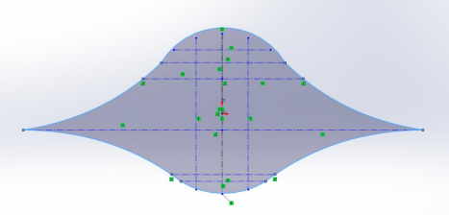*starting point: 2D sketch of fuselage cut in half*

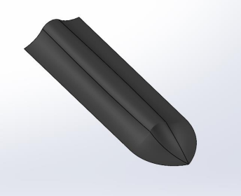

*front fuselage*

Steps for the front fuselage

1. Only available data found online was a 5.33 ft (63.96 inches) fuselage diameter 2. We decided to use approximations based on blueprints we could find online to get the rest of the data

3. Fuselage was made first using a 2.66 foot (31.98 inches) radius circle as a base and splines reaching out to total radial length of 9.3 feet (111.6 inches)

4. Created a reference plane based on the front plane 108 inches away from the front plane. 5. Copy-pasted the fuselage 2D sketch and scaled it up to match the dimensions of the main body 6. Created another reference plane based on the first reference plane 432 inches away 7. Copy-pasted the scaled-up version of the 2D sketch

8. Created sketches on the top and right planes to use as guide curves for a lofted boss base 9. Used the lofted boss/base feature to connect all three sketches using guide curves in step 8

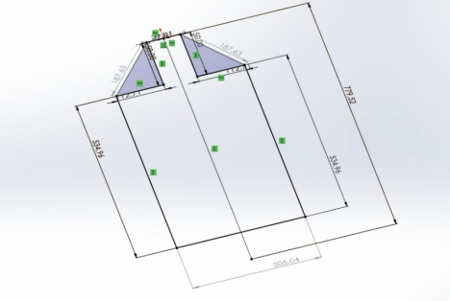*beginning dimensions of the rear fuselage front*

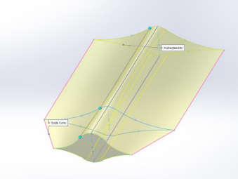

*rear fuselage front*

Steps for the rear fuselage front

1. Rear fuselage is based on the scaled-up sketches from the front half of the fuselage 2. Copy-pasted scaled up 2D fuselage sketch from the front fuselage Solidworks file 3. Created reference plane based on the front plane 111 inches away

4. Using a 2.66 foot (31.98 inch) radius circle, added splines that reached out to a new radius of 132.05 inches

5. Created another reference plane based on the first reference plane 333.6 inches away 6. Copy-pasted the 2D sketch created in step 5 on the new plane

7. Created sketches on the top and right planes to use as guide curves for a lofted boss base 8. Used the lofted boss/base feature to connect all three sketches using guide curves in step 7

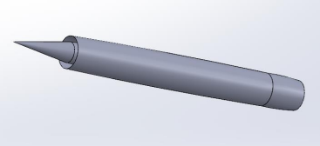*engine and casing*

Steps for the engine

1. The length 214 inches of Pratt and Whitney J-58 Engine was used to make approximations 2. Found casing length is 534.96 inches (tip of inlet spike to rear of exhaust for length of engine casing) and width is 64.2 inches

3. Based on these dimensions created a 2D cutout sketch of the engine casing with spike and exhaust included

4. Created an infinite line horizontally on the origin for reference

5. Using the Revolved boss/base feature and revolved the sketch around the aforementioned infinite line along the origin

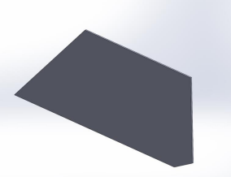

*rudder*

Steps for the Rudder

1. The length 214 inches of Pratt and Whitney J-58 Engine was used to make approximations 2. Found height of rudder to be 86.16 inches and angle (based on unit circle) to be 107.53 Degrees (based on 90 degrees, the rudder would be at an angle of 17 degrees) 3. The top dimension of the rudder is 112.98 inches and the bottom dimension is 171.2 inches 4. Created a 2D pentagonal sketch using above dimensions

5. Extruded the pentagonal sketch to desired width of the rudder (2 inches)

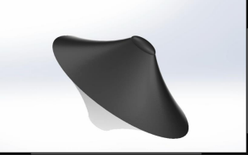

*cockpit*

Steps for the Cockpit:

1. No exact measurements were available online for the SR-71 cockpit

2. We decided to use approximation based on the outline or blue print we used for the rest of the plane

3. Cockpit is made using 3 ellipses and using referenced plane and the extruded boss/base feature 4. The base of the cockpit is an ellipse which has a minor axis length of around 1/3rd front fuselage width which is around 62 inches and major axis is at a 2:1 ratio with minor making it around 120 inches

5. The height of the cockpit was around 1/4th the height of our rudder which is about 45 inches 6. The second ellipse is about 20 inches in an offset plane above base ellipse with dimensions 60 vs 30 ( major vs minor axis)

7. The final ellipse is another 20 inches above in the 3rd offset plane.

8. Finally, the cockpit is closed using the insert dome feature of which has a height of 5 inches above our 3rd offset plane making the final height of the cockpit 45 inches

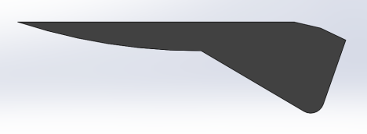*outer wing*

Steps for the Outer Wing:

1. Using approximations based on the total length, the length of the wing tip was determined by the top view.

2. Found total length to be 491.01 inches, the distance from the tip to the other tip, the total width is 116.37 inches from edge that attaches to engine to the outer edge

3. Determined the other necessary lengths and points to make the wingtip the appropriate shape like the distance from the engine edge to the curved portion, 41.91 inches

4. Based on these dimensions a 2D sketch was drawn on the front plane

5. This sketch was then extruded to give it definition

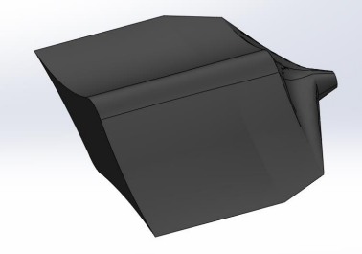*rear fuselage back*

Steps for the Rear Fuselage Back:

1. Using the rear sketch of the rear fuselage front as a starting point, first the sketch was copied 110 inches down the fuselage

2. The sketch was copied 41.52 inches down the fuselage

3. This sketch was shortened on each side by 20.85 inches on each side

4. A reference plane was created 33.51 inches down, where a circle was sketched with a radius of 13.9 inches

5. Another circle was sketched on a reference plane 19.09 inches down with a radius of 6.95 inches

6. Guide curves were then drawn in the right and top planes,

7. Used lofted boss/base to connect all the sketches

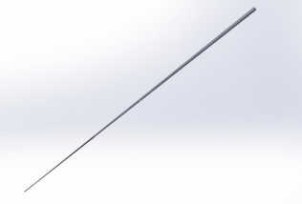

Steps of the pressure gauge:

1. We did not have the exact measurements of the pressure gauge, so we based it on the size of the nose of the plane

2. The end tip of the plane is 0.2 inches

3. Found the length of the pressure gauge to be 36 inches

4. Made two more front planes 18 inches apart reducing the radii of the circles 5. Lofted the planes together

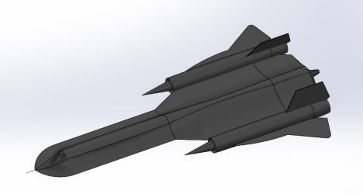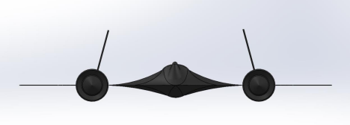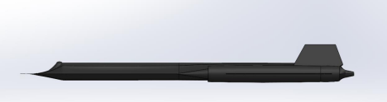



Sources for information, history and measurements:

https://www.nasa.gov/centers/armstrong/news/FactSheets/FS-030-DFRC.html https://www.sr-71.org/blackbird/sr-71/

https://aerocorner.com/aircraft/lockheed-sr-71-blackbird/

https://en.wikipedia.org/wiki/Lockheed_SR-71_Blackbird

http://www.fiddlersgreen.net/models/aircraft/Lockheed-SR71.html

Work Cited

Gibbs, Yvonne. “NASA Dryden Fact Sheets - SR-71 Blackbird.” NASA, 11 Aug. 2015, http://www.nasa.gov/centers/armstrong/news/FactSheets/FS-030-DFRC.html.

“Lockheed SR-71 Blackbird - Price, Specs, Photo Gallery, History.” Aero Corner, https://aerocorner.com/aircraft/lockheed-sr-71-blackbird/.

“Lockheed SR-71 Blackbird.” Wikipedia, 28 Apr. 2022. Wikipedia,

https://en.wikipedia.org/w/index.php?title=Lockheed_SR-71_Blackbird&oldid=1085031187. Lockheed SR-71 | Aircraft |. http://www.fiddlersgreen.net/models/aircraft/Lockheed-SR71.html.