**Medicine Recommendation System**

**Introduction and Background of the Project:**

There are Multiple Drugs in the Market for every health issue and sometimes it is very difficult for the patients to sit for a long time in the waiting room until they get their turn for a doctor’s appointment and getting some medicines suggested by doctors. Now we can get rid of all these processes and make it easy for both doctors and patients by developing a Medicine Recommendation System using Machine Learning and recommendation techniques.

This Project focuses on Medical Recommendation System which can predict accurate medical needs or medicines required for a patient based on the user (Patient) inputs about disease or symptom and these recommendations are mainly designed to use various filtering methods to recommend a specific product to its users. Using NLP techniques, we can learn the utility of items to each user which helps in predicting the medication and is trained on unsupervised learning.

**Statement of the Project Problem:**

Since Medicines are undoubtedly, one of the saviors of humankind a medical recommendation system is an essential tool for patients and as well as doctors who work 24*7 under heavy pressure, and patients will also have a second opinion on the medicines which are recommended by another doctor and thus could help in improving the productivity of clinical treatment by recommending standard medicines and reducing personal cost.

**Review of Literature:**

In past research there are many recommendation systems in health care, one of them is recommending doctors and medicines using review mining, this recommendation system will suggest doctors and medicines to users. For this, they used an SVM (support vector machine), VSM (vector space model) based health recommendation system (HRS) is discussed for the user that contains a web-based assessment system using review mining [1]. Another recommendation system is like Medical Recommendation systems this type of Recommendation system will help to explore potential knowledge from diagnosis history records and help doctors to prescribe medication correctly and for creating this strong Recommendation system they used the Naïve Bayesian Classifier ML method [2]. Recommendation systems that I am going to create are related to healthcare and little related to two previous works that I mentioned.

**Objectives of the Study:**

As there are many medicines in the market and it is very difficult for the patients which one to use for any health issue. To determine this factor, I am going to design a recommendation system that will help both patients to take the right medicine for any health issue and with this system, they can get some knowledge on medicines.

**Data Collection:**

Dataset is collected from UCI Machine Learning Repository. My dataset consists of 107532 records with 7 columns unique ID, condition, rating, drug name, review, date, useful count. Condition column represents the health issue of patient and in rating columns says how much patient is suffering from that health issue and then the third column is the drug name for that health issue along with rating. Review column tells how patients feel about that medicine and useful counts tells how many people feel that review helps them.

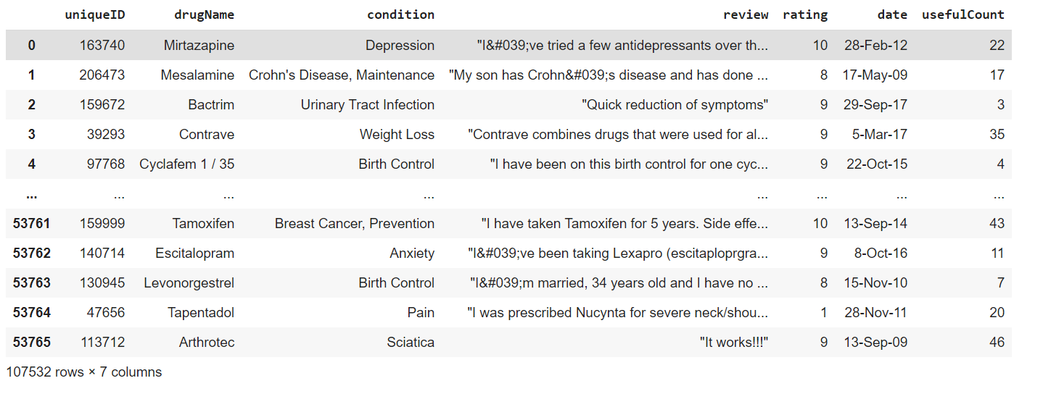

Dataset URL: <https://archive.ics.uci.edu/ml/datasets/Drug+Review+Dataset+%28Drugs.com%29>

**Exploratory data analysis** :

This below screenshot tells us the summary statistics of each columns in our dataset.

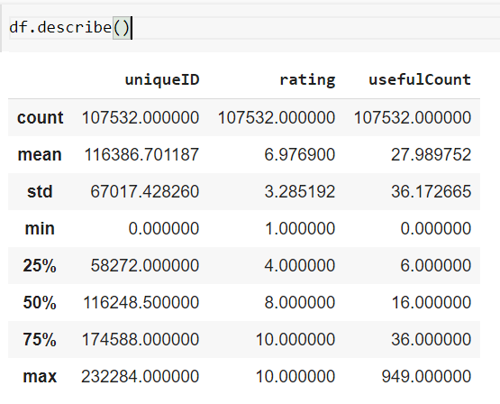

There are 590 null values in condition column.

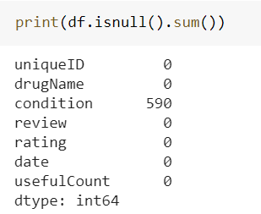

Unique values in condition column.

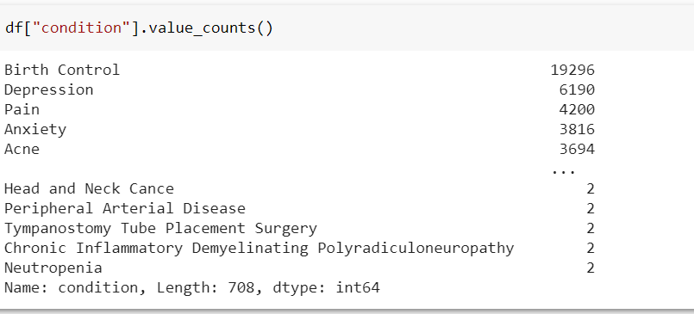

I have removed Span names rows from the condition column because there won’t be any use in our analysis.

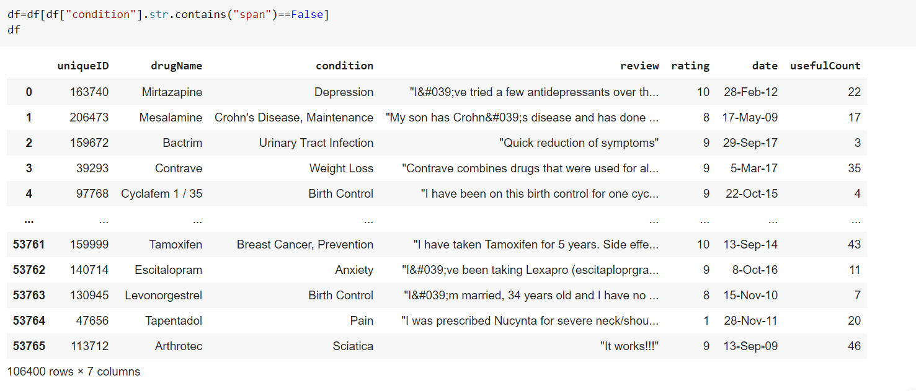

**Below Bar graph tells us top 20 frequently occurring conditions in our dataset.**

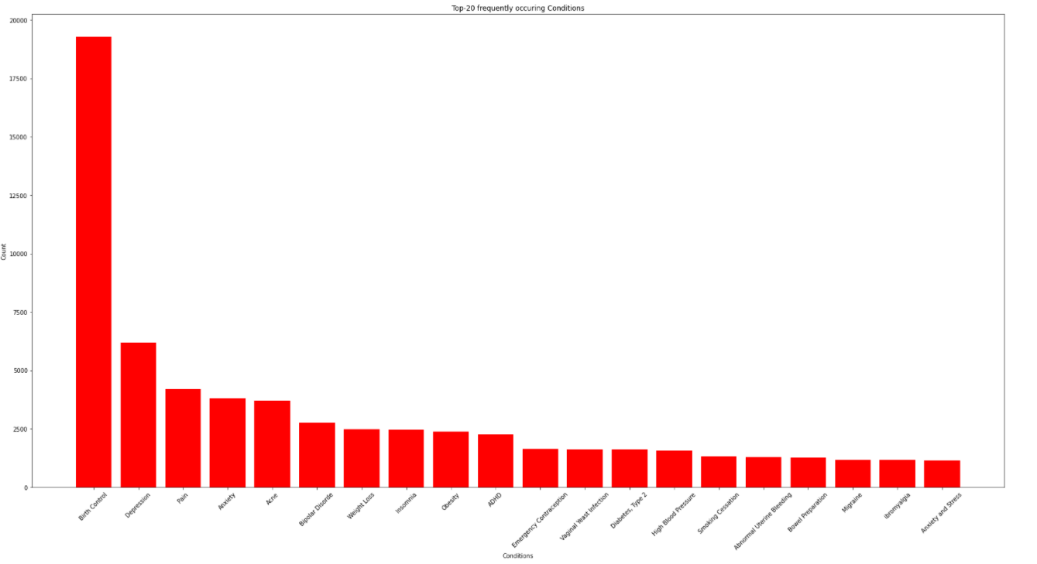

Below bar graph tells us number of reviews in each year. In 2016 there are many reviews where in 2008 there are less reviews.

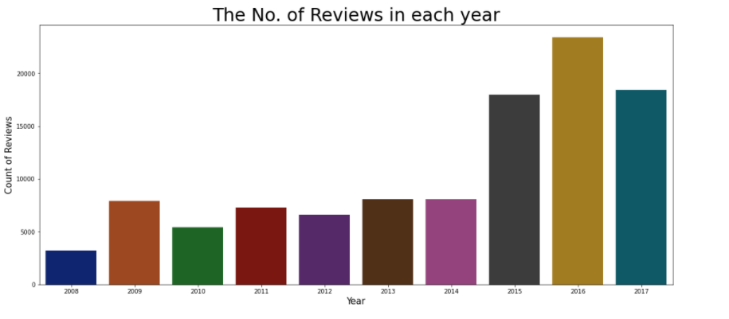

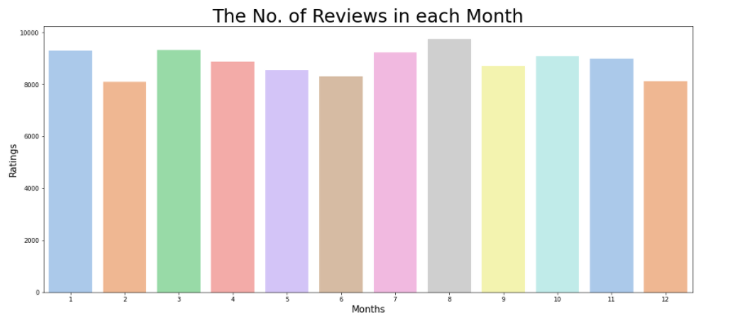

Below Pie chart tells us the sharing of rating. Many users given rating 10 for many drugs along with patient condition and less rating is 4 given by people who uses drugs basing on there condition.

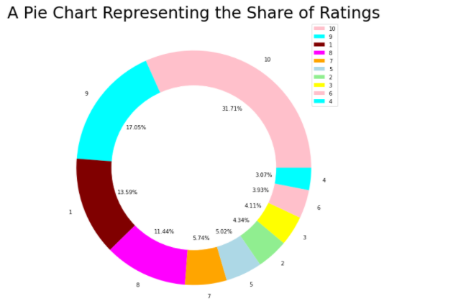

Data Pre-Processing:

Before finding the sentiment of each review we need to pre-process our review columns using following steps

* Tokenization
* Stemming
* Lemmatization
* Stop Words Removal
* Rejoining Reviews

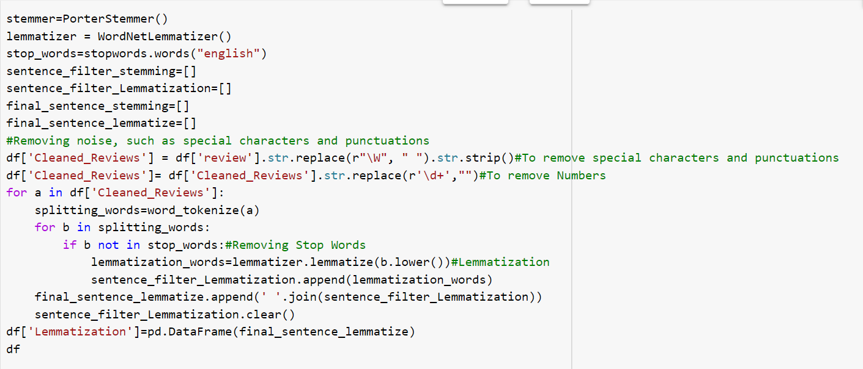

**Cleaned Dataset:**

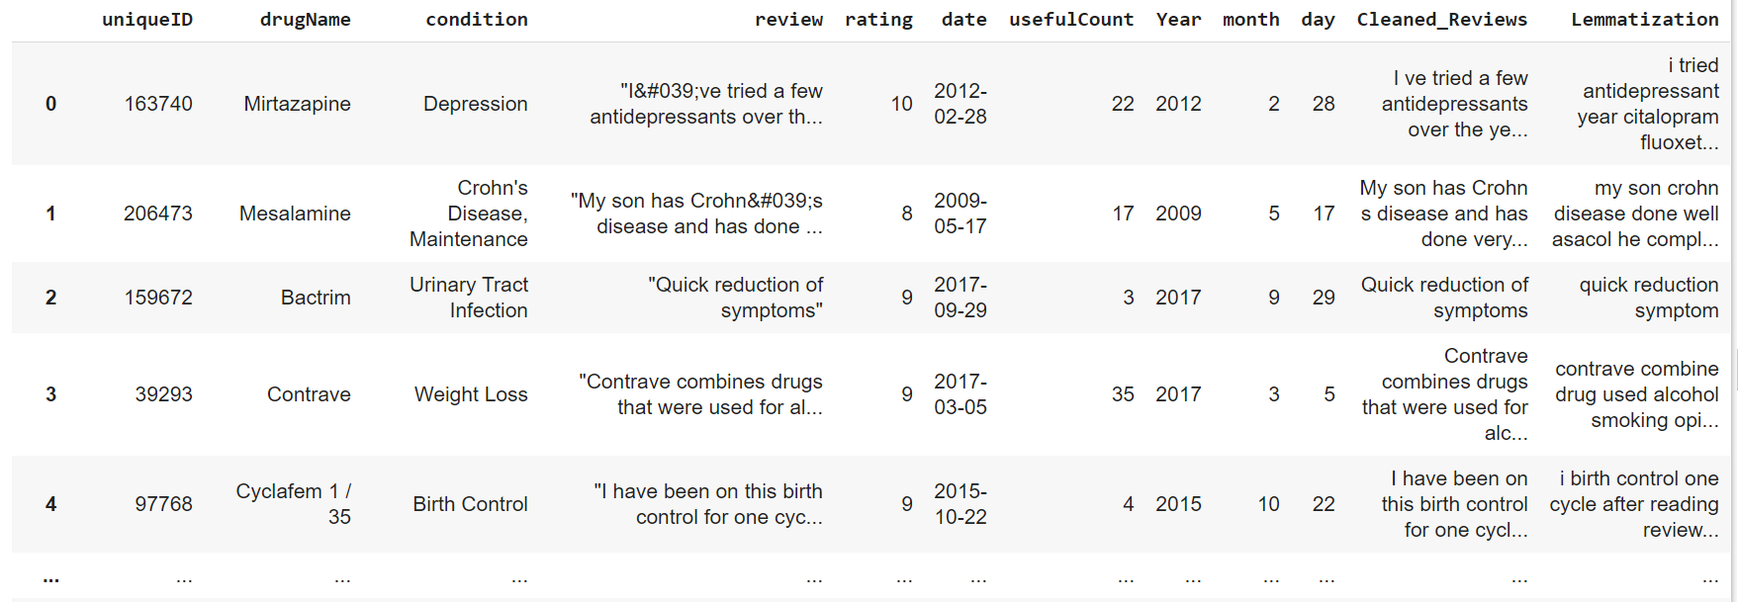

Now, we will find sentiments for each review with the help of Text blob package in python.

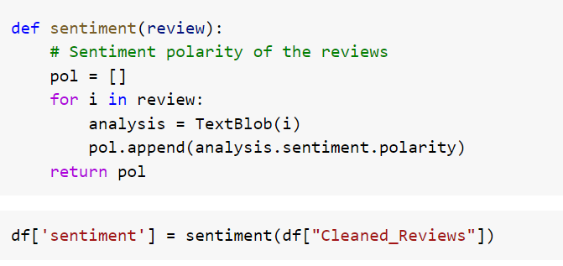

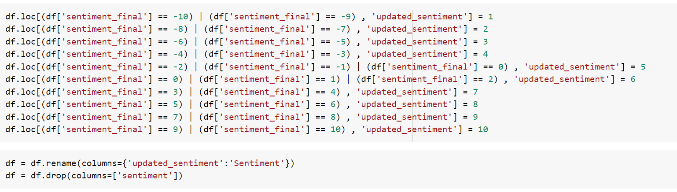

With the help of above code we will calculate final sentiment for each review.

**Sample Sentiment Dataset:**

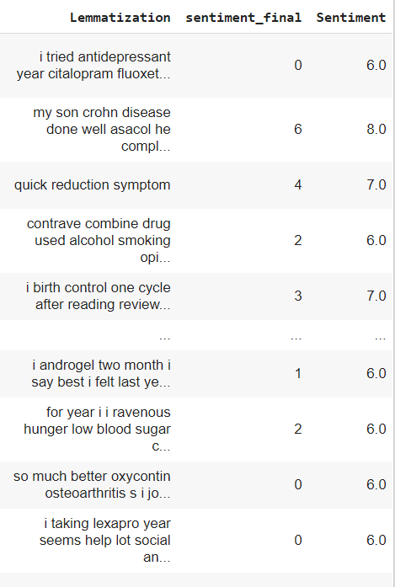

**Hypothesis:**

Null Hypothesis(H0): There are many drugs for each condition.

Alternative Hypothesis(H1): There are less drugs for each condition.

**Research Design and Methodology:**

Collected medical data online and I am going to clean and prepare my data and then I will analyze my data then after I will design my recommendation system using NLP methods and Recommendation Techniques and then I am going to predict medicines for users and then after I am going to give Medicine overview based on user choice in that overview user can able can make decision like whether they can use this drug or not and then I will create a small web application and integrate with my Recommendation model.

**Data Analytics:**

Once all sentiment all calculated for each review then we will recommend medicines to users based on the user input.

Once we get input from user then based on condition we will check all the drugs that are suitable for that condition then based on Sentiment and useful count we will rank the drug and then we will recommend medicine to users.

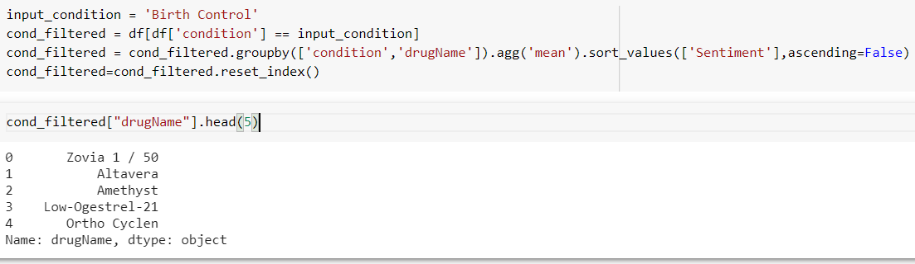

In my recommendation system users can able to see review of each drug by sentiments of each drug.

I have considered NRC-Emotion-Lexicon-Worldlevel text file and in this file, we can see sentiments of all the words.

In the below dataset we can see the reactions of each word and with the help of this we can able to find the reactions of the users who already used any drug.

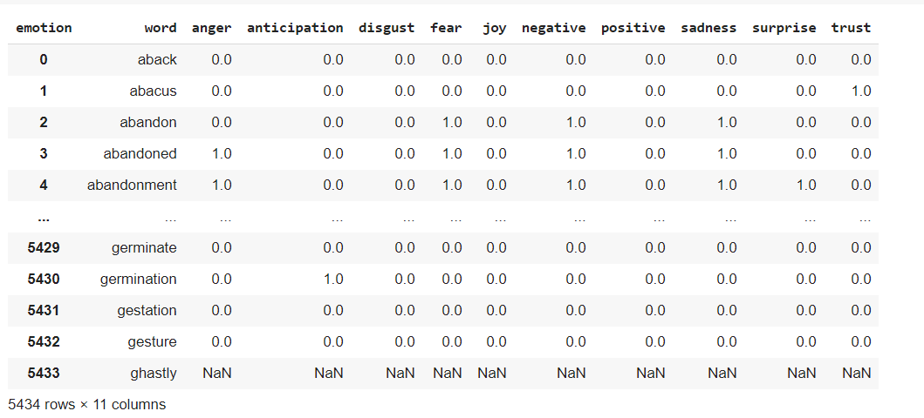

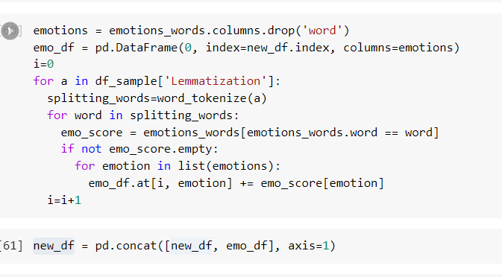

From the below dataset we can see emotions of each review.

Based on the emotions we can suggest patients weather they can prefer drug or not, because sometimes there are multiple drugs for one condition and side effects may differ for each drug, so basing on emotions of each drug patients can decide which drug is suitable for their body.

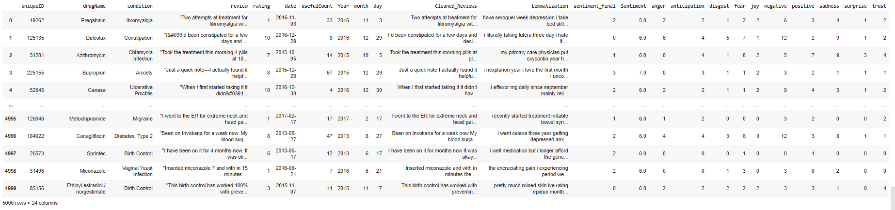

**Data Visualization and Result Reports:**

**Drug Recommendation:**

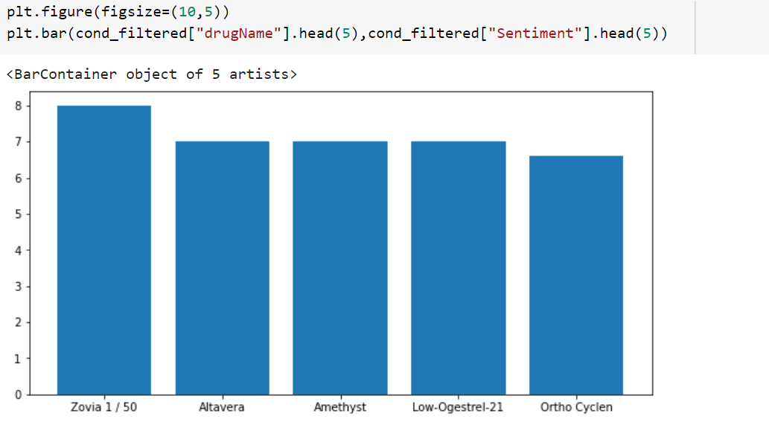

In the above bar graph we have recommended top 5 drugs for Birth Control condition and patient can see what are the emotions or any side effect of any particular drug.

**About Drug:**



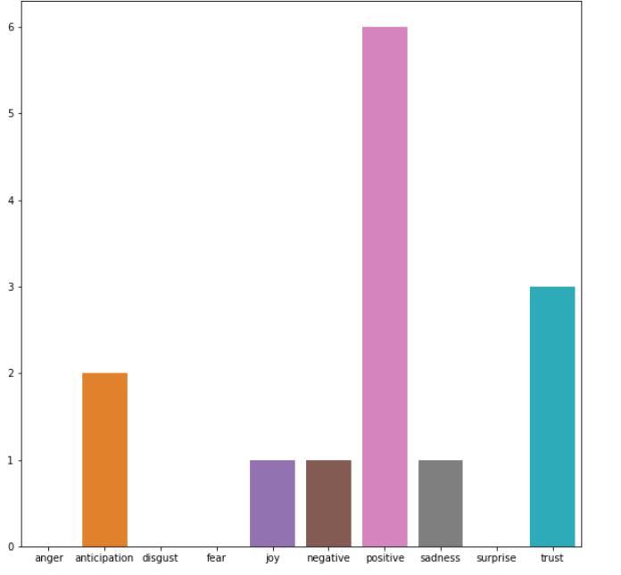

So from above bar graph we can see drug emotions.

**Web Application:**

Created a Simple Recommendation web application using streamlit module in python.

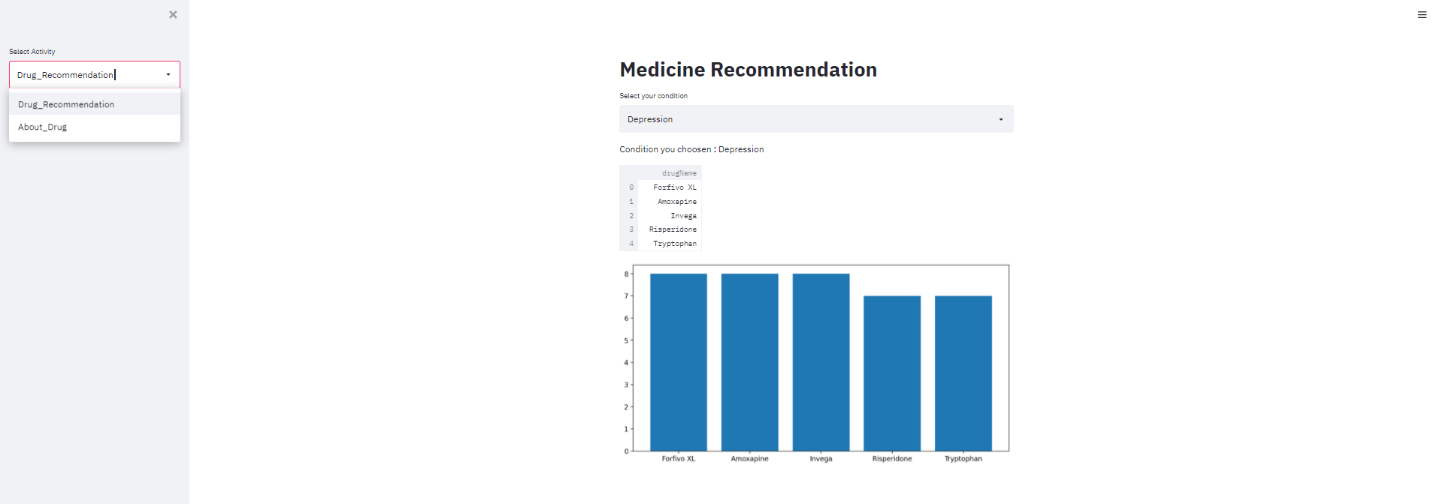

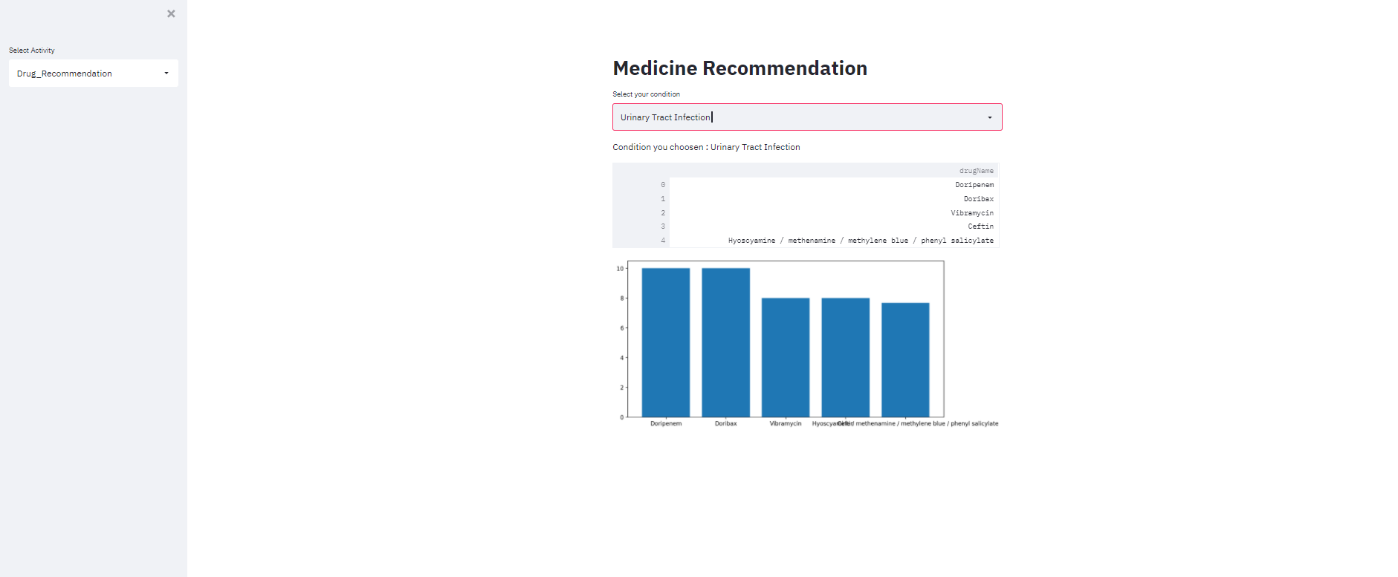

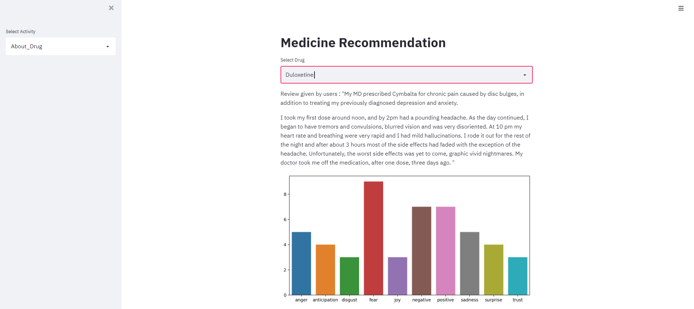

**Conclusion:**

From Machine Learning Algorithm we can develop recommender systems that can give a medical recommendation with excellent efficiency and accuracy based on diagnosis and symptoms. The results using NLP methods and Recommendation will help in knowing the drugs based on condition.

**Bibliography:**

*References*

[1] Recommendation of Doctors and Medicines Using Review Mining,” The FDA Safety Information and Adverse Event Reporting Program, 18 Apr. 2018, pp. 1-2.

[2] RPubs - Project 5: Medical Recommender System. (2019b, May 12). Rajwant Mishra. <https://rpubs.com/Rajwantmishra/project5_final>/, 2012.

[3] Kordík, P. (2019, December 15). Machine Learning for Recommender systems — Part 1 (algorithms, evaluation, and cold start). Medium. <https://medium.com/recombee-blog/machine-learning-for-recommender-systems-part-1-algorithms-evaluation-and-cold-start-6f696683d0ed>.

[4] Bansal, M. (2019, October 18). Decoding the output of a hybrid recommendation system. Medium. <https://towardsdatascience.com/decoding-the-output-of-a-hybrid-recommendation-system-2007d85547bf>

[5] Cates, J. (2019, October 4). How to Build a Recommender Engine for Medical Research Papers. Medium. https://medium.com/@topspinj/how-to-build-a-recommender-engine-for-medical-research-papers-a9dc1bad12f2