
JAVA PROGRAMMING LAB (BCS-553)
B.Tech CSE 5th SEMESTER
SUBMITTED TO: | SUBMITTED BY:
MR. Manish Choudhary | AKHILESH GANGWAR  Roll No.: 2410303049  Student ID: BCS2024022

INDEX
SN. | PROGRAM NAME | PAGE | DATE | SIGNATURE
1 | Reading Array Values
2 | Largest, Smallest and Count
3 | Bubble Sort
4 | Selection Sort
5 | Linear Search
6 | Binary Search on a Sorted Array
7 | Practice Set
8 | Classes and Objects
9 | Constructors
10 | Parent and Child Classes
11 | Method Overriding
12 | Recursive Factorial, Sum and Power
13 | Recursion on Arrays
14 | Sorted Check, Search and Fibonacci
15 | Subsets and Arrangements

ASSIGNMENT 1: Reading Array Values

Task 01
Source file: Main.java
/*
* Name: Akhilesh Gangwar
* Roll No: 2410303049
* Student ID: BCS2024022
* Email: akhilonix.in@gmail.com
* GitHub: akhilonix
GitHub repo: https://github.com/akhilonix/BCS553-Applied-Data-Structures-Algorithms-Lab
* Course: BCS553 - Applied Data Structures & Algorithms Lab
* Assignment: 1
* Task: 1
*/
public class Main {
public static void main(String[] args) {
int[] marks = {45, 67, 80, 52, 90};
System.out.println("First: " + marks[0]);
System.out.println("Last: " + marks[marks.length - 1]);
}
}
Actual program output
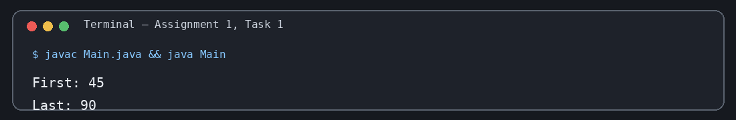
Assignment 1 – Task 1 | Output verified

Task 02
Source file: Main.java
/*
* Name: Akhilesh Gangwar
* Roll No: 2410303049
* Student ID: BCS2024022
* Email: akhilonix.in@gmail.com
* GitHub: akhilonix
GitHub repo: https://github.com/akhilonix/BCS553-Applied-Data-Structures-Algorithms-Lab
* Course: BCS553 - Applied Data Structures & Algorithms Lab
* Assignment: 1
* Task: 2
*/
public class Main {
public static void main(String[] args) {
int[] marks = {45, 67, 80, 52, 90};
for (int mark : marks) {
System.out.println(mark);
}
}
}
Actual program output
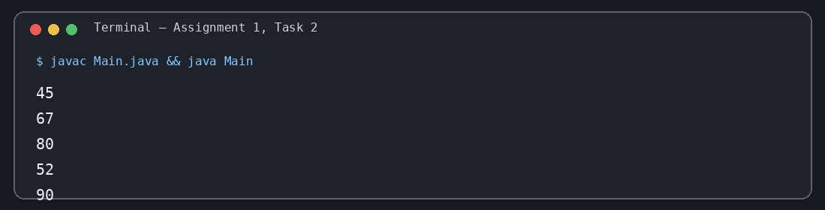
Assignment 1 – Task 2 | Output verified

Task 03
Source file: Main.java
/*
* Name: Akhilesh Gangwar
* Roll No: 2410303049
* Student ID: BCS2024022
* Email: akhilonix.in@gmail.com
* GitHub: akhilonix
GitHub repo: https://github.com/akhilonix/BCS553-Applied-Data-Structures-Algorithms-Lab
* Course: BCS553 - Applied Data Structures & Algorithms Lab
* Assignment: 1
* Task: 3
*/
public class Main {
public static void main(String[] args) {
int[] marks = {45, 67, 80, 52, 90};
int sum = 0;
for (int mark : marks) {
sum += mark;
}
System.out.println("Sum: " + sum);
}
}
Actual program output
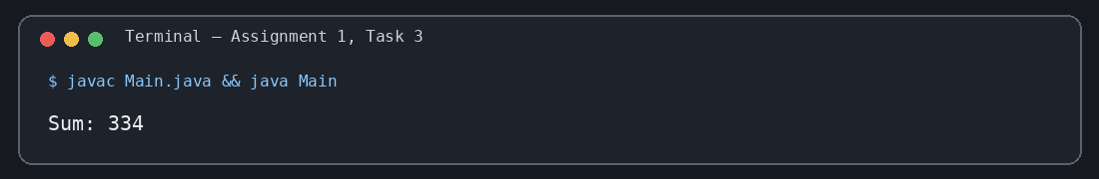
Assignment 1 – Task 3 | Output verified

ASSIGNMENT 2: Largest, Smallest and Count

Task 01
Source file: Main.java
/*
* Name: Akhilesh Gangwar
* Roll No: 2410303049
* Student ID: BCS2024022
* Email: akhilonix.in@gmail.com
* GitHub: akhilonix
GitHub repo: https://github.com/akhilonix/BCS553-Applied-Data-Structures-Algorithms-Lab
* Course: BCS553 - Applied Data Structures & Algorithms Lab
* Assignment: 2
* Task: 1
*/
public class Main {
public static void main(String[] args) {
int[] marks = {45, 67, 80, 52, 90};
int largest = marks[0];
for (int mark : marks) {
if (mark > largest) largest = mark;
}
System.out.println("Largest: " + largest);
}
}
Actual program output
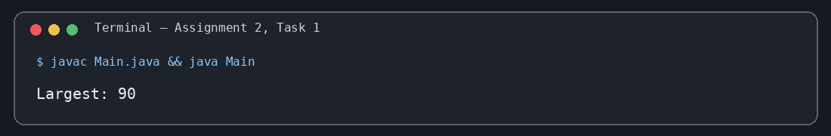
Assignment 2 – Task 1 | Output verified

Task 02
Source file: Main.java
/*
* Name: Akhilesh Gangwar
* Roll No: 2410303049
* Student ID: BCS2024022
* Email: akhilonix.in@gmail.com
* GitHub: akhilonix
GitHub repo: https://github.com/akhilonix/BCS553-Applied-Data-Structures-Algorithms-Lab
* Course: BCS553 - Applied Data Structures & Algorithms Lab
* Assignment: 2
* Task: 2
*/
public class Main {
public static void main(String[] args) {
int[] marks = {45, 67, 80, 52, 90};
int smallest = marks[0];
for (int mark : marks) {
if (mark < smallest) smallest = mark;
}
System.out.println("Smallest: " + smallest);
}
}
Actual program output
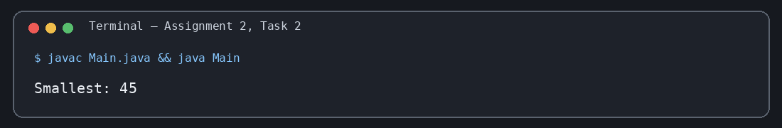
Assignment 2 – Task 2 | Output verified

Task 03
Source file: Main.java
/*
* Name: Akhilesh Gangwar
* Roll No: 2410303049
* Student ID: BCS2024022
* Email: akhilonix.in@gmail.com
* GitHub: akhilonix
GitHub repo: https://github.com/akhilonix/BCS553-Applied-Data-Structures-Algorithms-Lab
* Course: BCS553 - Applied Data Structures & Algorithms Lab
* Assignment: 2
* Task: 3
*/
public class Main {
public static void main(String[] args) {
int[] marks = {45, 67, 80, 52, 90};
int count = 0;
for (int mark : marks) {
if (mark > 60) count++;
}
System.out.println("Count: " + count);
}
}
Actual program output
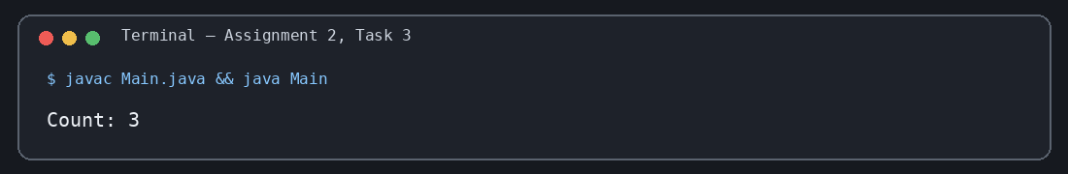
Assignment 2 – Task 3 | Output verified

ASSIGNMENT 3: Bubble Sort

Task 01
Source file: Main.java
/*
* Name: Akhilesh Gangwar
* Roll No: 2410303049
* Student ID: BCS2024022
* Email: akhilonix.in@gmail.com
* GitHub: akhilonix
GitHub repo: https://github.com/akhilonix/BCS553-Applied-Data-Structures-Algorithms-Lab
* Course: BCS553 - Applied Data Structures & Algorithms Lab
* Assignment: 3
* Task: 1
*/
public class Main {
public static void main(String[] args) {
int[] a = {5, 1, 4, 2, 8};
for (int i = 0; i < a.length - 1; i++) {
if (a[i] > a[i + 1]) {
int temp = a[i]; a[i] = a[i + 1]; a[i + 1] = temp;
}
}
for (int value : a) System.out.println(value);
}
}
Actual program output
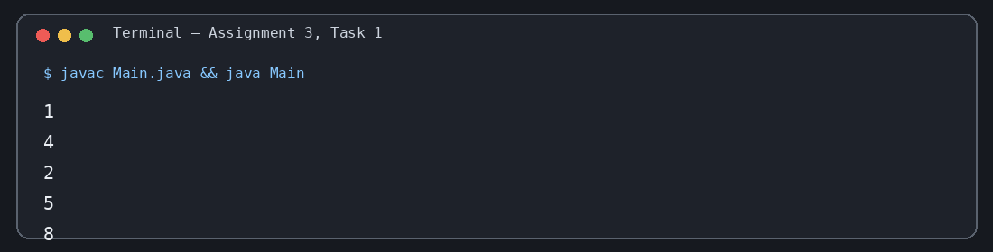
Assignment 3 – Task 1 | Output verified

Task 02
Source file: Main.java
/*
* Name: Akhilesh Gangwar
* Roll No: 2410303049
* Student ID: BCS2024022
* Email: akhilonix.in@gmail.com
* GitHub: akhilonix
* Course: BCS553 - Applied Data Structures & Algorithms Lab
* Assignment: 3
* Task: 2
*/
public class Main {
public static void main(String[] args) {
int[] a = {5, 1, 4, 2, 8};
for (int i = 0; i < a.length - 1; i++) {
for (int j = 0; j < a.length - 1 - i; j++) {
if (a[j] > a[j + 1]) {
int temp = a[j]; a[j] = a[j + 1]; a[j + 1] = temp;
}
}
}
for (int value : a) System.out.println(value);
}
}
Actual program output
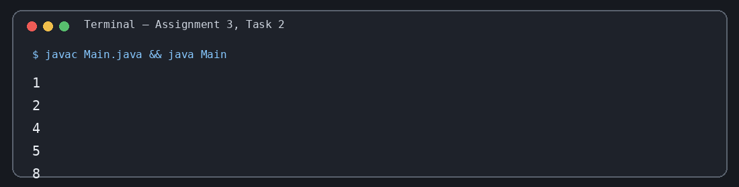
Assignment 3 – Task 2 | Output verified

Task 03
Source file: Main.java
/*
* Name: Akhilesh Gangwar
* Roll No: 2410303049
* Student ID: BCS2024022
* Email: akhilonix.in@gmail.com
* GitHub: akhilonix
* Course: BCS553 - Applied Data Structures & Algorithms Lab
* Assignment: 3
* Task: 3
*/
public class Main {
public static void main(String[] args) {
int[] a = {9, 7, 3};
for (int i = 0; i < a.length - 1; i++) {
for (int j = 0; j < a.length - 1 - i; j++) {
if (a[j] > a[j + 1]) {
int temp = a[j]; a[j] = a[j + 1]; a[j + 1] = temp;
}
}
}
for (int value : a) System.out.println(value);
}
}
Actual program output
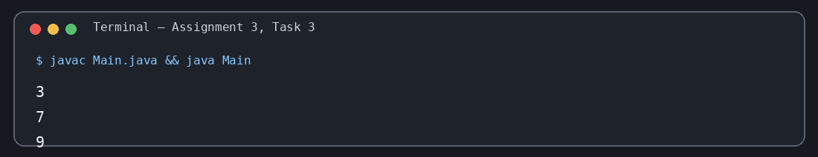
Assignment 3 – Task 3 | Output verified

ASSIGNMENT 4: Selection Sort

Task 01
Source file: Main.java
/*
* Name: Akhilesh Gangwar
* Roll No: 2410303049
* Student ID: BCS2024022
* Email: akhilonix.in@gmail.com
* GitHub: akhilonix
* Course: BCS553 - Applied Data Structures & Algorithms Lab
* Assignment: 4
* Task: 1
*/
public class Main {
public static void main(String[] args) {
int[] a = {64, 25, 12, 22, 11};
int minIndex = 0;
for (int i = 1; i < a.length; i++) {
if (a[i] < a[minIndex]) minIndex = i;
}
System.out.println(minIndex);
}
}
Actual program output
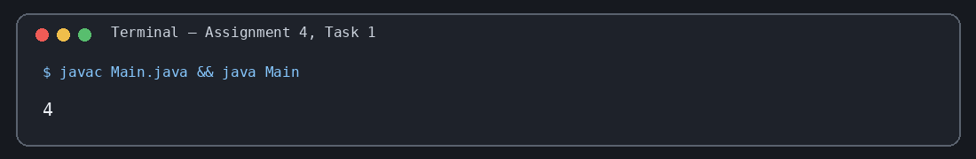
Assignment 4 – Task 1 | Output verified

Task 02
Source file: Main.java
/*
* Name: Akhilesh Gangwar
* Roll No: 2410303049
* Student ID: BCS2024022
* Email: akhilonix.in@gmail.com
* GitHub: akhilonix
* Course: BCS553 - Applied Data Structures & Algorithms Lab
* Assignment: 4
* Task: 2
*/
public class Main {
public static void main(String[] args) {
int[] a = {64, 25, 12, 22, 11};
for (int i = 0; i < a.length - 1; i++) {
int minIndex = i;
for (int j = i + 1; j < a.length; j++) {
if (a[j] < a[minIndex]) minIndex = j;
}
int temp = a[i]; a[i] = a[minIndex]; a[minIndex] = temp;
}
for (int value : a) System.out.println(value);
}
}
Actual program output
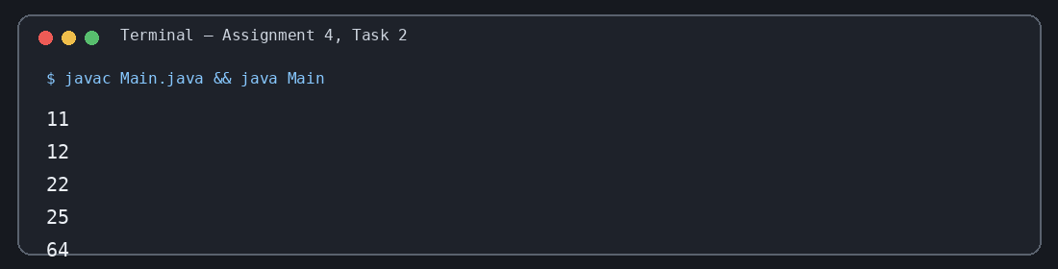
Assignment 4 – Task 2 | Output verified

Task 03
Source file: Main.java
/*
* Name: Akhilesh Gangwar
* Roll No: 2410303049
* Student ID: BCS2024022
* Email: akhilonix.in@gmail.com
* GitHub: akhilonix
* Course: BCS553 - Applied Data Structures & Algorithms Lab
* Assignment: 4
* Task: 3
*/
public class Main {
public static void main(String[] args) {
int[] a = {64, 25, 12, 22, 11};
int minIndex = 0;
for (int i = 1; i < a.length; i++) {
if (a[i] < a[minIndex]) minIndex = i;
}
int temp = a[0]; a[0] = a[minIndex]; a[minIndex] = temp;
for (int value : a) System.out.println(value);
}
}
Actual program output
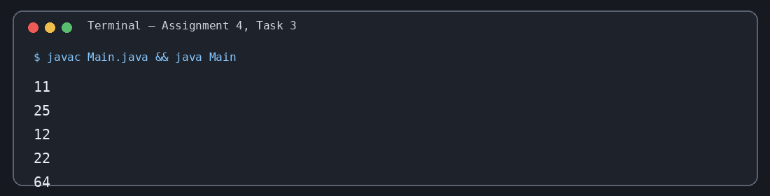
Assignment 4 – Task 3 | Output verified

ASSIGNMENT 5: Linear Search

Task 01
Source file: Main.java
/*
* Name: Akhilesh Gangwar
* Roll No: 2410303049
* Student ID: BCS2024022
* Email: akhilonix.in@gmail.com
* GitHub: akhilonix
* Course: BCS553 - Applied Data Structures & Algorithms Lab
* Assignment: 5
* Task: 1
*/
public class Main {
public static int linearSearch(int[] a, int key) {
for (int i = 0; i < a.length; i++) {
if (a[i] == key) return i;
}
return -1;
}
public static void main(String[] args) {
int[] a = {45, 67, 80, 52, 90};
System.out.println(linearSearch(a, 80));
}
}
Actual program output
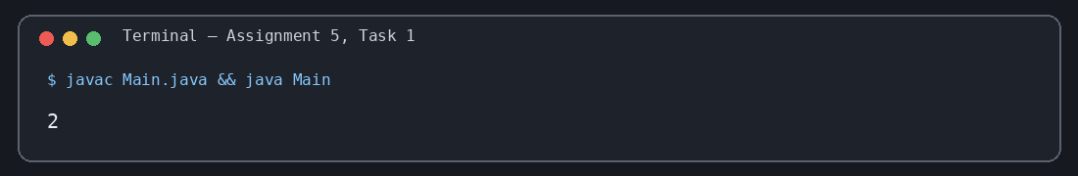
Assignment 5 – Task 1 | Output verified

Task 02
Source file: Main.java
/*
* Name: Akhilesh Gangwar
* Roll No: 2410303049
* Student ID: BCS2024022
* Email: akhilonix.in@gmail.com
* GitHub: akhilonix
* Course: BCS553 - Applied Data Structures & Algorithms Lab
* Assignment: 5
* Task: 2
*/
public class Main {
public static int linearSearch(int[] a, int key) {
for (int i = 0; i < a.length; i++) {
if (a[i] == key) return i;
}
return -1;
}
public static void main(String[] args) {
int[] a = {45, 67, 80, 52, 90};
System.out.println(linearSearch(a, 100));
}
}
Actual program output
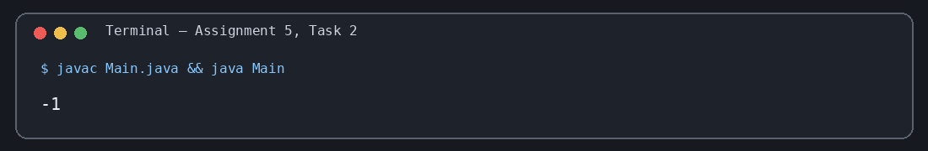
Assignment 5 – Task 2 | Output verified

Task 03
Source file: Main.java
/*
* Name: Akhilesh Gangwar
* Roll No: 2410303049
* Student ID: BCS2024022
* Email: akhilonix.in@gmail.com
* GitHub: akhilonix
* Course: BCS553 - Applied Data Structures & Algorithms Lab
* Assignment: 5
* Task: 3
*/
public class Main {
public static void main(String[] args) {
int[] a = {52, 10, 52, 7, 52};
int count = 0;
for (int value : a) {
if (value == 52) count++;
}
System.out.println("Count: " + count);
}
}
Actual program output
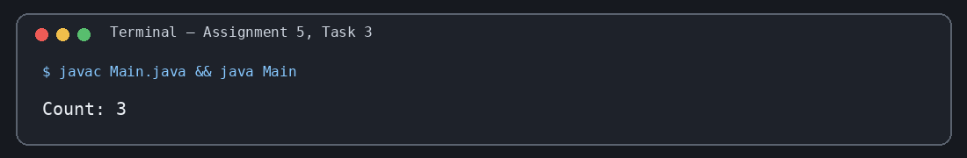
Assignment 5 – Task 3 | Output verified

ASSIGNMENT 6: Binary Search on a Sorted Array

Task 01
Source file: Main.java
/*
* Name: Akhilesh Gangwar
* Roll No: 2410303049
* Student ID: BCS2024022
* Email: akhilonix.in@gmail.com
* GitHub: akhilonix
* Course: BCS553 - Applied Data Structures & Algorithms Lab
* Assignment: 6
* Task: 1
*/
public class Main {
public static int binarySearch(int[] a, int key) {
int low = 0, high = a.length - 1;
while (low <= high) {
int mid = low + (high - low) / 2;
if (a[mid] == key) return mid;
if (a[mid] < key) low = mid + 1;
else high = mid - 1;
}
return -1;
}
public static void main(String[] args) {
int[] a = {10, 20, 30, 40, 50};
System.out.println(binarySearch(a, 40));
}
}
Actual program output
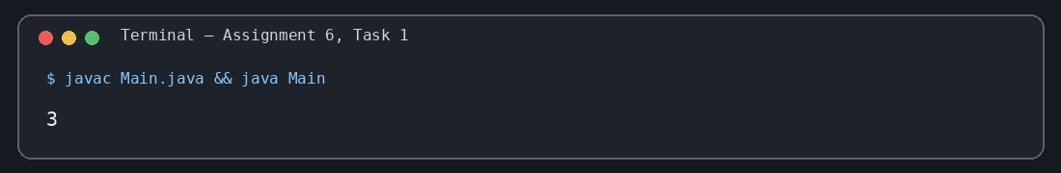
Assignment 6 – Task 1 | Output verified

Task 02
Source file: Main.java
/*
* Name: Akhilesh Gangwar
* Roll No: 2410303049
* Student ID: BCS2024022
* Email: akhilonix.in@gmail.com
* GitHub: akhilonix
* Course: BCS553 - Applied Data Structures & Algorithms Lab
* Assignment: 6
* Task: 2
*/
public class Main {
public static int binarySearch(int[] a, int key) {
int low = 0, high = a.length - 1;
while (low <= high) {
int mid = low + (high - low) / 2;
if (a[mid] == key) return mid;
if (a[mid] < key) low = mid + 1;
else high = mid - 1;
}
return -1;
}
public static void main(String[] args) {
int[] a = {10, 20, 30, 40, 50};
System.out.println(binarySearch(a, 35));
}
}
Actual program output
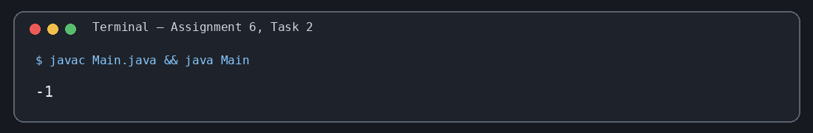
Assignment 6 – Task 2 | Output verified

Task 03
Source file: Main.java
/*
* Name: Akhilesh Gangwar
* Roll No: 2410303049
* Student ID: BCS2024022
* Email: akhilonix.in@gmail.com
* GitHub: akhilonix
* Course: BCS553 - Applied Data Structures & Algorithms Lab
* Assignment: 6
* Task: 3
*/
public class Main {
public static int binarySearch(int[] a, int key) {
int low = 0, high = a.length - 1;
while (low <= high) {
int mid = low + (high - low) / 2;
if (a[mid] == key) return mid;
if (a[mid] < key) low = mid + 1;
else high = mid - 1;
}
return -1;
}
public static void main(String[] args) {
int[] a = {10, 20, 30, 40, 50};
System.out.println(binarySearch(a, 10));
}
}
Actual program output
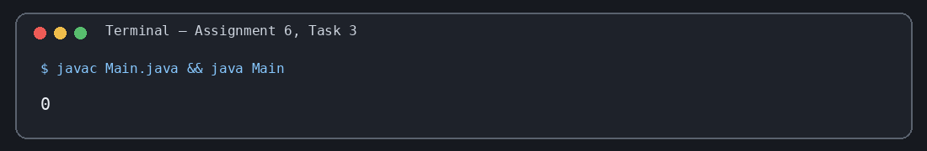
Assignment 6 – Task 3 | Output verified

ASSIGNMENT 7: Practice Set

Task 01
Source file: Main.java
/*
* Name: Akhilesh Gangwar
* Roll No: 2410303049
* Student ID: BCS2024022
* Email: akhilonix.in@gmail.com
* GitHub: akhilonix
* Course: BCS553 - Applied Data Structures & Algorithms Lab
* Assignment: 7
* Task: 1
*/
public class Main {
public static void main(String[] args) {
int[] a = {45, 52, 80};
int index = -1;
for (int i = 0; i < a.length; i++) {
if (a[i] == 52) { index = i; break; }
}
if (index != -1) System.out.println("Found at index " + index);
else System.out.println("Not found");
}
}
Actual program output
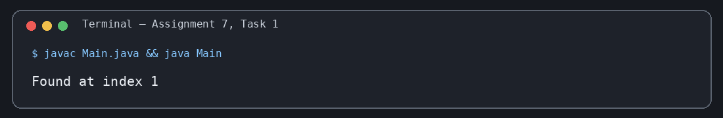
Assignment 7 – Task 1 | Output verified

Task 02
Source file: Main.java
/*
* Name: Akhilesh Gangwar
* Roll No: 2410303049
* Student ID: BCS2024022
* Email: akhilonix.in@gmail.com
* GitHub: akhilonix
* Course: BCS553 - Applied Data Structures & Algorithms Lab
* Assignment: 7
* Task: 2
*/
public class Main {
public static void main(String[] args) {
int[] a = {3, 1, 2};
for (int i = 0; i < a.length - 1; i++) {
for (int j = 0; j < a.length - 1 - i; j++) {
if (a[j] > a[j + 1]) {
int temp = a[j]; a[j] = a[j + 1]; a[j + 1] = temp;
}
}
}
for (int value : a) System.out.println(value);
}
}
Actual program output
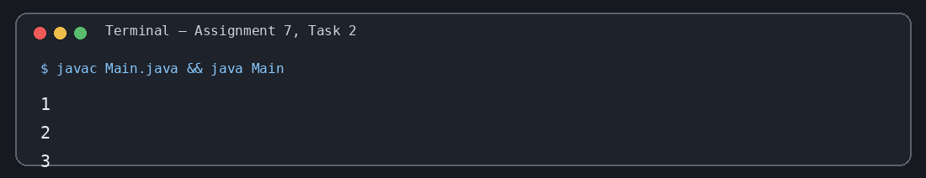
Assignment 7 – Task 2 | Output verified

Task 03
Source file: Main.java
/*
* Name: Akhilesh Gangwar
* Roll No: 2410303049
* Student ID: BCS2024022
* Email: akhilonix.in@gmail.com
* GitHub: akhilonix
* Course: BCS553 - Applied Data Structures & Algorithms Lab
* Assignment: 7
* Task: 3
*/
public class Main {
public static void main(String[] args) {
int[] a = {2, 3, 4};
int product = 1;
for (int value : a) product *= value;
System.out.println("Product: " + product);
}
}
Actual program output
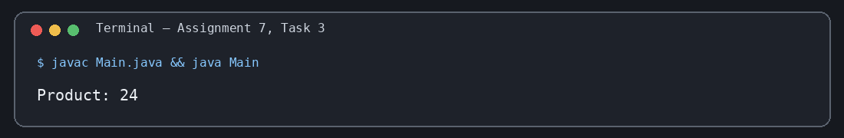
Assignment 7 – Task 3 | Output verified

Task 04
Source file: Main.java
/*
* Name: Akhilesh Gangwar
* Roll No: 2410303049
* Student ID: BCS2024022
* Email: akhilonix.in@gmail.com
* GitHub: akhilonix
* Course: BCS553 - Applied Data Structures & Algorithms Lab
* Assignment: 7
* Task: 4
*/
public class Main {
public static void main(String[] args) {
int[] a = {1, 2, 3, 4};
for (int value : a) {
if (value % 2 == 0) System.out.println(value);
}
}
}
Actual program output
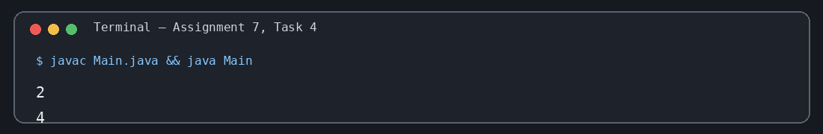
Assignment 7 – Task 4 | Output verified

ASSIGNMENT 8: Classes and Objects

Task 01
Source file: Main.java
/*
* Name: Akhilesh Gangwar
* Roll No: 2410303049
* Student ID: BCS2024022
* Email: akhilonix.in@gmail.com
* GitHub: akhilonix
* Course: BCS553 - Applied Data Structures & Algorithms Lab
* Assignment: 8
* Task: 1
*/
class Student {
int roll;
String name;
void show() {
System.out.println("Roll: " + roll);
System.out.println("Name: " + name);
}
}
public class Main {
public static void main(String[] args) {
Student s = new Student();
s.roll = 5; s.name = "Rohan";
s.show();
}
}
Actual program output
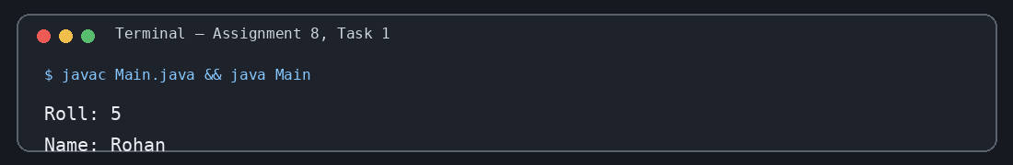
Assignment 8 – Task 1 | Output verified

Task 02
Source file: Main.java
/*
* Name: Akhilesh Gangwar
* Roll No: 2410303049
* Student ID: BCS2024022
* Email: akhilonix.in@gmail.com
* GitHub: akhilonix
* Course: BCS553 - Applied Data Structures & Algorithms Lab
* Assignment: 8
* Task: 2
*/
class Student {
int roll;
String name;
void show() {
System.out.println("Roll: " + roll);
System.out.println("Name: " + name);
}
}
public class Main {
public static void main(String[] args) {
Student s1 = new Student();
s1.roll = 5; s1.name = "Rohan"; s1.show();
Student s2 = new Student();
s2.roll = 8; s2.name = "Meera"; s2.show();
}
}
Actual program output
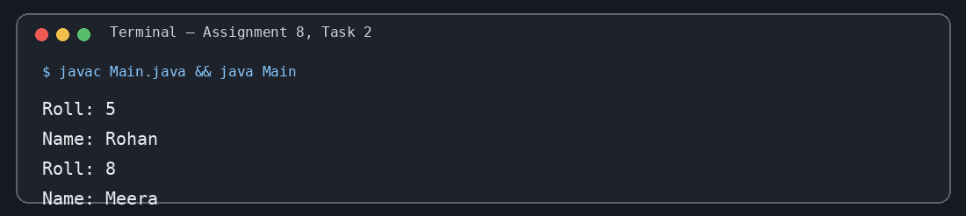
Assignment 8 – Task 2 | Output verified

Task 03
Source file: Main.java
/*
* Name: Akhilesh Gangwar
* Roll No: 2410303049
* Student ID: BCS2024022
* Email: akhilonix.in@gmail.com
* GitHub: akhilonix
* Course: BCS553 - Applied Data Structures & Algorithms Lab
* Assignment: 8
* Task: 3
*/
class Book {
int pages;
boolean isLong() { return pages > 300; }
}
public class Main {
public static void main(String[] args) {
Book b1 = new Book(); b1.pages = 450;
Book b2 = new Book(); b2.pages = 120;
System.out.println(b1.isLong());
System.out.println(b2.isLong());
}
}
Actual program output
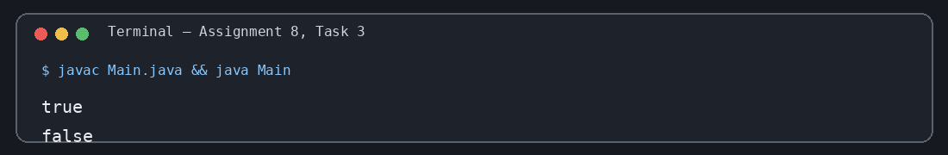
Assignment 8 – Task 3 | Output verified

ASSIGNMENT 9: Constructors

Task 01
Source file: Main.java
/*
* Name: Akhilesh Gangwar
* Roll No: 2410303049
* Student ID: BCS2024022
* Email: akhilonix.in@gmail.com
* GitHub: akhilonix
* Course: BCS553 - Applied Data Structures & Algorithms Lab
* Assignment: 9
* Task: 1
*/
class Box {
int width;
Box() { width = 10; }
}
public class Main {
public static void main(String[] args) {
Box b = new Box();
System.out.println("Width: " + b.width);
}
}
Actual program output
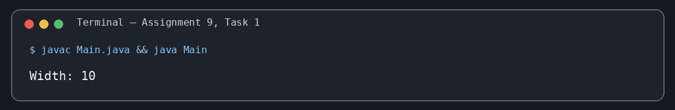
Assignment 9 – Task 1 | Output verified

Task 02
Source file: Main.java
/*
* Name: Akhilesh Gangwar
* Roll No: 2410303049
* Student ID: BCS2024022
* Email: akhilonix.in@gmail.com
* GitHub: akhilonix
* Course: BCS553 - Applied Data Structures & Algorithms Lab
* Assignment: 9
* Task: 2
*/
class Box {
int width;
Box(int width) { this.width = width; }
}
public class Main {
public static void main(String[] args) {
Box b = new Box(25);
System.out.println("Width: " + b.width);
}
}
Actual program output
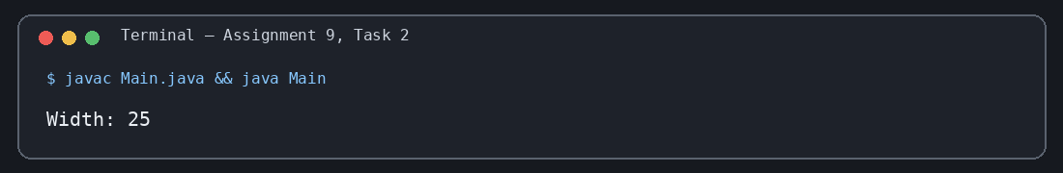
Assignment 9 – Task 2 | Output verified

Task 03
Source file: Main.java
/*
* Name: Akhilesh Gangwar
* Roll No: 2410303049
* Student ID: BCS2024022
* Email: akhilonix.in@gmail.com
* GitHub: akhilonix
* Course: BCS553 - Applied Data Structures & Algorithms Lab
* Assignment: 9
* Task: 3
*/
class Counter {
int count;
Counter() { count = 0; }
void increment() { count++; }
}
public class Main {
public static void main(String[] args) {
Counter c = new Counter();
c.increment(); c.increment(); c.increment();
System.out.println("Count: " + c.count);
}
}
Actual program output
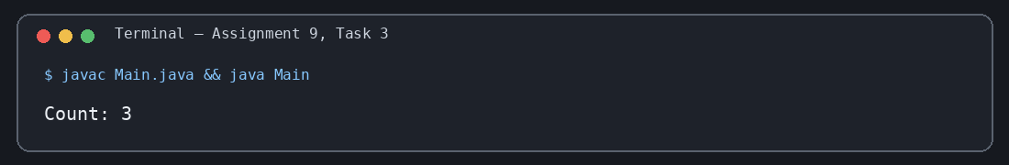
Assignment 9 – Task 3 | Output verified

ASSIGNMENT 10: Parent and Child Classes

Task 01
Source file: Main.java
/*
* Name: Akhilesh Gangwar
* Roll No: 2410303049
* Student ID: BCS2024022
* Email: akhilonix.in@gmail.com
* GitHub: akhilonix
* Course: BCS553 - Applied Data Structures & Algorithms Lab
* Assignment: 10
* Task: 1
*/
class Animal {
void sound() { System.out.println("Some sound"); }
}
class Dog extends Animal { }
public class Main {
public static void main(String[] args) {
Dog d = new Dog();
d.sound();
}
}
Actual program output
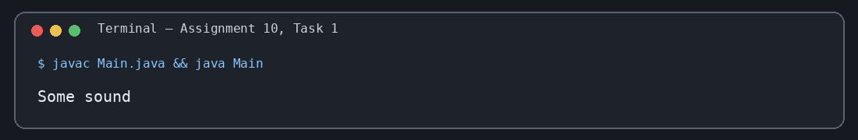
Assignment 10 – Task 1 | Output verified

Task 02
Source file: Main.java
/*
* Name: Akhilesh Gangwar
* Roll No: 2410303049
* Student ID: BCS2024022
* Email: akhilonix.in@gmail.com
* GitHub: akhilonix
* Course: BCS553 - Applied Data Structures & Algorithms Lab
* Assignment: 10
* Task: 2
*/
class Person {
String name;
Person(String name) { this.name = name; }
}
class Student extends Person {
Student(String name) { super(name); }
}
public class Main {
public static void main(String[] args) {
Student s = new Student("Neha");
System.out.println("Name: " + s.name);
}
}
Actual program output
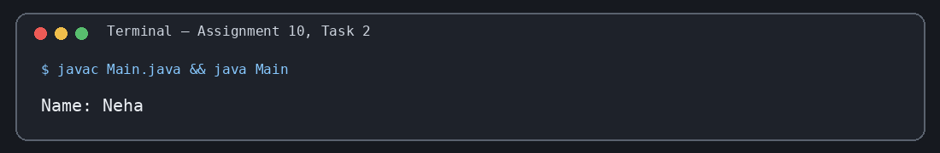
Assignment 10 – Task 2 | Output verified

Task 03
Source file: Main.java
/*
* Name: Akhilesh Gangwar
* Roll No: 2410303049
* Student ID: BCS2024022
* Email: akhilonix.in@gmail.com
* GitHub: akhilonix
* Course: BCS553 - Applied Data Structures & Algorithms Lab
* Assignment: 10
* Task: 3
*/
class Person {
String name;
void greet() { System.out.println("Hello, " + name); }
}
class Teacher extends Person { }
public class Main {
public static void main(String[] args) {
Teacher t = new Teacher();
t.name = "Kiran";
t.greet();
}
}
Actual program output
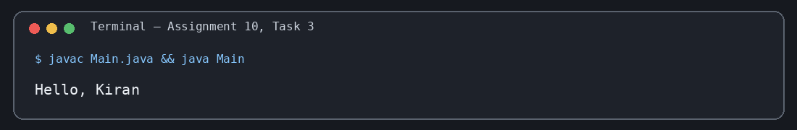
Assignment 10 – Task 3 | Output verified

ASSIGNMENT 11: Method Overriding

Task 01
Source file: Main.java
/*
* Name: Akhilesh Gangwar
* Roll No: 2410303049
* Student ID: BCS2024022
* Email: akhilonix.in@gmail.com
* GitHub: akhilonix
* Course: BCS553 - Applied Data Structures & Algorithms Lab
* Assignment: 11
* Task: 1
*/
class Shape {
int area() { return 0; }
}
class Square extends Shape {
int side;
@Override int area() { return side * side; }
}
public class Main {
public static void main(String[] args) {
Square s = new Square(); s.side = 4;
System.out.println("Area: " + s.area());
}
}
Actual program output
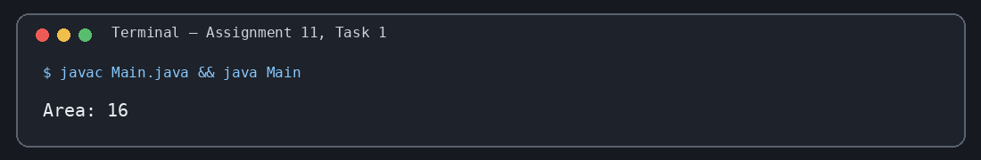
Assignment 11 – Task 1 | Output verified

Task 02
Source file: Main.java
/*
* Name: Akhilesh Gangwar
* Roll No: 2410303049
* Student ID: BCS2024022
* Email: akhilonix.in@gmail.com
* GitHub: akhilonix
* Course: BCS553 - Applied Data Structures & Algorithms Lab
* Assignment: 11
* Task: 2
*/
class Shape {
int area() { return 0; }
}
class Rectangle extends Shape {
int length, breadth;
@Override int area() { return length * breadth; }
}
public class Main {
public static void main(String[] args) {
Rectangle r = new Rectangle(); r.length = 4; r.breadth = 5;
System.out.println("Area: " + r.area());
}
}
Actual program output
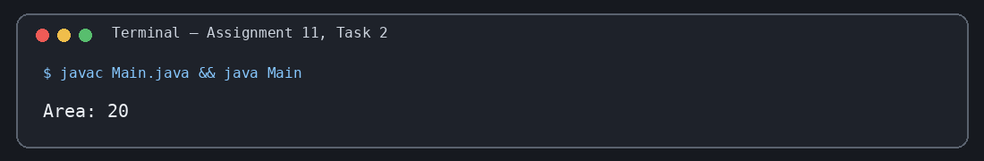
Assignment 11 – Task 2 | Output verified

Task 03
Source file: Main.java
/*
* Name: Akhilesh Gangwar
* Roll No: 2410303049
* Student ID: BCS2024022
* Email: akhilonix.in@gmail.com
* GitHub: akhilonix
* Course: BCS553 - Applied Data Structures & Algorithms Lab
* Assignment: 11
* Task: 3
*/
class Shape {
int area() { return 0; }
}
class Square extends Shape {
int side;
@Override int area() { return side * side; }
}
public class Main {
public static void main(String[] args) {
Shape s = new Square();
((Square) s).side = 3;
System.out.println("Area: " + s.area());
}
}
Actual program output
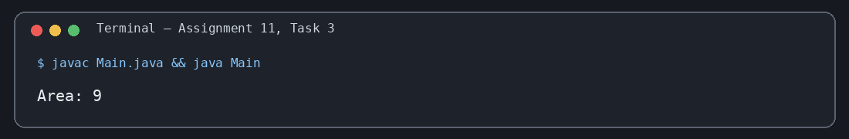
Assignment 11 – Task 3 | Output verified

ASSIGNMENT 12: Recursive Factorial, Sum and Power

Task 01
Source file: Main.java
/*
* Name: Akhilesh Gangwar
* Roll No: 2410303049
* Student ID: BCS2024022
* Email: akhilonix.in@gmail.com
* GitHub: akhilonix
* Course: BCS553 - Applied Data Structures & Algorithms Lab
* Assignment: 12
* Task: 1
*/
public class Main {
static int factorial(int n) {
if (n == 0) return 1;
return n * factorial(n - 1);
}
public static void main(String[] args) {
System.out.println(factorial(5));
}
}
Actual program output
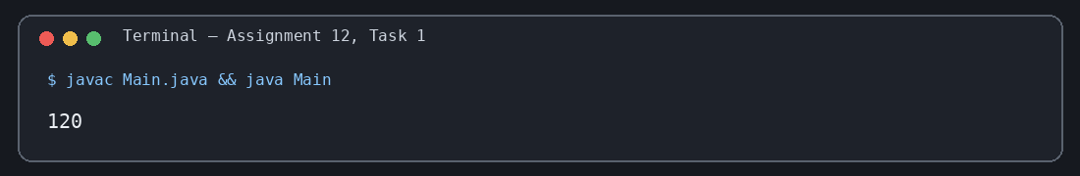
Assignment 12 – Task 1 | Output verified

Task 02
Source file: Main.java
/*
* Name: Akhilesh Gangwar
* Roll No: 2410303049
* Student ID: BCS2024022
* Email: akhilonix.in@gmail.com
* GitHub: akhilonix
* Course: BCS553 - Applied Data Structures & Algorithms Lab
* Assignment: 12
* Task: 2
*/
public class Main {
static int sum(int n) {
if (n == 0) return 0;
return n + sum(n - 1);
}
public static void main(String[] args) {
System.out.println(sum(10));
}
}
Actual program output
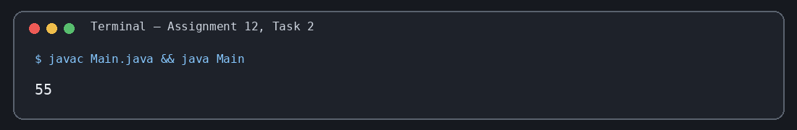
Assignment 12 – Task 2 | Output verified

Task 03
Source file: Main.java
/*
* Name: Akhilesh Gangwar
* Roll No: 2410303049
* Student ID: BCS2024022
* Email: akhilonix.in@gmail.com
* GitHub: akhilonix
* Course: BCS553 - Applied Data Structures & Algorithms Lab
* Assignment: 12
* Task: 3
*/
public class Main {
static int power(int base, int exp) {
if (exp == 0) return 1;
return base * power(base, exp - 1);
}
public static void main(String[] args) {
System.out.println(power(2, 5));
}
}
Actual program output
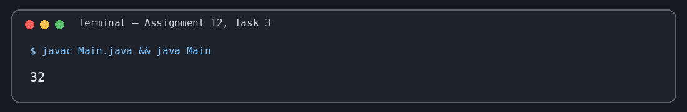
Assignment 12 – Task 3 | Output verified

ASSIGNMENT 13: Recursion on Arrays

Task 01
Source file: Main.java
/*
* Name: Akhilesh Gangwar
* Roll No: 2410303049
* Student ID: BCS2024022
* Email: akhilonix.in@gmail.com
* GitHub: akhilonix
* Course: BCS553 - Applied Data Structures & Algorithms Lab
* Assignment: 13
* Task: 1
*/
public class Main {
static int sum(int[] a, int i) {
if (i == a.length) return 0;
return a[i] + sum(a, i + 1);
}
public static void main(String[] args) {
int[] a = {3, 6, 9, 12, 15};
System.out.println(sum(a, 0));
}
}
Actual program output
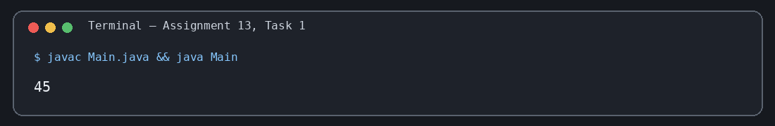
Assignment 13 – Task 1 | Output verified

Task 02
Source file: Main.java
/*
* Name: Akhilesh Gangwar
* Roll No: 2410303049
* Student ID: BCS2024022
* Email: akhilonix.in@gmail.com
* GitHub: akhilonix
* Course: BCS553 - Applied Data Structures & Algorithms Lab
* Assignment: 13
* Task: 2
*/
public class Main {
static int max(int[] a, int i) {
if (i == a.length - 1) return a[i];
return Math.max(a[i], max(a, i + 1));
}
public static void main(String[] args) {
int[] a = {3, 6, 9, 12, 15};
System.out.println(max(a, 0));
}
}
Actual program output
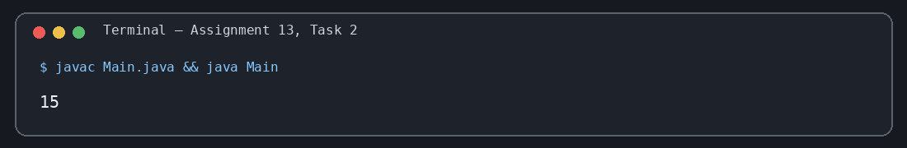
Assignment 13 – Task 2 | Output verified

Task 03
Source file: Main.java
/*
* Name: Akhilesh Gangwar
* Roll No: 2410303049
* Student ID: BCS2024022
* Email: akhilonix.in@gmail.com
* GitHub: akhilonix
* Course: BCS553 - Applied Data Structures & Algorithms Lab
* Assignment: 13
* Task: 3
*/
public class Main {
static void printReverse(int[] a, int i) {
if (i < 0) return;
System.out.println(a[i]);
printReverse(a, i - 1);
}
public static void main(String[] args) {
int[] a = {3, 6, 9, 12, 15};
printReverse(a, a.length - 1);
}
}
Actual program output
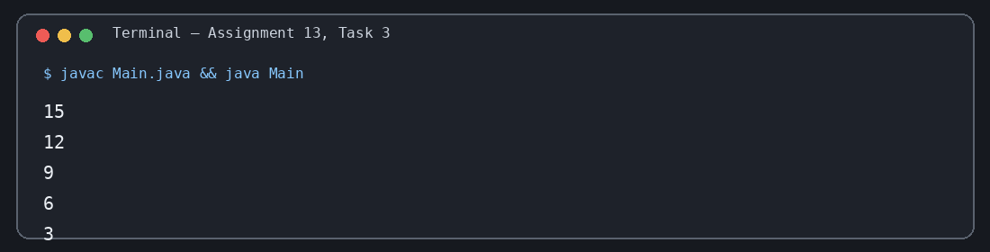
Assignment 13 – Task 3 | Output verified

ASSIGNMENT 14: Sorted Check, Search and Fibonacci

Task 01
Source file: Main.java
/*
* Name: Akhilesh Gangwar
* Roll No: 2410303049
* Student ID: BCS2024022
* Email: akhilonix.in@gmail.com
* GitHub: akhilonix
* Course: BCS553 - Applied Data Structures & Algorithms Lab
* Assignment: 14
* Task: 1
*/
public class Main {
static boolean isSorted(int[] a, int i) {
if (i >= a.length - 1) return true;
if (a[i] > a[i + 1]) return false;
return isSorted(a, i + 1);
}
public static void main(String[] args) {
int[] a = {2, 4, 6, 8, 10};
System.out.println(isSorted(a, 0));
}
}
Actual program output
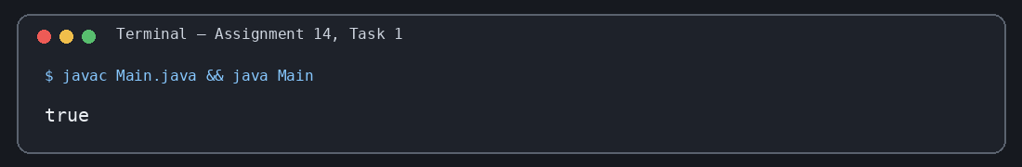
Assignment 14 – Task 1 | Output verified

Task 02
Source file: Main.java
/*
* Name: Akhilesh Gangwar
* Roll No: 2410303049
* Student ID: BCS2024022
* Email: akhilonix.in@gmail.com
* GitHub: akhilonix
* Course: BCS553 - Applied Data Structures & Algorithms Lab
* Assignment: 14
* Task: 2
*/
public class Main {
static int findIndex(int[] a, int key, int i) {
if (i == a.length) return -1;
if (a[i] == key) return i;
return findIndex(a, key, i + 1);
}
public static void main(String[] args) {
int[] a = {45, 67, 80, 52, 90};
System.out.println(findIndex(a, 80, 0));
}
}
Actual program output
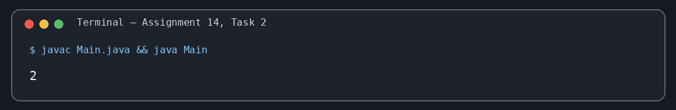
Assignment 14 – Task 2 | Output verified

Task 03
Source file: Main.java
/*
* Name: Akhilesh Gangwar
* Roll No: 2410303049
* Student ID: BCS2024022
* Email: akhilonix.in@gmail.com
* GitHub: akhilonix
* Course: BCS553 - Applied Data Structures & Algorithms Lab
* Assignment: 14
* Task: 3
*/
public class Main {
static int fib(int n) {
if (n == 0) return 0;
if (n == 1) return 1;
return fib(n - 1) + fib(n - 2);
}
public static void main(String[] args) {
System.out.println(fib(7));
}
}
Actual program output
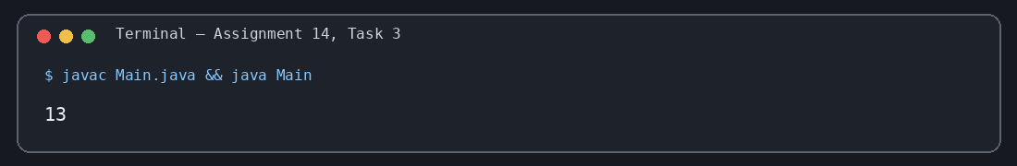
Assignment 14 – Task 3 | Output verified

ASSIGNMENT 15: Subsets and Arrangements

Task 01
Source file: Main.java
/*
* Name: Akhilesh Gangwar
* Roll No: 2410303049
* Student ID: BCS2024022
* Email: akhilonix.in@gmail.com
* GitHub: akhilonix
* Course: BCS553 - Applied Data Structures & Algorithms Lab
* Assignment: 15
* Task: 1
*/
public class Main {
static int[] a = {1, 2, 3};
static boolean[] chosen = new boolean[a.length];
static void subsets(int i) {
if (i == a.length) {
System.out.print("{");
boolean first = true;
for (int j = 0; j < a.length; j++) {
if (chosen[j]) {
if (!first) System.out.print(", ");
System.out.print(a[j]);
first = false;
}
}
System.out.println("}");
return;
}
chosen[i] = false;
subsets(i + 1);
chosen[i] = true;
subsets(i + 1);
}
public static void main(String[] args) { subsets(0); }
}
Actual program output
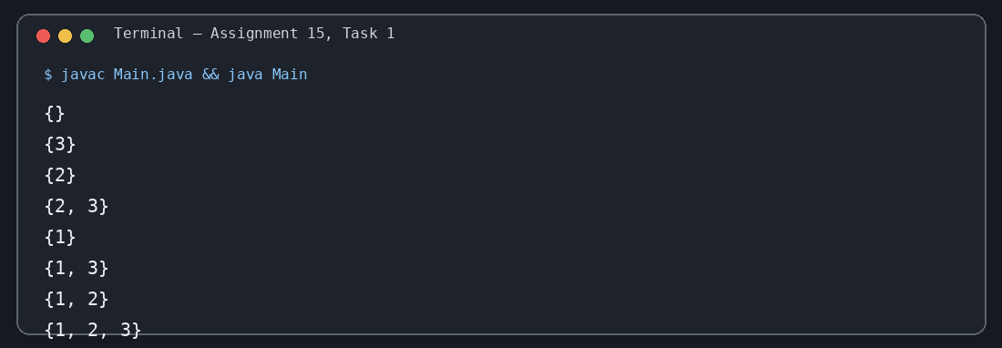
Assignment 15 – Task 1 | Output verified

Task 02
Source file: Main.java
/*
* Name: Akhilesh Gangwar
* Roll No: 2410303049
* Student ID: BCS2024022
* Email: akhilonix.in@gmail.com
* GitHub: akhilonix
* Course: BCS553 - Applied Data Structures & Algorithms Lab
* Assignment: 15
* Task: 2
*/
public class Main {
static char[] letters = {'a', 'b', 'c'};
static boolean[] used = new boolean[letters.length];
static char[] result = new char[letters.length];
static void arrange(int pos) {
if (pos == letters.length) {
System.out.println(new String(result));
return;
}
for (int i = 0; i < letters.length; i++) {
if (!used[i]) {
used[i] = true;
result[pos] = letters[i];
arrange(pos + 1);
used[i] = false;
}
}
}
public static void main(String[] args) { arrange(0); }
}
Actual program output
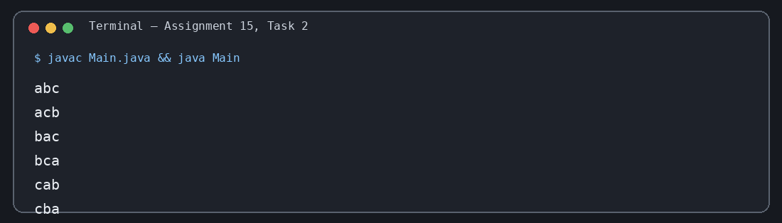
Assignment 15 – Task 2 | Output verified

Task 03
Source file: Main.java
/*
* Name: Akhilesh Gangwar
* Roll No: 2410303049
* Student ID: BCS2024022
* Email: akhilonix.in@gmail.com
* GitHub: akhilonix
* Course: BCS553 - Applied Data Structures & Algorithms Lab
* Assignment: 15
* Task: 3
*/
public class Main {
static char[] letters = {'x', 'y'};
static boolean[] used = new boolean[letters.length];
static char[] result = new char[letters.length];
static void arrange(int pos) {
if (pos == letters.length) {
System.out.println(new String(result));
return;
}
for (int i = 0; i < letters.length; i++) {
if (!used[i]) {
used[i] = true;
result[pos] = letters[i];
arrange(pos + 1);
used[i] = false;
}
}
}
public static void main(String[] args) { arrange(0); }
}
Actual program output
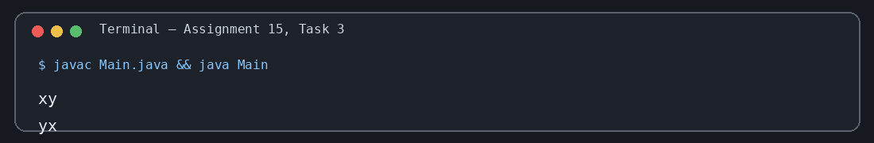
Assignment 15 – Task 3 | Output verified

