# Custom Application for Google Assistant (Smart Integration with Google mini/home)

**Goal**: Create Google Assistant agents which answer questionnaire based on the research document by an external source or google drive.

The API.AI Python SDK can be used to integrate speech recognition with API.AI natural language processing API. API.AI allows using voice commands and integration with dialog scenarios defined for an agent in API.AI. Google Actions using Machine Learning techniques to cross check the phrases using MAD LIB technique, a way of asking questions and fill in the blanks based on uses answers.

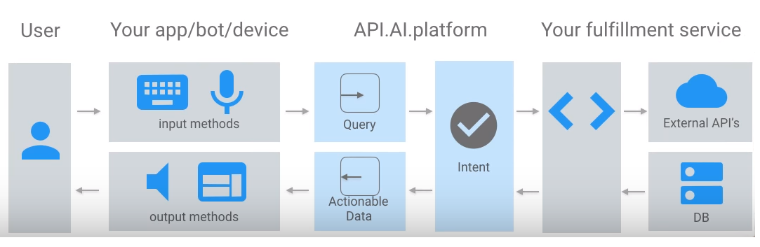

The apps or bots receives request which is analysed and segmented based on the Intent and fulfilment using Node JS or Python API creating response and understand context.

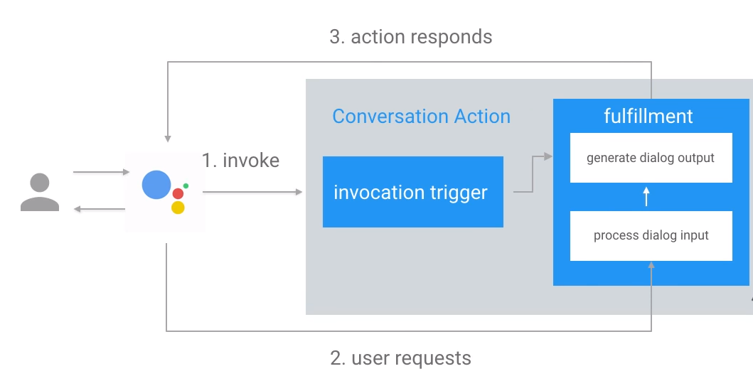

This explains the dialogflow and user interactions. Invocation trigger will trigger fulfilment which involves the processed dialog input to generate the output by processing the input which is sent to actions responder to the google assistant which is again returned to user as a response.

# sample.png­

Google Action Platform takes input from device which is passed to Server-Side App which is custom agent handling all the requests generating results as json content.

The simulation goes as follows:

**ME**: “Hey Google, talk to ‘Document Reader’”  
**Google**:” Okay Loading Document Reader”   
**Google (Agent):** “You are Talking to Document Reader. How can I help you?”  
**ME:** “Load the document XYZ from Google Drive”  
**Google (Agent):**” Loading the document from the drive, give me couple of minutes to go through the document”  
**Google (Agent):**” Done! Do you have a question in your mind? you can say ‘what is xyz? How is done?’ “  
**ME:** “What is XYZ?”

**Note:** Google Agent analyses the textual question using machine learning techniques to understand and transform to nearest possible question which suits the context and pull the information form the document. This is done using dialogflow. It mimics a game “MAD lib” which is a game of words, google assistant ask question in return to fill all the possible blanks and understand the context of the user to enhance the understanding of the question to generate appropriate answer.  
**Google (Agent):** “According to the document, XYZ is something which is generated using something and for a period it’s ……… a so on. Do you have any other question in your mind?”  
**ME:** “Yes”  
**Google (Agent):**” Go ahead and ask”  
**ME:”** why is it not ABC instead of XYZ”  
**Google (Agent):**” Sorry, I looked for that in the document. Couldn’t find it or it’s irrelevant “  
**ME:** “okay, bay bye”  
**Google (Agent):**” Closing the Document Reader”

**NOTE:** Once the bot goes off the track, google gets back the control.

The first step of the project is to create a successfully functional agent which can be moved further into other platforms such as slack and telegram. Soon, developing complex implementations and understanding. This can be published back into the community as a contribution from NIU Computer Science – Data Lab project which I verified by developers and published into all the devices across the world.

# References:

[1] **Python Integrations:**  https://github.com/dialogflow/fulfillment-webhook-translate-python, https://github.com/dialogflow/dialogflow-python-client-v2

[2] **Google API (dialog flow):** https://dialogflow.com/docs/integrations/google-assistant

[3] **Google Actions:** <https://developers.google.com/actions>