Pulse — Walkthrough and Test Guide
  - How to run it, where to click, and what you should see — with screenshots
17 October 2026

1. What this guide is
Pulse is a system that, on its own and every cycle, scores each customer account’s risk of cancelling or shrinking in the next 90 days, ranks the accounts a customer-success manager (CSM) should act on this week, shows why (down to the original source records), drafts a first message, and lets a human approve it. It runs for three simulated customer organisations (“workspaces”) with about 5,000 accounts and 350,000 events from five systems.
This guide walks you through every feature as the right person, one step at a time. Each test says what to do, what you should see, and what it means if you don’t. Screenshots show the real screens; a red outline marks what to click or look at.
Time needed: about two hours for everything. Parts A–E need only a browser. Part F (language-model drafting) needs a free local model that you install once.
Contents
Part | What you will test
2 | Before you start: who you sign in as, starting everything
A | Signing in and security: sessions, roles, one CSM versus another, workspace isolation
B | The weekly queue, browsing every account, history, evidence, “what moved”, your judgement, low confidence
C | Drafts and email: review, the safety gate, demo mode, opt-outs, the mail inbox
D | The autonomous agent: run log, declined decisions, unattended worker, automatic sending
E | Administration: users, ownership, audit trail, settings, coverage, model card
F | Language-model drafting with a free local model
G | Things that are true, so you are not surprised; reset; checklist; hosting
Words you will meet
Word | Meaning
Workspace | One customer organisation (tenant). Data of one workspace is never visible in another.
Operator | An administrator of a workspace: sees every account, has the Admin page, can approve any draft.
CSM | A customer-success manager: sees only the accounts they own.
Risk | Probability (calibrated) that the account cancels or shrinks within 90 days.
Value at risk | Annual contract value × risk. Big accounts matter more.
Queue | The short, ordered list for this week, sized to the team’s weekly capacity (12).
Driver | Why an account is flagged: Usage decline, Support experience, Relationship engagement, Payment friction, Commercial signals, or Data quality.
Evidence | The real source records (billing, support tickets, product usage…) behind a driver.
Low confidence | An account the system refuses to score because evidence is thin. Never shown as healthy.
Draft | A first message the agent prepared. A human reviews it; nothing is sent without the safety checks passing.
Demo mode | The default. Mail goes only to a test inbox (or is captured, delivering nothing).

2. Before you start

2.1 Who you sign in as
The sign-in asks for Workspace, Email and Password. Every demo user shares one password. It is stored in the file .demo-credentials.pulse at the top of the project folder (the VS Code task Pulse: show demo sign-ins prints it).
Role | Workspace | Email | What they can do
Operator (Dana Okafor) | northwind | csm00@northwind.example.com | Whole workspace, Admin page, approve any draft
CSM (Priya Rossi) | northwind | csm01@northwind.example.com | Only the accounts they own; no Admin page
Operator | globex | csm00@globex.example.com | A different organisation (1,700 accounts)
Operator | initech | csm00@initech.example.com | The smallest organisation (500 accounts)
Use two browser windows where a test says “second window”: one normal and one private (incognito), so the two sessions do not share a login.

2.2 Start everything
- In VS Code press Cmd+Shift+P (the Command Palette), type Tasks: Run Task and press Enter. (Or use the menu Terminal ▸ Run Task….)
- Run Pulse: 1. start Postgres. It prints postgres already running if the database is already up.
- Run Pulse: 3b. run the demo with local mail (Mailpit + API + UI). It opens three terminal panels: the mail inbox, the API and the web app.
- Wait about ten seconds until you see Uvicorn running on http://127.0.0.1:8000 and Local: http://localhost:5173/.
- Open http://localhost:5173 for the app and http://localhost:8025 for the mail inbox (keep both open in tabs).
If a panel says “Address already in use”, an older copy is still running. Close the old Pulse: terminal panels (trash icon), then run the task once. Do not also run task 3 at the same time as 3b.

2.3 History for the week picker
The demo database already holds 9 weekly snapshots (17 August to 12 October 2026). If you rebuild the database, add history again once (about 12 minutes):
cd backend && source .venv/bin/activate && PGTZ=UTC python3 -m pulse.cli backfill --weeks 8

2.4 How to read the tests
✅ means what you should see. ❌ means what it means if you do not. ✏️ marks a test that changes data in the demo database (the Reset section at the end undoes everything). 🧪 marks a test that should be run on a scratch copy (recipe in section D.5).

Part A — Signing in and security

A1 · Sign in
Why it matters: nothing may be visible without a real session.
- Open http://localhost:5173 in a private window.
- ✅ You see only Sign in to Pulse with three fields. No account data is visible.
- Enter workspace northwind, email csm00@northwind.example.com and the password, then click Sign in.
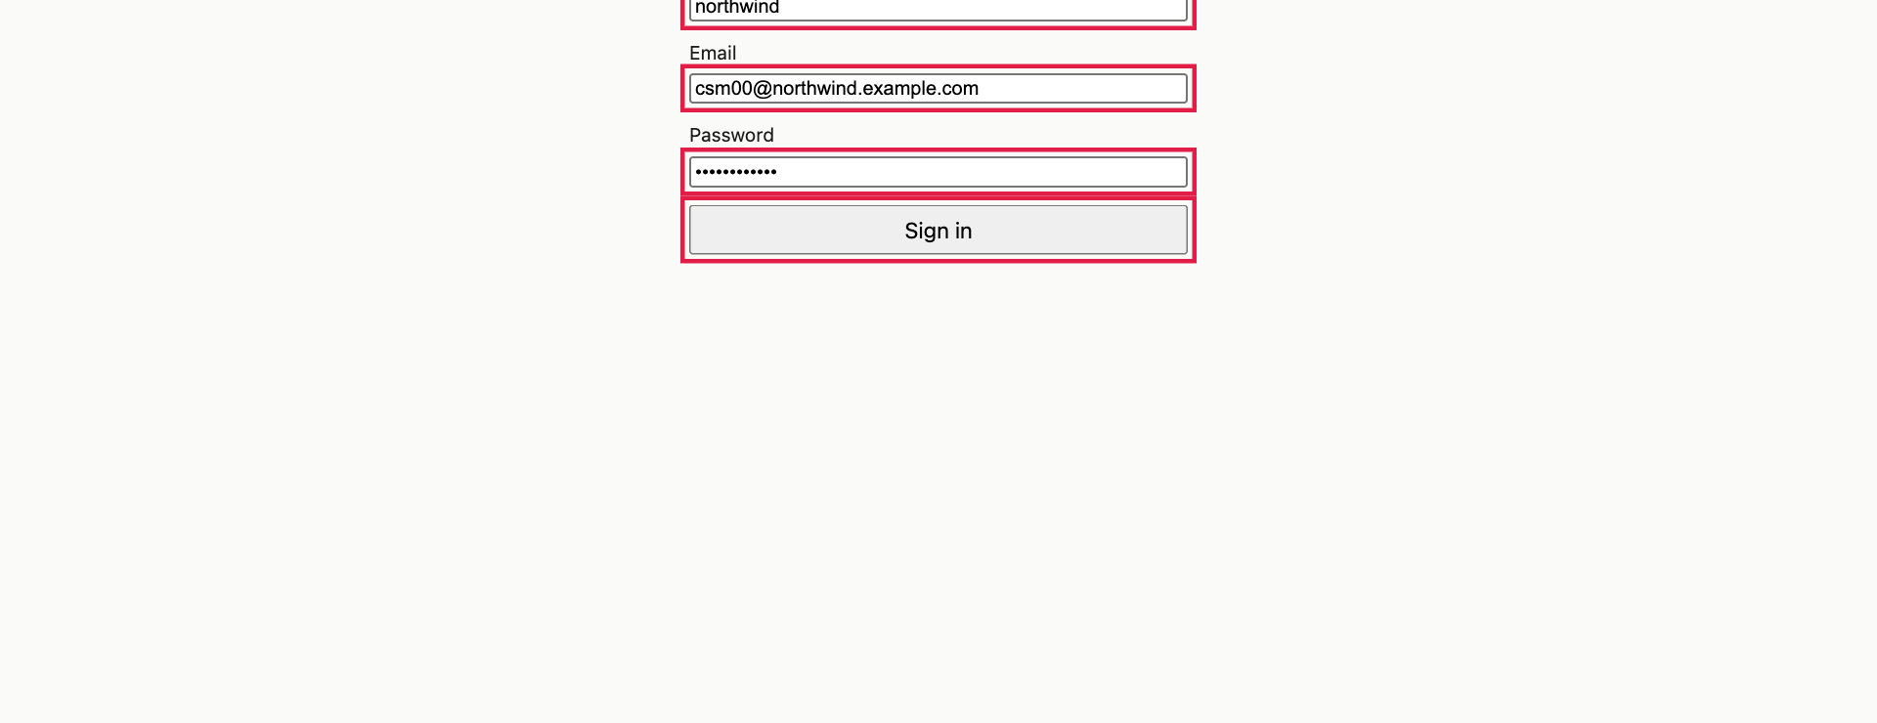
The sign-in screen. Red boxes mark the three fields and the button.
- ✅ The top bar shows Dana Okafor · operator · northwind and the menu: Queue · Low confidence · Drafts · Run log · Admin.
The top bar for an operator. The Admin link only exists for operators.

A2 · A wrong password gives one generic message
- Sign out (top right). Try a wrong password.
- ✅ A red invalid credentials. Try a wrong workspace (nowhere) and a wrong email: ✅ exactly the same message, so an attacker cannot learn which part was wrong.

A3 · Pages are protected when signed out
- While signed out, open http://localhost:5173/drafts, /admin and /runs. ✅ Each shows the sign-in form, never data.
- Open http://localhost:8000/queue. ✅ An error (401), not data.

A4 · Login rate limiting ✏️ (locks one login for five minutes)
Why it matters: stops password guessing and spraying.
- Sign out. Enter the wrong password five times for csm01@northwind.example.com.
- ✅ On the sixth try, even with the right password, you get too many attempts; try again later.
- Wait five minutes (or restart the API); ✅ it works again.

A5 · Signing out really ends the session
- Signed in, open the app in two tabs. In tab 1 click Sign out.
- In tab 2 click Queue. ✅ You are asked to sign in: the session is dead on the server, not just hidden.

A6 · A CSM sees only their own accounts
Why it matters: a real organisation has many CSMs; none may see another’s book. The server enforces this, not just the screen.
- Window 1: sign in as the operator. Open Queue and note the line 2254 more accounts below the weekly capacity cut.
- Window 2 (private): sign in as csm01@northwind.example.com.
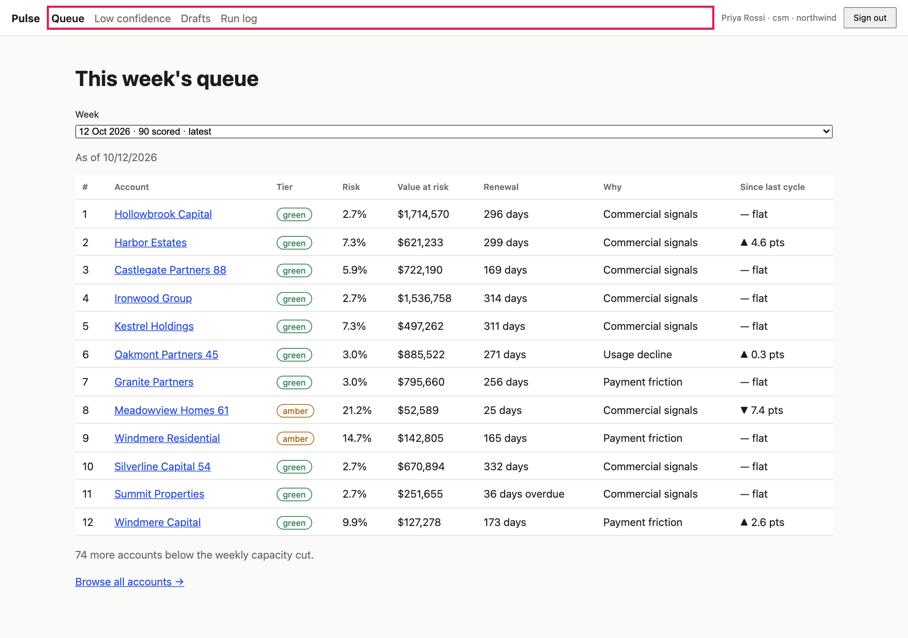
A CSM’s queue. There is no Admin link and the list is that CSM’s own accounts only.
- ✅ No Admin link, and the queue and “below the cut” number are much smaller.
- In window 2 open http://localhost:5173/admin. ✅ This page is for operators.

A CSM who types the Admin address is refused.
- Copy an account link from the operator’s queue that is not in the CSM’s list and paste it in window 2. ✅ Not found. (The server answers “not found”, which does not even confirm the account exists.)

A7 · The server refuses the Admin API, not just the screen
In a terminal (replace PASSWORD):
curl -s -c /tmp/csm.txt -X POST localhost:8000/auth/login -H 'Content-Type: application/json' \
-d '{"workspace":"northwind","email":"csm01@northwind.example.com","password":"PASSWORD"}'
curl -s -b /tmp/csm.txt localhost:8000/admin/outbound
✅ The first call returns the CSM’s profile. The second returns 403.

A8 · One workspace cannot see another
Sign in as the globex operator (csm00@globex.example.com). ✅ Different accounts and a different queue size. A northwind account link pasted here is not found.

Part B — The queue, the evidence and your judgement

B1 · The weekly queue
Sign in as the northwind operator and open Queue.
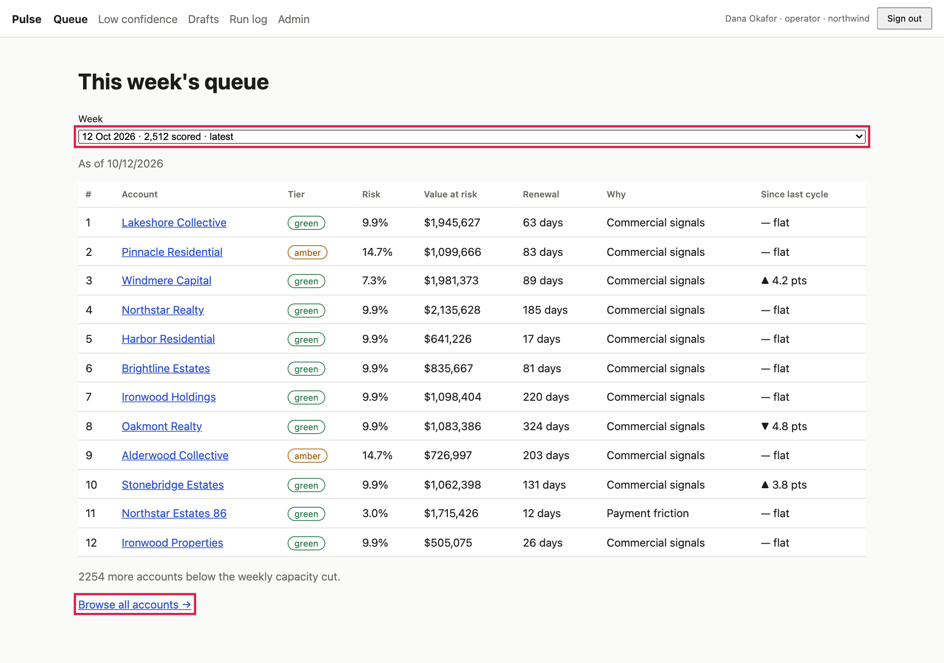
The weekly queue. The red boxes mark the Week picker and the Browse all link.
- ✅ This week’s queue with a Week dropdown and As of date.
- ✅ A table of 12 rows (the weekly capacity) with #, Account, Tier, Risk, Value at risk, Renewal, Why, Since last cycle.
- ✅ Why is one of the six drivers.
- ✅ Under the table: 2254 more accounts below the weekly capacity cut and Browse all accounts →.
Do not be surprised that many of the top 12 are green or amber. The order is risk × value at risk × urgency, so a very large account renewing soon can outrank a riskier small one. Only a handful of accounts (about 7) clear the red threshold at all. Risk on its own is therefore not sorted descending: that is intentional.

B2 · The week picker and history
- Open the Week dropdown. ✅ Nine weeks, newest first, the first marked latest, each with how many accounts were scored.
- Pick an earlier week.
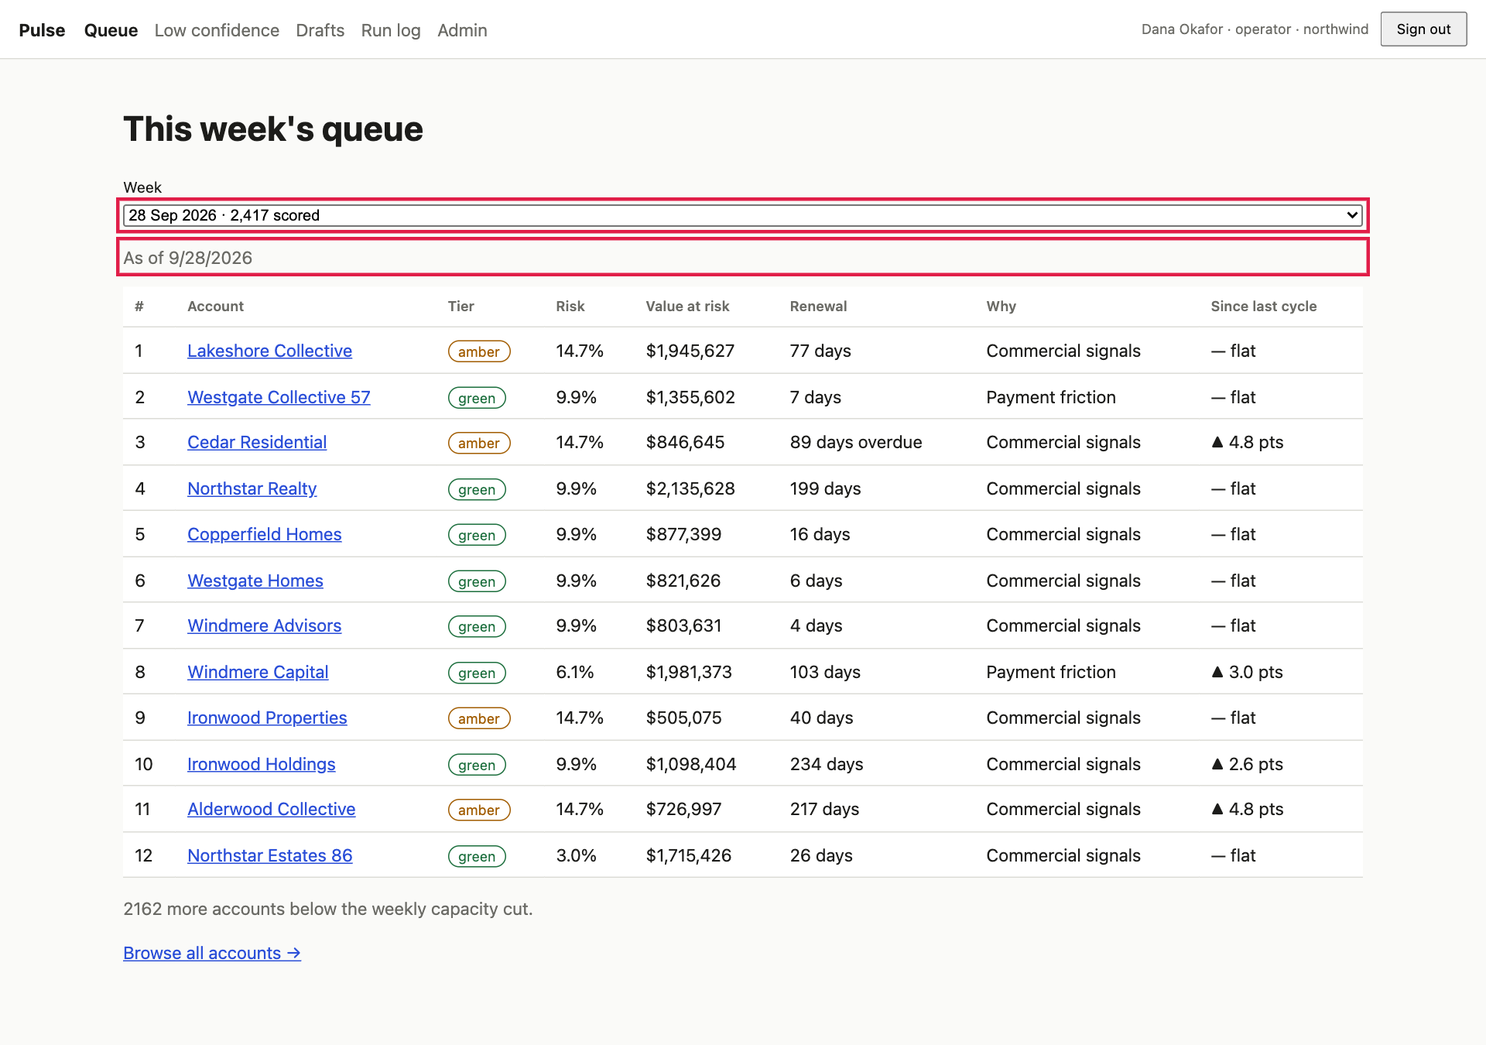
An earlier week selected. The date and the rows change and the address gains ?as_of=…, so the view can be shared as a link.
- ✅ As of changes and the table reloads. The Since last cycle column shows ▲ / ▼ N pts against the week before, and — flat where nothing moved. For the oldest week it reads new (nothing before it).
- Choose latest again; ✅ the ?as_of disappears.

B3 · Browse every account (below the cut)
- Click Browse all accounts →.
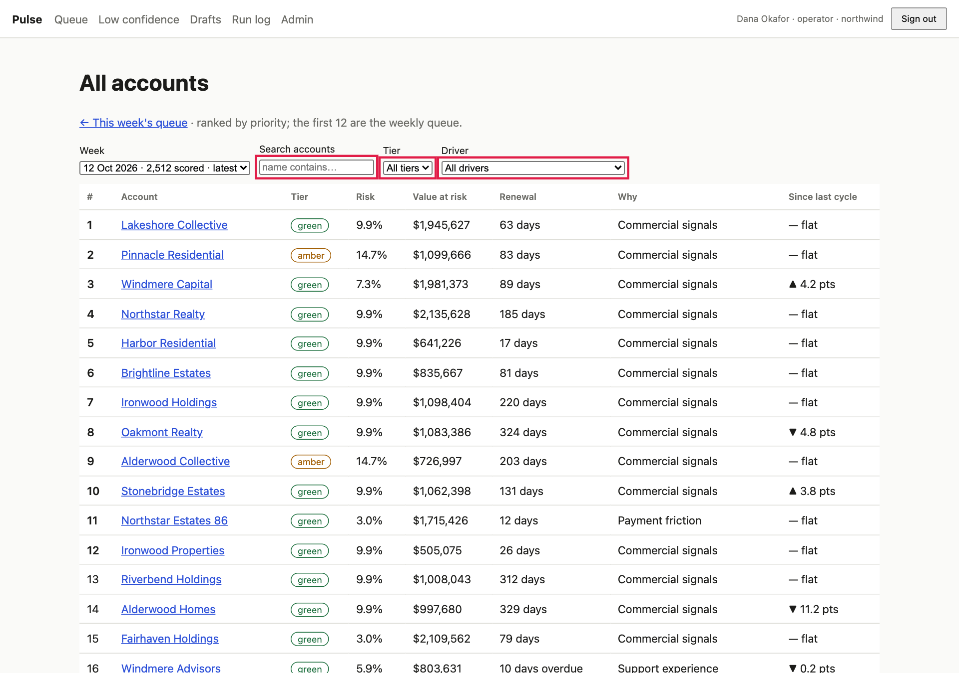
All accounts. Red boxes mark the search box, the Tier and Driver filters and the Next button. Row numbers are the true rank; the first 12 are this week’s queue.
- ✅ A table of 50 rows with a Showing 1–50 of 2,512 line. Ranks start at 1; the first 12 (the weekly queue) are in bold.
- Click Next. ✅ Showing 51–100, and the first row is 51: ranks continue, they do not restart.
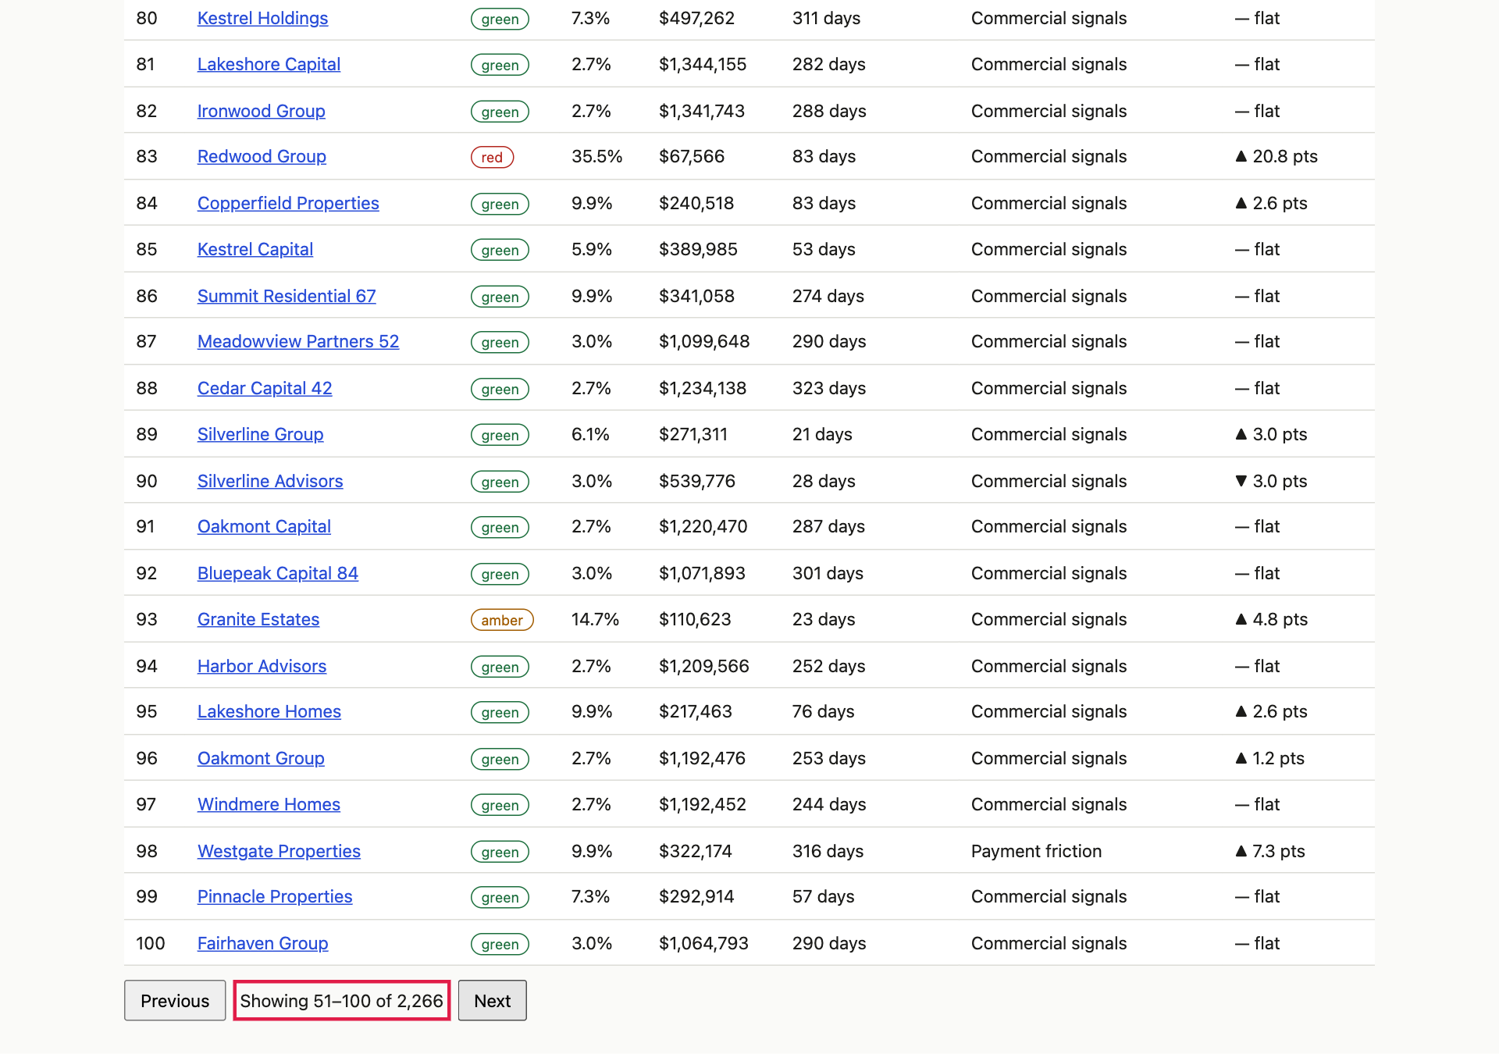
Page 2. Rank 51 onwards.
- Search: type part of a name. ✅ The list narrows after a moment and every name contains your text.
- Filter: choose Tier = red and Driver = Payment friction.
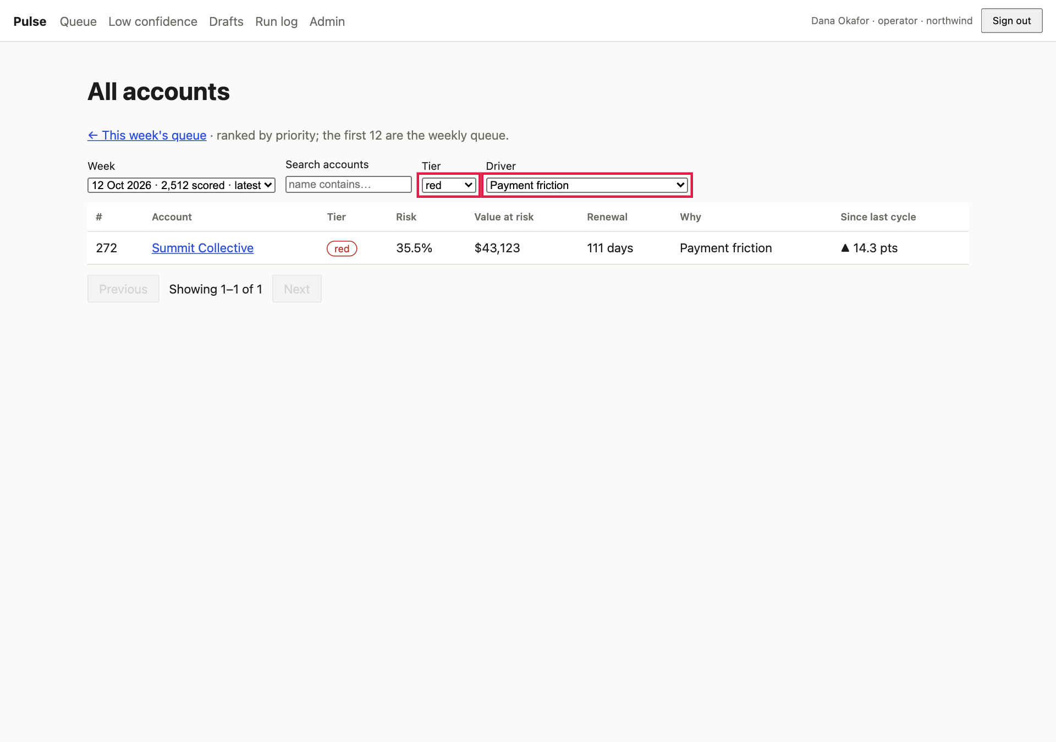
Filters combined. Only red accounts whose main driver is Payment friction remain.
- ✅ Only matching rows. Search for nonsense such as zzzzqq: ✅ No accounts match.
- Change the Week here: ✅ the list changes, and ← This week’s queue returns you to the same week.

B4 · The account page: why is it flagged?
Open any account from the queue.
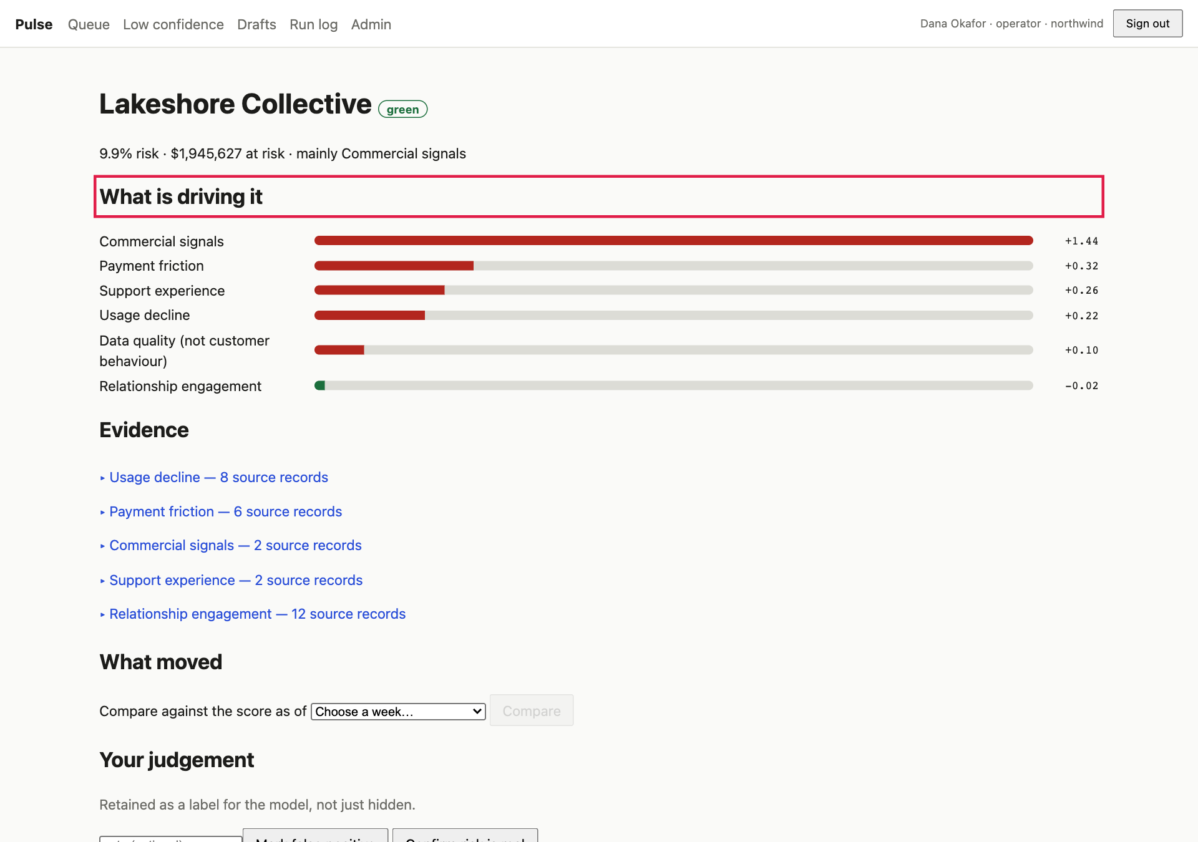
The account page. The drivers show what pushes the score up.
- ✅ A header with the account name and tier, then one line such as 9.9% risk · $1,945,627 at risk · mainly Commercial signals.
- ✅ What is driving it: bars for the six drivers.
- ✅ Evidence: one line per driver. Click one, then click a record.
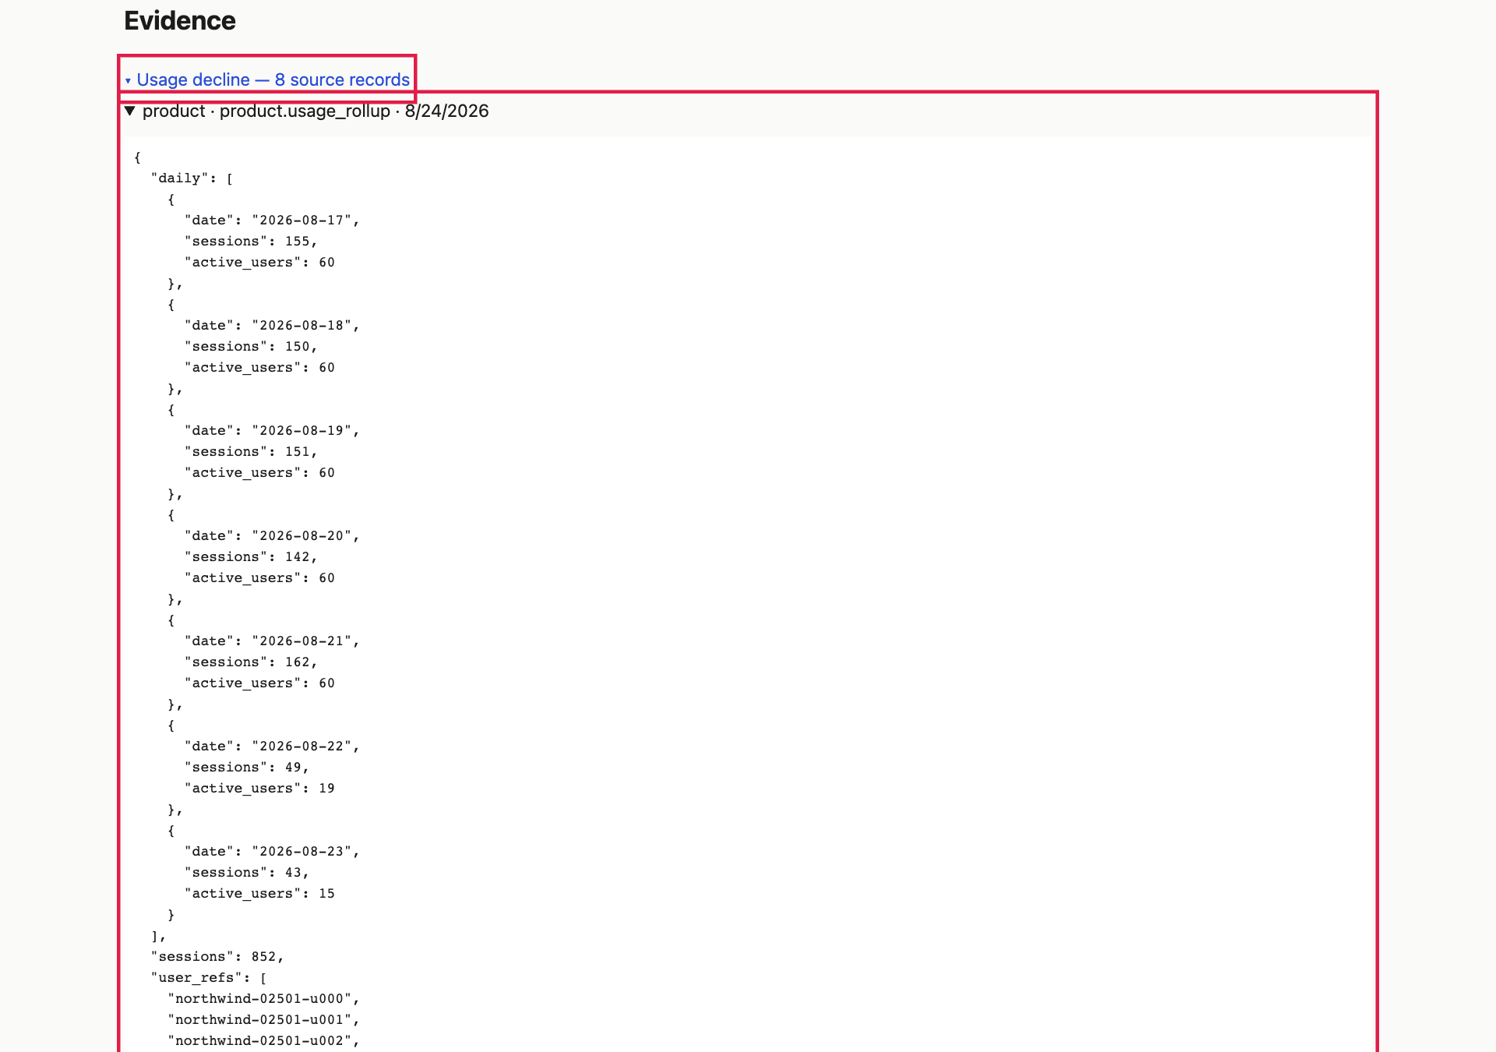
Evidence expanded. Each line is a real source record; opening one shows the original data as received.
- ✅ Feature values (collapsed near the bottom) lists about 38 measurements. Where a source has no data it says absent. Absent is deliberately not zero.

B5 · “What moved”: compare two weeks
- On the account page find What moved. In Compare against the score as of, choose an earlier week and click Compare.
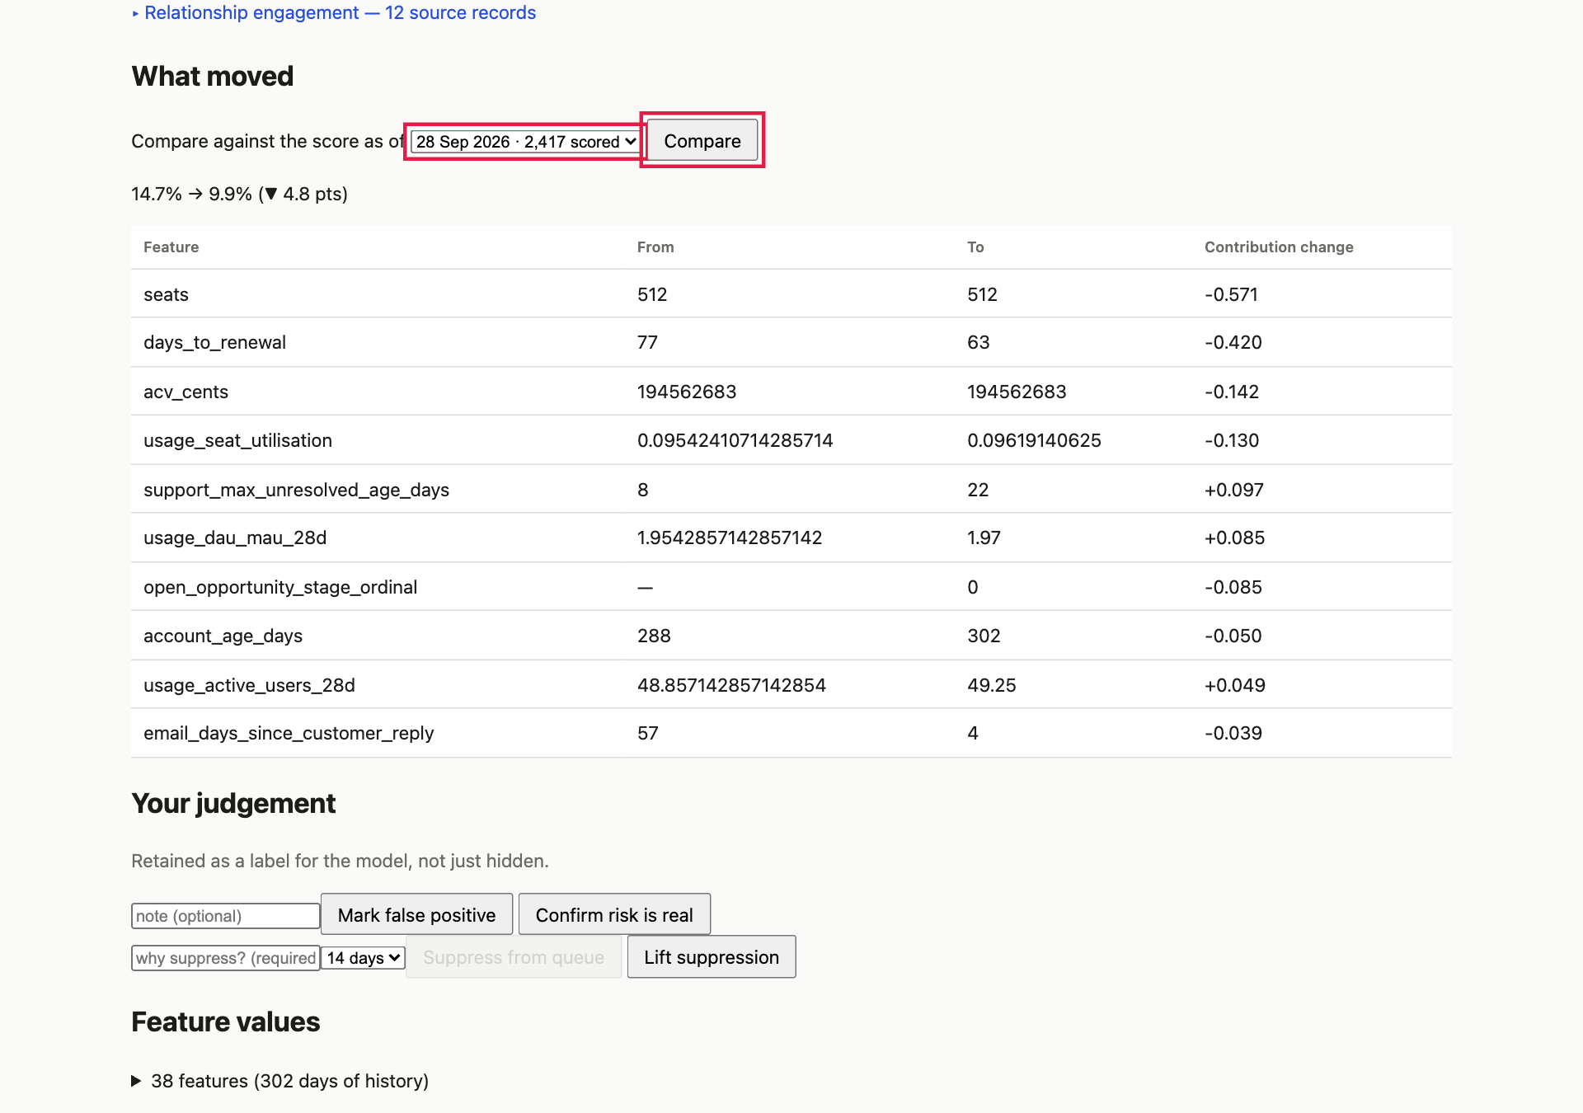
What moved. The line shows the risk before and after; the table shows which measurements changed it most.
- ✅ A line such as 14.7% → 9.9% (▼ 4.8 pts) and a table Feature · From · To · Contribution change, biggest change first. This answers “why did it move” without a data request.
- If the account did not exist in that week, you get a clear message in place of a table, not a crash.

B6 · Your judgement: confirm, false positive, suppress ✏️
On the account page, scroll to Your judgement.
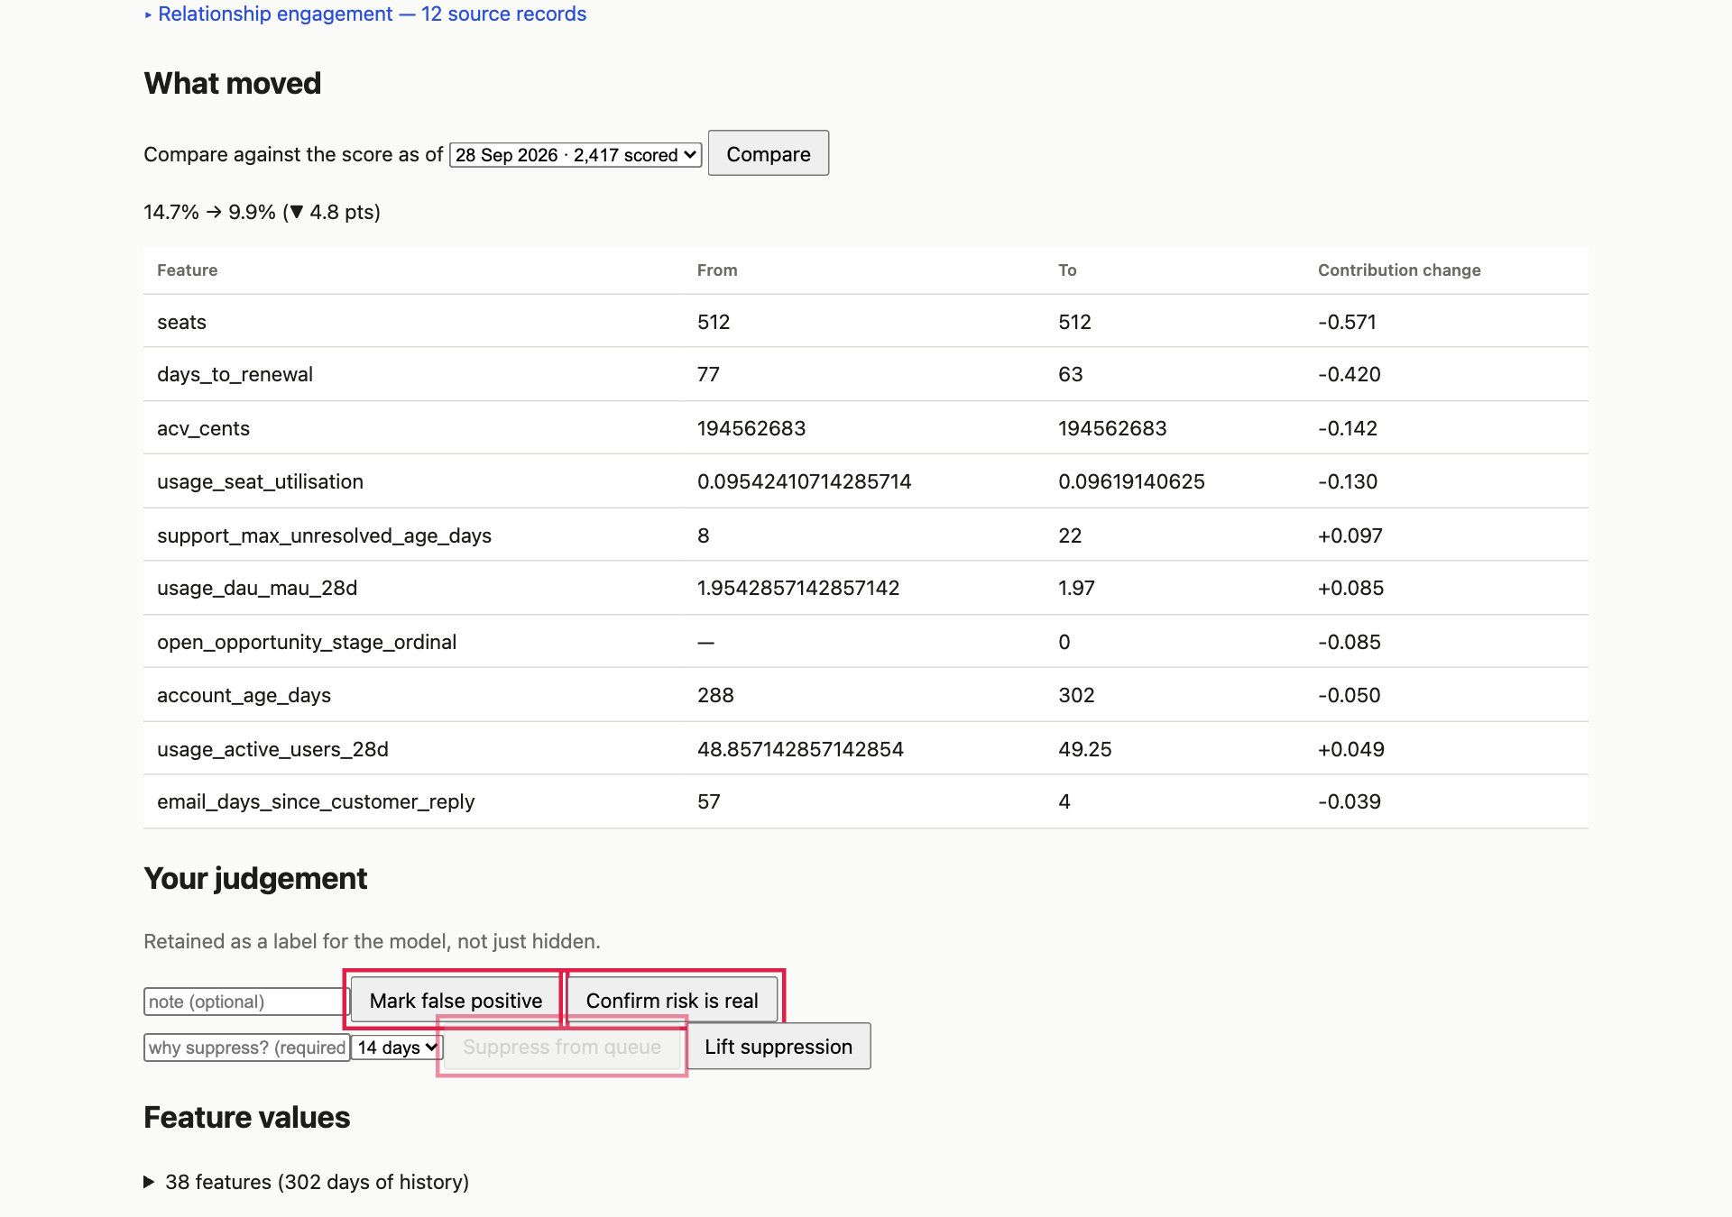
Confirm risk is real, Mark false positive, and Suppress from queue.
- Type a note, then Confirm risk is real. ✅ “Recorded as a true positive.” Try Mark false positive: ✅ “Marked as a false positive.” Both are kept as labels the model can learn from.
- Suppress: the button stays disabled until you give a reason. Enter one, choose 14 days, click Suppress from queue. ✅ “Suppressed from the queue for 14 days; still scored.”
- Go to Queue. ✅ That account is gone from the top 12 and from Browse all, but it is still scored.
- Return and click Lift suppression. ✅ It comes back.
- As the CSM, repeat on one of their accounts (✅ works) and on another’s (✅ not found).

B7 · Low confidence: never shown as healthy
- Open Low confidence.
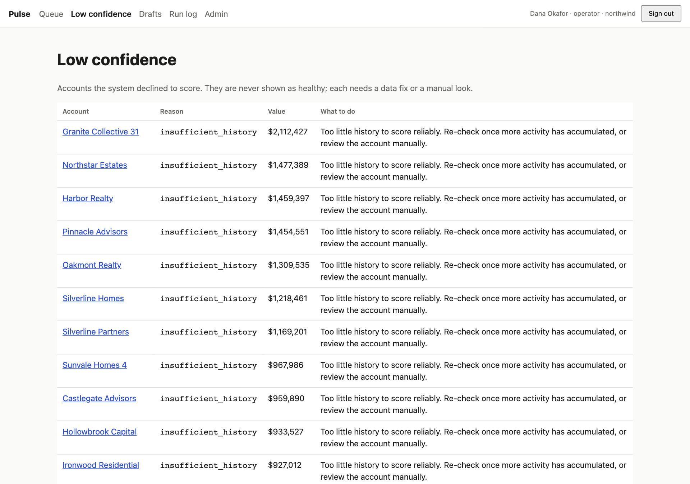
Accounts the system declined to score, each with a reason and what to do about it.
- ✅ A table of accounts with a Reason (for example too little history or too few data sources) and a plain What to do.
- Open one. ✅ It says Not scored … This is missing evidence, not a clean bill of health, with no green badge. None of these appear in the Queue or Browse all.

Part C — Drafts and email
The idea. The agent prepares a first message for each flagged account. A human reviews and approves it. Whether it is really sent depends on a safety gate: outbound switched on, a verified sender, a mail provider, a known customer contact, and no opt-out. In demo mode (the default) mail goes only to a test inbox. Test this hard: it is the system’s safety net.

C1 · Review a draft
Operator → Drafts.
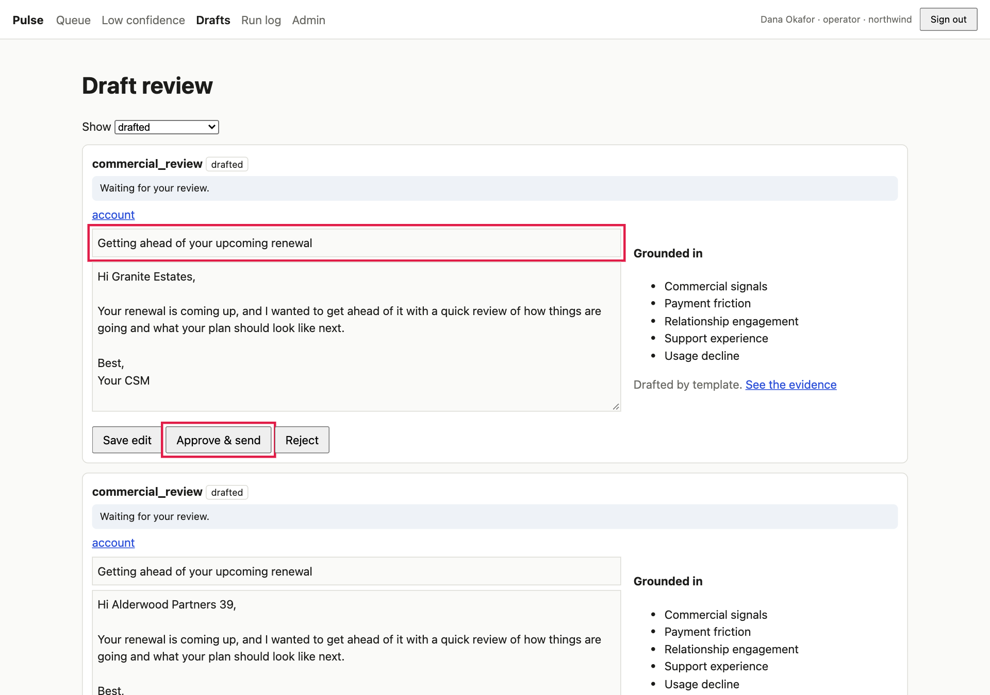
A draft. Left: subject and body (editable until it is approved). Right: “Grounded in”, the evidence the message was built from.
- ✅ Each card shows the play name (for example commercial_review), a state, and Waiting for your review.
- ✅ Grounded in lists the drivers behind the message and Drafted by template (or the model’s name once Part F is on). The body mentions only facts the system derived.

C2 · Edit a draft ✏️
Change the subject and a sentence, then Save edit. ✅ Reload: your edit stays and the state is still drafted.

C3 · With outbound off, approving is blocked and says why ✏️
- With outbound still off (a fresh install), click Approve & send.
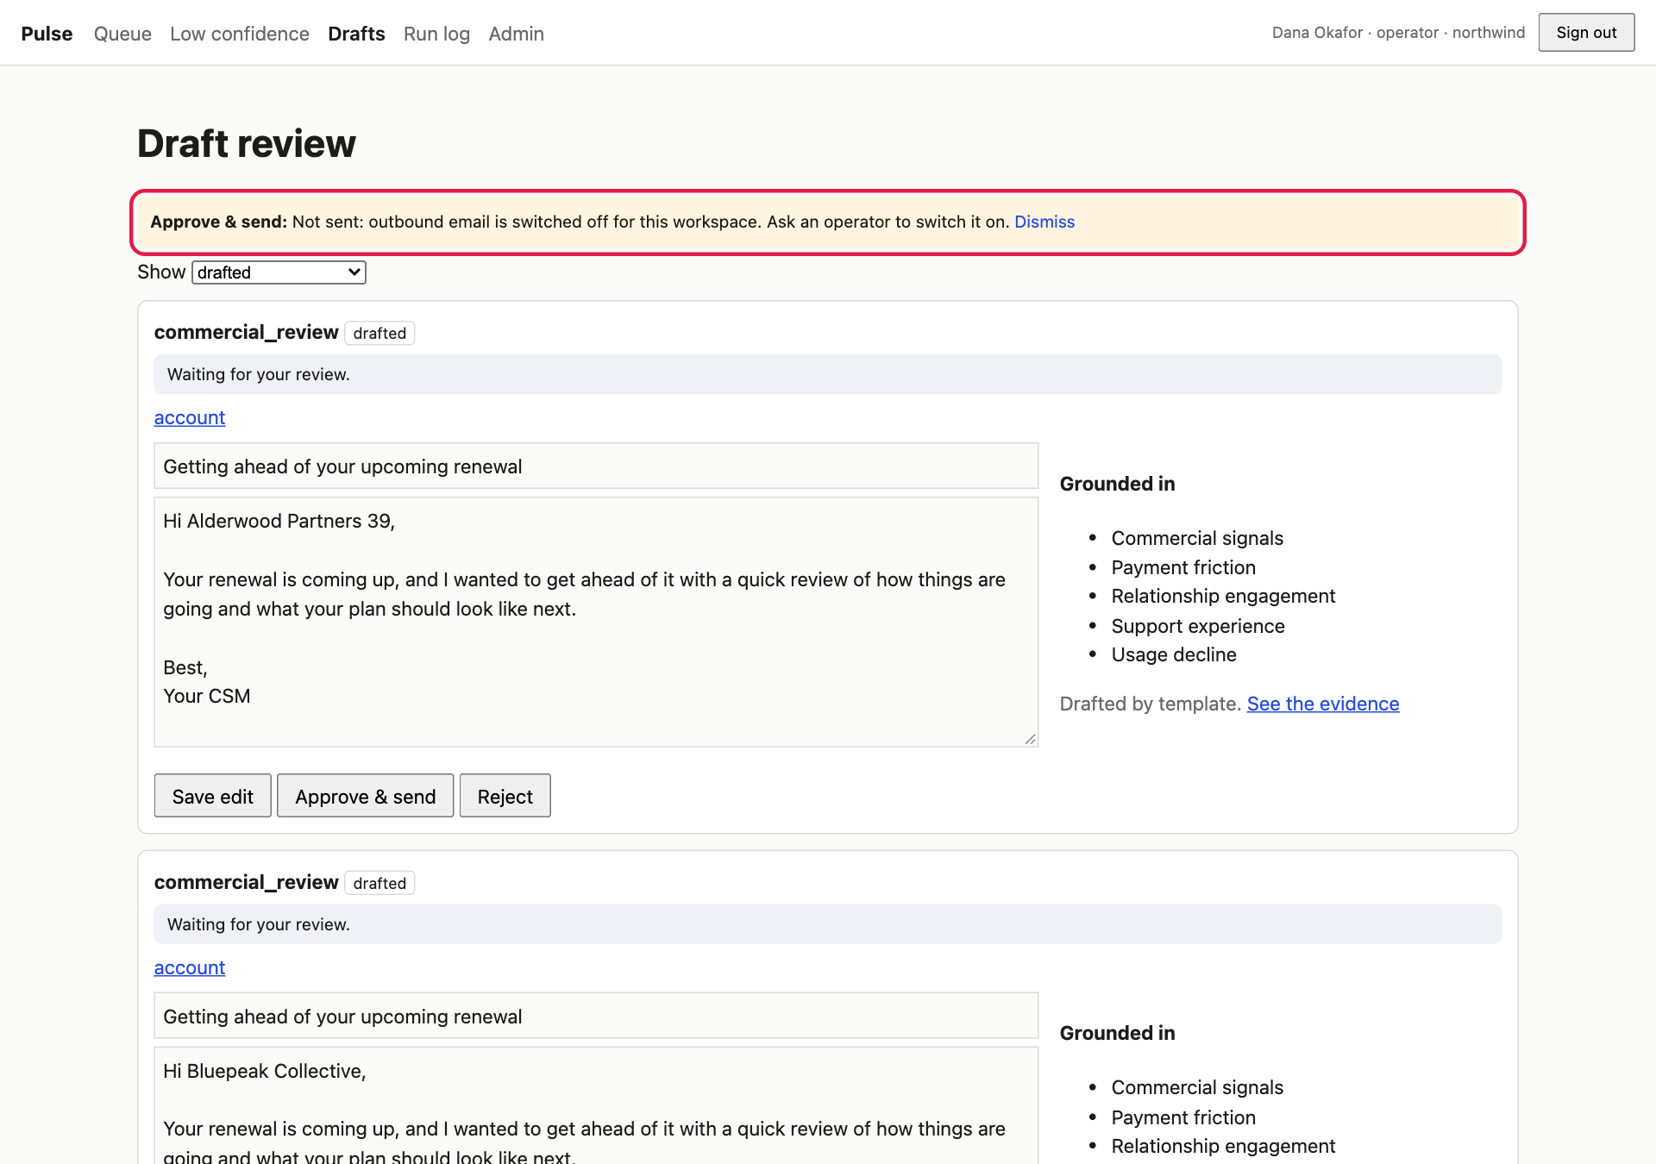
Immediately after the click, a banner explains the outcome. The draft leaves the “drafted” list because it has moved to a new state.
- ✅ A banner: Not sent: outbound email is switched off for this workspace. Ask an operator to switch it on. The mail inbox (http://localhost:8025) stays empty.
- The draft now has the state outbound_disabled. Choose that in the Show filter to find it; ✅ it can still be approved later (it definitely did not leave).

C4 · Switch outbound on (Admin) ✏️
Operator → Admin → Outbound email.
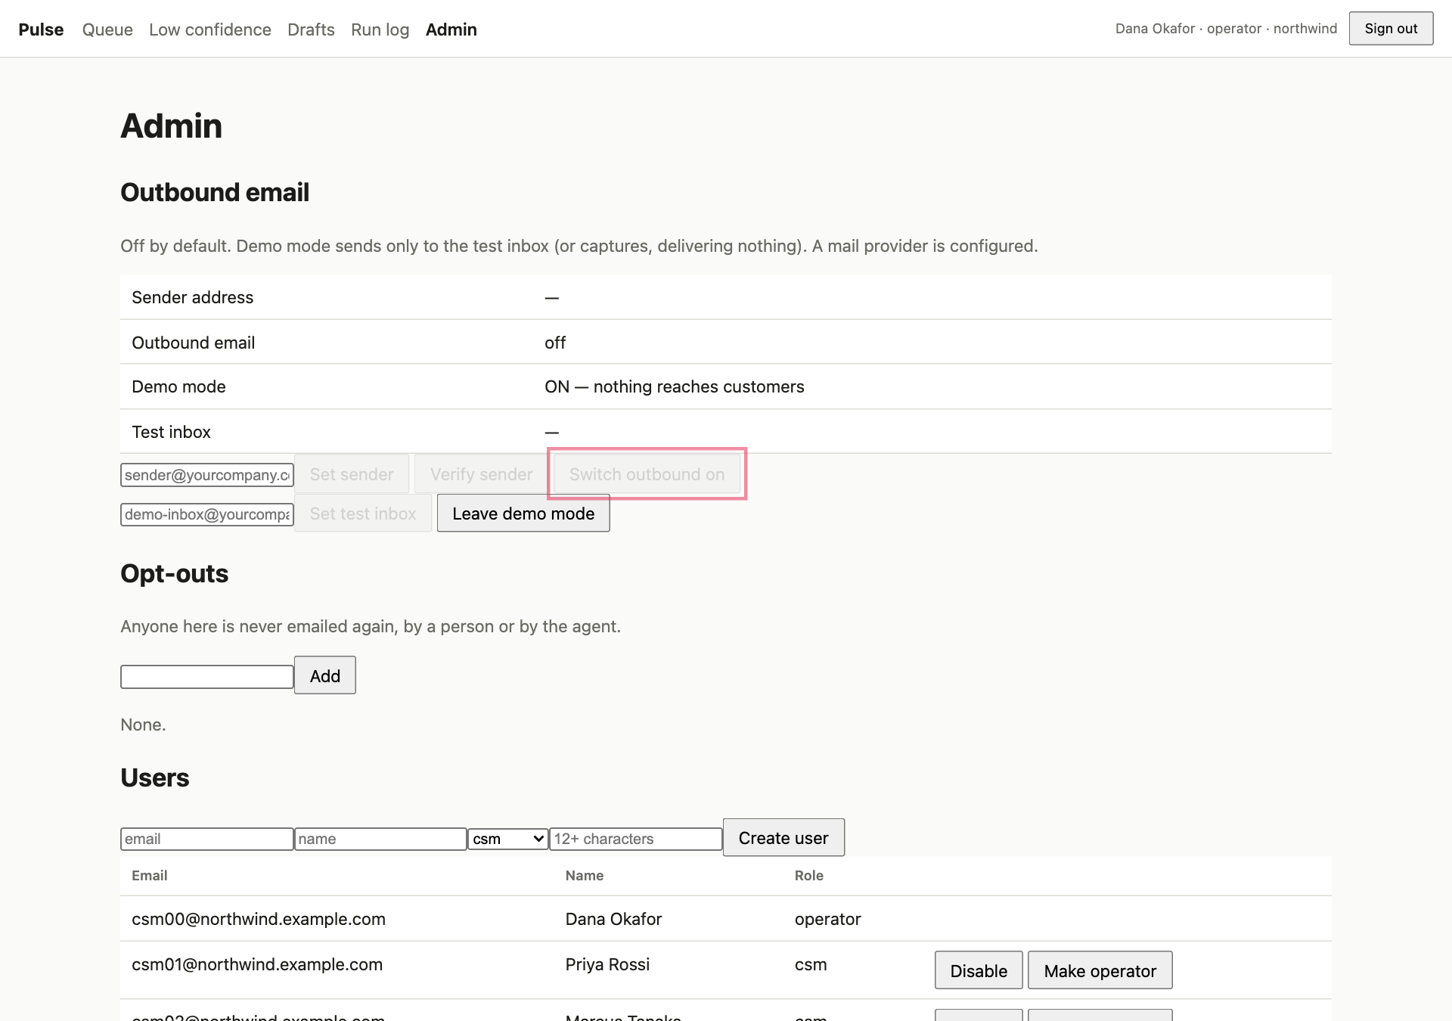
Before: no sender, outbound off, demo mode on. The Switch outbound on button is greyed out.
- ✅ Switch outbound on and Verify sender are disabled. You cannot enable sending before a verified sender exists.
- Enter csm@northwind.example.com under Sender address and click Set sender (✅ shows “not verified”), then Verify sender (✅ “✓ verified”), then Switch outbound on (✅ ON).
- Enter demo-inbox@northwind.example.com under Test inbox and click Set test inbox.
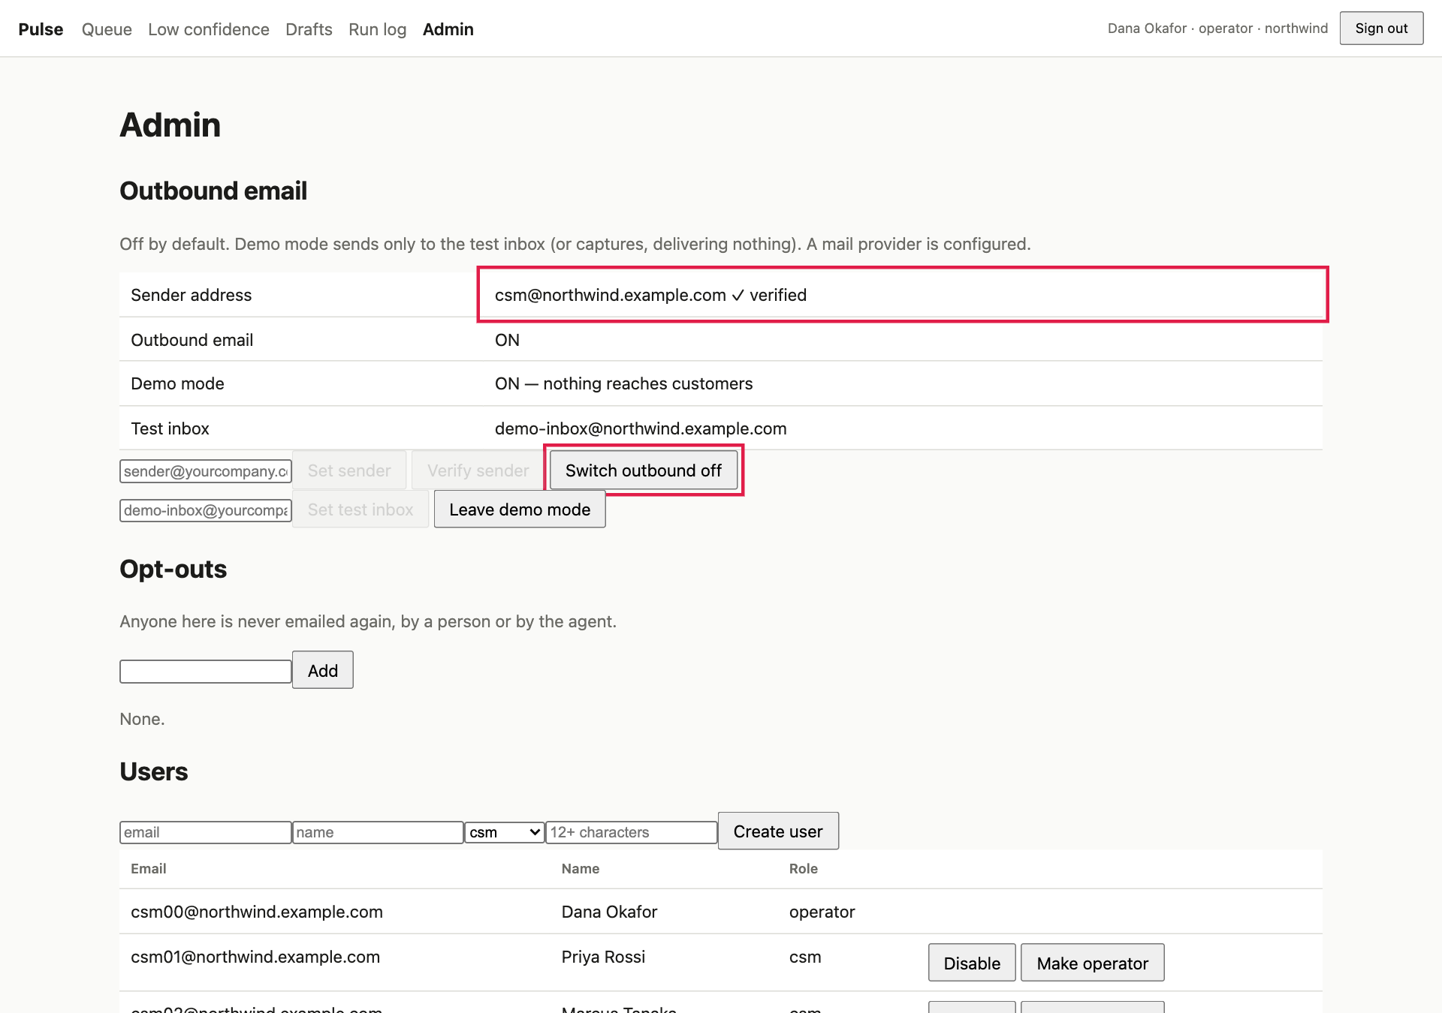
After: sender verified, outbound ON, demo mode ON — “nothing reaches customers”, and a test inbox.
- Change the sender address again. ✅ Verification is revoked and outbound switches off (a new address must be re-verified).

C5 · Approve in demo mode: the email lands in the inbox ✏️
- Redo C4.2–C4.3 if you changed the sender. Drafts → pick a draft (or filter outbound_disabled) → Approve & send.
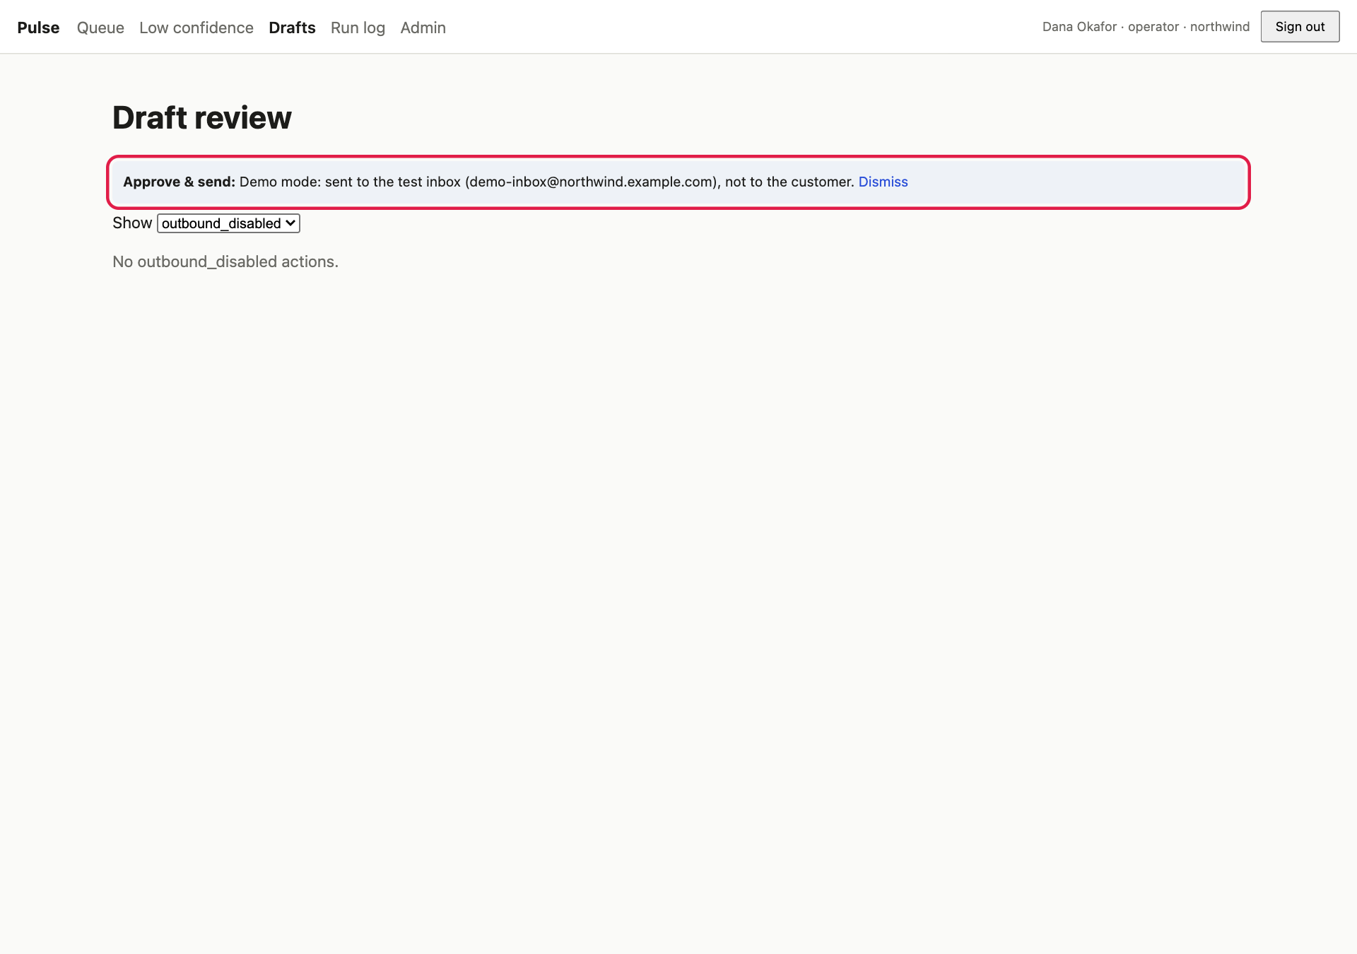
The banner now says the message went to the test inbox, not to the customer.
- ✅ Demo mode: sent to the test inbox (demo-inbox@northwind.example.com), not to the customer.
- Switch to the mail inbox tab (http://localhost:8025).
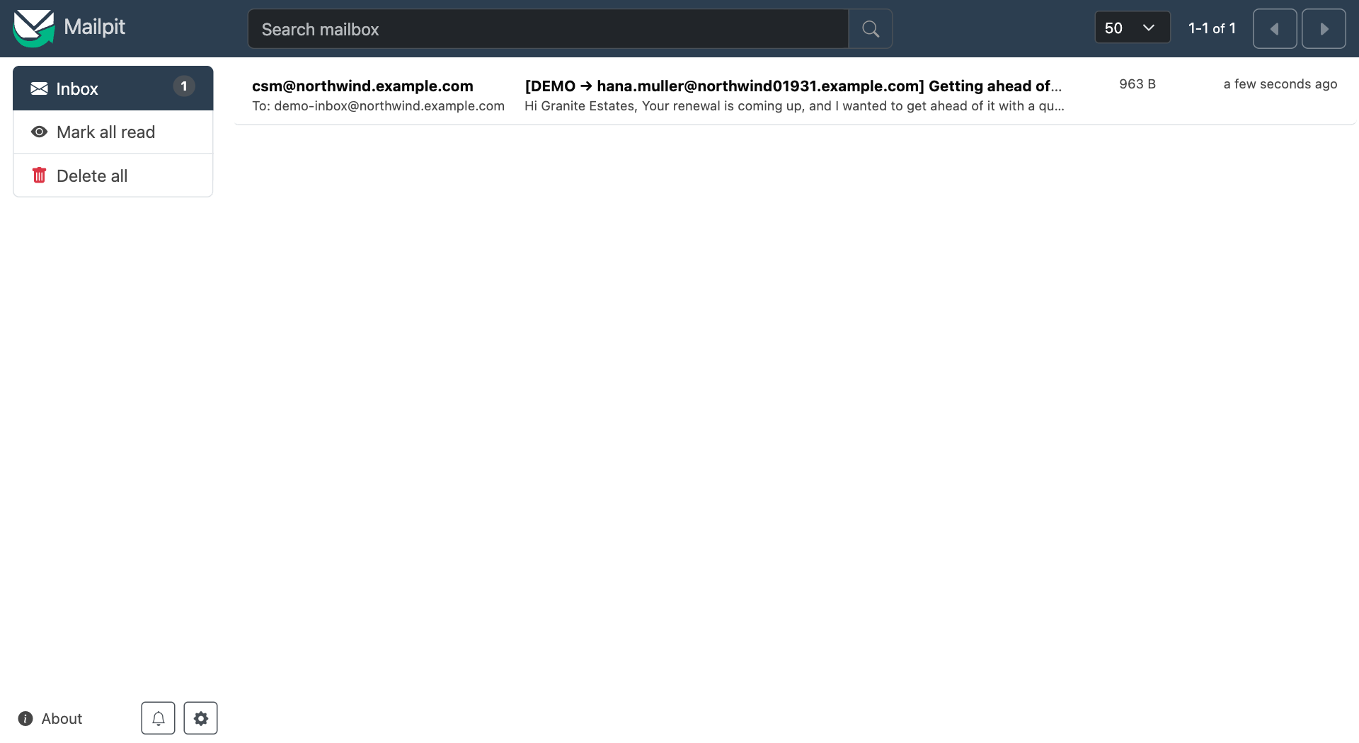
The inbox. The message went to the test address; the subject names who it would really have gone to.
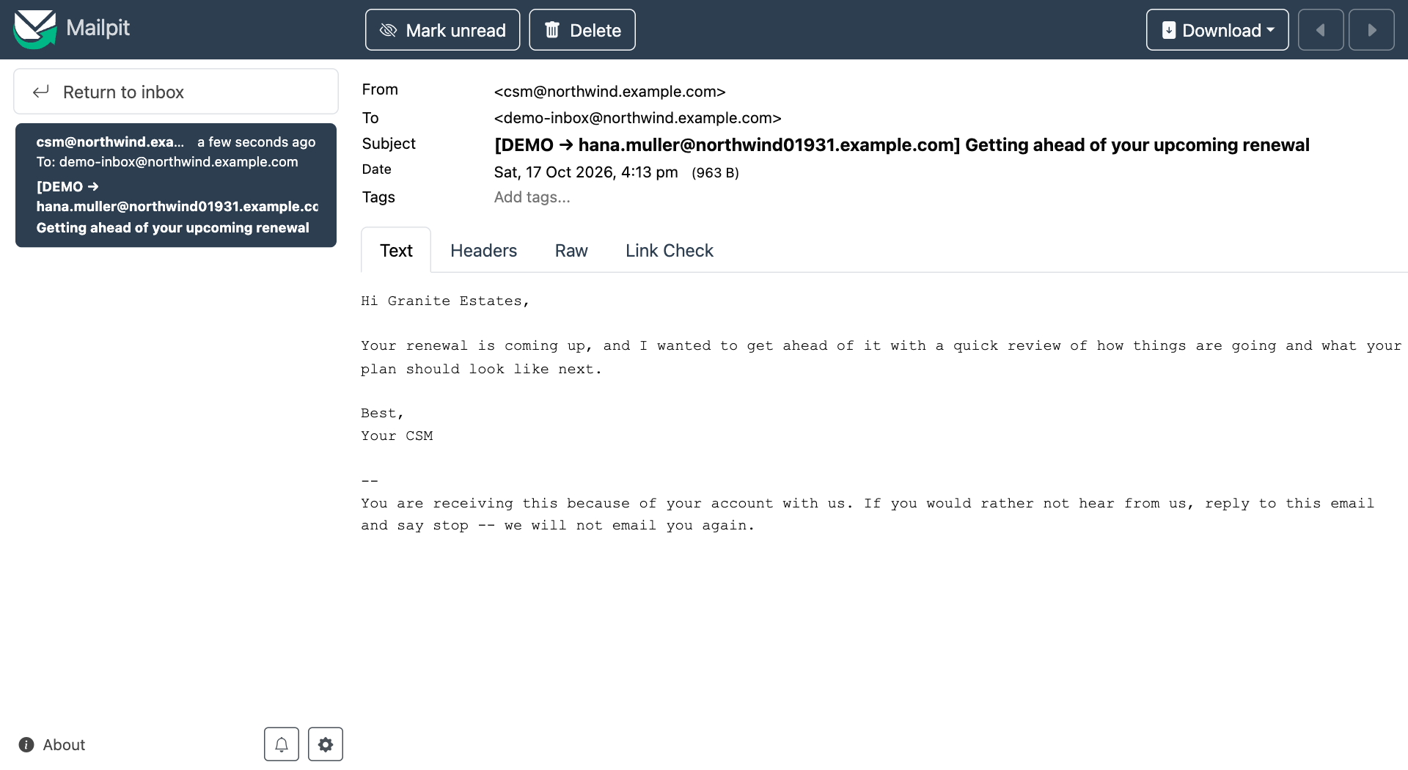
The message. The body is what you approved, followed by an unsubscribe footer.
- ✅ To: the test inbox; From: the verified sender; subject starting [DEMO → the customer’s real address]; and a footer saying the customer can reply “stop”.

C6 · Approving twice sends once ✏️
On a sent draft there is no Approve button. Prove it at the API (after logging in as in A7, but as the operator, saving the cookie to /tmp/op.txt):
curl -s -b /tmp/op.txt -X POST localhost:8000/actions/<DRAFT_ID>/approve \
-H 'Content-Type: application/json' -H 'X-Requested-With: pulse' -d '{}'
✅ The draft is returned still sent, and the inbox count does not change.

C7 · Opt-outs are honoured ✏️
- Drafts → pick a drafted card → click its account link and copy the account id from the address bar (/accounts/<ACCOUNT_ID>).
- Look up that account’s contact: /opt/homebrew/opt/postgresql@16/bin/psql -h localhost -U pulse -d pulse -tAc "select contact_email from account where id='<ACCOUNT_ID>'" (Nothing printed means no contact — choose another; that is test C10.)
- Admin → Opt-outs: enter that address and click Add.
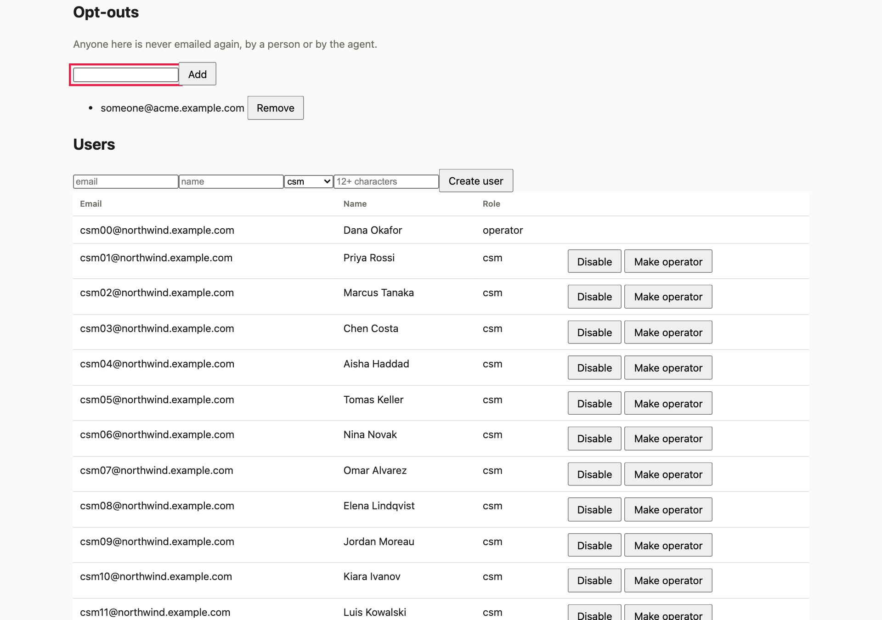
Opt-outs. Anyone listed is never emailed again, by a person or by the agent.
- Back in Drafts, Approve & send that card. ✅ Not sent: this contact asked not to be emailed. The inbox is unchanged.
- Remove the opt-out and approve again. ✅ It now sends (to the test inbox).

C8 · Demo mode off: it goes to the real contact ✏️ (still only your local inbox)
- Admin → Leave demo mode. ✅ “off — real customers are emailed”.
- Approve a fresh draft. ✅ In the inbox the message is To the customer’s own address, with no [DEMO → prefix. (This is real SMTP to your local inbox only, so no real person is contacted. With a real provider this would be a real email — never leave demo mode off on a real deployment unless you mean it.)
- Admin → Back to demo mode.

C9 · Reject ✏️
On a drafted card click Reject. ✅ State rejected. Filter rejected: it is there, read-only. A rejected draft cannot be approved (the server answers “action was rejected and cannot be approved”).

C10 · An account with no contact cannot be emailed ✏️
About 12% of accounts have no known contact (a realistic CRM gap). Approve drafts until one reports Not sent: this account has no known contact. Add one in the CRM. ✅ The inbox is unchanged.

C11 · The command-line mail check
cd backend && source .venv/bin/activate
PULSE_SMTP_HOST=127.0.0.1 PULSE_SMTP_PORT=1025 PULSE_SMTP_STARTTLS=false \
python3 -m pulse.cli send-test --to me@example.test --sender pulse@example.test
✅ delivered to the provider for me@example.test, and the inbox shows Pulse test message. With a wrong port (PULSE_SMTP_PORT=1) it prints FAILED with advice.

Part D — The autonomous agent

D1 · The run log
Any user → Run log.
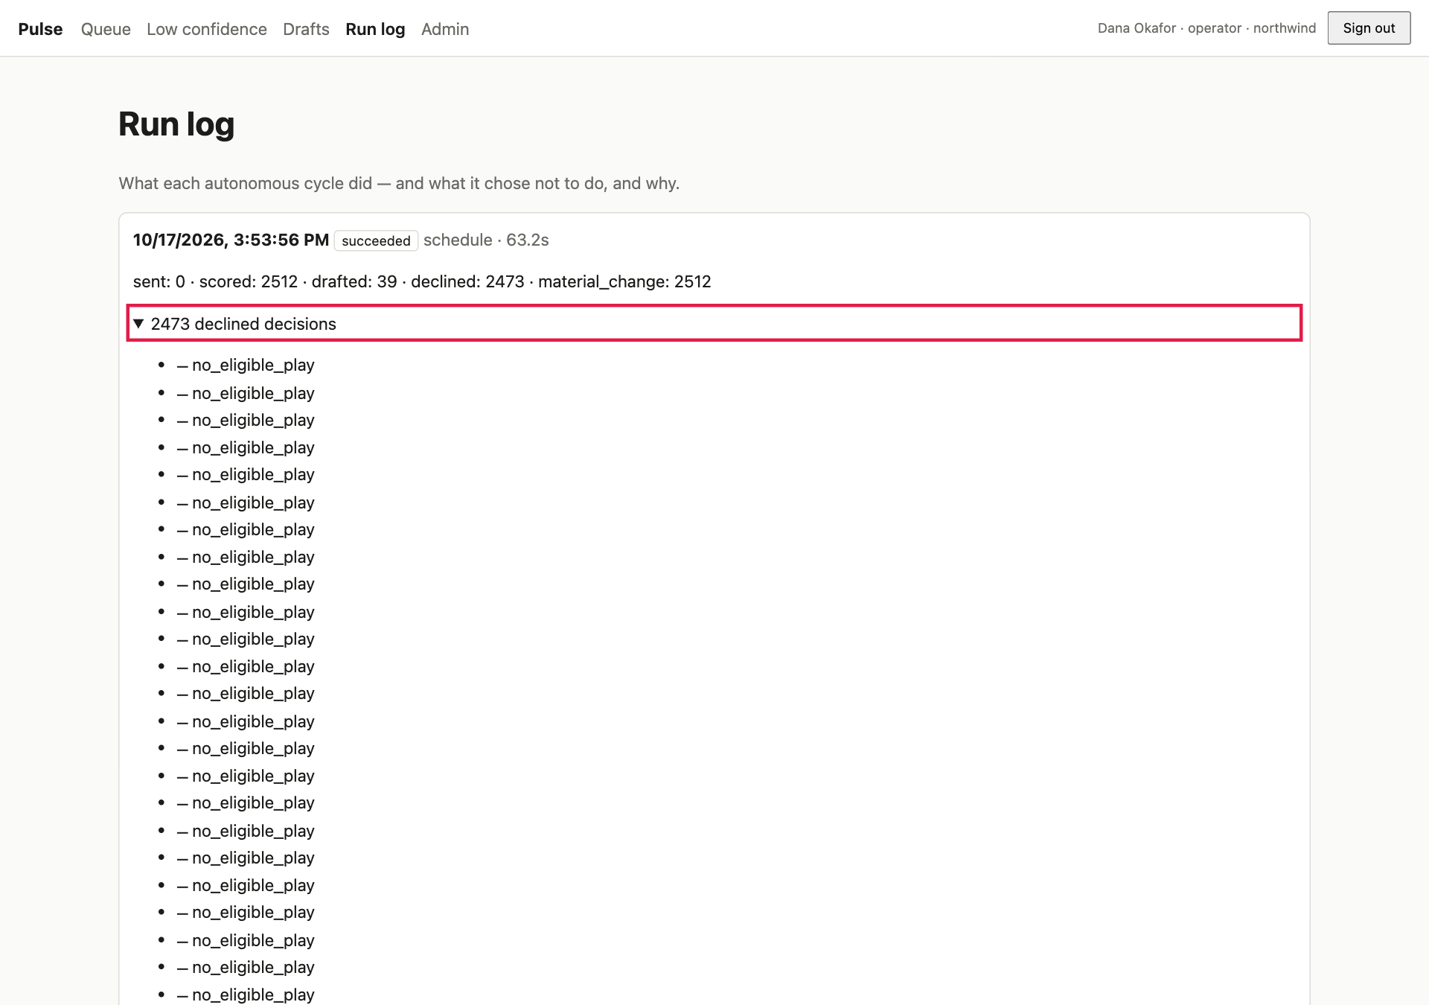
One card per cycle: what it scored, drafted and sent, and a list of what it declined to do and why.
- ✅ One card per cycle: time, status (succeeded), duration and counts such as scored · material_change · drafted · sent · declined.
- ✅ N declined decisions opens a list. What the agent chose not to do, and why is as visible as what it did.

D2 · Why it declines: read the reasons
Reason | Meaning
no_eligible_play | The score moved materially but no play fits that driver and tier.
suppressed | A human suppressed the account (try B6, then run a cycle in D4).
suppression_window_active | The agent already contacted this account within the last 14 days.
a grounding reason | The draft said something the evidence does not support, so it was discarded.
send_blocked:<state>:… | The send gate stopped an automatic send.
Not a decline: when a play is not allowlisted, or the per-cycle send cap (30) is reached, the draft is still created for a human to review and is simply not sent automatically.

D3 · The unattended worker ✏️
- Run the task Pulse: 4. unattended worker. It prints pulse worker: 3 tenants, model ready; cycle every 15 min….
- For a quick demo, stop it and run: cd backend && source .venv/bin/activate && PGTZ=UTC PULSE_CYCLE_INTERVAL_MINUTES=1 python3 -m pulse.cli serve --simulate-present.
- Refresh Run log every minute. ✅ A new succeeded run per workspace each interval with nobody clicking anything. drafted: 0 is correct when no new data arrived.
- Stop with Ctrl-C (✅ “stopped”). Starting two workers is safe: a lease lets only one process a workspace at a time.

D4 · Autonomous sending, gated by an operator allowlist 🧪 (sends up to 30 emails — use a scratch copy)
Why it matters: auto-emailing customers is the riskiest thing the system can do. By default no play auto-sends; an operator must allowlist each play.
- Make a scratch copy (D5) and run its API on port 8001 with the mail settings.
- Log in as the operator (cookie file /tmp/op.txt), set up outbound as in C4, then:
curl -s -b /tmp/op.txt localhost:8001/admin/allowlist # ✅ [] nothing auto-sends by default
curl -s -b /tmp/op.txt -X PUT localhost:8001/admin/allowlist/adoption_nudge \
-H 'Content-Type: application/json' -H 'X-Requested-With: pulse' -d '{"auto_send":true}'
- Run one cycle a week after the newest snapshot: python3 -m pulse.cli cycle --as-of 2026-10-19T09:00:00+00:00.
- ✅ The output shows sent: 30 for northwind (the per-cycle cap). The inbox gains about 30 messages, each tagged [DEMO → …], all to the test inbox. The other drafts wait in Drafts for a human. Switch the allowlist off ({"auto_send":false}) and rerun: ✅ sent: 0.

D5 · Scratch-copy recipe
B=/opt/homebrew/opt/postgresql@16/bin
$B/createdb -h localhost -U pulse pulse_scratch
$B/pg_dump -h localhost -U pulse pulse | $B/psql -h localhost -U pulse -d pulse_scratch -q -o /dev/null
cd backend && source .venv/bin/activate
export PGTZ=UTC PULSE_DATABASE_URL_OWNER="postgresql+psycopg://pulse@/pulse_scratch?host=/tmp&port=5432" \
PULSE_DATABASE_URL_APP="postgresql+psycopg://pulse_app:pulse_app@/pulse_scratch?host=/tmp&port=5432" \
PULSE_SMTP_HOST=127.0.0.1 PULSE_SMTP_PORT=1025 PULSE_SMTP_STARTTLS=false
uvicorn pulse.api.main:app --port 8001 # leave running; use localhost:8001 in the curl examples
# when finished: $B/dropdb -h localhost -U pulse --force pulse_scratch

Part E — Administration (operators only)

E1 · Users ✏️
Operator → Admin → Users.
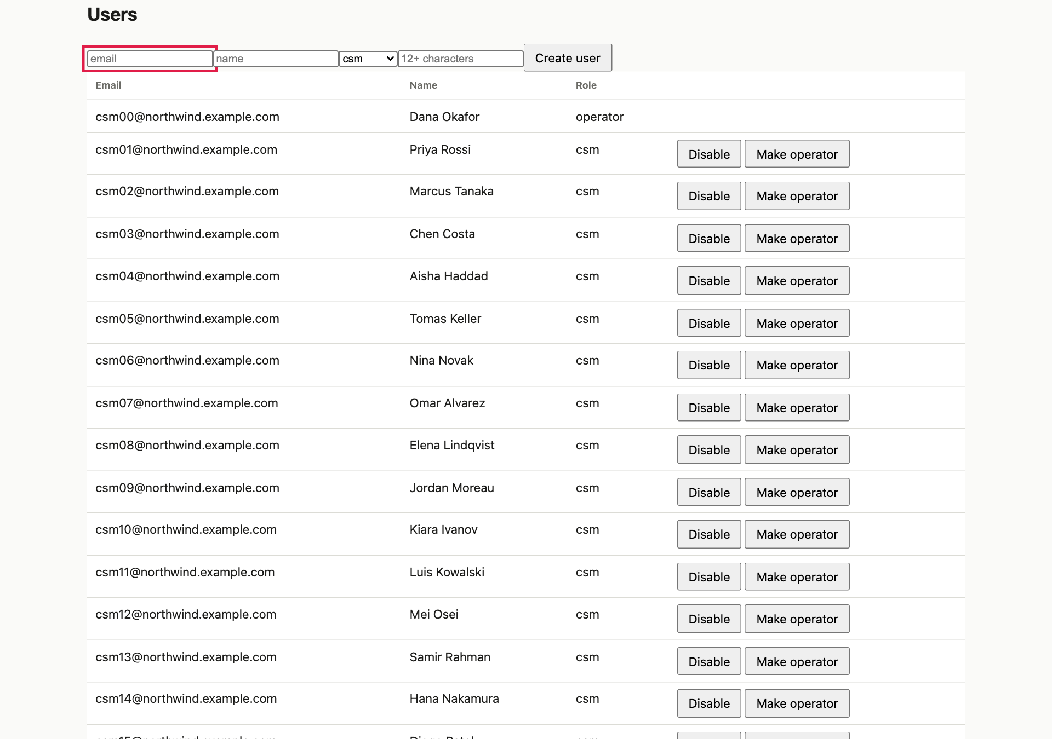
Create users, change a role, or disable a user. You cannot change your own row.
- Create a user: email tester@northwind.example.com, name Test Tester, role csm, a password of 12+ characters → Create user. ✅ They appear in the table. A short or common password is refused with a reason.
- Sign in as that user in window 2. ✅ It works: an empty queue (they own no accounts) and no Admin link.
- Click Make operator on them. ✅ Their role changes; they gain the Admin page after their next request.
- Click Disable. ✅ The row greys out. In window 2 click anything: ✅ they are signed out on the next request, and sign-in fails with invalid credentials.
- ✅ You cannot disable or demote yourself (no buttons on your own row).

E2 · Giving a CSM accounts ✏️
Accounts are owned by one user; only the owner (and operators) see them.
- Get the CSM’s id from curl -b /tmp/op.txt localhost:8000/admin/users and an account id from an account page address.
- Assign it:
curl -s -b /tmp/op.txt -X PATCH localhost:8000/admin/accounts/<ACCOUNT_ID> \
-H 'Content-Type: application/json' -H 'X-Requested-With: pulse' -d '{"owner_user_id":"<USER_ID>"}'
- ✅ In window 2 (that CSM) the account now appears in Browse all and can be opened. Send "owner_user_id":null to unassign it.

E3 · The audit trail ✏️
Admin → Audit trail (bottom of the page).
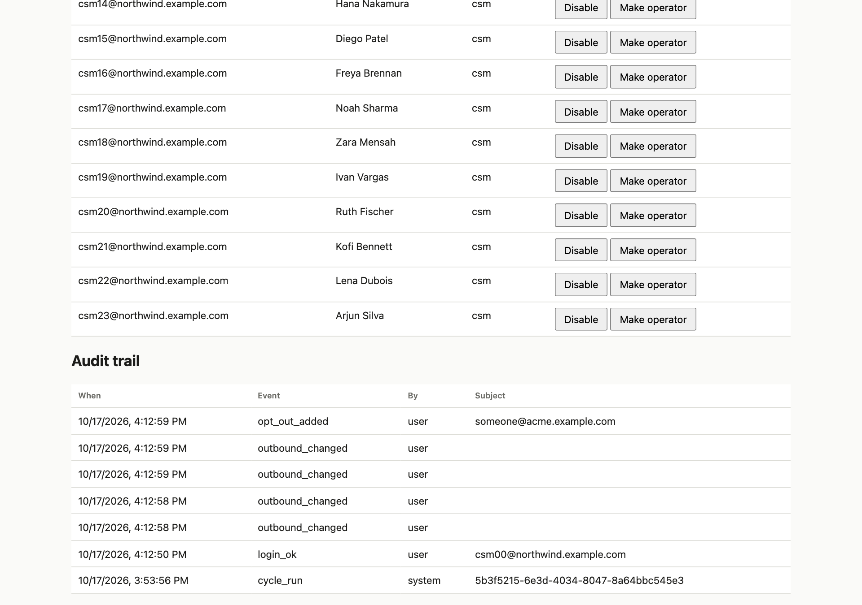
Who did what, when. Newest first.
- ✅ Recorded here: login_ok / login_failed / logout, user_created, user_enabled / user_disabled, role_changed, password_reset, outbound_changed, opt_out_added / opt_out_removed, cycle_run.
- ℹ️ Not in this list: draft approve / reject / edit and allowlist changes. Those are recorded on the draft itself (who decided, when) and on the allowlist row (who enabled it). That is a known gap.

E4 · Per-workspace settings (API) ✏️
curl -s -b /tmp/op.txt localhost:8000/admin/config
curl -s -b /tmp/op.txt -X PATCH localhost:8000/admin/config \
-H 'Content-Type: application/json' -H 'X-Requested-With: pulse' -d '{"weekly_capacity":5}'
✅ Reload Queue: now 5 rows and the “below the cut” number grows by 7. Set it back to 12. ✅ An unknown field ({"banana":1}) is rejected (422).

E5 · Data coverage per source (API)
curl -s -b /tmp/op.txt localhost:8000/admin/coverage
✅ One entry per source (salesforce, gmail, zendesk, product, stripe): whether it is connected, events landed, unresolved events (records that could not be tied to an account — surfaced, never silently dropped, never creating phantom accounts) and the date last received.

E6 · The model card (API)
curl -s -b /tmp/op.txt localhost:8000/model | python3 -m json.tool | head -80
- ✅ Operating point: precision at weekly capacity about 0.29, against about 0.04 for a trivial baseline and 0.02 for a hand-built heuristic. ROC-AUC about 0.69.
- ✅ Per-workspace results, and leave-one-workspace-out: a small new workspace (initech) gets almost nothing from the shared model (ROC-AUC about 0.53).
- ✅ Anything the pipeline could not produce says available: false with a reason (for example lead time). It is stated, not invented. A CSM gets 403 here.
- Honest reading: the model is moderately useful, not magic.

Part F — Language-model drafting (free, local)
What it is. A language model only writes the prose of a draft from facts the system already derived. It never ranks, scores or filters anything, and the system produces identical scores with it off, on or failing. Without a model, every draft is a deterministic template.
You do not need a paid key. The drafting code speaks the common “OpenAI-style” protocol, so it works with a free model running on your own Mac (Ollama), and also with hosted providers that have free tiers. Switching to Anthropic later is one setting.

F1 · Install a free local model (once, about 5 minutes)
brew install ollama
ollama serve & # starts the local model server on port 11434
ollama pull qwen2.5:7b # about 4.7 GB; a good small instruction-following model

F2 · Run a cycle with the model switched on 🧪 (use a scratch copy)
PULSE_LLM_ENABLED=true PULSE_LLM_PROVIDER=openai_compatible \
PULSE_LLM_BASE_URL=http://127.0.0.1:11434/v1 PULSE_LLM_MODEL=qwen2.5:7b \
python3 -m pulse.cli cycle --as-of 2026-10-19T09:00:00+00:00
(Run it with the scratch-copy settings from D5.) Calls are capped per cycle (50 by default); the remaining drafts use templates.

F3 · What to check
- Drafts: ✅ newer cards say Drafted by llm and name the model.
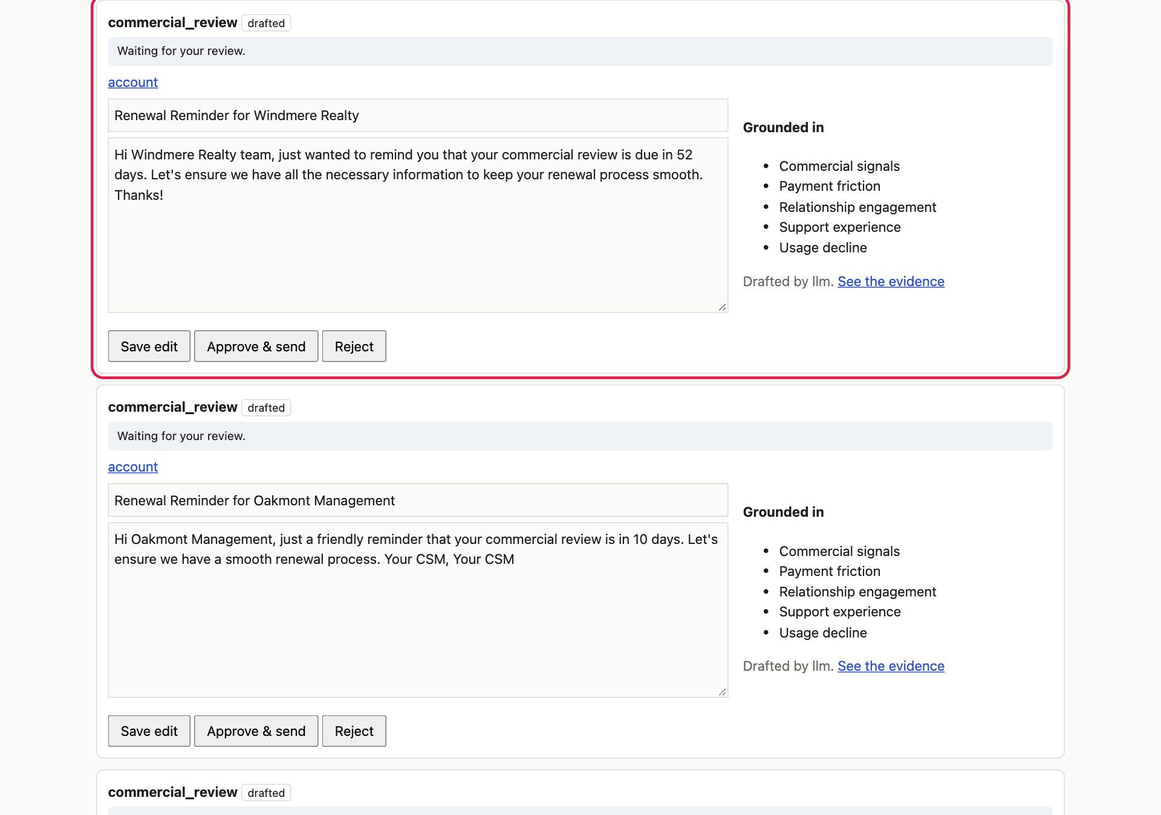
A draft written by the local model. Compare it with a template draft: same facts, different wording.
- Guardrails: read several. ✅ No numbers, links or claims that are not in the facts; plain prose; no markdown. A reply containing anything unsupported is rejected and a template is used instead.
- Failure is safe: set PULSE_LLM_BASE_URL=http://127.0.0.1:1/v1 (nothing listening) and rerun. ✅ The cycle still succeeds, every draft falls back to a template, and scores are identical.
- Same scores either way: ✅ ranks and risks are identical with the model on, off or failing.

F4 · Other providers (later)
Provider | Settings | Notes
Ollama / LM Studio (local) | PULSE_LLM_PROVIDER=openai_compatible, PULSE_LLM_BASE_URL=http://127.0.0.1:11434/v1, no key | Free, private, slower on a laptop
Hosted with a free tier (Groq, OpenRouter, Google Gemini’s OpenAI-compatible endpoint) | same provider, the provider’s base URL, PULSE_LLM_API_KEY=<their key>, PULSE_LLM_MODEL=<their model name> | Free tiers and limits change; check the provider
Anthropic Claude | PULSE_LLM_PROVIDER=anthropic, PULSE_LLM_API_KEY=<key>, pip install -e ".[llm]" | Needs an API key (separate from a chat subscription)

Part G — Things that are true, so you are not surprised
- The weekly queue is dominated by large renewals, not only red accounts, by design (risk × value × urgency). Only about 7 accounts are red.
- Backfilled history is in-sample: the model learned from those same weeks, so earlier weeks flatter it. Use them to browse and compare, not to judge the model.
- No real email provider has been exercised. The local inbox is real SMTP, but STARTTLS, authentication, rate limits, bounces and spam filtering are untested. Bounces and replies are not processed.
- A free local model writes plainer, sometimes slightly awkward prose than a frontier model. The guardrails, not the model, are what make it safe.
- All demo users share one password; there is no SSO or MFA; cookies are not marked Secure (needs HTTPS); the app’s database role passwords are development defaults.
- Account names repeat within a workspace (as in a real CRM). Drafts for accounts with no CRM record greet by reference and cannot be sent.
- Model quality: ROC-AUC about 0.69. The two planted “lost renewal” accounts are missed, lead time is not reported, and a small new workspace gets little from the shared model.
- All data is simulated; addresses end in @example.com.

Reset
- Undo your test data (users, opt-outs, outbound settings, approved drafts): run the task RESET demo database, then Pulse: 2. build demo data (about 4 minutes), then the backfill in 2.3 (about 12 minutes).
- Clear the mail inbox: in the inbox choose Delete all.
- Stop everything: close the task panels; pkill mailpit.

Appendix — One-page checklist
# | Feature | Where | Pass?
A1–A3 | Sign-in, generic error, protected pages | Sign-in, /drafts | ☐
A4 | Rate limit | Sign-in ×6 | ☐
A5 | Sign-out kills the session | Two tabs | ☐
A6–A8 | CSM scoping, Admin API refused, workspace isolation | Two windows | ☐
B1–B2 | Queue, week picker, history | Queue | ☐
B3 | Browse all: paging, search, filters | All accounts | ☐
B4–B5 | Account, evidence, What moved | Account page | ☐
B6 | Confirm / false positive / suppress / lift | Account page | ☐
B7 | Low confidence | Low confidence | ☐
C1–C2 | Draft review and edit | Drafts | ☐
C3–C4 | Blocked when off; configure outbound | Drafts, Admin | ☐
C5–C6 | Email arrives in the inbox; no double send | Mail inbox | ☐
C7–C10 | Opt-out, demo off, reject, no contact | Drafts, Admin | ☐
C11 | Command-line mail check | Terminal | ☐
D1–D3 | Run log, declined reasons, unattended worker | Run log | ☐
D4 | Allowlisted automatic sending | Scratch copy | ☐
E1–E3 | Users, ownership, audit | Admin | ☐
E4–E6 | Settings, coverage, model card | API | ☐
F | Free local model drafting | Scratch copy | ☐

Appendix — Hosting this for a reviewer
Nothing in the hosting section below has been done yet; it is what the research found.
Option | Cost | Fit
Your Mac plus a Cloudflare quick tunnel (cloudflared tunnel --url http://localhost:5173) | Free, no account | Public link while your laptop is on; the address changes each run. Good for a live review slot.
AWS | New accounts get credits ($100, up to $200) on a Free Plan that ends after six months or when the credits run out, and then closes the account. A 4 GB server costs roughly $25–30 a month, so credits cover a short review period. | Works. The containers are verified on ARM, so choose a Graviton server (t4g.medium). Needs a card. Lower cost-surprise risk than the paid plan because the free plan closes instead of billing.
Oracle Cloud Always Free ARM | Free, but reportedly cut to about 2 CPUs and 12 GB in 2026 | Durable but fiddly signup and capacity
Render free tier | Free | Does not fit: sleeps, no free background worker, free database expires after 30 days
Before any public hosting: set the PULSE_COOKIE_SECURE, POSTGRES_PASSWORD and PULSE_DEMO_PASSWORD settings, keep demo mode on, and put no mail or model keys on the server.

