Multi-Threaded Web Proxy
In this project, you will implement additional features for the web proxy from project 1. The web proxy we developed for project 1 was very simple in terms of functionality: it worked as an intermediary between a browser and a server. Here, we are going to add the following functionality:
1. Blocking web sites if they are found in a black list (www.facebook.com, www.youtube.com, www.hulu.com, www.virus.com)
2. Filtering out inappropriate language (http://www.hyperhero.com/en/insults.htm) from a requested site
3. Caching sites that have already been visited. The implementation of this feature should be based on HTTP conditional GET request.
To test your program, use a web browser as a client. The following address format should be used in the address bar:
129.120.151.96:8888/www.google.com
- 129.120.151.96 -> ip address of the proxy server
- 8888 -> port number of the proxy server
- www.google.com -> the address of the website being accessed
The project can be completed in the following manner:
Comments
Individual journal
README text file (it describes how to set up, compile, and run your program)
Report (what problem is being solved, your approach, and your solution)
Evidence of compilation and execution (Screen Shots of handling multiple clients)
Code

Journal.

1. Created file with improper words – blockwords.txt. Added function hide_bad_words() that scans a buffer with data, and search for bad word. If word is found – is replaced with “-”.
2. Created file with blocked sites – blocksites.txt. Added function to read file , and compare it with given site by the browser.
3. Added function to read request from browser and resolve the IP address of the server from the host name provided in first get- request.
4. Implemented connection to the web-server, and main loop to read from server and write back to browser.
5. Added ability to save received data to a cache file. Chosen to save all cache files to a ./cache/ directory. Host name and URL are saved too.
6. Added calls to filter blocked site, and replace bad words before send buffers with data to the web browser.
7. Added function find_cache_file() that for requested host and URL, will try to locate stored cache file .
8. Added function get_cache_tags() that will search for conditional tag in stored cache, to help building conditional HTTP request.
9. Implemented etag conditional request. When HTTP request is sent to remote Web server, search cache, and fill in conditional get tag.
If page on server, it will return response 403, meaning that server didn’t change, and we return to the browser cached content.
10. Changed logic of content retrieval, in case server response does not include Code 403, to return to the Web browser data as it was sent by the server.
11. Tested various scenarios and fixed few small problems – not initialized properly variables. Tested filtered words by adding a word matching on the page (“sport”) , and checked that will appear in browser as “-----”.

README
1. Compile :
gcc proxy.c -lpthread -o proxy -Wall

2. Two text files with blocked sites and words: blocksites.txt blockwords.txt

3. Cache files stored in ./cache/ directory.
Each page is stored in randomly named file. Hostname and URL information are stored in another file, with the same name as cache, with “.txt” extension.

4. Run:
./proxy

Screenshots
1. Compile and start of proxy. Accessed www.bbc.co.uk:
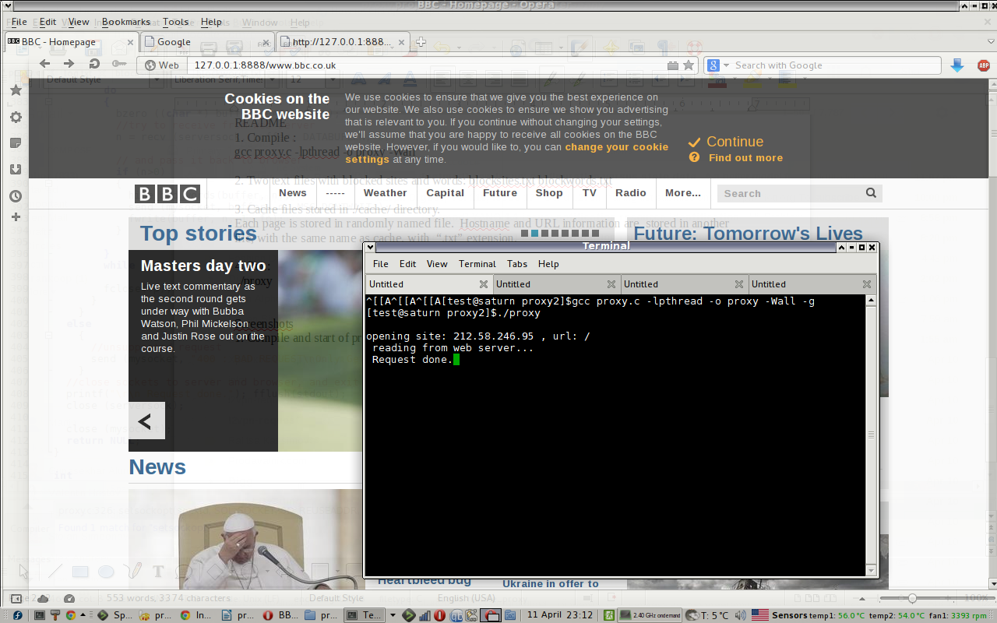
2. Accessed once more, retrieved from cache
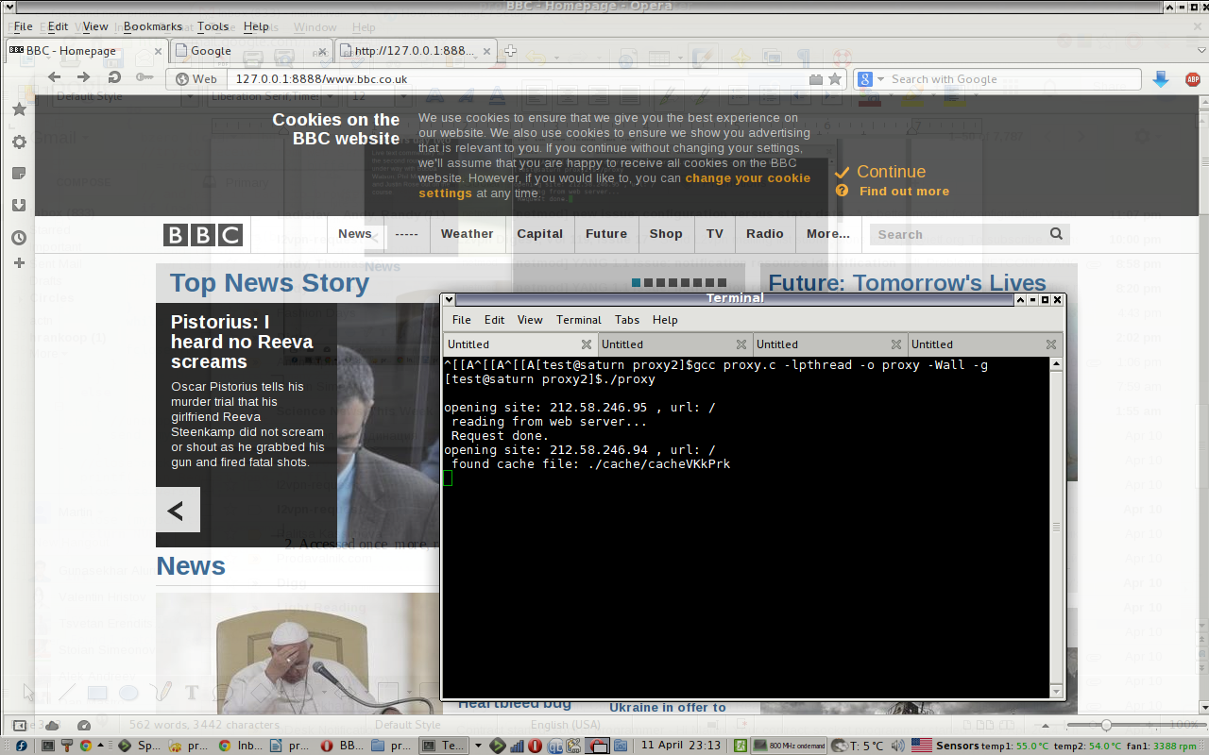

3. content of the cache – Etag can be noticed, used to check if cache is valid.
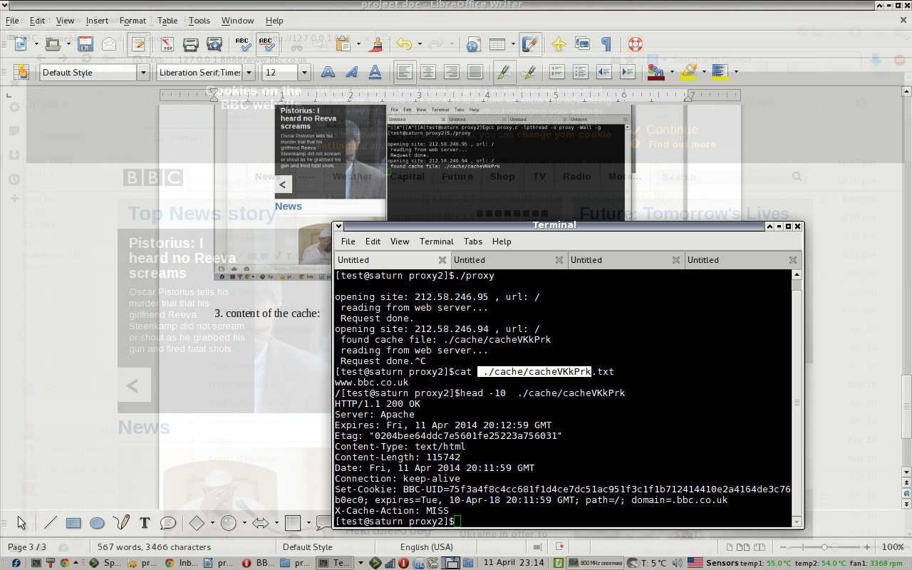
4. Check blocked word, add word “News” as blocked in blockedwords.txt.
Check again output in browser.
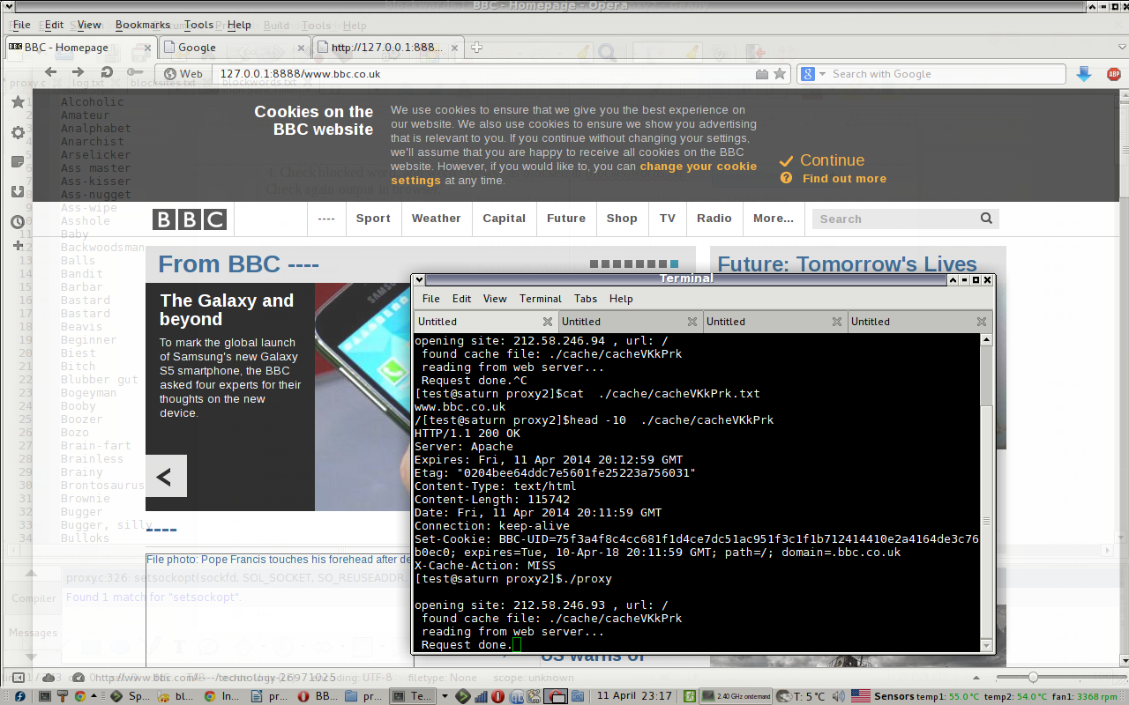
5. Tried multiple clients
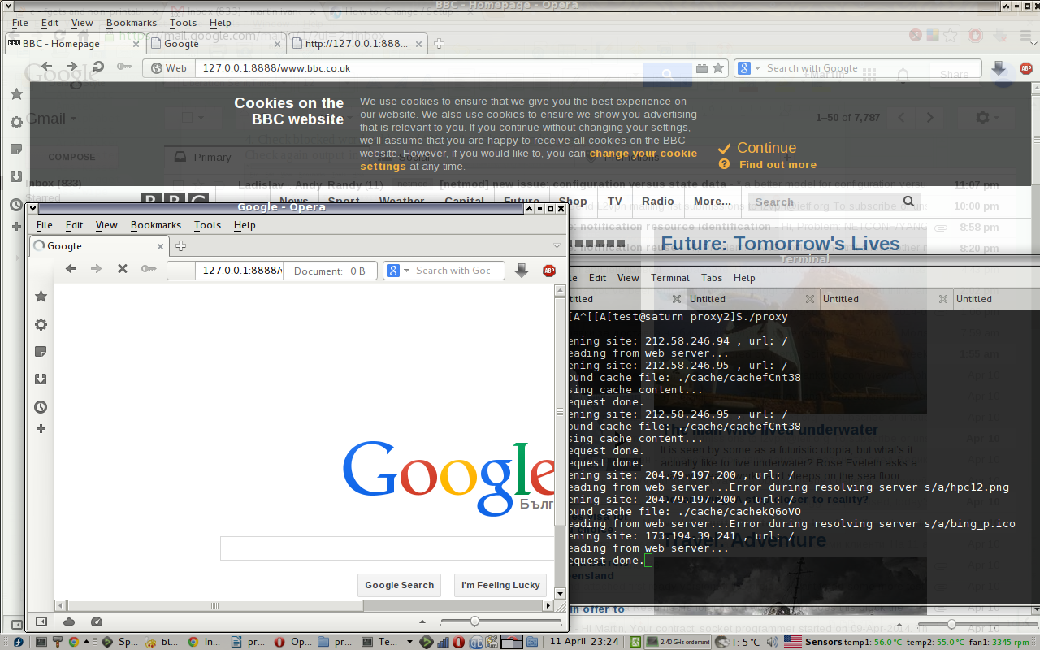

6. Tried to access blocked site.
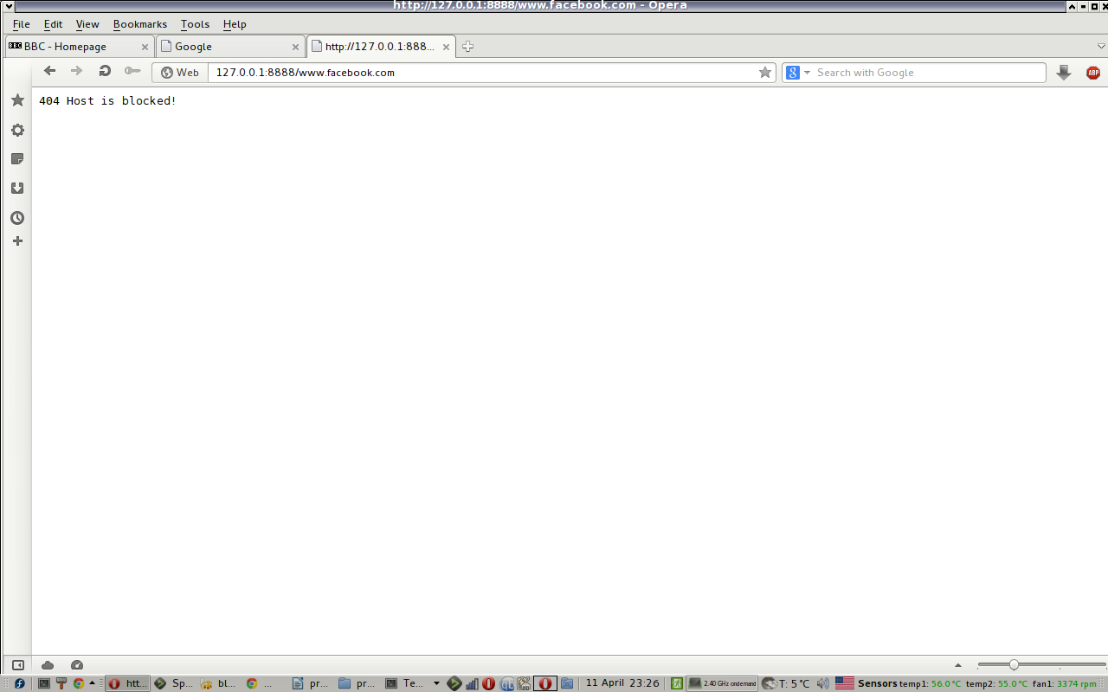

Solved problems:
1. Cached data requires to keep also URL and host name , tried to keep this info in separate file, for easy searching – when trying to locate the cache, will only search for URL .
2. Every new cached URL has to be kept in new file, used tempnam() to return unique file every time new URL has to be cached.
3. Very problematic was to find good sites to test the proxy:
- Sites that do not redirect the browser to a new address, where proxy will not be active.
- Sites that correctly implement conditional get request.
Used google.com and bbc.co.uk for testing.
4. Tried to implement conditional get-request using Etag and Last modified timestamp, but found second one to be problematic – few checked sites used different format of the header to represent the timestamp. Decided to use only etag tag for conditional header.
5. Bad words filtering implemented using case insensitive search, and surrounding characters in the found words are non-alphanumeric .

Not solved problems:
1. Cache files are not deleted (i.e. when they are found to be old).

