OntoGate-RAG: Selective Biomedical Question Answering with an LLM Evidence Judge and Ontology-Based Cost Screening
[Author Name]
[Department], [Institution]
[email address]
Abstract
Retrieval-augmented question answering systems usually answer every question they are given. When the retrieved evidence is thin the answer is often wrong but still confident, which is a poor fit for medicine. We present OntoGate-RAG, a system for PubMedQA-style yes/no/maybe questions that decides, for each question, whether to answer or to stay silent. It retrieves ten candidate abstracts with a dense index, then makes one call to a small language model that returns two things at once: a three-level verdict on whether the evidence is sufficient, and a provisional answer. A small gate turns those outputs into an answer or an abstention. A MeSH–Hetionet ontology layer links question and evidence text to medical concepts and measures concept coverage, both as a gate feature and as a free pre-screen. On the 500-question test half the gated system answers 65.2% of questions at 78.2% accuracy (95% confidence interval 73.6–82.5), against 58.8% when the same model answers everything. Three results are less obvious. Ontology coverage on its own is no better than chance as an accuracy signal (AUC 0.49). The fitted gate makes exactly the same decisions as an untrained rule that trusts only fully confident, non-“maybe” judge outputs. And the ontology’s measurable value is cost rather than accuracy: as a pre-screen it removes 19.4% of judge calls for a cost of 0.9 accuracy points. We report the negative results alongside the positive ones.
Keywords: biomedical question answering; selective prediction; retrieval-augmented generation; ontology; confidence estimation; abstention; PubMedQA
1. Introduction
Retrieval-augmented generation (RAG) has become the default way to ground a language model in a document collection [2]. The model is shown a handful of retrieved passages and writes an answer that should follow from them. The design assumes the passages are useful. In practice they sometimes are not: the search may return related but uninformative text, or the collection may simply not contain the answer. The model still responds, usually in a confident tone. In medicine this failure mode is expensive, because a fluent wrong answer is harder to catch than a refusal.
Selective prediction gives a model a third option: abstain [4], [5]. Instead of always answering, the system decides per input whether it knows enough. The two quantities that matter are coverage, the share of inputs that receive an answer, and selective accuracy, the accuracy on that answered subset. Their trade-off is usually plotted as a risk–coverage curve. Two conventions keep such numbers honest. First, an abstention is never counted as correct, so a system cannot raise its score by refusing everything. Second, the decision threshold must be fixed on data that is not used for the final report.
Prior work offers several kinds of confidence signal. Sampling-based methods estimate uncertainty by generating multiple answers [12], critic models learn when retrieval is needed [3], and prompting methods ask a model how sure it is [9]–[11]. These approaches work, but they cost extra model calls, extra training, or access to internal model state. Ontologies, meanwhile, are widely used in biomedical search for entity normalisation and query expansion [6]–[8]. What is less explored is whether ontology coverage alone can tell us that retrieved evidence is sufficient to answer a question. Our experiments suggest it cannot, but it is useful in a different role: as a free filter that decides when not to pay for a model call.
This paper asks a practical question: can a single structured judgement from a small language model, combined with ontology coverage, decide when retrieved biomedical evidence is good enough to answer, and at what cost? We study this on PubMedQA [1], which provides expert-labelled yes/no/maybe questions about published abstracts. Our system, OntoGate-RAG, is deliberately simple: one retrieval step, one judge call per question, one two-feature gate, and an optional ontology pre-screen. The evaluation is fully paired, so every arm sees the same retrieved passages and the same model output; the only difference is whether the system was allowed to abstain.
The contributions of the work are as follows.
1. A selective question-answering pipeline for PubMedQA in which a single LLM call produces both the candidate answer and the sufficiency signal used to gate it, so the gating costs no extra API calls.
2. Evidence that the judge’s own uncertainty is the strongest available signal: its sufficiency label reaches AUC 0.736 on the test half, adding the fact that it answered “maybe” raises this to 0.770, and the fitted two-feature gate reduces to an untrained rule that makes identical decisions.
3. A quantified account of what the ontology contributes. MeSH and Hetionet coverage is a near-chance accuracy gate (AUC 0.49) but a useful cost filter, removing 19.4% of judge calls for a 0.9 point accuracy loss.
4. A set of documented negative results — ontology reranking, query expansion, many-feature gates and alternative confidence features — reported with both dev and test numbers so that overfitting is visible.
The rest of the paper describes related work (Section 2), the system architecture (Section 3), the implemented workflows (Section 4), the evaluation protocol (Section 5), results and discussion (Section 6), limitations and future work (Section 7), and conclusions (Section 8).
2. Related Work
Four threads meet in this project: selective prediction, retrieval-augmented biomedical question answering, biomedical ontologies, and confidence elicitation from language models.
2.1 Selective Prediction and Abstention
The reject option has a long history in pattern recognition. Chow showed that an optimal error–reject trade-off exists when a classifier may decline low-confidence inputs [5]. Geifman and El-Yaniv brought the idea to deep networks, selecting a threshold on a confidence score to guarantee a target risk [4]. Their framing assumes a score that is already calibrated on held-out data. Our setting is different in one respect: the score comes from a language model’s judgement about evidence, not from the classifier that produces the label. The threshold is still fitted on a development split and applied once to a test split.
2.2 Retrieval-Augmented Biomedical QA
PubMedQA introduced 1,000 expert-labelled questions whose answers are yes, no or maybe, each accompanied by abstracts from the source paper [1]. It remains a standard test bed for biomedical reading comprehension. RAG [2] pairs a dense retriever with a generator; later systems improve either side, for example with domain-specific biomedical encoders such as MedCPT [15]. Dense retrieval with sentence-transformer encoders [16] and approximate nearest-neighbour search [17] is now routine. Retrieval benchmarks such as BEIR [13] and claim-verification datasets such as SciFact [14] show that retrieval quality depends strongly on the corpus. In PubMedQA’s open-book setting the relevant abstracts are present and questions share vocabulary with them, so retrieval is close to ceiling. That is why our work concentrates on the decision after retrieval rather than on ranking.
2.3 Biomedical Ontologies and Knowledge Graphs
MeSH provides a controlled vocabulary and hierarchy maintained by the U.S. National Library of Medicine [8]; UMLS integrates many biomedical vocabularies into one terminology [7]. Hetionet combines curated pharmacological and genetic relationships into a single graph and has been used to prioritise drug repurposing candidates [6]. In question answering, ontologies usually serve entity linking, query expansion, or graph-based reranking. Using coverage of question concepts as a proxy for evidence sufficiency is less common. Our results explain why: on a corpus where ten abstracts are retrieved per question, the concepts are almost always mentioned somewhere, so coverage saturates and loses discriminative power.
2.4 Language Models and Their Own Uncertainty
Large language models can often tell when they do not know. Kadavath et al. show that models assign higher probability to their own correct answers [9]; Lin et al. teach models to express uncertainty in words [10]; Xiong et al. compare several confidence elicitation strategies [11]. Self-RAG trains a model to emit reflection tokens that decide when to retrieve and when to trust its output [3]. Semantic entropy uses meaning-level sampling to detect confabulation [12]. These methods are more elaborate than ours. We test a cheaper version of the same idea: ask the model for a coarse sufficiency verdict, and treat its explicit “maybe” as a refusal. The finding that this single bit matches a fitted gate is, to our knowledge, a useful practical result for low-budget systems.
2.5 Literature Review Matrix
Table I compares representative prior work with this project. The column “limitation” is relative to our goal, not a criticism of the original work.
Table I. Literature review matrix for selective biomedical QA.
Work | Core problem | Approach | Main finding / limitation
Jin et al. (2019) [1] | Expert-labelled biomedical QA | 1,000 questions from PubMed abstracts with yes/no/maybe labels | Strong benchmark; no mechanism for deciding when evidence is insufficient
Lewis et al. (2020) [2] | Grounding generation in retrieved documents | Dense retriever plus sequence-to-sequence generator | Effective grounding; always generates, so retrieval failures become confident errors
Asai et al. (2024) [3] | Deciding when to retrieve and when to trust output | Self-reflection tokens produced by a fine-tuned critic | Accurate control; needs additional training and multiple inference passes
Geifman and El-Yaniv (2017) [4] | Selective classification with a risk target | Threshold on a learned confidence score, risk–coverage analysis | Principled abstention; assumes a calibrated in-model score and retraining
Himmelstein et al. (2017) [6] | Integrating biomedical knowledge for drug repurposing | Hetionet graph of curated clinical and genetic relations | Rich relational resource; not designed to estimate answerability of a QA instance

3. System Architecture
The system is a linear pipeline with two early exits (Fig. 1). Each stage is a separate module with a small interface, which made it possible to swap gates and features without touching retrieval or the judge. All derived artefacts are cached on disk, so an experiment can be stopped and resumed.
3.1 Data Layer
We use the 1,000 expert-labelled PubMedQA questions (552 yes, 338 no, 110 maybe) and the public corpus of 3,000 abstracts. The questions were split once, at random with a fixed seed, into a development half and a test half of 500 each. The retrieval corpus is shared by both halves. Following the standard open-book protocol, the question’s own source abstract is left in the corpus; the system is not told which abstract it is. We later confirmed that removing it makes the task close to unsolvable for this judge, which is consistent with the benchmark’s design and is reported as a hard-mode result rather than used for the headline.
3.2 Retrieval
Abstracts are embedded once with the multi-qa-MiniLM-L6-cos-v1 sentence-transformer model [16] and indexed with FAISS [17] using inner-product search over normalised vectors. At query time the question is embedded with the same model and the ten nearest abstracts are returned. Ten is the top-k used throughout; it is also the depth at which coverage was measured. Retrieval is fast and free after the index is built, and on this corpus it is already close to ceiling (Section 6.6).
3.3 Ontology Layer
The ontology is built from two public sources. MeSH 2026 contributes 31,110 descriptors and 65,242 hierarchy edges [8]. Hetionet v1.0 contributes 147,591 edges over six clinical relation types, such as compound–treats–disease and disease–associates–gene [6]. No part of the graph is generated by a language model, and the build records the source files and licences.
At inference time, question and passage text are scanned for mentions of ontology labels and synonyms. Each question is reduced to a small set of weighted concepts, typically one or two. The layer then computes several features: coverage of the question’s concepts by the retrieved abstracts (top-1, top-3, or all ten); coverage of the concept in section headings; whether two question concepts occur in the same sentence; and whether the relation implied by the question is asserted near both concepts. A separate pass assigns each question a MeSH disease category (C01–C26) so that results can be reported per specialty. The features are deliberately inspectable: every number can be traced back to a concept label and a passage.
3.4 The Evidence Judge
The judge receives the question and the ten abstracts in one prompt and must return a small JSON object: a sufficiency label (yes / partial / no) and a provisional answer (yes / no / maybe). The labels are mapped to scores 1.0, 0.5 and 0.0. The prompt instructs the model to say “maybe” only when the evidence is genuinely ambiguous or conflicting, and to mark evidence as “partial” when the passages are related but do not settle the question. This design serves two purposes. It yields a candidate answer, so no second generation call is needed, and it yields an explicit uncertainty statement that can be used as a gate feature. We use gemini-3.1-flash-lite [18] with thinking disabled, temperature 0, and a hard output cap. Responses are cached by a hash of the prompt, and quota errors stop the run immediately instead of retrying, because retrying cannot help until the quota resets.
3.5 Gate and Cascade
The gate is a two-feature logistic model over the judge’s sufficiency score and a binary indicator for “the judge answered maybe”. Features are standardised with statistics from the development split. For a target coverage, the threshold is the smallest score whose coverage still meets the target, and it is stored with the model so that a demo or a re-run reproduces the same decisions. The two-feature restriction is a deliberate defence against overfitting: with only 283 development rows, larger feature sets improve dev AUC and lose on test (Section 6.3).
In front of the judge sits an optional pre-screen. If the ontology coverage of the retrieved evidence is at or below a threshold, the question is answered with an abstention without calling the model. The threshold is the only free parameter, and it is selected on development data. The cascade is therefore a cost control, not an accuracy mechanism.
3.6 Reproducibility and Cost Control
Every experiment is driven by scripts that write JSONL records, one per question, containing the retrieved passage ids, the judge output, the coverage features and the final decision. The analysis script reads those records and refits the gates, so tables and plots can be regenerated without any API calls. The response cache means a question is never paid for twice. The observed free-tier envelope was about 500 judge calls in one day, which is why the test half was completed first and the development half is reported at 283 of 500 rows. The run resumes by skipping questions that already have a record.
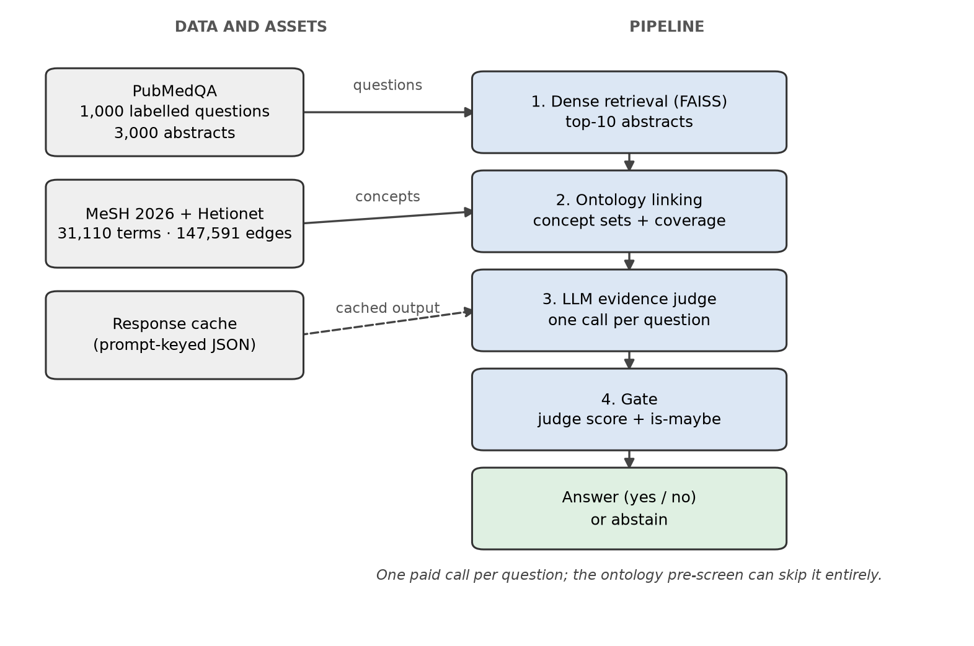
Fig. 1. System architecture. Data assets on the left feed a linear pipeline; the ontology pre-screen can bypass the paid judge call.
4. Implemented Workflows
The pipeline has three observable paths. All three are exercised by the demo script, which prints the retrieved evidence, the linked concepts, the judge output and the final decision for a single question. The examples below are real test questions, quoted by their PubMed identifier.
4.1 Answer Path
Question 21645374 asks whether mitochondria play a role in remodelling lace plant leaves during programmed cell death. Retrieval returns ten abstracts, the top one with cosine similarity 0.73. The ontology links two concepts, “Mitochondria” and “Plant Leaves”, and both are covered by the retrieved evidence, so coverage is 1.0 and the pre-screen does not fire. The judge marks the evidence as sufficient and answers “yes”. The gate score is above the threshold, so the system answers “yes”. The gold label is also yes.
4.2 Abstention from Judge Uncertainty
Question 10966337 asks whether a short-stay ward in a children’s hospital is effective. Coverage is 1.0, because the concept “Hospitals” appears in the evidence, so the ontology has no reason to object. The judge, however, returns “partial” and answers “maybe”. The system abstains. The gold label is yes, so this is a lost point in principle, but it is the kind of case where a committed answer would have had no clear support: the abstracts discuss the ward but do not settle its effectiveness. Across the test half, questions on which the judge said “maybe” were answered correctly only 18.6% of the time when forced.
4.3 Abstention from the Free Pre-Screen
Question 26852225 asks whether adjustment for reporting heterogeneity is necessary in sleep disorders. The only linked concept is “Sleep Disorders”, and none of the ten retrieved abstracts mentions it. Coverage is 0.0, the pre-screen fires, and the system abstains without a model call. In this case the judge would also have abstained, so the screen saved a call without changing the decision. Section 6.4 reports how often that is true across the test half.
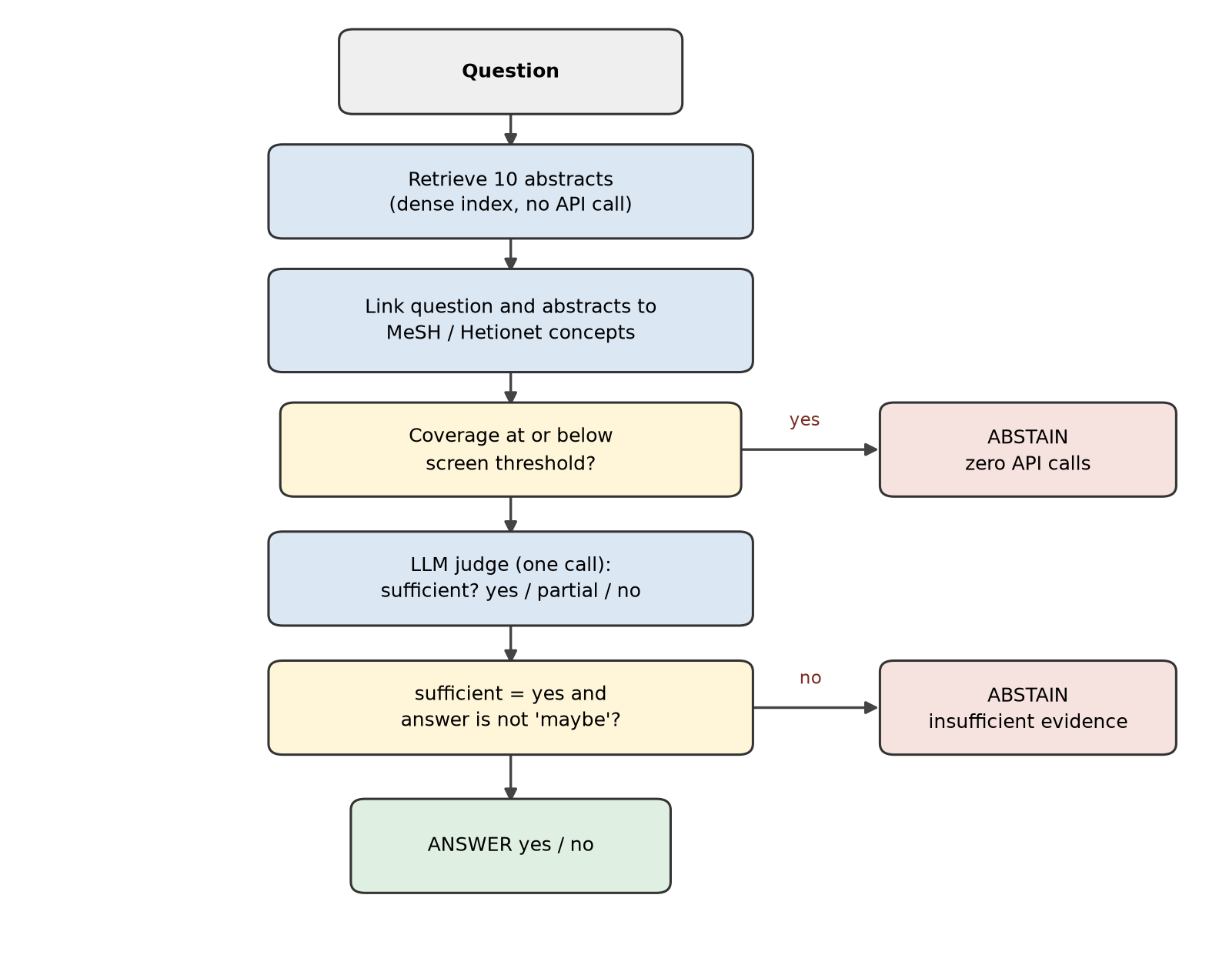
Fig. 2. Decision workflow. Two early exits produce an abstention without committing to an answer; both are evaluated under the same scoring rule.
4.4 Analysis Workflow
After a sweep, an offline script loads the records, computes risk–coverage curves and AUC for every candidate signal, fits each gate on the development rows, applies the stored thresholds to the test rows, and writes a Markdown report plus three plots. A second script evaluates retrieval recall and MRR, and a third compares the gate against a plain-prompt baseline on the questions both runs share. None of these steps calls the API.
5. Evaluation Methodology
5.1 Protocol
All design choices were made on the development half. The test half was processed once, after the gates, thresholds and the feature list had been fixed, and no test number was used to revise them. The primary comparison was specified before the test run: the two-feature gate at a 60% coverage target, fitted on development data, evaluated on test. Secondary comparisons are reported with both dev and test values. Every arm is evaluated on the same 500 questions and the same retrieved passages, so differences cannot come from retrieval randomness. An abstention receives no credit, even when the gold label is “maybe”.
Thresholds are matched-coverage thresholds: for a target coverage c, the threshold is the smallest score whose coverage on the fitting split is at least c. This makes dev and test comparisons fair even when the score distributions differ slightly. The 95% confidence interval for the headline accuracy is a bootstrap over test questions (1,000 resamples).
5.2 Metrics
Four metrics are used throughout.
- Coverage: the fraction of questions that receive a yes or no answer. An abstention lowers coverage.
- Selective accuracy: accuracy on the answered subset only. This is the headline number.
- AUC: the probability that a randomly chosen correct question scores higher than a randomly chosen incorrect one, computed over all questions. It measures ranking quality independent of any threshold.
- AURC: the area under the risk–coverage curve. Lower is better; it summarises the whole trade-off rather than one operating point.
5.3 Gate Variants
Several signals and gates were compared. Table II groups them by family. The ontology features are included so that their contribution can be measured, not because we expected them to win. Two variants exist solely as overfitting checks: a gate that adds coverage to the two-feature model, and a gate that adds all features including a one-hot encoding of the disease specialty.
Table II. Gate variants evaluated in this study.
Signal or gate | What it measures | Role in the study
Retrieval similarity | Cosine score of the closest abstract, mean and spread over ten | Baseline signal
Ontology coverage, top-3 / all ten | Share of question concepts mentioned in the abstracts | Gate feature and pre-screen
Heading coverage | Concept matches in abstract section headings | Ablation
Sentence-pair coverage | Whether two question concepts occur in one sentence | Ablation
Relation coverage | Whether the question’s relation is asserted near both concepts | Ablation
Judge score (1.0 / 0.5 / 0.0) | Three-level verdict on evidence sufficiency | Gate feature
Judge answered “maybe” | The model’s own refusal signal | Gate feature
Two-feature gate | Judge score plus the maybe indicator | Primary gate
Gate with coverage | Two-feature gate plus ontology coverage | Overfitting check
All features | Eleven features including specialty one-hot | Overfitting check

5.4 Baselines
The main baseline is the same model answering with the judge prompt and no abstention. This is the strictest paired comparison, because the passages and the model output are identical. Two weaker reference points are also reported: a forced-answer variant in which every “maybe” is converted to “yes”, and the majority-class rate. Finally, an earlier plain-prompt RAG run with a different model version is compared on the 50 questions the two runs share; that comparison is indicative only, because the model version differs.
6. Results and Discussion
6.1 Main Results
Table III reports the test half. The always-answer arm reaches 58.8%, which is close to the majority-class rate of 55.3% and well below the 67.4% obtained by forcing every “maybe” to “yes”. The judge prompt therefore costs some raw accuracy when no abstention is allowed. The gate recovers much more than it loses: it answers 326 of 500 questions (65.2% coverage) with 78.2% accuracy, an absolute gain of 19.4 points over the same model answering everything. The 95% confidence interval is 73.6–82.5, so the gain is clearly separated from zero. The development estimate was 83.2% at 67.1% coverage; the 5-point gap between dev and test is the honest measure of how much the fitted threshold and gate benefited from the fitting data.
Table III. Test-half results (n = 500). Coverage is the share of questions answered; accuracy is measured on that answered subset. An abstention is never counted as correct.
System | Coverage | Accuracy
Always answer (judge prompt) | 100.0% | 58.8%
Forced answer (“maybe” → “yes”) | 100.0% | 67.4%
Majority class (“yes”) | 100.0% | 55.3%
Judge score threshold (dev-fitted) | 69.2% | 75.1%
Judge self-abstention score | 65.2% | 78.2%
Two-feature gate (primary) | 65.2% | 78.2% [73.6, 82.5]
Gate plus ontology coverage | 62.2% | 78.1%

Two ablations deserve their own sentence. Adding ontology coverage to the gate slightly lowers both coverage and accuracy at the matched target (78.1% at 62.2%). Adding every feature, including the specialty one-hot, produces the best development AUC (0.834) and a worse test AUC than the two-feature gate (0.772 versus 0.774). The lesson is not that these features are uninformative in principle; it is that with 283 development rows, extra parameters buy dev-set noise.
6.2 Signal Quality
Table IV ranks the candidate signals by AUC. The ordering is unambiguous. Ontology features sit between 0.461 and 0.559 on test, which is chance level or slightly below it. Retrieval similarity is also chance level (0.527). The judge score is far ahead at 0.736. Adding the binary “maybe” indicator raises the ranking to 0.770, and the fitted two-feature gate reaches 0.774. The AURC column tells the same story: the risk–coverage curve of the judge-based signals is flatter across coverage levels, meaning that the accuracy penalty for answering more questions is smaller.
Table IV. AUC and AURC of candidate signals. AUC is computed over all questions; higher is better. AURC summarises the risk–coverage curve; lower is better.
Signal | Dev AUC | Test AUC | Test AURC
Retrieval similarity | 0.552 | 0.527 | 0.395
Ontology coverage (top-3) | 0.502 | 0.493 | 0.409
Ontology coverage (all ten) | 0.497 | 0.491 | 0.413
Ontology heading coverage | 0.512 | 0.534 | 0.382
Ontology relation (sentence) | 0.461 | 0.559 | 0.383
LLM judge score | 0.768 | 0.736 | 0.291
Judge score + self-abstention | 0.812 | 0.770 | 0.254
Judge fully confident (rule) | 0.803 | 0.761 | 0.256
Two-feature gate | 0.816 | 0.774 | 0.254
Gate + ontology coverage | 0.815 | 0.766 | 0.262
All features | 0.834 | 0.772 | 0.247

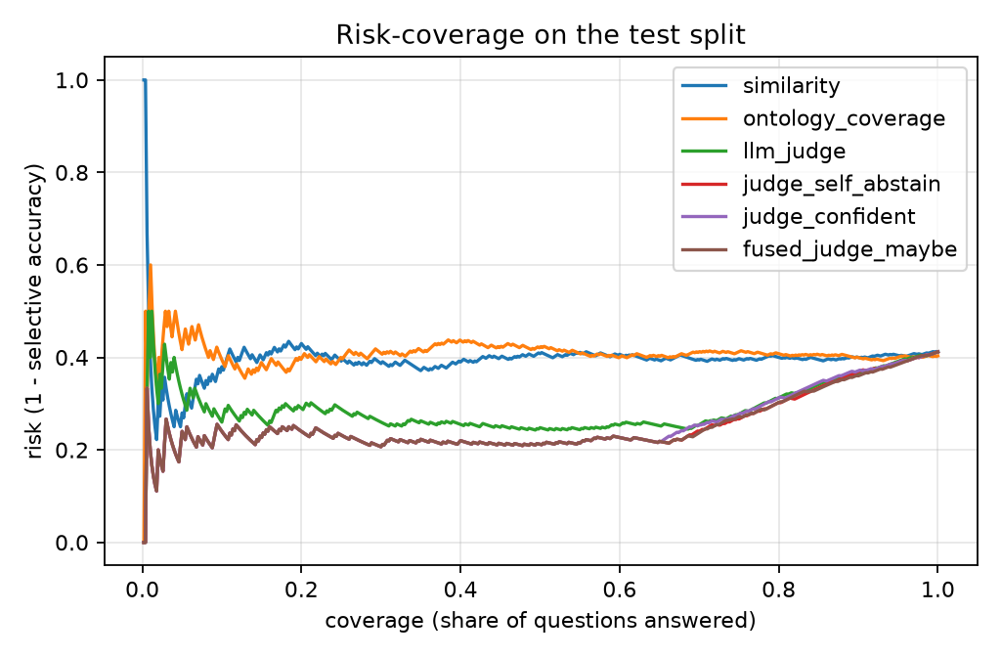
Fig. 3. Risk–coverage curves on the test half (lower risk is better). Judge-based gates stay well below the always-answer risk as coverage grows; ontology and similarity signals do not.
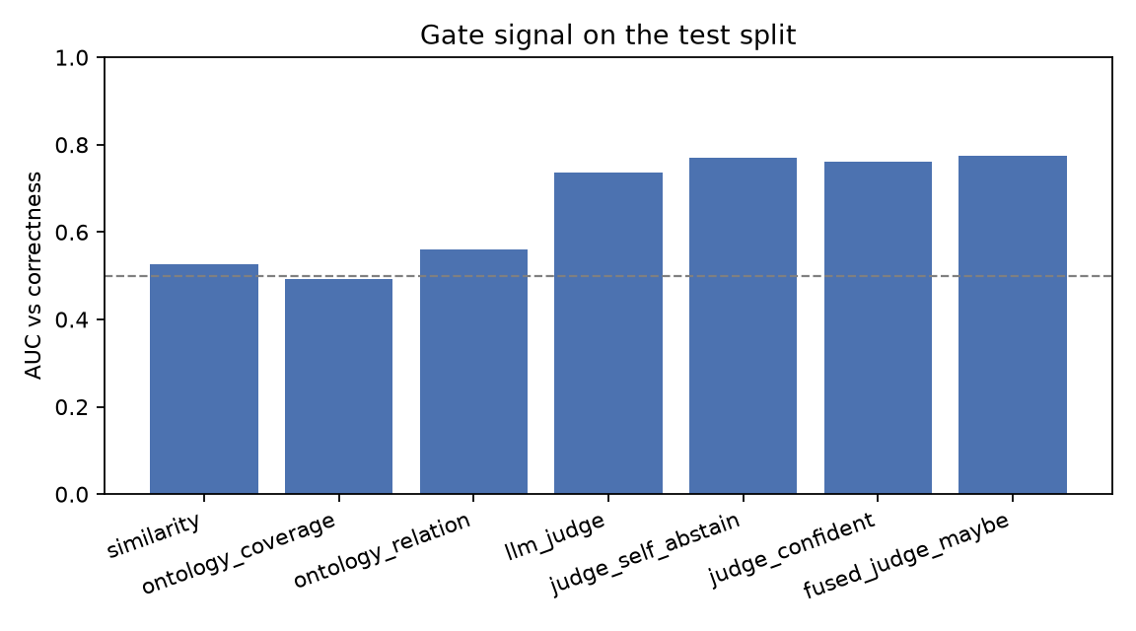
Fig. 4. Test-set AUC of the main candidate signals. The dashed line marks chance; the judge-based signals are the only ones clearly above it.
6.3 The Fitted Gate Collapses to a Rule
The most interesting result is not visible in a table of accuracies. When the two-feature gate is fitted on the development half, its weights are +0.376 for the standardised judge score and −1.222 for the maybe indicator, with a bias of +0.532. The resulting probability for a question with score 1.0 and no “maybe” is 0.8261. The threshold chosen for a 60% target is 0.8261 as well. In other words, the learned boundary lands exactly on the score level that corresponds to the rule “answer only when the judge is fully confident and did not answer maybe”. Because score levels are discrete, the gate includes the whole tie group, and the decision set is identical to the rule’s decision set. The rule, with no training at all, gives the same 78.2% at 65.2% coverage on test and 83.2% at 67.1% on dev.
This has a practical consequence. For this task, a deployable system does not need a learned gate; it needs a judge that is asked the right question and is allowed to say “maybe”. The gate is still useful as an analysis tool, because it shows where a threshold would sit if the label distribution changed, but its contribution to accuracy is nil. We report both numbers so that the claim “the gate works” is not confused with the claim “the gate is necessary”. It is not necessary here.
6.4 The Ontology as a Cost Filter
If coverage cannot rank questions by answerability, can it at least identify hopeless ones? Table V shows the cascade on test. With the screen at zero coverage, 5.6% of judge calls are skipped and accuracy is unchanged, because the removed questions were almost all ones the system would have answered incorrectly. At a screen threshold of 0.5, 14.4% of calls are skipped and accuracy falls by 0.2 points. At 0.75, 19.4% of calls are skipped and accuracy falls by 0.9 points (78.2% to 77.3%). The development half shows the same pattern (20.5% saved, 0.7 points lost), so the effect is not a test-set accident.
Table V. Ontology pre-screen cascade. A question whose coverage is at or below the screen threshold abstains without a judge call. Accuracy is on the remaining, answered questions.
Screen threshold | Dev calls saved | Dev accuracy | Test calls saved | Test accuracy
0.00 | 5.3% | 83.6% | 5.6% | 78.2%
0.50 | 13.8% | 82.4% | 14.4% | 78.0%
0.75 | 20.5% | 83.2% | 19.4% | 77.3%

The saving is real but modest, and it comes from a specific population: questions with almost no ontology evidence. Those questions are, if anything, slightly easier than average (0.619 versus 0.581 forced accuracy), which is the opposite of what a cost-aware screen usually hopes for. The reason is saturation: mean document coverage is 0.932, and 87.1% of questions have coverage 1.0. A feature that is constant for most of the data cannot separate hard from easy questions; it can only flag the small tail where the evidence shares no vocabulary with the question.
6.5 Error Analysis
On the 500 test questions the judge answered “yes” 215 times, “no” 124 times and “maybe” 161 times. Forced accuracy was 79.5% on the yes group and 75.0% on the no group. The maybe group is the interesting one: forced accuracy was 18.6%. The sufficiency label shows the same structure. When the judge called the evidence sufficient, forced accuracy was 75.1% (n = 346); for partial evidence it was 24.4% (n = 90); for insufficient evidence it was 18.8% (n = 64). The gate is therefore not exploiting a quirk of the answer field; the sufficiency label and the maybe answer are two views of the same uncertainty, and both are informative.
Per specialty, the gate improves selective accuracy in every group with at least ten questions except one. That exception is a group of ten methodology questions (analytical and diagnostic techniques) on which the judge called the evidence sufficient with high confidence on all ten and was wrong on eight. It is a genuine failure of the judge, not an abstention pattern, and it is the clearest example of why a confident judge is not the same as a correct one. The largest groups in the test half are neoplasms (n = 93), pathological conditions and symptoms (n = 57) and cardiovascular diseases (n = 53); all three follow the overall trend.
6.6 Retrieval Saturation and Negative Results
Retrieval was measured on a 200-question development sample. Recall at 1 is 0.885, at 3 is 0.940, at 5 is 0.950 and at 10 is 0.970; MRR is 0.916. The question’s own abstract is usually ranked first. This is expected in PubMedQA’s open-book setting, where questions are written from the source abstract and the source is in the corpus. Because recall at 10 is 97%, there is very little room for a reranker to help.
We tested that conclusion rather than assuming it. Blending the dense score with ontology coverage over a grid of weights changed recall at 1 from 0.885 to at best 0.890 and recall at 3 to 0.945, differences that are within noise for 200 questions. Adding ontology terms to the query reduced performance, because the expanded query drifted towards generic disease vocabulary. These results are negative and are reported as such. They also explain why the ontology could not act as an accuracy gate: the information it captures is already present in the retrieved text, and the ranking step has no headroom.
6.7 Comparison with a Plain-Prompt Baseline
The always-answer baseline in Table III uses the judge prompt, which is not how a standard RAG system is usually prompted. The judge prompt invites “maybe” and therefore abstains on some questions even when no gate is applied, which makes the ungated number a conservative baseline. To check how much this matters, we compared the gated system with an earlier plain-prompt RAG run on the 50 test questions the two runs share. That run used a different model version (gemini-3.5-flash-lite), so the comparison is indicative. On the 32 questions the gate answered, gate accuracy was 75.0% and plain-prompt accuracy was 71.9%, a difference of +3.1 points (McNemar p = 1.0): the direction favours the gate, but the sample is too small to claim significance. We report this openly rather than presenting the 19-point paired gain as if it were a gain over standard RAG. A same-model plain-prompt runner is included in the repository and is the first planned follow-up.
6.8 Discussion
Three lessons generalise beyond this dataset. First, the cheapest useful confidence signal in a RAG system may be an explicit uncertainty label produced by the generator itself. It costs one field in an existing prompt, needs no extra sampling, and, in our case, matched a fitted gate exactly. Second, ontologies are better at telling you what a question is about than at telling you whether the answer is present. That makes them natural candidates for cost control, entity-level auditing and specialty routing, not for accuracy gating on a saturated open-book corpus. Third, a matched-coverage protocol with a single test pass is what makes the comparison credible; without it, a 19-point gain could easily be an artefact of a weak baseline or of fitting thresholds on the test set.
A practical system would combine the two roles: use the ontology screen to avoid calls for questions outside the corpus’s vocabulary, then rely on the judge’s own uncertainty for the final decision. In our measurements that combination saves roughly one call in five and keeps 99% of the accuracy of always calling the judge.
7. Limitations and Future Work
7.1 Current Limitations
We list the limitations that a reader should keep in mind.
1. Development data is incomplete. The test half is complete (500 questions), but only 283 of the 500 development questions have judge records because of the free-tier quota. The fitted thresholds are therefore noisier than the test-side confidence interval suggests. Finishing the dev sweep can only refine the thresholds; it cannot change the test half, which is already fixed.
2. The main baseline uses the judge prompt. It is the correct paired baseline for the gating question, but it is weaker than a conventional plain-answer prompt. The plain-prompt comparison we have uses a different model version and only 50 shared questions, so the size of the gain over standard RAG remains uncertain.
3. One model and one prompt. All judge behaviour comes from gemini-3.1-flash-lite with a single prompt template. A larger model, a different provider, or a differently worded prompt could change both the sufficiency distribution and the usefulness of the “maybe” signal.
4. The corpus is small and open-book. Three thousand abstracts for 1,000 questions, with the source abstract present, makes retrieval easy. The findings about retrieval saturation and ontology reranking are specific to this setting.
5. Label noise. Only 11% of gold labels are “maybe”, and inter-annotator agreement on that class is known to be lower than on yes/no. Per-class error rates, especially for three-way scoring, are correspondingly noisy.
6. No human evaluation of the abstentions. We measure whether abstaining helps accuracy, not whether the stated reason would convince a clinician. The system outputs no explanation, only a decision.
7. Single run per configuration. The test half was processed once; the bootstrap interval captures sampling variability of the metric, not variability across API runs or model snapshots.
7.2 Future Work
The first priority is a same-model plain-prompt baseline on the full test half, which removes the model-version confound from the comparison. The second is to finish the development sweep and refit the thresholds on 500 rows. Third, the ontology could be used at the level of claims rather than terms: extract the relation asserted by the question and check whether the passage asserts the same relation, instead of checking whether two labels co-occur. That is a harder feature, but it is the version of “ontology coverage” that could plausibly estimate sufficiency. Fourth, specialty-aware thresholds are tempting because the judge behaves differently in method-oriented categories, but our experiments with class-aware gates overfit badly at the current data size; they should be revisited only with more development rows. Finally, the system should be tested with a different judge model and with a short rationale field, to see whether explanations improve trust without hurting the calibration of the “maybe” signal.
8. Conclusion
OntoGate-RAG shows that a small, cheap language-model judgement can make a biomedical RAG system selective. One structured call per question, asking for a sufficiency label and a provisional answer, produces a signal strong enough to raise accuracy from 58.8% to 78.2% while answering 65.2% of questions on a held-out test half. The fitted gate that achieves this turns out to make exactly the same decisions as a rule that trusts only fully confident, non-“maybe” outputs, so the learning adds interpretability rather than accuracy.
The ontology plays a different role than we originally expected. MeSH and Hetionet coverage is a near-chance accuracy signal on this corpus, and ontology-aware reranking and query expansion do not improve an already saturated retriever. Used as a pre-screen, however, coverage removes 19.4% of paid judge calls at a cost of 0.9 accuracy points. Reporting that honestly is part of the contribution: it delimits when curated biomedical knowledge helps a question-answering system, and when the evidence itself already contains everything the graph can say.
References
[1] Q. Jin, B. Dhingra, Z. Liu, W. W. Cohen, and X. Lu, “PubMedQA: A dataset for biomedical research question answering,” in Proc. EMNLP-IJCNLP, 2019, pp. 2567–2577.
[2] P. Lewis et al., “Retrieval-augmented generation for knowledge-intensive NLP tasks,” in Proc. NeurIPS, 2020.
[3] A. Asai, Z. Wu, Y. Wang, A. Sil, and H. Hajishirzi, “Self-RAG: Learning to retrieve, generate and critique through self-reflection,” in Proc. ICLR, 2024.
[4] Y. Geifman and R. El-Yaniv, “Selective classification for deep neural networks,” in Proc. NeurIPS, 2017.
[5] C. K. Chow, “On optimum recognition error and reject tradeoff,” IEEE Trans. Inf. Theory, vol. 16, no. 1, pp. 41–46, 1970.
[6] D. S. Himmelstein et al., “Systematic integration of biomedical knowledge prioritizes drugs for repurposing,” eLife, vol. 6, e26726, 2017.
[7] O. Bodenreider, “The Unified Medical Language System (UMLS): Integrating biomedical terminology,” Nucleic Acids Research, vol. 32, suppl. 1, pp. D267–D270, 2004.
[8] U.S. National Library of Medicine, “Medical Subject Headings (MeSH),” 2026. [Online]. Available: https://www.nlm.nih.gov/mesh/
[9] S. Kadavath et al., “Language models (mostly) know what they know,” arXiv:2207.05221, 2022.
[10] S. Lin, J. Hilton, and O. Evans, “Teaching models to express their uncertainty in words,” Trans. Machine Learning Research, 2022.
[11] M. Xiong et al., “Can LLMs express their uncertainty? An empirical evaluation of confidence elicitation in LLMs,” in Proc. ICLR, 2024.
[12] J. Kuhn, Y. Gal, and S. Farquhar, “Semantic uncertainty: Linguistic invariances for uncertainty estimation in natural language generation,” in Proc. ICLR, 2023.
[13] N. Thakur, N. Reimers, A. Rücklé, A. Srivastava, and I. Gurevych, “BEIR: A heterogeneous benchmark for zero-shot evaluation of information retrieval models,” in Proc. NeurIPS Datasets and Benchmarks, 2021.
[14] D. Wadden et al., “Fact or fiction: Verifying scientific claims,” in Proc. EMNLP, 2020.
[15] Q. Jin, W. Kim, Q. Chen, D. C. Comeau, L. Yeganova, W. J. Wilbur, and Z. Lu, “MedCPT: Contrastive pre-trained transformers with large-scale PubMed search logs for zero-shot biomedical information retrieval,” Bioinformatics, vol. 39, no. 11, btad651, 2023.
[16] N. Reimers and I. Gurevych, “Sentence-BERT: Sentence embeddings using Siamese BERT-networks,” in Proc. EMNLP-IJCNLP, 2019.
[17] J. Johnson, M. Douze, and H. Jégou, “Billion-scale similarity search with GPUs,” IEEE Trans. Big Data, vol. 7, no. 3, pp. 535–547, 2021.
[18] Google, “Gemini API documentation,” 2026. [Online]. Available: https://ai.google.dev/

