Akhil Pradeep  Devi Nivas,  HariNagar, poonkunnam  House No.256,9th Street,  Thrissur. 680 002.Contact : 9562820777 / 8848533464  Email : akhilpradeep11@gmail.com | 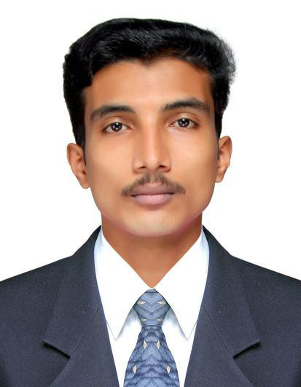

Position Desired :Graphic Designer

Objective:

To attain advancement in a more competitive working environment where I can apply further, enhance and refine my skills and knowledge learned from work experiences and academic qualification as a Graphic Designer

Credentials:

Energetic and talented graphic designer with a proven record of delivering creative and innovative design solutions. A proven ability of developing projects from inception through production to final delivery, ensuring that all work is effective, appropriate and delivered within a timescale.

Competencies:

- Excellent knowledge in Graphic Designing
- Managing, producing and Designing projects
- Creating marketing materials on a range of projects
- Creating artwork for projects
- Involved in designing and aadvertisements, brochures, handouts, flyers and online Graphics.
- Producing graphic content for site re-skins, page layouts, email designs, site graphics & Static & Flash banners.
- Strong Interpersonal skills
- Ability to work in diverse culture
- Team player, Ambitious and energetic
- Ability to work under pressure and time bounded

Areas of Expertise :

- Graphics Section : Illustrator, Corel Draw, Photoshop, Indesign
- Animation Section : Maya, 3DxMax
- Post Production Section : Adobe Primer, Adobe after effects, Eduis
- Web Design section : Dream Viewer, Adobe Flash

Professional Work History:

DLI Systems (P) Ltd Feb 2017
Graphic Designer Malappuram –Kerala
Presently Working in DLI Systems (P) Ltd

Developing concepts and Artwork, Wire Frame Design, Logo Resizing , Icon Design and other Application Frame Design.

Nandilath G-Mart May 2016 – November 2016
Corporate Graphic Designer Thrissur-Kerala

Developing website images, Creating website banners, Online product designing,

Pedler Group September 2014 – April 2016
Graphic Designer Thrissur- Kerala

Developing concepts and Artwork, Creating Graphic Design solutions from concept to completion. Responsible for developing and creating both digital and print design for a wide range of print and online campaigns, publications and advertising.

PDMA, Professional Diploma in Multimedia Animation
Info Prism Solutions, Thrissur (Malayala Manorama Info Prism Multimedia Animation)

Plus two
Senior Secondary National Institute of Open School (NIOS) ,– April 2014

Computer, MS Office General Knowledge

Language Proficiency:

- English : Read, Write and Speak (fair)
- Tamil : Speak
- Malayalam : Mother tounge
Personal Details:

- Nationality : Indian,
- Father’s name : Pradeep Kumar
- Date of Birth : 15July, 1994

References : Shall be furnished upon request.

