**Install WinDbg on windows 7**

**Window debugging tool come as a part of Microsoft** Windows SDK

🡺Navigate to below mentioned URL and download exe file for Windows SDK

<https://www.microsoft.com/en-us/download/confirmation.aspx?id=8279>

🡺Run the executable file to open Windows SDK Setup Wizard, the click **Next** to proceed.

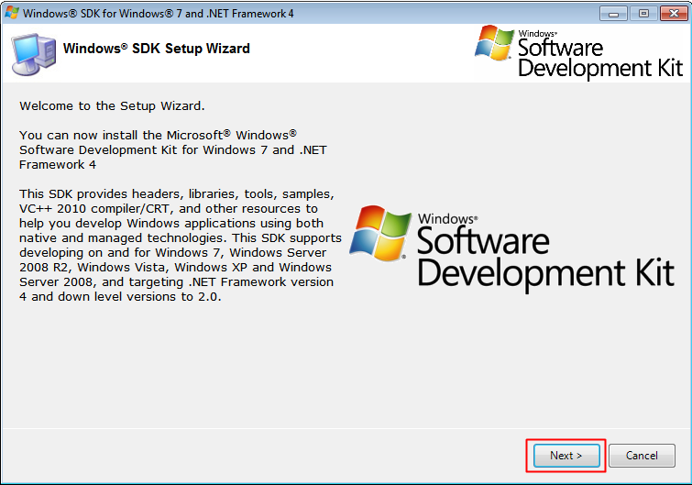

🡺In the Installation Options page, only select the **Debugging Tools for Windows**the click **Next**to begin installation.

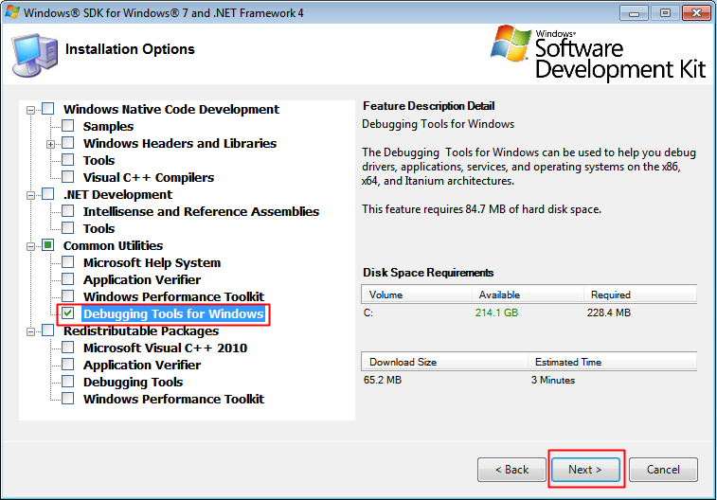

🡺Click the **Finish to** complete the installation.

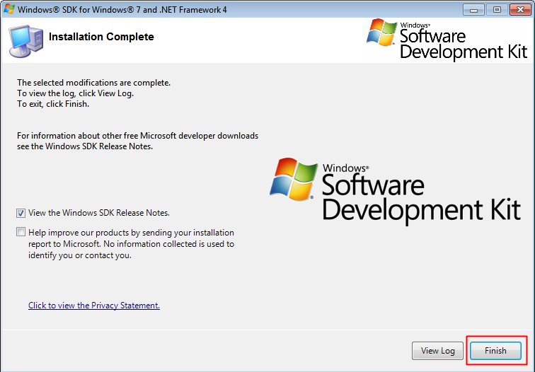

In windows 8 and 10