**Install WinDbg on windows 7**

**Window debugging tool as a part of Microsoft Windows SDK**

🡺Navigate to below mentioned URL and download exe file for Windows SDK

<https://www.microsoft.com/en-us/download/confirmation.aspx?id=8279>

🡺Run the executable file to open Windows SDK Setup Wizard, the click **Next** to proceed.

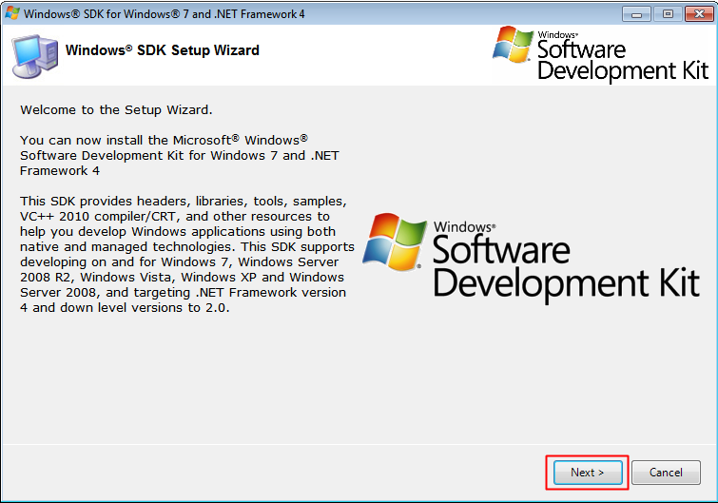

🡺In the Installation Options page, only select the **Debugging Tools for Windows**the click **Next**to begin installation.

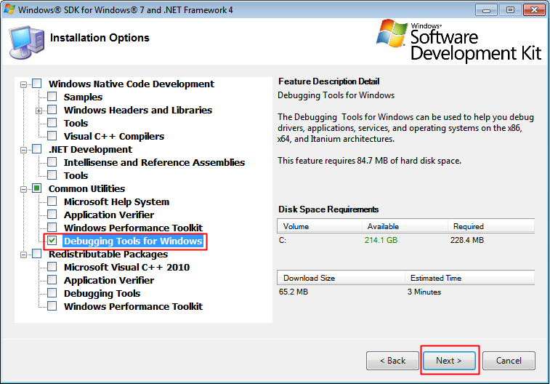

🡺Click the **Finish to** complete the installation.

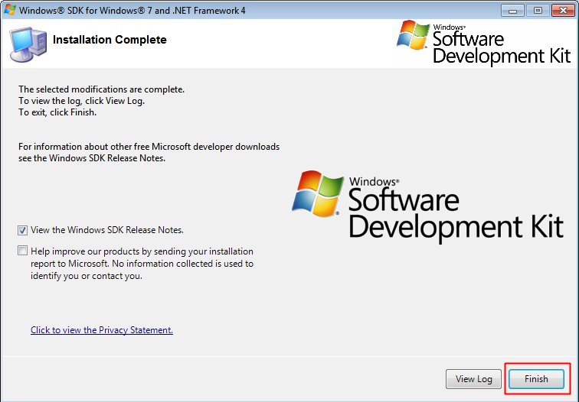

**WinDbg preview for windows 8 and 10**

WinDbg preview (a new version of WinDbg with more modern visuals, faster windows, and a full-fledged scripting experience) can be downloaded directly from Microsoft store.

🡺https://www.microsoft.com/en-us/p/windbg-preview/9pgjgd53tn86?activetab=pivot:overviewtab