**Index**

**Navbar(**static**)**

🡪 Navbar will have number of menus which will show their content accordingly.

🡪content can not be edited using Google sheet though which content to load is decided dynamically from google sheet

🡪Navbar also shows Time and Date at every screen as it is mounted on root directory



🡪DB icon is provided at the right corner of the Navbar which indicates the connectivity of site with backend

 ---------------🡪Not connected with Backend

****---------------🡪Connected with Backend

**__________________________________________________________________________________**

**Home(static)**

🡪Home page will **#always have** logo and Intro (Both are **#hardcoded**, logo could be rotatable )

**Integration with Instagram:**

There is no need to maintain separate database to maintain gallery and images, as this app can integrate with Instagram and hence all post/images/gallery can be directly accessed from Instagram.

**#always have** means regardless of screen-size, Logo and Intro will always be there on home page, On other pages logo will not be there on mobile size screen.

**#hardcoded** means can not be edited using Google sheet

**__________________________________________________________________________________**

**About (**static**)**

🡪About is also static/hardcoded page, will have introduction in more words, can contain other links too

**__________________________________________________________________________________**

**Download** (Dynamic)

🡪 Download will have concept of Menu, submenu, sub-submenu…and so on..  
 used recursive function….

🡪At every level of click the colour of the background is changed, so that event handling can easily be observed (future scope will use animation)

🡪Will **indicate** whether button is another **menu or a link.**

🡪At every stage of menu and submenu **back button** is provided **except main menu**

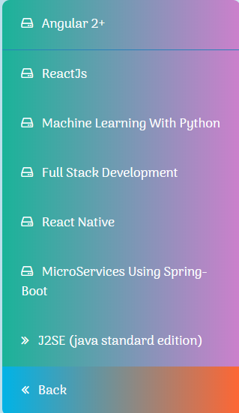

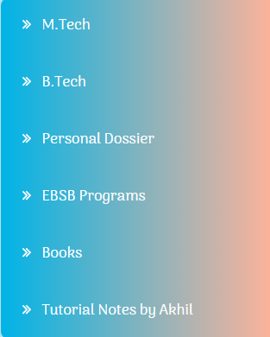

**__________________________________________________________________________________**

**Get In touch**(Dynamic)

🡪 Get in touch will be having dynamic form which can be created or edited using google sheet

🡪9 fields/Input of any type (input type text, select option, select multiple options etc.) can be provided to this form using google sheet in which one field (i.e textField 9th is explicitly mapped for type of date, if assigned).  
  
 All these 9 field have these number of properties

1) Label

2) Placeholder

3) Type (can be text,select,multiple etc)

4) Regular Expression(RegEx) //for text input pattern mapping

5) Error message if wrong input provided according to the RegEx provided

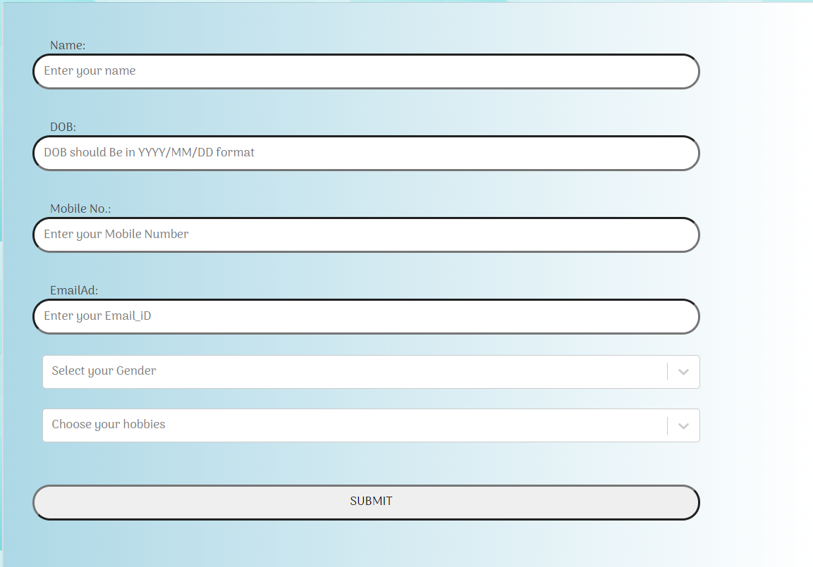

**Accessing the Data**

As this form is dynamically generated or can be changed time to time, so that we will be having requirement to access data from the data and time of creation of form.  
hence we can also provide date and time of the creation of the form, so that appropriate date can be retrieved.

Admin Login is required to access data.

**Type of data that can be provided so far.**

Text

Select

Multi-select

All these data can be synched with their respective Regular expression and hence can be used in

Various forms like Date, Yes/No, Mobile No etc.

**__________________________________________________________________________________________________**

**Footer**



**Other Features:**

**This application is totally responsive and can be accessed in various size of screen.**

**This application is totally free.**

**Various regular expression is already provided**

**Android & IOS app of this web application is under development**