**Setting up ONTAP for Integration with CM 2.2**

1. Sign up On Netapp Portal (<https://services.cloud.netapp.com/fabric-view>)
2. Subscribe to Cloud ONTAP on the [AWS Marketplace](https://aws.amazon.com/marketplace/pp/B011KEZ734)
3. Create connector (AWS Access key and Secret key is required)

<https://docs.netapp.com/us-en/occm/task_creating_connectors_aws.html#setting-up-aws-permissions-to-create-a-connector>

🡺Create working environment

In order to create working environment with Ontap connector, it is needed to have S3 endpoint service (endpoint type of Gateway) in your VPC.

In AWS console, Go to

Networking & Content Delivery 🡺VPC 🡺 Endpoints

And check for the same for your VPC

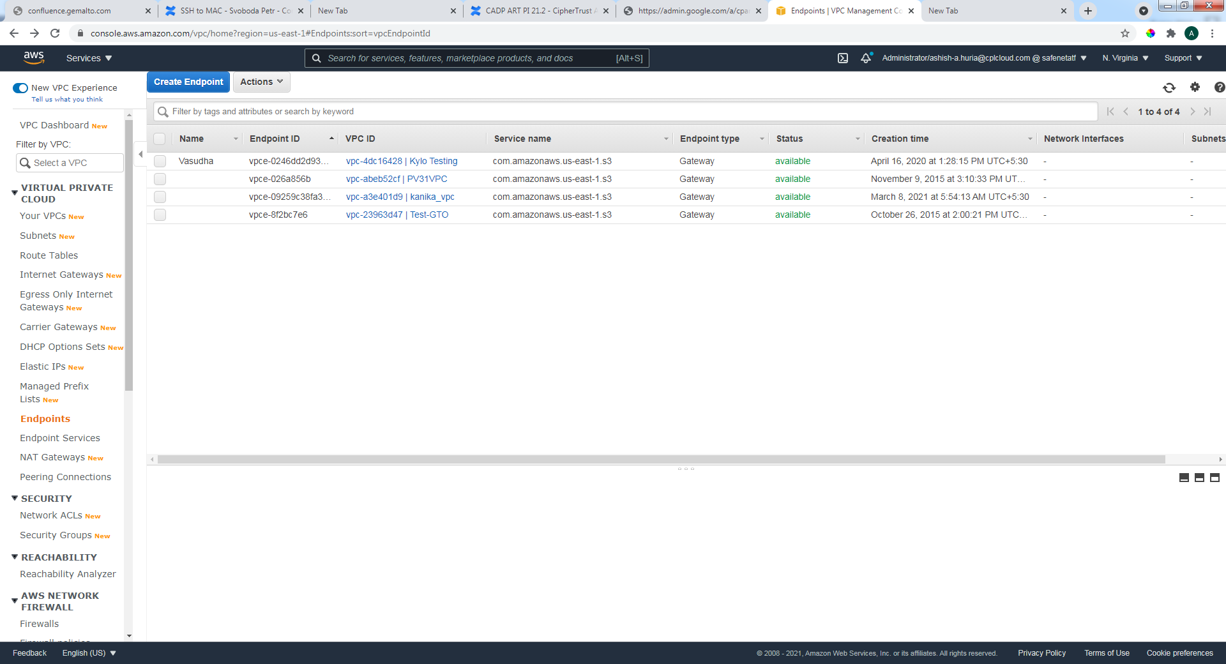

🡺Choose AWS as web service

🡺Choose cloud Volumes ONTAP (Single Node)

🡺Choose Working environment name (instance of same name will be created at AWS)

🡺Set credential for admin

🡺select AWS region

🡺select VPC

🡺Create a security group of your own on AWS

🡺create one key pair of your own on AWS

🡺select existing security group option

🡺select SSh authentication method as key pair

🡺use this security group and key pair for setting up of Working environment

🡺select pay as you go

🡺click on create my own configuration (and select version of ONTAP to be integrated)

🡺Instance type is m5.xlarge

🡺Instance tenancy is shared

🡺select general purpose SSD

🡺AWS disk size is 100GB

🡺write speed is normal

🡺Give volume name

🡺NFS (Network file system) protocol should be selected

🡺Accept term & conditions, and click on GO for creating working environment

**\*Note : It will take 20-25 minutes to create working environment**

You can refer to this video for setting up <http://peertube.gemalto.com/videos/watch/f9c41625-f550-46dd-afc0-95aedf9d832b>

1. Once working environment is ready to use

🡺Stop Ontap instance and Create 5 EBS volumes and attach to Ontap Instance on AWS.

🡺after attaching volumes, restart the ontap Instance

1. Now connect to Ontap Instance vis ssh

🡺ssh admin@<ontap-instance-ip>

🡺check for unowned disks

🡺 storage disk show -container-type unassigned

🡺Assign each disk

🡺 storage disk assign -disk disk_name -owner owner_name

🡺Zero the newly added disk

🡺storage disk zerospares

1. After assigning owner name, owner name should be reflected

