********************************************************************************
Freenas tutorial ::

http://freenas.2trux.com/
https://doc.freenas.org/9.10/intro.html

********************************************************************************

ssmtp config ::

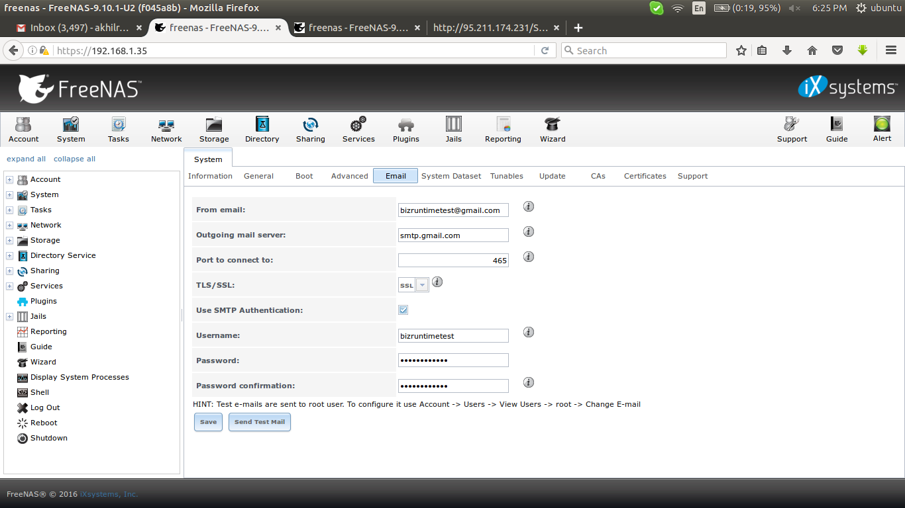
ssl certs creation ::

1) create ca

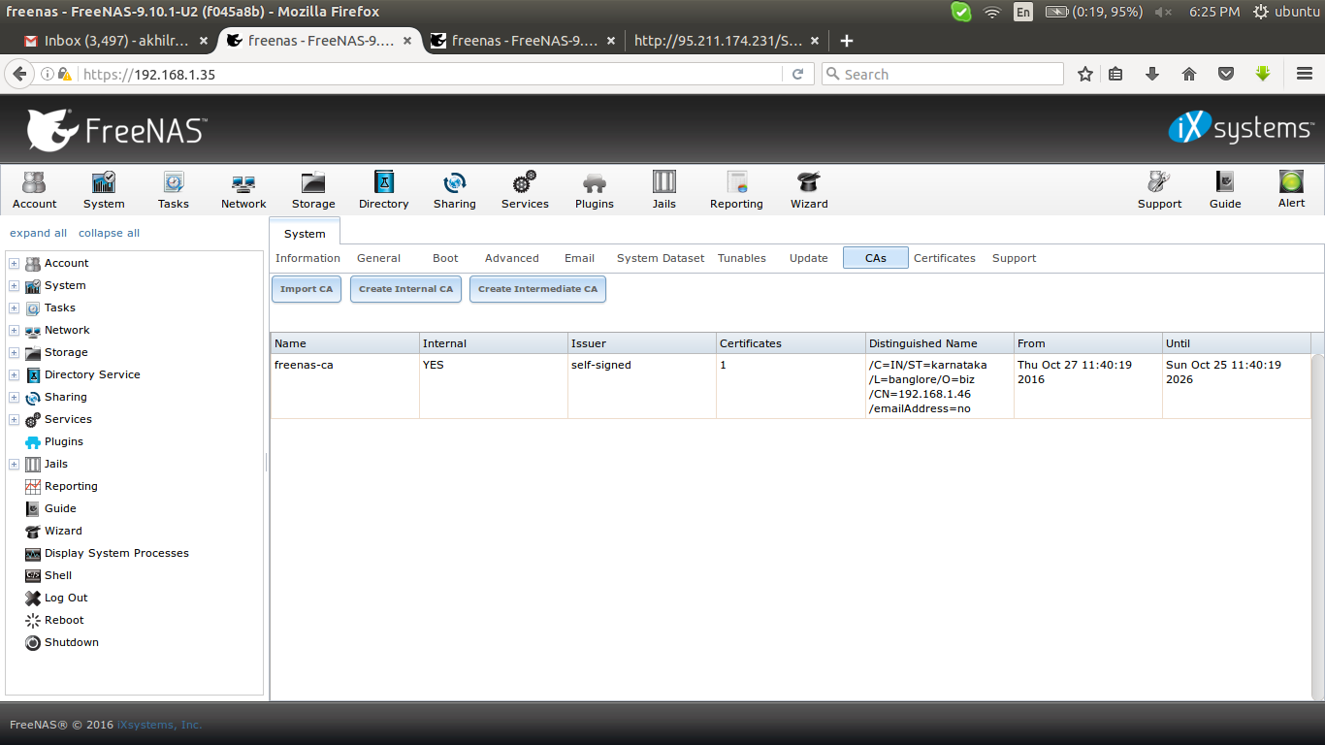

2) create ssl key and certs using ca

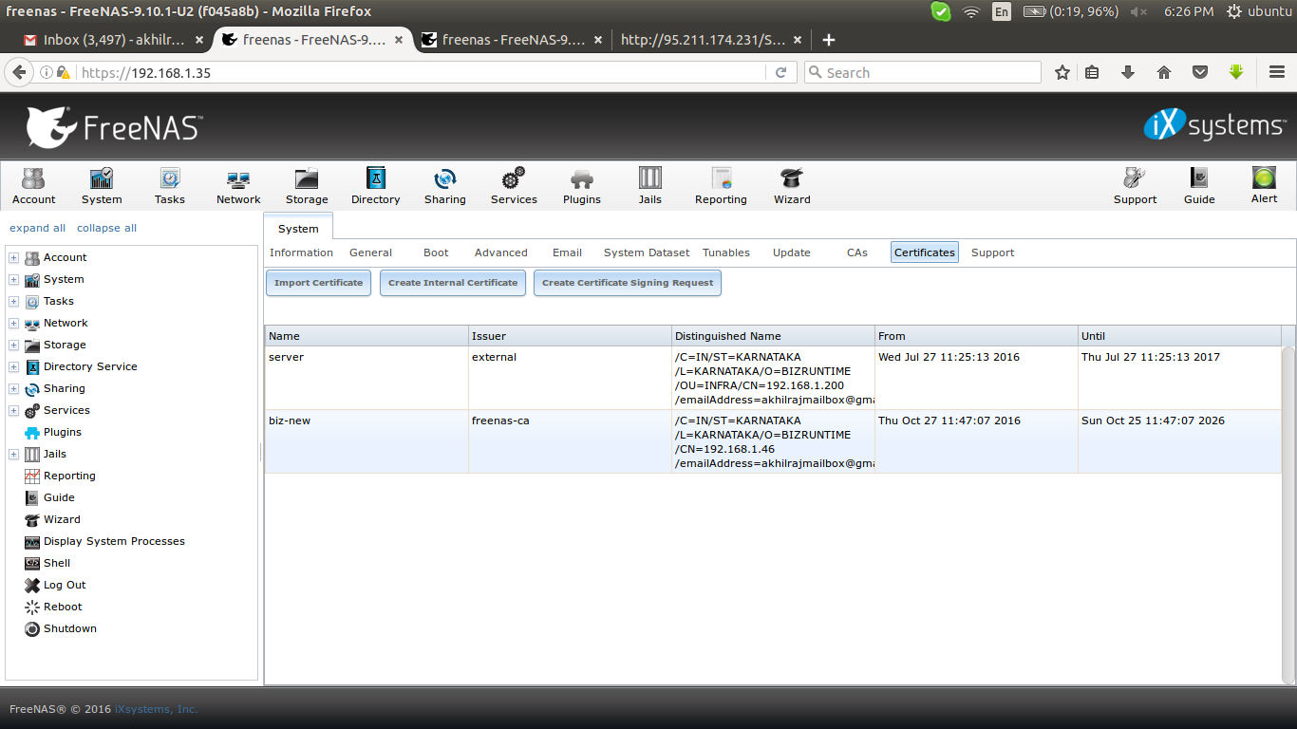

ldap configuration ::

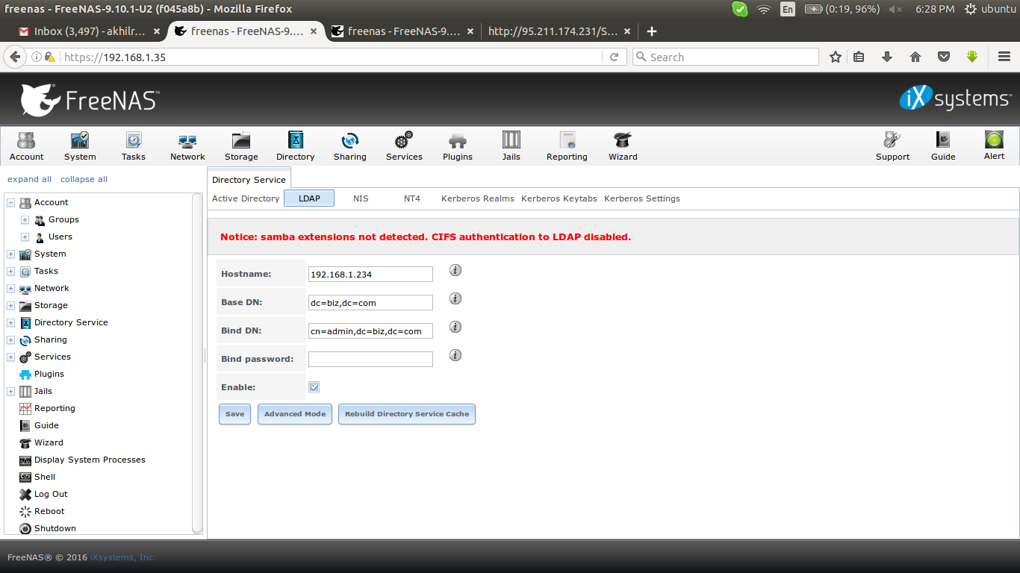
users listed in share configuration windows only,

attaching volume in vmware ::
https://forums.freenas.org/index.php?threads/freenas-8-on-vmware-4-1-no-member-disks.1230/

********************************************************************************
s3 bucket mounting in freenas
********************************************************************************

Run freenas os in a server, then go to web GUI and go inside the shell (working inside the shell is not recomended because the data will not persist inside the server after reboot, so use jail with same version of freenas server).

Edit /usr/local/etc/pkg/repos/FreeBSD.conf “no” to “yes”

# nano /usr/local/etc/pkg/repos/FreeBSD.conf
change no to yes

# pkg update # if it doent work, go through the following steps

# rm /var/db/pkg/repo-*.sqlite
# pkg update

# pkg install fusefs-s3fs

to start it at booting

# kldload fuse

# nano /etc/rc.conf >> fusefs_enable="YES"

after this create a directory for mounting

# mkdir /mnt/mys3bucket

Now create a file in /etc/ called passwd-s3fs and set its perms to 640. In that file add your S3 access-key and secret key as follows:

# nano /etc/passwd-s3fs

accessKeyId:secretAccessKey

# /usr/local/etc/rc.d/fusefs start

mount the s3 bucket to that directory

# s3fs <bucket-name> /mnt -ouse_cache=/tmp,allow_other

# s3fs freenas-test-02 /mnt/mys3bucket

********************************************************************************

links::

installation in ubuntu >>
https://github.com/s3fs-fuse/s3fs-fuse/wiki/Installation%20Notes
https://ports.markheppner.com/sysutils/fusefs-s3fs

remote sync >>
http://www.inetpub.dk/index.php/widgetkit/just-going-through-the-motions/60-remote-synchronization-from-freenas-to-amazon-s3

jail setup >>
https://forums.freenas.org/index.php?threads/virtualbox-in-a-jail-in-freenas.20185/

error inside jail and solutions >>
https://forums.freebsd.org/threads/57203/
https://forums.freebsd.org/threads/25920/
https://forums.freebsd.org/threads/44181/
http://unix.stackexchange.com/questions/301640/how-to-pkg-upgrade-on-freenas-freebsd
https://forums.freebsd.org/threads/15961/

mounting s3 >>
http://superuser.com/questions/327661/how-to-mount-amazon-s3-bucket-to-a-directory-on-freebsd

********************************************************************************

