Ldap configuration in alfresco

1) add users in ldap

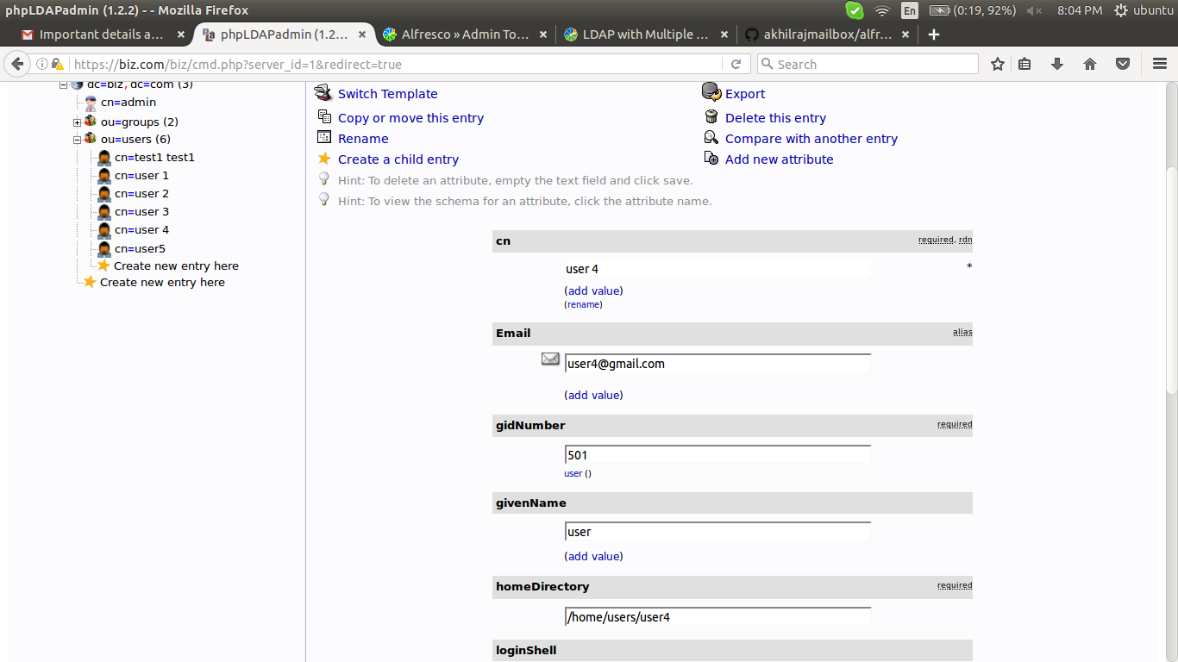

2) find the doirectory /${alfresco-home}/tomcat/shared/classes/alfresco/extension/subsystems/Authentication/ldap/ldap1, if it not found just create it.

3) configure ldap-authentication.properties

###############################################################################
# ldap-authentication.properties
#path to create the ldap-file
#/${alfresco-#home}/tomcat/shared/classes/alfresco/extension/subsystems/Authentication/ldap/l#dap1/ldap-authentication.properties
#use this link for detailed info
#https://community.alfresco.com/thread/184630-ldap-with-multiple-domain

# This flag enables use of this LDAP subsystem for authentication. It may be
# that this subsytem should only be used for synchronization, in which case
# this flag should be set to false.
ldap.authentication.active=true

# This properties file brings together the common options for LDAP authentication rather than editing the bean definitions
ldap.authentication.allowGuestLogin=true

#make it empty so that all ldap user will queried
ldap.authentication.userNameFormat=

# The LDAP context factory to use
ldap.authentication.java.naming.factory.initial=com.sun.jndi.ldap.LdapCtxFactory

# The URL to connect to the LDAP server
ldap.authentication.java.naming.provider.url=ldap://192.168.1.234:389

# The authentication mechanism to use
ldap.authentication.java.naming.security.authentication=simple

# Escape commas entered by the user at bind time
# Useful when using simple authentication and the CN is part of the DN and contains commas
ldap.authentication.escapeCommasInBind=false

# Escape commas entered by the user when setting the authenticated user
# Useful when using simple authentication and the CN is part of the DN and contains commas, and the escaped \, is
# pulled in as part of an LDAP sync
# If this option is set to true it will break the default home folder provider as space names can not contain \
ldap.authentication.escapeCommasInUid=false

#for making a particular user as admin
ldap.authentication.defaultAdministratorUserNames=admin,user4
ldap.authentication.authenticateFTP=true

# This flag enables use of this LDAP subsystem for user and group
# synchronization. It may be that this subsytem should only be used for
# authentication, in which case this flag should be set to false.
ldap.synchronization.active=true

# The default principal to use (only used for LDAP sync)
ldap.synchronization.java.naming.security.authentication=simple
ldap.synchronization.java.naming.security.principal=cn\=admin,dc\=biz,dc\=com

# The password for the default principal (only used for LDAP sync)
ldap.synchronization.java.naming.security.credentials=appoozz18

# If positive, this property indicates that RFC 2696 paged results should be
# used to split query results into batches of the specified size. This
# overcomes any size limits imposed by the LDAP server.
ldap.synchronization.queryBatchSize=1000

# If positive, this property indicates that range retrieval should be used to fetch
# multi-valued attributes (such as member) in batches of the specified size.
# Overcomes any size limits imposed by Active Directory.
ldap.synchronization.attributeBatchSize=1000

# The query to select all objects that represent the groups to import.
#eg : ldap.synchronisation.groupQuery=(objectclass=zimbraDistributionList)(zimbraMailStatus=enabled)
ldap.synchronization.groupQuery=(objectclass\=groupOfUniqueNames)

# The query to select objects that represent the groups to import that have changed since a certain time.
ldap.synchronization.groupDifferentialQuery=(&(objectclass\=groupOfUniqueNames)(!(modifyTimestamp<\={0})))

# The query to select all objects that represent the users to import.
#eg : ldap.synchronization.personQuery=(&(objectClass=organizationalPerson)(zimbraMailStatus=enabled))
ldap.synchronization.personQuery=(objectclass\=inetOrgPerson)

# The query to select objects that represent the users to import that have changed since a certain time.
ldap.synchronization.personDifferentialQuery=(&(objectclass\=inetOrgPerson)(!(modifyTimestamp<\={0})))

# The group search base restricts the LDAP group query to a sub section of tree on the LDAP server.
ldap.synchronization.groupSearchBase=dc\=biz,dc\=com

# The user search base restricts the LDAP user query to a sub section of tree on the LDAP server.
ldap.synchronization.userSearchBase=dc\=biz,dc\=com

# The name of the operational attribute recording the last update time for a group or user.
ldap.synchronization.modifyTimestampAttributeName=modifyTimestamp

# The timestamp format. Unfortunately, this varies between directory servers.
ldap.synchronization.timestampFormat=yyyyMMddHHmmss'Z'

#for login with particular atrribute of ldap, here example=mail (cannt login as user id)
ldap.synchronization.userIdAttributeName=mail
#ldap.synchronization.userIdAttributeName=uid

# The attribute on person objects in LDAP to map to the first name property in Alfresco
ldap.synchronization.userFirstNameAttributeName=givenName

# The attribute on person objects in LDAP to map to the last name property in Alfresco
ldap.synchronization.userLastNameAttributeName=sn

# The attribute on person objects in LDAP to map to the email property in Alfresco
ldap.synchronization.userEmailAttributeName=mail

# The attribute on person objects in LDAP to map to the organizational id property in Alfresco
ldap.synchronization.userOrganizationalIdAttributeName=o

# The default home folder provider to use for people created via LDAP import
ldap.synchronization.defaultHomeFolderProvider=largeHomeFolderProvider

# The attribute on LDAP group objects to map to the authority name property in Alfresco
ldap.synchronization.groupIdAttributeName=cn

# The attribute on LDAP group objects to map to the authority display name property in Alfresco
ldap.synchronization.groupDisplayNameAttributeName=description

# The group type in LDAP
#eg : ldap.synchronisation.groupType=zimbraDistributionList
ldap.synchronization.groupType=groupOfUniqueNames

# The person type in LDAP
#eg : ldap.synchronisation.personType=organizationalPerson
ldap.synchronization.personType=inetOrgPerson

# The attribute in LDAP on group objects that defines the DN for its members
#eg : ldap.synchronisation.groupMemberAttributeName=zimbraMailForwardingAddress
ldap.synchronization.groupMemberAttributeName=uniqueMember

# If true progress estimation is enabled. When enabled, the user query has to be run twice in order to count entries.
ldap.synchronization.enableProgressEstimation=true
ldap.authentication.java.naming.read.timeout=0
4) add the following lines in alfresco-global.properties

##################################################################################################
############################ alfresco-global.properties ########################################
##################################################################################################

authentication.chain=alfrescoNtlm1:alfrescoNtlm,ldap1:ldap

#ldap auth only can done with following (no alfrsco admin can login)
#authentication.chain=ldap1:ldap

synchronization.synchronizeChangesOnly=true
synchronization.syncWhenMissingPeopleLogIn=true
synchronization.syncOnStartup=true

5) all ldap users will sync to alfresco, we can see that as below,

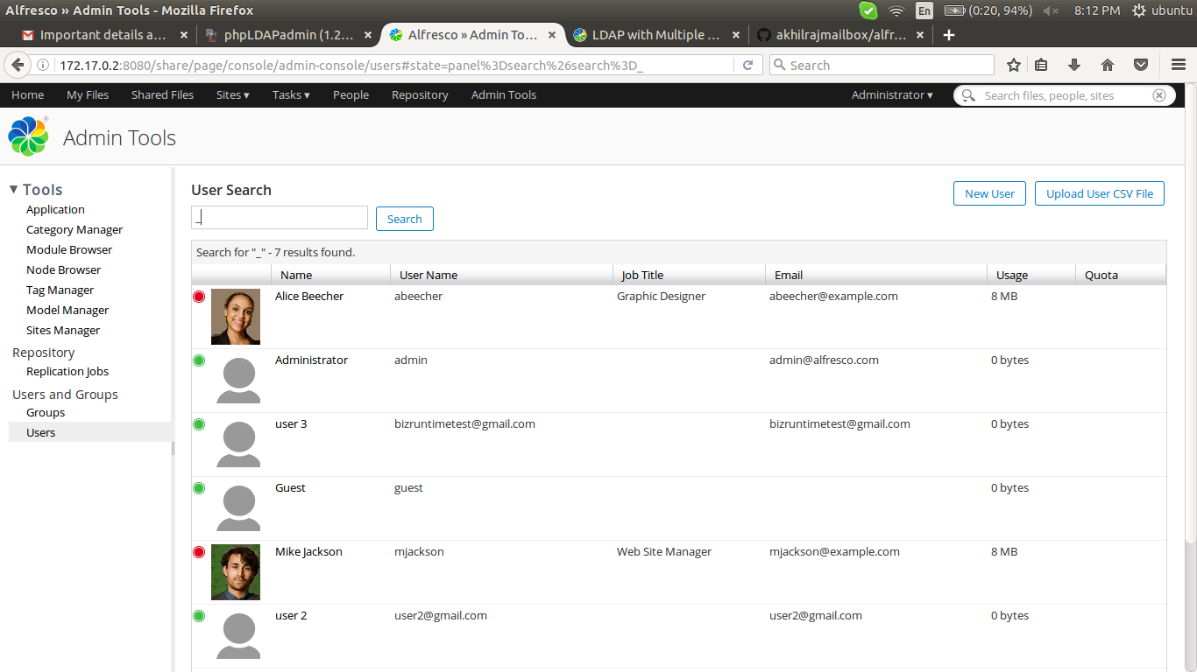

6) try to login as ldap user (in this senario, i configured to login as mail attributes of ldap user)

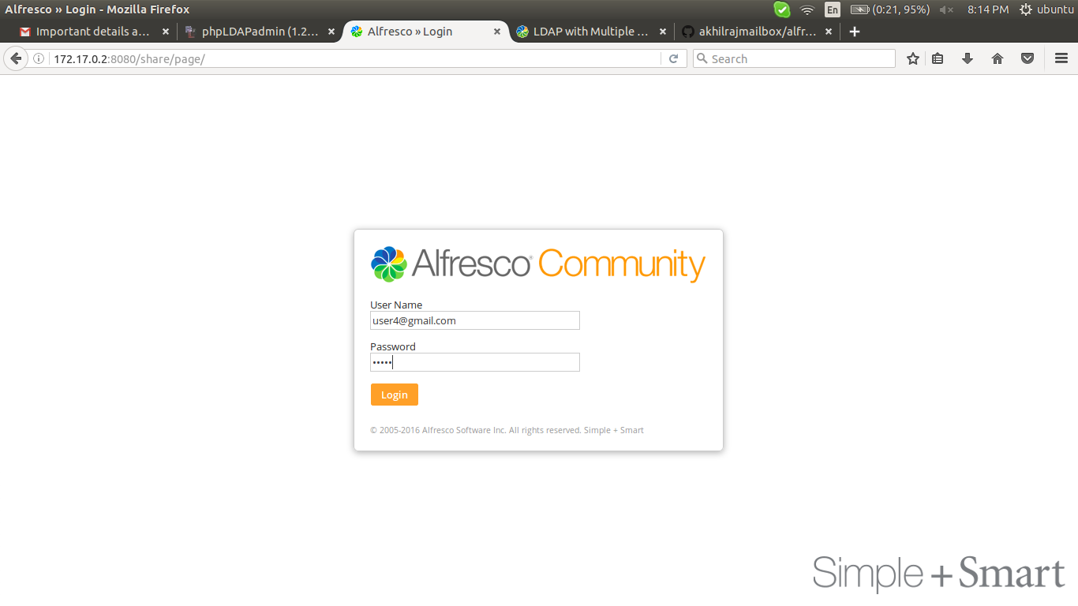
7) check it

