Alfresco Multi-tenancy with alfresco cluster

1. First we need to reffers the document of alfresco cluster which has given
installation of Alfresco cluster.

2. Now we need to login with admin account in “Alfresco Administration Console(admin only)”

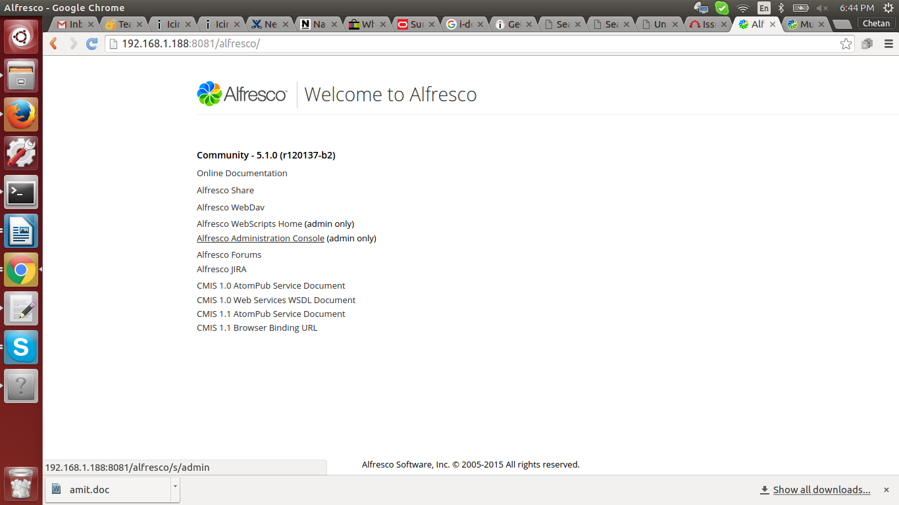

3. we will get following screen.

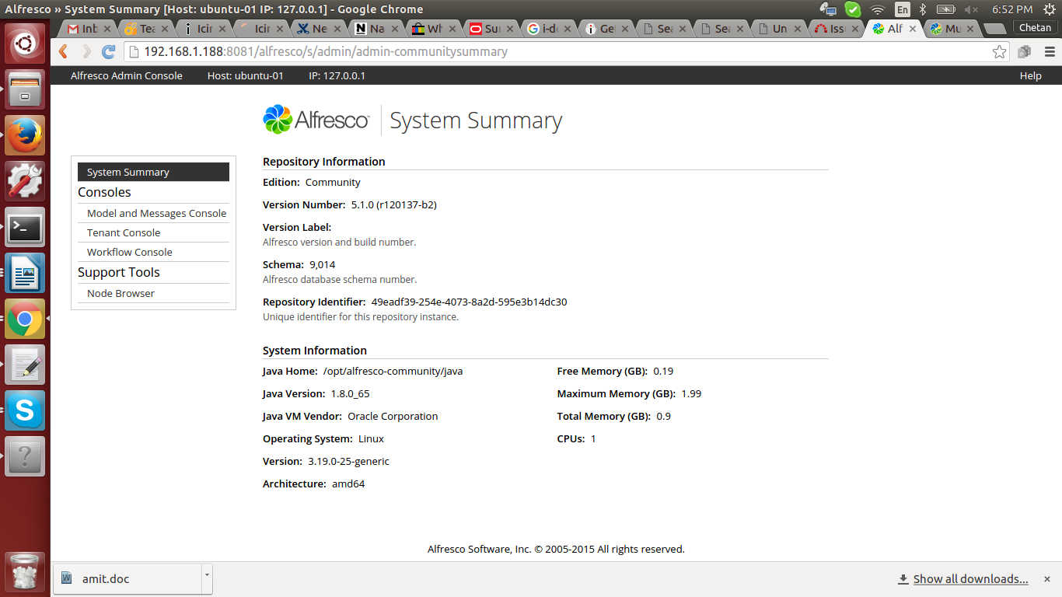

4. Click on “Tenant Console” on left side.

Now, we have to create tenant for this server.

First create directory on server.

ex. mkdir -p /usr/bizruntime/BBB

mkdir -p /usr/bizruntime/CCC

Now create tenant: --

a. create bbb.com bizruntime@123 /usr/bizruntime/BBB

create ccc.com bizruntime@123 /usr/bizruntime/CCC

Here, “bbb.com and ccc.com” are tenant name , “bizruntime@123” is password and
“/usr/bizruntime/BBB and /usr/bizruntime/CCC” are directories which point to particular
tenants.

b. By using following command we can see all tenants.

show tenants

c. we can enable and disable tenants with following commands

enable bbb.com

disable bbb.com

d. we can delete tenants with following comand.

delete bbb.com

5. Now we can loging to share with newly created tenants. By default “admin” is user for newly
created tenants.

So, we can login as,

User- admin@bbb.com
Pass- bizruntime@123

6. Once login we will get administrator login. Now we can create users in each
tenants which will be different from another tenants.

If we created user under bbb.com tenant then user will be login as

ex. User- chetan@bbb.com
Pass- bizruntime@123

7. Now, Here we have alfresco setup. So, we need to share directory of each tenants
with another server.

So, export directory as follow.

# nano /etc/exports

/usr/bizruntime/BBB 192.168.1.* (rw,sync)
/usr/bizruntime/CCC 192.168.1.* (rw,sync)

# /etc/init.d /nfs-kernel-server restart

8. Now , mount share on another server . Create directory /usr/bizruntime/BBB

# mount -t nfs 192.168.1.188:/use/bizruntime/BBB /usr/bizruntime/BBB

9. Now, we are able to login to both servers with tenants.

