setting up an Alfresco cluster

Need to know

alfresco clustering

1) make sure that nfs share point reachable
2) run docker-container with --privileged for mounting nfs
3) change root directory option in option-file which used in auto-installation of alfresco (prifix option in option-file)
4) change the share point and mount path in dockerfile
5) give same database path & all db info in all alfresco server ( in option-file )

Here we have two alfresco server.

1. 192.168.1.188

2. 192.168.1.187

A) Configuration For server 192.168.1.188.

1. we need to download alfresco setup.

# cd /opt/

# wget https://sourceforge.net/projects/alfresco/files/Alfresco%20201512-EA%20Community/alfresco-community-installer-201512-EA-linux-x64.bin/download

after that you will see file with name download.

Now change permition with following.

# chmod 777 download

2. Now run setup with the following command.

# ./download

Follow the installation steps as shown in the following figure.

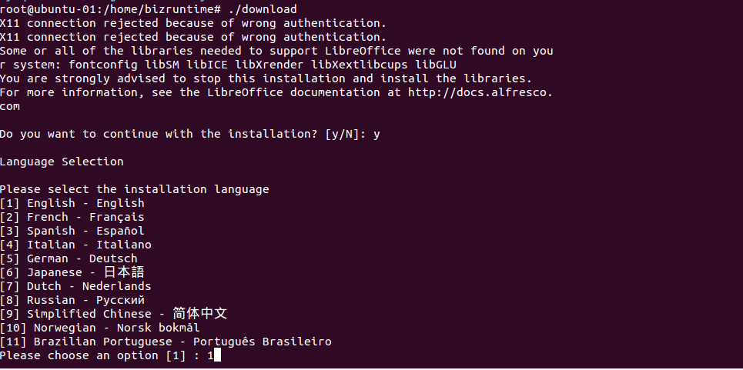
Fig 1

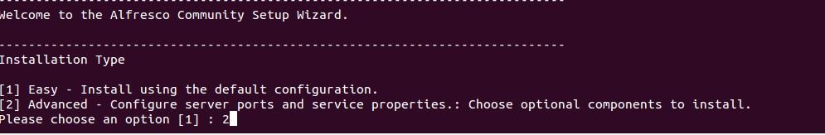
Fig 2

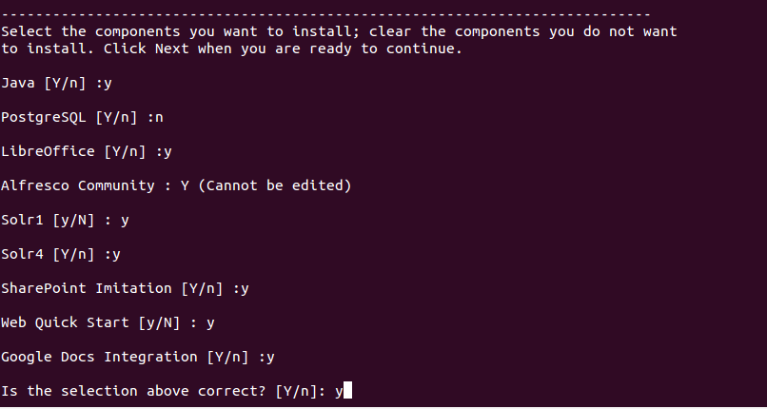
Fig 3

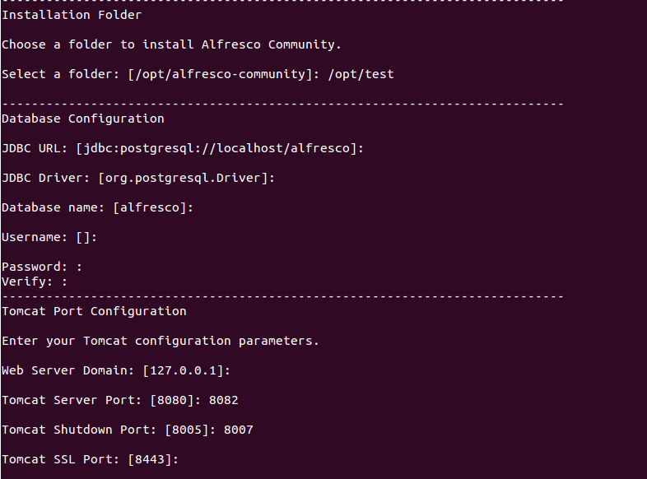
Fig 4

Continue with installation.......!

3. In this setup we are going to use mysql database. In this case our mysql database will be

Running on 192.168.1.188. Here we are using comman database for both alfresco server.

We can use RDS database also.

So, we need to install mysql database server.

# sudo apt-get install mysql-server

4. Here our database is ready. Check the configuration of mysql whether it is accessible by remotly.

5. Now create database and grant permition.

mysql> CREATE DATABASE alfresco_cluster DEFAULT CHARACTER SET utf8 COLLATE
utf8_unicode_ci;

mysql> GRANT ALL PRIVILEGES ON alfresco_cluster.* TO alfresco_cluster@'%' IDENTIFIED BY
'alfresco_cluster';

mysql>GRANT SELECT,LOCK TABLES ON alfresco_cluster.* TO alfresco_cluster@'%'
IDENTIFIED BY 'alfresco_cluster';

mysql > FLUSH PRIVILEGES;

6. Now, we need Mysql connector.

# cd /opt/

# wget https://dev.mysql.com/get/Downloads/Connector-J/mysql-connector-java-5.1.38.tar.gz

# tar -xvf mysql-connector-java-5.1.38.tar.gz

# cd mysql-connector-java-5.1.38

Now, copy .jar in /opt/alfresco-community/tomcat/lib

# cp mysql-connector-java-5.1.38-bin.jar /opt/alfresco-community/tomcat/lib

7. Now Configuration of alfresco cluster.

# nano /opt/alfresco-community/tomcat/shared/classes/alfresco-global.properties

Create root directory /tmp/alfresco

------------------------------------------------------------------------------------------------------------------------------------------------------Change Configuration According to Following----------------------------------
------------------------------------------------------------------------------------------------------------------------
###############################
## Common Alfresco Properties #
###############################

dir.root=/tmp/alfresco/alf_data

alfresco.context=alfresco
alfresco.host=127.0.0.1
alfresco.port=8081
alfresco.protocol=http

share.context=share
share.host=127.0.0.1
share.port=8081
share.protocol=http

### database connection properties ###
db.driver=com.mysql.jdbc.Driver
#db.driver=org.gjt.mm.mysql.Driver
db.username=alfresco_cluster
db.password=alfresco_cluster
db.name=alfresco_cluster
db.host=192.168.1.188
db.port=3306
db.url=jdbc:mysql://${db.host}:${db.port}/${db.name}?useUnicode=yes&characterEncoding=UTF-8

# Note: your database must also be able to accept at least this many connections. Please see your database documentation for instructions on $
db.pool.max=275
db.pool.validate.query=SELECT 1
user.name.caseSensitive=true
# The server mode. Set value here
# UNKNOWN | TEST | BACKUP | PRODUCTION
system.serverMode=UNKNOWN

### RMI registry port for JMX ###
alfresco.rmi.services.port=50500

### External executable locations ###
ooo.exe=/opt/alfresco-community/libreoffice/program/soffice.bin
ooo.enabled=true
ooo.port=8100
img.root=/opt/alfresco-community/common
img.dyn=${img.root}/lib
img.exe=${img.root}/bin/convert

jodconverter.enabled=false
jodconverter.officeHome=/opt/alfresco-community/libreoffice
jodconverter.portNumbers=8100

### Initial admin password ###
alfresco_user_store.adminpassword=4100799eed85b5f14f36c283fb0f019c

### E-mail site invitation setting ###
notification.email.siteinvite=false

### License location ###
dir.license.external=/opt/alfresco-community

### Solr indexing ###
index.subsystem.name=solr4
dir.keystore=/opt/alfresco-community/alf_data/keystore
solr.host=localhost
solr.port.ssl=8443

### Allow extended ResultSet processing
security.anyDenyDenies=false

### Virtual Folders Config Properties ###
virtual.folders.enabled=false

##############################################

dir.indexes=/opt/alfresco-community/alf_data/lucene-indexes
dir.indexes.backup=/opt/alfresco-community/alf_data/backup-lucene-indexes
dir.indexes.lock=/opt/alfresco-community/alf_data/locks
hibernate.dialect=org.hibernate.dialect.MySQLInnoDBDialect

################################################

alfresco.cluster.name=home-test-cluster
alfresco.tcp.initial_hosts=192.168.1.188[7800],192.168.1.187[7800]
alfresco.jgroups.defaultProtocol=TCP

--------------------------------------------------------------------------------------------------------------------------------------------------------------End Of File ------------------------------------------------------------------
-----------------------------------------------------------------------------------------------------------------------

8. Now, we can start our First Alfresco server.

# cd /opt/alfresco-community/tomcat/bin

# ./catalina.sh start

check whether port 8080 is runnint or not by usting following command.

# netstat -antp | grep LISTEN

9. Here our Fisrt server is ready.

As per we said we are using comman database. Here also we need to share comman root directory.

So, In our case we will share comman root directory for both server.

On server 192.168.1.188 our root directory is /tmp/alfresco

Give proper permition to alfresco directory chmod -R 777 /tmp/alfresco

Now we will share this directory with another server using NFS.

Install NFS server

# sudo apt-get install nfs-server

Add the following line.

# nano /etc/exports

/tmp/alfresco 192.168.1.187 (rw,sync)

# /etc/init.d/nfs-kernel-server restart

B) Configuration For server 192.168.1.187.

1. In this First we need to mount NFS Share

Install nfs client

# sudo apt-get install nfs-common

Create directory /tmp/alfresco

# mkdir /tmp/alfresco

# mount -t nfs 192.168.1.188:/tmp/alfresco /tmp/alfresco

2. Now follow the same steps as above (steps 1,2,6,7,8) leave reamaning steps.

Note - Here Both servers are Running. Check with uploading files. On both server same file will be reflect.

