What is VMware vCloud?
Posted on January 2, 2013 by David Davis in Cloud Computing with 0 Comments
Share Tweet 0 Pin it +1 Reddit Share Share
Cloud computing is all the rage, right? Microsoft has Azure, Amazon has AWS, VMware has vCloud, and Apple has iCloud. As a consumer and server admin, what are you to do? The most important thing is not to jump into any marriage with a cloud provider. Here’s what you need to know about the cloud.

The Types of Cloud Computing
While the TV commercials saying “take it to the cloud!” might make it sound like there is just one type of cloud computing and even one cloud, it’s a lot more complex than that. There are multiple forms of cloud computing and multiple providers offering them – each with their own twist. In essence, there are three types of cloud computing:
- Software as a Service (SaaS) — Software that used to be running on your local computer now runs at a service provider and you use it over the Internet. Most likely, you are already using SaaS every day. Examples include Gmail.com and Dropbox.com — even Facebook could be a type of SaaS.
- Infrastructure as a Service (IaaS) — These are virtualized servers running at a service provider instead of in your company’s own datacenter. Many companies use IaaS; examples include Amazon Web Services (AWS), Rackspace, and VMware vCloud providers.
- Platform as a Service (PaaS) — This is a ready-made web and database service where application developers can get their application available to the world even faster than ever before. Examples of PaaS include Microsoft Azure and VMware CloudFoundry.
Thus, most everyone uses SaaS, Admins use IaaS, and Developers use PaaS.
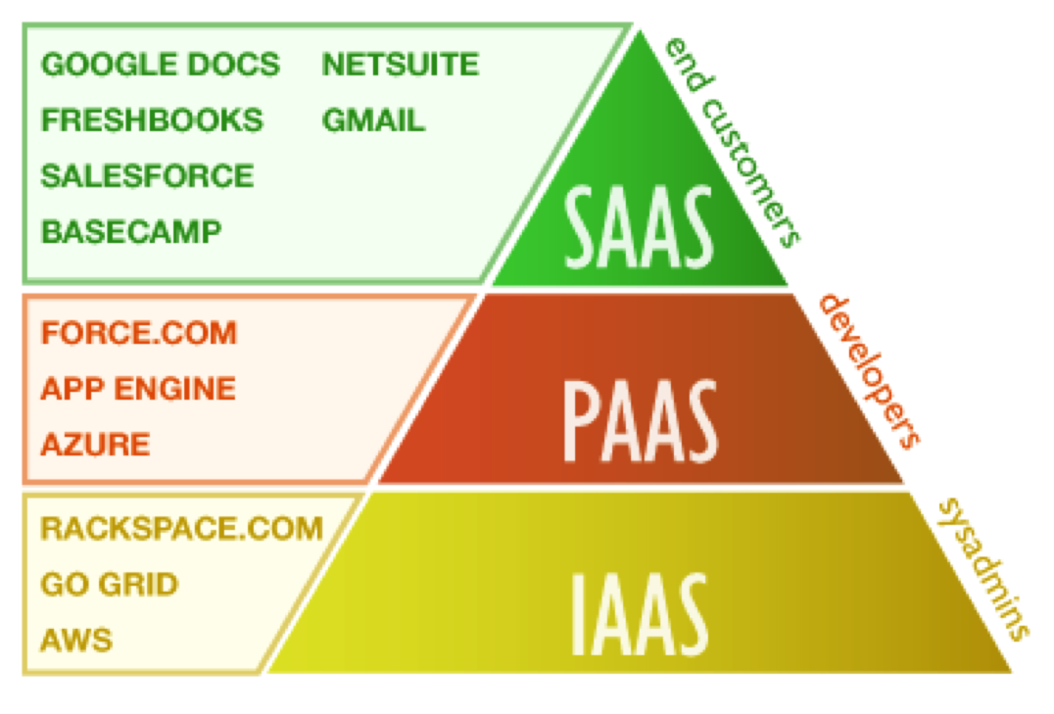
Graphic Thanks to Fibertown.com
Sponsored

What Is VMware vCloud?
VMware promotes vCloud a lot on the web but, like “cloud computing,” it may be confusing as to many what vCloud actually is. To clarify, VMware vCloud isn’t a product or service at all. vCloud is a brand and a part of a family of VMware products, with the most popular being the vCloud Suite and vCloud IaaS offerings.
VMware vCloud providers are third-party companies that offer infrastructure as a service (IaaS) solutions. These providers run the VMware vCloud Suite (covered next) and allow you to move your existing VMware vSphere virtual machines to their infrastructure clouds. Also, you can use the VMware vCloud Connector to connect your internal vSphere infrastructure with their vCloud datacenters. VMware houses a director of service providers at vCloud.VMware.com
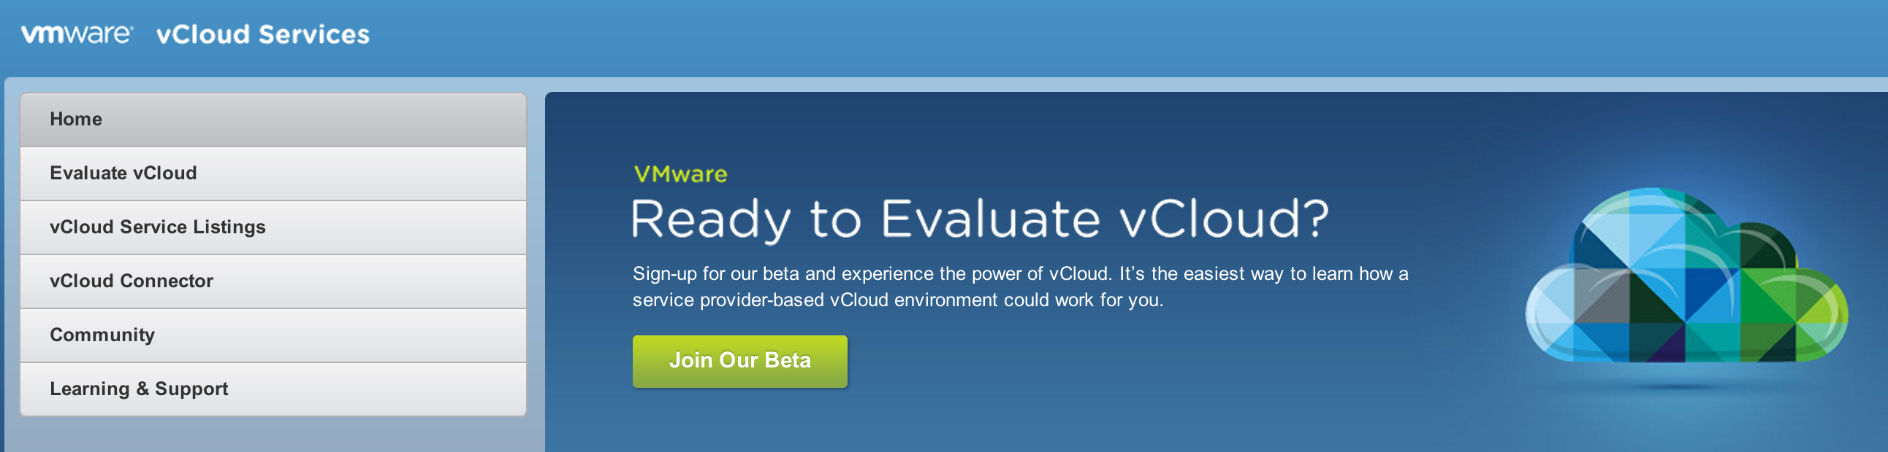

What About VMware vCloud Suite?
The other side of the vCloud family is the VMware vCloud Suite. Prior to vSphere 5.1, VMware offered vSphere, vCenter, vCloud Director, and other products, but with the announcement of vSphere 5.1, all these infrastructure products are now offered as a suite called the vCloud Suite. In the graphic below, you can see what makes up the vCloud Suite. The major components are:
- vSphere / ESXi — the hypervisor you load on your physical servers
- vCenter — the centralized management console for all the vSphere hosts and virtual machines
- vCloud Director — the private cloud self-service portal
- vCloud Networking and Security (vCNS) — previously called vSphere, vCNS is what keeps the cloud infrastructure secure
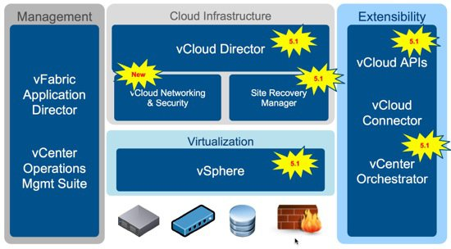
The vCloud Suite could be used by private companies in their own datacenter to create a private cloud. Or, the vCloud Suite could be used by vCloud service providers to offer public IaaS clouds, available to admins around the world. If you connect your private vCloud to your provider’s public vCloud, you have created a hybrid cloud.

Links ::
https://www.petri.com/vmware-vcloud

