********************************************************************************

How To Create Your First DigitalOcean Droplet Virtual Server

********************************************************************************

Introduction
DigitalOcean calls its virtual private servers Droplets; each Droplet that you spin up is a new VPS for your personal use.
The setup is very easy — the entire process can take as little as a minute! This tutorial will walk you through creating and accessing your new server.
Step One — Log In
To create your first Droplet go to the DigitalOcean Control Panel and log in with your email and password. The create button will be right there on the first page: click on "Create Droplet":
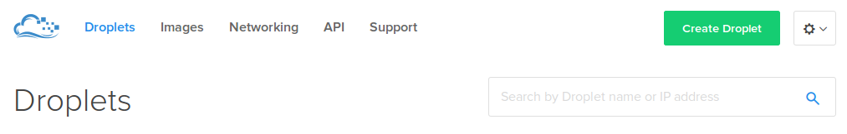

Step Two — Select Droplet Image
You can create your Droplet image from 4 possible categories:
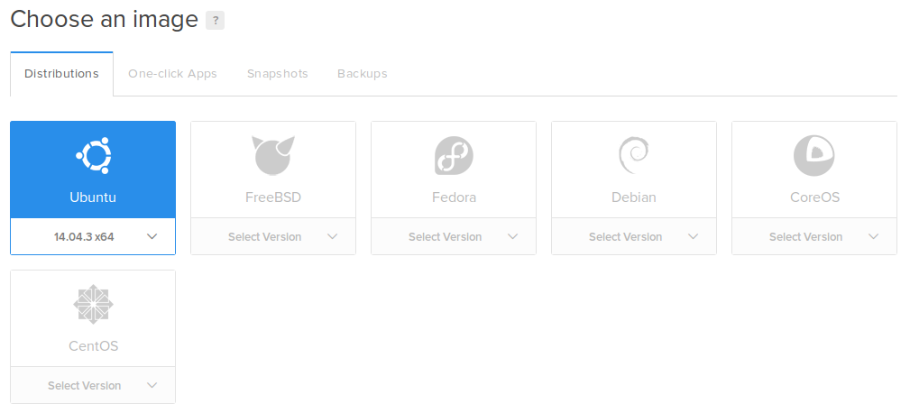

- Distributions: Create from several operating systems, such as Ubuntu, Debian, CoreOS, and CentOS. After selecting your distribution, be sure to select the image of your choice (specifying the version and 64 bit or 32 bit).
- One-click Apps: Create from images that have pre-installed and configured programs that will get your Droplet off to a strong start.
- Snapshots: Create from a snapshot that you previously made, letting you create backup copies or scale quickly.
- Backups: Create from a previously automatically generated backup, the option that you can enable on each Droplet individually with the "Backups" button.

32-bit vs. 64-bit Systems
A 32-bit operating system is recommended for cloud servers with less than 3 GB of RAM -- this is especially true for servers with 1 GB, or less, of RAM. Processes can require significantly more memory on the 64-bit architecture. On servers with a limited amount of RAM, any performance benefits that one might gain from a 64-bit operating system would be diluted by having less memory available for buffers and caching.

Step Three — Select Your Droplet's Size
Depending on your needs and budget, you can select the Droplet option that works best for you.
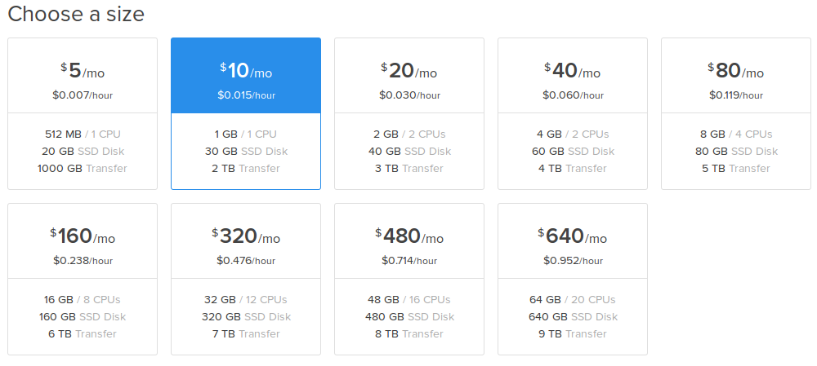
There is a wide spectrum for prices, power, and storage capacity. The smallest and least expensive option starts at 512MB of RAM with 1 CPU and 20GB of SSD storage. The size options grow larger from there, all the way up to 64GB of RAM with 20 CPUs and 640GB of SSD storage. Should your needs change at a future point, you can adjust your Droplet's plan using the flexible and permanent resize options.

Step Four — Select Your Droplet Region
You may choose the most effective region for your Droplet location. Although equally powerful, the best region to choose is the one nearest to you and your customers or other possible users. Selecting a more distant server location may increase your server latency without serving any practical purpose.
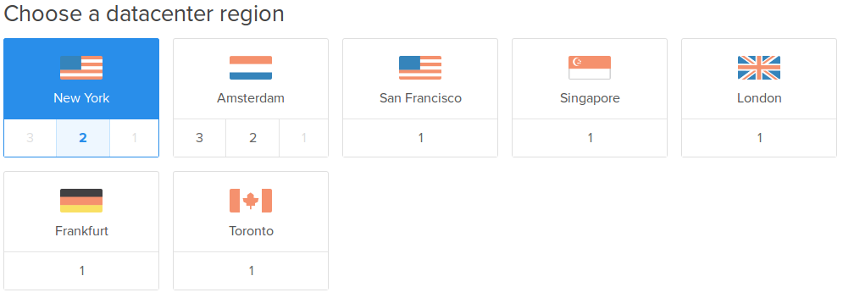

Step Five — Select Additional Options
The Select additional options section allows you to select which features you would like your Droplet to have:
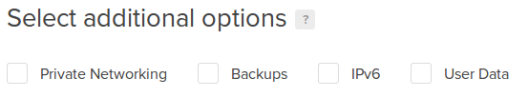
- Private Networking: Enables a private networking interface, in addition to the default public interface, that can only be accessed via the private network of other Droplets within the same datacenter.
- Backups: Enables automatic backups of the Droplet — for more information about the backup service, click here
- IPv6: Enables IPv6 access for your Droplet.
- User Data: Enables you to pass arbitrary data into the user-data key of the DigitalOcean Metadata service. This setting is required for CoreOS Droplets. To read more about user data, check out the tutorial on Droplet Metadata.
Select any of the settings you would like to enable. The Private Networking feature is very useful if you have multiple Droplets in the same datacenter that communicate with each other.

Step Six — Select SSH Keys (Optional)
Optional: Select which SSH keys you would like to add to your new Droplet.

It is recommended that you set up SSH keys to authenticate to your Droplets because it provides better security than a basic password. For more information about setting up SSH keys with your DigitalOcean Droplets, refer to this tutorial.

********************************************************************************

Setup SSH for Auto Login without a Password and without user

********************************************************************************

cd .ssh
ssh-keygen -t rsa (hit return through prompts)
copy this rsa.pub and paste it in web-console of digitalocean
then click ok

local machine optional work for sh make more easy ::

nano .ssh/config
the public key must be provided in that user's .ssh/authorized_keys

Eg 1 >>

Host digital
Hostname 192.168.1.234
User ubuntu
IdentityFile /home/ubuntu/Desktop/digital

ssh digital
in here, login as ubuntu and private key taken from IdentityFile path.

Eg 2 >>

Host akhil
Hostname 192.168.1.235
User root
IdentityFile /home/ubuntu/Desktop/digital

ssh akhil
in here, login as root and private key taken from IdentityFile path.

links : http://www.beginninglinux.com/home/server-administration/openssh-keys-certificates-authentication-pem-pub-crt

Step Seven — Select the Number and Names of the Droplets to Create
Next, you can choose the number and names of the Droplets you wish to create. Depending on the number of Droplets currently in your account, you can create up to five Droplets that will use the configuration that you have selected. By default, a single Droplet is set to be created. You can adjust the number of Droplets to create be clicking the plus or minus buttons.
Each Droplet must have a name. This name will be used in the DigitalOcean control panel and as the server's hostname. A default name will be provided for your Droplet(s) based on the options you have selected, but you can modify the name(s) to best suit your needs. You may want to use a Fully Qualified Domain Name (e.g. droplet1.example.com).
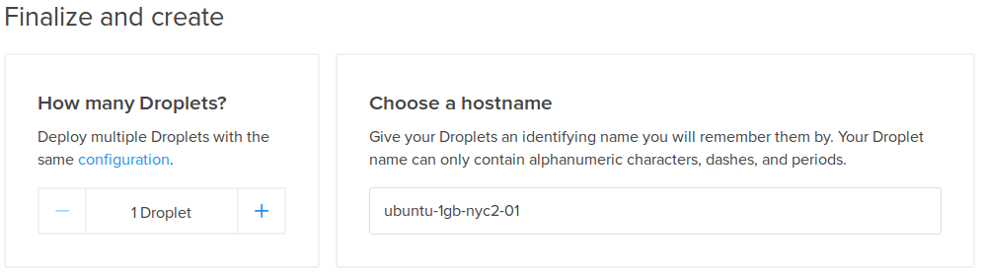

Step Eight — Create Your Droplet
Once you have selected all of your preferred options, click on "Create".
After your Droplet is created, its root password will arrive in your email inbox and the Droplet will be set up. If you included an SSH key in the previous steps, you will not be emailed a root password — use your SSH private key to authenticate as the root user instead.
With that, your server is ready!

Step Nine — Log In To Your Droplet
The process is slightly different for Mac and Windows Computers:

How to Log In With a Mac
- To log in from a computer running OS X, open the terminal program (in the utilities folder) and type in the following command. In the command use the IP address found in the DigitalOcean control panel: ssh root@droplet_ip_address
- Type "yes" if the prompt asks if you would like to connect to the host.
- If you did not use SSH keys, when prompted, type in the root password that was emailed to you and press ENTER. Although the password is entered when you type, it does not show up on the screen for security reasons.
You will then be connected to your DigitalOcean Droplet.

How to Log In With Windows
To log in to your Droplet on Windows, you will need to have PuTTY, an SSH client, installed on your computer.
- You can download the program here. Choose the Windows installer.
- Once PuTTY is downloaded and installed, starting the program will take you to the configuration screen.
- Fill in the "Host Name (or IP address)" field with the Droplet IP address from the DigitalOcean control panel. Make sure that the port number is 22 and that the connection type is SSH.
- Additionally, click on the "SSH" sidebar entry and select "2 only" as the preferred SSH protocol version.
- Once everything is configured, you can save these settings for future logins by clicking on the "Session" item in the side bar and entering a title into the "Saved Sessions" field. Click save to store your settings.
- Double-click on the session name to connect. Accept the subsequent pop up to confirm that you wish to connect to the host. After PuTTY starts up, type in the root password that was emailed to you.
You will then be connected to your DigitalOcean Droplet.

Link:
https://www.digitalocean.com/community/tutorials/how-to-create-your-first-digitalocean-droplet-virtual-server

