********************************************************************************HAProxy to Set Up MySQL Load Balancing ********************************************************************************

Droplet 2 - Node 1
Hostname: mysql-1
OS: ubuntu 14.04 Private IP: 172.17.0.2

Droplet 2 - Node 2
Hostname: mysql-2
OS: ubuntu 14.04 Private IP: 172.17.0.3

Droplet 1 - Load Balancer
Hostname: haproxy
OS: ubuntu 14.04 Private IP: 172.17.0.4

172.17.0.2 and 172.17.0.3 were already configured with master-master replication.

Prepare MySQL Servers

We need to prepare the MySQL servers by creating two additional users for HAProxy. The first user will be used by HAProxy to check the status of a server.

Because of the two mysql servers are in master-master configuration, configure the following only in anyone of the mysql server.

# mysql -u root -p -e "INSERT INTO mysql.user (Host,User) values ('172.17.0.4','haproxy_check'); FLUSH PRIVILEGES;"

A MySQL user is needed with root privileges when accessing the MySQL cluster from HAProxy. The default root user on all the servers are allowed to login only locally. While this can be fixed by granting additional privileges to the root user, it is better to have a separate user with root privileges.

# mysql -u root -p -e "GRANT ALL PRIVILEGES ON *.* TO 'haproxy_root'@'172.17.0.4' IDENTIFIED BY 'password' WITH GRANT OPTION; FLUSH PRIVILEGES"

Replace haproxy_root and password with your own secure values. It is enough to execute these queries on one MySQL master as changes will replicate to others.

Install MySQL Client
MySQL client has to be installed on the HAProxy droplet to test connectivity.

# apt-get install mysql-client

Now try executing a query on one of the masters as the haproxy_root user.

# mysql -h 172.17.0.2 -u haproxy_root -p -e "SHOW DATABASES"

# mysql -h 172.17.0.3 -u haproxy_root -p -e "SHOW DATABASES"

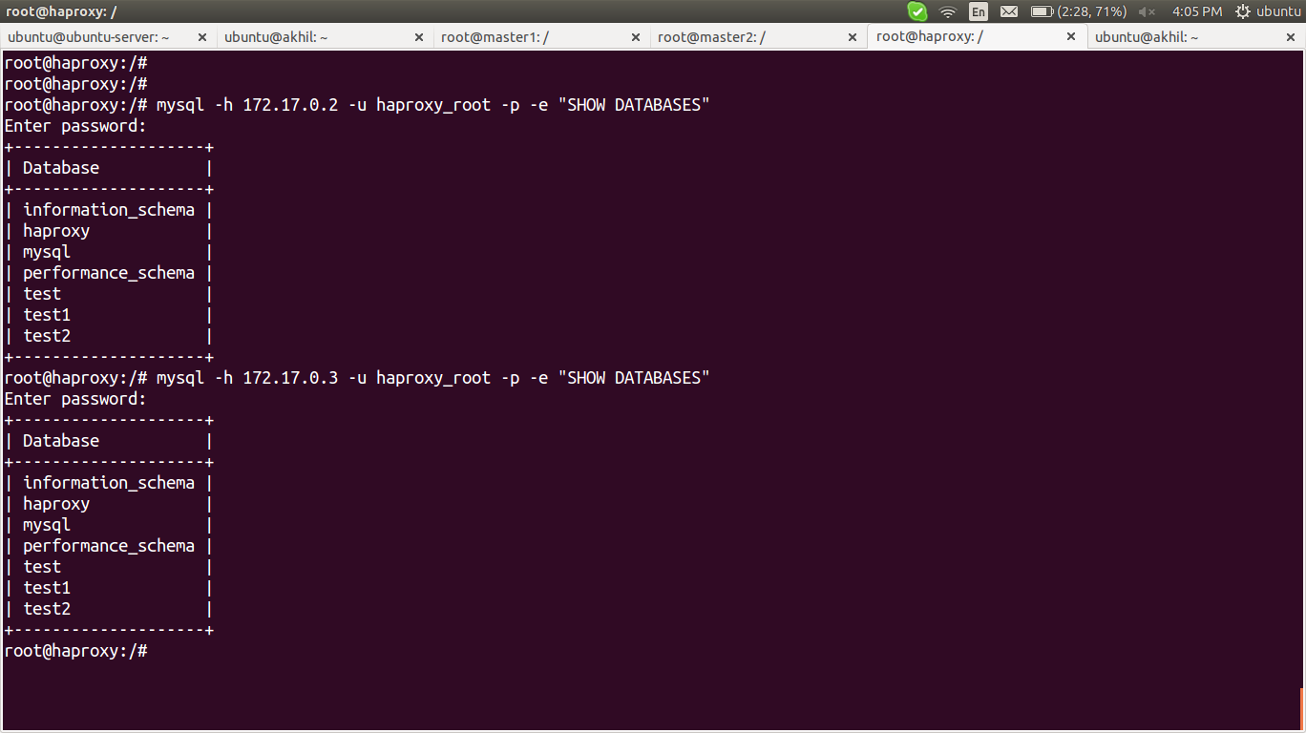

Installing HAProxy
On the HAProxy server install the package.

# apt-get install software-properties-common
# add-apt-repository ppa:vbernat/haproxy-1.6
# apt-get update
# apt-get install haproxy

Enable HAProxy to be started by the init script.

# nano /etc/default/haproxy
ENABLED=1

Configuring HAProxy
Rename the original configuration file
# cp /etc/haproxy/haproxy.cfg /etc/haproxy/haproxy.cfg.dup

Create and edit a new one
# nano /etc/haproxy/haproxy.cfg
The first block is the global and defaults configuration block.

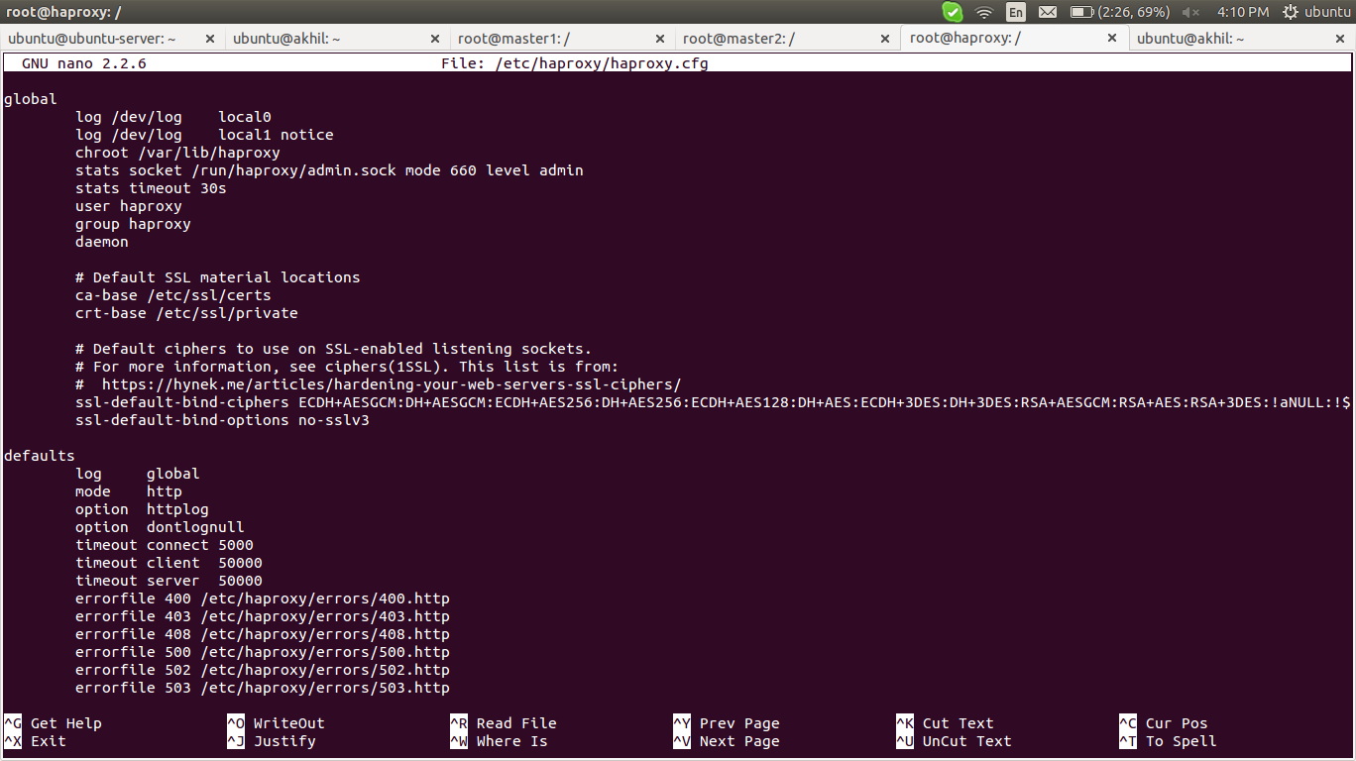
Moving to the main configuration part.

listen webui # used for web interface http://IP:8888
bind *:8888
stats enable
stats uri /
mode http
stats auth admin:admin

listen mysql-cluster # used for connecting mysql servers to haproxy server
bind *:3306
mode tcp
option mysql-check user haproxy_check
balance roundrobin
server master1 172.17.0.2:3306 check weight 2
server master1 172.17.0.3:3306 check

weight 2 means whenever the clients write on mysql, haproxy choose master1 mysql server 2 times when master2 mysql server choose once.

# service haproxy start

http://172.17.0.4:8888

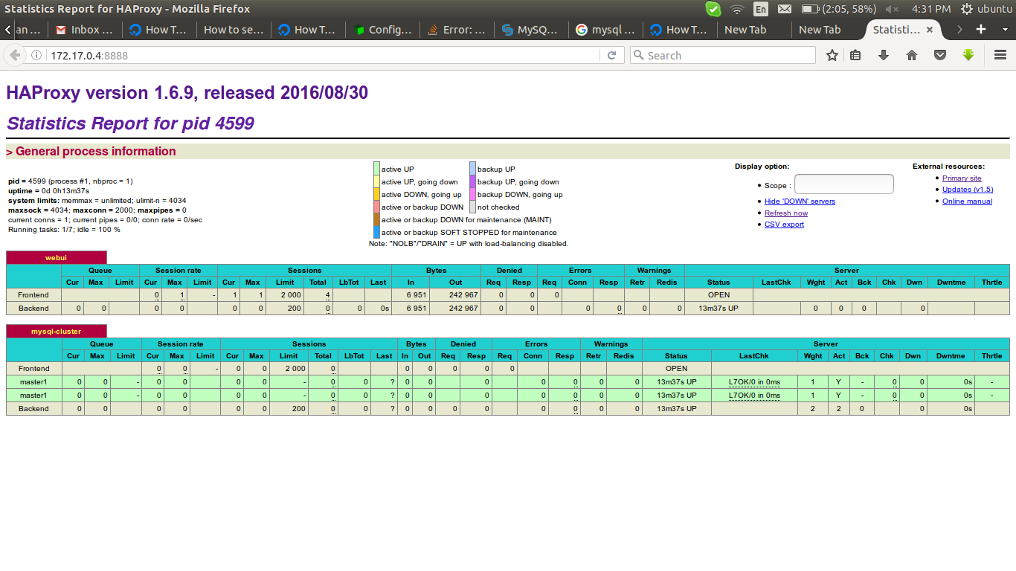
Testing Load Balancing

To check if load balancing is working query the server_id variable twice or more.

Use haproxy ip address to access mysql server from remote machine

# mysql -h 172.17.0.4 -u haproxy_root -p -e "show variables like 'server_id'"

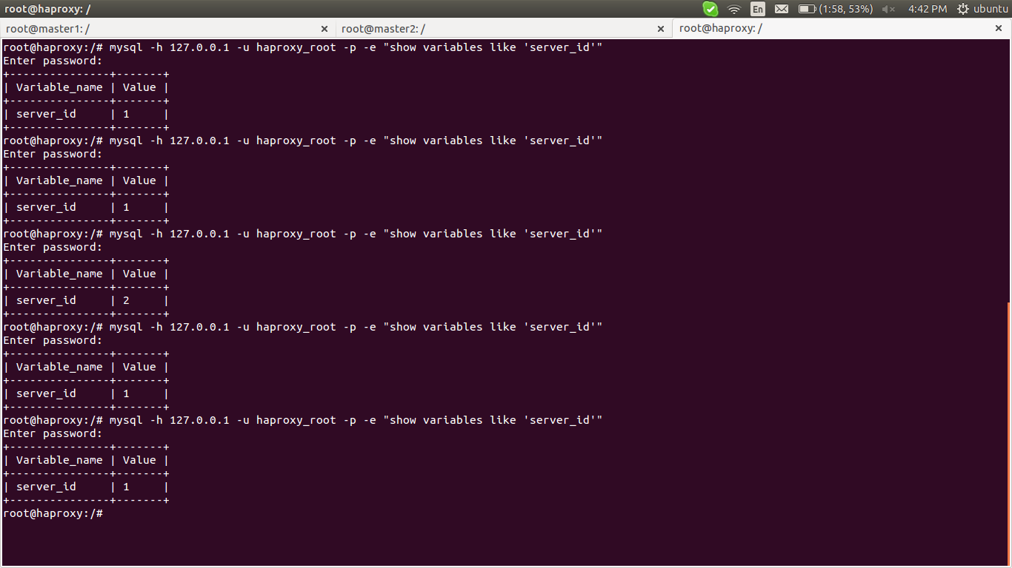

try to create databases from another machine with haproxy ip address

remote machine using haproxy server ip address

# mysql -u haproxy_root -h 172.17.0.4 -p

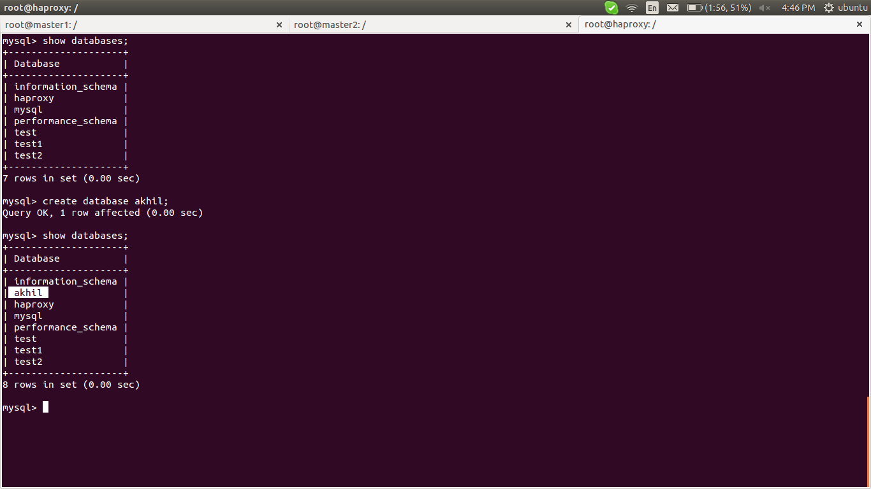

master1 (mysql server 1)

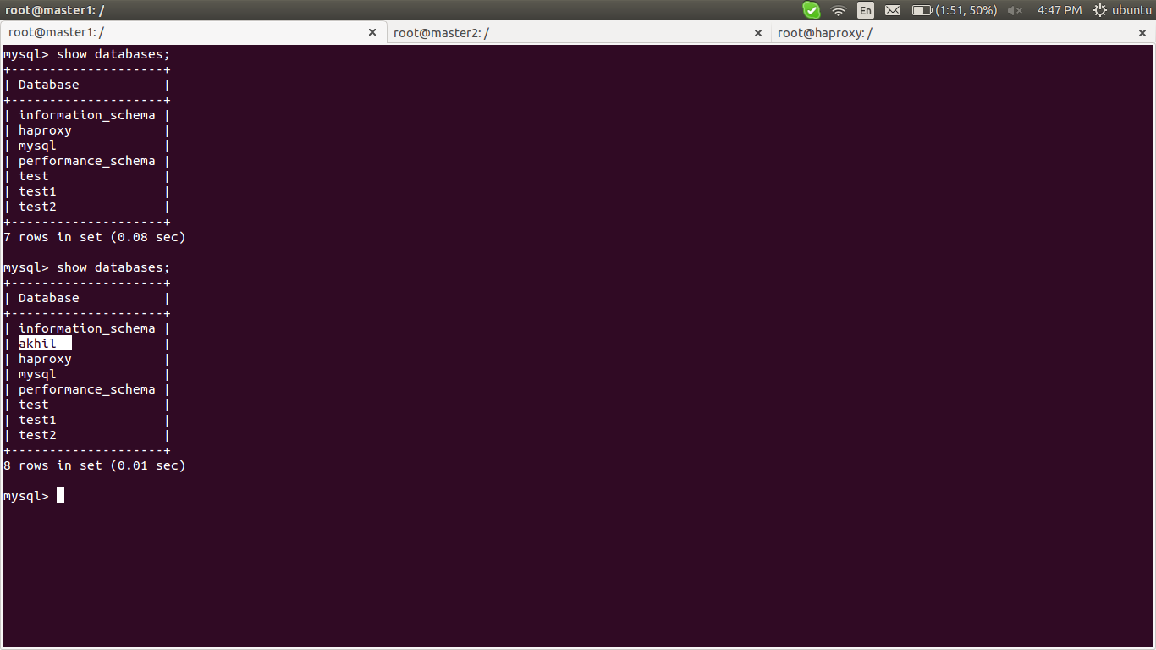

master2 (mysql server 2)

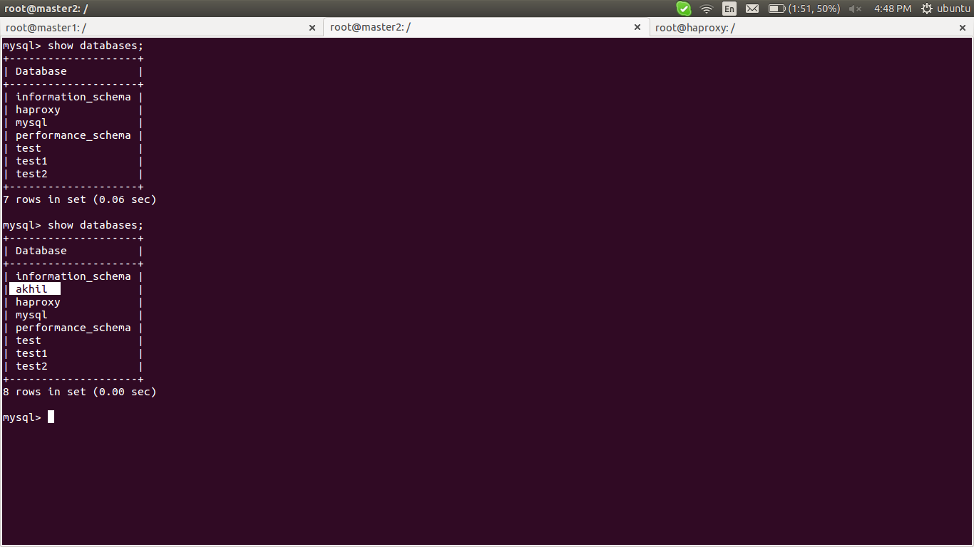

********************************************************************************
link ::
https://www.digitalocean.com/community/tutorials/how-to-use-haproxy-to-set-up-mysql-load-balancing--3

********************************************************************************

