********************************************************************************

Setup and Configure Chef Server on Ubuntu 14.04
********************************************************************************

The central Chef server is one of the core component of chef infrastructure automation. Central Chef server acts as a single point of contact for agents to pull configurations that are applicable for them. Chef server stores cookbooks, metadata of the nodes, environment and policy details etc. Every agent in the environment will be configured to contact a central chef server.

Read : http://www.slashroot.in/chef-tutorial-beginners-getting-started-introduction

Before getting started, let's understand the different components of Chef server. Chef server will automatically install the below items on the server.
- Nginx: Nginx is an open source webserver that will be used by chef as a front end web interface. Each and every HTTP request that comes to chef server, will actually be going via Nginx web server. Once the request hits Nginx web server, Nginx will then re-route those requests according to the type of request. For example...If the request is to access bookshelf, it will be forwarded to localhost port number 4321(where bookshelf service will be listening.). If it's search related request, then Nginx will forward it to Solr listening on localhost port number 8983(all of these different services are installed by chef server package automatically, without any user intervention.)
Bookshelf is a component of chef server where all cookbook related contents are stored. If you have ever worked with Puppet configuration management tool, then you can compare cookbook with modules of puppet.
- Chef Web Interface: This is a Ruby application that listens on localhost port number 9462. Using this interface, administrators can configure and manage different aspects of chef server. Like which cookbooks to be applied on which node etc. This component is also something that gets installed by chef automatically without any manual intervention(we will be doing the installation part shortly). The requests to access the chef user interface will also first reach Nginx web server, which will then redirect it to port number 9462 where the ui application is running.
Please keep the fact in mind that chef web interface is only free for the first 25 nodes. You will have to pay for using this web interface for more number of nodes. However..You can have chef working without the web interface. The operations and features exposed by this web interface is actually doable using command line as well.

- Chef API: This is the core API of Chef. The opscode engineering team reworked the API using Erland programming language. Hence this is called as "Erchef". This API service runs on port number 8000. Here also Nginx redirects requests to localhost port number 8000.
- Solr: This component provides indexing and searching feature for Chef. All node details and attributes are stored in the open source search engine called Apache Solr. Solr service exposes itself in the form of a search api to chef using port number 8983. Nginx forwards requests for searches to this localhost port number 8983.
- PostgreSQL Database Server: This is a popular open source relational database server. Chef uses this as the primary database for storing things. PostgreSQL server listens on port number 5432.
- RabbitMQ: This is used as a message queuing component of chef. Things are grabbed from RabbitMQ for indexing to solr search engine.
As mentioned earlier...None of the above mentioned components need to be configured manually. All these components are configured by chef installation script automatically for you.

Step 1: The very first step is to verify that correct hostname is configured on the server. And the hostname FQDN is actually resolvable. Its very much necessary and recommended to have proper DNS entries in place for your chef server. If you are not in a production environment, you can get it done using hosts file as well. Login to the server, and run the below commands to set correct hostname..
edit /etc/hosts # 127.0.1.1 ubuntu-server.com
/etc/hostname # ubuntu-server.com

Step 2: The second step is to ensure time synchronization. So we need to configure NTP on the server. This can be done by installing ntp package in Ubuntu as shown below..

# apt-get update

# apt-get install ntp

# service ntp start

Step 3: The next step is to download Chef server package from official website
# wget https://packages.chef.io/stable/ubuntu/14.04/chef-server-core_12.7.0-1_amd64.deb

Step 5: The next step is to install this downloaded package using the below command.
# dpkg -i chef-server*

Step 6: The next step is to ask chef server to configure itself with the default settings. This can be done by running the below command.

# chef-server-ctl reconfigure

This command will take a while to complete. This is because it installs and configures all the previously mentioned components of chef server(ie: Nginx, RabbitMQ, Postgresql, Solr etc.). The successful completion of the above command should show you something like the below towards the end..

it show like following

Chef Client finished, 39/411 resources updated in 31 seconds
Chef Server Reconfigured!

Step 7: Once the above command is completed successfully, we have chef server components installed and configured on the server. You can actually have an optional web interface for chef as well. This web interface is called as chef manage. It can be installed using the below command.
https://downloads.chef.io/chef-manage/ubuntu/

# dpkg -i chef-manage*

# chef-server-ctl reconfigure

# chef-manage-ctl reconfigure

Once the above three commands succeeds, you have the web interface called chef manage ready for you to use. You can access the web interface by either using the IP address of your server or the DNS name of the server(if you have DNS configured correctly in your environment.)

Before we can access the web interface, we need to create an admin user and credentials..This can be done by executing the below command.

# chef-server-ctl user-create akhil akhil raj akhil.raj@bizruntime.com secret --filename akhil.pem

here ::

"akhil" in the above command is the username.
"akhil raj" is the full name of the user.
"akhil.raj@bizruntime.com" is the email address.
"secret" is the actual password for the user..Replace it with something complex
"akhil.pem" is the private key file for the user(this will be created in the current directory after the command completes.)

You can now access the web interface by using the IP address of the server in the web browser. The login page looks like the below..

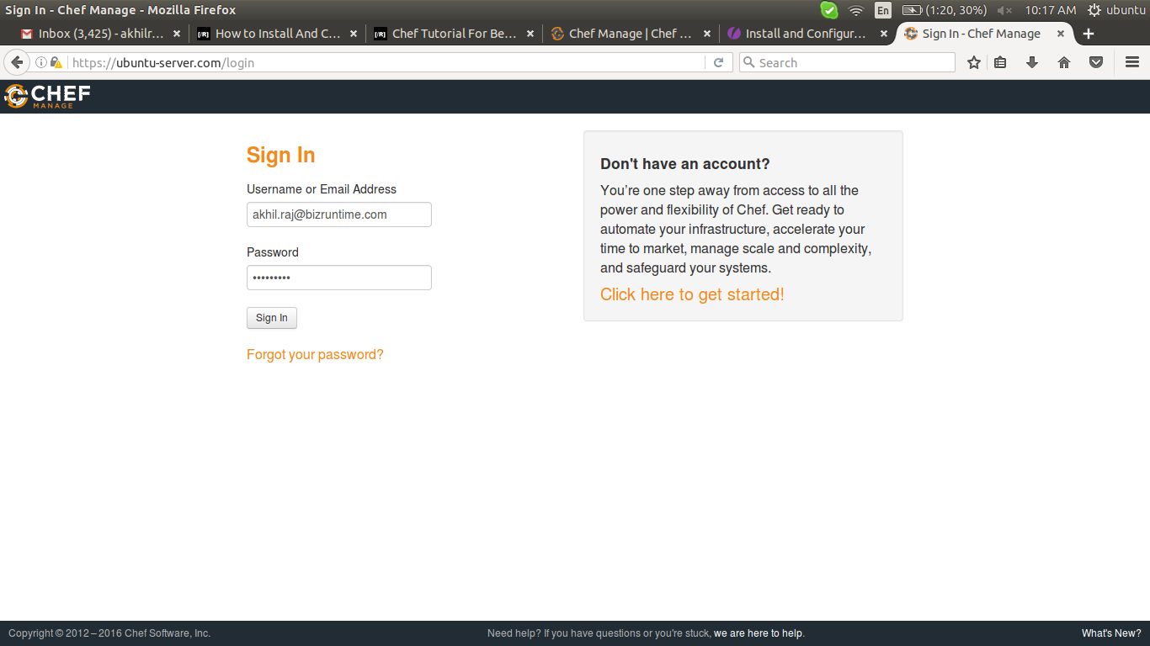
once provide username and password, it shows like below,

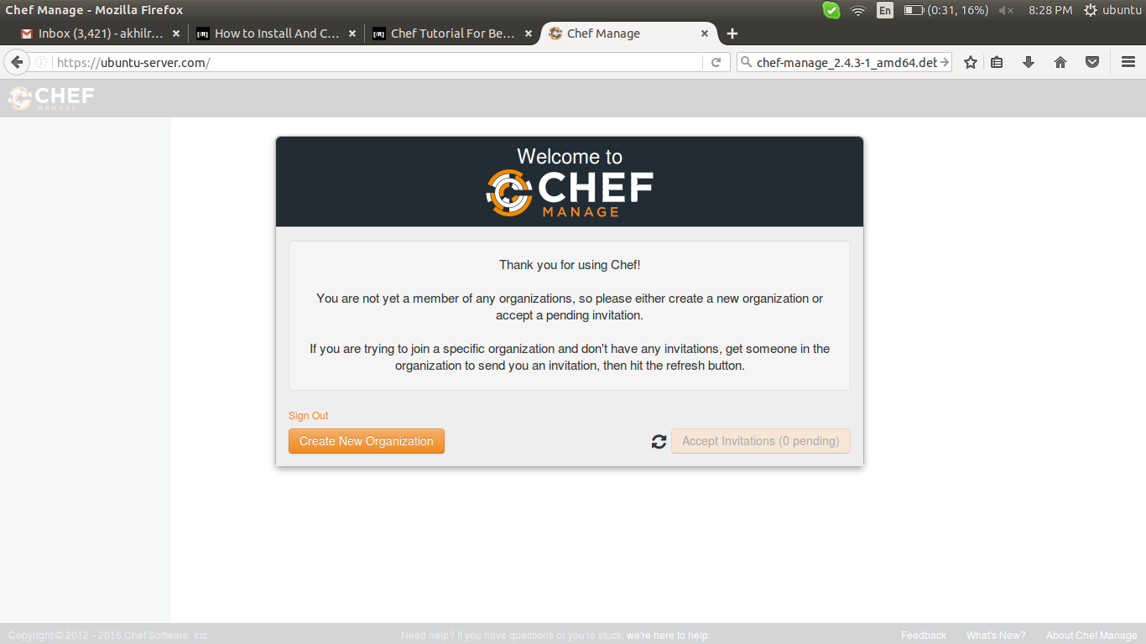

links ::

****************************************************************************

install and configure chef-server >>
www.slashroot.in/how-install-and-configure-chef-server-ubuntu-1404
http://www.slashroot.in/chef-tutorial-beginners-getting-started-introduction

install chef-manage (web-interface)>>
https://downloads.chef.io/chef-manage/ubuntu/

****************************************************************************

didnt try (if above one fail try this)>>
https://hostpresto.com/community/tutorials/install-and-configure-chef-server-on-ubuntu-14.04/

dockerfile installation(not recommending)>>
https://github.com/tmc/dockerfiles/tree/master/chef-server

********************************************************************************

Setup and Configure Chef Workstation on Ubuntu 14.04
********************************************************************************

You can consider Chef workstation as a place where all the development work of chef happens. This is the place where most of the administrators will start working on creating cookbooks and recipes. The workstation contains a local chef repository. This repository can then be synchronized with the central chef server.

Chef workstation also will have a command line utility called "Knife", which will be used to interact with the central chef server.

If you are new to chef and its working..I would recommend reading the below article first.
Read: A beginners guide to Chef Configuration Management
This article is the continuation of the previous article in this tutorial series. You can access the previous article, which walks through the steps for installing and configuring Chef server using the below Link.
Read: Installing And Configuring Chef Server

Chef workstation consists of two primary components as mentioned earlier.
- Chef Repository
- Knife Utility

Let's first install Knife utility on our chef workstation. Knife utility and chef client can be installed easily on the workstation by simply firing up the below curl command. The below curl command downloads a bash shell script provided by chef, and then executes it.

If you need to use kitchen in chef then try https://downloads.chef.io/chef-dk/ for install, not curl command

Before that tell to the workstation about ip and FQDN of chef-server

# nano /etc/hosts

192.168.1.64 ubuntu-server.com

# curl -L https://omnitruck.chef.io/install.sh | sudo bash

Successful completion of the above command will look like the below..

Installing chef
installing with dpkg...
Selecting previously unselected package chef.
(Reading database ... 51193 files and directories currently installed.)
Preparing to unpack .../chef_12.11.18-1_amd64.deb ...
Unpacking chef (12.11.18-1) ...
Setting up chef (12.11.18-1) ...
Thank you for installing Chef!

Alternatively you can also do the following steps to install chef workstation specific components.
Step 1: Chef officially provides a debian and rpm package called chefdk. chefdk stands for chef development kit. You can download your operating system specific package by navigating to the below URL.
https://downloads.chef.io/chef-dk/
Step 2: Second step is download it to your workstation server by simply copying the URL specified in the download page and then pass it as a parameter to wget command.

For Ubuntu, you will be doing something like the below..

# wget https://packages.chef.io/stable/ubuntu/12.04/chefdk_0.15.15-1_amd64.deb

# dpkg -i chefdk*

Chef Starter kit

Chef starter kit is nothing but an archive that contains the directory structure for doing development work on chef workstation. It contains the cookbook and knife settings.
You can simply download it and copy the archive to your chef workstation server.
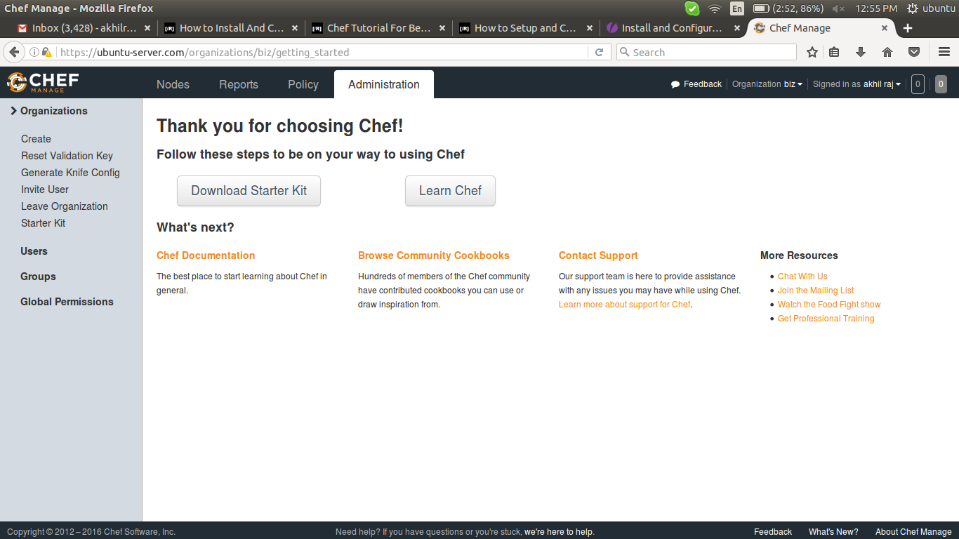

When you click on the download button above, you will be shown a message with regard to resetting of the user keys. Proceed with it. This new key will be part of the starter kit that we are downloading now.

Once downloaded(chef-starter.zip), copy it down to the chef workstation server. Once copied, you can then decompress it as shown below.

# unzip chef-starter.zip

The above command will create a directory called chef-repo in the current location. This directory contains all the basic settings for interacting with chef server from workstation.
It also has a cookbook directory inside, where all cookbooks will be stored and later pushed to central chef server.
Let's get inside the "chef-repo" directory, and see what's inside.

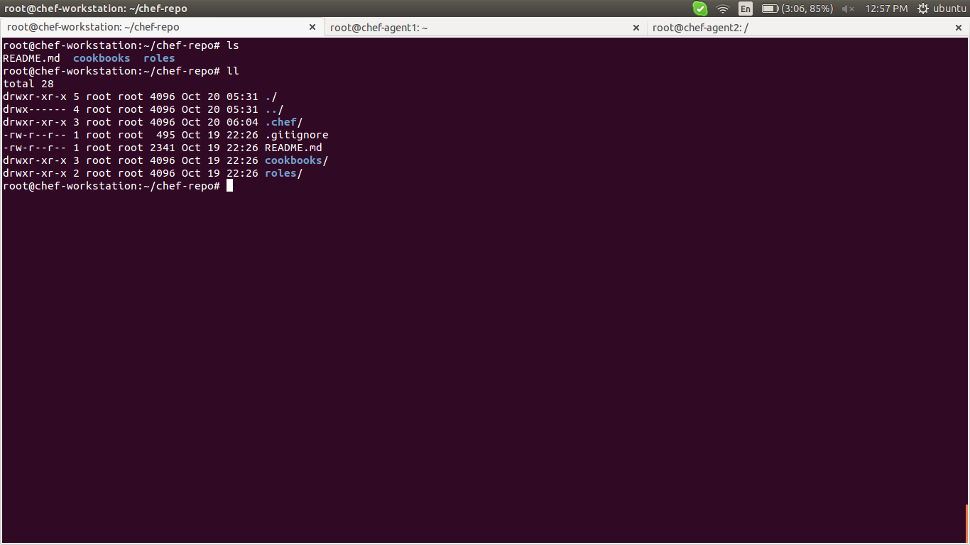

There is a directory called ".chef" as evident from the directory listing above. This .chef directory contains the private key for the user. Also this ".chef" directory contains knife configuration file called knife.rb.

The trusted_certs directory createed only after run some commands for connecting to server, it will come later in this documentation

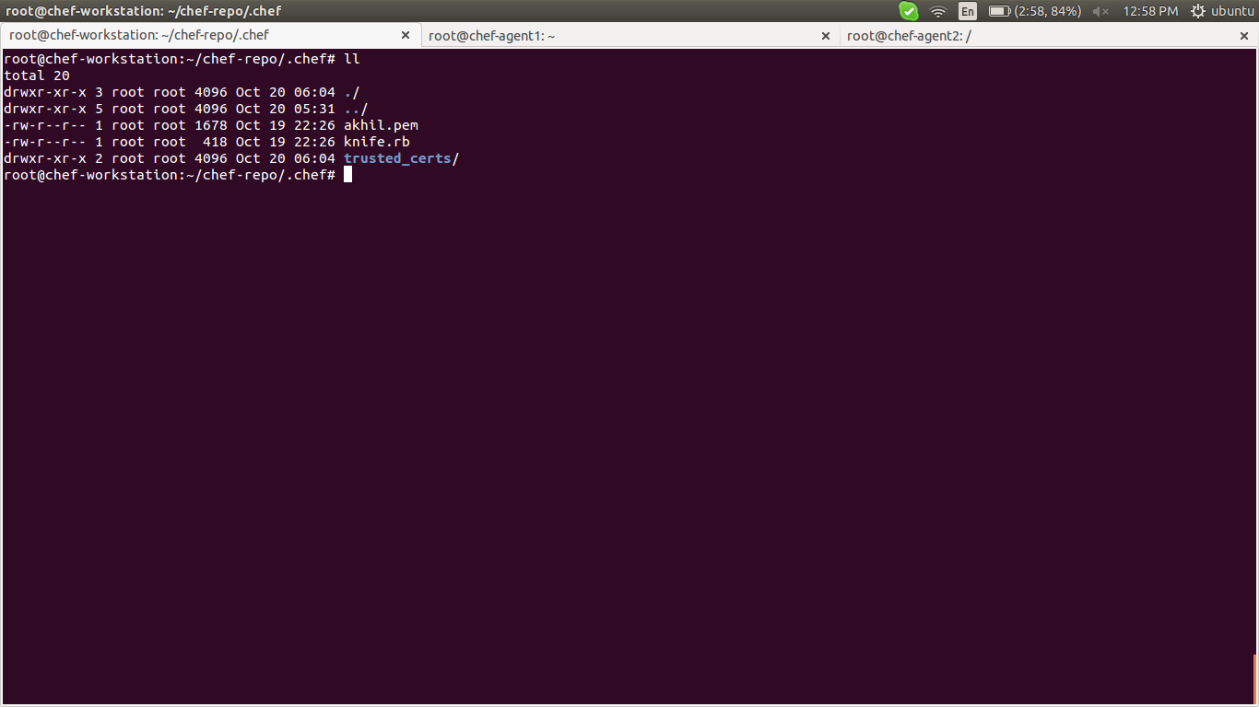

Knife.rb file will be read by knife tool while interacting with central chef server from workstation. The contents of knife.rb file looks like the below.

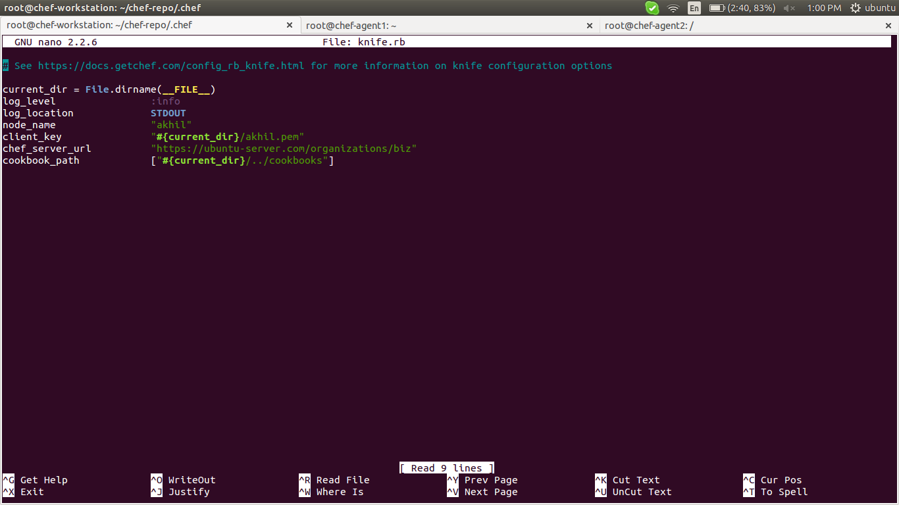

client_key: Specifies the path of the private key file associated with the user. This private key will be used to authenticate workstation against the chef server.

chef_server_url: This is the full URL of the chef server with the organization path(we did create an organization during our previous tutorial of installing chef server. Our organization's name is "slashroot")

cookbook_path: The absolute path where cookbooks will be stored on the workstation. This is because knife will be syncing cookbooks to server, it will also be downloading cookbooks, will be creating new cookbooks etc.

client_name: This is the user name associated with the organization. We created a user named "sarath" in our previous tutorial.

Once all the above mentioned items are configured and ready. Let's verify the connectivity between chef workstation and chef server. As mentioned earlier, knife is going to be our tool while interacting with central chef.

Note :::
Please remember the fact that you should execute knife commands only after navigating to the chef-repo directory. This is because knife looks for a directory called .chef, which contains our knife.rb settings file.

# knife ssl fetch

The above command interacts with the chef server (by using the URL defined inside knife.rb file), and grabs the SSL certificates of the server. This SSL certificate is then stored inside a new directory called trusted_certs.

Once the SSL certificates are added to the trusted list of knife. You can then verify the connectivity to central chef server using the below command.

# knife ssl check

Connecting to host ubuntu-server.com:443
Successfully verified certificates from `ubuntu-server.com'

If things are correctly configured..You should be able to see the above output. Now knife can do all the operations on the chef server using the user we have created(which is defined inside knife.rb), and the organization associated with that user.

Links ::

workstation configuration >>
http://www.slashroot.in/how-setup-and-configure-chef-workstation

kitchen installation>>
https://learn.chef.io/local-development/rhel/get-started-with-test-kitchen/
https://docs.chef.io/kitchen.html
https://www.safaribooksonline.com/blog/2014/11/27/opscode-chef-vagrant-test-kitchen/
http://kitchen.ci/docs/getting-started/
http://kitchen.ci/

********************************************************************************

Boostrap a node using chef workstation
********************************************************************************

Bootstrapping a node is nothing but the job of installing and configuring chef agent on a server that needs to be automated via chef. Installing and configuring a node with chef agent which will then start pulling configuration from central chef server, is a single knife command away as shown below.

Before that tell to the client about ip and FQDN of chef-server

# nano /etc/hosts
192.168.1.64 ubuntu-server.com

# knife bootstrap 172.17.0.4 --sudo --ssh-user chef --ssh-password chef --node-name chef-agent2
where,

172.17.0.4 >> node ip
--sudo >> used for fill permission for user in that node
chef >> user-name

chef >> password for user # username and password are same for my scenario
chef-agent2 >> node name for that node # use FQDN of that node for better understanding

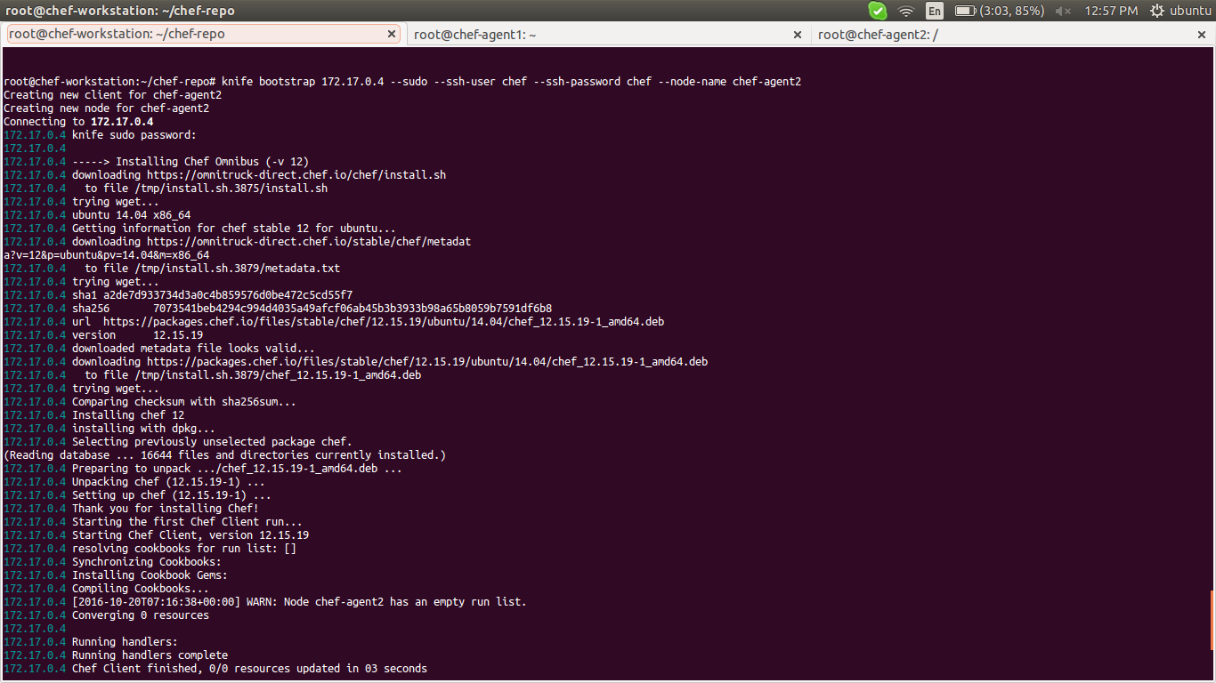

by this way we can many nodes with company requirement

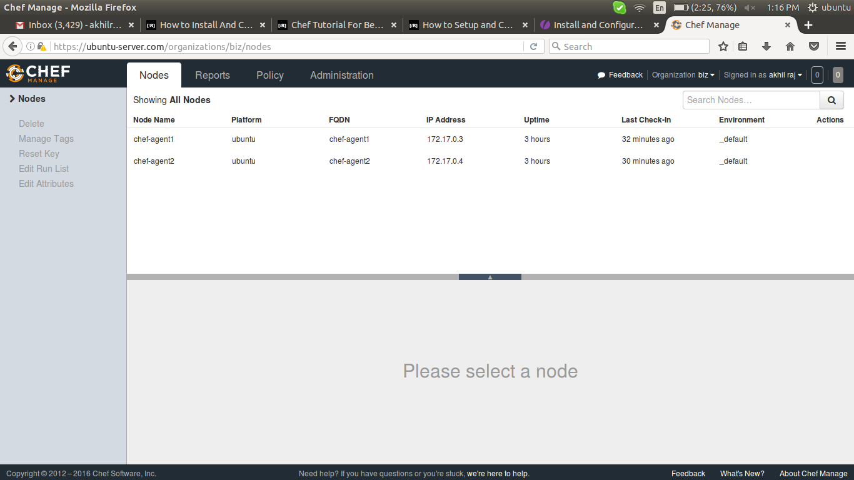

links ::

node installation >>
http://www.slashroot.in/how-setup-and-configure-chef-workstation

********************************************************************************

Create and Upload a cookbook to chef server from workstation
********************************************************************************

The second operation that the chef workstation does is to create a cookbook which acts as the main basic block of configuration that will be applied on nodes.
You can create a skeleton cookbook by using the below command.
# knife cookbook create name

note ::
Again..Please do not forget the fact that knife commands needs to from chef-repo directory(as it requires .chef directory, which has the knife.rb settings file)

You can then upload this cookbook that we just created to central chef server using the below command.

# knife cookbook upload name

for testing from work-station :

# knife bootstrap 172.17.0.4 --sudo --ssh-user chef --ssh-password chef --node-name chef-agent2 --run-list 'recipe[user]'

or run the following command in node side

# chef-client

to set the run list in server

# knife node run_list set chef-agent2 'recipe[user]'

# knife node run_list add chef-agent2 'recipe[user]'

to edit a node info

# knife node edit node-name -a

if found some error related to editor

# export "EDITOR=nano"

links ::
http://stackoverflow.com/questions/17562837/chef-how-to-set-editor-for-knife

to list nodes

# knife node list -w

to include another recipe in one recipe

1) create a cookbook
2) create a recipe (default.rb)
3) add a line in 2nd recipe file (default.rb) as follow
include_recipe 'another-cookbook-name'
4) edit metadata.rb of the cookbook which have include_recipe directives in default.rb and add the
following line.
depends cookbook name
5) upload both cookbook to chef-master (there is a order for uploading, see below figure)
6) done

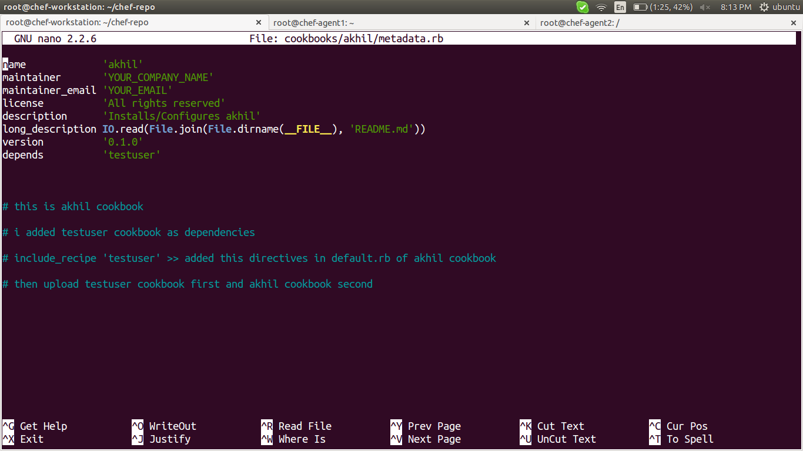

link :
http://stackoverflow.com/questions/16947393/should-i-use-include-recipe-or-add-the-recipe-to-run-list

check the server whether the cookfile uploaded or not in policy

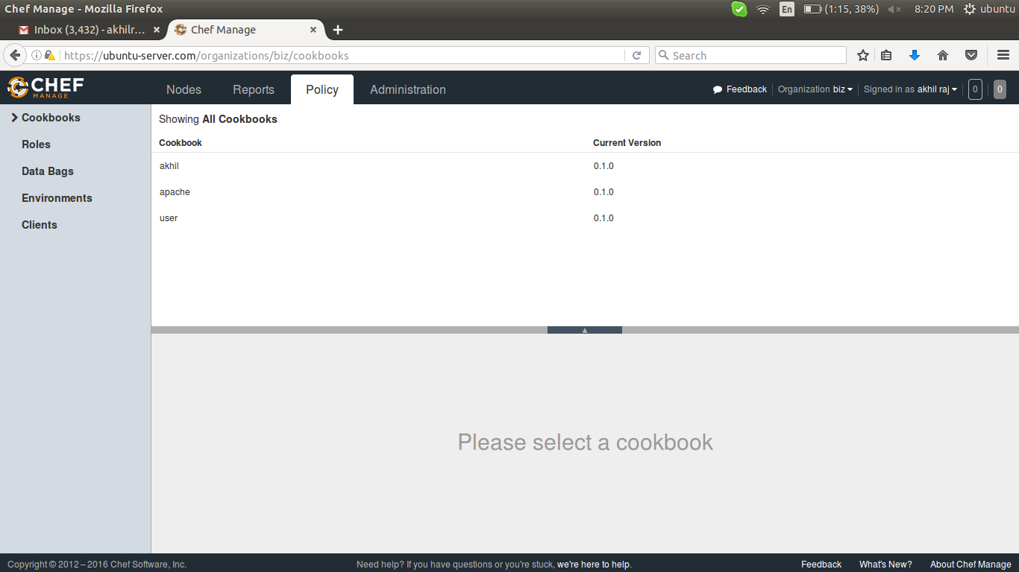

then take node

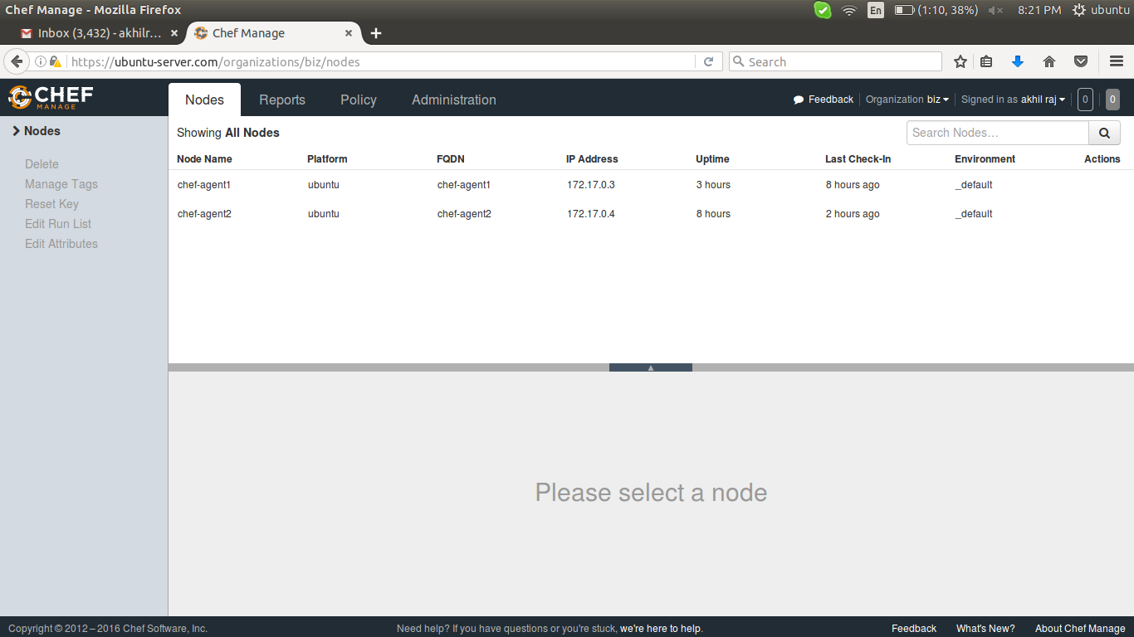

then click on right most side of any node and choose edit run list

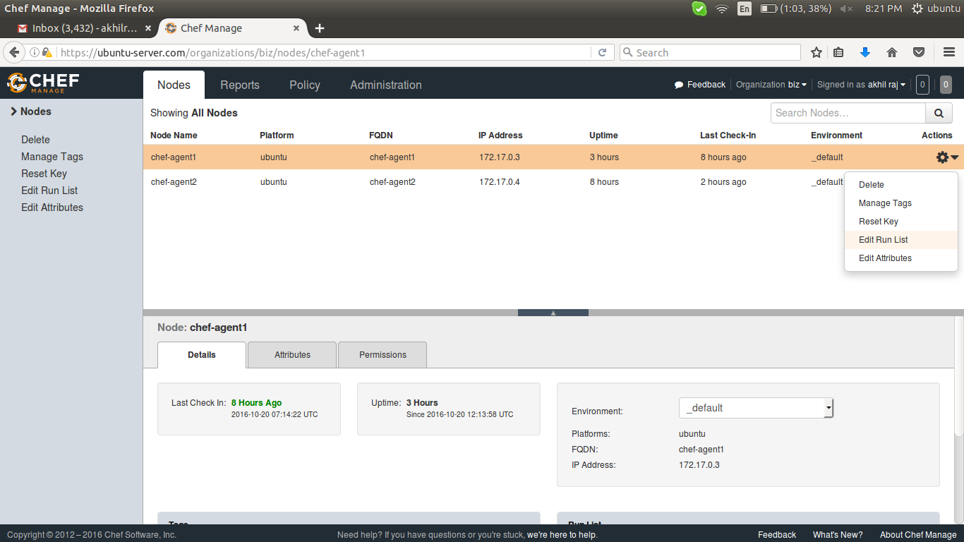

then add the cookbook which needed for this particular node by drag the cookbook from available recipes to curent run list

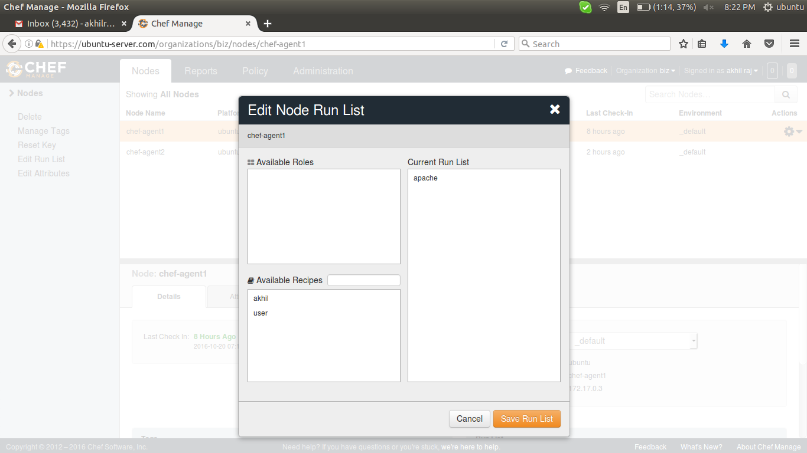

********************************************************************************
RECIPE

********************************************************************************

******************************Recipe*********************************

to install package

package 'package-name' do
action 'install'
end

******************************Recipe*********************************

to start the service

service 'service-name' do
action 'start' # action [ :enable, :start ] for start at booting.
end

******************************Recipe*********************************

to create a file

file '/path/file-name' do
content 'some-data'
owner 'root'
group 'root'
mode '777'
end

******************************Recipe*********************************

to add some file from master,

use
cookbook_file instead of file in above
and add some file in files/default directory of cookbook

or

template instead of file in above
and add some file in templates/default directory of cookbook

cookbook_file '/path/file-name' do
source 'file-name-in /files/default/ '
owner 'root'
group 'root'
mode '777'
end

template '/path/file-name' do
source 'file-name-in /templates/default/ '
owner 'root'
group 'root'
mode '777'
end

******************************Recipe*********************************

to create directory

directory '/path/dir-name' do
owner 'root'
group 'root'
mode '777'
end

******************************Recipe*********************************

to create a group

group 'group-name' do
action 'create'
gid '1500'
end

******************************Recipe*********************************

to create a user

user 'user-name' do
action 'create'
uid '1500'
gid '1500' # use group if create a group already with this gid
password 'any'
home '/home/user-name'
shell '/bin/bash'
end

******************************Recipe*********************************

to notify

notifies :restart, 'service[apache2]' # if there is a service in the name of apache2

******************************Recipe*********************************

to execute a command

execute 'update-upgrade' do
command 'apt-get update && apt-get upgrade -y'
environment 'path' => '/bin:/sbin:/usr/bin:/usr/sbin' # optional, will work without path also
action 'run'
end

******************************Recipe*********************************

notifies # notify some command when change in this command
subscribes # notify this command when change in another command

:before
:immediate
:delayed

eg:

notifies :action, 'resource[name]', :timer # action specifies for that command not for this command
notifies :restart, 'file[/var/www/html/index.html]', :immediate

subscribes :action, 'resource[name]', :timer # action specifies for this command not for that command

subscribes :restart, 'file[/var/www/html/index.html]', :immediate

******************************Recipe*********************************

notifies

Ruby Type: Symbol, ‘Chef::Resource[String]’
A resource may notify another resource to take action when its state changes. Specify a 'resource[name]', the :action that resource should take, and then the :timer for that action. A resource may notifiy more than one resource; use a notifies statement for each resource to be notified.
A timer specifies the point during the chef-client run at which a notification is run. The following timers are available:
:before
Specifies that the action on a notified resource should be run before processing the resource block in which the notification is located.
:delayed
Default. Specifies that a notification should be queued up, and then executed at the very end of the chef-client run.
:immediate, :immediately
Specifies that a notification should be run immediately, per resource notified.
The syntax for notifies is:
notifies :action, 'resource[name]', :timer

to do this command before some command

notifies :restart, 'file[/var/www/html/index.html]', :immediate

******************************Recipe*********************************

subscribes

Ruby Type: Symbol, ‘Chef::Resource[String]’
A resource may listen to another resource, and then take action if the state of the resource being listened to changes. Specify a 'resource[name]', the :action to be taken, and then the :timer for that action.
A timer specifies the point during the chef-client run at which a notification is run. The following timers are available:
:before
Specifies that the action on a notified resource should be run before processing the resource block in which the notification is located.
:delayed
Default. Specifies that a notification should be queued up, and then executed at the very end of the chef-client run.
:immediate, :immediately
Specifies that a notification should be run immediately, per resource notified.

subscribes :action, 'resource[name]', :timer

eg ::

subscribes :restart, 'file[/var/www/html/index.html]', :immediate

******************************Recipe*********************************

Arguments
The following arguments can be used with the not_if or only_if guard properties:
:user
Specify the user that a command will run as. For example:
not_if 'grep adam /etc/passwd', :user => 'adam'
:group
Specify the group that a command will run as. For example:
not_if 'grep adam /etc/passwd', :group => 'adam'

:environment
Specify a Hash of environment variables to be set. For example:
not_if 'grep adam /etc/passwd', :environment => {
'HOME' => '/home/adam'
}
:cwd
Set the current working directory before running a command. For example:
not_if 'grep adam passwd', :cwd => '/etc'
******************************Recipe*********************************

******************************Links*********************************

recipe >>
https://docs.chef.io/resource_execute.html

source-file >>
https://docs.chef.io/resource_cookbook_file.html

execute >>
https://docs.chef.io/resource_execute.html

user-creation>>
https://docs.chef.io/resource_user.html

running nodes >>
https://www.linode.com/docs/applications/chef/creating-your-first-chef-cookbook

knife and recipe >>
https://docs.chef.io/knife_node.html

