***************************************************************************************
multi-host networking with docker-overlay
***************************************************************************************

Docker Engine supports this out-of-the-box through the overlay network. Unlike bridge networks, overlay networks require some pre-existing conditions before you can create one. These conditions are:

1) Access to a key-value store. Engine supports Consul, etcd, ZooKeeper
2) A cluster of hosts with connectivity to the key-value store.
3) A properly configured Engine daemon on each host in the cluster.
4) The Docker host must be running at least version 3.16 or later of the Linux kernel

I will use all four nodes : node-0, node-1, node-2, and node-3.

Node-0 >> 192.168.1.253
Node-1 >> 192.168.1.131
Node-2 >> 192.168.1.235
Node-3 >> 192.168.1.234

***************************************************************************************
step 1 : Configure the Engine to use key-value store
***************************************************************************************

choose which node used for run consul container for service discovery, in my case i choose Node-0 ( 192.168.1.253 )

On each node, do the following:

step 1(a) : edit /etc/default/docker , commented out and add DOKER_OPTS= like this:

#Use DOCKER_OPTS to modify the daemon startup options.
#DOCKER_OPTS="--dns 8.8.8.8 --dns 8.8.4.4"

DOCKER_OPTS="-H tcp://0.0.0.0:2375 -H unix:///var/run/docker.sock --cluster-store=consul://192.168.1.253:8500/network –cluster-advertise=eth0:2375"

step 1(b) : Restart the Docker Engine for these settings to take effect:

# service docker restart

docker stop/waiting
docker start/running, process 2003

step 1(c) : Ensure that each engine restarts successfully, some systems get error due to kernel issue :

# docker ps

CONTAINER ID IMAGE COMMAND CREATED STATUS PORTS NAMES

***************************************************************************************
step 2 : Set up a key-value store
***************************************************************************************

in Node-0 ( 192.168.1.253 )

# docker run -d -p 8500:8500 -h consul --name consul progrium/consul -server -bootstrap

Ensure that the container is Up and listening to port 8500

# docker ps

CONTAINER ID IMAGE COMMAND CREATED STATUS PORTS NAMES

3092b9afa96c progrium/consul "/bin/start -server -" 35 seconds ago Up 34 seconds 53/tcp, 53/udp, consul
8300-8302/tcp,
8301-8302/udp,
8400/tcp,
0.0.0.0:8500->8500/tcp
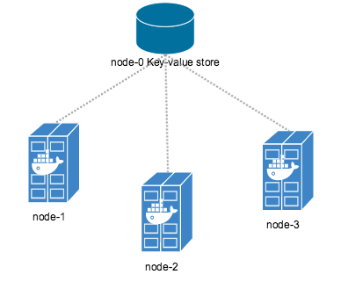

***************************************************************************************
step 3 : Learn the default networks
***************************************************************************************

Before you create an overlay network, it is a good idea to understand the default networks that Docker creates. Go ahead and list the networks on any of your nodes.

# docker network ls

NETWORK ID NAME DRIVER
38ffb13fa56d none null
34c7921e8cb7 host host
25b439c6c8ca bridge bridge

Each Docker host has these default networks, only the IDs differ.
Historically, these three networks are part of Docker's implementation. When you run a container you can use the --net flag to specify which network you want to run the container on. These three networks are still available to you.
- The bridge network represents the docker0 network present in all Docker installations. Unless you specify otherwise with the docker run --net=<NETWORK> option, the Docker daemon connects containers to this network by default.
- The none network adds a container to a container-specific network stack. That container lacks a network interface.
- The host network adds a container on the hosts network stack. You'll find the network configuration inside the container is identical to the host.

***************************************************************************************
Step 4 : Create the "RED" overlay Network
***************************************************************************************

Pick one of the nodes and log into that node, in my case i choose Node-0 ( 192.168.1.253 )

Create an overlay network.

# docker network create -d overlay --subnet=10.10.10.0/24 RED

Check that the network is running on your node.

# docker network ls

NETWORK ID NAME DRIVER
7b1cda01f47f RED overlay
38ffb13fa56d none null
34c7921e8cb7 host host
25b439c6c8ca bridge bridge

Now, log into the remaining nodes and immediately list the networks.

# docker network ls

NETWORK ID NAME DRIVER
7b1cda01f47f RED overlay
1ae83a006465 host host
501f891883cf bridge bridge
a141cc346b6c none null

You'll find that all three nodes can see the RED network, and that unlike the default networks, RED has the same ID on all three hosts even though you created it on only one of them.

***************************************************************************************
Step 5 : Run Containers on the RED network
***************************************************************************************
Once your network is created, you can start a container on any of the hosts and it automatically is part of the network.
The following steps will create two containers and connect them both tot the RED network.

log into one node, in my case i choose Node-0 ( 192.168.1.253 )
# docker run -itd --name container1 --net RED ubuntu:14.04

log into one node, in my case i choose Node-1 ( 192.168.1.131 )
# docker run -itd --name container2 --net RED ubuntu:14.04

log into one node and use docker network inspect to inspect the RED network
# docker network inspect RED
[
{
"Name": "RED",
"Id": "56a39f7406040ca221bed48cd31dca3bb79ec7e187dad4f93f0e8659a5fb90a5",
"Scope": "global",
"Driver": "overlay",
"EnableIPv6": false,
"IPAM": {
"Driver": "default",
"Options": {},
"Config": [
{
"Subnet": "10.10.10.0/24"
}
]
},
"Internal": false,
"Containers": {
"e7a546434fdaab2b49e44e8384d9657ee593ad677de118ba2e639a7d434874ff": {
"Name": "container1",
"EndpointID": "c9119a8b8ad39f2d91f5166c7478ab03e74e4fc8226aee963065684383e18554",
"MacAddress": "02:42:0a:0a:0a:02",
"IPv4Address": "10.10.10.2/24",
"IPv6Address": ""
},
"ep-c9e3a593678efab9dc83667f58f98a96173b06bc27c1429aa75855e1cb6bdfef": {
"Name": "container2",
"EndpointID": "c9e3a593678efab9dc83667f58f98a96173b06bc27c1429aa75855e1cb6bdfef",
"MacAddress": "02:42:0a:0a:0a:03",
"IPv4Address": "10.10.10.3/24",
"IPv6Address": ""
}
},
"Options": {},
"Labels": {}
}
]

Look at the container1 network configuration in Node-0

# docker exec container1 ifconfig

eth0 Link encap:Ethernet HWaddr 02:42:0a:0a:0a:02
inet addr:10.10.10.2 Bcast:0.0.0.0 Mask:255.255.255.0
inet6 addr: fe80::42:aff:fe0a:a02/64 Scope:Link
UP BROADCAST RUNNING MULTICAST MTU:1450 Metric:1
RX packets:978 errors:0 dropped:0 overruns:0 frame:0
TX packets:594 errors:0 dropped:0 overruns:0 carrier:0
collisions:0 txqueuelen:0
RX bytes:95420 (95.4 KB) TX bytes:57908 (57.9 KB)

eth1 Link encap:Ethernet HWaddr 02:42:ac:12:00:02
inet addr:172.18.0.2 Bcast:0.0.0.0 Mask:255.255.0.0
inet6 addr: fe80::42:acff:fe12:2/64 Scope:Link
UP BROADCAST RUNNING MULTICAST MTU:1500 Metric:1
RX packets:85 errors:0 dropped:0 overruns:0 frame:0
TX packets:8 errors:0 dropped:0 overruns:0 carrier:0
collisions:0 txqueuelen:0
RX bytes:13307 (13.3 KB) TX bytes:648 (648.0 B)

lo Link encap:Local Loopback
inet addr:127.0.0.1 Mask:255.0.0.0
inet6 addr: ::1/128 Scope:Host
UP LOOPBACK RUNNING MTU:65536 Metric:1
RX packets:8 errors:0 dropped:0 overruns:0 frame:0
TX packets:8 errors:0 dropped:0 overruns:0 carrier:0
collisions:0 txqueuelen:0
RX bytes:654 (654.0 B) TX bytes:654 (654.0 B)

You can see that eth0 was assigned an IP from RED's 10.10.10.0/24 subnet. There is also an eth1 interface with a 172.18.0.0/16 address. When you create your first overlay network on any host, Docker also creates another network on each host called docker_gwbridge. Docker uses this network to provide external access for containers

Every container in an overlay network gets an eth interface on the docker_gwbridge which allows the container to access the external world. The docker_gwbridge is similar to Docker's default bridge network, but unlike the bridge it restricts Inter-Container Communication(ICC). Docker creates only one docker_gwbridge bridge network per host regardless of the number of overlay networks present.

Overlay networks also support a container discovery feature. Still on

log into Node-0 and check connectivity

# docker exec container1 ping -w 3 container2

PING container2 (10.10.10.3): 56 data bytes
64 bytes from 10.10.10.3: seq=0 ttl=64 time=1.221 ms
64 bytes from 10.10.10.3: seq=1 ttl=64 time=1.106 ms
64 bytes from 10.10.10.3: seq=2 ttl=64 time=1.042 ms

similarly log into Node-1 and check connectivity

# docker exec container2 ping -w 3 container1

PING container2 (10.10.10.3): 56 data bytes
64 bytes from 10.10.10.3: seq=0 ttl=64 time=1.221 ms
64 bytes from 10.10.10.3: seq=1 ttl=64 time=1.106 ms
64 bytes from 10.10.10.3: seq=2 ttl=64 time=1.042 ms

***************************************************************************************
step 6 : Create the "BLUE" Overlay Network
***************************************************************************************
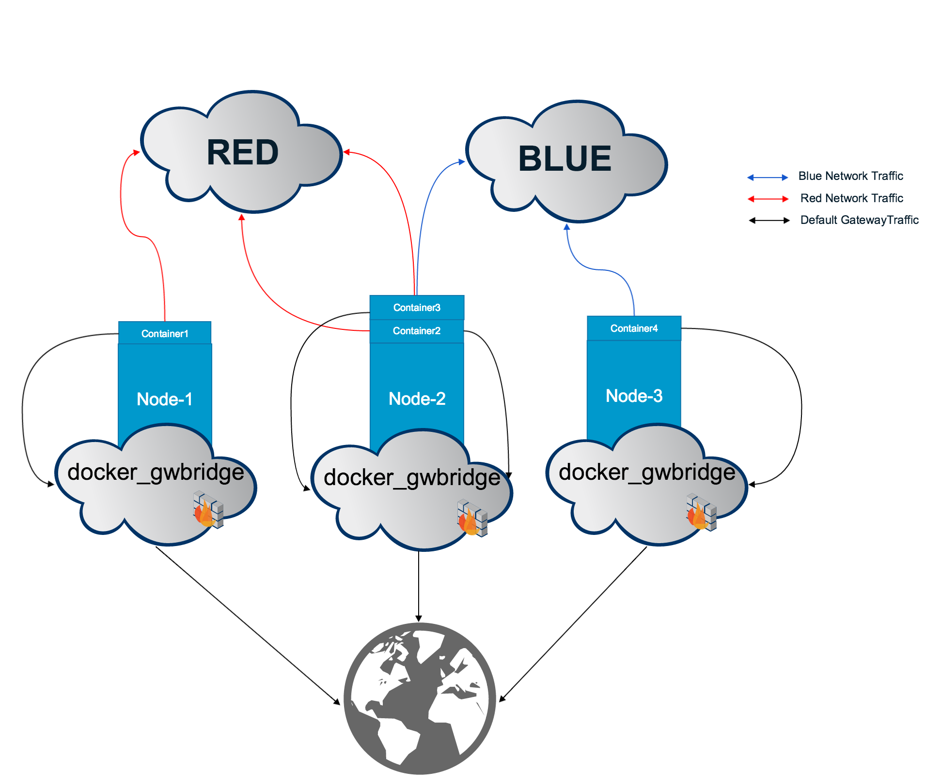
Create another overlay network called BLUE with the 10.10.20.0/24 subnet.
# docker network create -d overlay --subnet=10.10.20.0/24 BLUE

Verify the network was created.
# docker network ls

NETWORK ID NAME DRIVER
4f2bbdadc4a9 BLUE overlay
a48323b9feea RED overlay
16cdaa4f5c70 none null
c8a3ec609d61 host host
0d24ea92c876 bridge bridge

Log into Node-2 and create container3 on the RED network
# docker run -itd --name container3 --net RED ubuntu:14.04

81f1d923a406471f2a3abdd2c56e942079c27cf092d45d241291156bd033f15d

Connect container3 to the BLUE network.
# docker network connect BLUE container3

Go to node-2 and observe that container3 now has interfaces in both networks.

# docker exec container3 ifconfig

eth0 Link encap:Ethernet HWaddr 02:42:0a:0a:0a:04
inet addr:10.10.10.4 Bcast:0.0.0.0 Mask:255.255.255.0
inet6 addr: fe80::42:aff:fe0a:a04/64 Scope:Link
UP BROADCAST RUNNING MULTICAST MTU:1450 Metric:1
RX packets:208 errors:0 dropped:0 overruns:0 frame:0
TX packets:17 errors:0 dropped:0 overruns:0 carrier:0
collisions:0 txqueuelen:0
RX bytes:20080 (20.0 KB) TX bytes:1418 (1.4 KB)

eth1 Link encap:Ethernet HWaddr 02:42:ac:13:00:02
inet addr:172.19.0.2 Bcast:0.0.0.0 Mask:255.255.0.0
inet6 addr: fe80::42:acff:fe13:2/64 Scope:Link
UP BROADCAST RUNNING MULTICAST MTU:1500 Metric:1
RX packets:8 errors:0 dropped:0 overruns:0 frame:0
TX packets:8 errors:0 dropped:0 overruns:0 carrier:0
collisions:0 txqueuelen:0
RX bytes:648 (648.0 B) TX bytes:648 (648.0 B)

eth2 Link encap:Ethernet HWaddr 02:42:0a:0a:14:02
inet addr:10.10.20.2 Bcast:0.0.0.0 Mask:255.255.255.0
inet6 addr: fe80::42:aff:fe0a:1402/64 Scope:Link
UP BROADCAST RUNNING MULTICAST MTU:1450 Metric:1
RX packets:34 errors:0 dropped:0 overruns:0 frame:0
TX packets:27 errors:0 dropped:0 overruns:0 carrier:0
collisions:0 txqueuelen:0
RX bytes:2900 (2.9 KB) TX bytes:2342 (2.3 KB)

lo Link encap:Local Loopback
inet addr:127.0.0.1 Mask:255.0.0.0
inet6 addr: ::1/128 Scope:Host
UP LOOPBACK RUNNING MTU:65536 Metric:1
RX packets:26 errors:0 dropped:0 overruns:0 frame:0
TX packets:26 errors:0 dropped:0 overruns:0 carrier:0
collisions:0 txqueuelen:0
RX bytes:2120 (2.1 KB) TX bytes:2120 (2.1 KB)

Log into Node-3 and create container4 on the BLUE network.

# docker run -itd --name container4 --net BLUE ubuntu:14.04

we can create many containers as we needed in particular network whether is in RED or BLUE, its completely up to you,
to find which containers are in RED network and which containers are in BLUE network

# docker network inspect RED

[
{
"Name": "RED",
"Id": "56a39f7406040ca221bed48cd31dca3bb79ec7e187dad4f93f0e8659a5fb90a5",
"Scope": "global",
"Driver": "overlay",
"EnableIPv6": false,
"IPAM": {
"Driver": "default",
"Options": {},
"Config": [
{
"Subnet": "10.10.10.0/24"
}
]
},
"Internal": false,
"Containers": {
"e7a546434fdaab2b49e44e8384d9657ee593ad677de118ba2e639a7d434874ff": {
"Name": "container1",
"EndpointID": "c9119a8b8ad39f2d91f5166c7478ab03e74e4fc8226aee963065684383e18554",
"MacAddress": "02:42:0a:0a:0a:02",
"IPv4Address": "10.10.10.2/24",
"IPv6Address": ""
},
"ep-288a0264091d9d8461796d883bbdf21d0a91d28404f3b8203a643b3f916e69e4": {
"Name": "container5",
"EndpointID": "288a0264091d9d8461796d883bbdf21d0a91d28404f3b8203a643b3f916e69e4",
"MacAddress": "02:42:0a:0a:0a:05",
"IPv4Address": "10.10.10.5/24",
"IPv6Address": ""
},
"ep-c9e3a593678efab9dc83667f58f98a96173b06bc27c1429aa75855e1cb6bdfef": {
"Name": "container2",
"EndpointID": "c9e3a593678efab9dc83667f58f98a96173b06bc27c1429aa75855e1cb6bdfef",
"MacAddress": "02:42:0a:0a:0a:03",
"IPv4Address": "10.10.10.3/24",
"IPv6Address": ""
},
"ep-ecf3b7ad9ff2391bb6529508e83b65b591387de8c80bd9a963c8589e6ba5d952": {
"Name": "container3",
"EndpointID": "ecf3b7ad9ff2391bb6529508e83b65b591387de8c80bd9a963c8589e6ba5d952",
"MacAddress": "02:42:0a:0a:0a:04",
"IPv4Address": "10.10.10.4/24",
"IPv6Address": ""
}
},
"Options": {},
"Labels": {}
}
]

# docker network inspect BLUE

[
{
"Name": "BLUE",
"Id": "6cd080c0c8dd22087271f69fad6c32f8fe4f2206725aa8e20fdc8dbb03e67aae",
"Scope": "global",
"Driver": "overlay",
"EnableIPv6": false,
"IPAM": {
"Driver": "default",
"Options": {},
"Config": [
{
"Subnet": "10.10.20.0/24"
}
]
},
"Internal": false,
"Containers": {
"ep-5daca544383d5a28abd236e0b5e1eb04c47226e15e8769f32a3e5390c74a7a3d": {
"Name": "container4",
"EndpointID": "5daca544383d5a28abd236e0b5e1eb04c47226e15e8769f32a3e5390c74a7a3d",
"MacAddress": "02:42:0a:0a:14:03",
"IPv4Address": "10.10.20.3/24",
"IPv6Address": ""
},
"ep-89f890a0bd859fe5f770ca578808cbe05092d5f87200e39a56d504b3dc1abc8c": {
"Name": "container5",
"EndpointID": "89f890a0bd859fe5f770ca578808cbe05092d5f87200e39a56d504b3dc1abc8c",
"MacAddress": "02:42:0a:0a:14:04",
"IPv4Address": "10.10.20.4/24",
"IPv6Address": ""
},
"ep-f3ccff90dd4672f8f8a01afac6bb65447bbbc9af5c5cf1fb76dfb486e93f9c76": {
"Name": "container3",
"EndpointID": "f3ccff90dd4672f8f8a01afac6bb65447bbbc9af5c5cf1fb76dfb486e93f9c76",
"MacAddress": "02:42:0a:0a:14:02",
"IPv4Address": "10.10.20.2/24",
"IPv6Address": ""
}
},
"Options": {},
"Labels": {}
}
]

***************************************************************************************
step 7 : Conclusion
***************************************************************************************

1) We can create many networks as we needed
2) The containers can talk each other with in that network
3) The containers in both networks can talk all other containers because of it has two interfaces apart from
eth1 for external connectivity (one for RED and another for BLUE)

***************************************************************************************
step 7 : Links
***************************************************************************************

https://github.com/docker/dceu_tutorials/blob/94fd5f3e9372a8f58ca7b25f3232305731f7cd36/06-networking.md

