********************************************************************************
EFK
********************************************************************************

system-1 >> 192.168.1.234
system-2 >> 192.168.1.235

system-1 >>

1) elasticsearch installation
2) fluentd (td-agent) installation
3) kibana installation

system-2 >>

1) fluentd (td-agent) installation

on system-1 & system-2 >>

Java installation ::

# add-apt-repository -y ppa:webupd8team/java
# apt-get update
# apt-get -y install oracle-java8-installer

on system-1 >>

********************************************************************************
Install Elasticsearch
********************************************************************************

choose the appropriate elasticsearch version if you are going with readonly plugins,

https://readonlyrest.com/#download

Run the following command to import the Elasticsearch public GPG key into apt:

wget
https://download.elasticsearch.org/elasticsearch/release/org/elasticsearch/distribution/deb/elasticsearch/2.4.3/elasticsearch-2.4.3.deb

# dpkg -i elasticsearch-2.4.3.deb

Elasticsearch is now installed. Let's edit the configuration:

# nano /etc/elasticsearch/elasticsearch.yml

network.host:0.0.0.0
port : 9200

Save and exit elasticsearch.yml.
Now start Elasticsearch:

# service elasticsearch restart
# curl -XGET http://localhost:9200

by this command cluster name and all get
GUI console ::

# cd /usr/share/elasticsearch

install the head by

# bin/plugin install mobz/elasticsearch-head

plugin site

http://server-ip:9200/_plugin/head

then we can see indexes all information here

on system-1 & system-2 >>

********************************************************************************
Fluentd via td-agent
********************************************************************************

# curl -L https://td-toolbelt.herokuapp.com/sh/install-ubuntu-trusty-td-agent2.sh | sh

if there is any error while installing, the,

# chown td-agent:td-agent /var/log/td-agent
# curl -L https://td-toolbelt.herokuapp.com/sh/install-ubuntu-trusty-td-agent2.sh | sh
# /opt/td-agent/embedded/bin/fluent-gem install fluent-plugin-elasticsearch
# /opt/td-agent/embedded/bin/fluent-gem install fluent-plugin-record-reformer

for installing inside the docker containers ::

# apt-get install -y curl
# curl https://packages.treasuredata.com/GPG-KEY-td-agent | apt-key add -
# echo "deb http://packages.treasuredata.com/2/ubuntu/trusty/ trusty contrib" > /etc/apt/sources.list.d/treasure-data.list
# apt-get update
# apt-get install -y td-agent
# /opt/td-agent/embedded/bin/fluent-gem install fluent-plugin-elasticsearch
# /opt/td-agent/embedded/bin/fluent-gem install fluent-plugin-record-reformer

config file format >>>

###################################

<source> # header
type tail # last logs visible first
format none # which file format needed, eg : json, txt
time_format %b %d %H:%M:%S %Y # time format appending to the logs
pos_file /var/log/td-agent/syslog.pos # last readed logs where stored in this file for updating only new logs
path /var/log/syslog # where is the log file in system
tag sys-log # tag for the match header
</source> # closing header

###################################

<match sys-log> # header
type elasticsearch # destination type
host 192.168.1.234 # destination host
port 9200 # port for the elasticsearch
include_tag_key true
tag_key @log_name
# user admin #
# password admin #
index_name syslog # index name to be visible in GUI
type_name syslog # type name to be visible in GUI
logstash_prefix syslog # for adding the logs to kibana GUI
logstash_format true # for adding the logs to kibana GUI
flush_interval 10s # refreshing time
</match> # closing header

###################################

you can check whether it working or not ; by useing tail -n 3 /var/log/td-agent/td-agent.log

Edit /etc/td-agent/td-agent.conf and add the following lines to the top of the file:

eg ::

# nano /etc/td-agent/td-agent.conf

<match docker.**>
type stdout
</match>

save and exit

or if there is no docker installation, then,

# nano /etc/td-agent/td-agent.conf

<source>
type tail
format none
path /var/log/syslog
tag sys-log
</source>

<match sys-log>
type stdout
</match>

save and exit

# sudo service td-agent restart

if there is docker configuration, then ,

# docker run --log-driver=fluentd hello-world

# tail -n 3 /var/log/td-agent/td-agent.log

2015-07-01 16:56:02 -0400 docker.c61d13c68659: {“container_id”:”c61d13c68659b622a01d8c3825b0bc1186391119d47dbf864d9c3a65c3f2aa79″,”container_name”:”/distracted_bell”,”source”:”stdout”,”log”:””}

if it is working fine, then lets move to next part,

Edit /etc/td-agent/td-agent.conf and add the following lines to the top of the file:

system-1 >>

# nano /etc/td-agent/td-agent.conf

###################################

<source>
type tail
format none
time_format %b %d %H:%M:%S %Y
pos_file /var/log/td-agent/syslog.pos
path /var/log/syslog
tag sys-log
</source>

###################################

<source>
type tail
format none
time_format %b %d %H:%M:%S %Y
path /var/log/apache2/*.log
pos_file /var/log/td-agent/access.log.pos
read_from_head true
tag apache-log
</source>

###################################

<source>
type tail
format none
time_format %b %d %H:%M:%S %Y
path /var/log/td-agent/*.log
pos_file /var/log/td-agent/td-agent.log.pos
read_from_head true
tag td-agent-log
</source>

###################################

<match sys-log>
type elasticsearch
host 192.168.1.234
port 9200
include_tag_key true
tag_key @log_name
# user admin
# password admin
index_name syslog
type_name syslog
logstash_prefix syslog
logstash_format true
flush_interval 10s
</match>

###################################

<match apache-log>
type elasticsearch
host 192.168.1.234
port 9200
include_tag_key true
tag_key @log_name
# user admin
# password admin
index_name apachelog
type_name apachelog
logstash_prefix apachelog
logstash_format true
flush_interval 10s
</match>

###################################

<match td-agent-log>
type elasticsearch
host 192.168.1.234
port 9200
include_tag_key true
tag_key @log_name
# user admin
# password admin
index_name local-td-agent
type_name local-td-agent
logstash_prefix local-td-agent-log
logstash_format true
flush_interval 10s
</match>

###################################

<match docker.**>
type elasticsearch
host 192.168.1.234
port 9200
index_name docker-log
flush_interval 5s
</match>

###################################

system-2 >>

# nano /etc/td-agent/td-agent.conf

###################################

<source>
type tail
format none
time_format %b %d %H:%M:%S %Y
pos_file /var/log/td-agent/syslog.pos
path /var/log/syslog
tag remote-sys-log
</source>

###################################

<source>
type tail
format none
time_format %b %d %H:%M:%S %Y
path /var/log/td-agent/*.log
pos_file /var/log/td-agent/access.log.pos
read_from_head true
tag remote-td-agent-log
</source>

###################################

<match remote-sys-log>
type elasticsearch
host 192.168.1.234
port 9200
include_tag_key true
tag_key @log_name
# user admin
# password admin
index_name remote-syslog
type_name remote-syslog
logstash_prefix remote-syslog
logstash_format true
flush_interval 10s
</match>

###################################

<match remote-td-agent-log>
type elasticsearch
host 192.168.1.234
port 9200
include_tag_key true
tag_key @log_name
# user admin
# password admin
index_name remote-td-agent
type_name remote-td-agent
logstash_prefix remote-td-agent-log
logstash_format true
flush_interval 10s
</match>

###################################

on system-1 & system-2 >>

give all pos_files in /var/log/td-agent
if there is a pos_file then create it and give permission,

eg ::

# touch /var/log/td-agent/syslog.pos
# chmod 777 /var/log/td-agent/syslog.pos
# chown -R td-agent:td-agent /var/log/td-agent

check the log file in the path directive is accesible by td-agent
service_
eg ::

# ll /var/log/syslog
-rw-r--r-- 1 syslog adm 2159588797 Jan 14 11:37 /var/log/syslog

add the td-agent to adm group,

# usermod -aG adm td-agent

restart the service and check th error,

# service td-agent restart
# tail /var/log/td-agent/td-agent.log

for adding docker logs, use docker-opts ::

DOCKER_OPTS="—log-driver=fluentd"

or

DOCKER_OPTS="--log-driver=fluentd --log-opt fluentd-address=server-ip:24224"

there is more optios for “DOCKER_OPTS” check the link

links ::
https://github.com/docker/docker/issues/15475

check in elasticsearch page ::
http://server-ip:9200/_plugin/head

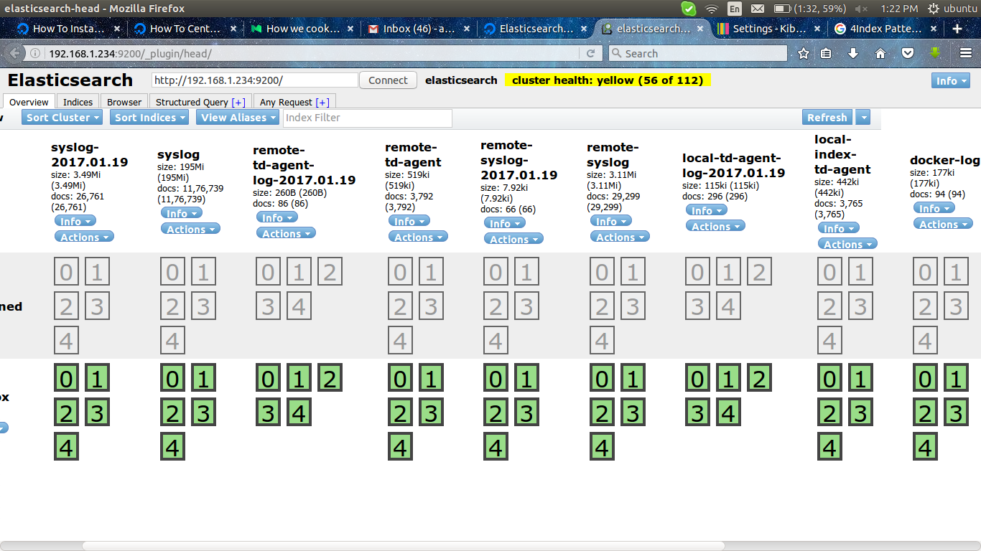

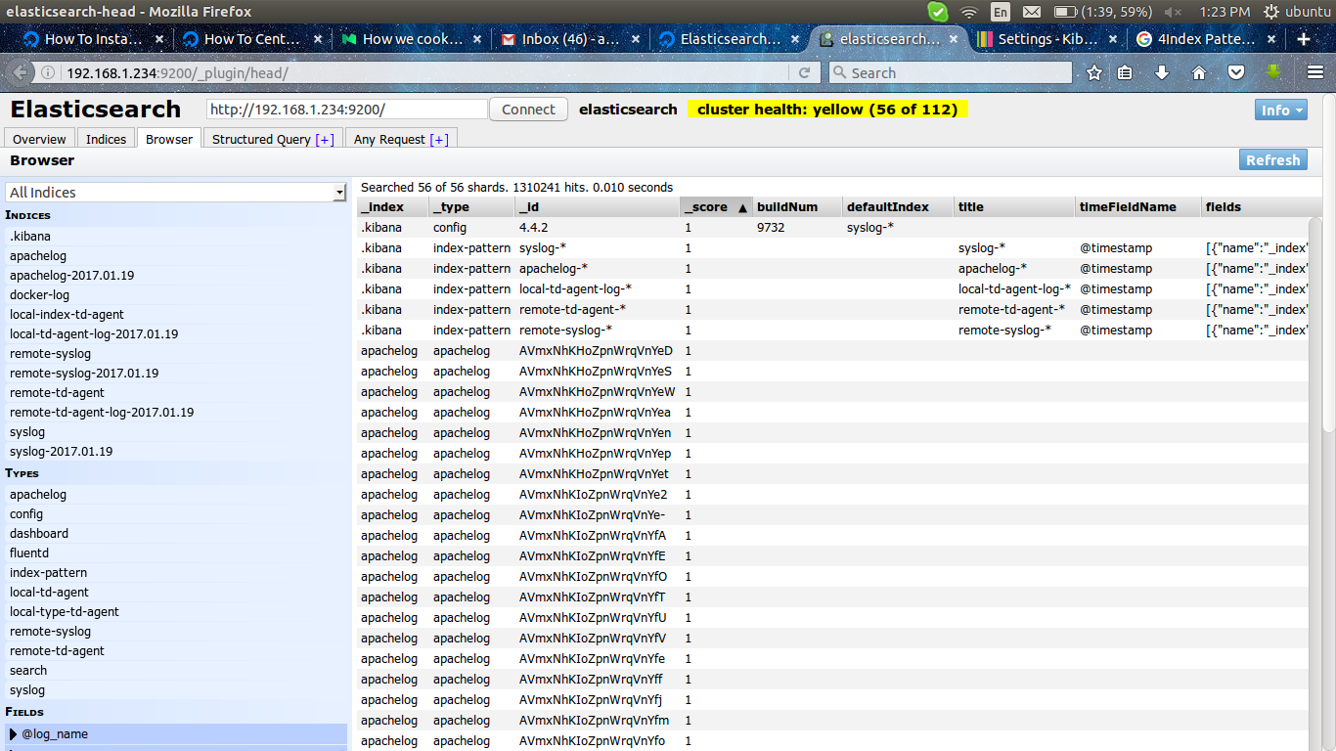

*******************************************************************************
links ::
********************************************************************************
config-file >>
http://docs.fluentd.org/articles/config-file
http://docs.fluentd.org/articles/in_tail

fluentd installation >>
https://blog.treasuredata.com/blog/2015/07/07/collecting-docker-logs-with-fluentd/
********************************************************************************

********************************************************************************Log Forwarder & Log Aggregator
********************************************************************************

To configure Fluentd for high availability, we assume that your network consists of ‘log forwarders’ and ‘log aggregators’.
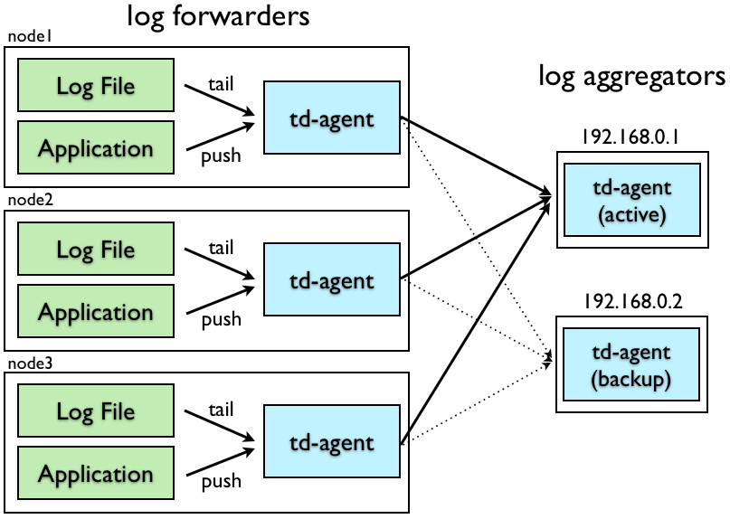
‘log forwarders’ are typically installed on every node to receive local events. Once an event is received, they forward it to the ‘log aggregators’ through the network.

In another system install the td-agent ::

# curl -L https://td-toolbelt.herokuapp.com/sh/install-ubuntu-trusty-td-agent2.sh | sh

Edit /etc/td-agent/td-agent.conf and add the following lines at the top:

# nano /etc/td-agent/td-agent.conf

<source>
type tail
format none
pos_file /var/log/td-agent/syslog.pos
path /var/log/syslog
tag remote.sys
</source>

# Log Forwarding

<match remote.**>
type forward
<server>
host 192.168.1.234
port 24224
</server>
</match>

the following this are optional ::

#heartbeat_type tcp
#flush_interval 10s
#num_threads 8
#expire_dns_cache 600
#buffer_path /var/log/td-agent/buffer/forward

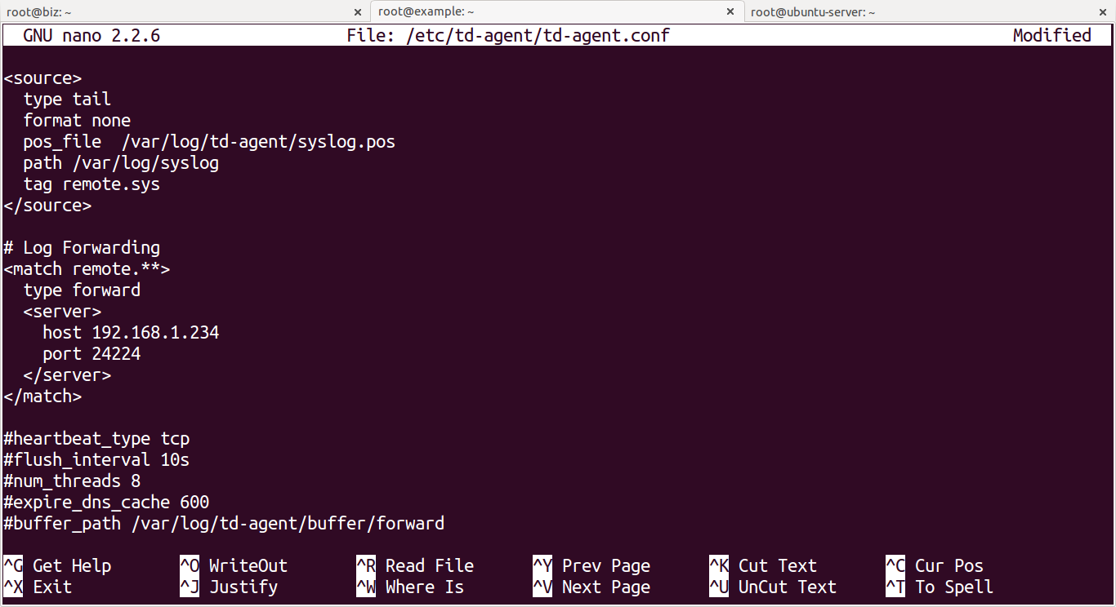

if there is a pos_file then create it and give permission,

eg ::

# touch /var/log/td-agent/syslog.pos
# chmod 777 /var/log/td-agent/syslog.pos

check the log file in the path directive is accesible by td-agent

eg ::

# ll /var/log/syslog
-rw-r--r-- 1 syslog adm 2159588797 Jan 14 11:37 /var/log/syslog

add the td-agent to adm group,

# usermod -aG adm

restart the service and check th error,

# service td-agent restart
# tail /var/log/td-agent/td-agent.log

check in the server side and change the configuration a little bit,

added this lines along with the existing configuration,

warning :: provided the “match” extension same as you providedin the remote machine (match remote.** )

<match remote.**>
type elasticsearch
host 192.168.1.234
port 9200
index_name remote.sys-log
flush_interval 5s
</match>

restart the service and check th error,

# service td-agent restart
# tail /var/log/td-agent/td-agent.log

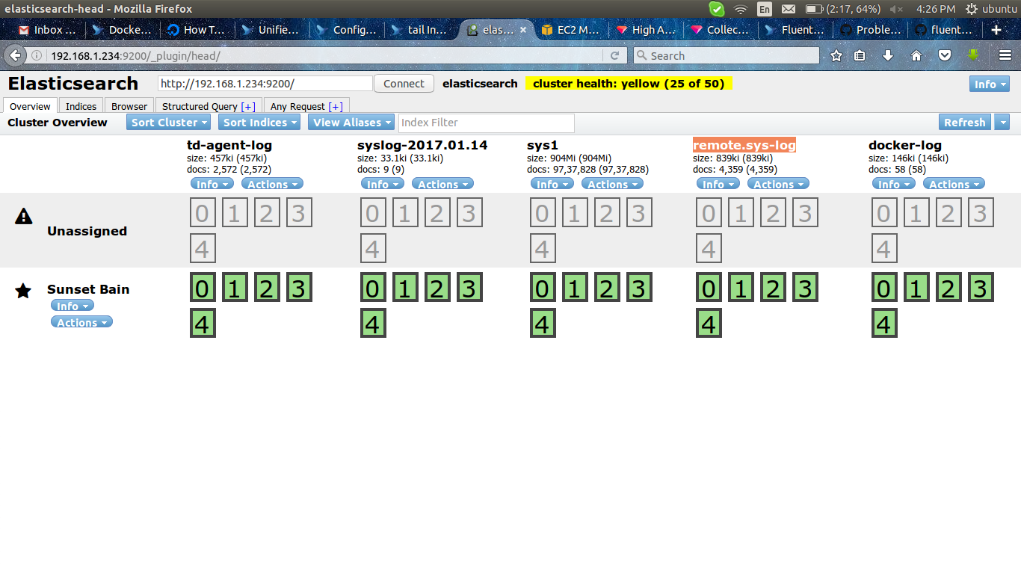
********************************************************************************
links ::
********************************************************************************

https://docs.treasuredata.com/articles/td-agent-high-availability
http://docs.fluentd.org/articles/high-availability#log-aggregator-configuration

********************************************************************************

on system-1 >>

********************************************************************************
Install Kibana
********************************************************************************

links >>

https://www.digitalocean.com/community/tutorials/how-to-install-elasticsearch-logstash-and-kibana-elk-stack-on-ubuntu-14-04

Kibana can be installed with a package manager by adding Elastic's package source list.
Create the Kibana source list:

# echo "deb http://packages.elastic.co/kibana/4.4/debian stable main" | sudo tee -a /etc/apt/sources.list.d/kibana-4.4.x.list
# sudo apt-get update
# sudo apt-get install kibana

edit the config file

# nano /opt/kibana/config/kibana.yml

server.host: 0.0.0.0
server.port: 5601

save and exit

# update-rc.d kibana defaults 96 9
# service kibana start

we can use either apache2 or nginx, here im using nginx

# apt-get install nginx apache2-utils

Now open the Nginx default server block in your favorite editor, Delete the file's contents, and paste the following code block into the file. Be sure to update the server_name to match your server's name:

# nano /etc/nginx/sites-available/default

server {
listen 80;

server_name biz.local;

auth_basic "Restricted Access";
auth_basic_user_file /etc/nginx/htpasswd.users;

location / {
proxy_pass http://0.0.0.0:5601;
proxy_http_version 1.1;
proxy_set_header Upgrade $http_upgrade;
proxy_set_header Connection 'upgrade';
proxy_set_header Host $host;
proxy_cache_bypass $http_upgrade;
}
}

# service nginx restart

Kibana is now accessible via your FQDN or the public IP address
http://192.168.1.234

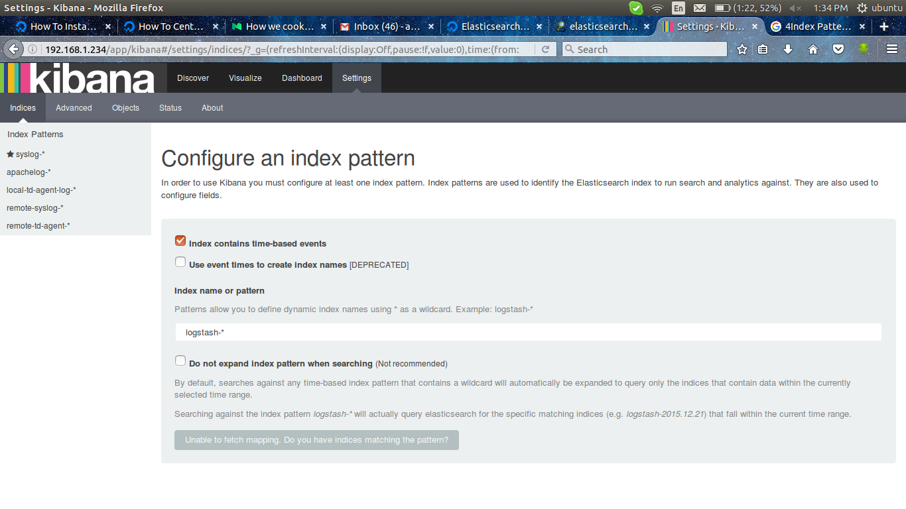

at the first time it showing like this,
kibana is asking to add the logs to the dashboard,

<< WARNING >>

in td-config we provided some configuration,

under <source>
time_format %b %d %H:%M:%S %Y

and

under <match some-tag>
logstash_prefix local-td-agent-log
logstash_format true

in absence of this configuration the kibana will not take the logs to the dashboard,

to add the logs to kibana dashboard >>

1) take a look into elasticsearch dashboard and select the name ending with date.

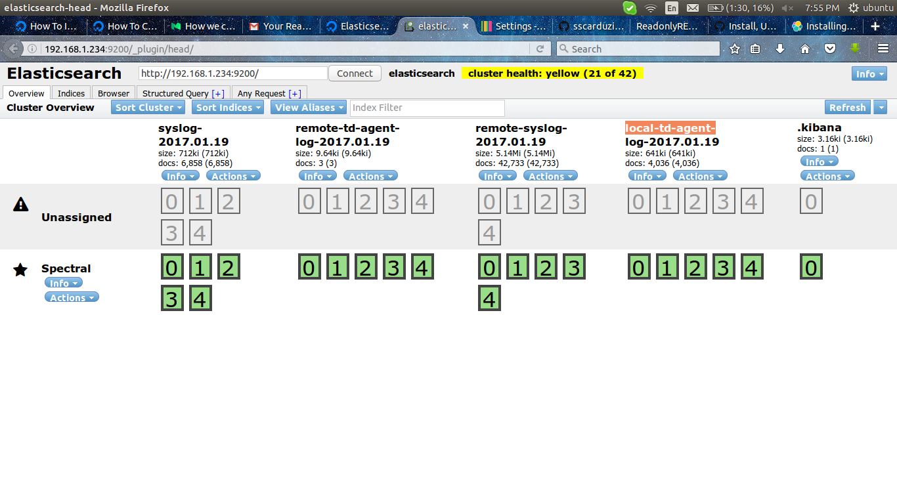

2) go to kibana >> settings >> under Index name or pattern >> local-td-agent-log-* >> then it will show something @timestamp >> done

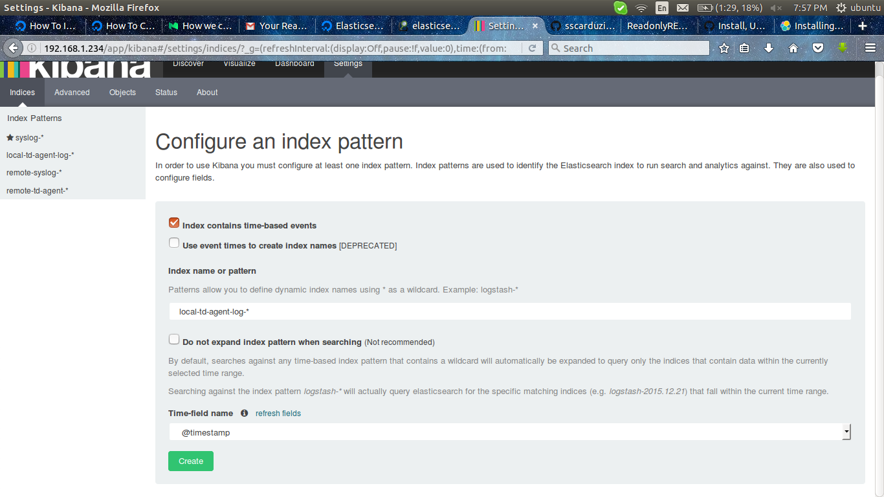

3) to view logs go to dashboard >> in right-up-corner >> click on last-15 mins* >> choose the time from where you need to see the logs.

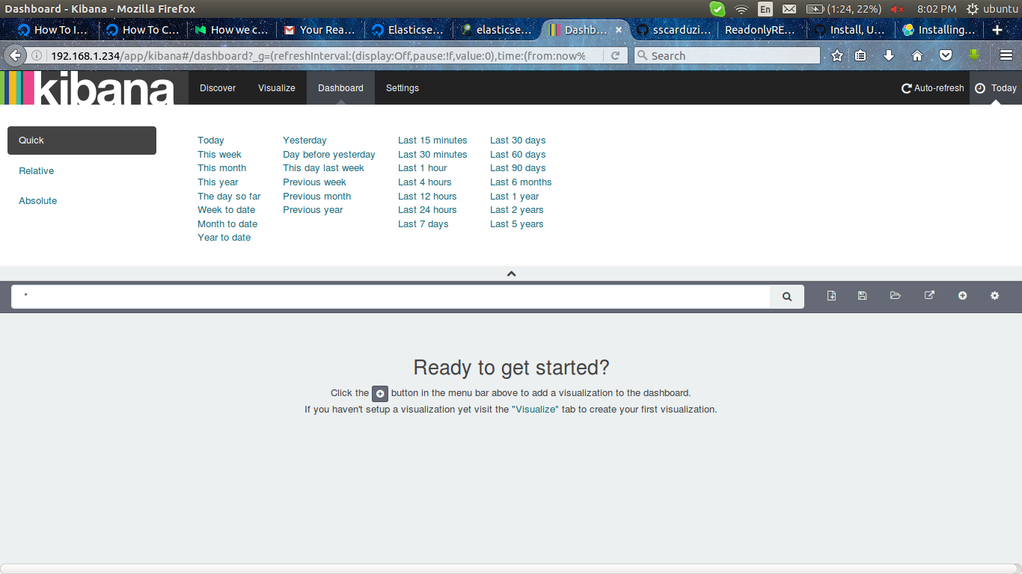

********************************************************************************
Install readonly plugin
********************************************************************************
downloaded the particular version from this site:
https://readonlyrest.com/#download

we get a zip file like,

elasticsearch-readonly*.zip

# cd /usr/share/elasticsearch

# bin/plugin install file:/tmp/elasticsearch-readonly*.zip

edit the configuration ::

# nano /etc/elasticsearch/elasticsearch.yml

add the following lines at the bottom of file,

network.bind_host: 0
http.cors.enabled: true
http.cors.allow-origin: "*"

readonlyrest:
enable: true
response_if_req_forbidden: <h1>Forbidden</h1>
access_control_rules:

- name: "Logstash can write and create its own indices"
auth_key: pass-gui:pass-gui
type: allow
actions: ["indices:data/read/*","indices:data/write/*","indices:admin/template/*","indices:admin/create"]
indices: ["pass-gui*", "<no-index>"]

- name: Kibana Server (we trust this server side component, full access granted via HTTP authentication)
auth_key: admin:admin
type: allow

- name: Developer (reads only logstash indices, but can create new charts/dashboards)
auth_key: dev:dev
type: allow
kibana_access: ro+
indices: ["<no-index>", ".kibana*", "cdci-01*", "default"]

we can add the particular user and password for particular kibana dashboard

********************************************************************************
links::
********************************************************************************

configuration>>
https://github.com/sscarduzio/elasticsearch-readonlyrest-plugin

