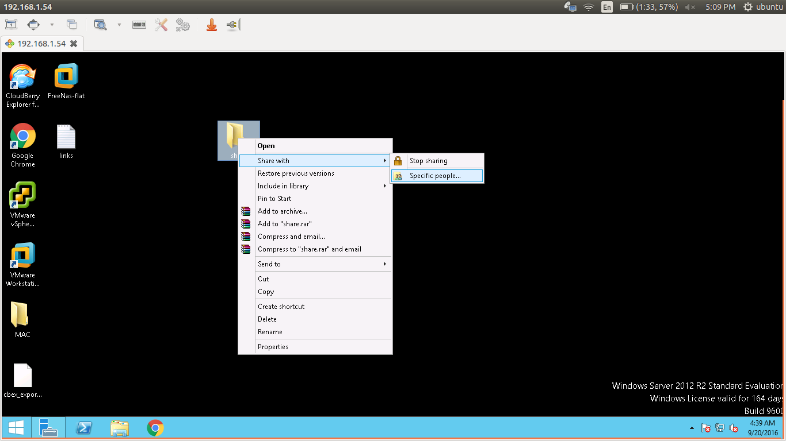
Create a directory and right click on that

create a new user if required, and give permissions

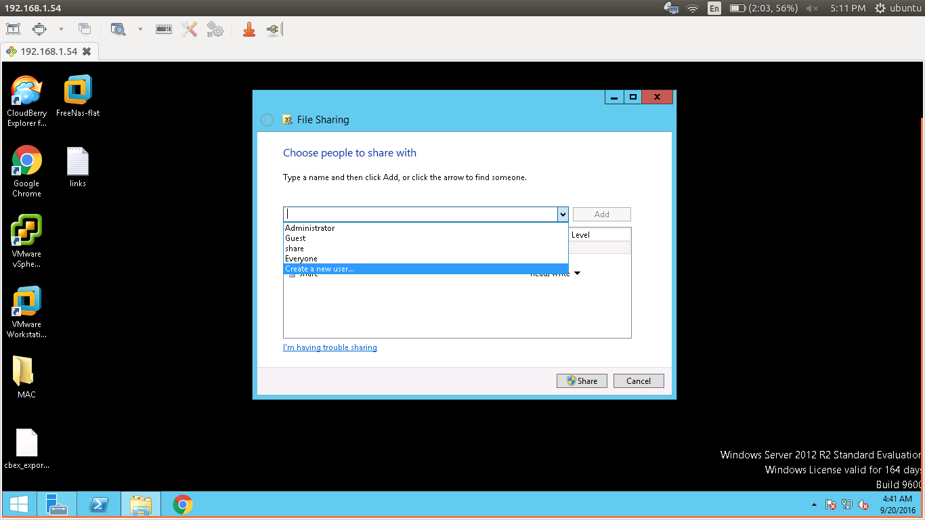

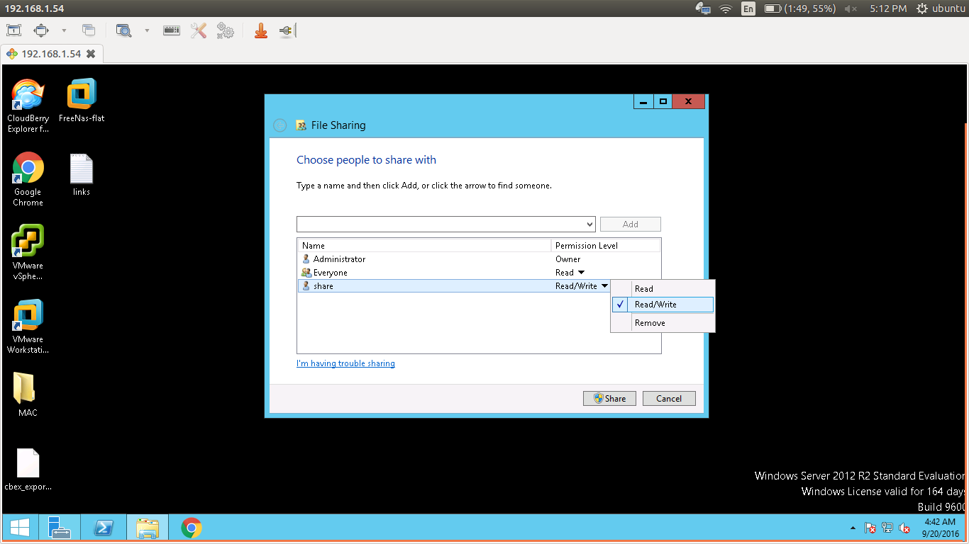

we can add many users as we want to add in samba who have different privillages according to your usage.

Go to control pannel > network and sharing center > change advanced sharing settings

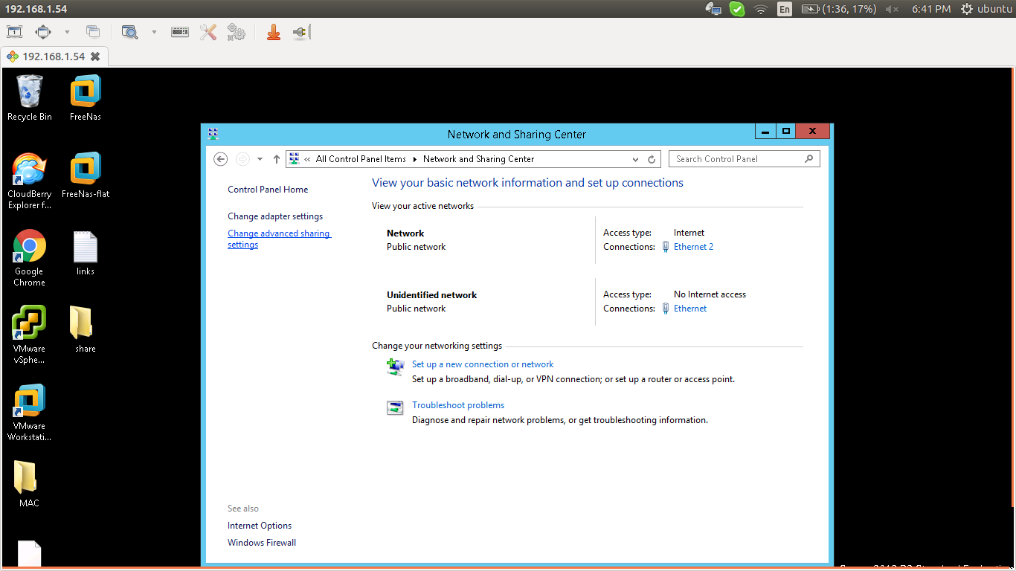

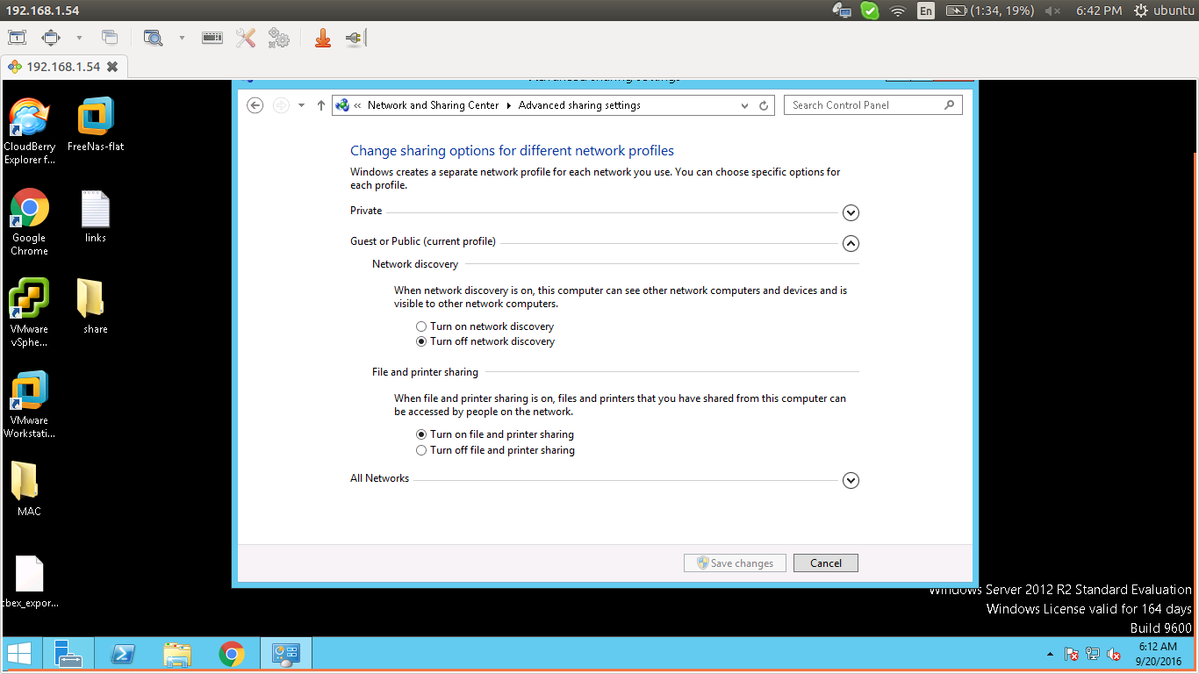
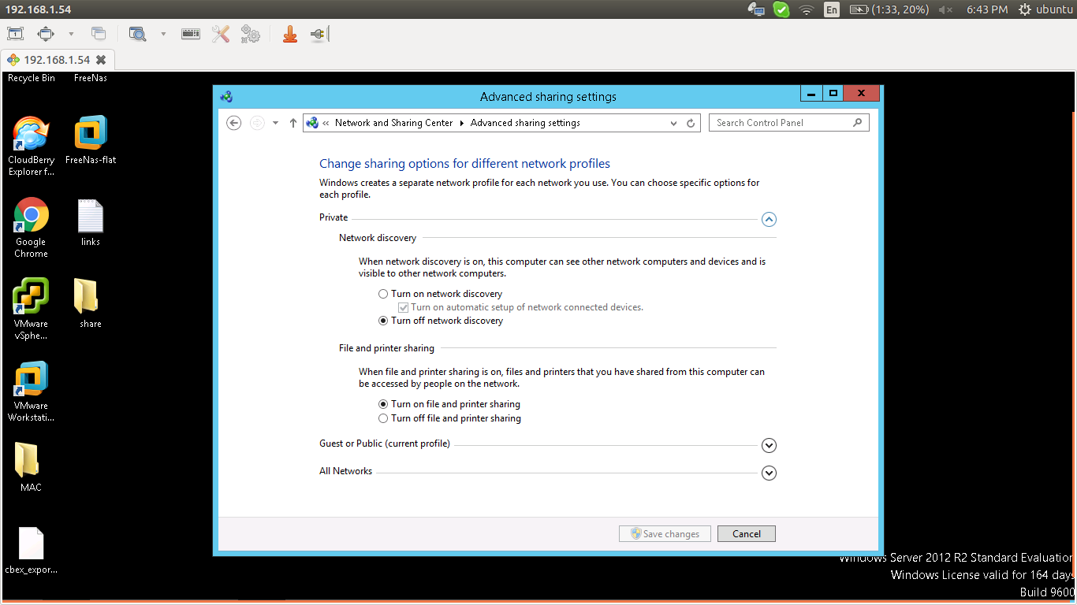

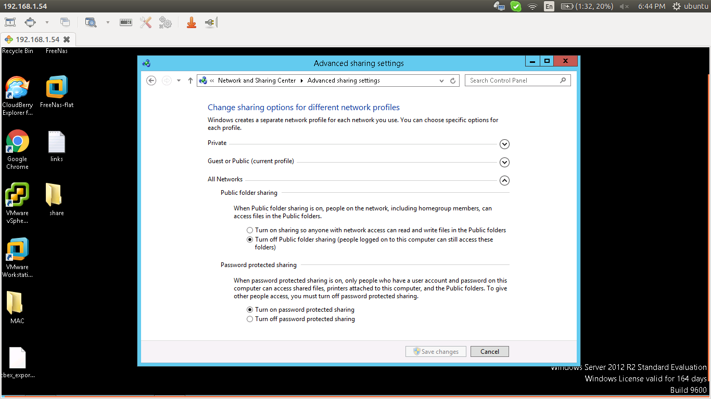

go to server manager > files and storage service > shares

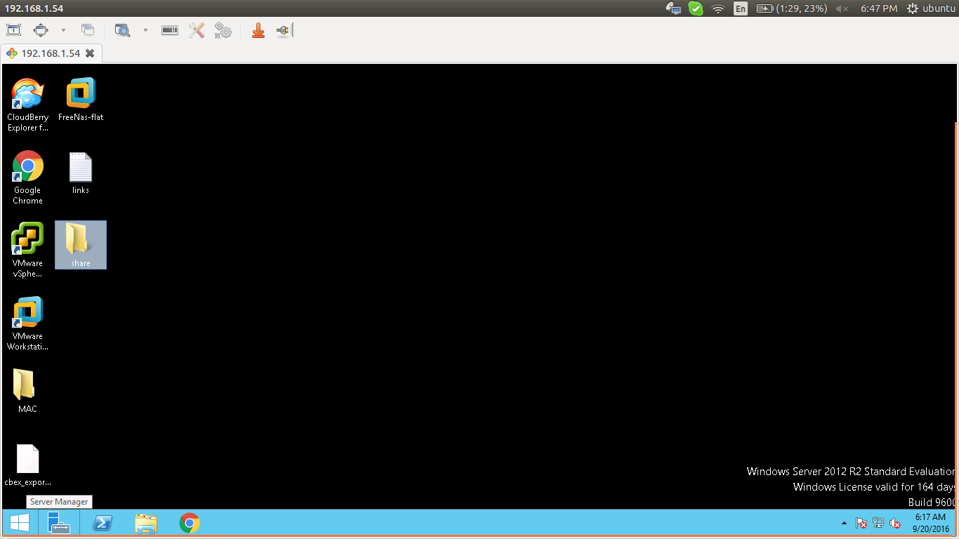

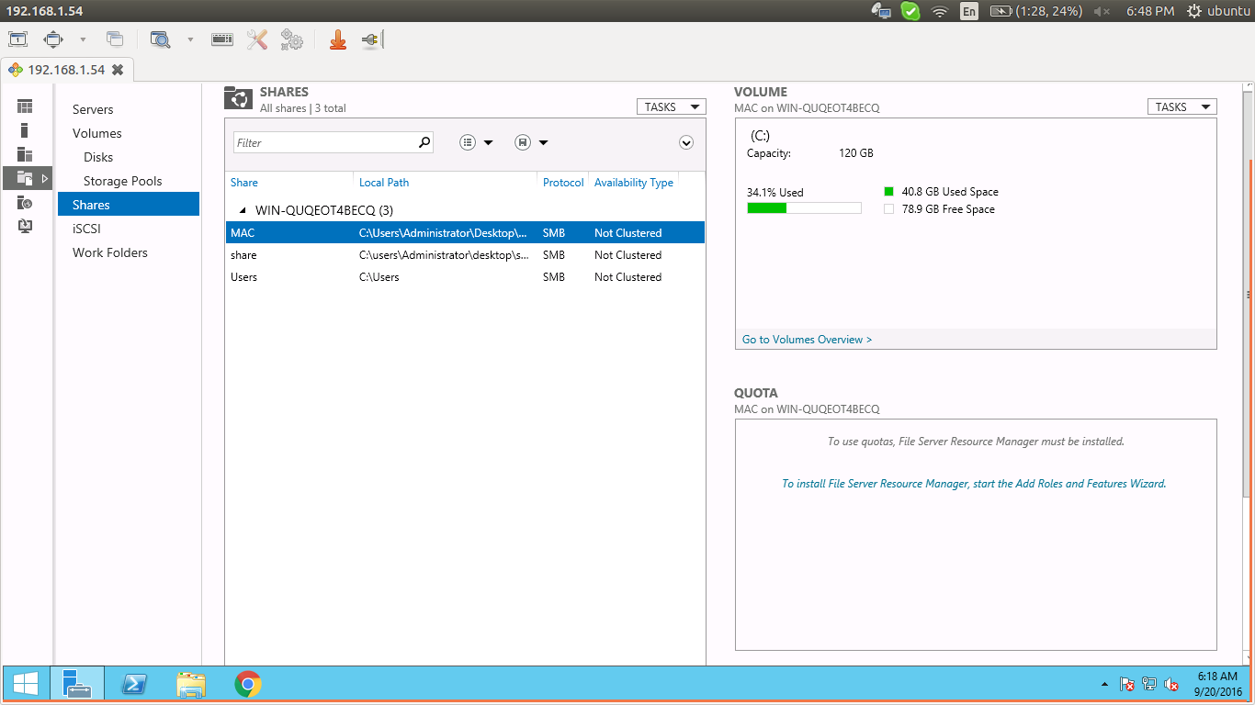

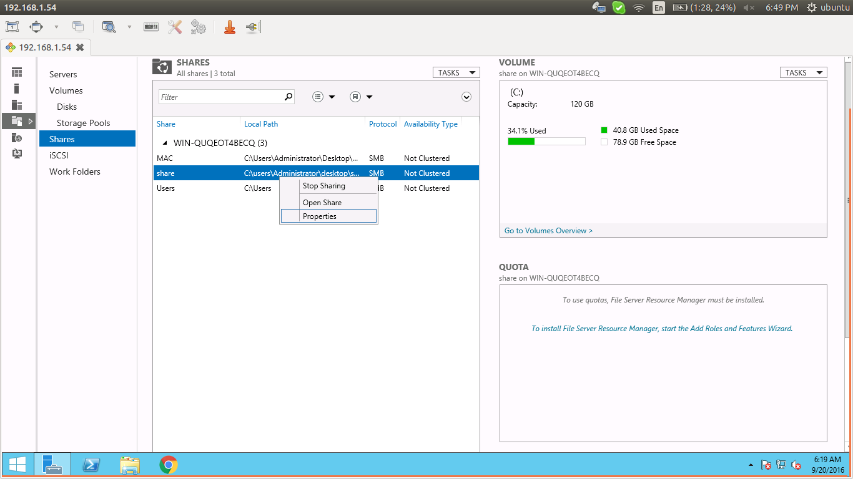

right click on share directory > properties

give all informations about that directory

change according to the following pics

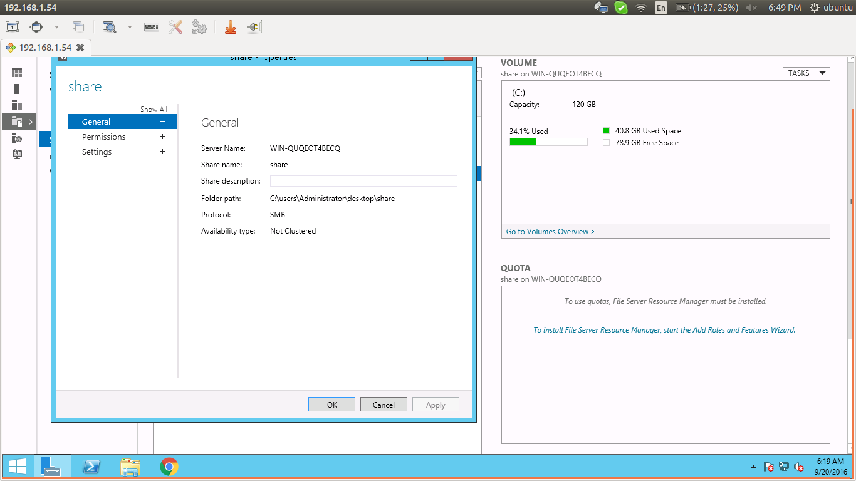

permissions > coustomise permissions > share

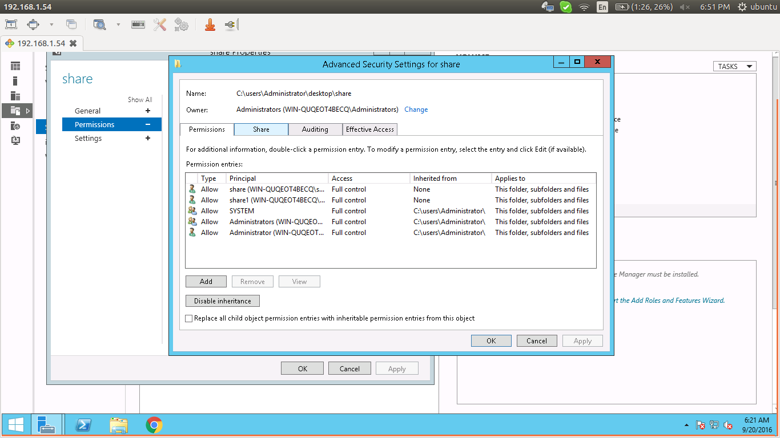
so, general and permissions are over, last one is settings

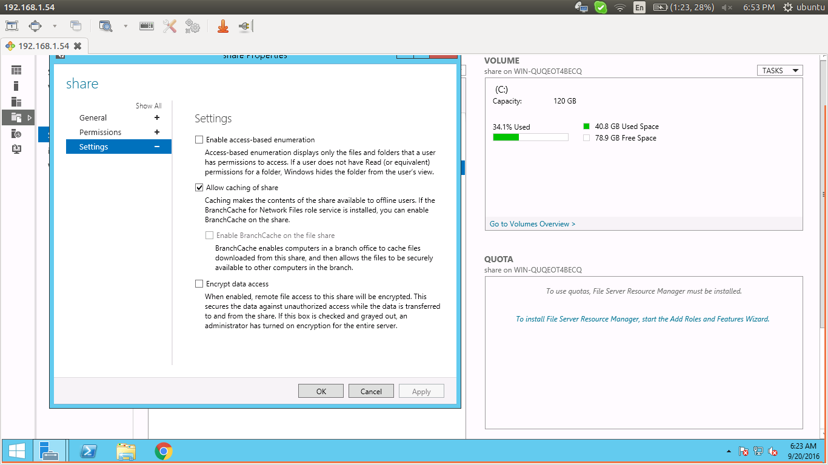
click on ok and use it

client side

to checking whether it is accessable or not,

smbclient //192.168.1.54/share --user=share

where,

//192.168.1.54/share >> server ip and share name for that share directory
--user=share >> user of samba server for accessing

use this options for mounting

mount -t cifs //192.168.1.54/share -o username=share,password=bizruntime@123,uid=1001,gid=1004 /mnt/aa

where,

//192.168.1.54/share >> server ip and share name for that share directory
username=share,password=bizruntime@123 >> instead of credential file
uid=1001,gid=1004 >> client side user who have privillage on that mount point for accessing
/mnt/aa >> mount point

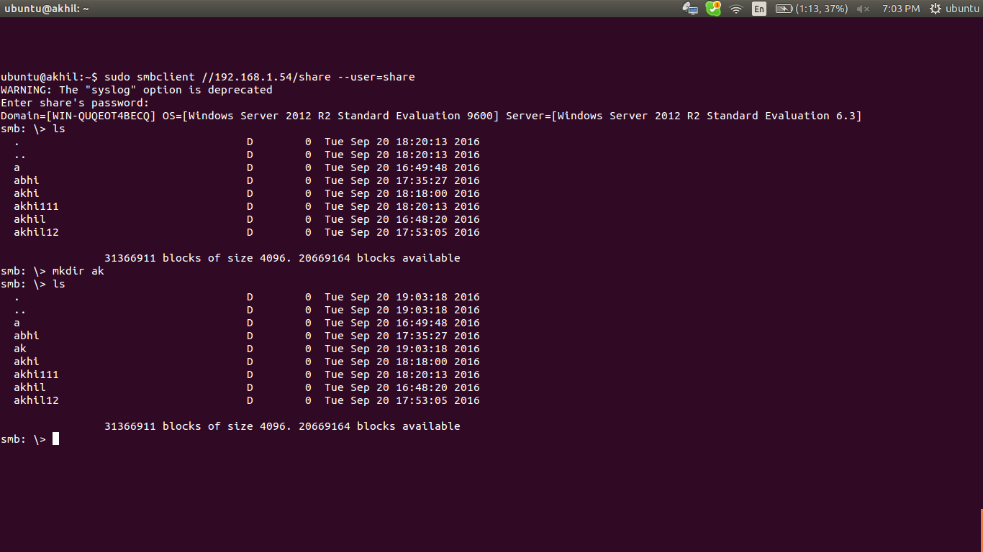

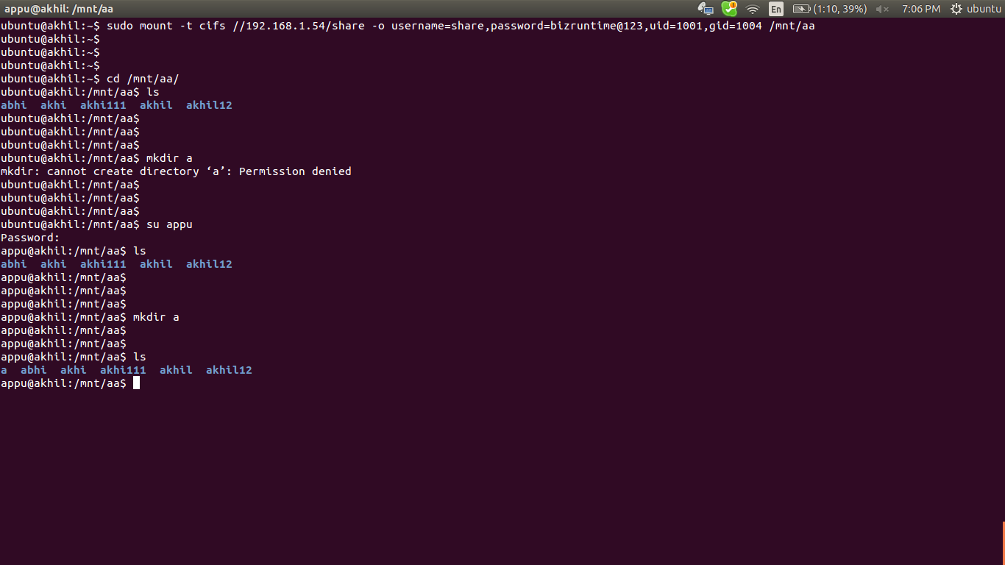

1) mount it
2) try to create directory in mount point as a user rather than user who have gid and uid mentioned
in the mount command >> cannt created
3) swich to user who have gid and uid mentioned in the mount command ; in my case
(uid=1001,gid=1004>> user=appu)
4) login as appu, can create directory in mount point

links for configure windows systems for smb-share

http://www.techrepublic.com/blog/data-center/how-to-share-a-folder-in-windows-server-2012/

